introduction
C1 – 1.1identification + 1.2conceptualization + 1.3formalization
C2 – 2.1ontology + 2.2solving methodology + 2.3implementation
C3 – 3.1clips code + 3.2test cases
C4 – conclusion
INTRODUCTION
In this project we have developed an expert system, following the steps of the knowledge engineering methodology explained in class: identification, conceptualization, formalization, implementation and testing

The report starts with describing the analysis and the identification of the problem, afterward the ontology is explained int the second chapter.
In the third chapter CLIPS code is reported and described, finally the last chapter contain the conclusion on the project.

C1
1.1-identification and description of the problem
--it means description of the KBS, and goals we want to reach

The KBS is meant to help people looking for the house which best fits their needs.
The user insert some constraints and requisites, and the expert system find out the house which is more adequate from a group of suitable houses.

The user is asked to answer some question in order to identify the preferences of him; basically, the main information asked are some house characteristics such as m2, monthly price for the rent, number of bedrooms and so on.
Moreover the questions posed by the KBS are done to figure out the kind of user, in example a young student looking for social life, a young couple looking for a place where make a family, an old couple in search of relax and tranquillity.

GOALS?

1.2-conceptualization of the problem
--description of the concepts in the domain, informal description of a solution of the prob

The domain of the problem is the house market.
In the ontology different type of houses, such as flat, attics and so on are described.
In addiction different service are handled, such university, hospital, public transportation and clubs, restaurants and different entertainments such theater and cinemas.

Another factor that has been taken into account is the location of each house and service among the city. This is handled by the use of coordinates.
We can determine if a specific place is near, mid distance or far to another depending on if it is less than 500 meters, less than 1000 meters or more that 1000 meters respectively.

We made some assumptions such as:
- To young people could be more important to have night life areas near.
- To big families could be more important to have a hypermarket near in order to do their monthly shopping.
- To elder members of the family is more important to have near healt services or supermarkets for their daily shopping.
- If there are children, it could be interesting to have near or at mid distance schools and green areas.
- Sunny place is always better
- attic is better than a ground level

1.3-formalization of the problem
--detailed explanation of the ontology(IN THE WEB PAGES)
--picture of the ontology
--subproblems identified and how we use them in order to solve bigger problem (bottom-up)

What is the domain that the ontology will cover?
The ontology will have to cover lots of flat's renting market.

For what we are going to use the ontology?
The ontology is used to provide a list of flats that satisfy the needs of a person looking for it.
The KBS is able to answer to question such as:
Does exist a flat with 3 bedrooms that cost less than 1200 euro per month?
Does exists an attic with a terrace and sunlight?
Does exist a furnished flat big at least 60m2 near an hospital?
There is any flat that cost less than 1000€/month with a shared swimming pool?

Who will use and maintain the ontology?
An estate office could use the KBS to restrict the number of suitable house for a client.

C2
AN ONTOLOGY, WITH JUSTIFICATION AND EXPLANATION

WE CAN PROVIDE THE HTML PAGES ?
SO I CAN PUT THE DESCRIPTIONS OF SLOTS AND CLASSES INSIDE PROTEGE, RIGHT?

Criteria for evaluations:
-implementation of the problem
--the ontology is correct and well organized
--description of the development of the ontology (prototypes)

We started with a big ontology which has created during the development of CLIPS code.
The original Onotology is the one shown in the following figure.

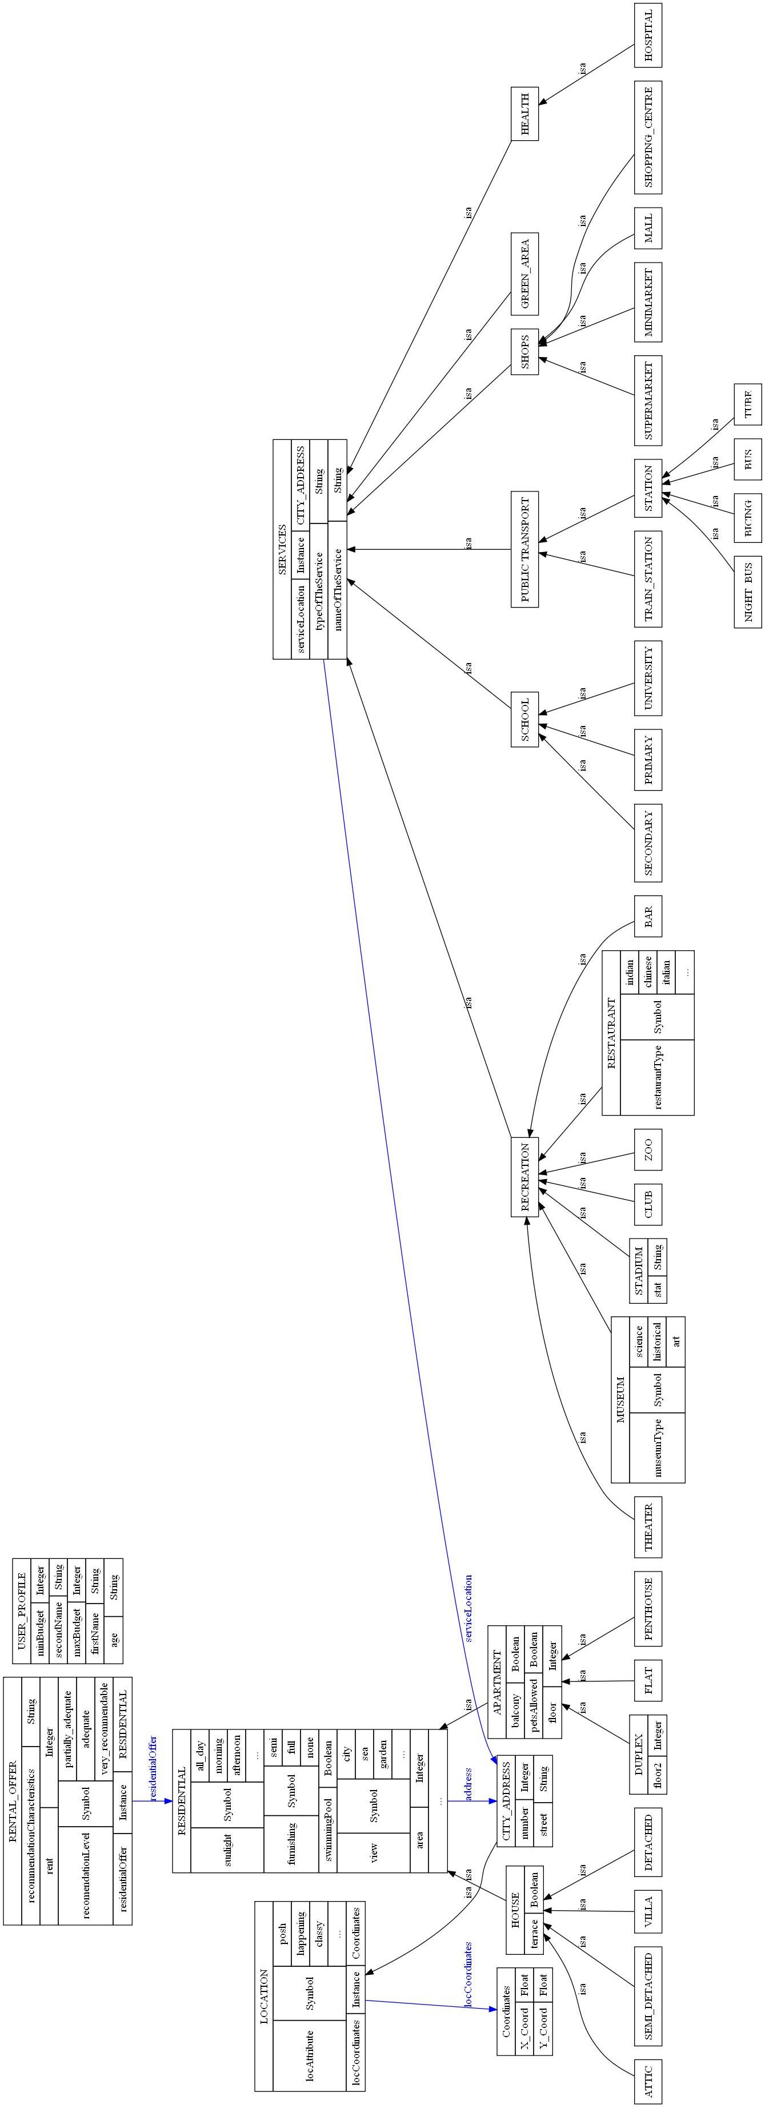

SOLVING METHODOLOGY and DEFINE A SOLUTION

Whichever solution, it has to be classified in this way:
- Partially adequate: Only one or two criteria fail, but it could be acceptable depending on client
consideration (rent is a little bit more that the specification, public transportation is at mid distance, there are not green areas at near distance,...).

- Adequate: All requirements are fulfilled by the other.

- Very recommendable: All requirements are fulfilled and it has extra characteristics that make this offer better than the rest (lower rent, more rooms, more services near than the explicitly specified,...)

So, we have to make a classification of what is better than the other.

C3
CLIPS CODE

criteria for evaluation
-knowledge of the language
--code use corrects deduction chains and declarative paradigms

TESTING & RESULTS

CRITERIA:
-coverage of the problem
--many fairly different test cases (>6)
--explanation on why that test cases are chosen
explanations of the results
--the result are compared and relate with the input and the KBS

TEST CASES

the following test cases have been thought to test our KBS:

1-single girl looking for a house near the UPC university and near the metro station. cheap rent =500

a couple that want to make baby and become a family. cheap rent=1000, near supermarket, with car.
House + supermarket

couple of old people. rent is not a problem(2000) but near the theater, the green area the hospital.
House + Green area + hospital + theater

a family of 6 people, with car. cheap rent (1500) and mall near.
House + mall

omosex couple. looking for a posh apartment in the posh block, rent is not a problem(2000), near clubs.
House + club

a soccer player, near clubs and near stadium. rent not (2000)a problem no car.
House + stadium

a vet, he wants to stay near green area zoo and theater.
House+ Zoo + theater

C4
CONCLUSION

CRITERIA FOR EVALUATION
coverage of the problem
--quantity of exceptions which are correctly handled
general quality of the solution
--marketing stuffs, following characteristics will be graduated:
---spelling and grammar
---organization and clarity
---graphs and image

