EAI Project
Web Design Showcase
Project Members:
Anshuman Mehta
Maximilian Speicher
Tim Church

Contents
1 Contents ii
2 Introduction 1
2.1 Concept 1
2.2 Technology Platform and Environment 1
3 Web Design Showcase – Design 2
3.1 Application Architecture 2
3.1.1 MVC 2
3.1.2 Design Decisions 3
3.2 System Architecture 4
3.2.1 Proposed System Architecture 4
3.2.2 Problems faced in the proposed System Architecture 4
3.2.3 Implemented System Architecture 5
3.3 Deployment 5
3.3.1 Requirements 5
3.3.2 DB Setup 5
3.3.3 Glassfish Deployment 6

Introduction

Concept
We identified a need in the social networking market and hence proposed to build a social networking site to enable content designers to showcase their designs and receive valuable comments and feedback from the community.

Technology Platform and Environment
We have chosen the J2EE stack as the technology platform on which to develop the project.
Specifically the technologies identified were as follows :

- Servlets : http requests control flow
- JSP : rendering the view
- JNDI : naming and directory services
- JMS : for asynchronous communication
- MDB : enabling messaging
- EJB : application server user session context, transactions and control flow
- JPA : transactions within user and application contexts
- CSS : standardisation of rendering view
- JDBC : database connectivity
- XML : configuration files

We worked with the following technology environment

- Glassfish : J2ee application server
- MySQL : Database
- Netbeans : Development environment
- SVN : Control repository

Web Design Showcase – Design

Application Architecture
The Architecture chosen for the application is described below in two broad categories.

MVC
We chose the popular Model View Control (MVC) architecture for our application architecture.
We identify below the design standards introduced inorder to maintain the architecture..

- Model
The Model is represented by the Object Relational Mapping between the entity beans ( of the EJB J2ee stack) .
- View
The View is maintained in the JSP’s and content rendering is standardized using CSS. The View is populated with standard Plain Old Java Objects ( POJO’s) to ensure consistency of data across layers.
- Control
The Control is implemented via Servlets to handle Http requests and the business logic is maintained with the Session Beans (of the EJB J2ee stack).

This can be visualised as follows

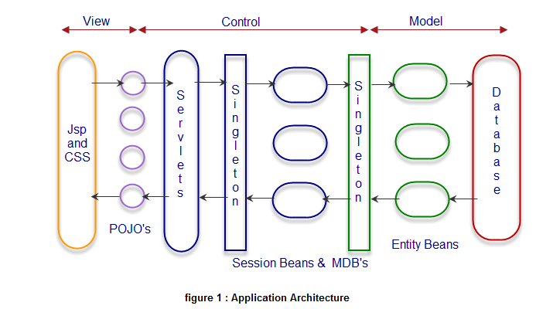

Design Decisions
We discuss briefly below our design decisions for the layers as shown above in figure 1 for the Application Architecture.

- View
The Jsp’s work only with POJO’s. They send and receives POJO’s from their respective Servlet handlers.

- Control
The Singleton Session Facade provides the interface to the Servlets for issuing business requests. The Singleton Session Facade acts as the manager for delegation of business requests across different Session Beans and for maintaining transactions of business requests across Session Beans.
The Session Beans handle all the necessary business operations in their respective business methods and delegate the task of persistence via the Singleton Session Facade over the Model Layer.
The Singleton Session Facade over the Model Layer acts as the manager for issuing requests for CRUD persistence over the Entity Beans. It also issues EntityManagers in a round robin fashion to the requesting Session Beans.

- Model
The Entity Beans contain the necessary mapping and CRUD operations over the Database.

System Architecture

Proposed System Architecture
We initially had in mind to develop the following System Architecture

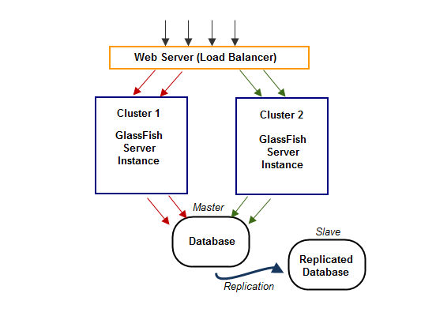
At the front end we would place a Web Server (Apache Web Server) and serve the requests in a round robin fashion to two GlassFish Server Instances deployed in their respective cluster. This would help in load-balancing the requests.
At the backend both the clusters would communicate with a single Database whose content would be replicated into a failover Database. The main Database would act as the Master and the replicated Database would act as the Slave.

Problems faced in the proposed System Architecture
- GlassFish V3 does not support Apache Modjk Load Balancing.
- GlassFish V3 does not have relevant documentation to show support for Sun WebServer
- GlassFish V3 does not support clustering.
- Application developed on GlassFish V3 is not backward compatible for deployment on GlassFish V2 which supports clustering.
For the above mentioned reasons we had to give up the proposed architecture.

Implemented System Architecture
The system architecture implemented supports replication of Databases as shown below

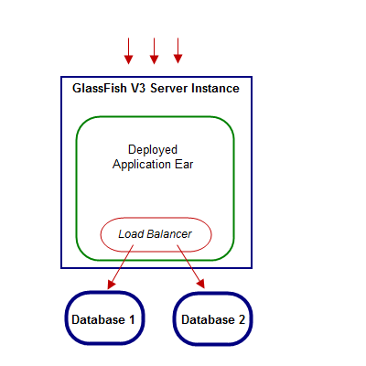

Deployment

Requirements
The application requires the following
- GlassFish Version 3
- MySql Database

DB Setup
        - Create two Databases named eai and eai2
        - Run the attached create_db.sql in both databases.
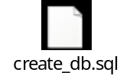

Glassfish Deployment

JMS Setup
        - Start the GlassFish Server
        - Log on into the Administration Console
        - Under Resources, Navigate to JMS Resources and Choose Destination Resources

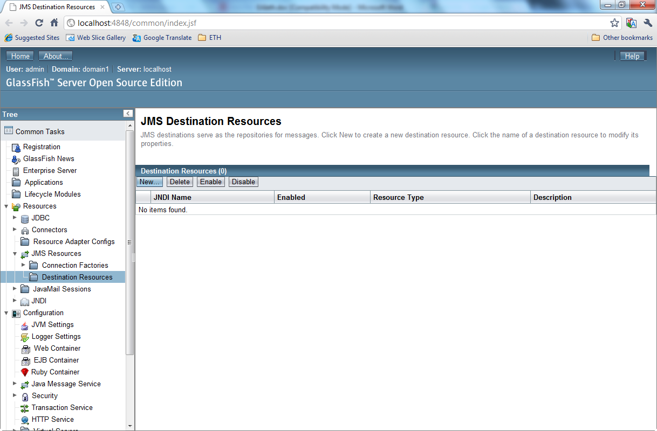

        - Click on New and type in JNDI name and Physical Destination as ‘Comments’ and press OK.

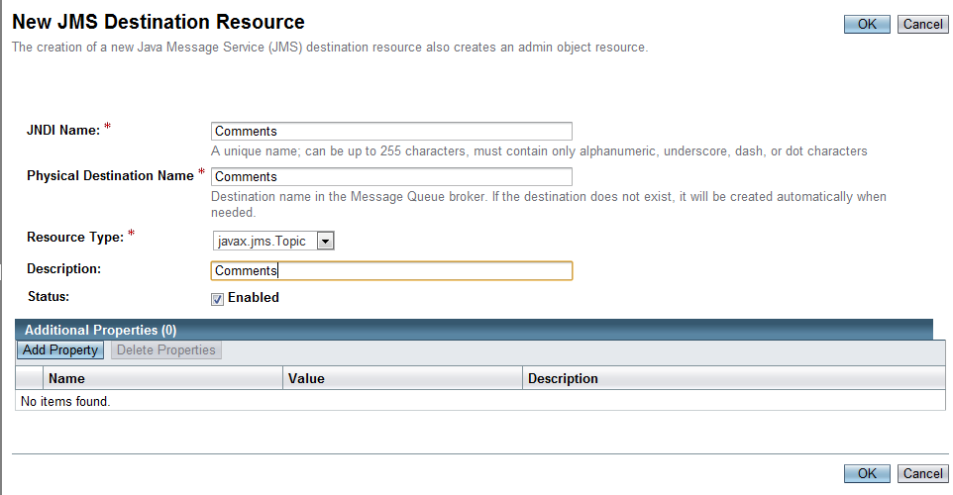

Database Setup
        - Navigate to JDBC Resource and then Connection Pools. Click New

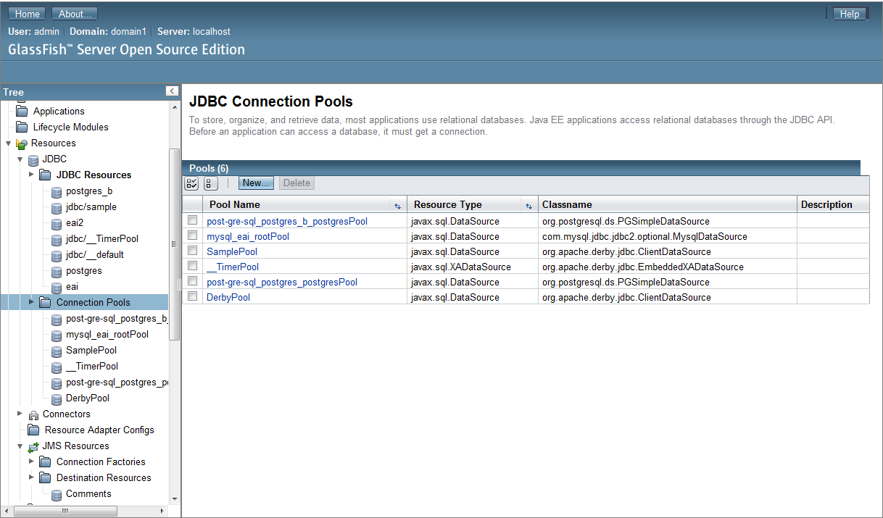

        - Enter the Connection Pool Name and press next

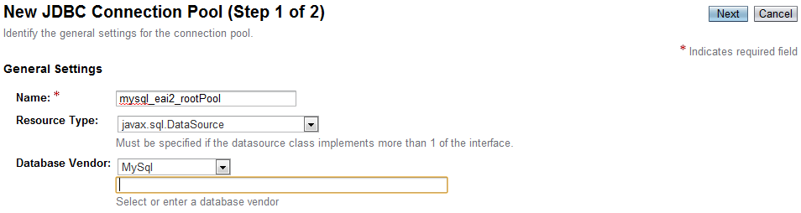

        - Enter the apporiate properties according to your environment

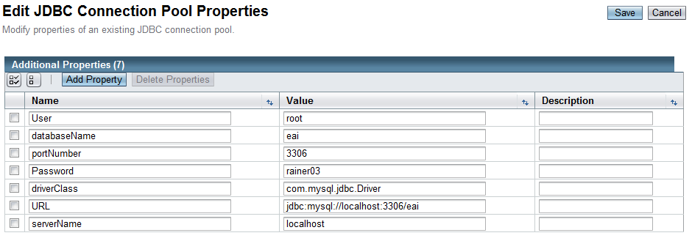

Deployment in Glassfish
        - Navigate to Applications

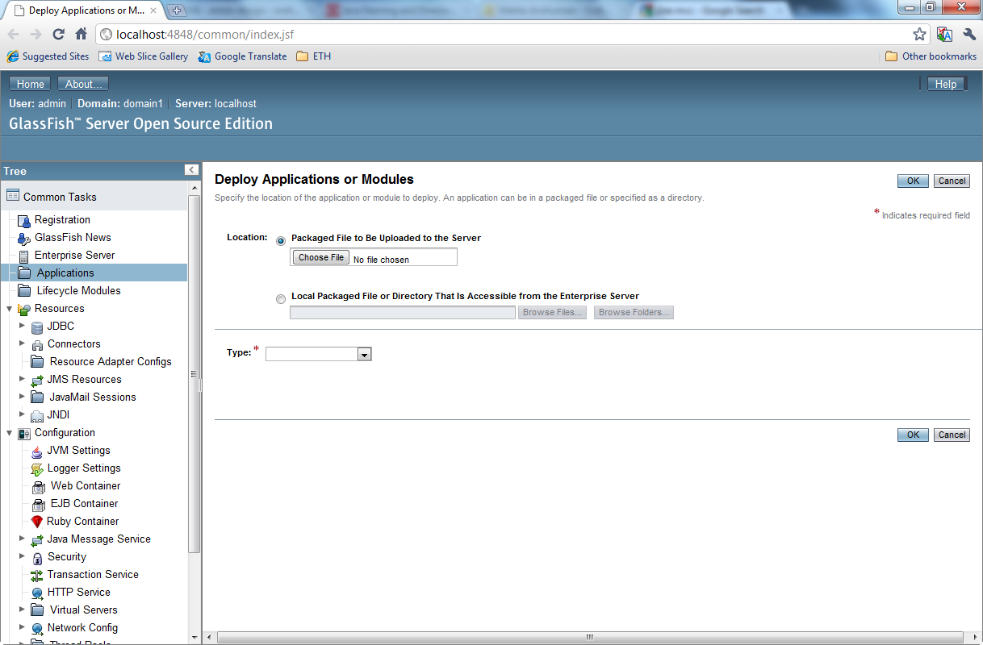

        - Click on Choose File

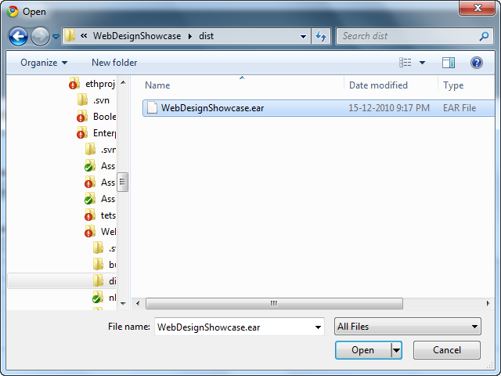

        - Navigate to the packaged ear location in the tarball and click open.
        - Choose deploy

Access Application
        - Type http://localhost:8080/WebDesignShowcase-war/ to access application.

