Hidato user manual
Contents
1 The game of Hidato 3
1.1 Introduction 3
1.2 Running application 3
2 Hidato Application 4
2.1 Interface 4
2.2 To play Hidato 4
2.2.1 Entering/deleting values to/from cell 5
3 Saving and loading games 6
4 View high scores 7

The game of Hidato

Introduction
Each Hidato puzzle starts with a grid partially filled with numbers. The goal is to fill the grid with consecutive numbers that connect horizontally, vertically or diagonally.
Hidato tips:
- The first and last numbers a puzzle are circled.
- It is not necessary to start from thr first number. Sometimes it is better to start elsewhere.
- Working backward (counting down in numbers) can reveal key clues to solving the puzzle.

Running application
This Hidato Application is provided under the Apache 2 Open Source license. It can be freely distributed with due acknowledgement to the developers.
The Application is provided as standalone executable jar and requires the java runtime environment of 1.6 and above to run.
It can be run by simply double clicking on the executable jar.

Hidato Application

Interface
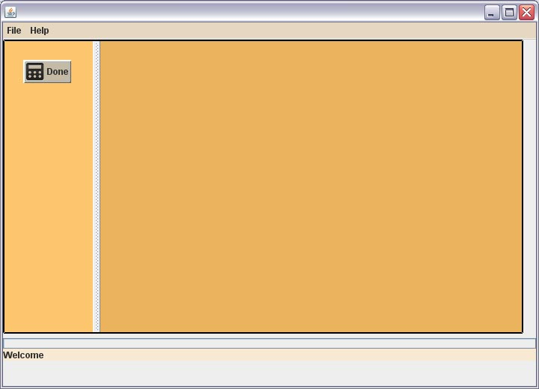

To play Hidato
- Double click on the Hidato.jar
- Click the File menu and the click the New game.
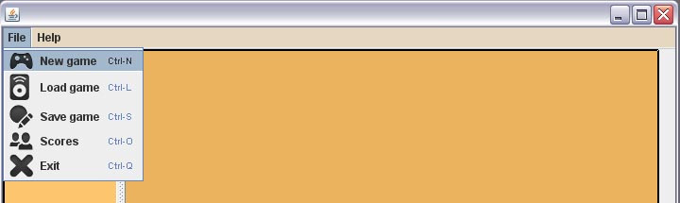
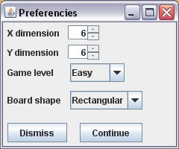
- Options for game generation will be shown. You can choose board size (x-dimension, y-dimension), difficulty level (easy, medium, hard) and board shape (rectangular, oval, donut).
Note: difficulty level „Test“ leaves you the whole game board revealed.
Note: board shape is to be rectangular, in general due to the algorithm that is actually
generating nondeterministic shapes on it's own.
- Press Continue to start a new game.
- The timer will be begin immediately.
- Select a cell and type in a number. Continue to fill up the grid.
- When you have finished, click Done.

Entering/deleting values to/from cell
- To enter value select cell by clicking on it. Enter number from 1 to N using keyboard (N – number of active cells)
- To delete value select cell by clicking on it. Remove number using keyboard

Saving and loading games
- If you want to save game, click on Save game in File menu
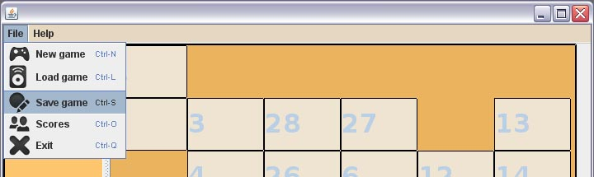
- Enter name for the file to save your Hidato game into and select the directory to save it into
- Click Save
- For loading game, click Load game in File menu
- Navigate to the directory where you have saved your previous game and select the file
- Click Open

View high scores
To view high score click on Scores in File menu.

