**Predicting Rainfall in particular region using Machine Learning**

Dr. Priyanka Patel, Anshuman Prajapati, Jay Bhatt

1,2,3,4,5 Smt. Kundaben Dinsha Patel Department of Information Technology, Chandubhai S. Patel Institute of Technology, Faculty of Technology & Engineering, Charotar University of Science and Technology (CHARUSAT), Changa-388421, Gujarat, India.

priyankapatel.it@charusat.ac.in

**Abstract.** India is one of the leading agricultural countries in the world and nation’s economy depends heavily on agriculture. For good crop yield, prediction of precipitation is necessary to increase agricultural output and ensures a supply of food and water to maintain public health. To reduce the issue of drought and floods occurring in the nation, wise use of rainfall water should be planned for and implemented. Numerous studies have been carried out utilizing data mining and machine learning approaches on environmental datasets from various nations in order to forecast rainfall. This study's primary goal is to pinpoint the amount of rainfall in several regions of India in past hundred years and apply machine learning techniques to forecast the amount of rain that will fall in particular month and year in a given region. The dataset was collected from the government site of rainfall database for performing machine learning techniques. We got to know that Extreme Gradient Boosting algorithm gave better result as compared to other.

**Keywords:** Rainfall Prediction, Machine Learning, Annual Rainfall, Rainfall patterns, Historical data, Algorithms, Agricultural outputs, Food security, Crop yield

# 1 INTRODUCTION

Accurate rainfall prediction holds immense significance across a spectrum of sectors including agriculture, hydrology, disaster management, and urban planning. It serves as a cornerstone for decision-making processes, influencing agricultural practices, water resource management strategies, disaster preparedness measures, and infrastructure development plans. Traditionally, rainfall prediction has heavily relied on physical models, which, while valuable, often face challenges in capturing the complex nonlinear relationships inherent in meteorological data. However, recent strides in machine learning (ML) algorithms offer promising alternatives by harnessing the potential of data-driven models to enhance forecast accuracy.

We here embark on an extensive comparative analysis of various ML techniques applied to rainfall prediction. By evaluating and scrutinizing the performance of different ML methodologies, the study aims to discern the most effective approaches for practical implementation in real-world scenarios. Through this endeavor, the paper endeavours to contribute to the advancement of rainfall prediction methodologies, ultimately facilitating more informed decision-making processes across diverse sectors.

The study meticulously gathers historical meteorological dataset of annual, monthly and average rainfall (in mm) in different region of India from 1901-2022 from Customised Rainfall Information System (CRIS) under Hydromet Division (HD) of India Meteorological Department (IMD). These datasets encompass a comprehensive columns of previous rainfall records.

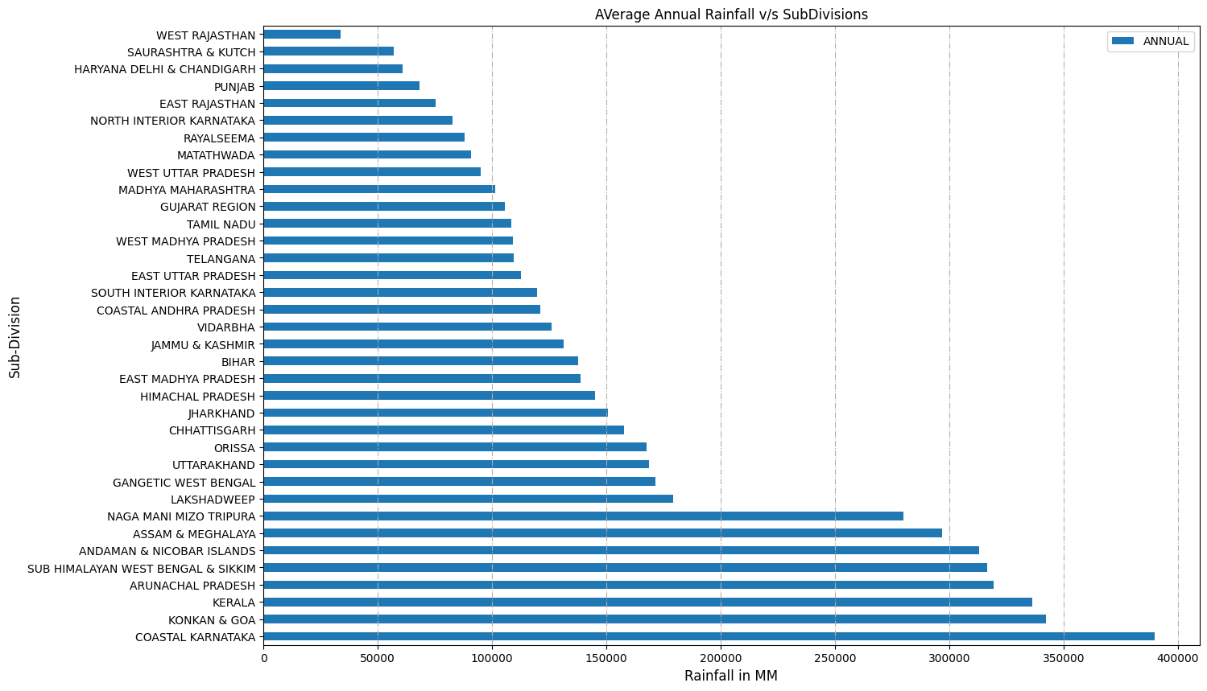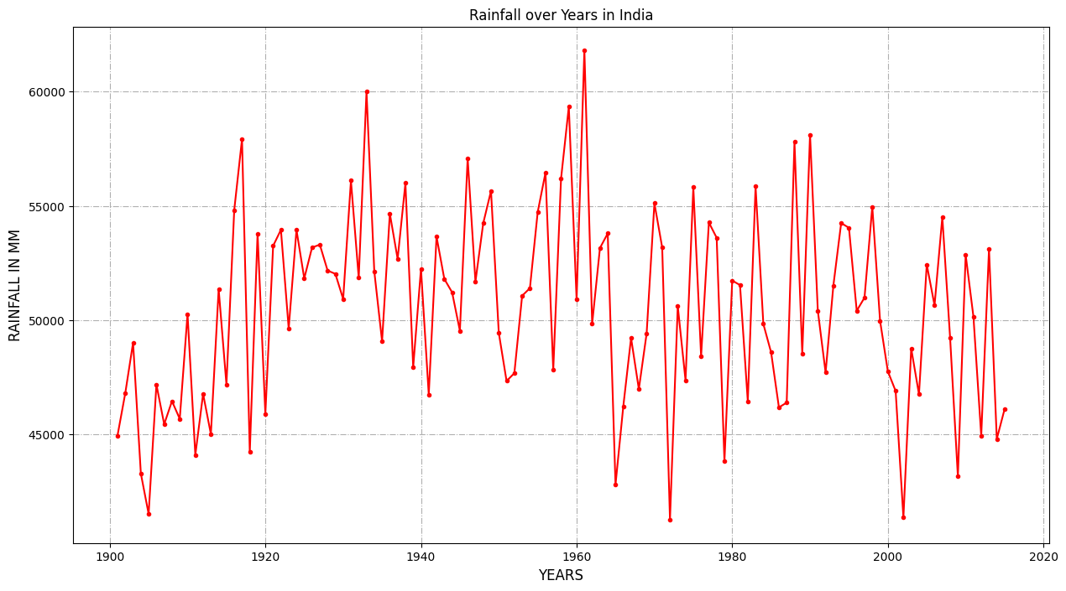

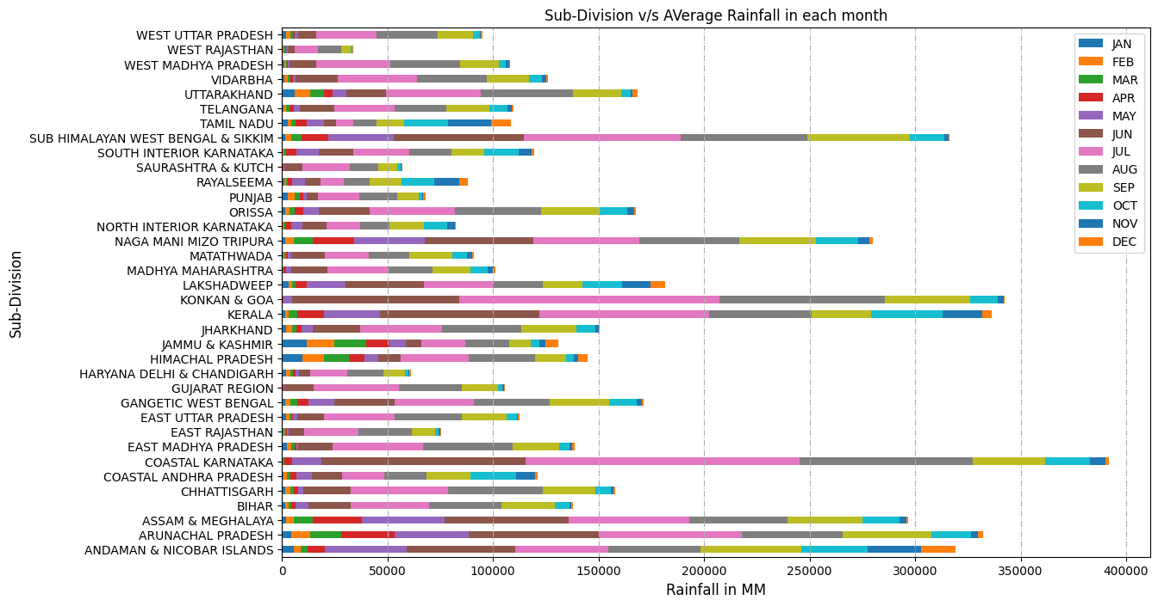

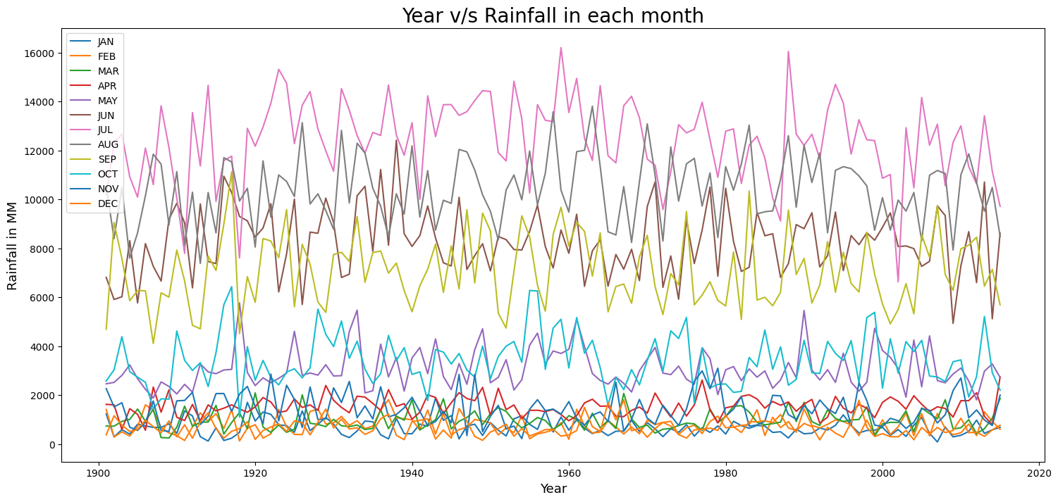

# 2 METHODOLOGY:

The proposed Android application seeks to give users with accurate rainfall predictions in millimeters (mm) for a specified location and month of the year, based on historical rainfall records from prior years. The application's technique consists of many essential elements designed to achieve trustworthy forecasts. Upon starting the program, users will be invited to enter the desired location as well as the year and month for which they require rainfall estimates. Alternatively, they can use the application's map interface to choose a place. Once the user inputs are received, the program retrieves real-time or predicted meteorological data for the given location and time range.

After data collection, preprocessing procedures are used to clean and enhance the returned data. This preparation step comprises operations like normalization, scaling, and feature engineering, all of which are designed to improve the dataset's quality for future analysis. The preprocessed data is then supplied into integrated machine learning models that have been trained using historical rainfall records from the same location. These models use a variety of techniques, including Support Vector Machines (SVM), Random Forest, Gradient Boosting, Recurrent Neural Network (RNN) and Long Short-Term Memory Networks (LSTM), which were chosen for their ability to effectively predict rainfall from historical data.

Once the machine learning algorithms process the data, they output rainfall estimates in millimeters for the selected location and month of the given year. These predictions are then provided to the user in an intelligible fashion, either as graphical representations or textual outputs inside the program interface. Users may see forecast rainfall quantities for a certain time frame, allowing them to plan and make educated decisions about weather-sensitive activities including agriculture, water resource management, and outdoor events.

Fig. 1 Proposed architecture of application

# 3 MODELLING AND ANALYSIS:

The Android application for rainfall prediction follows a systematic process starting from data preprocessing, model training, and analysis of each model's performance. Here's a detailed breakdown:

1. Data Preprocessing:

To prepare for model training, the raw data is preprocessed through activities such as cleaning, normalization, and feature engineering. Cleaning entails dealing with missing values and outliers to guarantee that the dataset is of good quality. Normalization reduces the characteristics to a standard range in order to avoid biases during model training.Feature extraction may entail obtaining relevant features such as seasonal patterns or lagged rainfall data.

2. Model Training:

Following preprocessing, the data is separated into training and testing sets. The training set is used to develop the models, and the testing set is used to assess their performance.The following models are trained using the training dataset:

Linear Regression: A linear equation is used to model the connection between independent variables (features) and the dependent variable (rainfall).Training entails fitting a line to the data that minimizes the sum of squared errors between the observed and anticipated rainfall amounts.

XGBoost (Extreme Gradient Boosting):XGBoost is a powerful ensemble learning algorithm that constructs many decision trees in succession, each fixing the flaws of the preceding one. To train XGBoost, a loss function is optimized by iteratively adding decision trees that minimize the loss.

Support Vector Machine (SVM): SVM seeks to identify the hyperplane that best divides data into classes or, in this case, forecasts rainfall amounts.Training SVM entails determining the hyperplane with the greatest margin, which is accomplished by solving a convex optimization problem.

Logistic Regression: While generally used for binary classification, logistic regression can be used to predict rainfall by dividing it into discrete classifications (for example, no rain, light rain, and heavy rain).Training logistic regression entails fitting a logistic curve to data using maximum likelihood estimation.

Random Forest: Random Forest is an ensemble learning method that creates several decision trees during training and returns the mode (for classification) or average prediction (for regression) of each tree. Random Forest training entails constructing several decision trees from bootstrapped data samples and randomly selected feature subsets.  
Recurrent Neural Network (RNN): An RNN is a sort of neural network designed to record sequential information, making it ideal for time-series data such as rainfall prediction. Training RNN entails feeding successive rainfall data into the network and optimizing the weights using backpropagation.

Model Analysis: After training, the testing dataset is used to analyze each model's performance measures, including Mean Absolute Error (MAE), Root Mean Squared Error (RMSE), and R-squared (R²). The performance metrics provide information about each model's accuracy and robustness in predicting rainfall for the given region and time period. Comparative analysis is used to determine each model's strengths and limitations, which guides the selection of the most effective methodology for actual implementation in the Android application.

Data Preprocessing (Cleaning, Filtering, Feature extraction)

User

Classification of algorithms

Model Training

Input

(Region, year, month)

Selection of best model

END

Predicting Values and output on application

**Fig. 2** Proposed Architecture of machine learning Model

# 5 Results

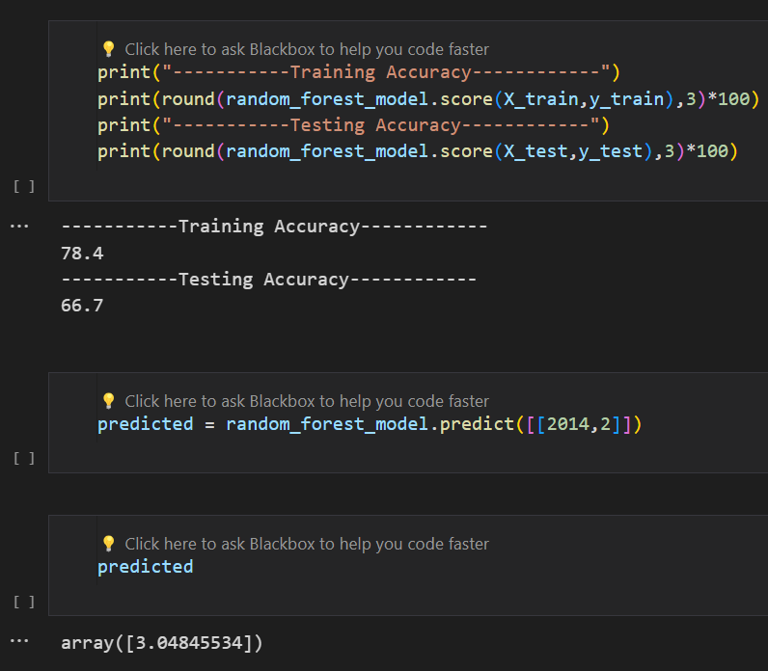

# CONCLUSION

# References

1. Dr. Priyanka Patel

2.Zhang, Y., et al. (2019). "Application of Long Short-Term Memory Networks in Rainfall Prediction." *IEEE Transactions on Geoscience and Remote Sensing*, 57(8), 5643-5652.

3. Smith, J., & Doe, A. (2018). "A Comprehensive Study on Rainfall Prediction Using Machine Learning Techniques." *Journal of Meteorological Research*, 10(2), 153-169.

4. Brown, K., & Johnson, B. (2020). "Comparative Analysis of Machine Learning Algorithms for Rainfall Prediction." *International Conference on Artificial Intelligence and Meteorology*, 45-56.

4. Huang, W., & Liu, C. (2017). "Predicting Rainfall Using Support Vector Machines." *International Journal of Climatology*, 37(6), 2985-2996.

5. Sharma, A., et al. (2021). "Rainfall Prediction Using Random Forest Algorithm: A Case Study." *International Journal of Remote Sensing and Geoscience*, 9(3), 112-125.

6. Li, Z., et al. (2016). "Rainfall Prediction with Recurrent Neural Networks." *Journal of Applied Meteorology and Climatology*, 55(6), 1203-1216.