CSN-361

Computer Networks Laboratory

Assignment 5

Name- Anshuman Shakya

Enrollment No.-17114013

Class: 3rd year, B.Tech CSE

**Problem Statement-**

**Q1- Using OPNET create Bus topology among a set of N computer nodes out of which two nodes are source and the rest are sink nodes. Model the traffic of source and sink nodes individually and demonstrate the packet transfer between them using Ethcoax (Ethernet using coaxial) cables. Use network scale as the “campus” of area 1km x 1km.**

**Sol->**

**Approach-** Used the Reverbed(OPNET) Modeler Academic Edition 17.5 to create bus topology. I created 10 nodes bus topology in which node_0 and node_1 are sources and other 8 nodes are sink. The simulation statistics are made over 1 hour.

**Data Structure Used-**

# Nodes – Represent the computers that are sending and receiving packets. Source nodes are used for sending packets. Sink nodes are used for receiving packets.

# Bus – Link used to transfer data between connected nodes.

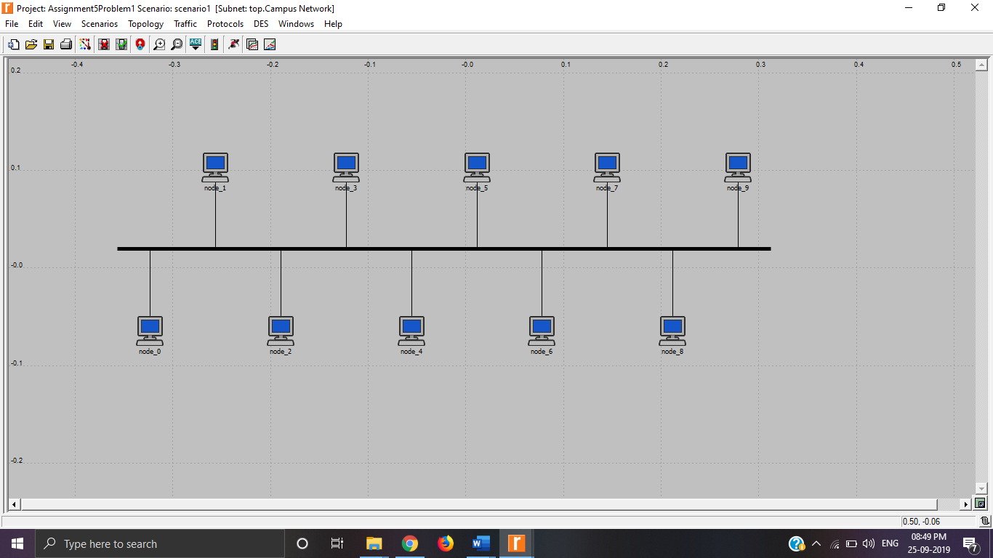**Screenshots-**

1. The following graph shows the rate of packet sent by both source nodes node_0 and node_1 and the rate of packet received by all the other nodes.

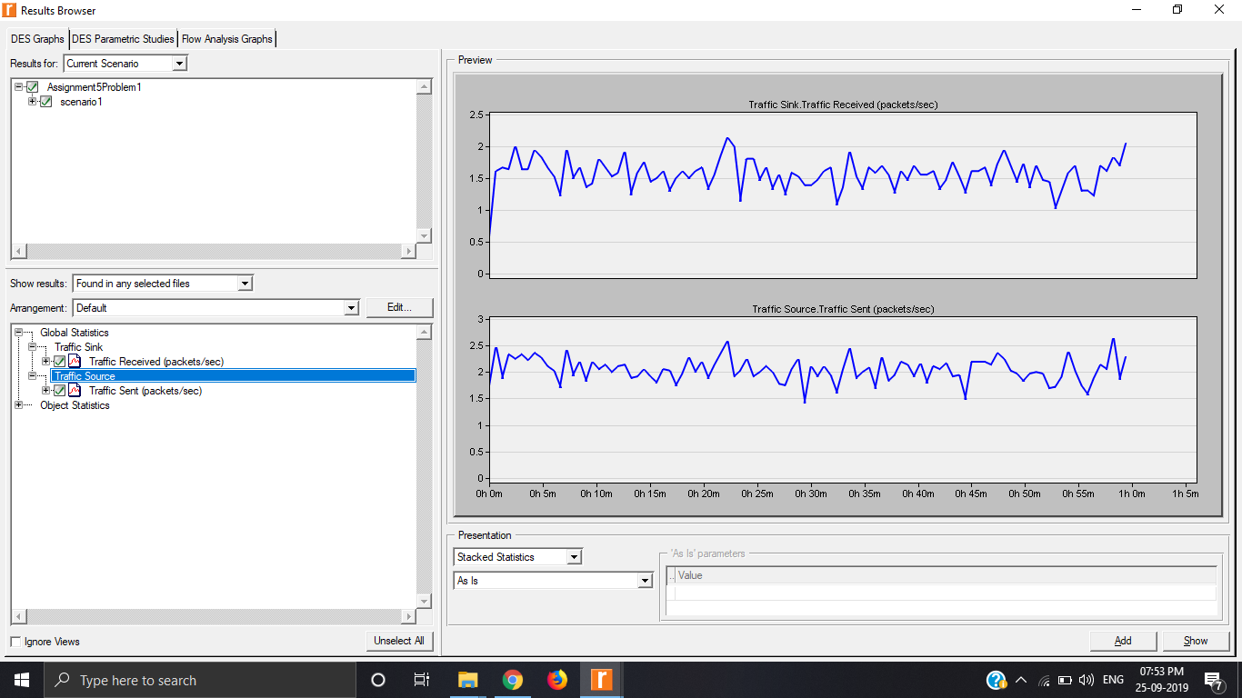

1. The following graph shows the bus throughput and utilization

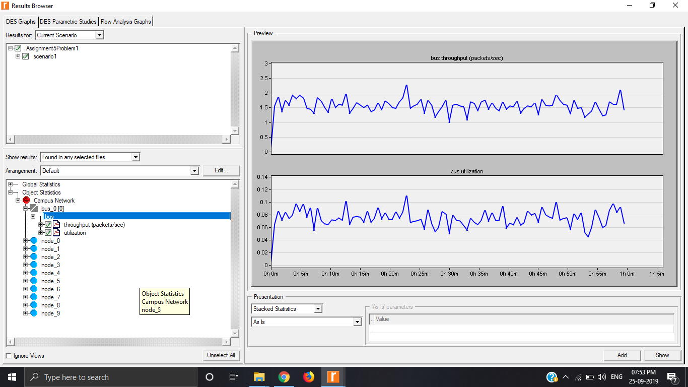

1. The following graph shows the packet transfer rate of both source nodes

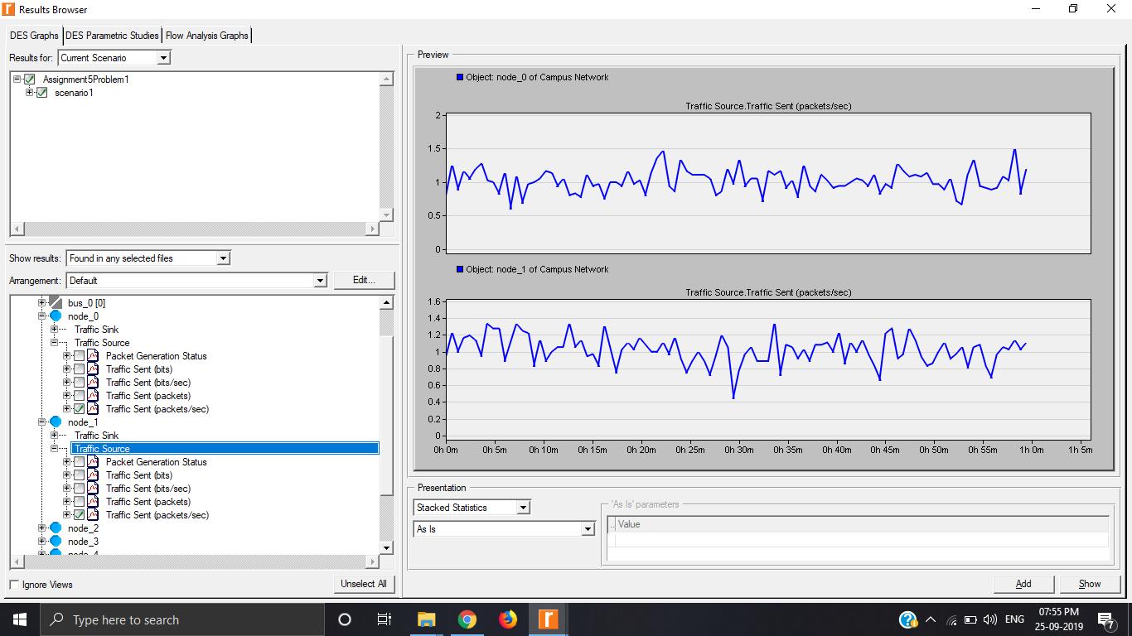

1. The following graph shows the traffic received and sent (which is zero) by sink node.

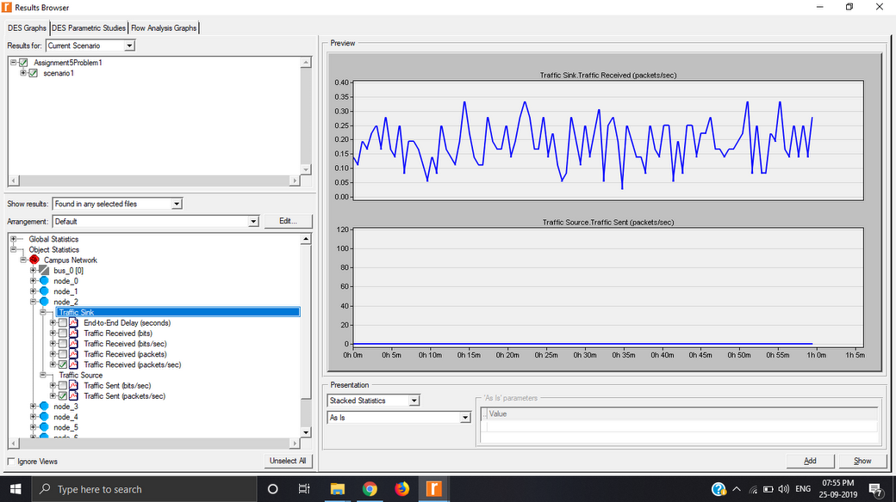

# Q2- Using OPNET create Star topology among a set of N computer nodes out of which one node is source and the rest are sink nodes. Model the traffic of source and sink nodes individually and demonstrate the packet transfer between them using Ethcoax (Ethernet using coaxial) cables. Use network scale as the “campus” of area 1km x 1km.

**Sol->**

**Approach-** Used the Reverbed(OPNET) Modeler Academic Edition 17.5 to create star topology. I created 7 nodes star topology in which node_0 is the source and node_7 is the router and other nodes are sink. The simulation statistics are made over 1 hour.

**Data Structure Used-**

# Nodes – Represent the computers that are sending and receiving packets. Source nodes are used for sending packets. Sink nodes are used for receiving packets.

# Bus – Link used to transfer data between connected nodes.

# Ethernet Station – For receiving and sending packets.

# Ethernet hub – Ethernet hubs work at the physical level, simply repeating any frames they receive on one port onto all other ports.

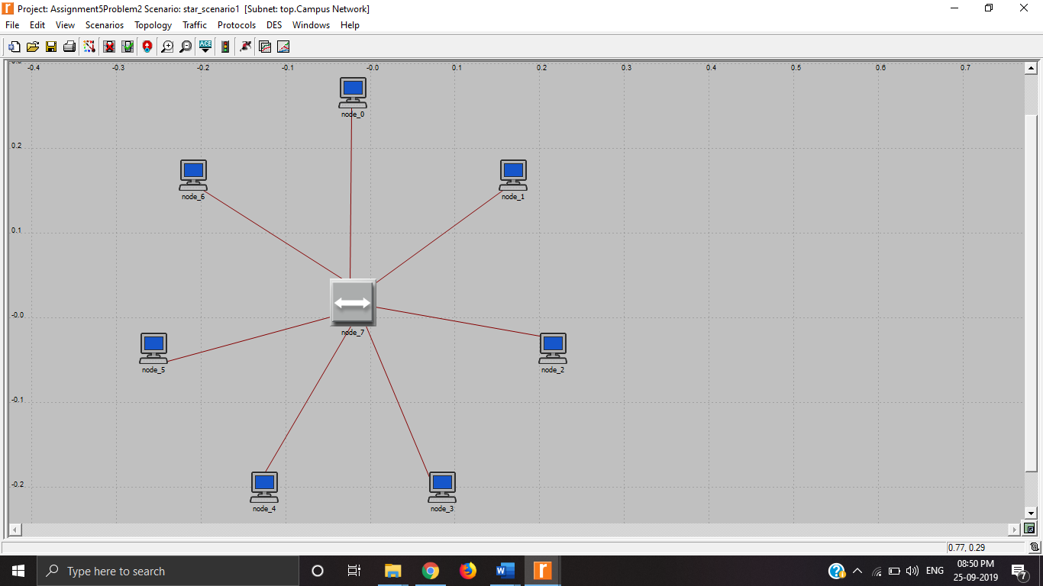**Screenshots-**

1. The following graph shows the rate of packets sent by source node node_0 and the rate of packets received by all the other nodes.

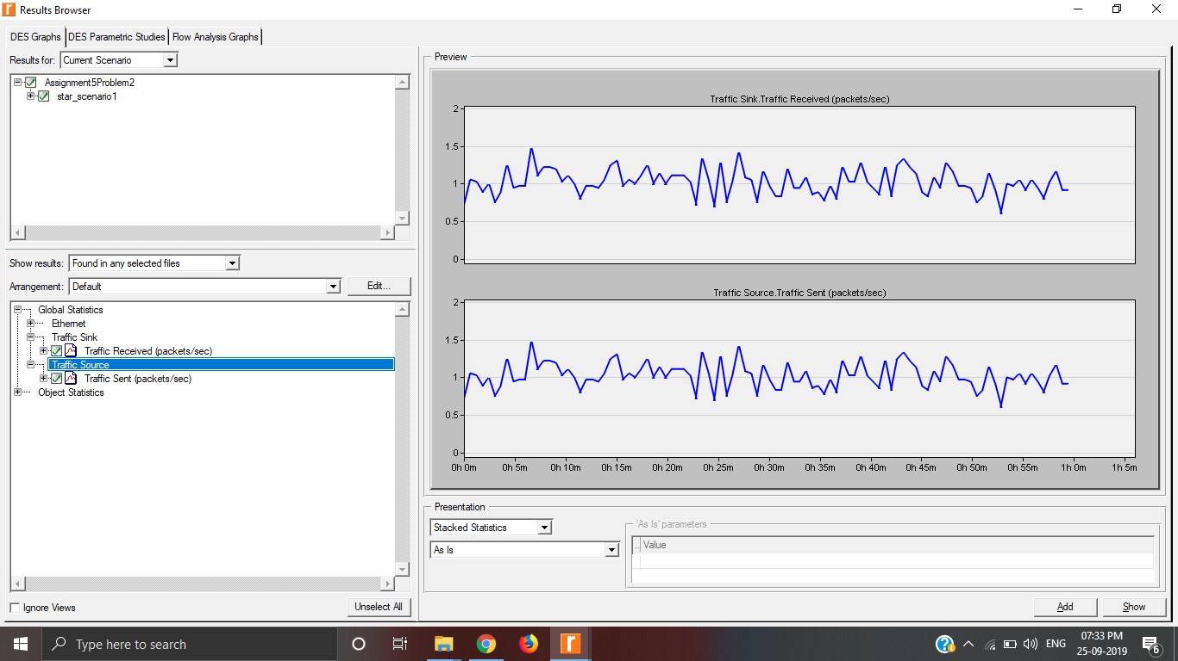

1. The following graph shows the traffic received and the traffic forwarded from the router.

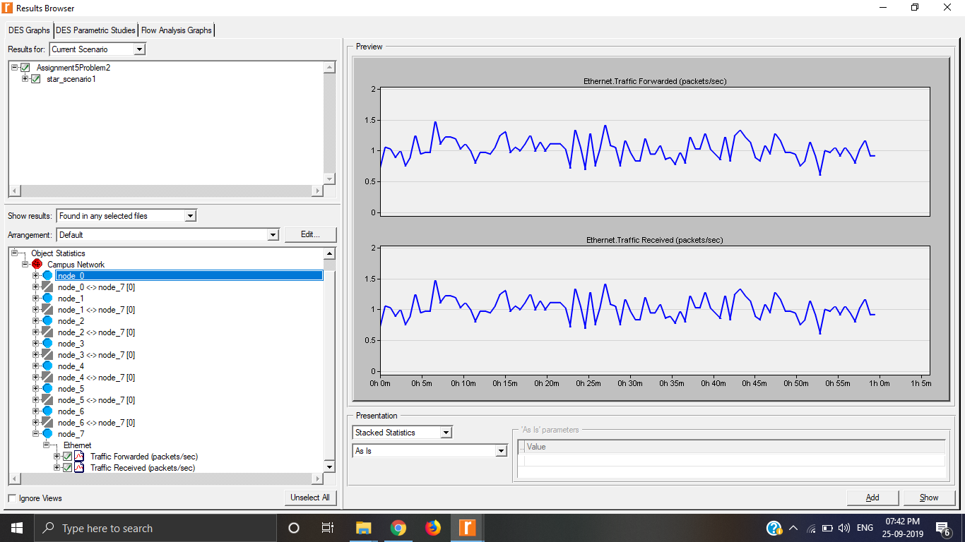

1. The following graph shows the traffic sent by node_7 and received by two sink nodes node_2 and node_4.

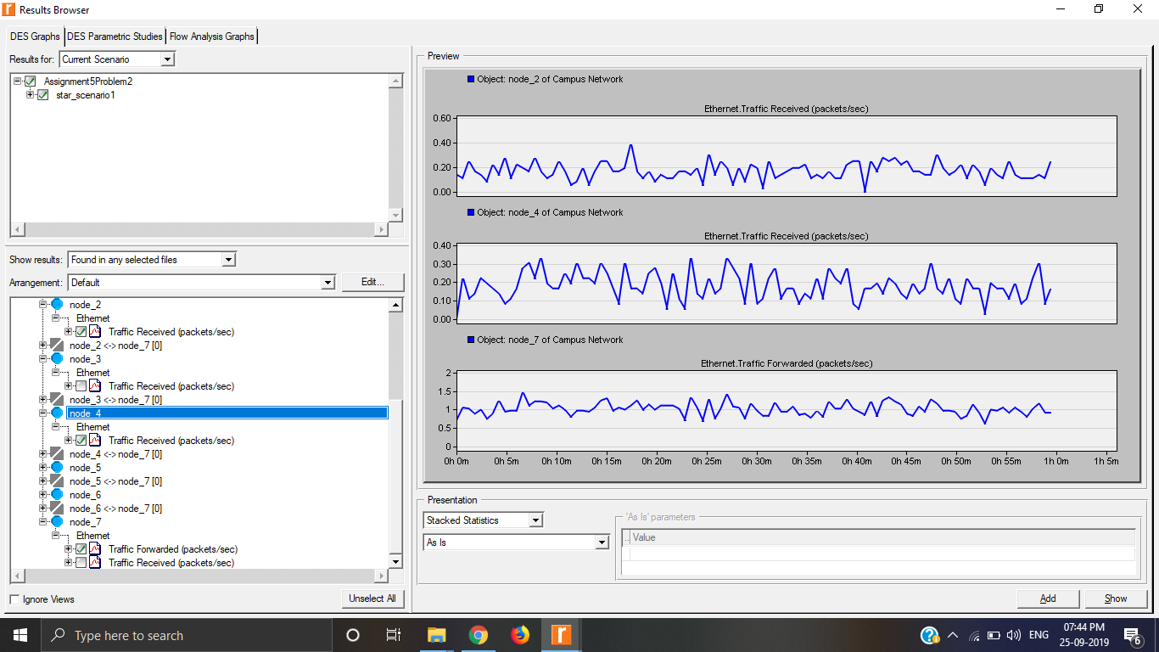

1. 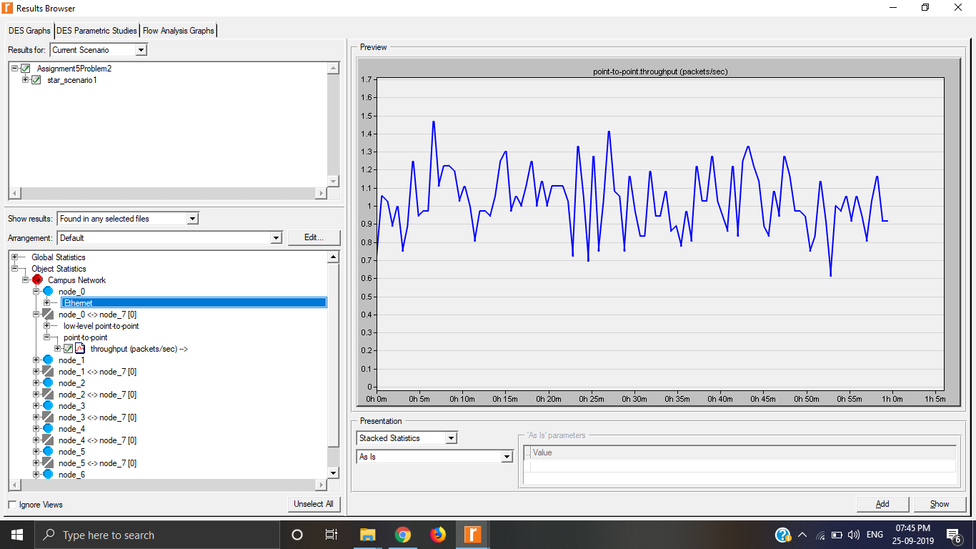The following graph shows the throughput of the source node node_0.