CSN-361

Computer Networks Laboratory

Assignment 6

Name- Anshuman Shakya

Enrollment No.-17114013

Class: 3rd year, B.Tech CSE

**Problem Statement-**

**Q1-** **Use OPNET to implement OSPF (Open Shortest Path First) protocol. Create a scenario – Scenario1, of 8 routers of any type (e.g., slip8_gtwy) and configure the Network topology.**

**Create a duplicate scenario – Scenario2, where the routers in Scenario1 are partitioned into 3 different areas.**

**Sol->**

**Approach-** Used the Reverbed(OPNET) Modeler Academic Edition 17.5 to create bus topology. I created 8 routers of type slip8_gtwy.

OSPF protocol is used, Open Shortest Path First (OSPF) is a link-state routing protocol which is used to find the best path between the source and the destination router.

The simulation statistics are made over 10 minutes.

In Scenario2 routers are patitioned as follows:

Area1: RouterA, RouterB, RouterC

Area2: RouterD, RouterE

Area3: RouterF, RouterG, RouterH

**Data Structure Used->**

**Slip8_gtwy Router**- The **slip8_gtwy** node model represents an IP-based gateway supporting up to eight serial line interfaces at a selectable data rate. The RIP or OSPF protocols may be used to automatically and dynamically create the gateway’s routing tables and select routes in an adaptive manner.

**PPP_DS3** **link**- The **PPP_DS3** link has a data rate of 44.736 Mbps.

**Screenshots:**

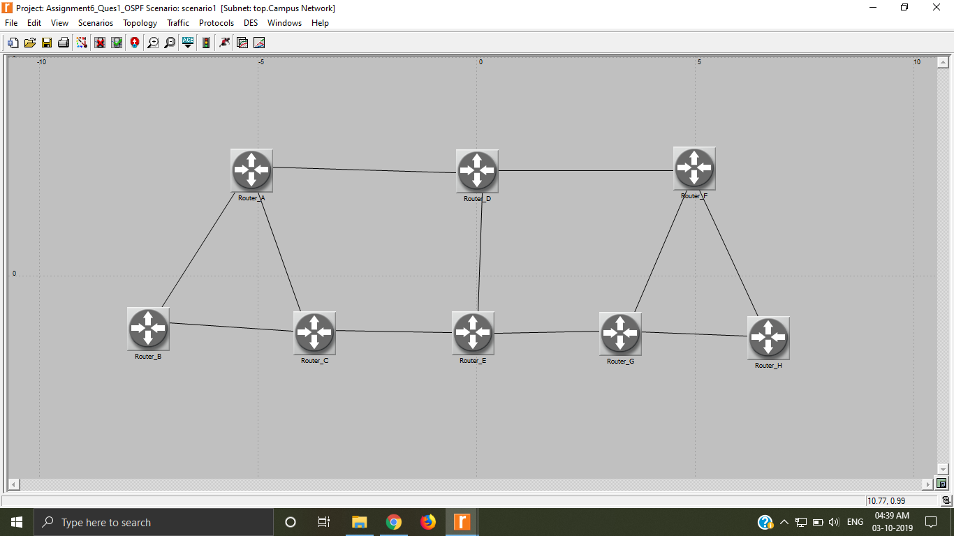

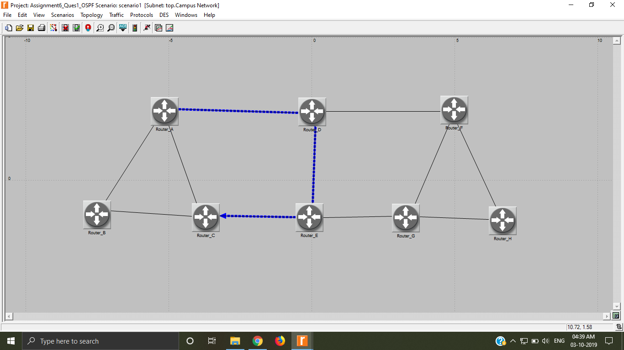Route for the traffic demand between RouterA and RouterC in Scenario1->

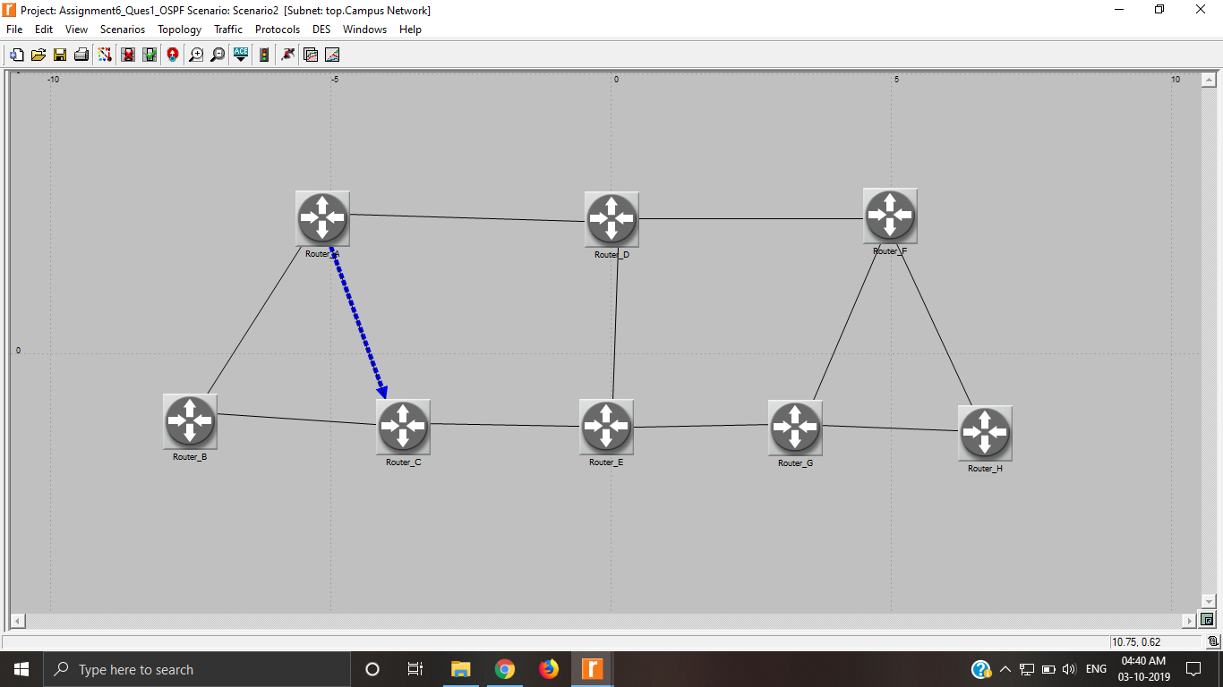Route for the traffic demand between RouterA and RouterC in Scenario2->

**Problem Statement 2: Use OPNET to implement RIP (Routing Information) protocol on the same network configurations as given in Problem 1.**

**Display the route for the traffic demand between RouterA and RouterC in Scenario1.**

**Display the route for the traffic demand between RouterA and RouterC in Scenario2**

**Sol->**

Used the Reverbed(OPNET) Modeler Academic Edition 17.5 to create bus topology. I created 8 routers of type slip8_gtwy.

The main class of routing algorithm is the distance-vector algorithm. Each node constructs a vector containing the distances (costs) to all other nodes and distributes that vector to its immediate neighbours. RIP is the canonical example of a routing protocol built on the distance-vector algorithm.

**Data Structure Used->**

**Slip8_gtwy Router**- The **slip8_gtwy** node model represents an IP-based gateway supporting up to eight serial line interfaces at a selectable data rate. The RIP or OSPF protocols may be used to automatically and dynamically create the gateway’s routing tables and select routes in an adaptive manner.

**PPP_DS3** **link**- The **PPP_DS3** link has a data rate of 44.736 Mbps.

**Screenshots:**

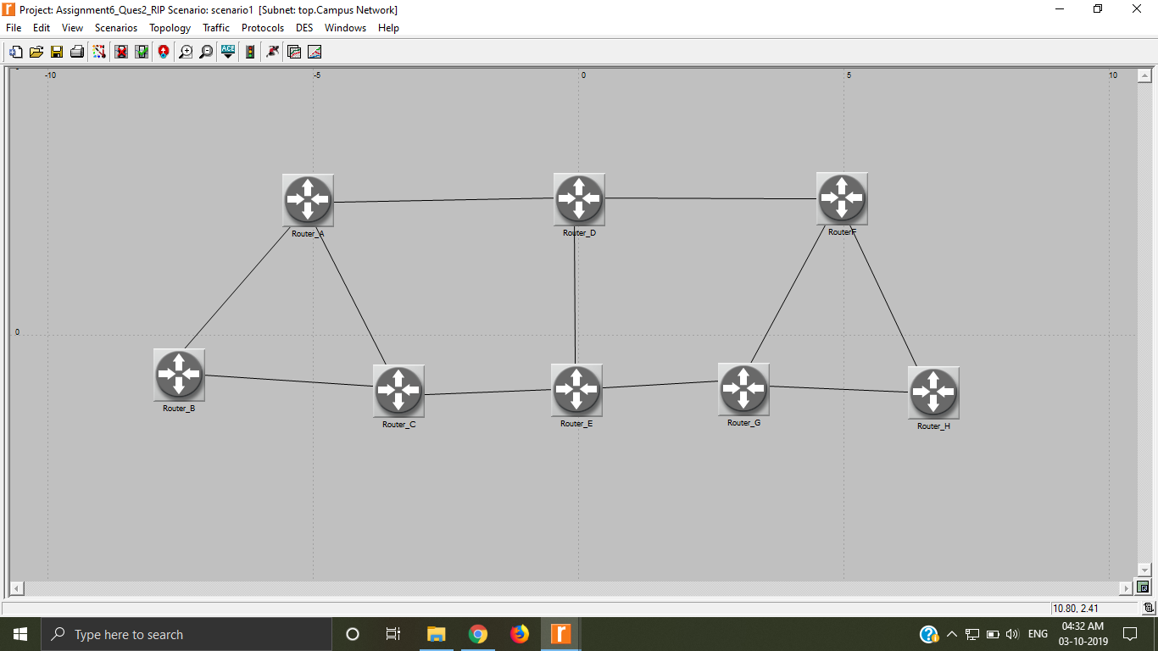

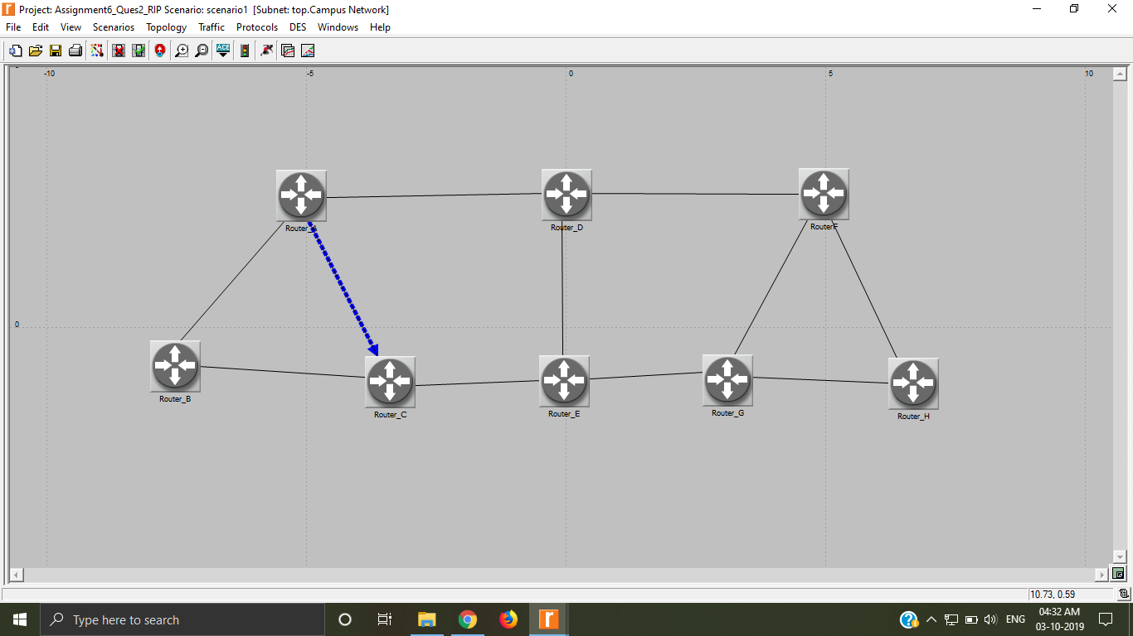Route for the traffic demand between RouterA and RouterC in Scenario1->