Computer Network Laboratory

CSN-361

Assignment 2

Name: Anshuman Shakya
Enrollment Number: 17114013
Class: 3rd year, B.Tech CSE

Problem Statement-

Question 1 : Write a socket program in C to connect two nodes on a network to communicate with each other, where one socket listens on a particular port at an IP, while other socket reaches out to the other to form a connection.

Sol->
Algorithm used:- Socket Programming
One socket(node) listens on a particular port at an IP, while other socket reaches out to the other to form a connection. Server forms the listener socket while client reaches out to the server.

1. Written a C program to create the server using TCP protocol and IPv4 address.
2. Written a C program to create the client using TCP protocol and IPv4 address and connects to the localhost.
Data structures used :

Server-

Socket creation:
sockfd: socket descriptor, an integer
struct sockaddr_in : structure to store internet addresses like IP address, port.

Bind:
int bind(int sockfd, const struct sockaddr *addr, socklen_t addrlen);

bind function binds the socket to the address and port number specified in addr.

Listen:
int listen(int sockfd, int backlog);

It puts the server socket in a passive mode, where it waits for the client to approach the server to make a connection. The backlog, defines the maximum length to which the queue of pending connections for sockfd may grow.

Accept:
int new_socket= accept(int sockfd, struct sockaddr *addr, socklen_t *addrlen);

It extracts the first connection request on the queue of pending connections for the listening socket, sockfd, creates a new connected socket, and returns a new file descriptor referring to that socket.

Client

Socket connection:
same as that of server’s socket creation
Connect:
int connect(int sockfd, const struct sockaddr *addr, socklen_t addrlen);

The connect() system call connects the socket referred to by the file descriptor sockfd to the address specified by addr. Server’s address and port is specified in addr.

Screenshots-

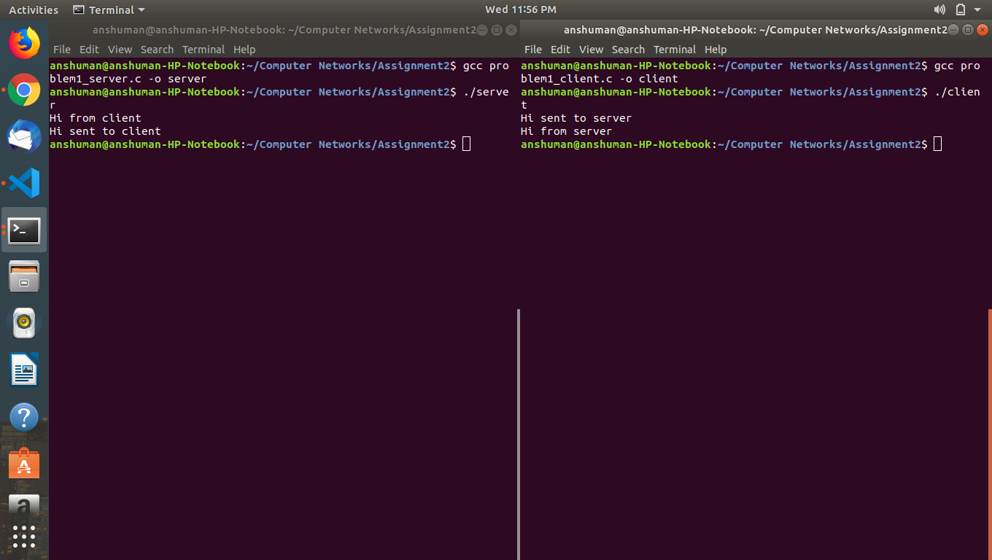

Question 2: Write a C program to demonstrate both Zombie and Orphan process.

Sol->
Algorithm used:- Created a parent process and a child process and then a child's child process. The parent process exits and child process becomes orphan then the child's child process exits and child process keeps running, which makes child's child process a zombie process.
The parent id of orphan process changes to the pid of init process.
Command to check the pid of zombie process : - ps aux | grep ‘Z’
Data structures used : No data structures used.

Screenshots-
