Computer Network Laboratory

CSN-361

Assignment 3

Name: Anshuman Shakya
Enrollment Number: 17114013
Class: 3rd year, B.Tech CSE

Problem Statement-

Question 1 : Write a socket program in C to determine class, Network and Host ID of an IPv4 address.

Sol->

Approach->
For determining the class: The idea is to check first octet of IP address. As we know, for class A first octet will range from 1 – 126, for class B first octet will range from 128 – 191, for class C first octet will range from 192- 223, for class D first octet will range from 224 – 239, for class E first octet will range from 240 – 255.
For determining the Network and Host ID:

IP address belonging to class A are assigned to the networks that contain a large number of hosts.
- The network ID is 8 bits long.
- The host ID is 24 bits long.
IP address belonging to class B are assigned to the networks that ranges from medium-sized to large-sized networks.
- The network ID is 16 bits long.
- The host ID is 16 bits long.
IP address belonging to class C are assigned to small-sized networks.
  - The network ID is 24 bits long.
  - The host ID is 8 bits long.
Class D and E doesn’t have any sub-net mask.
Data Structure used->
No specific data structure used, only character array is used.
Screenshots->
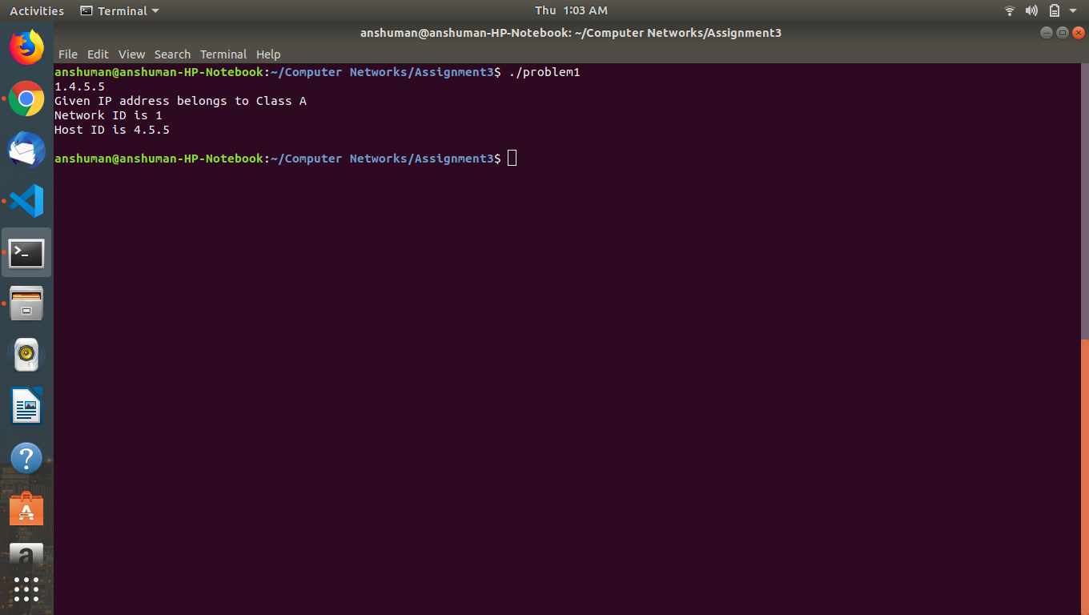
Question 2 : Write a C program to demonstrate File Transfer using UDP.
Sol->
Algorithm :
We create a Server and a client, The server starts and waits for filename. The client sends a filename. The server receives filename. If file is present, server starts reading file and continues to send a buffer filled with file contents encrypted until file-end is reached. End is marked by EOF. File is received as buffers until EOF is received. Then it is decrypted. If Not present, a file not found is sent.
Data Structure used->

Socket creation:
sockfd: socket descriptor, an integer
struct sockaddr_in : structure to store internet addresses like IP address, port.

Bind:
int bind(int sockfd, const struct sockaddr *addr, socklen_t addrlen);

bind function binds the socket to the address and port number specified in addr.

Recvfrom():

recvfrom() function receives data on a socket named by descriptor socket and stores it in a buffer. The recvfrom() function applies to any datagram socket, whether connected or unconnected.

Sendto():

The sendto() function sends data on the socket with descriptor socket. The sendto()call applies to either connected or unconnected sockets.

Screenshots->

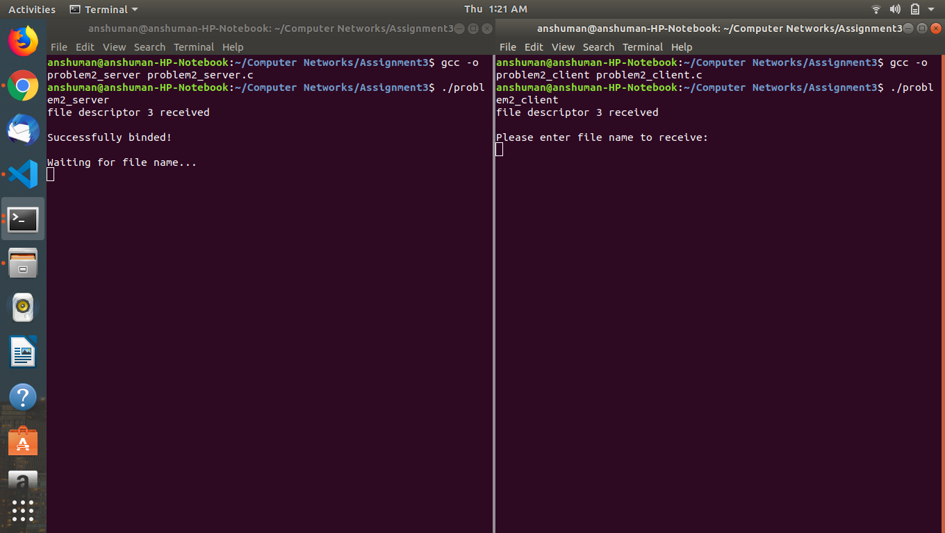
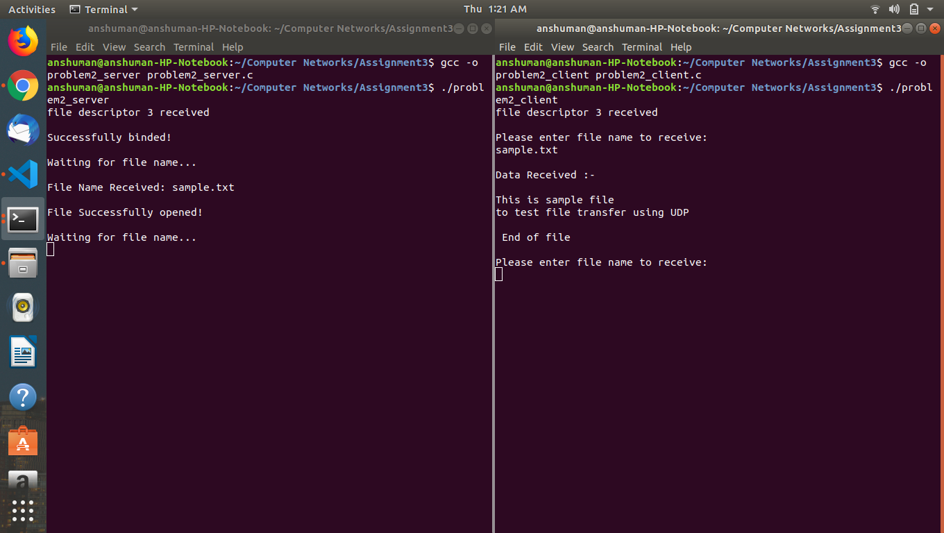

Question 3 : Write a TCL code for network simulator NS2 to demonstrate the star topology among a set of computer nodes. Given N nodes, one node will be assigned as the central node and the other nodes will be connected to it to form the star. You have to set up a TCP connection between k pairs of nodes and demonstrate the packet transfer between them using Network Animator (NAM). Use File Transfer protocol (FTP) for the same. Each link should have different color of packets to differentiate the packets transferred between each pair of nodes. The program should take the number of nodes (N) as input followed by k pairs of nodes.
Sol->
Algorithm used:- Nodes communicate using the communication model that consists of Transport Control Protocol (TCP) agent, TCPSink agent, and File Transfer Protocol (FTP) application. The sender node is attached to the TCP agent while the receiver node is attached to the TCPSink agent. The connection between TCP agent and TCPSink agent is established using the keyword “connect”. Transport agent (TCP) and application (FTP) are connected using the keyword “attach-agent”. TCP agent sends data to TCPSink agent.
In the Star topology each node is connected to another node through a router/switch(central node). The number of nodes in the network are taken as user input. Also, the nodes which are connected are taken by the user.

Data Structure used->
ns2-Simulator class, TCP agents, FTP.
Screenshots->
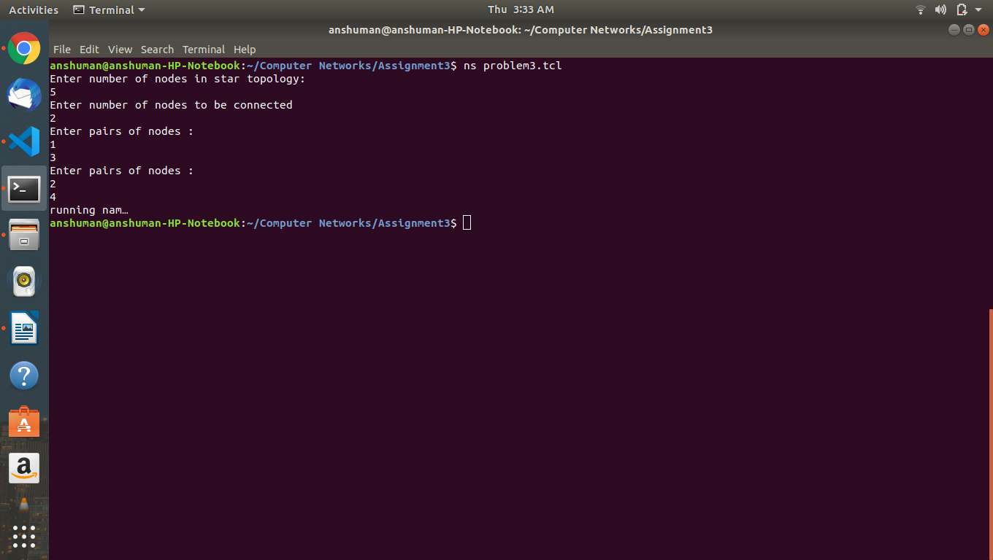
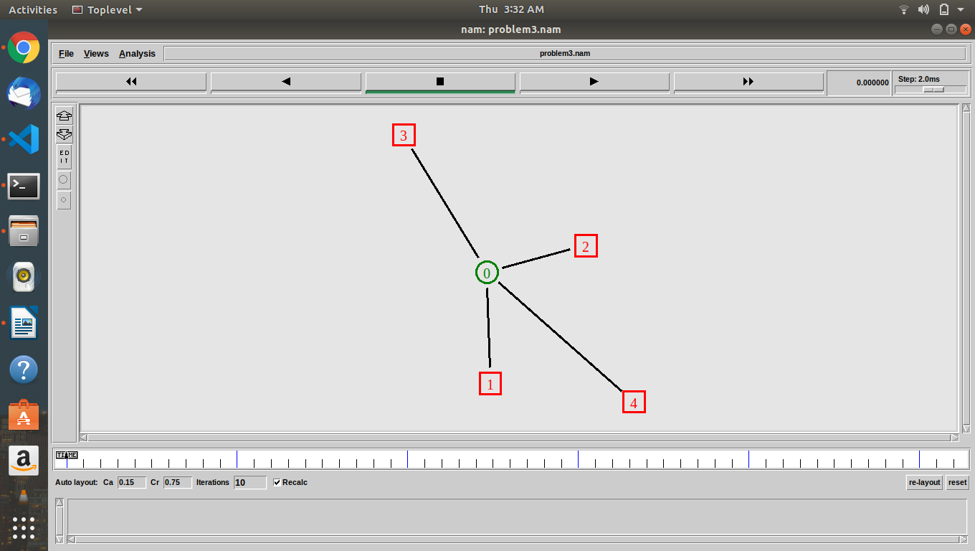

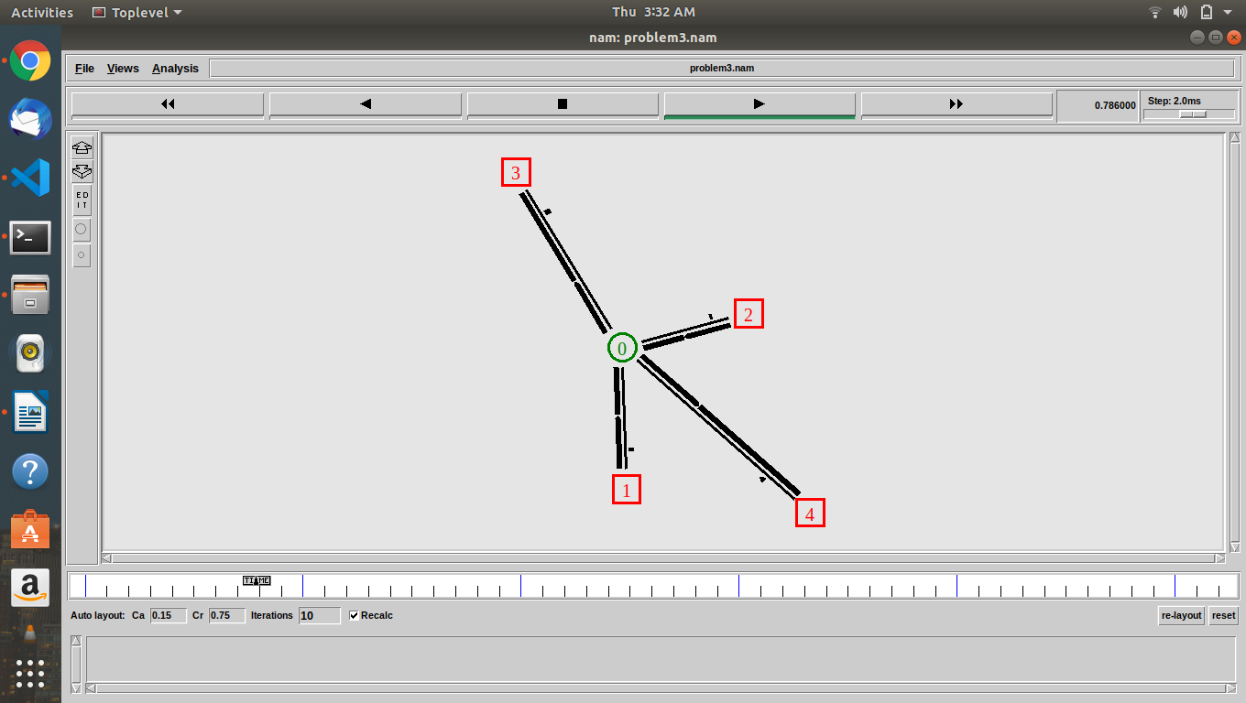
Question 4 : Write a TCL code for network simulator NS2 to demonstrate the ring topology among a set of computer nodes. Given N nodes, each node will be connected to two other nodes in the form of a ring. You have to set up a TCP connection between k pairs of nodes and demonstrate packet transfer between them using Network Animator (NAM). Use File Transfer protocol (FTP) for the same. Each link should have different color of packets to differentiate the packets transferred between each pair of nodes. The program should take the number of nodes (N) as input followed by k pairs of nodes.

Sol->
Algorithm used:- Nodes communicate using the communication model that consists of Transport Control Protocol (TCP) agent, TCPSink agent, and File Transfer Protocol (FTP) application. The sender node is attached to the TCP agent while the receiver node is attached to the TCPSink agent. The connection between TCP agent and TCPSink agent is established using the keyword “connect”. Transport agent (TCP) and application (FTP) are connected using the keyword “attach-agent”. TCP agent sends data to TCPSink agent.
In the Ring topology each node is connected to its adjacent nodes directly. The number of nodes in the network are taken as user input. Also, the nodes which are connected are taken by the user.
Data Structure used->
ns2-Simulator class, TCP agents, FTP.
Screenshots->
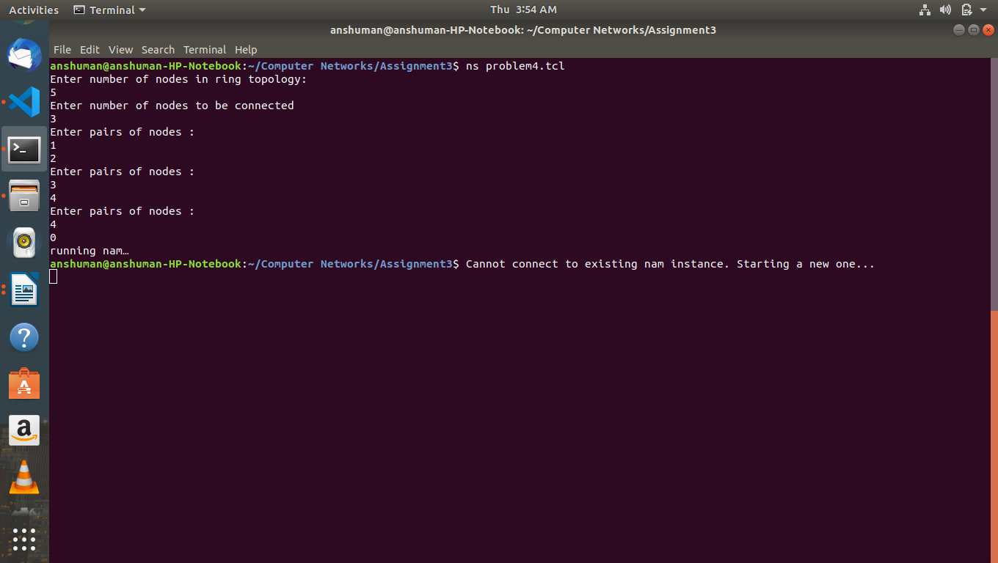

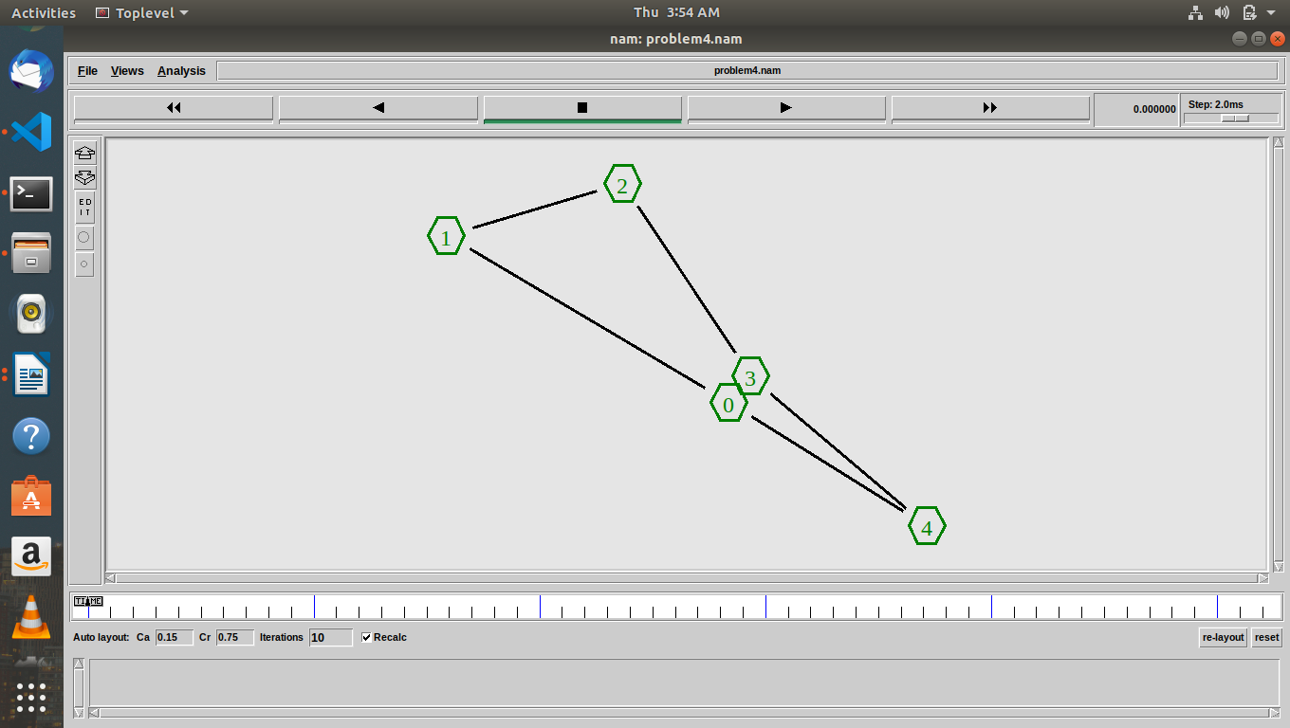
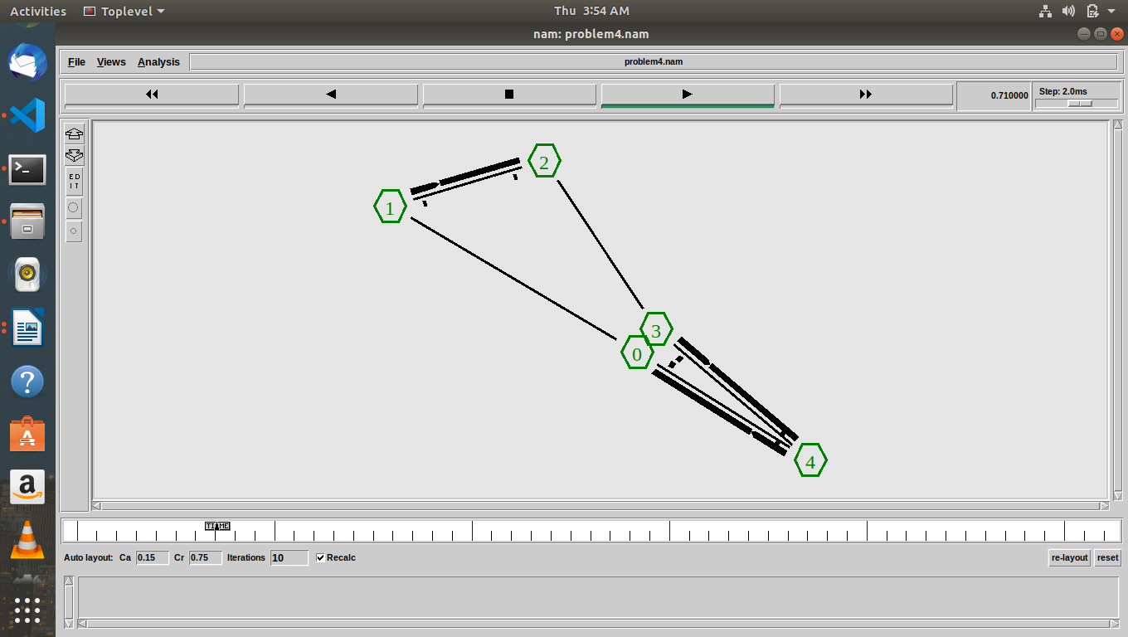

Question 5 : Write a TCL code for network simulator NS2 to demonstrate the bus topology among a set of computer nodes. Given N nodes, each node will be connected to a common link. You have to set up a TCP connection between k pairs of nodes and demonstrate packet transfer between them using Network Animator (NAM). Use File Transfer protocol (FTP) for the same. Each link should have different color of packets to differentiate the packets transferred between each pair of nodes. The program should take the number of nodes (N) as input followed by k pairs of nodes.

Sol->
Algorithm used:- Nodes communicate using the communication model that consists of Transport Control Protocol (TCP) agent, TCPSink agent, and File Transfer Protocol (FTP) application. The sender node is attached to the TCP agent while the receiver node is attached to the TCPSink agent. The connection between TCP agent and TCPSink agent is established using the keyword “connect”. Transport agent (TCP) and application (FTP) are connected using the keyword “attach-agent”. TCP agent sends data to TCPSink agent.
In the Bus topology each node is connected to a common line to all the nodes on the network. The number of nodes in the network are taken as user input. Also, the nodes which are connected are taken by the user.
Data Structure used->
ns2-Simulator class, TCP agents, FTP.
Screenshots->
