Computer Network Laboratory

CSN-361

Assignment 1

Name: Anshuman Shakya
Enrollment Number: 17114013
Class: 3rd year, B.Tech CSE

Problem Statement-

Question 1 : Write a C program in the UNIX system that creates two children and four grandchildren (two for each child). The program should then print the process-IDs of the two children, four grandchildren and the parent in this order.

Sol->
Algorithm used:- Brute Force
Data structures used :

1. Array: To store the process ids’.
2. Shared memory: So that all processes can copy the process ids to one location in the memory.
3. pid_t: C struct to store the process id.

Screenshot :
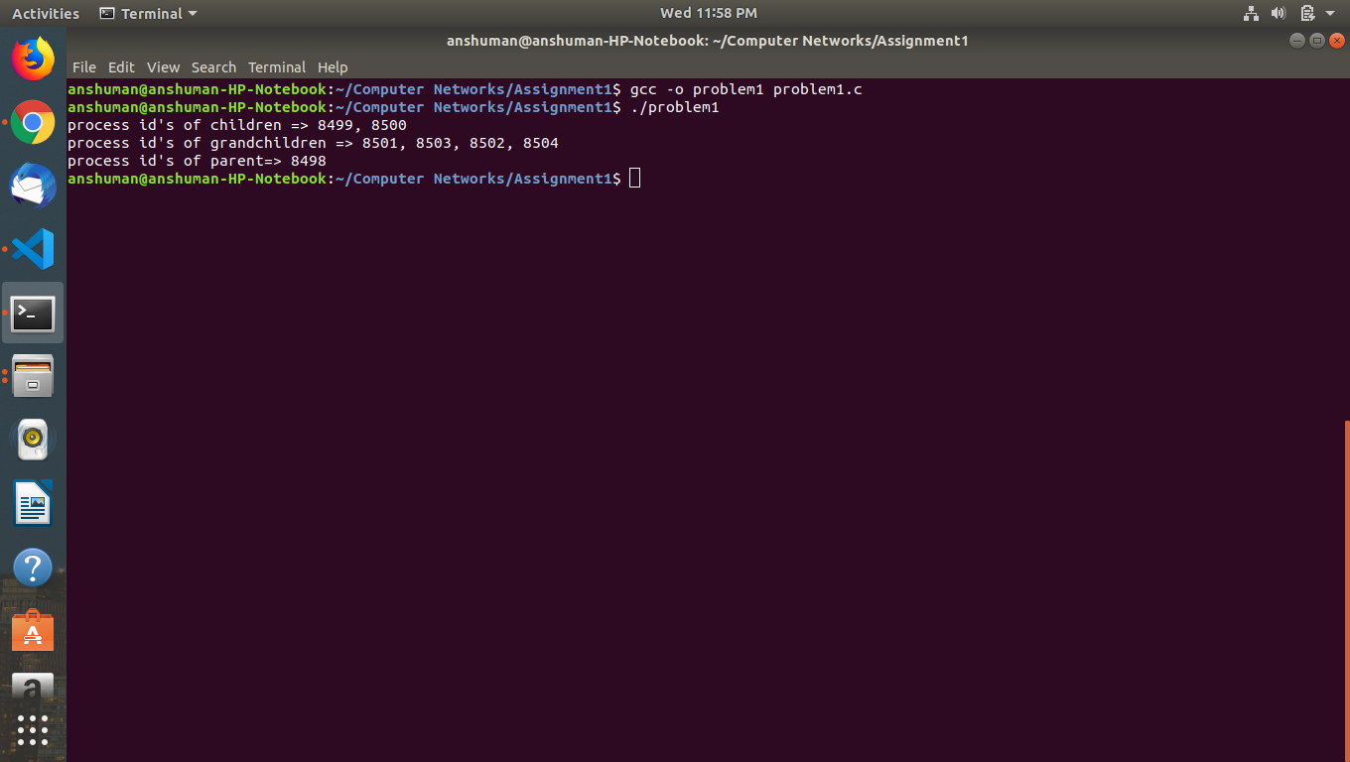

Question 2 : Write a C++ program to print the MAC address of your computer

Sol->

Algorithms used :
1. ioctl: Input-Output Control Command. To make device-specific system calls.
2. socket: To create a socket for getting the address.
Data Structures used :
1. ifreq: C++ struct to store the mac address.
2. SIOCGIFHWADDR: code to request the hardware address through the ioctl
command.
Screenshot :

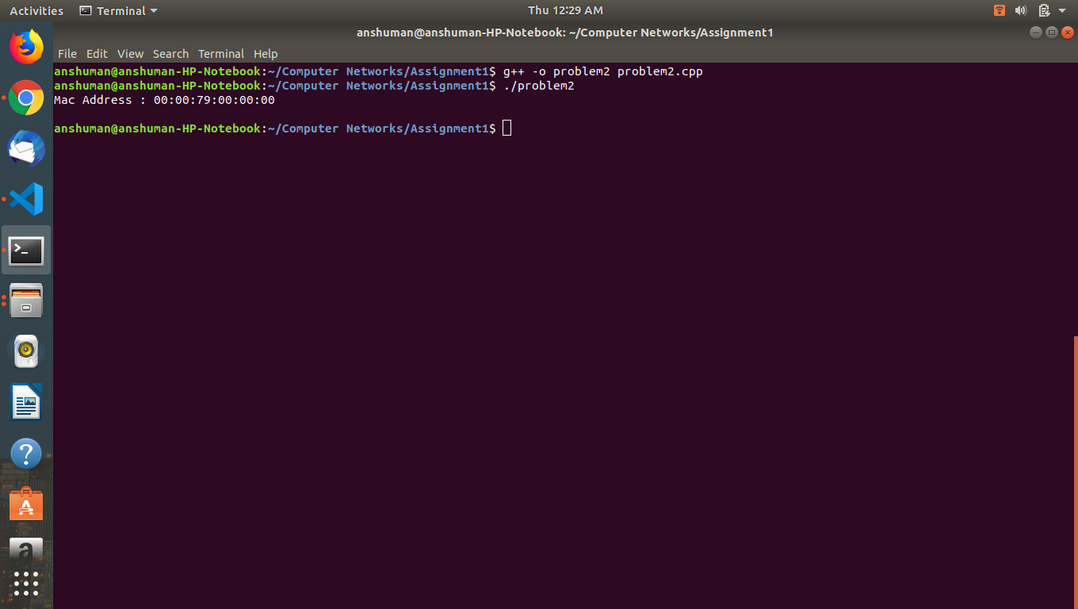

Question 3 : Write a ping program in C.

Sol->

Algorithms used :
1. gethostbyname: to get the IP address of the host.
2. inet_addr: for proper conversion of the IP address returned.
3. socket: to create a socket of AF_INET address family.
4. getpid : system call of the process id.
5. in_cksum: code to calculate the checksum.
6. FD_ZERO: clear an fdset.
7. FD_SET: add a socket descriptor to the fdset.
8. select: select return values from different sockets without multithreading.
9. sendto: To send the data to the opened socket to the specified IP address.
10. recvfrom: To receive the data from the socket.
11. gettimeofday: To calculate the ping time.

Data Structures used :
1. hostent: It contains the information obtained from a name server To store the return value of gethostbyname().
2. sock_addr_in: to specify a transport address and port for the AF_INET
address family.
3. ip: IP header.
4. icmp: icmp header.
5. timeval: checking interval for the socket.
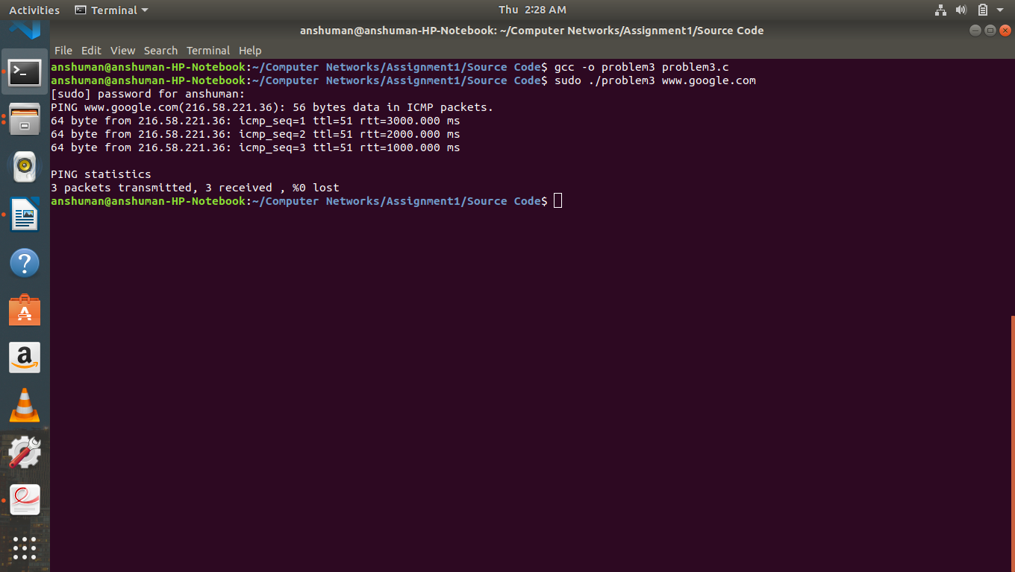
Screenshot :
Question 4 : Write a C program to find the host name and the IP address of your computer.

Sol->
Algorithms used :
1. gethostname: retrieves the host name
2. gethostbyname: returns details about a host if we give a hostname.
3. inet_ntoa: returns the dots-and-numbers string format of the IP address.
Data Structures used :
1. hostent: It contains the information obtained from a name server To store the return value of gethostbyname().
2. in_addr: To store the internet address.
Screenshot :
