Given below are the questions along with the solution:

1. ***the total amount spent and the country for the Pending delivery status for each country.***

*SELECT c.customer_country,*

*SUM(o.amount) AS pending_amount*

*FROM public.fact_orders o*

*LEFT JOIN public.dim_customers c ON o.customer_id = c.customer_id*

*LEFT JOIN public.dim_delivery d ON d.customer_id = c.customer_id*

*WHERE d.delivery_status = 'Pending'*

*GROUP BY 1*

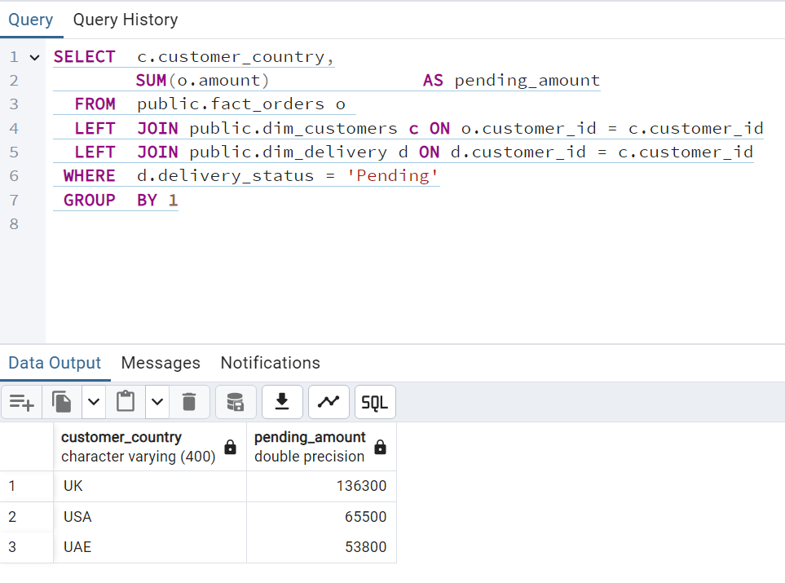

1. ***the total number of transactions, total quantity sold, and total amount spent for each customer, along with the product details.***

*SELECT c.customer_id,*

*o.item_name,*

*COUNT(o.order_id) AS transactions,*

*SUM(o.amount) AS sales*

*FROM public.dim_customers c*

*LEFT JOIN public.fact_orders o ON o.customer_id = c.customer_id*

*WHERE item_name IS NOT NULL*

*GROUP BY 1,2*

*ORDER BY 1*

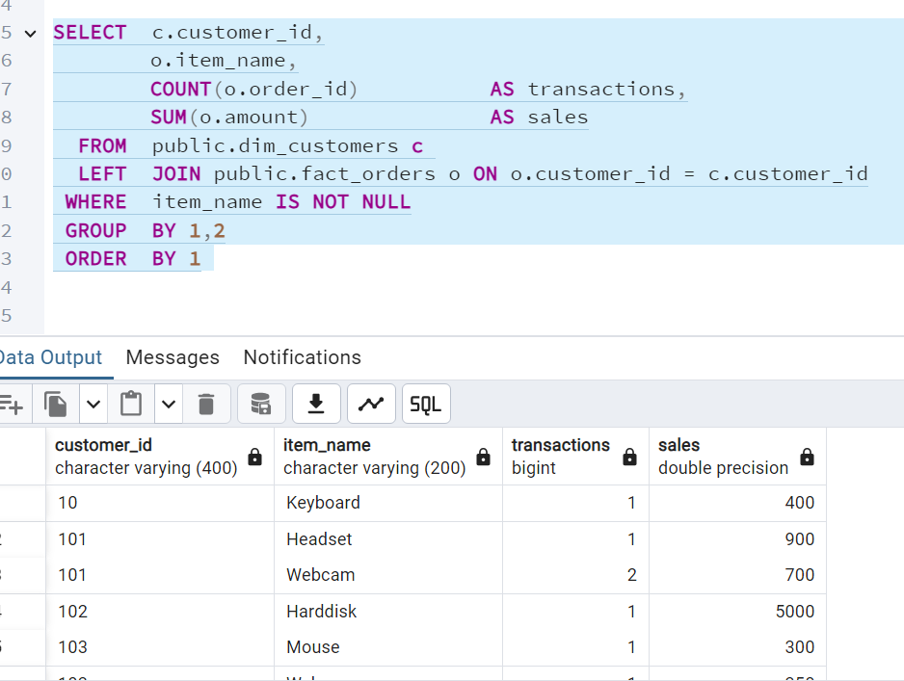

1. ***the maximum product purchased for each country.***

*WITH CTE AS (*

*SELECT customer_country,*

*o.item_name,*

*COUNT(1) AS no_of_prod*

*FROM public.dim_customers c*

*LEFT JOIN public.fact_orders o ON o.customer_id = c.customer_id*

*WHERE item_name IS NOT NULL*

*GROUP BY 1,2*

*ORDER BY 3 DESC*

*),*

*cte2 AS (*

*SELECT customer_country,*

*item_name,*

*no_of_prod,*

*RANK () OVER(PARTITION BY customer_country ORDER BY no_of_prod DESC) AS rank*

*FROM CTE*

*)*

*SELECT customer_country,*

*item_name,*

*no_of_prod*

*FROM cte2*

*WHERE rank = 1;*

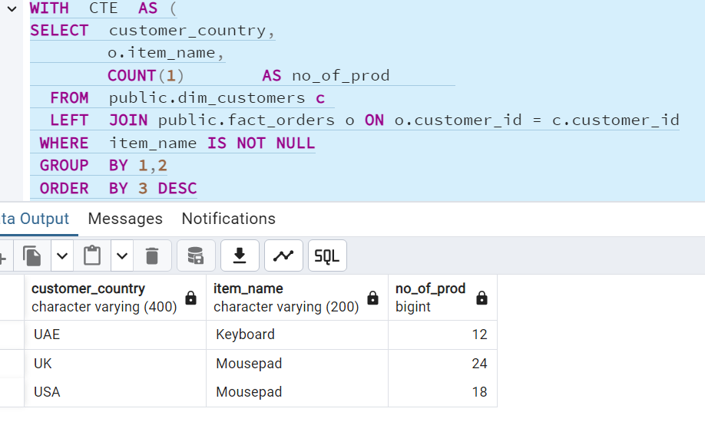

1. ***the most purchased product based on the age category less than 30 and above 30.***

*WITH cat1 AS (*

*SELECT 'age above 30' AS category,*

*o.item_name,*

*count(o.item_name) AS count*

*FROM public.dim_customers c*

*LEFT JOIN public.fact_orders o ON o.customer_id = c.customer_id*

*WHERE c.customer_age > 30*

*GROUP BY 1,2*

*),*

*cat2 AS (*

*SELECT 'age below 30' AS category,*

*o.item_name,*

*count(o.item_name) AS count*

*FROM public.dim_customers c*

*LEFT JOIN public.fact_orders o ON o.customer_id = c.customer_id*

*WHERE c.customer_age < 30*

*GROUP BY 1,2*

*),*

*final AS (*

*SELECT *,*

*RANK () OVER(PARTITION BY category ORDER BY count DESC) AS rank*

*FROM cat1*

*UNION ALL*

*SELECT *,*

*RANK () OVER(PARTITION BY category ORDER BY count DESC) AS rank*

*FROM cat2*

*)*

*SELECT category,*

*item_name AS most_purchased_product,*

*count AS count_most_purchased_product*

*FROM final*

*WHERE rank =1*

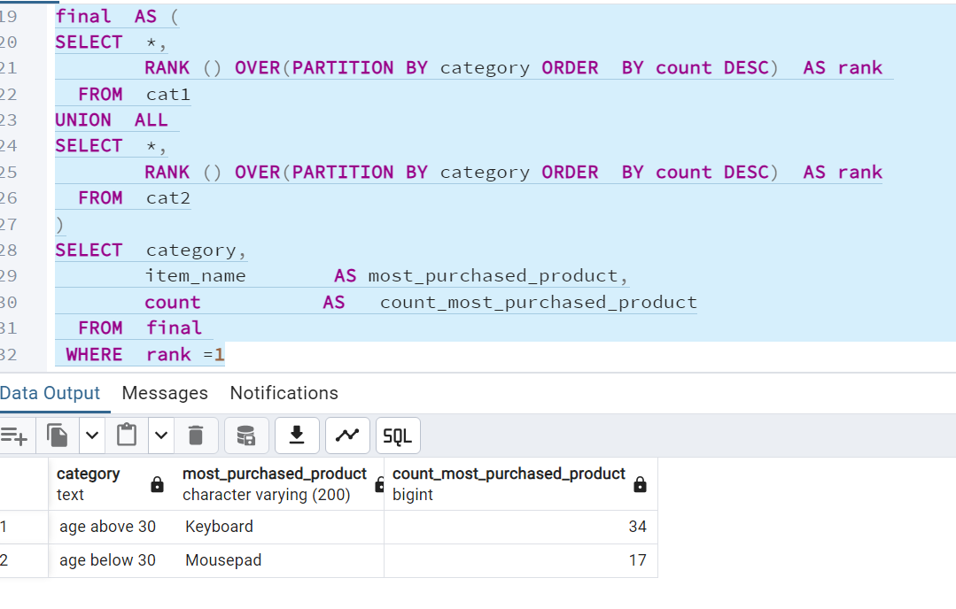

1. *t****he country that had minimum transactions and sales amount****.*

*SELECT c.customer_country,*

*COUNT(o.order_id) AS transactions,*

*SUM(o.amount) AS sales*

*FROM public.dim_customers c*

*LEFT JOIN public.fact_orders o ON o.customer_id = c.customer_id*

*GROUP BY 1*

*ORDER BY 1,2*

*LIMIT 1*

