WOXSEN UNIVERSITY
School of Technology
LAB ASSIGNMENT - Q48
Express.js Middleware
Request ID, Structured Request Logging and X-Response-Time Header
Detailed Project Report
Field | Details
Student Name | Anshu
Roll Number / ID | ____________________
Programme | B.Tech
Course | SDLC - React & Node.js
Assignment | Lab Assignment Q48 (React & Node.js)
Faculty | ____________________
Date of Submission | ____________________

Table of Contents
- Abstract
- Aim and Objectives
- Problem Statement and Motivation
- Background Theory (HTTP, Express, middleware)
- Requirements (functional and non-functional)
- Tools and Technologies
- Project Setup (step by step)
- System Design
- Source Code with Screenshots
- Line-by-Line Code Walkthrough
- Design Decisions
- Security Considerations
- How to Run
- Output and Evidence
- Performance Benchmark
- Testing (test cases, unit tests, coverage)
- Comparison with Existing Libraries (morgan, pino-http)
- Challenges and Troubleshooting
- Limitations and Future Scope
- Learning Outcomes
- Conclusion
- Glossary
- Viva Questions and Answers
- References
- Appendix - Full Source Code (text)

1. Abstract
This project implements three reusable Express.js middleware functions. The first gives every HTTP request a unique request ID (reusing a safe ID sent by the client). The second measures how long the server needs to answer and returns the value in an X-Response-Time header. The third writes one structured JSON log line per request after the response is finished, containing the time, level, request ID, method, path, status code, duration, response size and user agent. The middleware is demonstrated on a small API with GET and POST routes, a slow route, a health check and error routes. Seventeen automated tests (100% line coverage) and a 200-request benchmark verify the behaviour and show that the middleware adds negligible overhead.

2. Aim and Objectives
Aim: to write Express middleware that adds a request ID, logs method/path/status/duration and returns an X-Response-Time header.
- Understand how middleware works in Express and why the order of app.use() matters.
- Generate and propagate a unique request ID (UUID) and accept a safe ID from the client for cross-service tracing.
- Measure request duration with a high-resolution monotonic timer.
- Log after the response has finished so the real status code is recorded, with levels (info, warn, error).
- Make the headers and logs work for success, 4xx, 5xx, async errors and malformed requests.
- Make the middleware configurable (header names, skipped paths, slow-request threshold) and testable.
- Verify behaviour with automated tests and a benchmark.

3. Problem Statement and Motivation
When a user says "the app gave me an error", developers need to find that exact request among millions of log lines. Teams also need to know which endpoints are slow. Without a request ID, log lines from one request cannot be connected; without timing, performance problems stay invisible; without a consistent log format, tools cannot search the logs. Production APIs therefore add an ID, timing and structured logs to every request. This assignment builds these three pieces as small middleware functions that can be reused in any Express project.

4. Background Theory

4.1 HTTP request-response cycle
A client sends an HTTP request (method, path, headers, optional body). The server answers with a status code (200 OK, 404 Not Found, 500 Internal Server Error, etc.), headers and a body. Headers are metadata: custom headers beginning with X- are commonly used for extra information such as X-Request-ID and X-Response-Time. All headers must be written before the body starts, which is why the response-time header has to be added just before the headers are sent.

4.2 Express and middleware
Express is a minimal web framework for Node.js. Every request passes through a stack of functions. A middleware function receives (req, res, next); it can read or change req and res, end the response, or call next() to pass control to the next function. Routes and error handlers are also part of the same stack. Because the stack runs in registration order, the order of app.use() calls decides what each function can see.
Middleware type | Example
Application-level | app.use(requestId()) - runs for every request
Route-level | app.get("/x", auth, handler) - runs only for that route
Built-in | express.json() - parses JSON request bodies
Error-handling | (err, req, res, next) - four parameters, registered last
Third-party | morgan, helmet, cors

4.3 Request IDs and observability
Observability means being able to understand what a system is doing from its outputs: logs, metrics and traces. A request ID is the simplest tracing tool: the same ID appears in the response header, the log line, the error body shown to the user, and (when forwarded) in other services, so one search finds everything about a request.

4.4 Measuring time in Node.js
Date.now() returns wall-clock time in milliseconds and can jump when the system clock changes. process.hrtime.bigint() returns a monotonic nanosecond counter, which only moves forward and is the right tool for measuring durations.

4.5 Node.js events used
The response object is an event emitter. The "finish" event is emitted when the response has been handed over to the operating system for sending. Logging in this event guarantees the final status code and total duration are known.

5. Requirements

5.1 Functional requirements
ID | Requirement
FR1 | Every response has an X-Request-ID header; the ID is also available as req.id.
FR2 | A valid client-supplied X-Request-ID is reused; an unsafe one is replaced.
FR3 | Every response has an X-Response-Time header in milliseconds.
FR4 | One JSON log line is written per request after it finishes: time, level, requestId, method, path, status, durationMs, bytes, userAgent.
FR5 | Level is info for success, warn for 4xx or slow requests, error for 5xx.
FR6 | Selected paths (for example /health) can be excluded from the logs.
FR7 | The headers and logs must also work for 404, 400, 500 and async errors.
FR8 | Error responses include the request ID in the body.

5.2 Non-functional requirements
- Low overhead: the middleware should add well under 1 ms per request (verified by benchmark).
- Reusable and configurable: header names, skip list and slow threshold are options.
- Testable: log output can be redirected to a function.
- No extra dependencies besides Express (uses built-in crypto and process.hrtime).

6. Tools and Technologies
Tool | Purpose
Node.js | JavaScript runtime
Express 5 | Web framework (also forwards async handler errors to the error handler)
crypto (built-in) | crypto.randomUUID() generates the request ID
node:test + fetch | Built-in test runner and HTTP client used for tests and benchmark
curl | Sends requests and shows response headers
npm | Installs dependencies and runs scripts

7. Project Setup (step by step)
- Create the folder and run npm init -y.
- Install Express: npm install express.
- Create the middleware folder with requestId.js, responseTime.js and logger.js.
- Create app.js (builds the app and registers the middleware in order) and server.js (starts listening).
- Create test/middleware.test.js and benchmark.js.
- Add scripts to package.json: "start" and "test".
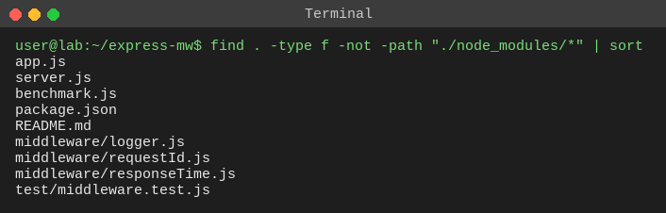
Figure 1: Project file structure
File | Role
middleware/requestId.js | Creates or reuses the request ID; sets req.id and X-Request-ID
middleware/responseTime.js | Starts a timer and adds the X-Response-Time header
middleware/logger.js | Writes one JSON log line when the response finishes
app.js | createApp(): registers middleware in order, defines routes, 404 and error handlers
server.js | Starts the HTTP server (PORT environment variable, default 3000)
benchmark.js | Sends N requests and prints response-time statistics
test/middleware.test.js | 17 automated tests

8. System Design

8.1 Middleware chain
The request ID is created first so every later step and every log line can use it. The timer starts second so that it measures almost the whole request. The logger is third; it only registers a listener and prints after the response finishes. express.json() comes after the logger so that even body-parsing errors are logged.
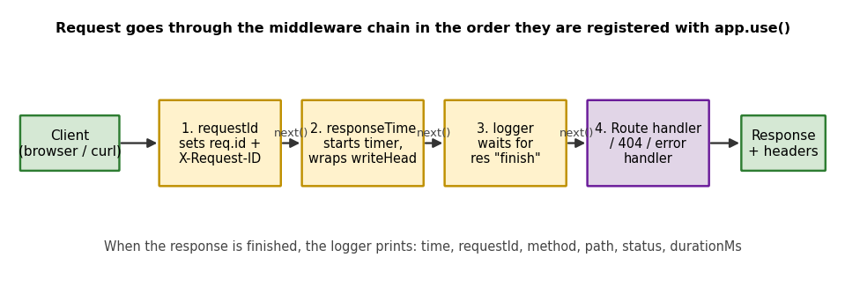
Figure 2: Middleware chain

8.2 Sequence of one request
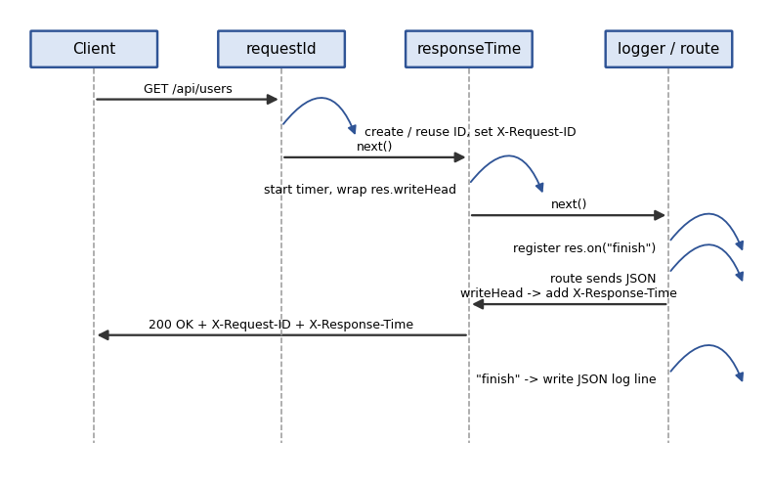
Figure 3: Sequence diagram for GET /api/users

8.3 Log levels
Level | When | Example
info | Status below 400 and faster than the slow threshold (250 ms) | GET /api/users 200
warn | Status 400-499, or request slower than 250 ms | 404 Not Found, /api/slow
error | Status 500 or above | /api/error 500

8.4 Routes in the demo app
Route | Status | Purpose
GET / | 200 | Hello message that returns the request ID
GET /health | 200 | Health check; not logged (would flood the logs)
GET /api/users | 200 | Returns the list of users
POST /api/users | 201 / 400 | Creates a user from JSON; 400 if name is missing
GET /api/slow | 200 | Waits 300 ms to show a measurable duration and a warn log
GET /api/error | 500 | Throws an error (synchronous)
GET /api/async-error | 500 | Rejects a promise (asynchronous error)
any other path | 404 | Not found handler

9. Source Code

9.1 middleware/requestId.js
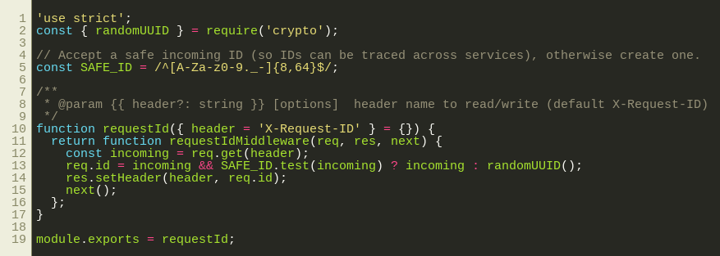
Figure 4: requestId.js

9.2 middleware/responseTime.js
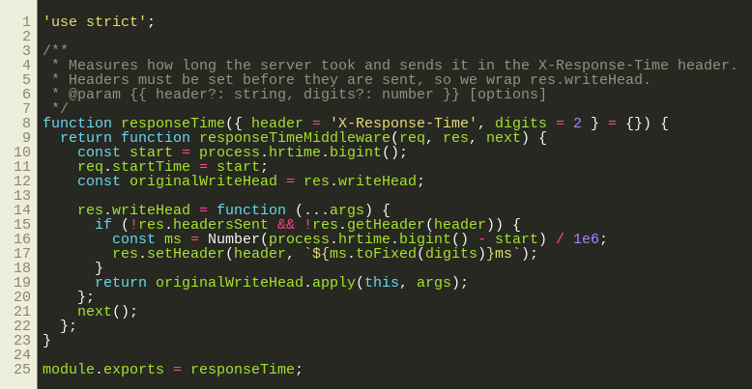
Figure 5: responseTime.js

9.3 middleware/logger.js
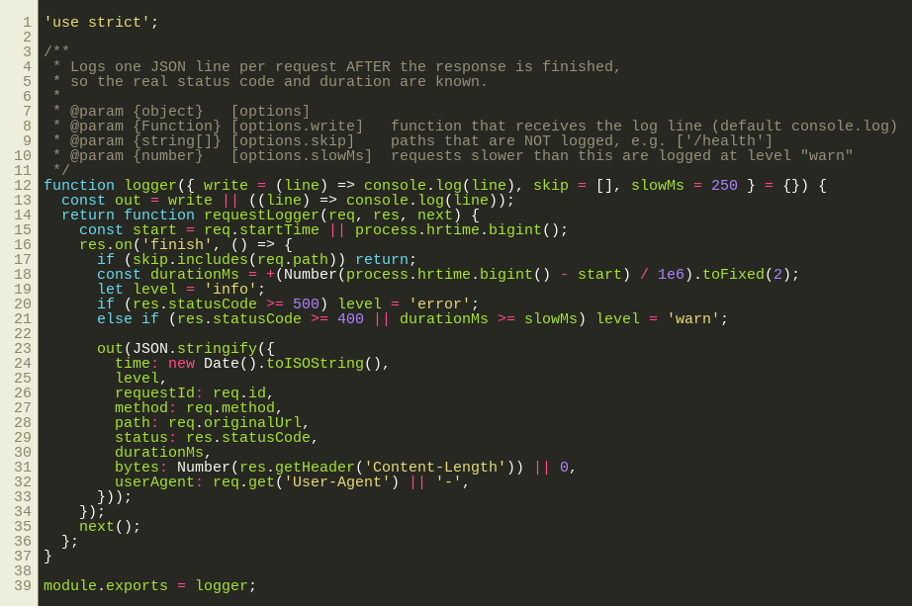
Figure 6: logger.js

9.4 app.js
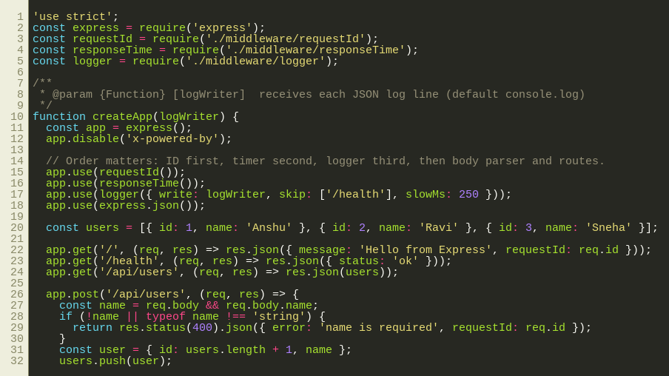
Figure 7: app.js (part 1)
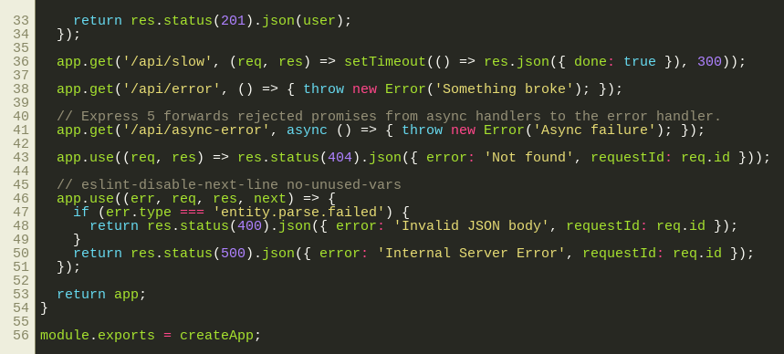
Figure 8: app.js (part 2)

9.5 server.js
Figure 9: server.js

9.6 benchmark.js
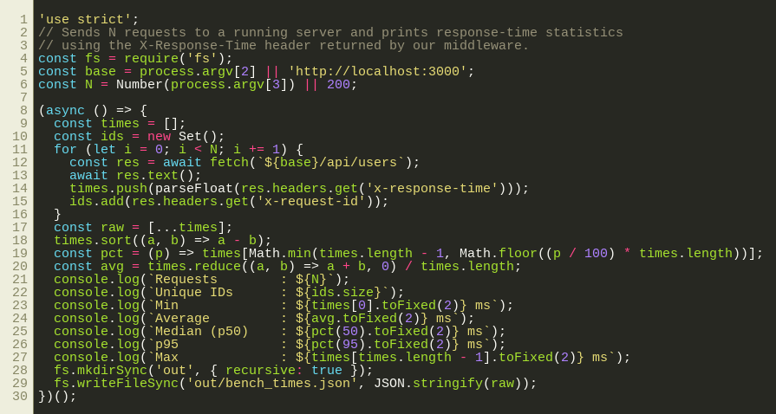
Figure 10: benchmark.js

9.7 test/middleware.test.js
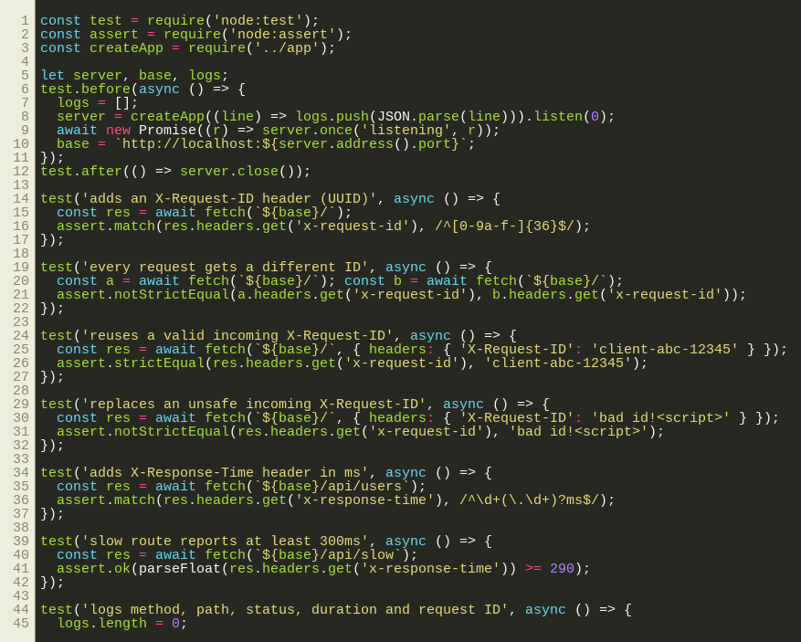
Figure 11: middleware.test.js (part 1)
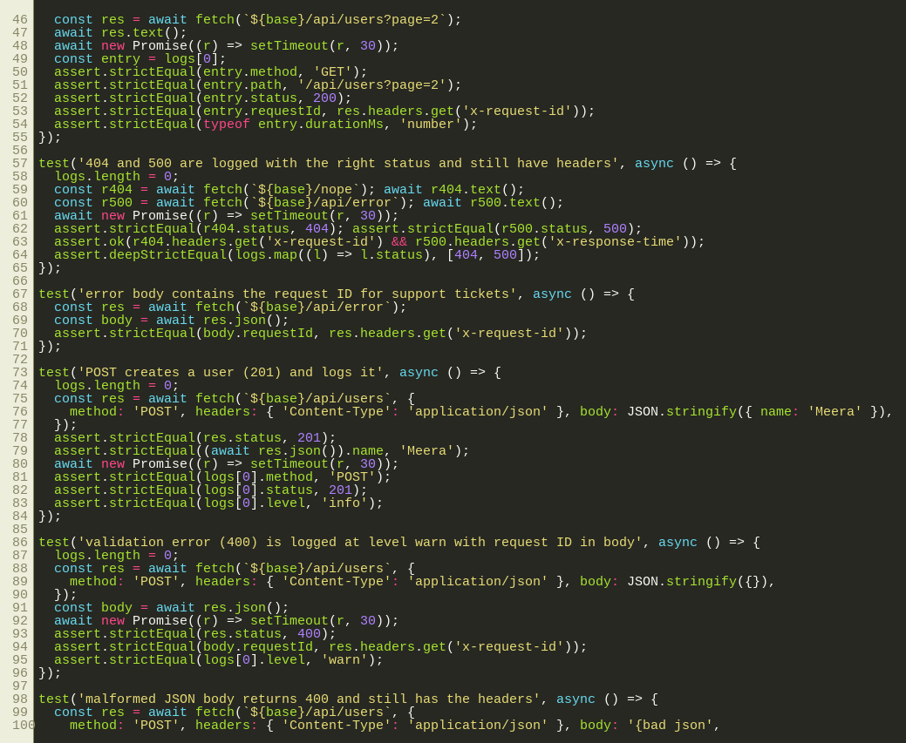
Figure 12: middleware.test.js (part 2)
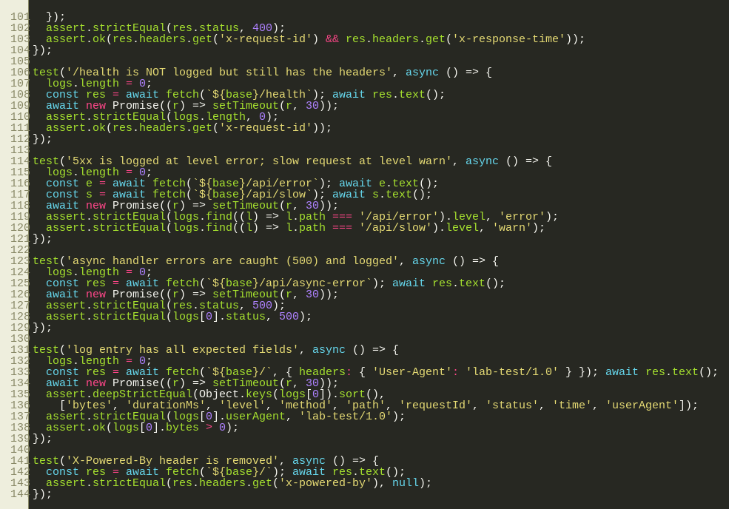
Figure 13: middleware.test.js (part 3)

9.8 package.json
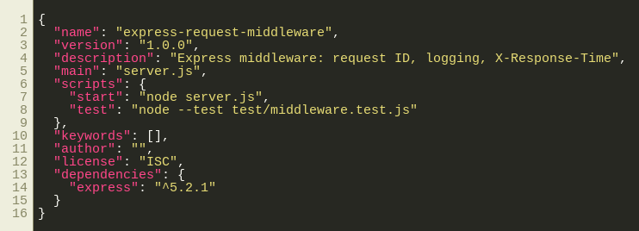
Figure 14: package.json

10. Line-by-Line Code Walkthrough

10.1 requestId.js
Code | Explanation
const SAFE_ID = /^[A-Za-z0-9._-]{8,64}$/ | Regular expression for an acceptable client ID: 8-64 characters, only letters, digits, dot, underscore, hyphen. Blocks spaces, newlines and script characters.
function requestId({ header = ... } = {}) | A factory: calling requestId() returns the actual middleware. This lets options (such as the header name) be passed in. Defaults make requestId() work with no arguments.
req.get(header) | Reads the incoming request header (case-insensitive).
incoming && SAFE_ID.test(incoming) ? incoming : randomUUID() | Reuse the client ID only if it exists and matches the pattern; otherwise generate a new UUID v4.
req.id = ... | Stores the ID on the request so later middleware, routes and the logger can use it.
res.setHeader(header, req.id) | Sends the ID back to the client in the response.
next() | Hands control to the next middleware. Without it the request would hang.

10.2 responseTime.js
Code | Explanation
const start = process.hrtime.bigint() | Records the start time in nanoseconds (BigInt).
req.startTime = start | Shares the start time so the logger uses the same starting point.
const originalWriteHead = res.writeHead | Keeps a reference to Node's own function that sends the status line and headers.
res.writeHead = function (...args) { ... } | Replaces it with a wrapper. Headers cannot be changed after they are sent, so the wrapper adds X-Response-Time at the last moment.
if (!res.headersSent && !res.getHeader(header)) | Safety checks: do nothing if headers were already sent or if the header is already set.
Number(process.hrtime.bigint() - start) / 1e6 | Elapsed nanoseconds converted to milliseconds.
originalWriteHead.apply(this, args) | Calls the real function so the response is sent normally.

10.3 logger.js
Code | Explanation
logger({ write, skip, slowMs } = {}) | Factory with options: where to send log lines, which paths to skip, and the slow threshold.
res.on("finish", () => { ... }) | Runs the callback after the response is complete, so statusCode and the total time are final.
if (skip.includes(req.path)) return | Skips noisy paths such as /health.
level = error / warn / info | 5xx gives error; 4xx or a slow request gives warn; everything else info.
JSON.stringify({ ... }) | Builds one JSON object per line. req.originalUrl is used so the query string is kept even inside routers.
bytes: Number(res.getHeader("Content-Length")) || 0 | Response size in bytes (0 if unknown).

10.4 app.js
Code | Explanation
app.disable("x-powered-by") | Removes the header that reveals the framework (small security hardening).
app.use(requestId()); app.use(responseTime()); app.use(logger(...)) | Registers the three middleware first, in the required order, so they run for every request including 404 and errors.
express.json() | Parses JSON request bodies into req.body (placed after the logger so parse errors are logged too).
app.post("/api/users", ...) | Validates the name, returns 400 with the request ID if invalid, otherwise 201 with the new user.
app.get("/api/async-error", async () => { throw ... }) | Shows that Express 5 passes errors from async handlers to the error handler automatically.
app.use((req, res) => res.status(404)...) | Catch-all after all routes: unmatched requests get a 404 JSON body with the request ID.
app.use((err, req, res, next) => ...) | Error-handling middleware (four parameters). Malformed JSON gives 400; everything else gives 500. The real error message is not sent to the client.
createApp(logWriter) | Builds and returns the app; tests pass their own log writer to capture log lines.

11. Design Decisions
Decision | Reason
Middleware as factories (requestId(), responseTime(), logger()) | Allows options and keeps each function independent and reusable.
Log on "finish", not at request start | The final status code and duration are only known after the response is sent.
Wrap res.writeHead for the timing header | The only way to set a header with the final duration right before headers are sent.
Monotonic timer (hrtime) not Date.now() | Accurate and immune to system clock changes.
One JSON object per line | Easy to search, filter and ship to log tools (jq, ELK, CloudWatch).
Validate incoming request IDs | Clients control headers; unchecked values could pollute logs or be very long.
Skip list for /health | Load balancers call health checks constantly; logging them hides real traffic.
Return generic 500 message | Do not leak internal error details; the request ID lets developers find the real error in the logs.
Inject the log writer | Makes the logger testable and lets production send logs elsewhere.

12. Security Considerations
- Log injection: an attacker could send a header with newlines or fake log text. Only IDs matching the safe pattern are accepted, and JSON.stringify escapes special characters in all logged values.
- Information disclosure: x-powered-by is disabled and error responses contain only a generic message plus the request ID.
- Sensitive data: only the method, path and query are logged, never request bodies or Authorization headers. Query strings can contain tokens, so production systems should redact them (see Future Scope).
- Denial of service: the ID length is capped at 64 characters, and express.json() limits the body size by default (100 kb).

13. How to Run
npm install
npm start # http://localhost:3000 (or: PORT=3100 npm start)
curl -i localhost:3000/ # in another terminal
curl -i -X POST -H "Content-Type: application/json" -d '{"name":"Meera"}' localhost:3000/api/users
node benchmark.js http://localhost:3000 200
npm test

14. Output and Evidence
The screenshots below come from a server started with PORT=3100 so the port in the commands is 3100.

14.1 Server log lines
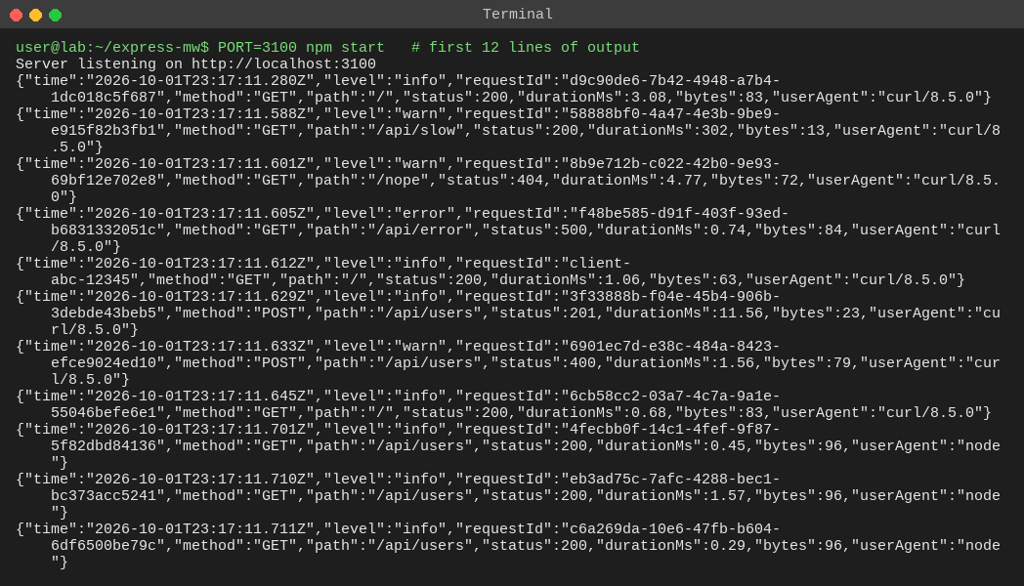
Figure 15: One JSON log line per request. Note the levels: info, warn (slow and 404), error (500)

14.2 Normal request
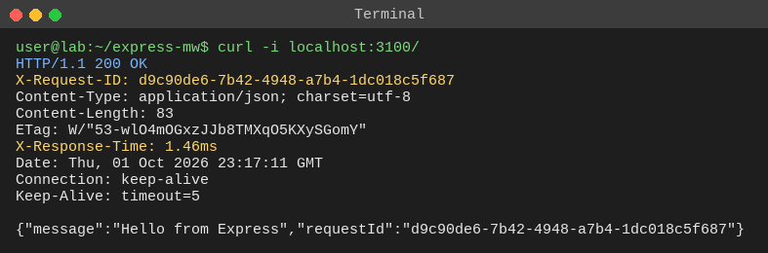
Figure 16: GET / - response headers include X-Request-ID and X-Response-Time

14.3 Only the new headers
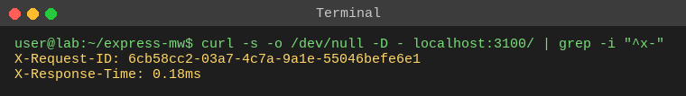
Figure 17: Filtering the response headers

14.4 Slow route (300 ms)
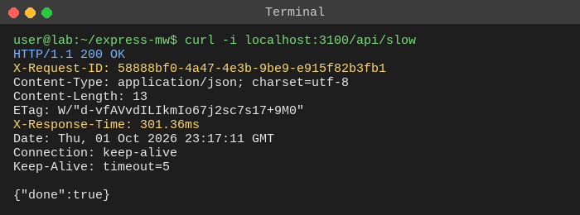
Figure 18: GET /api/slow - X-Response-Time is about 300 ms

14.5 Client supplies its own request ID
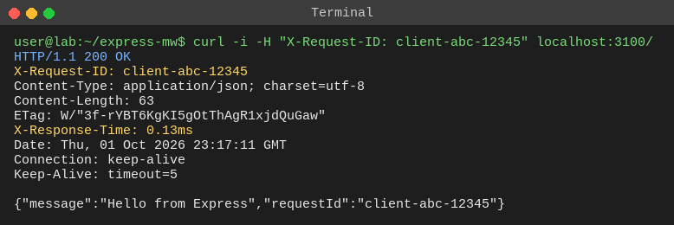
Figure 19: The valid ID client-abc-12345 is reused

14.6 POST request - success (201)
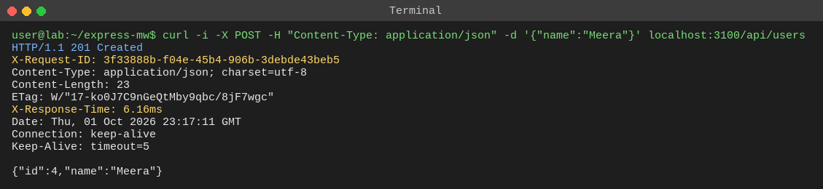
Figure 20: POST /api/users creates a user

14.7 POST request - validation error (400)
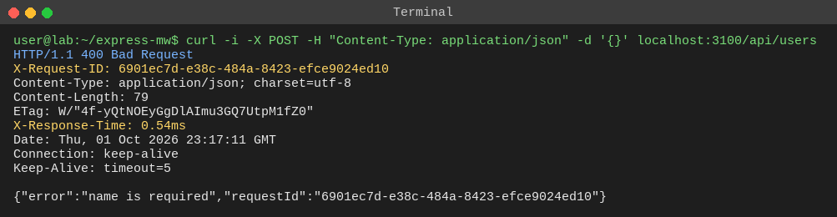
Figure 21: The 400 body contains the request ID

14.8 404 Not Found
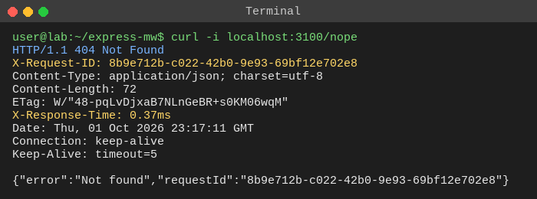
Figure 22: Headers are present on 404 responses

14.9 500 Internal Server Error
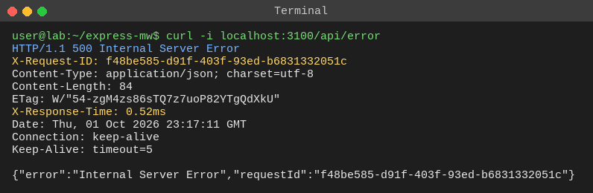
Figure 23: Headers are present on 500 responses; the body contains the request ID

15. Performance Benchmark
benchmark.js sent 200 sequential requests to GET /api/users and collected the X-Response-Time values. The numbers are from a real run on the development machine; absolute values depend on the hardware, but they show that the middleware overhead is tiny.
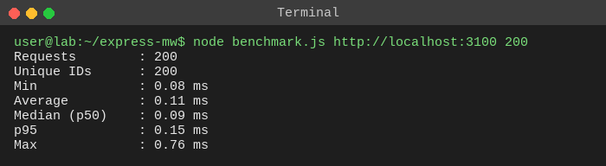
Figure 24: Benchmark output (all 200 request IDs were unique)
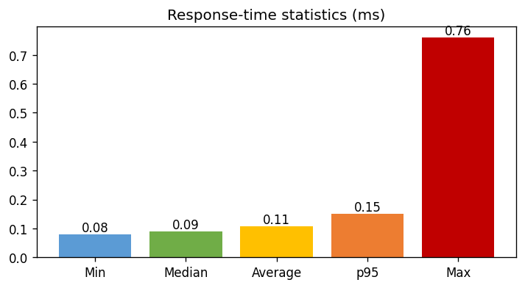
Figure 25: Response-time statistics
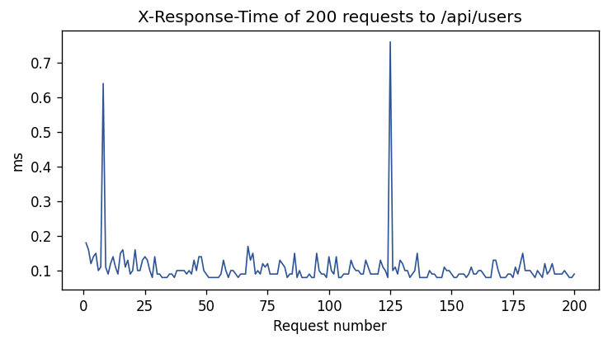
Figure 26: Response time of each request
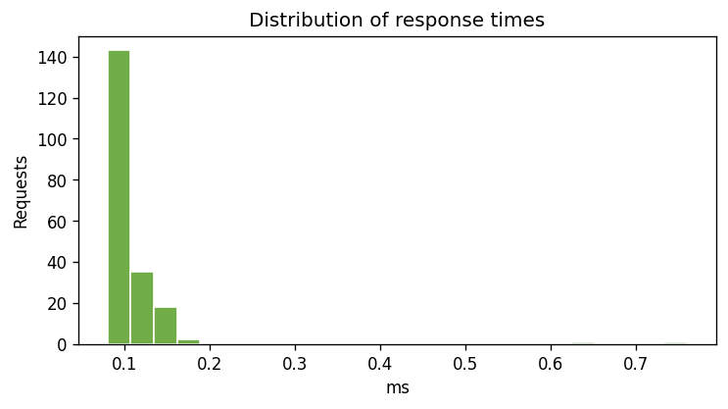
Figure 27: Distribution of response times
Observation: the median is under 0.1 ms and 200 of 200 IDs were unique. The first request is slightly slower because Node compiles the code on first use (warm-up).

16. Testing

16.1 Test cases
# | Test case | Expected result | Status
1 | Request to / | X-Request-ID header is a UUID | Pass
2 | Two requests | IDs are different | Pass
3 | Valid incoming X-Request-ID | Same ID returned | Pass
4 | Unsafe incoming ID (spaces, <script>) | Replaced by a new ID | Pass
5 | Request to /api/users | X-Response-Time like 0.42ms | Pass
6 | Request to /api/slow | X-Response-Time at least 300 ms | Pass
7 | Request with query string | Log has method, path, status, duration, ID | Pass
8 | 404 and 500 responses | Correct status logged; both headers present | Pass
9 | 500 error body | Contains the same request ID | Pass
10 | POST with valid JSON | 201, logged as POST at level info | Pass
11 | POST with missing name | 400, level warn, request ID in body | Pass
12 | Malformed JSON body | 400 and headers still present | Pass
13 | GET /health | Not logged but has the headers | Pass
14 | /api/error and /api/slow | error level for 500, warn level for slow | Pass
15 | Async handler throws | 500 returned and logged | Pass
16 | Log entry fields | Exactly the 9 expected fields; user agent and bytes correct | Pass
17 | X-Powered-By header | Header is removed | Pass

16.2 Test run
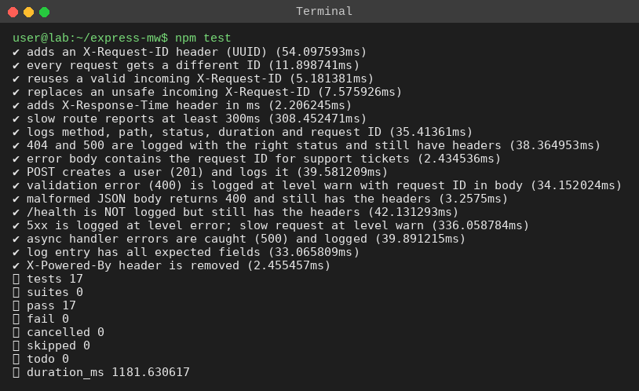
Figure 28: All 17 tests passing (npm test)

16.3 Coverage
Node's built-in coverage report shows 100% line coverage for every source file.
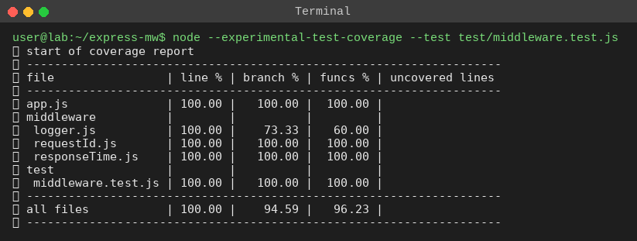
Figure 29: Coverage report

17. Comparison with Existing Libraries
Feature | This project | morgan | pino-http
Request ID | Yes (reuse or UUID) | No (needs custom token) | Yes (genReqId option)
X-Response-Time header | Yes | No (separate package: response-time) | No
JSON logs | Yes | Optional (custom format) | Yes (default)
Log levels | info / warn / error | No | Yes
Dependencies | None extra | Yes | Yes (pino)
Best use | Learning, small APIs | Quick dev logging | High-volume production
Writing the middleware by hand shows how these libraries work internally. In a large production system, a tested library such as pino-http is usually preferred.

18. Challenges and Troubleshooting
Challenge / problem | Solution
A header cannot be set after the response is sent | Wrapped res.writeHead so X-Response-Time is added just before headers are sent.
Status code is unknown when the request starts | Logged inside res.on("finish"), when the final status is available.
Client-supplied IDs could contain harmful characters | Only IDs matching a safe pattern are accepted; otherwise a UUID is generated.
Request hangs (no response) | Usually next() was not called in a middleware.
Header missing on 404 | The middleware must be registered before the routes and the 404 handler.
Logs not showing in tests | createApp accepts a log writer; tests collect lines in an array and wait briefly for the "finish" event.
Port already in use (EADDRINUSE) | Start with another port: PORT=3100 npm start.
fetch is not defined | Use Node 18 or newer (fetch is built in).

19. Limitations and Future Scope
- Use AsyncLocalStorage so the request ID is available anywhere in the code without passing req around.
- Forward the request ID in calls to other services (distributed tracing, W3C traceparent).
- Redact sensitive query parameters (tokens, passwords) before logging.
- Send logs to a service (ELK, CloudWatch, Datadog) and add log rotation.
- Add the Server-Timing header and Prometheus metrics (request count, latency histogram).
- Limitation: the timer ends when headers are written, so it does not include time spent sending a very large body.

20. Learning Outcomes
- Wrote Express middleware as factories with options and understood next() and ordering.
- Learned how HTTP headers work and why they must be set before the body.
- Used Node events (finish), monotonic timers and crypto.randomUUID().
- Practised structured logging, log levels and basic security thinking (log injection, information disclosure).
- Wrote automated tests, measured coverage and ran a simple benchmark.

21. Conclusion
Three small middleware functions made every response traceable and measurable: each request gets a unique ID, each finished request produces a structured JSON log line with a level, and each response carries an X-Response-Time header, even for 404, 400 and 500 responses. Seventeen automated tests with full line coverage confirm the behaviour, and the benchmark shows the overhead is far below one millisecond. The same pattern is used in real production systems and can be extended with tracing and metrics.

22. Glossary
Term | Meaning
Middleware | Function (req, res, next) that runs during request handling
Request ID | Unique identifier of one request used for tracing in logs
UUID | Universally unique identifier, 128-bit, generated randomly
Header | Name-value metadata sent with an HTTP request or response
Monotonic clock | Timer that only moves forward; safe for measuring durations
Structured logging | Logs written in a machine-readable format such as JSON
Latency / p95 | Time taken to answer; p95 is the value 95% of requests are faster than
Observability | Ability to understand a system from logs, metrics and traces
Health check | Endpoint used by load balancers to see if the server is alive
Log injection | Attack that adds fake or harmful content to log files

23. Viva Questions and Answers
Q1. What is middleware in Express?
A function with the signature (req, res, next) that runs in the request-response cycle. It can read or change the request and response, end the response, or call next() to pass control on.
Q2. Why does the order of app.use() matter?
Express runs middleware in registration order. The request ID must come first so later middleware and routes can use it, and all three must come before the routes so they run for every request.
Q3. Why does every request need an ID in production?
So one request can be found in logs across servers and services, support can quote the ID from an error response, and developers can trace a problem from the user report to the exact log lines.
Q4. Why log inside res.on("finish") and not at the start?
At the start the status code and duration are not known. The finish event fires after the response is sent, so the final status and total time are available.
Q5. Why is the X-Response-Time header set inside res.writeHead?
HTTP headers must be set before the response starts. Wrapping writeHead lets us calculate the time at the last moment before the headers are sent.
Q6. Why use process.hrtime.bigint() instead of Date.now()?
It is a high-resolution monotonic timer. Date.now() has only millisecond precision and can jump if the system clock changes.
Q7. What happens if you forget to call next()?
The request never reaches the next middleware or route and the client waits until it times out.
Q8. Why validate an incoming X-Request-ID?
Clients control that header. An unchecked value could contain newlines or script characters (log injection) or be extremely long, so only a safe pattern is accepted.
Q9. Why use JSON logs?
One JSON object per line is easy for tools to parse, search and filter (for example by requestId or status), unlike free-form text.
Q10. How do error-handling middleware functions differ?
They have four parameters (err, req, res, next) and are registered after the routes. Express calls them when a route throws or calls next(err).
Q11. How does the 404 response still get the headers?
The three middleware functions are registered before the routes and the 404 handler, so they run first for every request, including unmatched ones.
Q12. Why are middleware written as factories (requestId())?
A factory returns the middleware, so options such as the header name can be passed and each use gets its own configuration.
Q13. How do you choose log levels here?
5xx is error, 4xx or a slow request is warn, everything else is info, so operators can filter for problems quickly.
Q14. Why is /health skipped in the logs?
Load balancers call it every few seconds; logging it would fill the logs with noise and hide real traffic.
Q15. What changed in Express 5 for async handlers?
Express 5 automatically passes rejected promises from async route handlers to the error-handling middleware. In Express 4 you had to catch the error and call next(err).
Q16. What is the difference between req.url, req.path and req.originalUrl?
req.path is the path without the query string; req.url can be changed by routers; req.originalUrl is the full original URL including the query string, so it is the right value to log.
Q17. Why not send the real error message to the client?
It can reveal internal details to attackers. The client gets a generic message and the request ID; developers find the real error in the server logs.
Q18. What is p95 and why is it used?
p95 is the response time that 95% of requests are faster than. It shows slow outliers that the average hides.
Q19. What is the difference between middleware and a route handler?
Middleware usually prepares or checks the request and calls next(); a route handler is the final function that sends the response for a specific method and path.
Q20. How did you test the middleware?
The app is started on a random port with node:test, requests are sent with fetch, and tests check headers and captured log lines. A custom log writer is injected into createApp so logs can be inspected.
Q21. How can this be improved for production?
Use AsyncLocalStorage for the ID, propagate it to other services, redact sensitive query parameters, ship logs to a log service, and add metrics.

24. References
- Express guide: Using middleware - https://expressjs.com/en/guide/using-middleware.html
- Express guide: Error handling - https://expressjs.com/en/guide/error-handling.html
- Node.js process.hrtime.bigint() - https://nodejs.org/api/process.html
- Node.js http: response "finish" event - https://nodejs.org/api/http.html
- Node.js test runner and coverage - https://nodejs.org/api/test.html
- MDN Web Docs: HTTP headers - https://developer.mozilla.org/docs/Web/HTTP/Headers

Appendix - Full Source Code (text)

middleware/requestId.js
'use strict';
const { randomUUID } = require('crypto');

// Accept a safe incoming ID (so IDs can be traced across services), otherwise create one.
const SAFE_ID = /^[A-Za-z0-9._-]{8,64}$/;

/**
* @param {{ header?: string }} [options] header name to read/write (default X-Request-ID)
*/
function requestId({ header = 'X-Request-ID' } = {}) {
return function requestIdMiddleware(req, res, next) {
const incoming = req.get(header);
req.id = incoming && SAFE_ID.test(incoming) ? incoming : randomUUID();
res.setHeader(header, req.id);
next();
};
}

module.exports = requestId;

middleware/responseTime.js
'use strict';

/**
* Measures how long the server took and sends it in the X-Response-Time header.
* Headers must be set before they are sent, so we wrap res.writeHead.
* @param {{ header?: string, digits?: number }} [options]
*/
function responseTime({ header = 'X-Response-Time', digits = 2 } = {}) {
return function responseTimeMiddleware(req, res, next) {
const start = process.hrtime.bigint();
req.startTime = start;
const originalWriteHead = res.writeHead;

res.writeHead = function (...args) {
if (!res.headersSent && !res.getHeader(header)) {
const ms = Number(process.hrtime.bigint() - start) / 1e6;
res.setHeader(header, `${ms.toFixed(digits)}ms`);
}
return originalWriteHead.apply(this, args);
};
next();
};
}

module.exports = responseTime;

middleware/logger.js
'use strict';

/**
* Logs one JSON line per request AFTER the response is finished,
* so the real status code and duration are known.
*
* @param {object} [options]
* @param {Function} [options.write] function that receives the log line (default console.log)
* @param {string[]} [options.skip] paths that are NOT logged, e.g. ['/health']
* @param {number} [options.slowMs] requests slower than this are logged at level "warn"
*/
function logger({ write = (line) => console.log(line), skip = [], slowMs = 250 } = {}) {
const out = write || ((line) => console.log(line));
return function requestLogger(req, res, next) {
const start = req.startTime || process.hrtime.bigint();
res.on('finish', () => {
if (skip.includes(req.path)) return;
const durationMs = +(Number(process.hrtime.bigint() - start) / 1e6).toFixed(2);
let level = 'info';
if (res.statusCode >= 500) level = 'error';
else if (res.statusCode >= 400 || durationMs >= slowMs) level = 'warn';

out(JSON.stringify({
time: new Date().toISOString(),
level,
requestId: req.id,
method: req.method,
path: req.originalUrl,
status: res.statusCode,
durationMs,
bytes: Number(res.getHeader('Content-Length')) || 0,
userAgent: req.get('User-Agent') || '-',
}));
});
next();
};
}

module.exports = logger;

app.js
'use strict';
const express = require('express');
const requestId = require('./middleware/requestId');
const responseTime = require('./middleware/responseTime');
const logger = require('./middleware/logger');

/**
* @param {Function} [logWriter] receives each JSON log line (default console.log)
*/
function createApp(logWriter) {
const app = express();
app.disable('x-powered-by');

// Order matters: ID first, timer second, logger third, then body parser and routes.
app.use(requestId());
app.use(responseTime());
app.use(logger({ write: logWriter, skip: ['/health'], slowMs: 250 }));
app.use(express.json());

const users = [{ id: 1, name: 'Anshu' }, { id: 2, name: 'Ravi' }, { id: 3, name: 'Sneha' }];

app.get('/', (req, res) => res.json({ message: 'Hello from Express', requestId: req.id }));
app.get('/health', (req, res) => res.json({ status: 'ok' }));
app.get('/api/users', (req, res) => res.json(users));

app.post('/api/users', (req, res) => {
const name = req.body && req.body.name;
if (!name || typeof name !== 'string') {
return res.status(400).json({ error: 'name is required', requestId: req.id });
}
const user = { id: users.length + 1, name };
users.push(user);
return res.status(201).json(user);
});

app.get('/api/slow', (req, res) => setTimeout(() => res.json({ done: true }), 300));

app.get('/api/error', () => { throw new Error('Something broke'); });

// Express 5 forwards rejected promises from async handlers to the error handler.
app.get('/api/async-error', async () => { throw new Error('Async failure'); });

app.use((req, res) => res.status(404).json({ error: 'Not found', requestId: req.id }));

// eslint-disable-next-line no-unused-vars
app.use((err, req, res, next) => {
if (err.type === 'entity.parse.failed') {
return res.status(400).json({ error: 'Invalid JSON body', requestId: req.id });
}
return res.status(500).json({ error: 'Internal Server Error', requestId: req.id });
});

return app;
}

module.exports = createApp;

server.js
'use strict';
const createApp = require('./app');
const PORT = process.env.PORT || 3000;
createApp().listen(PORT, () => console.log(`Server listening on http://localhost:${PORT}`));

benchmark.js
'use strict';
// Sends N requests to a running server and prints response-time statistics
// using the X-Response-Time header returned by our middleware.
const fs = require('fs');
const base = process.argv[2] || 'http://localhost:3000';
const N = Number(process.argv[3]) || 200;

(async () => {
const times = [];
const ids = new Set();
for (let i = 0; i < N; i += 1) {
const res = await fetch(`${base}/api/users`);
await res.text();
times.push(parseFloat(res.headers.get('x-response-time')));
ids.add(res.headers.get('x-request-id'));
}
const raw = [...times];
times.sort((a, b) => a - b);
const pct = (p) => times[Math.min(times.length - 1, Math.floor((p / 100) * times.length))];
const avg = times.reduce((a, b) => a + b, 0) / times.length;
console.log(`Requests : ${N}`);
console.log(`Unique IDs : ${ids.size}`);
console.log(`Min : ${times[0].toFixed(2)} ms`);
console.log(`Average : ${avg.toFixed(2)} ms`);
console.log(`Median (p50) : ${pct(50).toFixed(2)} ms`);
console.log(`p95 : ${pct(95).toFixed(2)} ms`);
console.log(`Max : ${times[times.length - 1].toFixed(2)} ms`);
fs.mkdirSync('out', { recursive: true });
fs.writeFileSync('out/bench_times.json', JSON.stringify(raw));
})();

test/middleware.test.js
const test = require('node:test');
const assert = require('node:assert');
const createApp = require('../app');

let server, base, logs;
test.before(async () => {
logs = [];
server = createApp((line) => logs.push(JSON.parse(line))).listen(0);
await new Promise((r) => server.once('listening', r));
base = `http://localhost:${server.address().port}`;
});
test.after(() => server.close());

test('adds an X-Request-ID header (UUID)', async () => {
const res = await fetch(`${base}/`);
assert.match(res.headers.get('x-request-id'), /^[0-9a-f-]{36}$/);
});

test('every request gets a different ID', async () => {
const a = await fetch(`${base}/`); const b = await fetch(`${base}/`);
assert.notStrictEqual(a.headers.get('x-request-id'), b.headers.get('x-request-id'));
});

test('reuses a valid incoming X-Request-ID', async () => {
const res = await fetch(`${base}/`, { headers: { 'X-Request-ID': 'client-abc-12345' } });
assert.strictEqual(res.headers.get('x-request-id'), 'client-abc-12345');
});

test('replaces an unsafe incoming X-Request-ID', async () => {
const res = await fetch(`${base}/`, { headers: { 'X-Request-ID': 'bad id!<script>' } });
assert.notStrictEqual(res.headers.get('x-request-id'), 'bad id!<script>');
});

test('adds X-Response-Time header in ms', async () => {
const res = await fetch(`${base}/api/users`);
assert.match(res.headers.get('x-response-time'), /^\d+(\.\d+)?ms$/);
});

test('slow route reports at least 300ms', async () => {
const res = await fetch(`${base}/api/slow`);
assert.ok(parseFloat(res.headers.get('x-response-time')) >= 290);
});

test('logs method, path, status, duration and request ID', async () => {
logs.length = 0;
const res = await fetch(`${base}/api/users?page=2`);
await res.text();
await new Promise((r) => setTimeout(r, 30));
const entry = logs[0];
assert.strictEqual(entry.method, 'GET');
assert.strictEqual(entry.path, '/api/users?page=2');
assert.strictEqual(entry.status, 200);
assert.strictEqual(entry.requestId, res.headers.get('x-request-id'));
assert.strictEqual(typeof entry.durationMs, 'number');
});

test('404 and 500 are logged with the right status and still have headers', async () => {
logs.length = 0;
const r404 = await fetch(`${base}/nope`); await r404.text();
const r500 = await fetch(`${base}/api/error`); await r500.text();
await new Promise((r) => setTimeout(r, 30));
assert.strictEqual(r404.status, 404); assert.strictEqual(r500.status, 500);
assert.ok(r404.headers.get('x-request-id') && r500.headers.get('x-response-time'));
assert.deepStrictEqual(logs.map((l) => l.status), [404, 500]);
});

test('error body contains the request ID for support tickets', async () => {
const res = await fetch(`${base}/api/error`);
const body = await res.json();
assert.strictEqual(body.requestId, res.headers.get('x-request-id'));
});

test('POST creates a user (201) and logs it', async () => {
logs.length = 0;
const res = await fetch(`${base}/api/users`, {
method: 'POST', headers: { 'Content-Type': 'application/json' }, body: JSON.stringify({ name: 'Meera' }),
});
assert.strictEqual(res.status, 201);
assert.strictEqual((await res.json()).name, 'Meera');
await new Promise((r) => setTimeout(r, 30));
assert.strictEqual(logs[0].method, 'POST');
assert.strictEqual(logs[0].status, 201);
assert.strictEqual(logs[0].level, 'info');
});

test('validation error (400) is logged at level warn with request ID in body', async () => {
logs.length = 0;
const res = await fetch(`${base}/api/users`, {
method: 'POST', headers: { 'Content-Type': 'application/json' }, body: JSON.stringify({}),
});
const body = await res.json();
await new Promise((r) => setTimeout(r, 30));
assert.strictEqual(res.status, 400);
assert.strictEqual(body.requestId, res.headers.get('x-request-id'));
assert.strictEqual(logs[0].level, 'warn');
});

test('malformed JSON body returns 400 and still has the headers', async () => {
const res = await fetch(`${base}/api/users`, {
method: 'POST', headers: { 'Content-Type': 'application/json' }, body: '{bad json',
});
assert.strictEqual(res.status, 400);
assert.ok(res.headers.get('x-request-id') && res.headers.get('x-response-time'));
});

test('/health is NOT logged but still has the headers', async () => {
logs.length = 0;
const res = await fetch(`${base}/health`); await res.text();
await new Promise((r) => setTimeout(r, 30));
assert.strictEqual(logs.length, 0);
assert.ok(res.headers.get('x-request-id'));
});

test('5xx is logged at level error; slow request at level warn', async () => {
logs.length = 0;
const e = await fetch(`${base}/api/error`); await e.text();
const s = await fetch(`${base}/api/slow`); await s.text();
await new Promise((r) => setTimeout(r, 30));
assert.strictEqual(logs.find((l) => l.path === '/api/error').level, 'error');
assert.strictEqual(logs.find((l) => l.path === '/api/slow').level, 'warn');
});

test('async handler errors are caught (500) and logged', async () => {
logs.length = 0;
const res = await fetch(`${base}/api/async-error`); await res.text();
await new Promise((r) => setTimeout(r, 30));
assert.strictEqual(res.status, 500);
assert.strictEqual(logs[0].status, 500);
});

test('log entry has all expected fields', async () => {
logs.length = 0;
const res = await fetch(`${base}/`, { headers: { 'User-Agent': 'lab-test/1.0' } }); await res.text();
await new Promise((r) => setTimeout(r, 30));
assert.deepStrictEqual(Object.keys(logs[0]).sort(),
['bytes', 'durationMs', 'level', 'method', 'path', 'requestId', 'status', 'time', 'userAgent']);
assert.strictEqual(logs[0].userAgent, 'lab-test/1.0');
assert.ok(logs[0].bytes > 0);
});

test('X-Powered-By header is removed', async () => {
const res = await fetch(`${base}/`); await res.text();
assert.strictEqual(res.headers.get('x-powered-by'), null);
});

package.json
{
"name": "express-request-middleware",
"version": "1.0.0",
"description": "Express middleware: request ID, logging, X-Response-Time",
"main": "server.js",
"scripts": {
"start": "node server.js",
"test": "node --test test/middleware.test.js"
},
"keywords": [],
"author": "",
"license": "ISC",
"dependencies": {
"express": "^5.2.1"
}
}

README.md
# express-request-middleware

Express middleware that (1) adds a request ID, (2) logs method/path/status/duration as JSON and (3) returns an X-Response-Time header.

npm install
npm start # http://localhost:3000
npm test

Routes: `/`, `/api/users`, `/api/slow` (300 ms), `/api/error` (500), anything else -> 404.

