Conclusion pharmaceutical

1. Based on the below pie chart we can see that there is equal distribution male and female in the study data frame.

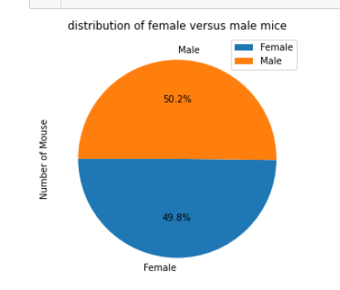

1. based on below box plot we can see that mouse treated with capomulin have least spread of tumor volume(lowest IQR).

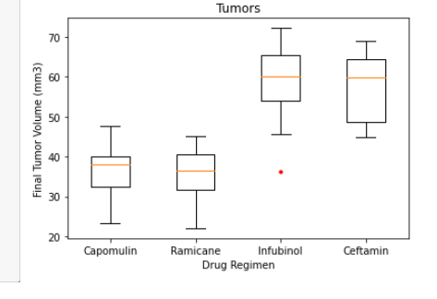

1. correlation between mouse weight and tumor volume 0.84 which means higher the mouse weight most likely higher the tumor volume. We can also see that from the below regression line.

