# PRACTICAL 5 b

Import the cube in Microsoft Excel and create the Pivot table and Pivot Chart to perform data analysis.

Step 1: Open Excel 2013 (Professional) Go to Data tab → Get External Data → From

Other Sources → From Analysis Services

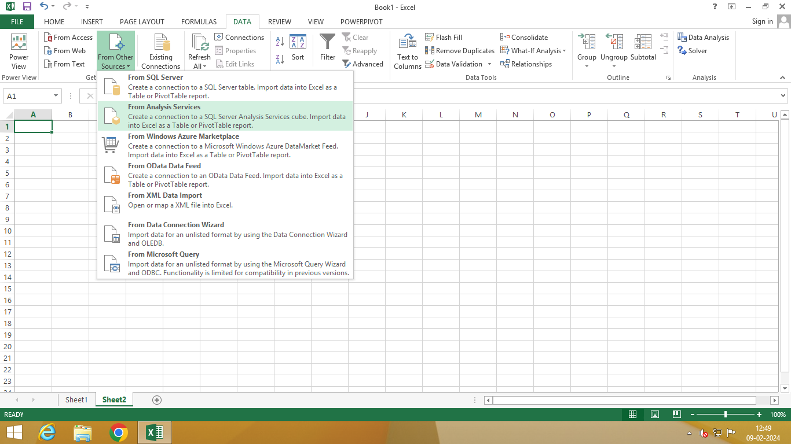

Step 2: Select Server name and Windows Authentication and click on Next

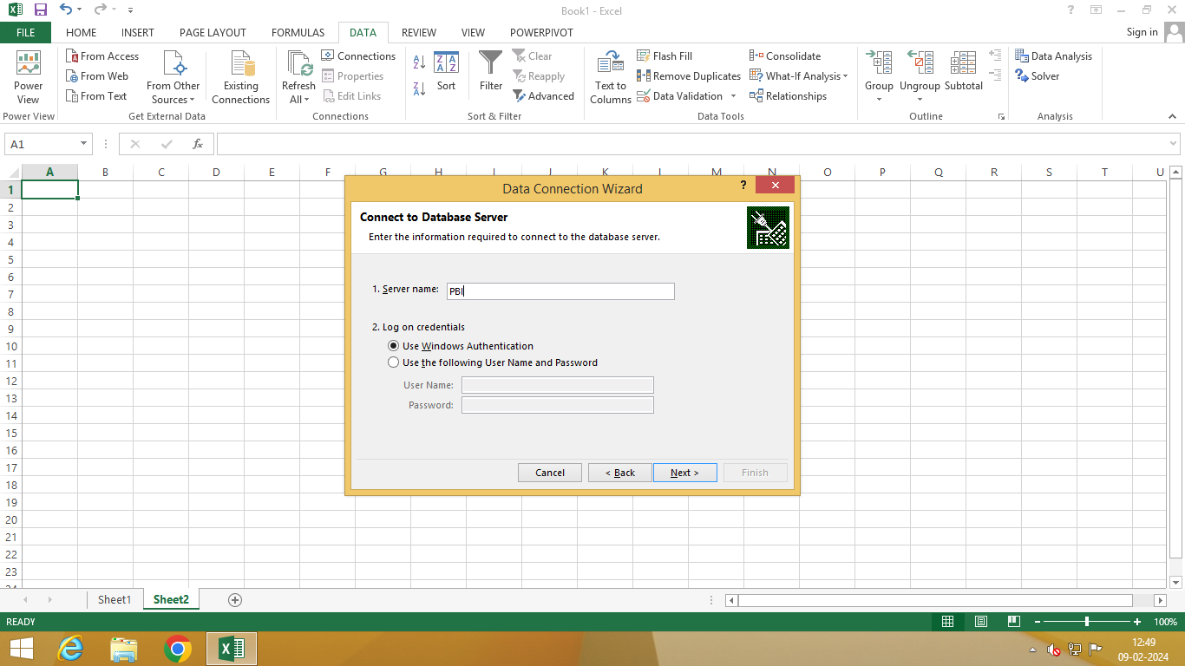

Step 4: Browse and select path name and click on Finish

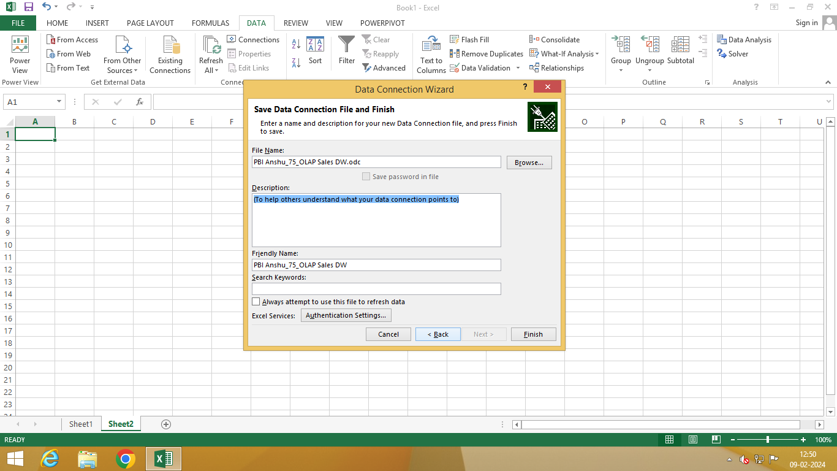

Step 5: Select PivotTableReport → OK

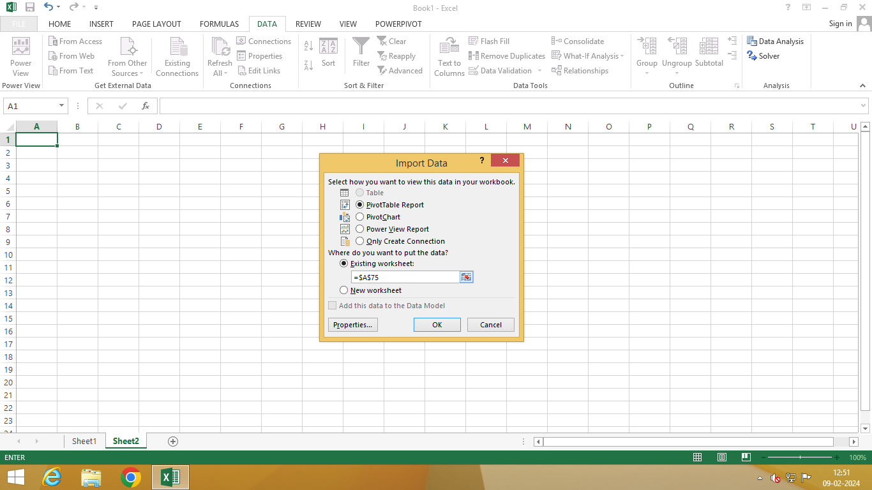

Step 6 : Drag and Drop Fields in rows column and values

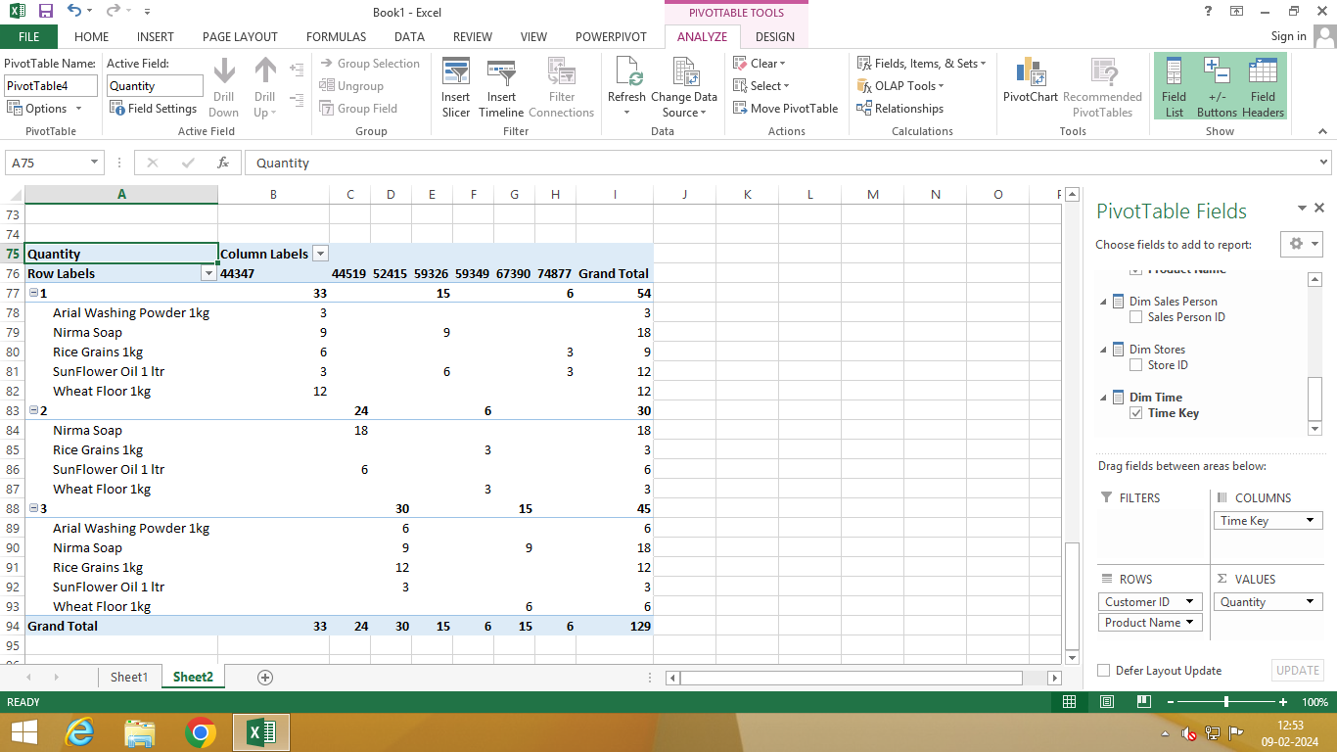

Step 7: Go to Insert tab → pivot chart and select Pivot Chart from drop down

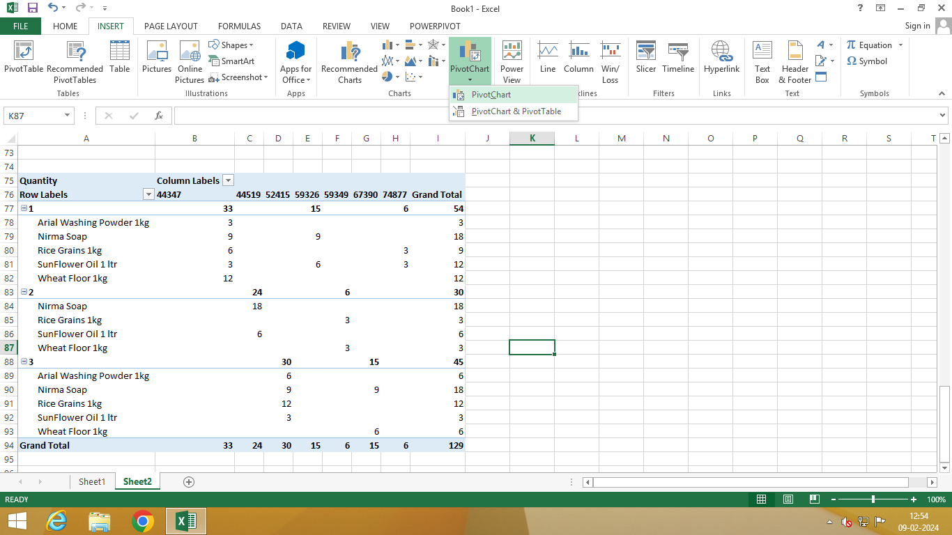

Step 8: Click on Choose connection to select path

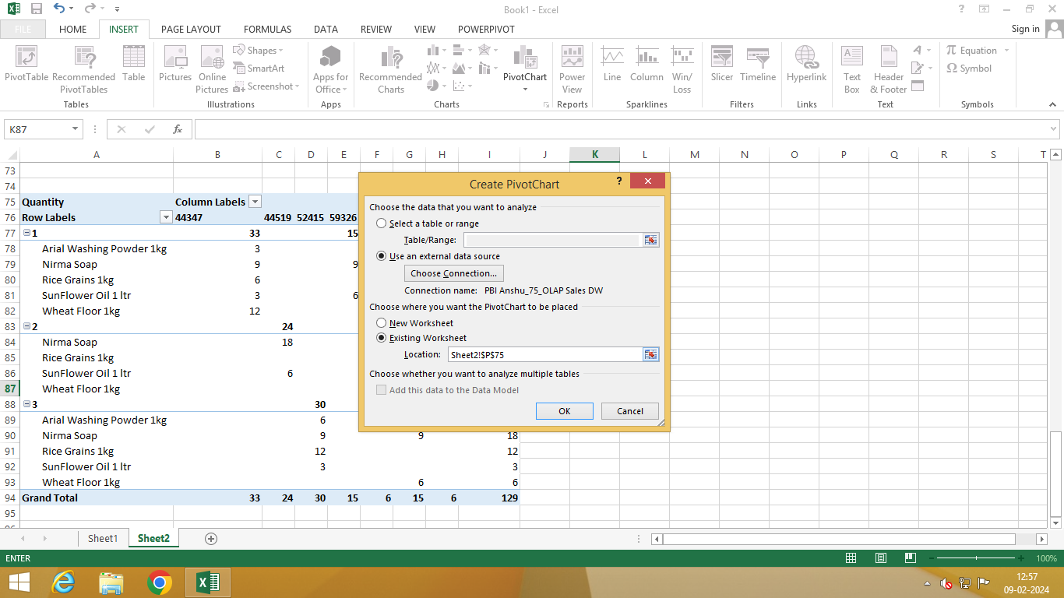

Step 9: Select existing connection OLAP Sales DW and click on Open

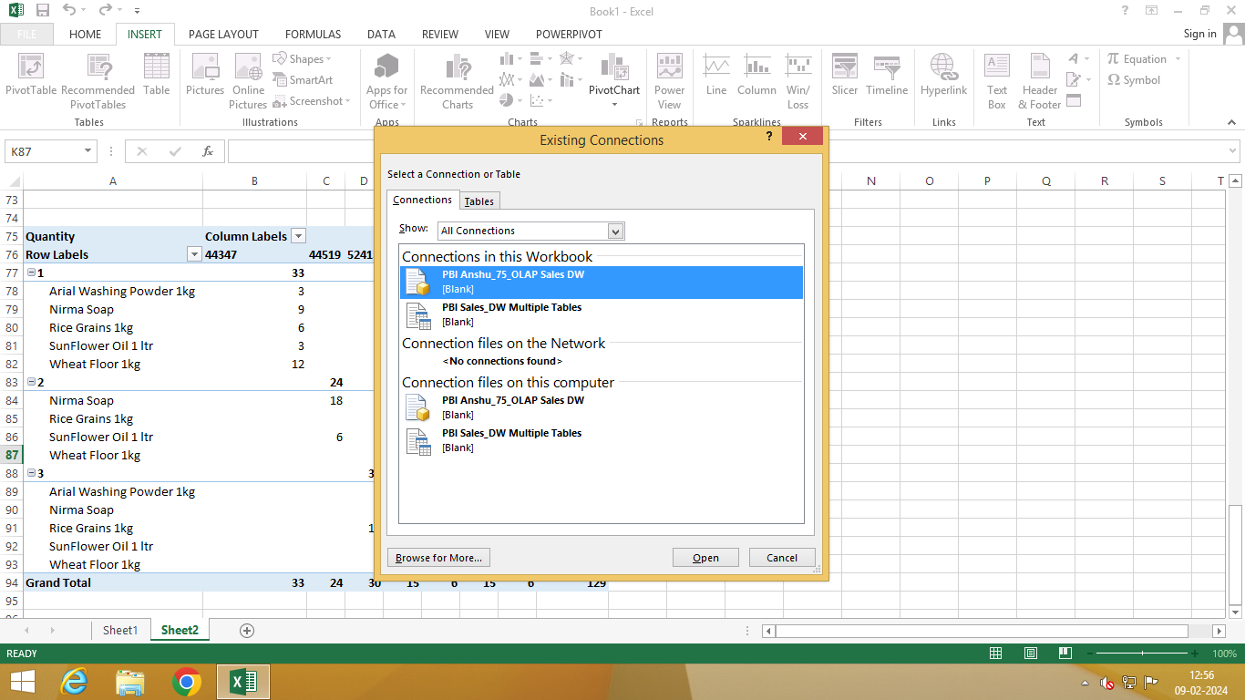



Step 10: Click on OK

