Layoff Risk Analysis Summary

Business Questions:

1. How many employees are available in the dataset?

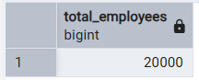
Result: The dataset contains 20,000 employees.

2. How many employees belong to each industry?

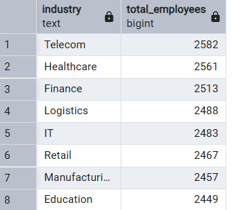
Result: The IT industry has the highest number of employees, followed by Healthcare and Manufacturing.

3. Which company size employs the highest number of employees?

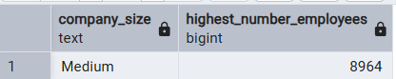
Result: Medium-sized companies employ the highest number of employees, with a total of 8,964 employees.

4. What is the distribution of employees across different job levels?

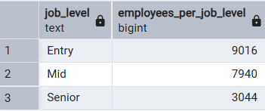
Result: Entry-level employees have the highest representation in the dataset, followed by Mid-level and Senior-level employees.

5. How many employees belong to each education level?

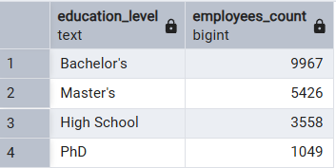
Result: Bachelor's degree holders have the highest representation in the dataset, followed by Master's, High School and PhD holders.

6. What percentage of employees fall into Low, Medium, and High layoff risk categories?

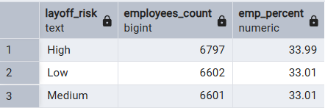
Result: High layoff risk has the highest share of employees, followed by Medium and Low layoff risk categories. But approx. all the percent share looks same there is no high difference in any one category of layoff risk.

7. Which industries have the highest average routine task percentage?

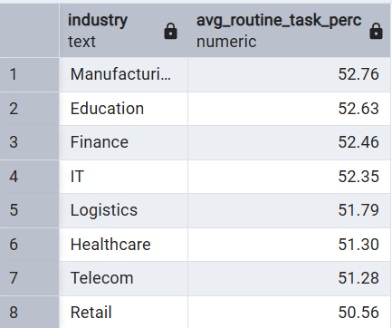
Result: Manufacturing has the highest average routine task percentage (52.76%), followed closely by Education (52.63%) and Finance (52.46%). Retail has the lowest average routine task percentage (50.56%) among all industries.

8. Which job roles have the highest average automation percentage?

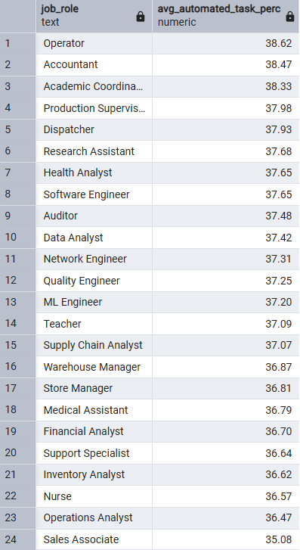
Result: Operators have the highest average task automation percentage (38.62%), followed by Accountants (38.47%) and Academic Coordinators (38.33%). Sales Associates have the lowest average task automation percentage (35.08%) among all job roles.

9. Which industries have the highest AI adoption level?

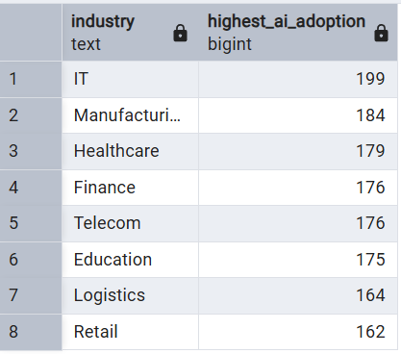
Result: The IT industry has the highest number of employees with a High AI adoption level (199), followed by Manufacturing (184) and Healthcare (179). Retail has the lowest number of employees with a High AI adoption level (162).

10. Which company size provides the highest average AI training hours?

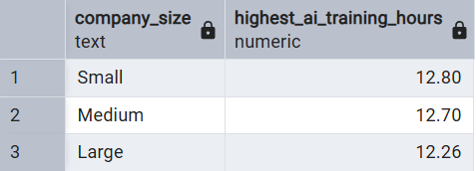
Result: Small companies provide the highest average AI training hours (12.80 hours), followed by Medium companies (12.70 hours), while Large companies have the lowest average AI training hours (12.26 hours).

11. Which job levels use the highest number of AI tools?

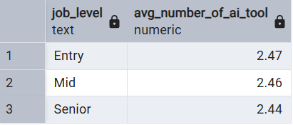
Result: Entry-level employees use the highest average number of AI tools (2.47), followed by Mid-level (2.46) and Senior-level employees (2.44).

12. Which industries have employees with the highest creativity requirements?

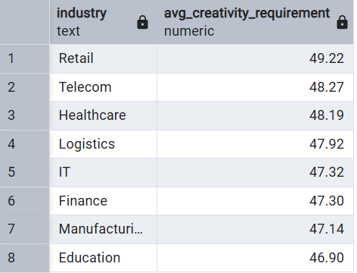
Result: The Retail industry has the highest average creativity requirement (49.22), followed by Telecom (48.27) and Healthcare (48.19). The Education industry has the lowest average creativity requirement (46.90).

13. Which industries are at the highest average layoff risk?

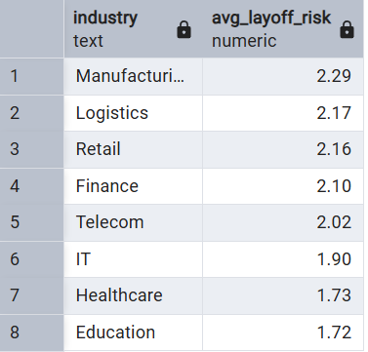
Result: Manufacturing has the highest average layoff risk score (2.29), followed by Logistics (2.17) and Retail (2.16). Education has the lowest average layoff risk score (1.72).

14. Which job roles have the highest proportion of High layoff risk employees?
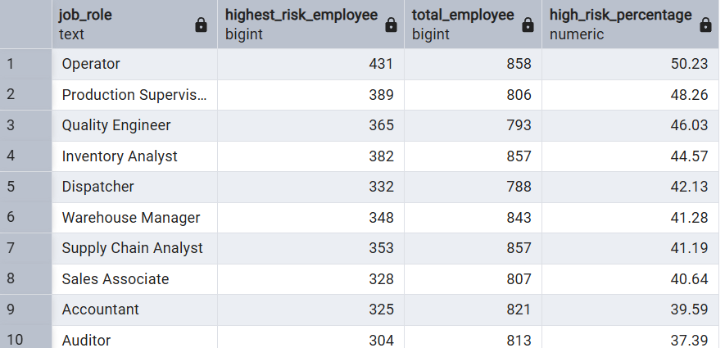
Result: Operators have the highest proportion of High layoff risk employees (50.23%), followed by Production Supervisors (48.26%) and Quality Engineers (46.03%).

15. Which company sizes have the highest percentage of High layoff risk employees?

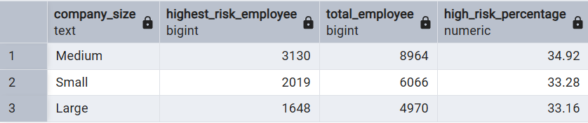
Result: Medium-sized companies have the highest percentage of High layoff risk employees (34.92%). However, the difference across company sizes is minimal, suggesting that company size has a limited impact on High layoff risk.

16. Which education levels are most associated with High layoff risk?

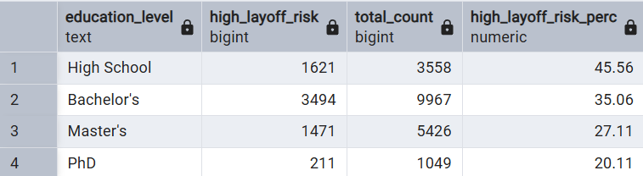
Result: Employees with a High School education have the highest proportion of High layoff risk (45.56%), while the percentage gradually decreases for Bachelor's (35.06%), Master's (27.11%), and PhD (20.11%). This suggests that higher education levels are associated with a lower proportion of High layoff risk.

17. Rank industries based on their Reskilling Priority Score by combining average layoff risk, task automation percentage, and AI training hours to identify which industries HR should prioritize for employee reskilling.

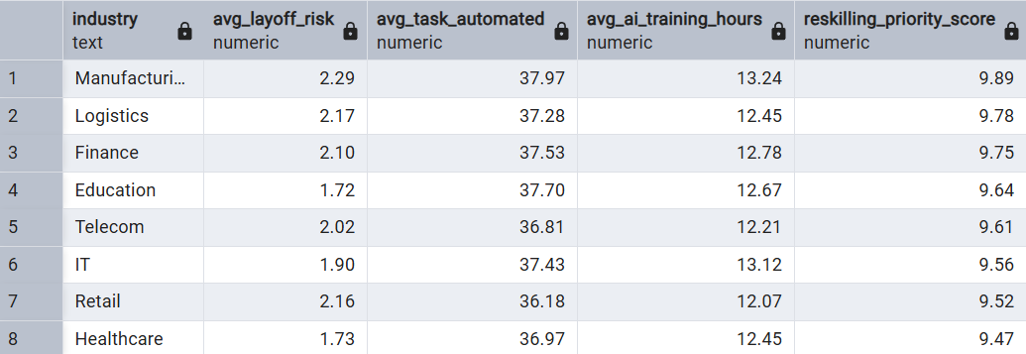
Result: Manufacturing ranks as the highest priority for employee reskilling due to its overall combination of higher layoff risk, greater task automation, and comparatively lower preparedness reflected in AI training. Logistics and Finance also show a high need for reskilling, whereas IT and Retail have relatively lower priority scores.

18. Rank the top 5 job roles with the highest average layoff risk score.

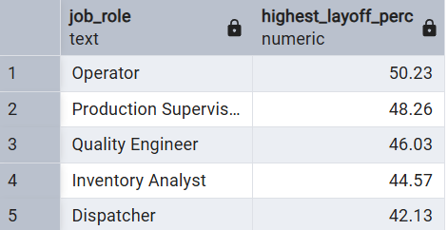
Result: Operators have the highest percentage of High layoff risk employees (50.23%), followed by Production Supervisors (48.26%), Quality Engineers (46.03%), Inventory Analysts (44.57%), and Dispatchers (42.13%). These job roles should be closely monitored as they represent the highest concentration of employees at High layoff risk.

19. Identify employees whose AI training hours are below the company average but whose layoff risk is High.

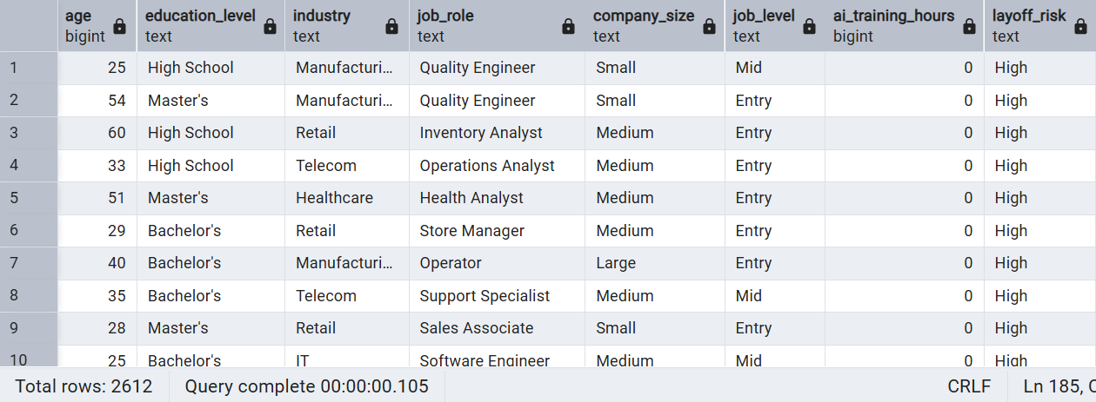
Result: The analysis identified 2,612 employees who are simultaneously at High layoff risk and have AI training hours below the company average. This group should be prioritized for targeted AI training and upskilling programs to improve workforce readiness and potentially reduce future layoff risk.

20. Create a workforce risk summary showing, for each industry:
- Total Employees
- Average Routine Task Percentage
- Average AI Adoption Level
- Average AI Training Hours
- Percentage of High Layoff Risk Employees

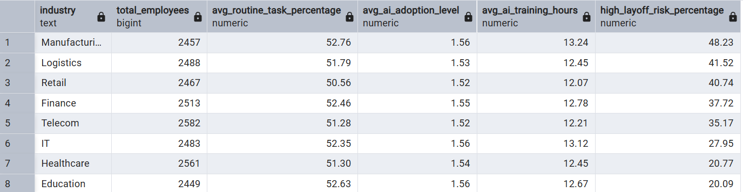
Result: The workforce risk summary shows that Manufacturing, Logistics, and Retail have the highest proportions of employees at High layoff risk, making them the industries that require the greatest workforce attention. Although AI adoption and AI training levels are relatively similar across industries, higher routine task percentages appear to be associated with higher layoff risk.

