Experiment15：ＭＡＸ7219

一、MAX7219chip pins

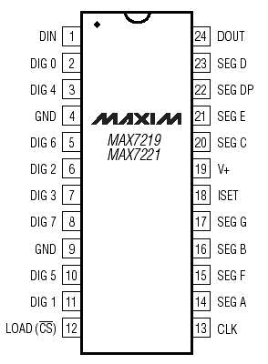

二、8*8Dot matrix pin

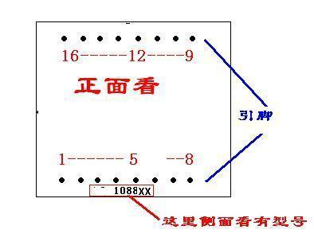

3.Arduino and 7219 chip wiring diagram 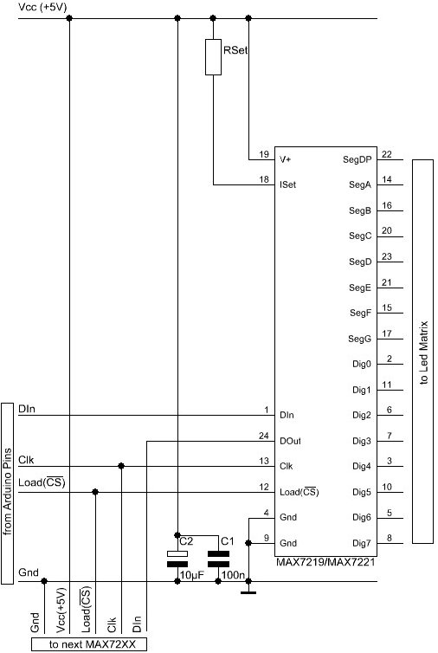

四、7219 chip and the connection of the dot matrix  
（1）Common cathode dot matrix connection diagram

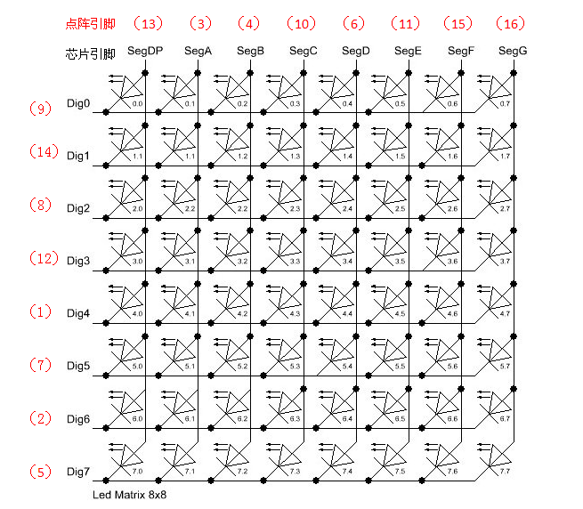

1. Common anode lattice connection  
   The pin of the chip, on the train。  
   Key: chip pin Seg should always be connected with the anode, pin Dig should always be connected to the cathode.  
   五、code
2. ARDUINO code

/*

Date: 2013-2-18

Function: MAX7219 driver 8*8 dot matrix

:YQ

Hardware: minimum system UNO

Description: the main reference to the official sample program*/

//官方的库

#include "LedControl.h"

/*

Now we need a LedControl to work with.

***** These pin numbers will probably not work with your hardware *****

The first parameter: pin 12 connected to the DataIn is

Second parameters: pin 11 connected to the CLK is

Third parameters: pin 10 connected to LOAD is

Fourth parameters: have only a single MAX72XX. We*/

LedControl lc=LedControl(12,11,10,1);

/* we always wait a bit between updates of the display */

**unsigned** **long** delaytime=100;

**unsigned** **long** delaytime1=2000;

**void** **setup**() {

  /*

   The MAX72XX is in power-saving mode on startup,

   we have to do a wakeup call

   */

  lc.shutdown(0,false);

  /* Set the brightness to a medium values */

  lc.setIntensity(0,8);

  /* and clear the display */

  lc.clearDisplay(0);

}

/*

This method will display the characters for the

word "Arduino" one after the other on the matrix.

(you need at least 5x7 leds to see the whole chars)

*/

**void** writeArduinoOnMatrix() {

  /* here is the data for the characters */

**byte** a[5]={B01111110,

                    B10001000,

                    B10001000,

                    B10001000,

                    B01111110};

**byte** r[5]={B00111110,

                    B00010000,

                    B00100000,

                    B00100000,

                    B00010000};

**byte** d[5]={B00011100,

                    B00100010,

                    B00100010,

                    B00010010,

                    B11111110};

**byte** u[5]={B00111100,

                    B00000010,

                    B00000010,

                    B00000100,

                    B00111110};

**byte** i[5]={B00000000,

                    B00100010,

                    B10111110,

                    B00000010,

                    B00000000};

**byte** n[5]={B00111110,

                    B00010000,

                    B00100000,

                    B00100000,

                    B00011110};

**byte** o[5]={B00011100,B00100010,B00100010,B00100010,B00011100};

  /* now display them one by one with a small delay */

  lc.setRow(0,0,a[0]);

  lc.setRow(0,1,a[1]);

  lc.setRow(0,2,a[2]);

  lc.setRow(0,3,a[3]);

  lc.setRow(0,4,a[4]);

**delay**(delaytime1);

  lc.setRow(0,0,r[0]);

  lc.setRow(0,1,r[1]);

  lc.setRow(0,2,r[2]);

  lc.setRow(0,3,r[3]);

  lc.setRow(0,4,r[4]);

**delay**(delaytime1);

  lc.setRow(0,0,d[0]);

  lc.setRow(0,1,d[1]);

  lc.setRow(0,2,d[2]);

  lc.setRow(0,3,d[3]);

  lc.setRow(0,4,d[4]);

**delay**(delaytime1);

  lc.setRow(0,0,u[0]);

  lc.setRow(0,1,u[1]);

  lc.setRow(0,2,u[2]);

  lc.setRow(0,3,u[3]);

  lc.setRow(0,4,u[4]);

**delay**(delaytime1);

  lc.setRow(0,0,i[0]);

  lc.setRow(0,1,i[1]);

  lc.setRow(0,2,i[2]);

  lc.setRow(0,3,i[3]);

  lc.setRow(0,4,i[4]);

**delay**(delaytime1);

  lc.setRow(0,0,n[0]);

  lc.setRow(0,1,n[1]);

  lc.setRow(0,2,n[2]);

  lc.setRow(0,3,n[3]);

  lc.setRow(0,4,n[4]);

**delay**(delaytime1);

  lc.setRow(0,0,o[0]);

  lc.setRow(0,1,o[1]);

  lc.setRow(0,2,o[2]);

  lc.setRow(0,3,o[3]);

  lc.setRow(0,4,o[4]);

**delay**(delaytime1);

  lc.setRow(0,0,0);

  lc.setRow(0,1,0);

  lc.setRow(0,2,0);

  lc.setRow(0,3,0);

  lc.setRow(0,4,0);

**delay**(delaytime1);

}

/*

  This function lights up a some Leds in a row.

The pattern will be repeated on every row.

The pattern will blink along with the row-number.

row number 4 (index==3) will blink 4 times etc.

*/

**void** rows() {

**for**(**int** row=0;row<8;row++)

  {

**delay**(delaytime);

    lc.setRow(0,row,B10100000);

**delay**(delaytime);

    lc.setRow(0,row,(**byte**)0);

**for**(**int** i=0;i<row;i++) {

**delay**(delaytime);

      lc.setRow(0,row,B10100000);

**delay**(delaytime);

      lc.setRow(0,row,(**byte**)0);

    }

  }

}

/*

  This function lights up a some Leds in a column.

The pattern will be repeated on every column.

The pattern will blink along with the column-number.

column number 4 (index==3) will blink 4 times etc.

*/

**void** columns() {

**for**(**int** col=0;col<8;col++) {

**delay**(delaytime);

    lc.setColumn(0,col,B10100000);

**delay**(delaytime);

    lc.setColumn(0,col,(**byte**)0);

**for**(**int** i=0;i<col;i++) {

**delay**(delaytime);

      lc.setColumn(0,col,B10100000);

**delay**(delaytime);

      lc.setColumn(0,col,(**byte**)0);

    }

  }

}

/*

This function will light up every Led on the matrix.

The led will blink along with the row-number.

row number 4 (index==3) will blink 4 times etc.

This function lights all LED on the dot matrix,

Each LED will blink the corresponding number of lines according to the number of rows.

For example: fourth lines of LED will flash four times*/

**void** single() {

**for**(**int** row=0;row<8;row++)

  {

**for**(**int** col=0;col<8;col++)

    {

**delay**(delaytime);

      lc.setLed(0,row,col,true);

**delay**(delaytime);

**for**(**int** i=0;i<col;i++)

      {

        lc.setLed(0,row,col,false);

**delay**(delaytime);

        lc.setLed(0,row,col,true);

**delay**(delaytime);

      }

    }

  }

}

**void** **loop**() {

  writeArduinoOnMatrix();

  rows();

  columns();

  single();

  lc.clearDisplay(0);

}