Bluetooth Messenger

Introduction

In recent years, the integration of wireless communication into embedded systems has significantly expanded the scope and capabilities of modern technology. One prominent wireless technology is Bluetooth, which offers a reliable and efficient means of data transmission over short distances.

This project involves developing a simple embedded system that utilizes a Bluetooth module for wireless communication. The goal is to create a basic yet functional prototype that demonstrates how Bluetooth can facilitate remote data exchange between devices. By integrating a Bluetooth module with a microcontroller, we can enable seamless and efficient communication over short distances, paving the way for various practical applications such as remote sensing, home automation, and wireless data transfer.

Overview

This project involves creating a simple embedded system using an HC-05 Bluetooth module, a VSD Squadron Mini microcontroller, and a 16x2 LCD display. The system receives messages via the Bluetooth module and VSD Squadron Mini processes the incoming data and updates the LCD in real-time. This project serves as an educational tool for understanding the basics of wireless communication and embedded system design, highlighting the ease of integrating different components to achieve a functional and practical solution.

Components Required

* HC05 Bluetooth module
* 16x2 LCD Module
* VSD Squadron Mini
* Jumper Cables
* Breadboard
* Mobile Phone (Message Transmission device)

Circuit Connection

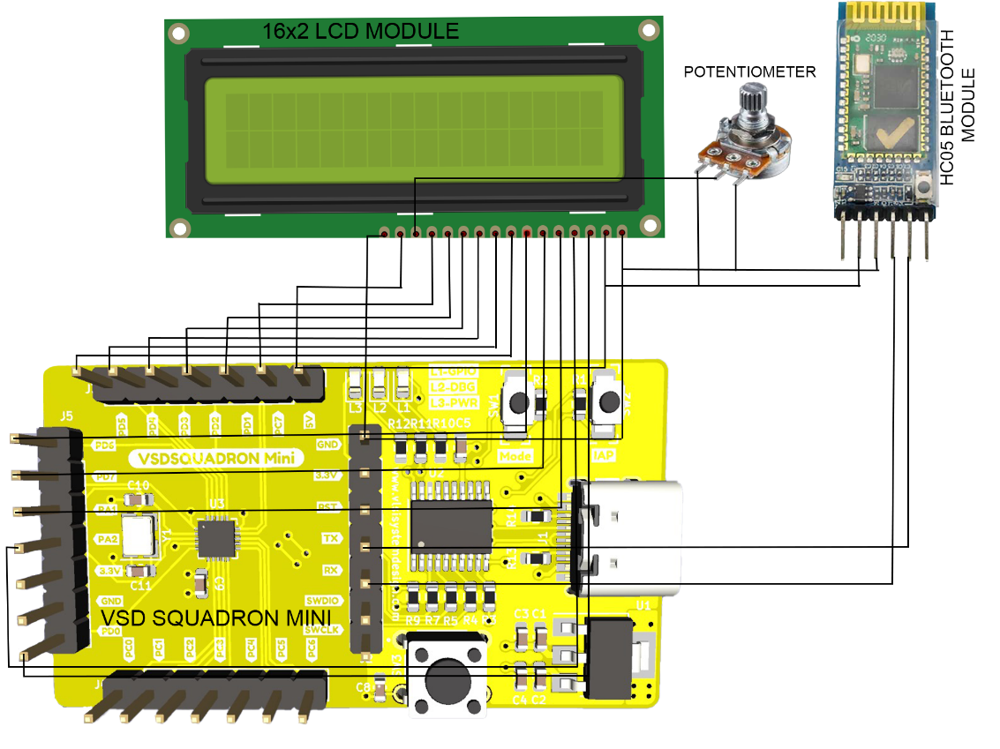

Pin Connection Table

LCD module pin table

|  |  |
| --- | --- |
| **VSD Squadron Mini** | **LCD Module** |
| VCC | 5V |
| GND | GND |
| PC7 | RS |
| PD1 | RW |
| PD2 | EN |
| PD3 | D0 |
| PD4 | D1 |
| PD5 | D2 |
| PD6 | D3 |
| PD7 | D4 |
| PA1 | D5 |
| PA2 | D6 |
| PD0 | D7 |
| VCC | Backlight(+) |
| GND | Backlight(-) |

Bluetooth pin table

|  |  |
| --- | --- |
| **VSD Squadron Mini** | **Bluetooth Module** |
| VCC | VCC |
| GND | GND |
| TXD | RXD |
| RXD | TXD |

Potentiometer connections

|  |  |
| --- | --- |
| **LCD** | **Potentiometer** |
| VCC | Terminal 1 |
| LCD Contrast | Terminal 2(Wiper) |
| GND | Terminal 3 |