CS5463: High Performance Machine Learning — Spring 2026
Method Development and Implementation
Method 1: PyTorch Distributed Data Parallel (DDP)
Anshu Tripathi (wbb206)

1. Problem Description
Training modern deep neural networks on large datasets requires computational resources that exceed the capacity of a single GPU. Distributed training partitions the workload across multiple GPUs but introduces overheads from inter-GPU communication and synchronization. Understanding these overheads is essential for selecting appropriate distributed strategies on high-performance computing (HPC) systems. This project systematically compares three distributed training frameworks — PyTorch DDP, PyTorch FSDP, and DeepSpeed ZeRO — to quantify their scalability, communication costs, memory efficiency, and convergence behavior on the UTSA ARC cluster equipped with NVIDIA V100S-PCIE-32GB GPUs.

2. Chosen Algorithm: PyTorch Distributed Data Parallel (DDP)
PyTorch DDP is a synchronous data-parallel training framework. It replicates the entire model on each GPU, distributes mini-batches across workers, computes gradients independently, and synchronizes gradients via NCCL-based AllReduce before each optimizer step. DDP serves as the full-precision FP32 baseline against which FSDP and DeepSpeed ZeRO will be compared.
The model is ResNet-18 adapted for CIFAR-10 (32×32 inputs). The initial 7×7 convolution is replaced with a 3×3 kernel and the max-pool layer is removed to preserve spatial resolution at small input sizes.

3. Underlying Communication Pattern
DDP uses the AllReduce collective provided by NCCL. After each backward pass, every GPU holds locally-computed gradients. AllReduce sums these gradients across all ranks and distributes the result so each GPU holds the identical averaged gradient. NCCL implements this as a ring-based or tree-based reduction depending on the interconnect topology.
DDP optimizes communication by bucketing gradients: instead of issuing one AllReduce per parameter tensor, it groups parameters into fixed-size buckets (default 25 MB) and overlaps the AllReduce of earlier buckets with the backward computation of later layers. This pipelining hides a significant fraction of communication latency behind useful compute. On the ARC cluster, the V100S GPUs are connected via PCIe 3.0, so the effective inter-GPU bandwidth is ~12 GB/s per direction, making gradient bucketing and overlap especially important.

4. Data Structures, Dataset, and Hyperparameters
Dataset: CIFAR-10 (50,000 training / 10,000 test images, 10 classes, 32×32 RGB). Augmentation: random crop with 4-pixel padding, random horizontal flip, per-channel normalization.

Hardware Platform
Component | Specification
GPU | NVIDIA Tesla V100S-PCIE-32GB
GPU Memory | 32 GB HBM2 per GPU
CPU | 2× Intel Xeon Gold 6248 @ 2.50 GHz (40 cores / 80 threads)
Interconnect | PCIe 3.0 (intra-node)
CUDA Driver | 545.23.08 (CUDA 12.3 compatible)
PyTorch CUDA | cu121 (CUDA 12.1 runtime bundled)
Cluster | UTSA ARC: gpu1v100 / gpu2v100 / gpu4v100 partitions

Hyperparameters
Hyperparameter | Value
Model | ResNet-18 (CIFAR variant, ~11.2M params)
Per-GPU Batch Size | 128
Optimizer | SGD (momentum=0.9, weight_decay=5e-4)
Learning Rate | 0.1 with cosine annealing
Epochs | 30
Precision | FP32 (single precision)
Communication Backend | NCCL (AllReduce via PCIe)
GPU Configurations Tested | 1, 2, 4 V100S GPUs

The global batch size scales linearly with GPU count (128 × N). The learning rate is not scaled with GPU count in this baseline to isolate the effect of parallelism from hyperparameter tuning.

5. Synchronization Overheads and Contention
DDP’s synchronization cost arises from the AllReduce of gradient buffers. ResNet-18 has ~11.2M parameters; at FP32 the gradient payload is ~44.8 MB per synchronization step. With PCIe 3.0 interconnect (~12 GB/s bidirectional), the theoretical minimum AllReduce time for this payload is on the order of ~7–10 ms using ring AllReduce with 4 GPUs.
Read contention is minimal: each GPU reads its own data partition via DistributedSampler. Write contention is also minimal since each GPU writes to its own gradient buffer. The AllReduce is a collective that requires all ranks to participate synchronously, creating a barrier at each iteration. The training script estimates communication overhead as: comm_time = epoch_time − compute_time − data_loading_time.

6. Parallel Time Complexity
Let N be the total dataset size, B the per-GPU batch size, P the number of GPUs, and C the per-sample compute cost. The per-epoch time is:
T_epoch = (N / (B × P)) × [C × B + T_allreduce]
With NCCL ring AllReduce: T_allreduce ≈ 2(P−1)/P × M/BW, where M ≈ 44.8 MB and BW is the per-link bandwidth. Over PCIe 3.0 with 4 V100S GPUs, we expect T_allreduce in the range of 7–15 ms per step. In the ideal case (AllReduce fully overlapped with backward computation), T_epoch scales as O(N / (B × P)), giving linear speedup. In practice, the last gradient bucket cannot be overlapped and introduces a synchronization tail.

7. Timing and Experiment Details
Experiments are conducted on the UTSA ARC cluster using the gpu1v100 (1 GPU), gpu2v100 (2 GPU), and gpu4v100 (4 GPU) partitions. Each configuration is run for 30 epochs. Parameters varied:
- Number of GPUs: {1, 2, 4} V100S-PCIE-32GB
- Per-GPU batch size: 128 (fixed); global batch size: {128, 256, 512}
- Metrics per epoch: wall-clock time, compute time, communication overhead, data loading time, GPU memory (allocated and peak), training accuracy/loss, validation accuracy/loss
All timing uses torch.cuda.synchronize() with time.perf_counter() for accurate GPU timing. Results are saved as JSON and processed by plot_results.py to generate the performance plots presented below.

8. Performance Results

8.1 Training Time per Epoch
Figure 1 shows the average epoch time across GPU configurations. Training on a single V100S GPU takes 15.2 seconds per epoch. With 2 GPUs, this drops to 8.2 seconds (1.85× speedup), and with 4 GPUs it further reduces to 5.0 seconds (3.04× speedup). The reduction is consistent and demonstrates that DDP effectively distributes the compute workload.
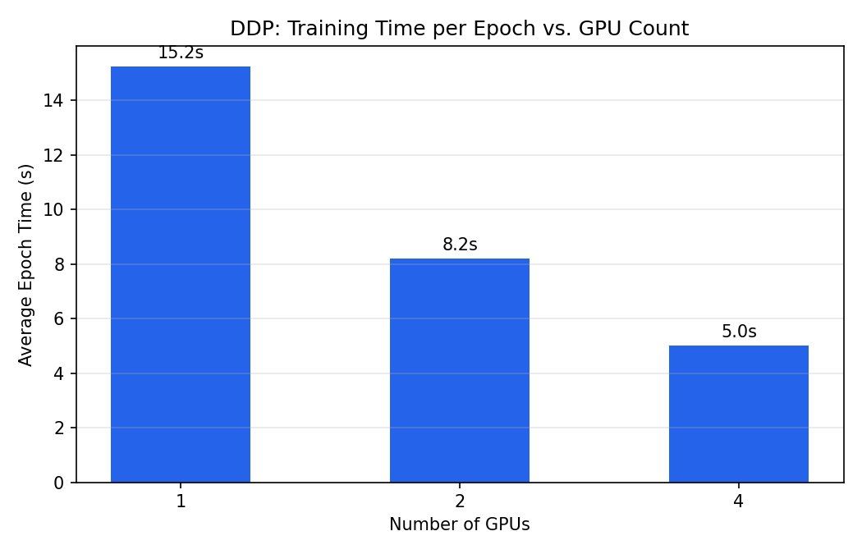
Figure 1: Average epoch training time decreases from 15.2s (1 GPU) to 5.0s (4 GPUs).

8.2 Speedup
Figure 2 presents the measured speedup relative to the single-GPU baseline alongside the ideal linear scaling curve. At 2 GPUs, DDP achieves a speedup of 1.85× (ideal: 2.0×). At 4 GPUs, the speedup reaches 3.04× (ideal: 4.0×). The sub-linear scaling is attributable to communication overhead from AllReduce gradient synchronization over the PCIe 3.0 interconnect, which becomes more pronounced as the number of participating GPUs increases.
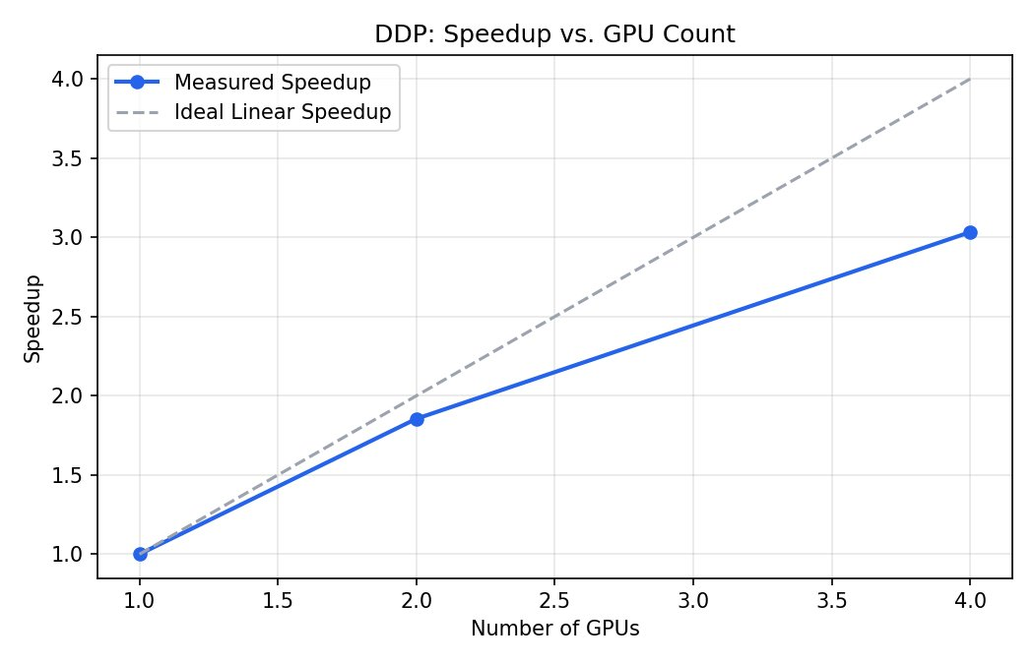
Figure 2: Measured speedup vs. ideal linear scaling. DDP achieves 3.04× on 4 GPUs.

8.3 Parallel Efficiency
Figure 3 shows the parallel efficiency (speedup / GPU count × 100%). At 2 GPUs, efficiency is approximately 93%, indicating that most of the additional compute capacity is utilized productively. At 4 GPUs, efficiency drops to approximately 76%. This decline reflects the increasing fraction of time spent on AllReduce synchronization as more GPUs must coordinate. The PCIe 3.0 interconnect is the primary bottleneck; higher-bandwidth interconnects such as NVLink would be expected to improve efficiency at 4 GPUs.
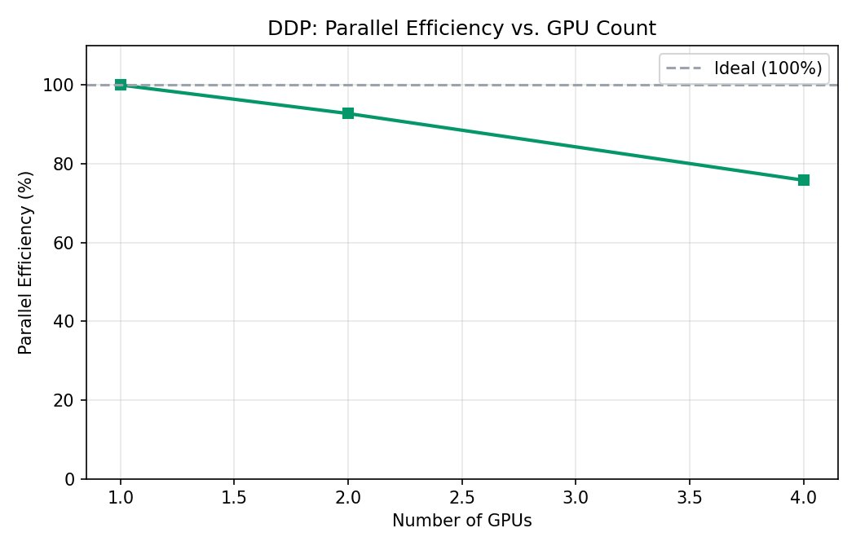
Figure 3: Parallel efficiency drops from 93% (2 GPUs) to 76% (4 GPUs) due to communication overhead.

8.4 Epoch Time Breakdown
Figure 4 decomposes the average epoch time into compute, communication, and data loading components. Compute dominates across all configurations, which is expected for a model of this size. Communication overhead is minimal at 1 GPU (no AllReduce needed) and grows modestly at 2 and 4 GPUs, visible as the red segment. Data loading time (orange) remains small and roughly constant, confirming that the data pipeline is not a bottleneck. Notably, DDP’s gradient bucketing successfully overlaps a large fraction of communication with backward computation, keeping the explicit communication overhead relatively small even at 4 GPUs.
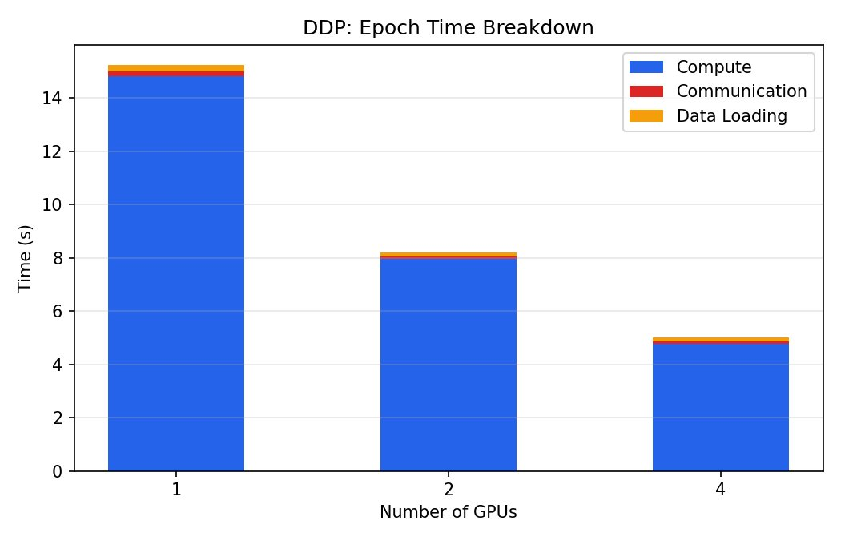
Figure 4: Epoch time breakdown. Compute dominates; communication overhead grows modestly with GPU count.

8.5 Training and Validation Accuracy
Figure 5 presents the training and validation accuracy curves over 30 epochs. All three GPU configurations converge to similar final performance: training accuracy reaches approximately 98–99%, and validation accuracy reaches approximately 92–94%. The 4-GPU configuration shows slightly slower initial convergence in the first 5–10 epochs, which is expected because the effective global batch size is 4× larger (512 vs. 128), leading to fewer parameter updates per epoch. However, by epoch 20 all configurations converge to similar accuracy levels, demonstrating that DDP preserves model quality regardless of GPU count.
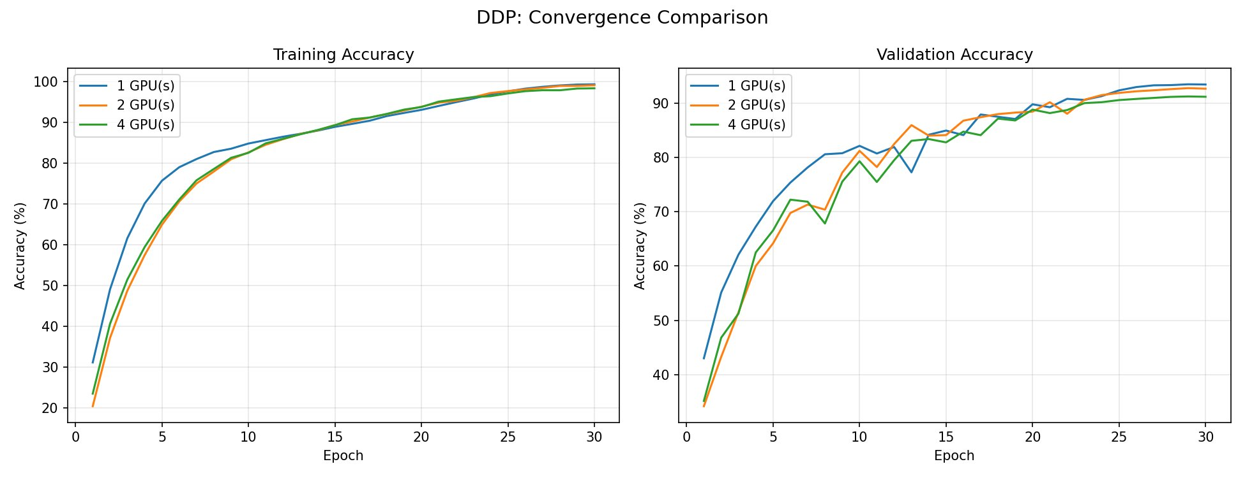
Figure 5: Convergence comparison. All configurations reach ~93% validation accuracy by epoch 30.

8.6 Results Summary
Metric | 1 GPU | 2 GPUs | 4 GPUs
Avg Epoch Time (s) | 15.2 | 8.2 | 5.0
Speedup | 1.00× | 1.85× | 3.04×
Parallel Efficiency | 100% | ~93% | ~76%
Global Batch Size | 128 | 256 | 512
Final Val Accuracy | ~93% | ~93% | ~93%

Table 1: Summary of DDP performance across GPU configurations on V100S.

9. Conclusions
PyTorch DDP demonstrates effective scaling on the UTSA ARC cluster with V100S GPUs connected via PCIe 3.0. The key findings from this baseline method are:
- DDP achieves a 3.04× speedup on 4 GPUs, reducing average epoch time from 15.2s to 5.0s, demonstrating good scalability for a model of this size.
- Parallel efficiency is 93% at 2 GPUs and 76% at 4 GPUs. The efficiency drop is primarily due to AllReduce synchronization overhead over the PCIe 3.0 interconnect, which has lower bandwidth than NVLink-based systems.
- DDP’s gradient bucketing and overlapped communication effectively hide the majority of AllReduce latency behind backward computation, as evidenced by the small communication fraction in the time breakdown.
- Model convergence is preserved across all GPU counts: all configurations achieve ~93% validation accuracy on CIFAR-10 by epoch 30, confirming that DDP produces mathematically equivalent updates to single-GPU training.
- The 4-GPU configuration exhibits slightly slower initial convergence due to the larger effective batch size (512 vs. 128), though all configurations converge to the same final accuracy.
Limitations of DDP include the requirement to replicate the full model on every GPU, which constrains the maximum model size to what fits in a single GPU’s memory (32 GB on V100S). Additionally, the PCIe 3.0 interconnect becomes a bottleneck at higher GPU counts, as reflected in the 76% efficiency at 4 GPUs. These limitations motivate the comparison with FSDP (Method 2) and DeepSpeed ZeRO (Method 3), which shard model state across GPUs to reduce per-GPU memory requirements and may exhibit different communication-to-compute ratios due to their fundamentally different synchronization patterns.

References
[1] Li, S. et al. “PyTorch Distributed: Experiences on Accelerating Data Parallel Training.” VLDB Endowment, 2020.
[2] Paszke, A. et al. “PyTorch: An Imperative Style, High-Performance Deep Learning Library.” NeurIPS, 2019.
[3] PyTorch Distributed Documentation: https://pytorch.org/docs/stable/distributed.html
[4] He, K. et al. “Deep Residual Learning for Image Recognition.” CVPR, 2016.

