* **ALL-114: COA – Forecast Screen [Header]**
* **ALL-1944: COA – Forecast Screen [Scope and Bookmarks]**
* **ALL-1945: COA – Forecast Screen [Refresh Dashboard]**
* **ALL-606: COA – Forecast [Allocation Section]**
* **ALL-607: COA – Forecast [Forecast Screen – Teu, Weight, Unit Columns]**
* **ALL-115: COA – Forecast [Edit TEU, Weight, Units]**
* **ALL-116: COA – Forecast [Edit Shortfall %]**
* **ALL-1785: COA – Forecast [Hyperlink to Booking List Pop-Up)**
* **ALL-1921: COA – Notification of COA changes into Agency Forecast Screen**

**Goal / User Story**

As a Booking Agent user,

*I want to* be able to input forecast values against a COA *so that* I can expose how my Booking Agency is performing against its target.

**User Journey**

* The user navigates to the Home page for Cargo Flow;
* The user clicks on the Forecast per Voyage Sub-section;
* The user is then transferred to the Forecast Screen;
* The user has filters pre-set for his user ID (as set under “My Scope of Services” sub-section of the Home page);
* The user can also filter through the columns’ filters;
* The user can view Target Allocation
* The user can input Forecast (Teu, Weight, Units, Shortfall %)

**Acceptance Criteria** forALL-114: COA – Forecast [Screen header]

1. As a user, I can see the service bounds filters applied as per the setting I have maintained in My Scope of Services.
2. As a user, I can see the Booking Country filter field with the Sales Office(s) for which I have the roles and authorizations.
3. As a user, I can select Booking Branch Office(s).
4. Once I have selected Booking Branch Office(s), I shall be able to save for that selection to persist for future navigations to the screen.
5. As a user, I can select a time range by dates.
6. By default, the time range is always set to current week and 5 consecutive weeks.

**Acceptance Criteria** forALL-1944: COA – Forecast [Scope and Bookmarks]

1. As a user, I can see drop downs for bookmarks – Bookmark and Bookmarks shared with me. Another option to create a new bookmark will also be available.
2. As a user, I shall not be able to proceed further until I have created or selected a bookmark.
3. I can set a bookmark as my favorite bookmark (only one) and the dashboard will open by default on the basis of this bookmark.
4. As a user, I can create a bookmark with the following criteria:

* Scope of services (service – bound)
* Booking Country(-ies)
* Booking Branch Office(s)
* Time Range

1. As a user, when I create a bookmark, the scope of services proposed is the one that I have defined in My Scope of Services.
2. As a user, I can enter a name for a Bookmark and save the bookmark under this name.

1. As a user, once I have saved the bookmark, I can find it in the Bookmarks drop-down menu
2. As a user, I can create 5 Bookmarks maximum
3. As a user, I can edit a bookmark, change some criteria (for instance the from-to dates) and save the changes to this existing bookmark.
4. As a user, I can share all my Bookmarks with other users (shared with users automatically that are associated with the selected branch offices) and the same should appear in the “Bookmarks shared with me” drop down of such users.

**Acceptance Criteria** forALL-1945: COA – Forecast [Refresh Dashboard]

1. As a user, I will open the forecast screen and trigger a refresh of data manually with the “Refresh Consumption” Button.
2. The refresh feature will scope the voyages (allocation and allocation values, flexibility, booking values, picked up values) for the scope defined by the user (including the time frame).
3. The refresh shall not reset the previous forecast values which shall persist until the user modifies them.

*Non-Functional Requirement*: the refresh shall be completed within 2 minutes maximum.

1. As a user, I shall see the Last Refresh dates and times.
2. *Non-Functional Requirement: All the data can be retrieved from the COA per Voyage inside the application.*

**Acceptance Criteria** forALL-606: COA – Forecast [Allocation Section]

1. As a user, I can visualize, as per the applied filter, the allocations assigned to my Booking Countries and Booking Branch Office.

If there is more than one Booking Country-Booking Branch Office allowed to the user, then there are as many Overall Total, Service-CVN-Vessel Total, and allocation details table (i.e., this level is like a parent level of all other levels into the table).

1. As a user, I can see a long leg tab and a short leg tab. The long leg tab is enabled by default. The logic is the same as developed for COA per Voyage or COA Template.
2. The allocations are displayed in a table with horizontal scrolling available to weeks and Commercial Voyages Numbers.
3. The week displayed in the one of the Schedule Week (at Berth) – First port of back-end CF CVN as determined in Cargo Flow Segmentation.
4. As a user, I can view the top part of the table called “Totals” and display the calculated totals (Voyage Target, Bookings, Forecast) of all voyages of a week.
5. As a user, I can view below the top part “Totals” a section displaying the services name corresponding to Commercial Voyage Number in focus.

The Vessel Name assigned to the commercial voyage number is also displayed.

1. With an expand and collapse feature, the user can expand the service section and display the allocation structure.
2. The display of the allocation structure is organized in the same way as the COA per voyage (except for the Booking Agency level which does not need to be repeated, it is already addressed with acceptance criteria #1).
3. The allocation structure displayed (in the left side of the forecast screen) is made of the level’s attributes of Target Allocation defined in COA per Voyage for the corresponding CVN.

The system shall display each attribute in the left screen section.

Only levels that strictly identical shall be consolidated in the allocation hierarchy structure of the forecast screen, as per below examples:

9.a) “*Carrier”* Level

* Single CMA attribute is found 2 times, on voyage A and B
* CMA attribute is found grouped 1 time (grouped with ANL), on voyage C
* Single CNC attribute is found 2 times, on voyage A and C
* CNC attribute is found grouped 1 time (grouped with ANL), on voyage B
* ALL OTHERS attribute is found 3 time, on voyage A, B and C
* So in the forecast allocation structure, there will be 5 distinct Carrier attribute per below example:

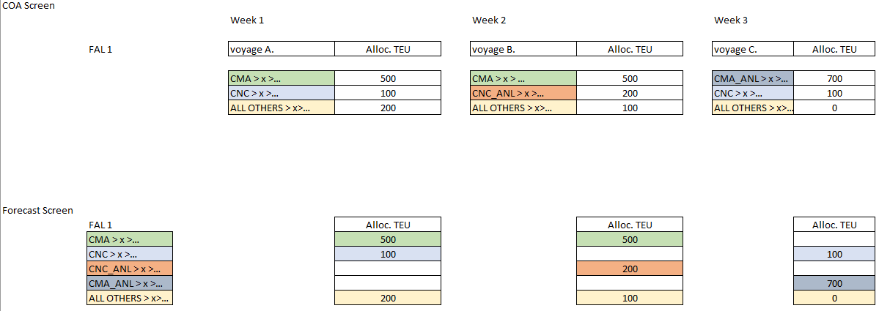

9.b) “*Sub-Trade+haul*” Level

* Single ASIA-NE MAIN PORT H.H attribute is found 2 times, on voyage B and C
* ASIA-NE MAIN PORT H.H attribute is found grouped 1 time (grouped with ASIA-NE BALTIC SCANDI H.H.), on voyage A
* Single ASIA-NE BALTIC SCANDI H.H. attribute is found 1 time, on voyage C
* ALL OTHERS attribute is found 3 time, on voyage A, B and C
* So in the forecast allocation structure, there will be 4 distinct Sub-Trade+Haul attribute per below example:

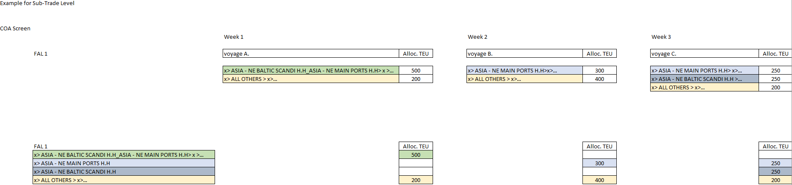

9.c) “*POL*” level

* Single POL A attribute is found 2 times, on voyage A and B
* POL A attribute is found grouped 1 time (grouped with POL C), on voyage C
* Single POL B attribute is found 1 time, on voyage A
* POL B attribute is found grouped 1 time (grouped with POL C), on voyage B
* ALL OTHERS attribute is found 3 time, on voyage A, B and C
* So in the forecast allocation structure, there will be 5 distinct Sub-Trade+Haul attribute per below example:

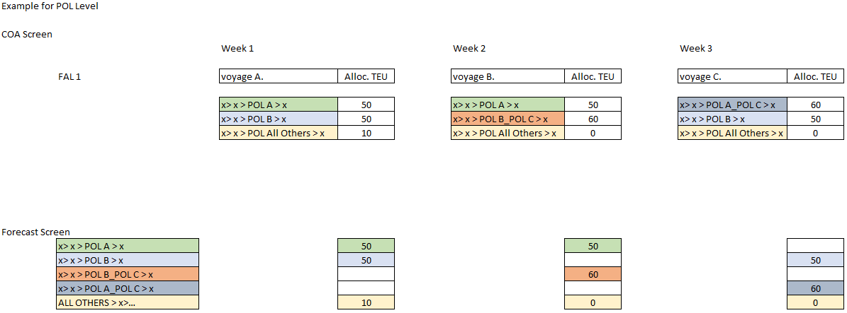

9.d) “*Cargo Type*” level

* Single Cargo Type All Other attribute is found 3 times, on voyage A, B and C
* Single Cargo Type Reefer attribute is found 2 times, on on voyage A and C
* So in the forecast allocation structure, there will be 2 distinct Cargo Type attribute per below example:

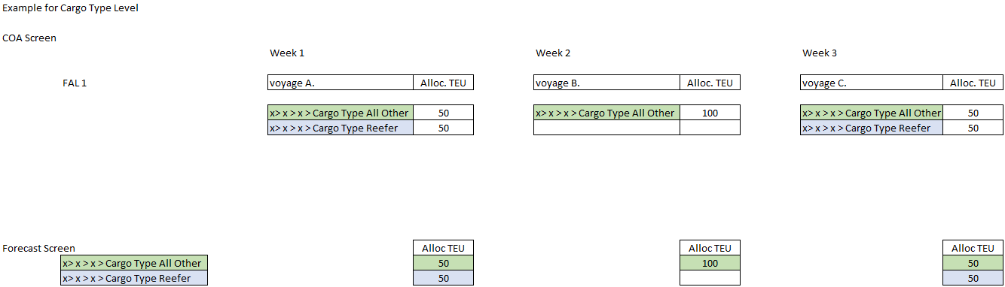

Note: due to cargo flow user choice in COA of voyage B, there could reefer including in Cargo Type All-Others. For simplication, the regular logic shall be followed and this cargo type will be mutualized with Cargo Type All-Others of voyage A and C, although these cannot include reefer because reefer is explicitly maintained for these voyages. It is the responsibility of the cargo flow user to align voyage B as required.

1. The system shall have a logic to retrieve and restrict the data display to the Booking Country-Booking Branch Office in top level:

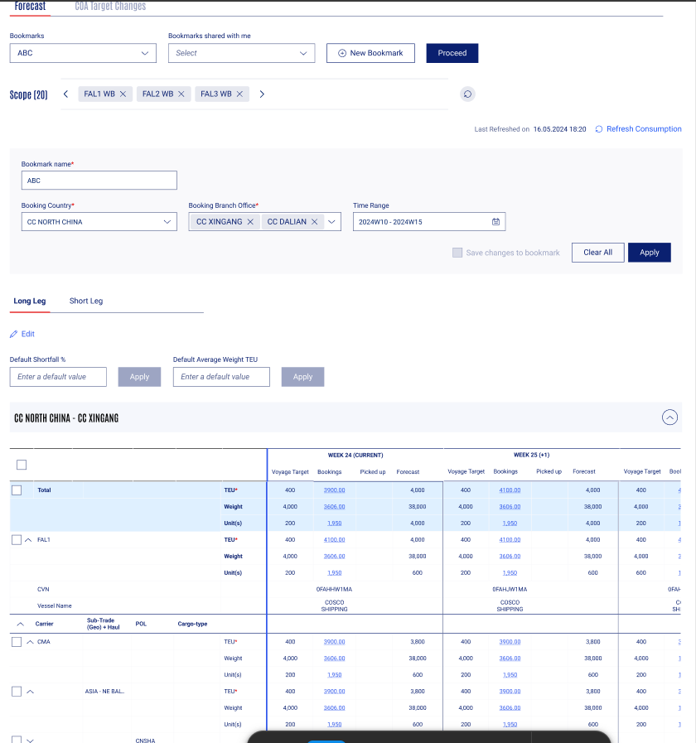

It shall consider this Booking Country-Branch Office (i.e. Booking Agency) and get from each COA per voyage the parent level of such agency, as well as the children levels, per below example:

* The Booking Agency in scope in the Forecast screen is CC CHINA-CC XINGANG
* On Voy A, CC XINGANG is found once, and the parent levels are CMA>TPEC HH>POL 1 with children level Cargo Type All other for 100 TEU allocated and Cargo Type Reefer for 50 TEU
* On Voy B, CC XINGANG is found twice, and the parent levels are:
  + CMA>TPEC HH>POL 1
  + CMA>TPEC HH>POL 2
* Therefore, in Forecast Allocation structure, POL 1 and POL 2 will appear distinctly per below:

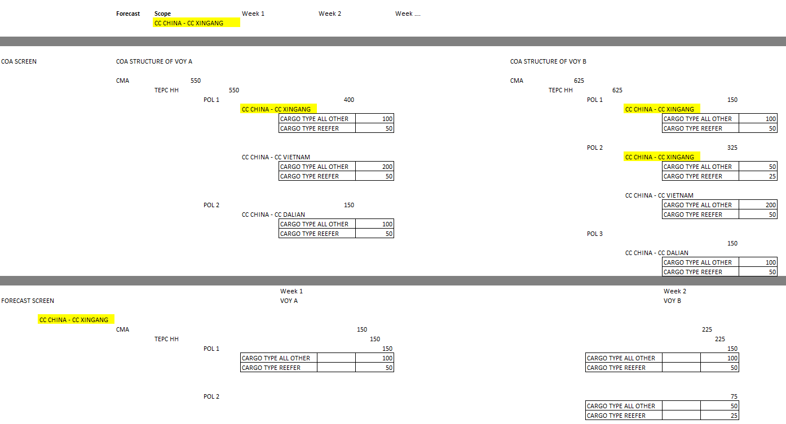

1. When for the same service, same week, there are more than one voyage then they should appear vertically consecutively.

For example week 24 there are two voyages scheduled for service ID FAL1 so a second block for FAL1 shall be visible

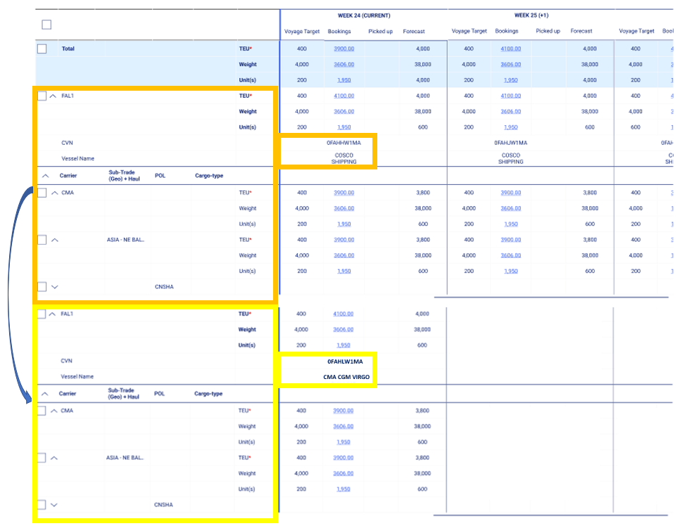

**Acceptance Criteria** for ALL-607: COA – **Forecast [Forecast Screen – Teu, Weight, Unit Columns]**

1. As a user, I can see a matrix table showing for each service / Week-CVN the below listed:
   1. Dimensions in Columns: Voyage Target (Standard Alloc), Bookings, Picked Up, Forecast
   2. Unit of Measures in Rows: TEU, Weight, unit(s)

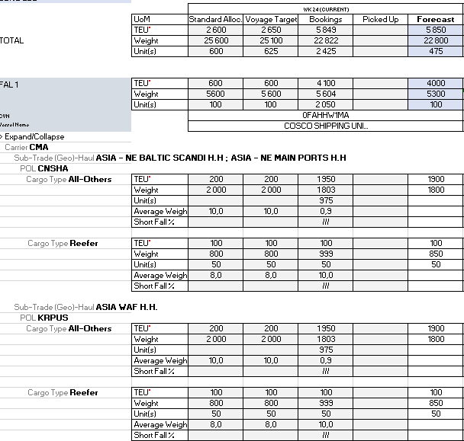

1. At Cargo Type level, one more row shall be available to the user to forecast the Short Fall %
2. The following logic shall apply to the column fields:
   1. Standard Alloc, Voyage Target, Bookings, Picked Up not editable fields and Forecast editable field only at Cargo Type level.
   2. Standard Alloc/Voyage Target, retrieved from COA at Voyage.
   3. Bookings retrieved from COA at Voyage.

When there is no booking consumption, the value 0 is displayed.

* 1. Picked Up: retrieved from Tracking System (LARA): Number of containers within the booked quantities, with a MOS tracking move code.

1. The following logic shall apply to the row fields:
   1. TEU, Weight, Units are displayed with the same integer or decimals rules than defined in COA.
   2. Average Weight is retrieved from COA and displayed with the integer rules than defined in COA.
   3. Shortfall % is blanked in all columns except Forecast where the field is editable
2. The logic to sum up the values to parent level is the same as described in COA Template, i.e. values are entered by user at cargo type level only, and the data is summed up to each parent level automatically.
3. Whenever the user is editing for Cargo Type Reefer, it is mandatory to add a value under units.

**Acceptance Criteria** forALL-115: COA – Forecast [Edit TEU, Weight, Units]

1. As a user, I can edit at cargo type level the values in:
   1. TEU (same as COA, decimals)
   2. Weight (same as COA, decimals)
   3. Units (same as COA, integer)
   4. Average Weight per Unit (same as, integer)
   5. Shortfall % (2 digits % - range 0% to 100%)
2. The user cannot enter any value if they have not entered a TEU value first.
3. As a user, I can set Average Weight per TEU at header level using default Avg Weight text box. This average weight per TEU will be pre-filled in Forecast.
4. The weight will be automatically calculated when a user enters a TEU value (as TEU x Average Weight)

The user can overwrite the calculated weight manually by entering a value.

1. **For Cargo Type reefer, the field “Unit” will be automatically calculated as TEU divided by 2.**

The user can overwrite the calculated unit value by entering a value.

If the user updates again later the TEU value, the calculation rule will be used again (TEU/2).

1. The forecast keyed by the user shall be stored at voyage level in the COA per Voyage back end table. Please refer to the ALL 1795 – COA Audit Trail.
2. Every time a dashboard is refreshed, the latest data stored in the COA per Voyage back-end table shall be displayed to the user. Refer ALL 1945 - Refresh Consumption.

**Acceptance Criteria** for ALL-116: COA – Forecast [Edit Shortfall %]

1. As a user, I can maintain a Forecast for Shortfall % at header level, as default, applying to all relevant allocation buckets (cargo type).
2. As a user, I can maintain a forecast for the shortfall % at individual allocation level (i.e. Cargo Type).

The field will be prefilled with the default Shortfall maintained at header level. The user can change the value at each forecast level, cargo type.

1. The forecast keyed by the user shall be stored at voyage level in the COA per Voyage back end table. Please refer to the ALL 1795 – COA Audit Trail.
2. The user can enter shortfall within the range of 0% to 100%.

**Acceptance Criteria** for ALL-1785: COA – Forecast [Hyperlink to Booking List Pop-Up]

1. As a user I can click on a hyperlink under each booking value in the forecast screen.
2. The booking list that will be displayed contains the below listed fields:

* Booking Number
* Quote Reference
* Booking Date
* Booking Conf. Date
* Booking Change Date
* Reserved
* Geo Trade & Haul
* CSA Rank
* ESR Y/N
* Service
* Cargo Type – Reefer, DG, OOG, BB, All Others
* Units
* TEU
* Weight
* Booking Agency
* Decidee / Customer Name – check where this info is being taken from
* Ultimate Owner – check with Lavanya
* POL
* POD
* FPD – Final Place in Delivery
* Picked Up TEUs
* Cargo Ranking Score

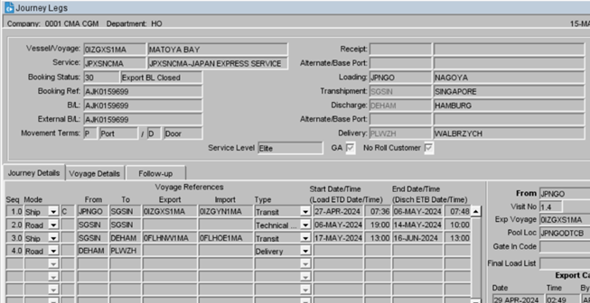

Examples and source application are described in US ALL-240 COA Screen at Voyage Level (Hyperlink for Booking TEU and pop-up window).

1. As a user, I can export the booking list I have opened (filtered download) in excel format.
2. If there is no booking, the hyperlink is available but the pop-up will display “No Booking is available”.

**Acceptance Criteria** for ALL-1921: COA – Notification of COA changes into Agency Forecast Screen

1. As a user, I shall be able to view in the screen a tab dedicated to COA Target Changes displaying the modifications of COA by the Cargo Flow user.
2. If a particular level is omitted, the agent is advised of the change by the value marked as Allocation Deleted.

Example:

The level CMA -> ASIA – NE BALTIC > CNSHA > Cargo Type Reefer is removed from the allocation hierarchy, then:

|  |  |  |  |  |  |  |  |  |  |  |  |  |  |  |  |  |  |
| --- | --- | --- | --- | --- | --- | --- | --- | --- | --- | --- | --- | --- | --- | --- | --- | --- | --- |
| Date and Times  Of COA  Change | Booking Country | Booking Branch Office | Service ID | CVN | Vessel Name | Carrier | Sub-Trade (Geo) + Haul | POL | Cargo Type | COA TEU Previous Value | COA TEU New Value | COA Weight Previous Value | COA Weight New Value | COA Unit Previous Value | COA Unit New Value | COA Flexibility Previous Value | COA Flexibility New Value |
| 19.07.2023 15:29 UTC | CC North China | CC Xingang | FAL1 | 0FAHHW1MA | COSCO Shipping | CMA | ASIA – NE BALTIC | CNSHA | Cargo Type Reefer | 200 | Allocation Deleted | 2000 | Allocation Deleted | 100 | Allocation Deleted | Open | Allocation Deleted |

1. This tab shall display the modifications of COA as they are executed in COA per Voyage by Cargo Flow.

The data displayed in this tab is as below:

|  |  |  |  |  |  |  |  |  |  |  |  |  |  |  |  |  |  |
| --- | --- | --- | --- | --- | --- | --- | --- | --- | --- | --- | --- | --- | --- | --- | --- | --- | --- |
| Date and Times  Of COA  Change | Booking Country | Booking Branch Office | Service ID | CVN | Vessel Name | Carrier | Sub-Trade (Geo) + Haul | POL | Cargo Type | COA TEU Previous Value | COA TEU New Value | COA Weight Previous Value | COA Weight New Value | COA Unit Previous Value | COA Unit New Value | COA Flexibility Previous Value | COA Flexibility New Value |
| 19.07.2023 15:29 UTC | CC North China | CC Xingang | FAL1 | 0FAHHW1MA | COSCO Shipping | CMA | ASIA – NE BALTIC | CNSHA | Cargo Type Reefer | 200 | 100 | 2000 | 1000 | 100 | 50 | Open | 80% |

1. The user shall be able to remove alert(s) from the list with a delete function.
2. Alerts shall expire and be removed automatically from the list after 8 days.
3. When an alert has expired, it should be consultable from an alert history table, which will not be relevant from email alert sign up in below acceptance criteria.

The records will be visible in the history table for 28 days, then the record will be deleted.

1. As a user, in my forecast dashboard, I should be able to view and click on the “Alert Sign Up” button.
2. As a user, once I click on the Alert Sign up button then a pop-up screen should appear titled

‘Email Alert Notification.’

1. As a user, I should be able to view a message inside the pop-up stating, ‘NOTE THAT YOU WILL ONLY RECEIVE ALERTS FOR YOUR DEFAULT FILTER’. (your default filter is your favorite bookmark).
2. As a user, I should be able to view a message inside the pop-up stating, ‘PLEASE SELECT TIME ’.
3. As a user, I should be able to use the toggle button called email alerts to switch on or switch off the alert’s notification. By default, the toggle button will be turned off.
4. As a user, I should be able to select the frequency of alert either once a day or twice a day using the frequency dropdown field.
5. As a user, I should view the frequency field populated as Once a day by default.
6. As a user, once the frequency is selected then the time at which the email needs to be received will be selected from the time email field.
7. As a user, the two time email fields should be available for my input. If I select frequency as once a day only one time email field will be enabled for input. If I select twice a day, then both the time email fields will be available for my input.
8. As a user, I should be able to exit creating email alert by using the cancel button.
9. As a user, I should be able to receive an email with the below fields as a part of my pending

bookings awaiting action:

|  |  |  |  |  |  |  |  |  |  |  |  |  |  |  |  |  |  |
| --- | --- | --- | --- | --- | --- | --- | --- | --- | --- | --- | --- | --- | --- | --- | --- | --- | --- |
| Date and Times  Of COA  Change | Booking Country | Booking Branch Office | Service ID | CVN | Vessel Name | Carrier | Sub-Trade (Geo) + Haul | POL | Cargo Type | COA TEU Previous Value | COA TEU New Value | COA Weight Previous Value | COA Weight New Value | COA Unit Previous Value | COA Unit New Value | COA Flexibility Previous Value | COA Flexibility New Value |
| 19.07.2023 15:29 UTC | CC North China | CC Xingang | FAL1 | 0FAHHW1MA | COSCO Shipping | CMA | ASIA – NE BALTIC | CNSHA | Cargo Type Reefer | 200 | 100 | 2000 | 1000 | 100 | 50 | Open | 80% |

The email object will contain the prefix “- COA Changes” then the “Bookmark name”.

Example: COA changes_My Forecast Bookmark

The email body contains a hyperlink. When the user clicks on it, user is taken to its forecast dashboard, on the notification tab.

**Mockup in Excel** [**here**](https://cmacgmgroup.sharepoint.com/:x:/r/sites/CMA-DataWays/Shared%20Documents/COA/02%20-%20Detailed%20User%20Stories/Forecast/Forecast%20Main%20Screen.xlsx?d=waf8ec11cbc44446d8f171f6bafcc6d0b&csf=1&web=1&e=ESoCMc)

Figma: <https://www.figma.com/design/xy8DT97bl6eT0aOZUqAnsY/DATAWAYS-COA?node-id=10550-147573&t=Uj7mHBKvvaTTUGcN-0>