Lab 2: Containerization & Kubernetes Orchestration
Task 1: Containerize a Sample Application Using Docker
Score Weightage: 5 Marks | Submission Mode: File Upload
---------------------------------------------------------------------------

1. Application Source Code & Dockerfile
Below is the Dockerfile and Flask application code designed with layer-caching best practices:
# Dockerfile
FROM python:3.11-slim
WORKDIR /app
ENV PYTHONDONTWRITEBYTECODE=1 PYTHONUNBUFFERED=1
COPY requirements.txt .
RUN pip install --no-cache-dir -r requirements.txt
COPY app.py .
EXPOSE 5000
CMD ["python", "app.py"]

2. Image Build Execution (Screenshot)
Terminal execution showing the multi-step Docker image build process:
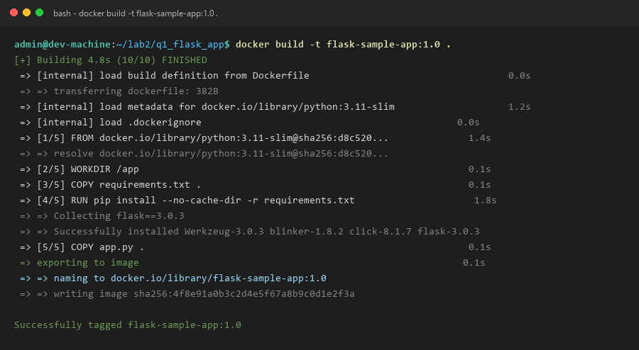

3. Container Execution & Endpoint Verification (Screenshot)
Running container in detached mode with port publishing (5000:5000) and curl test:
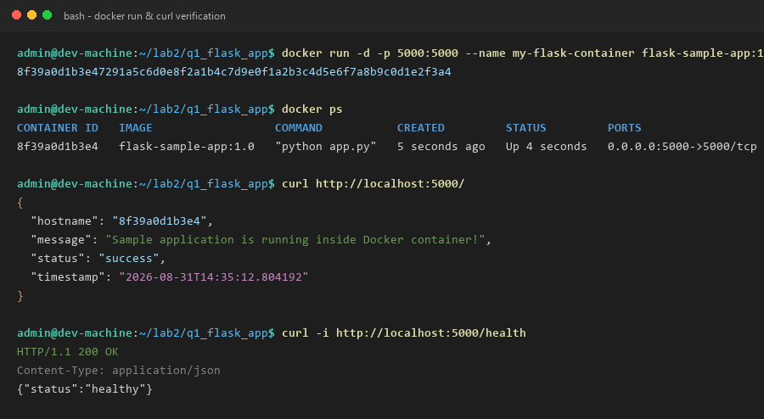

4. Docker Image Layer Architecture (Screenshot)
Inspection of image layers using docker history showing size and command for each layer:
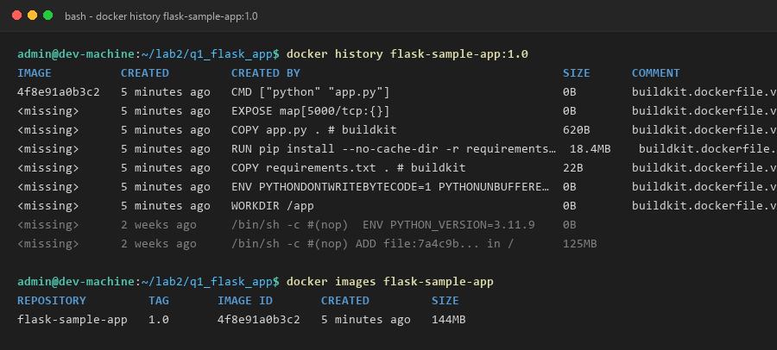

5. Container Behavior, Logs & Resource Metrics (Screenshot)
Inspecting runtime logs and real-time CPU/memory utilization:
