Lab 2: Containerization & Kubernetes Orchestration
Task 2: Manage Docker Containers, Images & Docker Compose
Score Weightage: 5 Marks | Submission Mode: File Upload
---------------------------------------------------------------------------

1. Container Lifecycle Management (Screenshot)
Demonstration of container inspection, stopping, starting, removing, and system disk cleanup:
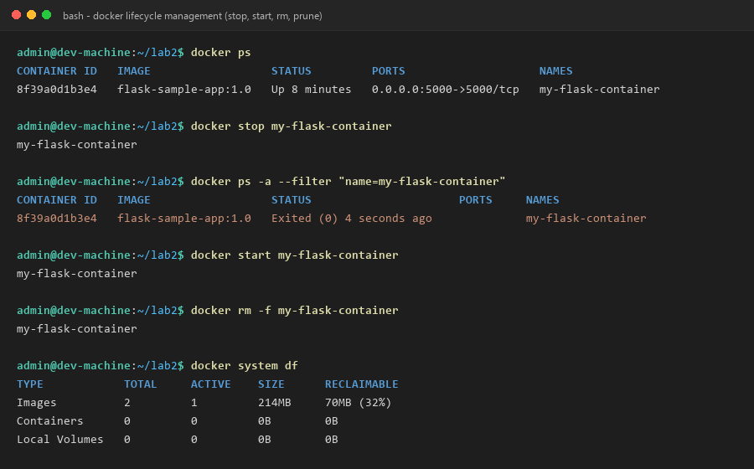

2. Image Tagging & Registry Push to Docker Hub (Screenshot)
Demonstration of logging in, tagging with version and latest tags, and pushing layers to registry:
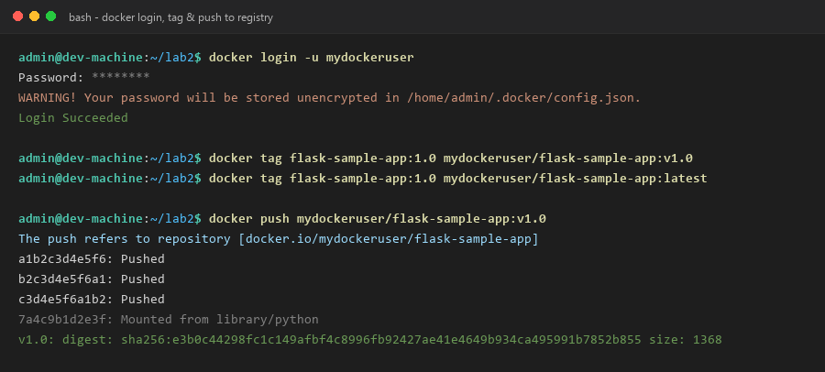

3. Multi-Container Orchestration with Docker Compose (Screenshot)
Starting multi-container stack (Flask Web Service + Redis Cache Database) via docker compose up:
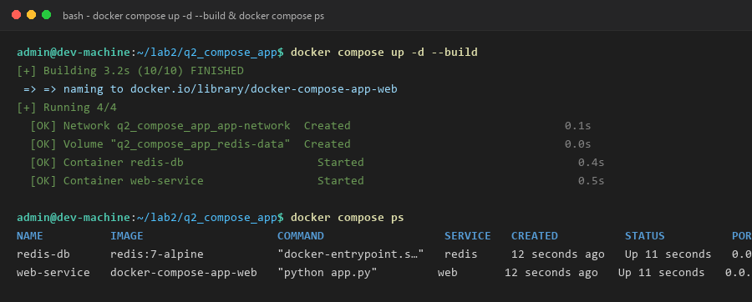

4. Multi-Service Communication & Volume Persistence (Screenshot)
Testing persistent session hit counts across services and tearing down the stack:
