Tasks

Learners have to develop a dashboard to support the answers to the following questions.

Objective Questions:

- What is the total no. of attributes present in the data?
Ans:
Ticket | 18
IT Agents | 10
Total | 28

- Which columns have inconsistent or missing values, and what is the count of such values?
Ans:
Approach:
- Used Remove Duplicates on ID Ticket and Agent ID (unique identifier)
- Provide Filter to all and checked for “Blanks”.
- Count of missing values = “0”
- Inconsistent values were found in Ticket sheet.
- Typo error was found:
  - Unclasified – Unclassified (Count – 356)
  - Mayor – Major (Count – 4836)

- What is the average daily ticket volume over time?
Ans:
Average Ticket Volume Over Time = 53.42

Approach:
- Use Pivot Table: Year → Rows, ID Ticket → Values → Count.
- Formula: Average Daily Tickets = Total Tickets in Year / 365
- Example: 2016 → 13051 / 365 ≈ 35.76

- Calculate Overall Average Daily Ticket Volume
- Formula: Overall Average Daily Volume = Average(C4:C8)

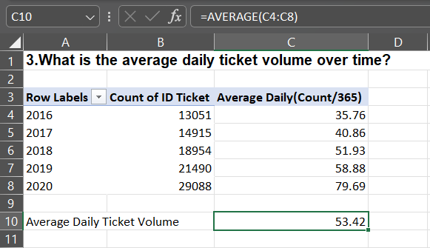

- What is the distribution of ticket categories (e.g., Login Access, System, Software)?
Ans:
System | 39002
Software | 19570
Hardware | 29193
Login Access | 9733

- How many tickets has each agent handled?
Ans:

Approach:
- Use the Agent ID column to group tickets.
- Count tickets handled per agent to get Count of ID Ticket.
- Pivot Table approach: Agent ID → Rows, ID Ticket → Values → Count.
- Create a line chart with Agent ID on X-axis and Count of ID Ticket or Average Daily Tickets on Y-axis.
- This highlights agents with higher or lower ticket volumes.

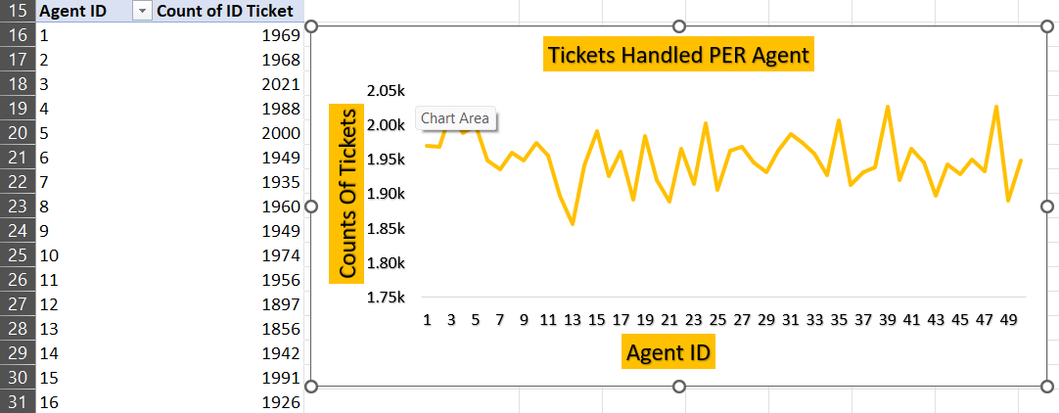

- How can you extract the domain from the email addresses in the IT Agents sheet?
Ans:
MID(C2,FIND("@",C2)+1,FIND(".com",C2)-FIND("@",C2)-1)

- How can you find the full name of an agent given their Agent ID?
Ans:
VLOOKUP ([@ [Agent ID]], IT_Agents[[Agent ID]:[Full Name]],2,0)

- What is the count of each issue type (e.g., IT Error, IT Request)?
Ans:
IT Error | 24278
IT Request | 73220

- What is the daily average resolution time for tickets?
Ans:
Daily average resolution time for tickets = 4.55
Approach:
Insert Pivot Table:
- Create a new Pivot Table from the dataset in a separate sheet.
- Place the Fecha field in Rows so each unique date is shown.

Calculate Daily Averages:
- Place Resolution Time (Days) in Values.
- Change Value Field Settings to Average.
- This computes the average resolution time for each date.

Summarize Across All Days:
- Since the dataset spans 2016–2020, Pivot generates 1,827 rows (one per day).
- To answer the question, compute the overall daily average resolution time by applying =AVERAGE() on these daily averages.

- How has the volume of tickets changed over time?
Ans:
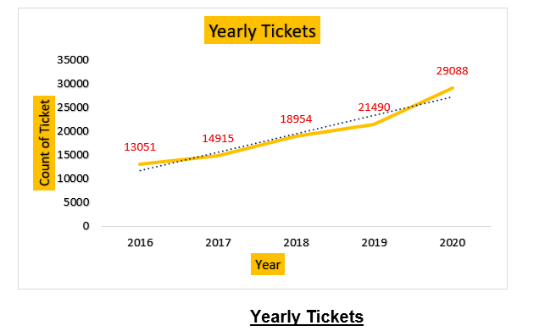

- What is the average age of the IT agents?
Ans:
Average age of agents = 40.08

- Is there a correlation between the severity of issues and the resolution time?
Ans:
Approach:
Identify Variables:
- Independent Variable: Severity Level (numeric:
  - 0 = Unclassified
  - 1 = Minor
  - 2 = Normal
  - 3 = Major
  - 4 = Urgent)
- Dependent Variable: Resolution Time (Days)
Prepare the Data:
- Ensure each ticket has a numeric severity level (0–4).
- Ensure Resolution Time values are numeric and clean (no blanks or errors).
Calculate Correlation:
- In Excel, use the CORREL function:
- =CORREL(SeverityLevelRange, ResolutionTimeRange)
- This calculates the Pearson correlation coefficient (r) between severity and resolution time.

Result:
- The correlation coefficient, r = -0.041, indicates a very weak negative relationship between severity level and resolution time.
Interpretation:
- This means that, in the dataset, higher severity issues do not consistently take longer to resolve.
- Resolution time appears to be largely independent of severity level.

- How many categorical columns are there in the data? [Search about categorical and continuous data, and try to answer this question]
Ans:
Categorical | 17
Continuous | 11

Subjective Question:

- If there is an investment, should it be used to hire more IT agents, improve training programs, or upgrade ticket management software?
Analysis: Perform a cost-benefit analysis using ticket resolution and satisfaction metrics.
Ans:
Approach:
- Used the pivot table created previously:
    - Rows: Agent ID
    - Values: Average Resolution Time and Average Satisfaction Rate
- Applied Conditional Formatting to highlight agents:
    - Avg Resolution Time > overall average
    - Avg Satisfaction < overall average
- Added an IF statement to flag agents for training:
    - IF(Avg_ResolutionTime > Overall_Avg AND Avg_Satisfaction < Overall_Avg, "Need Training", "Okay")

Ticket Workload Analysis:
- Average tickets handled per agent (5 years) ≈ 1,950
- Maximum tickets handled by a single agent = 2,027
- Minimum tickets handled by a single agent = 1,856
- Observation: Ticket load is fairly balanced among agents.

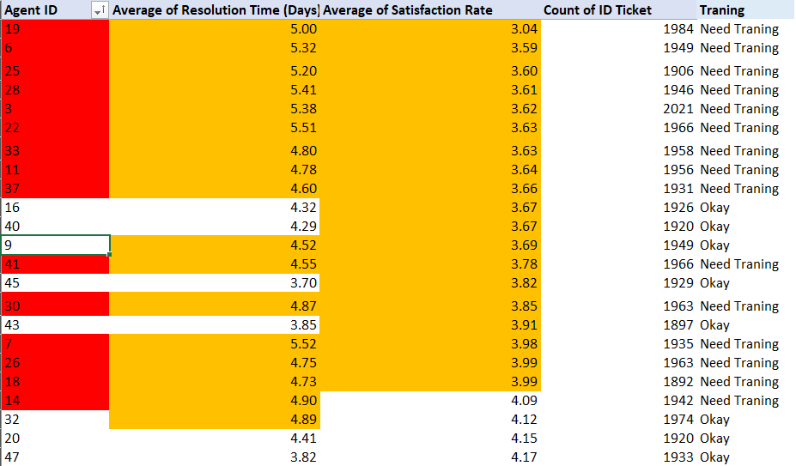

Agents That Need Training Based on Results

Insights:
- Agents flagged are those with slower resolution times and lower satisfaction scores.
- Performance differences are identifiable, allowing targeted training rather than training all agents.
- Ticket workload is not extreme, so overload is not a major issue.

Recommendations:
- Training Programs: Prioritize agents flagged in the analysis to improve resolution efficiency and customer satisfaction.
- Hiring More Agents: Currently, not immediately necessary given balanced ticket load.

Ticket Management Software Analysis

Approach:

Identify the Variables:
- Severity: Categorical (Unclassified → Urgent).
- Priority: Categorical (Low, Medium, High, Critical).

Create a Cross-Tab / Pivot Table
- Put Severity Class in Rows.
- Put Priority Class in Columns.
- Use Count of Tickets as Values.
- This creates a matrix showing how many tickets of each severity level are assigned to each priority level.

Analyze Alignment
- Check if high-severity tickets (3 = Major, 4 = Urgent) are being assigned to high-priority levels.
  - Look for mismatches:
  - High severity → Low/Medium priority → inefficiency.
  - Low severity → High priority → possible over-allocation.

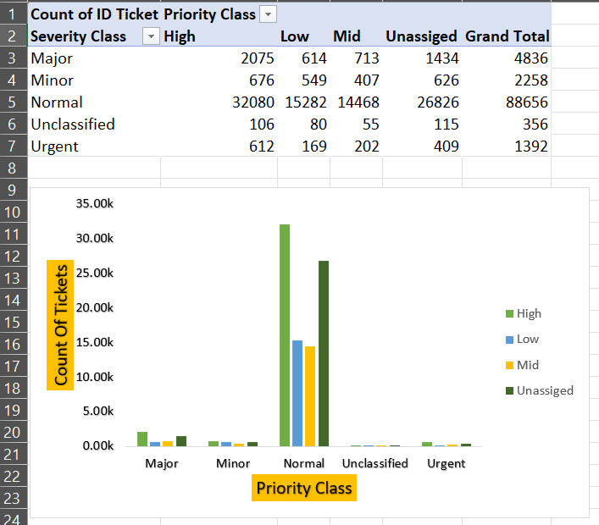

Insights:
Alignment Check:
- High severity (Major, Urgent) should ideally mostly be in High priority column.
- Here, you see:
  - Major: 2,075 out of 4,836 (~43%) are High priority → the rest are Mid, Low, or Unassigned → indicates misalignment.
  - Urgent: 612 out of 1,392 (~44%) are High priority → rest are not assigned correctly → inefficiency.
Impact:
- High-severity tickets being under-prioritized can cause:
  - Increased customer dissatisfaction
  - Delayed issue resolution
  - Inefficient resource allocation

Recommendation:

Review and Upgrade Ticket Management Software:
  - Ensure the system automatically maps high-severity tickets to high-priority levels.
  - Consider software that allows customizable rules or workflows for severity-to-priority mapping.
Implement Validation Rules:
  - Enforce checks so that no high-severity ticket remains unassigned or assigned a low priority.
Monitor and Audit Regularly:
  - Use regular reports (like the Severity vs Priority matrix) to track alignment.
  - Adjust rules and workflows as needed based on trends and exceptions.
Training for Agents (Optional):
  - Ensure agents understand how to classify and prioritize tickets correctly.

- Which agents need additional training based on their performance metrics?
Analysis: Identify agents with the lowest satisfaction ratings and longest resolution times.
Ans:
Approach:
- Used the pivot table created previously:
  - Rows: Agent ID
  - Values: Average Resolution Time , Average Satisfaction Rate and Count of Tickets
- Applied Conditional Formatting to highlight agents:
  - Avg Resolution Time > overall average
  - Avg Satisfaction < overall average
- Added an IF statement to flag agents for training:
- IF(Avg_ResolutionTime > Overall_Avg AND Avg_Satisfaction < Overall_Avg, "Need Training", "Okay")



Agents Marked Red with Low Performance

Insights:
Overall Performance Trends
- The dataset contains ~50 agents with varying performance metrics.
- Average Resolution Time ranges roughly from 3.60 to 5.55 days, indicating some agents take significantly longer to resolve tickets.
- Average Satisfaction Rate ranges from 3.04 to 4.60, showing variation in customer feedback.

Agents Needing Training
- Using the criteria Avg Resolution Time > overall average and Avg Satisfaction < overall average, the following agents were flagged:
  - Agent IDs: 3, 6,7, 11,18, 19, 22, 25, 26, 28, 30, 33, 37,41
- These agents have both high resolution times and lower satisfaction scores, indicating performance bottlenecks.

Patterns and Observations
- Several high-volume agents (e.g., handling ~1,900–2,000 tickets) are flagged for training — workload may be impacting performance.
- Some agents with very high resolution times (>5 days) still have moderate satisfaction rates (3.6–3.7), suggesting customers may tolerate delays for certain ticket types, but efficiency can still be improved.
- Most agents not flagged have either low resolution times or high satisfaction, showing effective handling.
Potential Risk Areas
- High-severity or urgent tickets handled by flagged agents could be delayed, impacting customer satisfaction.
- Agents with both high resolution and moderate satisfaction may indicate process inefficiency rather than skill gaps.

Recommendations:
Targeted Training for Flagged Agents
- Focus training on time management, ticket prioritization, and effective problem-solving.
- Examples: agents 3, 6, 7, 9, 11, 18, 19, 22, 25, 26, 28, 30, 33, 37.
Process Improvement
- Review ticket handling workflow to identify bottlenecks:
  - Ticket routing
  - Standard operating procedures
  - Knowledge base utilization
- Reducing unnecessary resolution time can increase both efficiency and satisfaction.
Mentorship / Peer Learning
- Pair underperforming agents with top performers to share best practices.
- Example: agents with low resolution times (<4 days) and high satisfaction (>4.4) can mentor flagged agents.
Monitor Workload Distribution
- Some agents handle close to 2,000 tickets — redistribute workload to avoid burnout and reduce resolution time.

Regular Performance Reviews
- Continue monitoring using Pivot Tables and conditional formatting.
- Quarterly or monthly reviews to track improvement after training interventions.
Software Support / Automation
- Consider tools for ticket prioritization, automated responses, or workflow optimization to help flagged agents improve.

- Do certain categories of requests have longer resolution times?
Analysis: Analyze the resolution times by request category.
Ans:

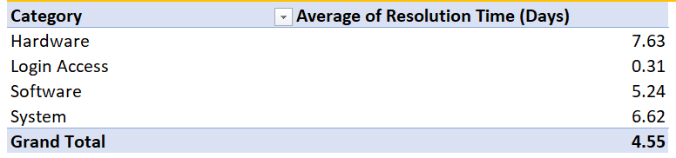

Approach:
- Created a pivot table with:
  - Rows: Request Category
  - Values: Average of Resolution Time (Days)
- This allowed comparison of resolution times across request categories.

Insights:
Overall Trends
- Average resolution time across all categories: 4.55 days.
- Category-wise breakdown:
  - Hardware: 7.63 days → longest resolution time
  - System: 6.62 days → second-longest
  - Software: 5.24 days → moderate
  - Login Access: 0.31 days → fastest resolution

Interpretation
- Hardware requests take significantly longer than the overall average (almost 3x), likely due to physical repair/replacement logistics or resource dependency.
- System requests also require longer resolution, possibly due to complex configuration or dependency on multiple teams.
- Software requests are moderately time-consuming, likely because they may require troubleshooting, updates, or coordination with IT teams.
- Login Access requests are resolved almost instantly, likely because they are simple and automated.

Patterns & Observations
- There is a clear variance in resolution times by request category, highlighting areas where processes or resources may be inefficient.
- Hardware and System tickets are bottlenecks affecting overall performance and customer satisfaction.
- Low-resolution categories (Login Access) show that automation or streamlined processes work well.

Recommendations:
Hardware Requests
- Investigate process delays (e.g., spare part availability, support scheduling).
- Consider dedicated hardware teams or faster procurement workflows.
- Implement tracking for high-resolution-time tickets to identify repeated delays.
System Requests
- Streamline multi-team coordination and define clear SLA (Service Level Agreement) timelines.
- Document common system issues in a knowledge base to reduce troubleshooting time.
Software Requests
- Identify repetitive issues and automate fixes or create self-service tools where possible.
- Provide training to agents on faster software troubleshooting.
Automation & Workflow Optimization
- Expand automated solutions for low-complexity requests (like Login Access) to other categories where possible.
- Use alerts or escalations for tickets exceeding average resolution thresholds.
Regular Monitoring & Reporting
- Track category-wise resolution times monthly to identify trends or regressions.
- Use dashboards to highlight slow categories and trigger process reviews.

- How effective are the current software tools in managing IT tickets?
Analysis: Evaluate performance metrics before and after the implementation of new tools.
Ans:
Approach:
Metrics Identification
- Resolution Time (Days): Continuous variable – measures efficiency of ticket resolution.
- Satisfaction Rate: Continuous variable – measures customer satisfaction.
- Severity & Priority: Categorical – evaluates alignment of ticket severity and assigned priority.
- Request Categories (optional): To identify bottlenecks in specific types of tickets.
Data Analysis Steps
Severity vs Priority Matrix
- Pivot Table:
  - Rows → Severity Class (Unclassified → Urgent)
  - Columns → Priority Class (Low, Mid, High, Unassigned)
  - Values → Count of Tickets
- Purpose: Identify misalignment in ticket handling (e.g., high-severity tickets assigned low or mid priority).

Year-wise Metrics Comparison
- Pivot Table:
- Rows → Year
- Values → Average Resolution Time & Average Satisfaction Rate
- Purpose: Compare performance metrics over time and assess impact of software changes.

Analysis of Misalignment & Inefficiencies
- Identify high-severity tickets (Major/Urgent) assigned to Low or Mid priority → indicates inefficiency.
- Identify low-severity tickets assigned to High priority → indicates over-allocation of resources.

Insights:
Severity vs Priority Alignment:



- High-severity tickets (Major/Urgent) are not fully prioritized; a substantial portion is assigned Mid, Low, or Unassigned priority.
- Low-severity tickets (Normal/Minor) are sometimes assigned High priority → potential misallocation of resources.
- Indicates partial inefficiency of the current software tools in enforcing SLA (Service Level Agreement) or priority rules.

Year-wise Performance (2016–2020):

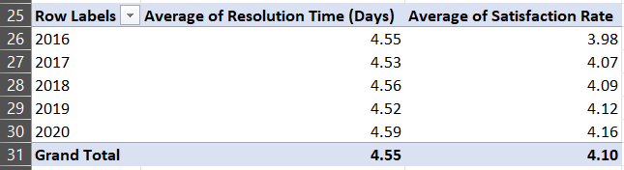

- Resolution time remains stable (~4.5 days), indicating minimal efficiency improvement over five years.
- Customer satisfaction shows gradual improvement (3.98 → 4.16), suggesting some benefit from tools or process changes.
- Despite stable resolution times, misalignment in severity-priority may still delay critical tickets, affecting service quality.

Recommendations:
Enhance SLA Compliance
- Configure software to automatically assign High priority to Major/Urgent tickets.
- Implement escalation rules if high-severity tickets exceed target resolution times.
Optimize Ticket Handling
- Review hardware, system, or other bottleneck categories for process improvements.
- Automate simple tickets (Login Access) and replicate automation for repetitive issues.
Agent Training & Support
- Target agents handling high volumes with high resolution times or low satisfaction for efficiency and prioritization training.
- Implement mentorship programs pairing high-performing agents with underperformers.
Process & Workflow Improvements
- Improve ticket routing, priority assignment, and task allocation within the software.
- Introduce dashboards to monitor severity-priority alignment, resolution times, and satisfaction metrics continuously.
Continuous Monitoring & Reporting
- Maintain yearly/quarterly dashboards to measure the impact of tool changes.
- Track misaligned tickets and bottleneck categories regularly to identify opportunities for improvement.

- How has the performance of the IT support team changed over time (e.g., monthly or quarterly)?
Analysis: Trend analysis using time series charts.
Ans:
Approach:
Metrics Identification
- Resolution Time (Days): Continuous variable – measures efficiency.
- Satisfaction Rate: Continuous variable – measures quality of support from end-users.
Data Preparation
Monthly Trend Analysis
- Pivot Table:
- Rows → Month Name (Jan → Dec)
- Values → Average Resolution Time, Average Satisfaction Rate
- Purpose: Identify seasonal or month-specific performance variations.
Quarterly Trend Analysis
- Pivot Table:
- Rows → Quarters (Q1 → Q4)
- Values → Average Resolution Time, Average Satisfaction Rate
- Purpose: Smooth monthly fluctuations and identify broader quarterly performance trends.

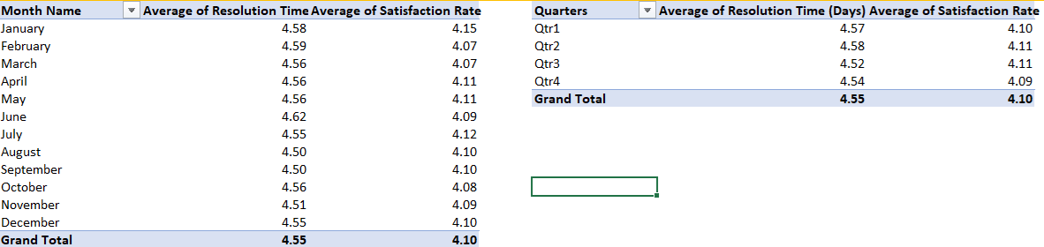

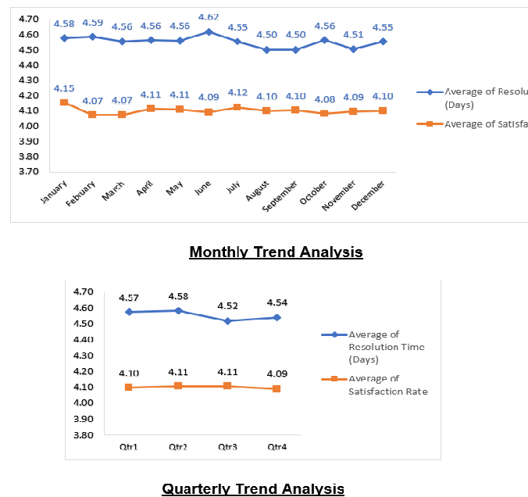

Insights:
Resolution Time:
- Slight variation across months (4.50 → 4.62 days), with highest in June (4.62) and lowest in August/September (4.50).
- Quarterly trend smooths monthly fluctuations: Q2 slightly higher (4.58), Q3 lower (4.52).
Satisfaction Rate:
- Fluctuates between 4.07 → 4.15.
- Slight dip in February (4.07) and March (4.07), correlating with slightly higher resolution times.
Pattern Recognition:
- Months with higher resolution times tend to have slightly lower satisfaction.
- Quarterly aggregation helps identify overall periods of efficiency improvement (Q3: lowest avg resolution, satisfaction slightly higher).

Overall Performance:
- Stable overall: Avg Resolution ~4.55 days, Avg Satisfaction ~4.10.
- Minor fluctuations indicate seasonal workload effects but no major performance degradation.

Recommendations:
Identify Peak Workload Months
- Focus on February, June, and early Q2, where resolution times spike and satisfaction dips.
- Analyze root causes: e.g., ticket volume spikes, staffing shortages, or critical projects.
Process Optimization
- Redistribute workload during high-volume periods to prevent delays.
- Consider temporary additional support or automated ticket routing in peak months.
Continuous Monitoring
- Maintain monthly and quarterly dashboards to track trends.
- Use dashboards for early detection of negative trends and corrective action.
Agent Training & Support
- If specific months show performance drops, train or rotate agents strategically.
- Use lessons learned from high-performance months (Q3) to replicate best practices.

- If we invest more on tech (Hardware, software, etc), do you think it will improve the ticket resolution times and employee satisfaction?
Analysis: Use historical data to project potential improvements.
Ans:
Approach:
Identify Metrics
- Count of Tickets: Measures workload per category.
- Average Resolution Time (Days): Measures efficiency.
- Average Satisfaction Rate: Measures end-user satisfaction.
- Request Category: Categorical variable to segment tickets.
Data Analysis Steps
- Create a Pivot Table:
  - Rows → Request Category
  - Values → Count of Tickets, Avg Resolution Time, Avg Satisfaction Rate
- Optional: Add conditional formatting or heatmap to highlight high resolution times and low satisfaction.
- Visualize with a clustered column chart or dual-axis chart:
  - X-axis → Request Category
  - Primary Y-axis → Avg Resolution Time / Satisfaction Rate
  - Secondary Y-axis → Count of Tickets
Historical Projection
- Use historical data to identify trends and predict potential improvement if efficiency measures are applied (e.g., reducing resolution times by 10–20%).

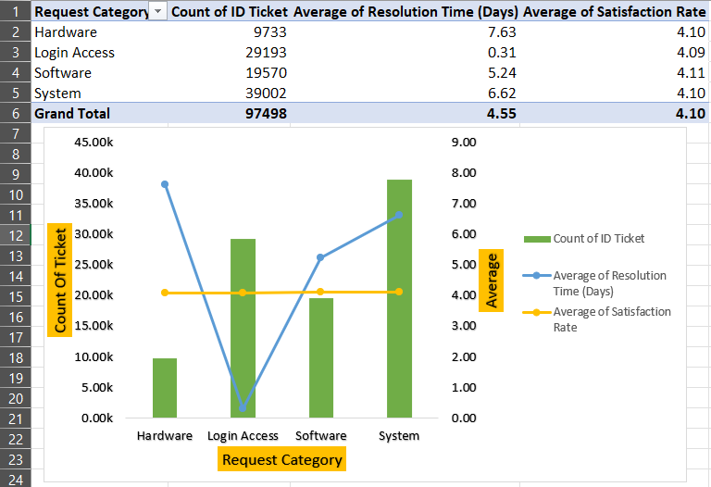

Insights:
- Hardware tickets: High resolution time (7.63 days) with moderate satisfaction (4.10) → major bottleneck.
- System tickets: Moderately high resolution time (6.62 days) with similar satisfaction → secondary bottleneck.
- Software tickets: Medium resolution time (5.24 days), good satisfaction (4.11) → manageable but can be optimized.
- Login Access tickets: Extremely fast resolution (0.31 days) with high satisfaction (4.09) → process is efficient and possibly automated.
Patterns:
- Categories with high ticket count and high resolution time have the greatest operational impact.
- Faster resolution correlates with slightly higher satisfaction, indicating efficiency directly influences end-user experience.

Recommendations:
Prioritize Bottleneck Categories
- Hardware & System: Assign specialized teams, optimize workflows, and track SLA compliance.
- Software: Standardize common procedures to reduce average resolution time.
Automation & Self-Service
- Replicate Login Access automation for repetitive tasks in Hardware/Software/System categories.
Resource Allocation
- Distribute workload according to ticket volume and resolution complexity to avoid bottlenecks.
- Consider temporary additional staffing during peak demand periods for Hardware/System tickets.
Monitor and Track KPIs
- Implement dashboards showing ticket count, resolution time, and satisfaction per category.
- Set up alerts for categories exceeding SLA thresholds.
Agent Training
- Train agents working on high-resolution-time categories to improve speed without compromising quality.
Project Improvements
- Using historical data, model potential improvements: e.g., reducing Hardware resolution time by 20% could improve satisfaction by ~0.2–0.3 points.

- What are the key performance metrics for IT agents, and how can they be improved, do we need to fire any agents?
Analysis: Define and analyze metrics such as average handling time, satisfaction scores, and number of tickets resolved.
Ans:
Approach:
- Analyzed average resolution time, average satisfaction, and number of tickets handled per agent using a pivot table:
  - Rows: Agent ID
  - Values: Avg Resolution Time, Avg Satisfaction Rate, Tickets Handled
- Identified agents performing above/below average on these metrics to understand distribution.



Insights:
- Average resolution time across agents: ~4.55 days
- Average satisfaction rate: ~4.10/5
- Average Tickets handled per agent over 5 years: ~1950, with a range of 1856–2027
- Most agents are performing consistently, with only minor variation in resolution time and satisfaction.
- Agents with higher resolution times and lower satisfaction were already highlighted in the training analysis.

Conclusion:
- Agent Performance: No direct evidence suggests firing any agents; overall performance is stable across resolution times, satisfaction rates, and ticket volumes.
- Monitoring Metrics: Continue tracking key metrics — average resolution time, satisfaction rate, and tickets handled — to quickly identify agents or processes needing support.
- Training Programs: Targeted training for agents with higher resolution times and lower satisfaction can help improve efficiency and customer experience.
- Technology & Tools: Investment in upgraded hardware, software tools, and automation systems could reduce resolution times, especially for complex request categories like Hardware (7.63 days) and System issues (6.62 days).

- How do employee demographics (e.g., department, seniority) impact satisfaction and ticket outcomes?
Analysis: Segment analysis using filters and pivot tables.
Ans:
Approach:
Define Groups by Age/Seniority
- Junior: ≤ 35 years
- Mid-Level: >35 and ≤45 years
- Senior: >45 years
Prepare Data
- Create a calculated column in Excel with nested IF:
- =IF(Age<=35,"Junior",IF(AND(Age>35,Age<=45),"Mid","Senior"))
- This assigns each employee to a seniority level.

Pivot Table Setup
- Rows: Seniority (Junior, Mid, Senior)
- Values:
  - Count of Tickets
  - Avg. Resolution Time (Days)
  - Avg. Satisfaction Rate

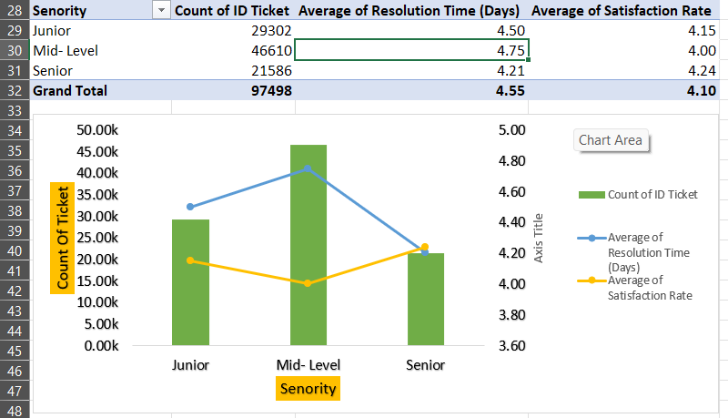

Insights:
Junior Employees
- Handle the highest ticket load (29,302).
- Maintain a balanced resolution time (4.50 days) and a satisfaction rate slightly above average (4.15).
- Shows that juniors are efficient despite high workloads.
Mid-Level Employees
- Handle the largest share of tickets (46,610).
- Have the slowest resolution times (4.75 days) and the lowest satisfaction score (4.00).
- This indicates potential gaps in efficiency and customer handling skills.
Senior Employees
- Handle the fewest tickets (21,586).
- Achieve the fastest resolution time (4.21 days) and the highest satisfaction rate (4.24).
- Suggests strong expertise, but their lower ticket volume may indicate under-utilization.
Overall Trend
- Resolution time and satisfaction rate do not improve with mid-level experience, but significantly improve at senior level.
- Mid-level performance is the bottleneck in overall service quality.

Recommendations:
Targeted Training for Mid-Level Agents
- Provide refresher workshops on technical problem-solving and soft skills.
- Focus on reducing resolution times and improving communication with customers.
Leverage Senior Employees as Mentors
- Implement a mentorship program where seniors guide mid-level employees.
- This can improve both efficiency and consistency in service delivery.
Workload Balancing
- Redistribute some of the ticket load from juniors to mid-level employees to avoid burnout at the entry level.
- Encourage mid-level staff to handle more complex cases where their experience should make a difference.
Performance Monitoring
- Regularly track satisfaction and resolution metrics by seniority group.
- Use these insights to adjust workforce allocation and training priorities.

- Identify the trends for IT support operations based on ticket volumes and satisfaction, and mention the peak and stable times?
Analysis: Use pivot tables and charts to identify peak and off-peak hours.
Ans:

“
Note:
- Hourly or daily timestamps were not available in the dataset, so the analysis is based on monthly and quarterly aggregates using the Fecha Date column.”



Monthly and Quarterly

Approach:
- Created pivot tables summarizing:
  - Average Resolution Time (Days)
  - Average Satisfaction Rate
  - Ticket Volume (Count of Tickets)
- Analyzed data by month and quarter to identify trends, peak workloads, and stable periods.
- Used line charts to visually show trends over time.

Insights:
Monthly Trends:
- Resolution time varies slightly between 4.50 and 4.62 days, with the highest in June (4.62 days) and the lowest in August & September (4.50 days).
- Satisfaction rates remain consistent around 4.07–4.15, with minor dips in February (4.07).
- Ticket volumes peak in August–October, indicating higher workload periods.

Quarterly Trends:
- Q2 shows the highest average resolution time (4.58 days), while Q3 is the most stable (4.52 days).
- Satisfaction remains stable across quarters (~4.10).
- Ticket volumes increase steadily each quarter, with Q4 having the highest (25,150 tickets).

Overall Observation:
- IT support performance is generally stable across the year, with slight variations in resolution times corresponding to peak ticket periods.
- Satisfaction remains consistent, suggesting the team manages workload effectively even during peak times.

Recommendations
- Align staffing with peak demand periods through flexible scheduling.
- Use automation for ticket triage and expand knowledge base resources.
- Investigate satisfaction dips via root cause analysis and targeted training.
- Introduce real-time feedback loops for quicker issue resolution.
- Forecast seasonal demand and strengthen self-service options (chatbots, FAQs).
- Track and improve first-contact resolution (FCR) to reduce backlog.
- Leverage AI analytics to predict ticket surges earlier.
- Conduct quarterly reviews linking workload to customer satisfaction.

- What metrics should be included in the final dashboard to provide a comprehensive view of call center performance and guide investment decisions?
Ans:

Approach:
- Considered the key performance metrics analyzed throughout the dataset: resolution time, satisfaction, ticket volumes, and agent performance.
- Focused on metrics that provide actionable insights for team performance, workload management, and investment decisions.
- Ensured metrics can be visualized clearly for decision-makers.

Recommended Metrics:

- Average Resolution Time (Days)
  - By ticket type, category, and agent seniority
  - Helps identify areas needing training or process improvement.
- Customer Satisfaction Rate
  - Overall and by ticket type/category
  - Highlights service quality and correlates with resolution time.
- Ticket Volume / Load
  - Monthly, quarterly, or by issue type
  - Identifies peak periods and staffing needs.
- Agent Performance Metrics
  - Average tickets handled per agent
  - Average resolution time and satisfaction per agent
  - Highlights training needs and resource allocation.
- Seniority / Experience Metrics
  - Compare Junior, Mid-Level, and Senior agents
  - Helps understand the impact of experience on performance.
- High-Impact Issue Categories
  - Track complex tickets (Hardware, System) separately
  - Guides technology upgrades or resource allocation.
- Trends Over Time
  - Monthly and quarterly trends for resolution time, satisfaction, and ticket volumes
  - Helps forecast workloads and assess improvements over time.

Overall Goal:
- Provide a comprehensive, actionable view of IT support performance.
- Enable investment decisions such as training programs, hiring, or software/hardware upgrades based on data-driven insights.

Ensure that you put the slicers for choosing the priority wise and year in order to observe the dashboard since the management will be having a long discussion which can go for weeks.

Note: The dashboard would be more interactive and user-friendly, allowing management to explore data in detail and make informed decisions.

