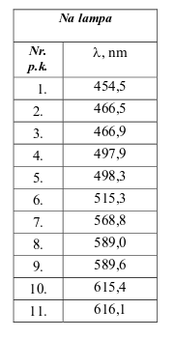red =6.1863e-07

yellow = 5.9281e-07

green =5.7133e-07

blue = 4.5203e-07

violet =4.3551e-07