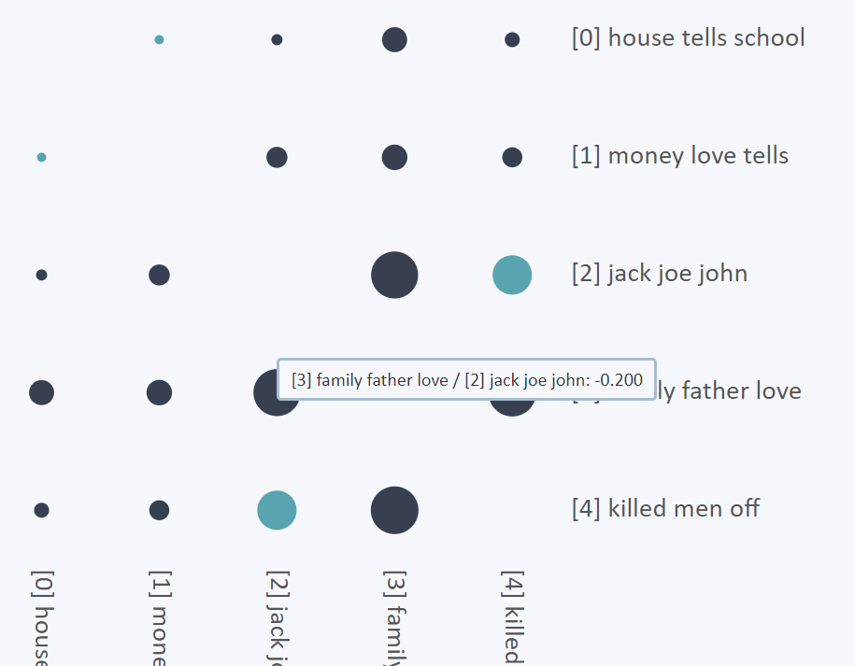

Axes list topics

(by number and the three most common words from the topic)

Hovering shows the two topics which the circle represents

Negative pointwise mutual information is dark, while positive is light. Larger circles represent larger magnitudes of positive or negative correlation.