**Product Feedback Management System – Documentation**

1. **Project Overview**

The **Product Feedback Management System** is a command‑line Python application backed by an SQLite database. It allows two types of users:

* **Admin users** – manage products, customers (non‑admin users), and all feedback data; may create additional admin accounts.
* **Customer users** – register, log in, browse products, and submit / manage their own feedback.

The system includes authentication, role‑based menus, CRUD operations for products and users, and a feedback workflow with ratings (1–5) and optional comments. The system includes authentication, role‑based menus, CRUD operations for products and users, and a feedback workflow with ratings (1–5) and optional comments.

**2.Database structure**

The project uses three core tables: users, products, and feedback.

* **Users/customer table**

|  |  |
| --- | --- |
| **Fields** | **Datatypes** |
| User_id | INTEGER PRIMARY KEY AUTOINCREMENT |
| name | TEXT NOT NULL |
| email | TEXT UNIQUE NOT NULL |
| password | TEXT NOT NULL |
| Is_admin | BOOLEAN |

**Notes**

* email uniquely identifies a login.
* is_admin distinguishes admin vs. customer (0/1 in SQLite).
* **Products table**

|  |  |
| --- | --- |
| **Fields** | **Datatypes** |
| Product_id | INTEGER PRIMARY KEY AUTOINCREMENT |
| Name | TEXT NOT NULL |
| Category | TEXT NOT NULL |
| price | REAL |

* **Feedback table**

|  |  |
| --- | --- |
| **Fields** | **Datatypes** |
| Feedback_id | INTEGER PRIMARY KEY AUTOINCREMENT |
| User_id | INTEGER PRIMARY KEY AUTOINCREMENT |
| Product_id | INTEGER PRIMARY KEY AUTOINCREMENT |
| rating | INTEGER |
| comment | TEXT |
| Date_submitted | DATETIME |

**Notes**

* Rating constrained to 1–5.
* Timestamp auto‑generated.
* Foreign keys are declared

**3. Key Features**

| **Feature** | **Admin** | **Customer** |
| --- | --- | --- |
| Register / Login | ✅ | ✅ |
| Add New Admin | ✅ | ❌ |
| View All Users (non‑admin) | ✅ | ❌ |
| Update / Delete Users | ✅ | ❌ |
| Add / View / Update / Delete Products | ✅ | View only |
| Submit Feedback | ❌ (blocked) | ✅ |
| View All Feedback | ✅ | View own only |
| Update / Delete Feedback | Admin: any | Customer: own only |
| **4. Technology Stack**   * **Python 3** (standard library only: sqlite3, datetime, getpass, re, csv optional) * **SQLite** (file database: e.g., product_feedback2.db) * IDE: VS Code * Runs in **terminal / command prompt**; no external dependencies. |  |  |

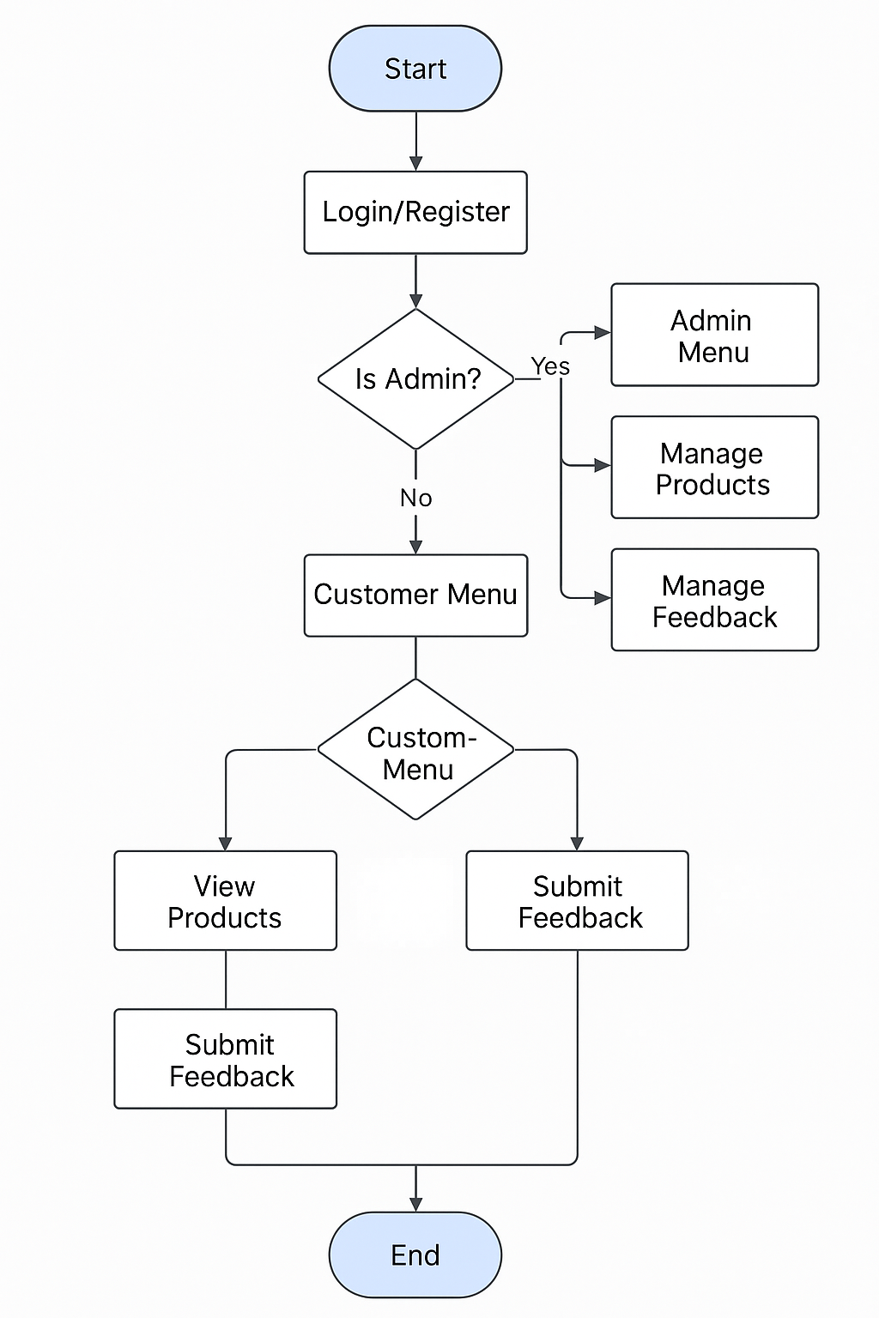**5.FLOW CHART**

**6. Menus & Navigation**

**6.1 Main Menu**

* **Login** – authenticate existing user.
* **Register** – create new (non‑admin) account.
* **Exit** – close program.

**6.2 Admin Dashboard (next_menu when is_admin=True)**

1. Customer Management
2. Product Management
3. Feedback Management
4. Add New Admin
5. Logout (return to Main Menu)

**6.3 Customer Dashboard (next_menu when is_admin=False)**

1. View Products
2. Feedback Menu
3. Logout (return to Main Menu)

**6.4 Customer Management Menu (Admin only)**

* View all non‑admin users
* Update / Delete users
* (Add user is disabled since registration handles this)

**6.5 Product Management Menu (Admin only)**

* Add / View / Update / Delete products

**6.6 Feedback Management Menu (Both roles; options vary)**

Admin:

* View all feedback
* Update/delete any feedback
* View feedback by customer ID

Customer:

* Submit feedback (one rating per product per user not enforced yet)
* View own feedback
* Update/delete own feedback

**7. Core Functions (API Layer)**

Below is a quick reference of major Python functions and their roles.

| **Function** | **Args** | **Role** | **Access** |
| --- | --- | --- | --- |
| register(is_admin=False) | bool | Create user | Public (main menu) / Admin (create admin) |
| login() | — | Authenticate; routes to dashboard | Public |
| next_menu(user_id, is_admin) | int, bool | Main post‑login router | Internal |
| view_customer() | — | List non‑admin users | Admin |
| update_customer() | — | Update user record by ID | Admin |
| delete_customer() | — | Delete user | Admin |
| add_product() | — | Insert product | Admin |
| view_all_products() | — | List all products | All (admin & customer dashboards) |
| update_product() | — | Update product | Admin |
| delete_product() | — | Delete product | Admin |
| submit_feedback(user_id, is_admin) | int, bool | Customer enters rating/comment | Customer |
| view_all_feedback(user_id, is_admin) | int, bool | Admin: all; Customer: own | Role based |
| update_feedback(user_id, is_admin) | int, bool | Update rating/comment | Role based |
| delete_feedback(user_id, is_admin) | int, bool | Delete feedback | Role based |
| view_feedback_by_customer(user_id, is_admin) | int, bool | Admin query | Admin |

**MAIN PAGE / LOGIN PAGE**

**Admin Login**

**The Admin Login feature enables authorized administrators to securely access the system's administrative panel where they can manage feedback records, products, users and add a new admin.**

**Admin select 2 for product management. In which admin can add products, view products, update product, delete products and go back to main choice.**

**Admin select 3 for updating an existing product based on product id.**

**Here we update the product name from football to basketball using the product id. Here we can see the change using view all products option.**

**Admin select 4 for deleting product using product_id , there is a confirmation prompt for deleting. In our output, product_id 5 is deleted, that is basketball is deleted.**

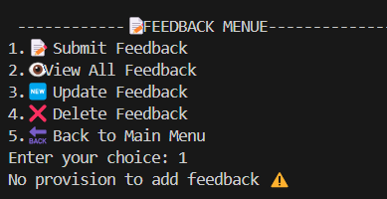

**When admin select Feedback menu and 1 there is no provision to add feedback for the admin.**

**When admin select view all feedback from feedback menu, all the customer details and feedback details are given.**

**Here we can update the feedback details.**

**When admin select 5 back to main menu . Admin select 3 which is add new admin, an admin can add another admin.**

**Here exiting program.**

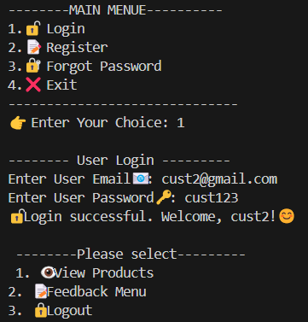

**When customer login is selected by entering customer email and password. For customers we can view products , feedback menu and logout.**

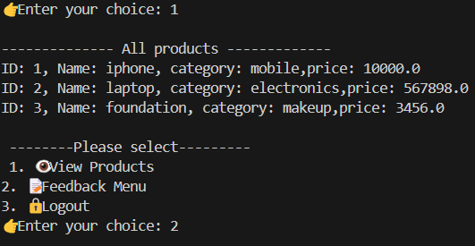

**Customer select 1 choice for view all products details including product name , product category and product price.**

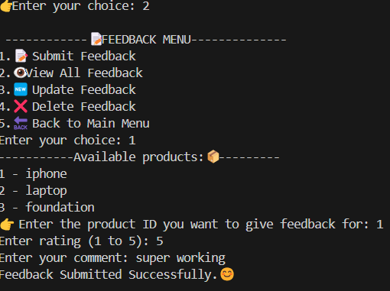

**When feedback menu for submitting feedback is selected all products are listed from where we can rate and comment the product using product id.**

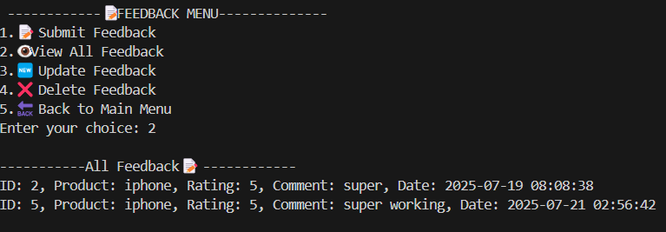

**feedback details are viewed by selecting view all feedback.**

**For updating feedback use update feedback option .**

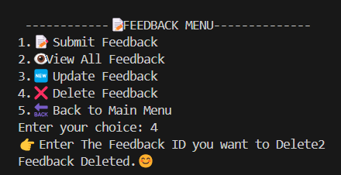

**For deleting feedback use delete feedback option**

**When the customer forgot password , select option forgot password and reset password using the email address.**

**Conclusion**

**The system successfully performs CRUD operations on feedback and user data, with basic admin control. It can be extended to include product-level feedback, visual dashboards, and web interfaces**