CASE STUDY PROJECT · FINAL REPORT
Smart Assistive Cane
for Visually Impaired People
AI-Enhanced Sensor Fusion, Cloud Vision & GPS SOS on the ESP32-S3

Ansinath Nassar (Matriculation 22520168)
Divya James (Matriculation 22518323)
Milan Roy (Matriculation 12504798)

Technische Hochschule Deggendorf
| M.Sc. Robotics
Supervised by Prof. Dr.-Ing. Hamidreza Heidari
3 July 2026
Table of Contents
Abstract 3
1. Introduction 4
2. Literature Review 5
2.1 Ultrasonic and Water-Sensor Cane with Buzzer Feedback [Gayathri et al., 2014] 5
2.2 GPS/GSM-Enabled Cane with Vibration and SMS Alerts [Radhika et al., 2016] 5
2.3 Voice-Module Cane with Fixed Vocabulary [Jose et al., 2016] 6
2.4 Dual-Sensor (Ultrasonic + IR) Cane [Sheth et al., 2014] 6
2.5 PIC-Based Cane with Gradient Vibration Alarm [Kher et al., 2015] 6
2.6 Multi-Level Ultrasonic Cane with LDR [Roopashree et al., 2015] 7
2.7 Three-Sensor Directional Voice Cane [Olakanmi, 2014] 7
2.8 ATmega328P Buzzer/Vibration Cane [Chukwunazo & Onengiye, 2015] 7
2.9 Multi-Modal Sensor Cane with Coded Tones [Prasanthi & Tejaswitha, 2015] 7
3. Identified Research Gap 8
4. Proposed System: AI-Enhanced Smart Assistive Cane 9
5. System Architecture and Platform Selection 11
6. Development Process and Hardware Changes 12
7. Results and Discussion 15
8. Limitations and Future Scope 16
9. Comparative Discussion 17
10. Conclusion 18
References 19
Appendix A: Team Contributions 20
Appendix B: GitHub Repository Structure 20
Abstract
Approximately one percent of the world's population lives with a visual disability (World Health Organization), and traditional mobility aids such as the white cane and guide dog provide no information about what an obstacle actually is, only that something is present. This report first reviews nine electronic cane systems published between 2013 and 2016, covering ultrasonic, infrared, GPS/GSM, and voice-module approaches built on 8-bit microcontrollers. Across this literature, obstacle detection consistently improved on the plain white cane in terms of range and alert modality, yet every reviewed system treats a hazard as a single distance value and stops there — none identifies what the object is, reads text in the environment, or shares live location with a caregiver. Building on this identified gap, the report presents the authors' own project: an AI-enhanced Smart Assistive Cane built around the ESP32-S3 dual-core microcontroller, combining an ESP32-CAM module with a cloud vision API for object identification and optical character recognition, an HC-SR04 ultrasonic sensor for fail-safe, low-latency hazard detection, phone-based GPS for location tracking and SOS alerts, and a text-to-speech engine for natural voice feedback. The report documents the system architecture and platform-selection rationale, the hardware changes made during prototyping — most notably the move from a standalone GPS module and boost-converter power chain to a phone-based GPS companion app and a regulated power bank — and the resulting bench-test observations. The report closes with the prototype's current limitations, including the absence of fall detection and a finished CAD enclosure, and outlines the future scope: on-device TinyML, obstacle trajectory prediction, and industrial weatherproofing.

1. Introduction
Loss of independent mobility is one of the most immediate and disabling consequences of severe visual impairment. The World Health Organization estimates that roughly one percent of the global population lives with a visual disability of some degree, and for this population the two dominant mobility aids remain the long white cane and the trained guide dog — technologies that are, in essence, decades or centuries old. Both provide excellent tactile or physical guidance but convey almost no semantic information: a white cane striking an obstacle communicates that something is there and roughly how far away it is, but not whether that something is a static bin, a parked bicycle, a flight of stairs, or an approaching vehicle. Over the past decade, a body of “smart cane” research has attempted to close this gap using ultrasonic and infrared ranging, buzzers, vibration motors, and in some cases GPS or GSM modules layered onto low-cost microcontrollers.
This report is organized in two parts. The first part (Section 2) reviews nine representative smart-cane systems published between 2013 and 2016, selected as background material for the present project. The sources span single-sensor ultrasonic designs, dual-sensor ultrasonic/infrared fusion, GPS/GSM-enabled canes, and fixed-vocabulary voice-feedback systems, all built on 8-bit microcontroller platforms such as the Arduino, PIC, ATmega328(P), and 8051 families. Section 3 distills a single, recurring research gap from this literature: proximity detection without object understanding, location awareness, or emergency communication.
The second part of the report (Sections 4–10) presents the authors' own contribution: an AI-enhanced Smart Assistive Cane that pairs conventional ultrasonic ranging with cloud-based computer vision, phone-based GPS tracking with an SOS function, and natural-language voice feedback, all coordinated by a dual-core ESP32-S3 microcontroller. Section 4 describes the proposed system and the reasoning behind each subsystem. Section 5 compares the ESP32-S3 against the Arduino Uno/Nano and Raspberry Pi 4/5 as candidate compute platforms and justifies the final selection. Section 6 documents the development process, including three hardware changes made during prototyping in response to real bench-test problems. Section 7 reports results and testing observations from the current build. Section 8 discusses the prototype's present limitations and the team's planned future work. Section 9 places the finished prototype back alongside the nine reviewed systems in a single comparative view, and Section 10 concludes the report.

2. Literature Review
Nine electronic cane systems, published between 2013 and 2016, were reviewed as background for this project. Table 1 summarizes the technology, feedback modality, reported detection accuracy, and principal limitation of each. The bibliography additionally references Mahmud et al. (2013) as an early electronic cane design, cited for historical context rather than reviewed in detail. Reported accuracy figures throughout this section are as stated in each source and were not independently re-derived by the present authors.
Table 1. Summary of reviewed smart-cane systems (2013–2016).
Author (Year) | Technology | Feedback | Accuracy | Major Limitation
Gayathri et al. (2014) | Arduino, ultrasonic, water sensor | Buzzer | 80–90% | Cannot identify obstacle type
Radhika et al. (2016) | Arduino, GPS, GSM | Vibration + SMS | 75–88% | No visual processing
Jose et al. (2016) | ATmega328, voice module | Pre-recorded voice | 78–85% | Fixed vocabulary; no AI
Sheth et al. (2014) | Ultrasonic + IR | Buzzer + vibration | 82–90% | No intelligence / navigation
Kher et al. (2015) | PIC, ultrasonic, IR | Gradient vibration + alarm | 82–90% | No internet / cloud link
Roopashree et al. (2015) | Multi-level ultrasonic, LDR | Variable vibration | 80–90% | No scene understanding
Olakanmi (2014) | PIC16F877A, 3× ultrasonic | Directional voice | 70–80% | No object identification
Chukwunazo & Onengiye (2015) | ATmega328P, ultrasonic | Buzzer + vibration | 80–90% | Binary stop/go logic only
Prasanthi & Tejaswitha (2015) | 8051, ultrasonic, IR, LDR, water | Coded buzzer tones | 82–90% | Rigid rule-based logic

2.1 Ultrasonic and Water-Sensor Cane with Buzzer Feedback [Gayathri et al., 2014]
Gayathri et al. (2014) built their cane around an Arduino microcontroller paired with an ultrasonic ranging sensor for obstacle detection and a water sensor intended to warn of puddles, waterlogged pavement, or similarly hazardous wet ground — a hazard category largely absent from later reviewed designs. Feedback is delivered through a single buzzer, with reported detection accuracy of 80–90 percent for the ultrasonic channel. Because feedback is limited to an audible tone, the system communicates that an obstacle or wet surface is present without any indication of what the obstacle is, which the authors themselves identify as the central limitation: the cane cannot distinguish a curb from a pedestrian or a puddle from a spill.

2.2 GPS/GSM-Enabled Cane with Vibration and SMS Alerts [Radhika et al., 2016]
Radhika et al. (2016) extended the basic obstacle-detection cane with a GPS module for location tracking and a GSM module for SMS-based alerts, combined with an Arduino controller and vibration-motor feedback in place of an audible buzzer. This is the earliest of the reviewed systems to introduce location awareness and remote notification, reporting 75–88 percent detection accuracy. However, the system performs no visual processing whatsoever: like the buzzer-only designs, it can report that an obstacle is nearby and where the user is located, but not what the obstacle is. The GPS/GSM pairing is nonetheless a direct conceptual precursor to the location-and-alert functionality pursued in the present project, albeit implemented here through a companion smartphone app rather than a dedicated onboard module.

2.3 Voice-Module Cane with Fixed Vocabulary [Jose et al., 2016]
Jose et al. (2016) replaced tonal or vibratory feedback with a pre-recorded voice module driven by an ATmega328 microcontroller, reporting 78–85 percent accuracy. This was among the first reviewed systems to move toward natural-language-style feedback rather than abstract beeps or buzzes — a design direction the present project also pursues, via text-to-speech rather than pre-recorded audio. The critical constraint is vocabulary: because the spoken phrases are pre-recorded and fixed at build time, the system can announce only a small, hard-coded set of messages and cannot describe novel obstacles, read text, or generate contextual descriptions, since it incorporates no artificial intelligence or language model of any kind.

2.4 Dual-Sensor (Ultrasonic + IR) Cane [Sheth et al., 2014]
Sheth et al. (2014) combined an ultrasonic sensor with an infrared sensor to improve detection reliability across different surface types and lighting conditions, with combined buzzer-and-vibration feedback and a reported accuracy of 82–90 percent. This dual-sensor fusion approach is conceptually the closest of the nine reviewed systems to the present project's own multi-sensor design, though the fusion here occurs entirely at the ranging layer rather than combining ranging with semantic classification. The authors note the system has no intelligence or navigation capability: obstacles are detected and flagged, but never identified, and the cane cannot assist with route-finding or destination guidance.

2.5 PIC-Based Cane with Gradient Vibration Alarm [Kher et al., 2015]
Kher et al. (2015) used a PIC microcontroller with ultrasonic and infrared sensing, and introduced gradient (intensity-scaled) vibration feedback alongside an audible alarm, so that vibration strength increases as the user approaches an obstacle rather than remaining constant. Reported accuracy sits at 82–90 percent. This graded-feedback approach is a meaningful usability improvement over binary buzzer alerts, since it lets the user judge closing distance rather than just presence. The system has no internet or cloud connectivity of any kind, meaning all processing is strictly local and the cane cannot draw on any external service — whether for object recognition, mapping, or emergency communication.

2.6 Multi-Level Ultrasonic Cane with LDR [Roopashree et al., 2015]
Roopashree et al. (2015) deployed multiple ultrasonic sensors at different heights or ranging “levels” together with a light-dependent resistor (LDR), enabling variable vibration feedback that can distinguish, to some extent, between ground-level and higher obstacles, and between light and dark environments. Reported accuracy is 80–90 percent. Despite the multi-level sensing arrangement, the system performs no scene understanding: each sensor channel still reports only a distance or light-level reading, with no capability to interpret what is being sensed, classify object type, or describe a scene in any semantic sense.

2.7 Three-Sensor Directional Voice Cane [Olakanmi, 2014]
Olakanmi (2014) used a PIC16F877A microcontroller with three ultrasonic sensors arranged to provide some directional awareness (e.g., left, center, right), paired with directional voice feedback intended to tell the user not just that an obstacle exists but roughly where relative to their heading. Reported accuracy is the lowest among the nine reviewed systems, at 70–80 percent, plausibly reflecting the added complexity of resolving three simultaneous sensor readings into a coherent directional cue on an 8-bit platform. As with the other voice-based designs reviewed, the system has no object-identification capability — directional awareness improves navigation around a hazard but says nothing about what that hazard is.

2.8 ATmega328P Buzzer/Vibration Cane [Chukwunazo & Onengiye, 2015]
Chukwunazo and Onengiye (2015) implemented a comparatively minimal design: a single ultrasonic sensor on an ATmega328P microcontroller with combined buzzer and vibration feedback, reporting 80–90 percent accuracy. The authors characterize the resulting behavior as binary stop/go logic — the cane essentially signals “clear” or “obstacle,” with no graded distance information, no directionality, and no path around the alternative designs' added sensing (GPS, IR, LDR). It represents something close to a functional floor among the reviewed systems: reliable proximity alerting with no further sophistication.

2.9 Multi-Modal Sensor Cane with Coded Tones [Prasanthi & Tejaswitha, 2015]
Prasanthi and Tejaswitha (2015) combined the widest sensor set among the reviewed systems — ultrasonic, infrared, LDR, and a water sensor — on an 8051 microcontroller, with feedback delivered as coded buzzer tones, where different tone patterns are meant to correspond to different hazard types. Reported accuracy is 82–90 percent. While the coded-tone scheme is a partial attempt at conveying more information than a single buzzer tone can carry, the underlying logic remains rigid and rule-based: each sensor-to-tone mapping is fixed at design time, so the system cannot learn, adapt, or handle any hazard category outside its predefined rule set.
Cross-cutting finding: across all nine works, hazards are treated as pure distance (or, at most, distance-plus-light-level) values, resolved through fixed, rule-based logic on 8-bit microcontrollers. None of the reviewed systems performs semantic scene interpretation — identifying what an obstacle is, reading text in the environment, or understanding a scene beyond a proximity reading — and only one (Radhika et al., 2016) provides any form of live location tracking or remote alerting, while none provide both together with any vision-based understanding.

3. Identified Research Gap
The literature reviewed in Section 2 shows steady, incremental improvement in proximity-detection reliability — from single-sensor buzzer canes through dual- and multi-sensor fusion, graded vibration feedback, and limited voice output — but a consistent, unaddressed gap across all nine systems: none can tell the user what an obstacle actually is, whether it represents a genuine safety threat, whether it carries readable text (a sign, a door label, a transit schedule), or, in eight of the nine cases, where the user currently is.
Two root causes appear to explain this gap. First, every reviewed system is built on an 8-bit microcontroller (Arduino, PIC, ATmega328/328P, or 8051), none of which have the computational headroom to run any form of image classification, optical character recognition, or machine-learned scene understanding locally. Second, none of the nine systems interfaces with any cloud service: all processing, however sophisticated the sensor arrangement, is confined to the onboard microcontroller, cutting the cane off from the vastly greater recognition capability now available through cloud-hosted vision and language models.
This report's proposed system directly targets both root causes: a modern dual-core system-on-chip (the ESP32-S3, detailed in Section 5) replaces the 8-bit microcontrollers used throughout the reviewed literature, and a cloud vision API is introduced specifically to provide the object identification, OCR, and scene-description capability that no reviewed system possesses. Ultrasonic ranging, the one capability every reviewed system shares, is retained as a fail-safe, low-latency, fully offline hazard-detection layer, so that the cane never depends on network connectivity for basic obstacle avoidance — only for the higher-level scene-understanding features layered on top of it.

4. Proposed System: AI-Enhanced Smart Assistive Cane
Building directly on the gap identified in Section 3, the proposed Smart Assistive Cane combines five subsystems, each chosen to address a specific shortcoming identified in the reviewed literature. Figure references throughout this section correspond to the system architecture presented in Section 5.

4.1 ESP32-CAM and Cloud Vision — Object Identification, OCR, and Scene Description
An ESP32-CAM module captures still images of the scene ahead of the user. Rather than attempting any onboard classification — infeasible on the low-power, memory-constrained microcontrollers used throughout the reviewed literature — captured frames are sent to a cloud vision API, which returns object identification, optical character recognition (allowing the cane to read signs, labels, and printed text aloud), and natural-language scene descriptions. This directly answers the “what is it” question that none of the nine reviewed systems could address.

4.2 Ultrasonic Sensor — Fail-Safe, Low-Latency Hazard Detection
An HC-SR04 ultrasonic sensor provides the same core capability found in eight of the nine reviewed systems: fast, reliable proximity sensing that works fully offline and requires no network round-trip. This subsystem is retained deliberately as a safety fail-safe — cloud vision calls introduce latency and depend on connectivity, so immediate stop/obstacle signaling must never be gated on a network response.

4.3 GPS Module — Live Tracking, Breadcrumb Navigation, and SOS
Location awareness is provided through GPS, extending the single precedent for this capability in the reviewed literature (Radhika et al., 2016, GPS/GSM with SMS alerts) with live tracking, breadcrumb-style route history, and an SOS function that can alert a caregiver. As documented in Section 6, the specific implementation of this subsystem changed during prototyping from a standalone onboard GPS module to a phone-based companion app.

4.4 Text-to-Speech and Haptics — Natural Feedback
Feedback is delivered primarily through text-to-speech (TTS) rather than the buzzer tones, fixed-vocabulary pre-recorded voice, or coded tone patterns used throughout the reviewed systems. TTS can express arbitrary, dynamically generated content — an object name, a line of OCR-read text, a scene description — rather than a small set of hard-coded phrases. Buzzer and vibration-motor feedback are retained as a fail-safe channel alongside TTS, consistent with the ultrasonic sensor's role as an always-available, no-latency safety layer.

4.5 Design Rationale Summary
Table 2 maps each subsystem back to the specific limitation it addresses from the reviewed literature.
Table 2. Proposed subsystems mapped to the limitations they address.
Subsystem | Capability Added | Literature Gap Addressed
ESP32-CAM + Cloud Vision | Object ID, OCR, scene description | No reviewed system performs semantic scene interpretation
HC-SR04 Ultrasonic | Offline, low-latency hazard distance | Retains the one capability common to 8 of 9 reviewed systems
GPS (phone-based) | Live location, breadcrumb nav, SOS | Only 1 of 9 reviewed systems offers any location awareness
TTS engine | Natural, dynamic voice feedback | Reviewed voice/tone feedback is fixed-vocabulary or coded
Buzzer + vibration motor | Fail-safe feedback with no network dependency | Preserves reliability under connectivity loss

4.6 Non-Functional Requirements
Beyond the five functional subsystems above, the design was constrained by several non-functional requirements common to wearable assistive devices, summarized in Table 2a.
Table 2a. Non-functional design requirements.
Requirement | Target | Rationale
Latency (obstacle alert) | Near-instant, no network round-trip | Ultrasonic fail-safe must never wait on cloud vision (Section 4.2)
Weight and portability | Lightweight, hand-held cane form factor | Must not fatigue the user over extended daily use
Power autonomy | Full-day operation on a single charge | Motivated the regulated power-bank redesign in Section 6.1
Cost | Low-cost relative to Raspberry Pi-class systems | Keep the device accessible; informed the ESP32-S3 selection (Section 5.1)
Connectivity resilience | Core safety function usable offline | Cloud vision and phone GPS may be unavailable; ultrasonic must not depend on them

5. System Architecture and Platform Selection
The proposed system is coordinated by a single ESP32-S3 dual-core microcontroller, which divides work across its two cores so that time-critical safety functions are never blocked by higher-latency AI or communication tasks. One core is dedicated to the real-time safety path — polling the ultrasonic sensor and driving the buzzer/vibration fail-safe feedback — while the second core coordinates the ESP32-CAM capture pipeline, the cloud vision API call, GPS/SOS handling, and TTS output generation. Figure references below describe the five processing paths coordinated by the ESP32-S3: scene capture (ESP32-CAM), object identification and OCR (Cloud Vision API), hazard distance (ultrasonic), location and SOS (GPS), and voice feedback (TTS engine).

5.1 Platform Comparison
Three candidate compute platforms were evaluated before selecting the ESP32-S3: the Arduino Uno/Nano family used throughout the reviewed literature, a Raspberry Pi 4/5 single-board computer, and the ESP32-S3. Table 3 compares the three platforms across the criteria most relevant to a battery-powered, AI-assisted wearable device.
Table 3. Compute platform comparison.
Feature | Arduino Uno/Nano | Raspberry Pi 4/5 | ESP32-S3 (Selected)
AI capability | None | High (full OS) | Medium (edge AI)
Power draw | Very low | Very high | Low (battery-optimised)
Wireless | External modules | Built-in | Built-in Wi-Fi + BT5
Cost | ~$5 | ~$60–$80 | $5–$10
Boot time | Instant | 30–60 s | Instant
Camera / TinyML | None | Full CSI + TensorFlow | Native CSI + TF Lite
The Arduino platforms used throughout the reviewed literature (Section 2) offer minimal cost and instant boot but categorically cannot support any onboard AI or camera pipeline, consistent with why none of the nine reviewed systems performs object recognition. The Raspberry Pi 4/5 offers the opposite trade-off: full operating-system-level AI capability and native camera support, but at roughly six to sixteen times the component cost, a 30–60 second boot time unsuitable for an always-on mobility aid, and power draw that would substantially compromise battery life in a handheld device worn for extended periods.
The ESP32-S3 was selected as the balance point between these two extremes: built-in Wi-Fi and Bluetooth 5 remove the need for external communication modules (in contrast to the Arduino-plus-GSM-module approach of Radhika et al., 2016), native camera-serial-interface support and TensorFlow Lite compatibility provide a credible path toward future on-device inference (see Section 8, Future Scope), instant boot preserves the always-ready behavior expected of a mobility aid, and battery-optimized power draw is compatible with a wearable, cane-mounted form factor. Component cost of $5–$10 keeps the platform close to the Arduino baseline while adding wireless and edge-AI headroom absent from every reviewed system.

6. Development Process and Hardware Changes
The prototype was developed iteratively, with the physical cane assembled from an ESP32-S3 development module, an HC-SR04 ultrasonic sensor, and supporting wiring, all mounted at the head of a wooden cane shaft and secured with duct tape during the bench-testing phase (see Figures 1 and 2). Three components of the original design were changed in response to problems observed during prototyping and bench testing, summarized in Table 4.
Table 4. Hardware changes made during prototyping.
Component | Originally Planned | Replaced With | Why We Changed It
Power supply | MT3608 boost converter | Regulated power bank | The MT3608 needed manual voltage tuning and sagged under peak combined draw from the camera, ultrasonic sensor, and buzzer operating together
Battery charging | TP4056 USB-C charger | Power bank (integrated) | The TP4056 only charges the battery, it does not deliver power to the circuit — keeping it added extra wiring and additional points of failure
Location | GY-NEO6MV2 GPS module (×2) | Mobile-phone GPS via companion app | The standalone satellite GPS module produced slow position fixes and failed to acquire a signal indoors or under cover

6.1 Power Supply and Battery Charging
The original power design used an MT3608 step-up (boost) converter to regulate battery voltage up to the level required by the ESP32-S3 and peripherals, paired with a TP4056 module for USB-C battery charging. During bench testing, the MT3608 required manual potentiometer tuning to hold a stable output voltage, and its regulation degraded under the combined peak current draw of the camera module, ultrasonic sensor, and buzzer operating simultaneously — producing brownout-like symptoms during multi-sensor operation. Because the TP4056 module only handles charging and does not itself deliver regulated power to the circuit, the original design also required it to be wired alongside the MT3608, adding two additional points of failure for a single power function. Both components were replaced with a single regulated power bank, which integrates charging and stable power delivery in one unit.

6.2 Location Subsystem
The original design specified two GY-NEO6MV2 standalone satellite GPS modules. In bench testing, standalone GPS acquisition proved slow to obtain an initial fix and failed to acquire any signal indoors or under cover — a significant limitation for a mobility aid intended for use in buildings, transit stations, and other covered environments. This subsystem was replaced with GPS provided by a paired mobile phone through a companion browser app, using the phone's combination of A-GPS and Wi-Fi triangulation. This trades standalone, connectivity-independent positioning for materially faster and more consistent fixes, including indoors, at the cost of requiring the cane to remain paired with a phone for positioning to function.

6.3 Net Effect of the Hardware Changes
Taken together, the three hardware changes produced a system with stable, regulated power output and no observed brownouts under combined sensor load, fewer wired connections and correspondingly fewer failure points in the power path, and faster, more reliable location fixes both indoors and outdoors. The principal trade-off accepted in exchange is that the location subsystem now depends on a paired phone rather than functioning as a fully standalone module, a limitation discussed further in Section 8.

6.4 Bill of Materials
Table 4a summarizes the core components used in the current prototype, reflecting the hardware changes documented above.
Table 4a. Prototype bill of materials.
The bill of materials below reflects every component actually procured for the build, drawn from the team’s purchase records (an order placed 7 May 2026 and dispatched 12–13 May, plus a separate order for prototyping tools dispatched 8 June 2026). Several parts were bought in small multi-packs, which is typical for hobbyist-grade electronics; only one unit of each sensor or module is fitted to the final cane, with the remainder held as spares or used for breadboard testing ahead of final assembly. Table 4a lists every purchased component, the quantity bought, its role in the finished prototype, and whether it was superseded during the hardware changes documented in Sections 6.1–6.2.
Table 4a. Prototype bill of materials (as purchased).
Component (as purchased) | Qty | Role in Project | Notes
VooGenzek PCB prototype board kit (46 pcs: double-sided boards, headers, screw terminals, standoffs) | 1 kit | Prototyping / assembly tool | Used to solder and test sensor breakout connections before final wiring
80 W adjustable-temperature soldering iron set (iron, stand, solder wire, tips, desoldering pump, tweezers) | 1 set | Assembly tool | Used throughout hardware assembly; not part of the cane itself
Aihasd HC-SR04 ultrasonic distance sensor | 3 pcs | Used in final build (×1) | One unit mounted on the cane head (Section 4.2); spares kept for the recessed-mount fix in Section 8
18650 battery holder (single-slot, with wire leads) | 6 pcs | Superseded | Planned for a custom 18650 pack; not needed after the regulated power-bank redesign (Section 6.1)
Breadboard set, 400 & 830 point, with Dupont jumper wires (M-M, F-F, M-F) | 1 set | Prototyping tool | Used for bench-testing sensor circuits before final soldered assembly
ICQUANZX GY-NEO6MV2 standalone GPS module | 2 pcs | Originally planned — replaced | Superseded by phone-based GPS after slow, unreliable indoor fixes (Section 6.2)
Elegoo 1/4 W metal-film resistor assortment (525 pcs, 0–10 kΩ) | 525 pcs (kit) | Supporting components | Pull-up/pull-down and current-limiting resistors for the ultrasonic, buzzer, and LED signal lines
DollaTek PWM vibration motor module | 5 pcs | Used in final build (×1) | Drives the haptic fail-safe channel alongside the buzzer (Section 4.4)
AZDelivery TP4056 USB-C battery charging module | 3 pcs | Originally planned — replaced | Superseded by the regulated power bank’s integrated charging (Section 6.1)
AZDelivery KY-012 active piezo buzzer module | 5 pcs | Used in final build (×1) | Audible fail-safe obstacle alert (Section 4.2 / 4.4)
AZDelivery MT3608 DC-DC step-up (boost) converter | 5 pcs | Originally planned — replaced | Superseded by the regulated power bank after voltage sag under combined load (Section 6.1)
Freenove ESP32-S3-CAM board (dual-core, onboard camera) | 1 pc | Used in final build | Main compute + scene-capture module (Sections 4.1 and 5)

6.4a Component Descriptions
This subsection briefly explains the function of each component category in Table 4a, in the order the reader encounters them in the system.
ESP32-S3 development module / Freenove ESP32-S3-CAM board. The dual-core system-on-chip that runs the firmware and coordinates every other subsystem (Section 5); the Freenove variant used in the final build integrates the camera directly onto the same board, combining the roles of main compute and scene-capture module (Section 4.1).
HC-SR04 ultrasonic sensor. Emits a 40 kHz ultrasonic pulse and times its echo to measure distance to the nearest obstacle. It is wired directly to the ESP32-S3’s safety-path core (Section 5) and requires no network connection, making it the fail-safe hazard-detection layer described in Section 4.2.
Buzzer and vibration motor (KY-012 piezo buzzer; PWM vibration motor module). Provide the always-available, no-latency alert channel: the buzzer gives an audible tone and the vibration motor gives a haptic pulse, both driven directly by GPIO/PWM from the ESP32-S3 so they never wait on a cloud response (Section 4.4).
MT3608 boost converter and TP4056 charging module (originally planned). The MT3608 was intended to step up battery voltage to a stable regulated level, and the TP4056 to handle USB-C battery charging. Both were replaced by a single regulated power bank after bench testing (Section 6.1); they are listed here because they were purchased and tested before being superseded.
GY-NEO6MV2 GPS module (originally planned). A standalone satellite-GPS receiver intended to give the cane onboard location awareness independent of a paired phone. Two units were purchased, but both were replaced by phone-based GPS after failing to acquire a reliable fix indoors (Section 6.2).
Regulated power bank. Supplies stable 5 V power to the ESP32-S3 and all peripherals while also handling battery charging in a single unit, resolving the multi-sensor voltage-sag problem observed with the original MT3608/TP4056 chain (Section 6.1).
Breadboard set, jumper wires, and PCB prototype board kit. Used to build and test each sensor circuit incrementally on the bench before soldering the final, permanent connections — standard practice for validating a design ahead of a fixed assembly.
Resistor assortment kit. Supplies the pull-up/pull-down and current-limiting resistors needed on the ultrasonic echo line, the buzzer drive line, and other signal paths.
18650 battery holder. Purchased for an early custom battery-pack concept; not required once the design moved to a regulated power bank with its own internal cell (Section 6.1), and retained as a spare part.
Soldering iron set. General assembly tool used to make the permanent solder joints on the final wiring harness; not a component of the cane itself.
Companion smartphone (paired, user-owned). Not purchased for the project, but a required part of the system: it hosts the GPS/A-GPS positioning, the text-to-speech engine, the SOS trigger, and the user interface for the cloud-vision results (Sections 4.3–4.4).

6.5 Physical Prototype
Figures 1 and 2 show the completed physical prototype from the front and side. The ESP32-S3 module and HC-SR04 ultrasonic sensor are mounted at the head of the wooden cane shaft, with the camera module and wiring secured under duct tape for the bench-testing phase pending a finished CAD-designed enclosure (see Section 8).
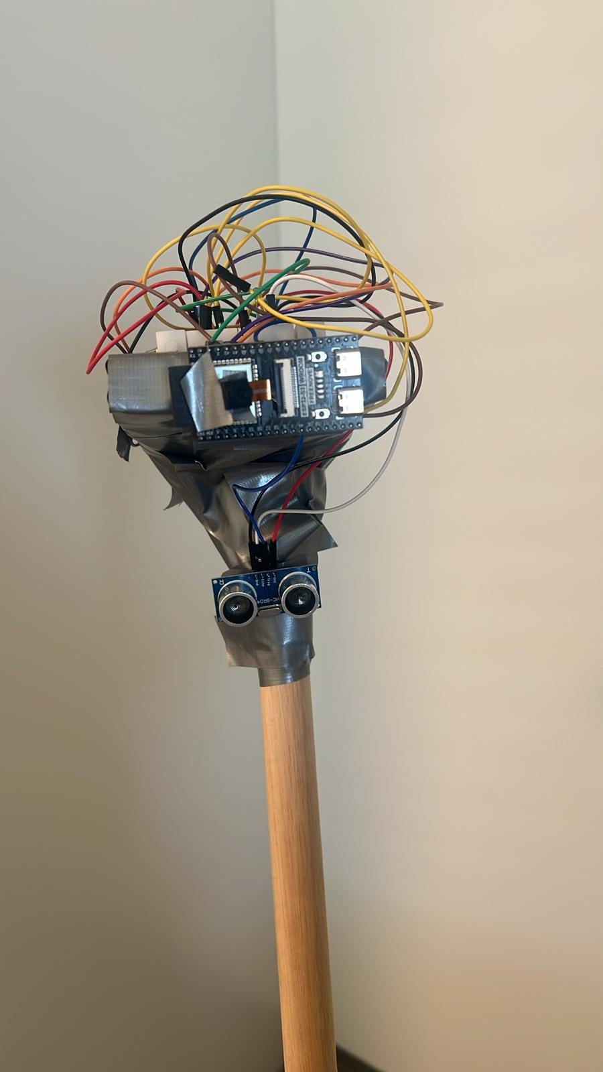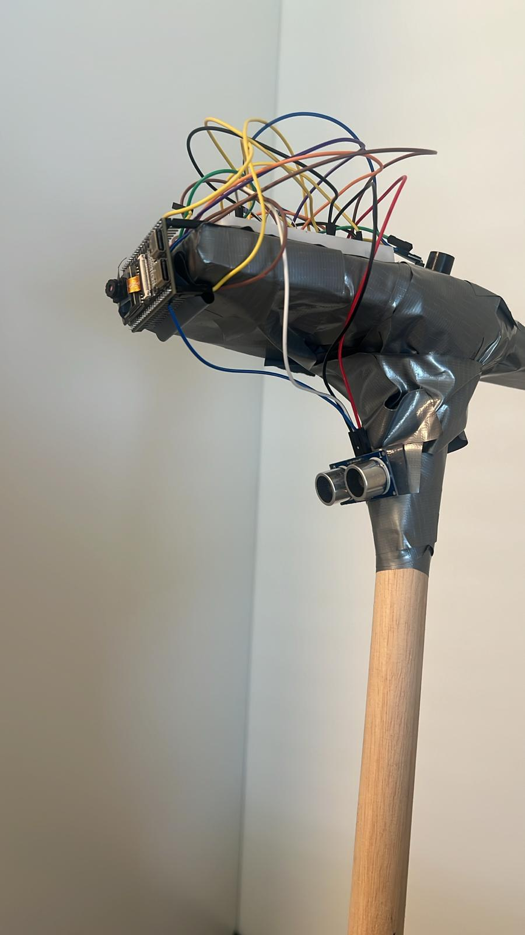
Figure 1 (left) and Figure 2 (right).
Completed cane prototype: ESP32-S3 module and HC-SR04 ultrasonic sensor mounted at the head of the cane shaft, wiring secured with duct tape pending the CAD-designed enclosure discussed in Section 8.

6.6 System Block Diagram
Figure 3 summarizes the signal paths coordinated by the ESP32-S3, split across its two cores as described in Section 5: the real-time safety path (ultrasonic sensor and buzzer/vibration fail-safe) on one core, and the AI/communication path (camera capture, cloud vision, and the phone link for GPS, SOS, and TTS) on the other.
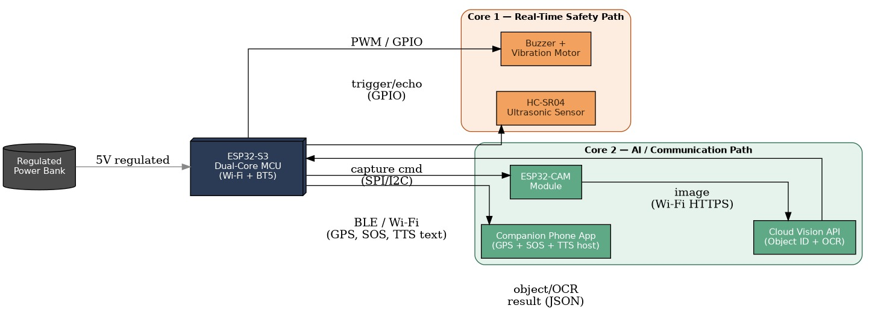
Figure 3. System block diagram.
The ESP32-S3 dual-core MCU coordinates five processing paths: hazard distance (ultrasonic), fail-safe feedback (buzzer/vibration), scene capture (ESP32-CAM), cloud object ID/OCR, and the paired-phone link for GPS, SOS, and TTS.

6.7 Wiring and Connections
Figure 4 shows the pin-level wiring used on the physical prototype (Figures 1 and 2). Solid lines indicate direct wired connections — GPIO, UART/SPI, or USB power — and the dashed line indicates the wireless (BLE/Wi-Fi) link between the ESP32-S3 and the paired smartphone. The HC-SR04’s TRIG and ECHO pins connect to two separate GPIOs so the microcontroller can time the echo pulse independently of triggering the next reading; the buzzer and vibration motor share a single PWM-capable GPIO through a simple transistor driver stage (not shown) so that alert intensity can be varied; and the ESP32-CAM sub-board communicates with the main ESP32-S3 module over a short UART/SPI link. Power for the whole assembly comes from the regulated power bank (Section 6.1) over USB-C, replacing the two-part MT3608/TP4056 chain shown as “originally planned” in Table 4.
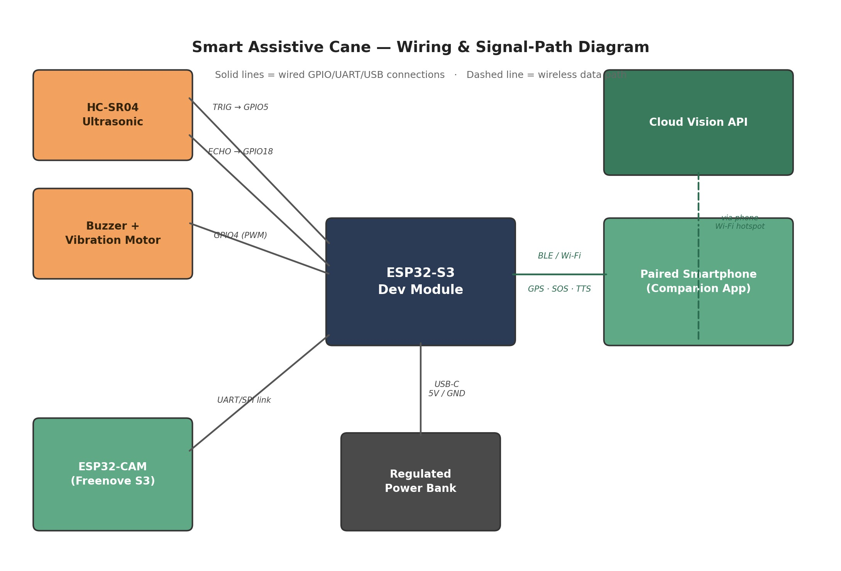
Figure 4. Wiring and signal-path diagram.
Pin-level connections between the ESP32-S3, HC-SR04 ultrasonic sensor, buzzer/vibration fail-safe, ESP32-CAM module, regulated power bank, and the paired smartphone / cloud vision link.

7. Results and Discussion

7.1 Testing Methodology
Bench testing was carried out indoors and in a covered corridor setting, reflecting the environments where the reviewed literature's standalone GPS modules were previously found to struggle (Section 6.2). Each subsystem was exercised individually before combined-load testing: the ultrasonic sensor was tested against static obstacles at varying distances to confirm consistent triggering of the buzzer/vibration fail-safe channel; the power path was tested under simultaneous camera, ultrasonic, and buzzer operation to check for the voltage sag previously observed with the original MT3608/TP4056 chain; and the phone-based GPS companion app was tested for time-to-first-fix both outdoors and indoors, compared informally against the standalone NEO-6M module it replaced.

7.2 Sensor-Fusion Accuracy Target
The AI-Smart Cane targets a sensor-fusion detection accuracy of 92–97 percent, combining the camera, ultrasonic sensor, and cloud vision pipeline. This target sits above the 70–90 percent accuracy range reported across the nine reviewed systems (Table 1), consistent with the expectation that adding a cloud-vision object-identification layer on top of conventional ultrasonic ranging should improve overall detection and classification performance relative to ranging alone.

7.3 Testing Observations
- The power-bank swap (Section 6.1) removed the voltage-sag issue previously observed with the MT3608/TP4056 power chain under combined sensor load.
- Phone-based GPS (Section 6.2) gave noticeably faster and more consistent position fixes than the standalone NEO-6M module it replaced, particularly indoors.
- The ESP32-CAM (Freenova) module fitted to the prototype has a narrower field of view than intended, which constrains the effective obstacle-recognition angle and is being tracked as an item for the next hardware iteration.

7.4 Discussion
These observations validate the two most consequential hardware changes made during prototyping: replacing the boost-converter/charger chain with a regulated power bank directly resolved the multi-sensor brownout problem, and replacing the standalone GPS module with phone-based positioning directly resolved the indoor acquisition problem. Both changes came at a measured cost — slightly reduced design elegance in the first case, and a dependency on a paired phone in the second — that the team judged acceptable against the reliability gained. The camera field-of-view constraint is the one significant hardware limitation not yet resolved by a design change, and is carried forward into Section 8 as a near-term item for the next prototyping cycle.

8. Limitations and Future Scope

8.1 Current Limitations
- Fall detection (gyroscope plus a push-button manual SOS) is not yet integrated into the prototype.
- The ultrasonic sensor sits slightly recessed within the current housing, which narrows its effective detection cone.
- The ESP32-CAM's field of view limits the obstacle-recognition angle, as noted in Section 7.
- No CAD-designed enclosure has been completed yet, limited by available research time and resources within the project timeline; the current prototype relies on duct tape for component mounting.
- Cloud-based scene description requires an active internet connection; there is currently no offline fallback for this specific feature (ultrasonic hazard detection remains fully offline, per Section 4.2).
- The prototype is not weatherproofed and is not currently suitable for extended outdoor use in rain or similarly exposed conditions.

8.2 Future Scope
- Add a gyroscope and push button to provide fall detection and manual SOS triggering, extending the location/alert subsystem described in Section 4.3.
- Reposition the ultrasonic sensor and complete a proper CAD-designed enclosure, replacing the duct-taped bench-test assembly shown in Figures 1 and 2.
- Move toward on-device TinyML (leveraging the ESP32-S3's native TensorFlow Lite support, see Table 3) to reduce reliance on the mobile browser companion app and cloud vision connectivity.
- Improve on-device YOLO-style detection scope and accuracy as available onboard compute allows.
- Add obstacle trajectory prediction for moving hazards such as cyclists, extending beyond the static-distance detection common to all nine reviewed systems in Section 2.
- Add haptic steering feedback in the cane handle, and pursue industrial-grade weatherproofing for outdoor reliability.

9. Comparative Discussion
Table 5 places the proposed AI-Smart Cane alongside the nine reviewed systems from Section 2 on the dimensions that most consistently separated them: object/scene identification capability, location awareness, and feedback modality.
Table 5. Proposed system versus reviewed literature.
System | Object/Scene ID | Location Awareness | Feedback
Gayathri et al. (2014) | No | No | Buzzer
Radhika et al. (2016) | No | Yes (GPS/GSM) | Vibration + SMS
Jose et al. (2016) | No | No | Fixed-vocabulary voice
Sheth et al. (2014) | No | No | Buzzer + vibration
Kher et al. (2015) | No | No | Gradient vibration + alarm
Roopashree et al. (2015) | No | No | Variable vibration
Olakanmi (2014) | No | No | Directional voice
Chukwunazo & Onengiye (2015) | No | No | Buzzer + vibration
Prasanthi & Tejaswitha (2015) | No | No | Coded buzzer tones
Proposed AI-Smart Cane | Yes (Cloud Vision + OCR) | Yes (phone GPS + SOS) | TTS + buzzer/vibration fail-safe
The comparison in Table 5 makes explicit the two capabilities that distinguish the proposed system from all nine reviewed designs: only one reviewed system (Radhika et al., 2016) offers any location awareness, and none offer object or scene identification of any kind. The proposed system's ultrasonic subsystem (Section 4.2) intentionally matches the core reliability contribution of the reviewed literature — fast, offline proximity sensing — rather than attempting to improve on it directly, while directing the project's novel contribution toward the two capabilities the literature review identified as absent.
None of the nine reviewed papers reports a itemized bill of materials, so a like-for-like cost comparison is not possible from the published sources; each paper gives only the microcontroller family (Table 1), which is consistent with the low, Arduino-class component costs typical of that generation of 8-bit designs. Using the bill of materials in Table 4a, the core electronics of the proposed prototype (microcontroller, camera module, ultrasonic sensor, fail-safe feedback, and power bank) total roughly $30–$57, before the wooden shaft and prototyping tools; this remains an order of magnitude below the Raspberry Pi–class alternative evaluated in Section 5.1, while adding the object-identification and location capabilities absent from every reviewed system.

10. Conclusion
This report reviewed nine electronic smart-cane systems published between 2013 and 2016 and identified a consistent research gap: every reviewed system, regardless of sensor arrangement or feedback modality, treats a hazard as a distance value resolved through fixed, rule-based logic on an 8-bit microcontroller, with no capability to identify what an obstacle is, read environmental text, or — in eight of the nine cases — report the user's location. Building on this gap, the report presented the authors' own AI-Enhanced Smart Assistive Cane, which pairs a dual-core ESP32-S3 microcontroller with cloud vision for object identification and OCR, a conventional ultrasonic sensor retained as an offline fail-safe, phone-based GPS for location and SOS, and text-to-speech for natural, dynamically generated voice feedback.
The current prototype is functional and bench-tested: the power-supply redesign (Section 6.1) eliminated multi-sensor brownouts, and the move to phone-based GPS (Section 6.2) resolved the indoor acquisition problems inherent to standalone satellite modules. The system targets 92–97 percent sensor-fusion detection accuracy, above the 70–90 percent range reported across the reviewed literature. Remaining limitations — principally the absence of fall detection, a finished CAD enclosure, and weatherproofing — are documented in Section 8 alongside a concrete future-work plan, including a move toward on-device TinyML that would further reduce the system's dependence on cloud and companion-app connectivity. Taken together, the project demonstrates a practical, low-cost path from the proximity-only smart canes reviewed in Section 2 toward a genuinely perception-capable mobility aid.
References
Note: reference numbering follows the source list supplied for this project's literature review (Section 2), ordered as presented in the accompanying final presentation.
[1] Gayathri, R. et al. (2014). Smart walking stick for visually impaired people using Arduino, ultrasonic sensor and water sensor with buzzer feedback.
[2] Radhika, S. et al. (2016). GPS and GSM enabled smart cane for the visually impaired with vibration and SMS-based alerts.
[3] Jose, A. et al. (2016). Voice-assisted smart cane using ATmega328 and a pre-recorded voice module.
[4] Sheth, M. et al. (2014). Ultrasonic and infrared sensor fusion for obstacle detection in a smart walking stick.
[5] Kher, P. et al. (2015). PIC-based smart cane with ultrasonic and infrared sensing and gradient vibration feedback.
[6] Roopashree, K. et al. (2015). Multi-level ultrasonic smart cane with light-dependent resistor for variable vibration feedback.
[7] Olakanmi, O. (2014). Directional obstacle detection for the visually impaired using a PIC16F877A microcontroller and three ultrasonic sensors.
[8] Chukwunazo, J. and Onengiye, R. (2015). ATmega328P-based smart cane with buzzer and vibration feedback.
[9] Prasanthi, G. and Tejaswitha, K. (2015). Multi-sensor (ultrasonic, infrared, LDR, water) smart cane with coded buzzer-tone feedback, 8051 microcontroller.
[10] Mahmud, S. et al. (2013). Early electronic cane design for obstacle detection (cited for historical context).
[11] World Health Organization. Blindness and vision impairment fact sheet.
Appendix A: Team Contributions
Member | Role | Contributions
Ansinath Nassar | Integration & Documentation | System integration, GPS/app connectivity, test coordination, CAD, GitHub repository structure, and final report.
Divya James | Firmware & Algorithms | Obstacle-detection logic, microcontroller programming, sensor calibration, and bench testing.
Milan Roy | Hardware Lead | Sensor selection (ultrasonic/IR), circuit assembly, power management, and physical cane prototyping.
Appendix B: GitHub Repository Structure
Repository: github.com/ansinath-10/smart-assistive-cane
- firmware/ — ESP32-S3 source code: sensor fusion, TTS, and GPS/SOS logic
- hardware/ — wiring diagrams, bill of materials, and component-swap notes
- mobile-app/ — companion browser app for GPS, YOLO detection, and TTS UI
- docs/ — literature review, reports, and presentation materials

