Name: | Sivakami Annamalai
Email: | sivakami_annamalai@mpa.gov.sg

Question 1
In your own words explain the 4 sub constraints in REST’s Uniform Interface. Give an everyday example to illustrate each of the constraint.

- Identify resources through identifiers: Every resource can be uniqulry identified, for example attendance record of a class for a particular day, particular class in a school.
- Manipulation of resources through its representation: Same report generated by an application can be presented in different representation, for example an image can be shown in jpeg, png format.
- Self description message: Every message passed from a client to a server must be self contained. Message containes everything to understand and decode the message. It supports stateless servers. Message semantics is also visible to intermediaries. For example, retrieve a list of male employees from a company who joined in the march 2022 and return in jason.
- Hypermedia as the engine of application states: Hypermedia or hyper text privides hyperlinks, some link navigate to other hypermedia or provide ways to change the state of the hypermedia. For example, get the personal particulars update form from the server. Update the particulars in the brower and submit for update in the server.

Question 2
What is the difference between the following HTTP methods?
- POST, PUT and PATCH
POST is used to upload data, PUT replaces the complete record and PATCH partially modifies the data of the specified resource. POST and PATCH are no idempotent, but PUT is idempotent.
b. GET and HEAD
GET requests a representation/data from the specified resource, but HEAD will GET without the response payload if any.
Head return only metadata, but GET returns metadata and output.
Question 3
You have a monolithic web application for managing warehouses. The application exposes the following end points
- /warehouses – list of all warehouses
- /warehouse/<warehouse_id> – returns the warehouse’s details
- /warehouse/<warehouse_id>/inventories – inventory list for the warehouse
- /inventories – list of all the inventories
- /inventory/<inventory_id> – inventory detail
- /inventory/<inventory_id>/report – generate a report
Describe how you can scale this application
a. By duplication
Break it up to 2 parts, warehouse and inventory.
https://app.acme.com/warehouse/
https://app.acme.com/inventories/
b. By functional decomposition
By splitting different microservices connected to database, where database is already split accoring to functions.
Warehouse.acme.com
inventories.acme.com
c. By data partitioning
By partitioning the data which are linked to seperate database, an the database are linked to each other. There is a smart service implemented so that when client send a request, it knows the relevant database to connect getting the data.

Question 4
Study the top headlines REST API from newsapi.org. Answer the following questions
- List the different ways you can present the API key when performing an invocation
via apiKey, X-Api-Key and Authorization
for example, with query string, GET https://newsapi.org/v2/top-headlines?country=us&apikey=API_KEY
b. Construct a URL to get 30 technologies headlines from Japan
GET https://newsapi.org/v2/top-headlines?country=jp&category=technology&pagesize=30
c. What is the status code if an incorrect API key is used?
401-unauthorised HTTP error
d. How long will the result be cached?
3min
Question 5
Study the following entity-relationship diagram
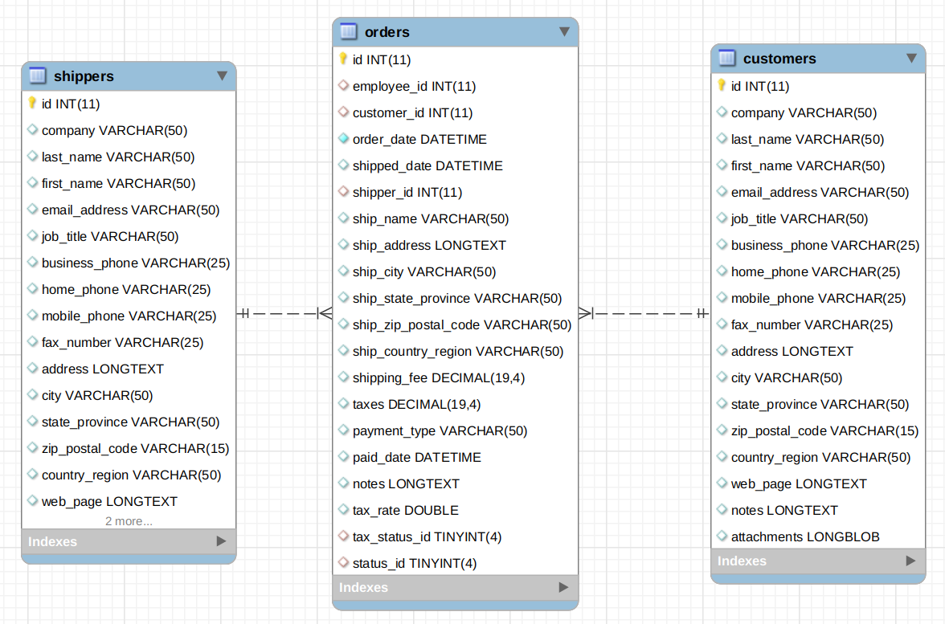
Both customer and shippers has a one to many relationships with orders.
Answer the following questions.
- Design one or more API endpoints to return a list of customers and a single customer
GET /api/customers
GET /api/customer/{id}
GET /api/customer?search={search terms}
GET /api/customers?offset=10&limit=20

b. What are some criteria and how might you might include in your endpoint (wrt Q5a)?
fieldset
pagination
filtering
searching
c. Show a sample output of a customer’s list as a result of performing a GET on the resource. (wrt Q5a)
{
“customer”: [{
“id”: “1234”,
“company”:”ABC Pte Ltd”,
.........
}]
}
d. How do you provide flow control or pagination support (wrt Q5a)?
Introduce throttling for flow control with offset and limit parameters for pagination support.
Question 6
You have deployed a service to encode video viz. convert AVI to mp4, etc. Subscribers of your service uploads their video to the service; after conversion the converted video is returned to the subscriber (assume that the conversion time is short).
You charge the subscribers based on the 2 criteria.
- Subscription rates based on the cumulative video sizes: 500GB, 1TB, 1.5TB, etc. A subscriber who subscribe to the 500GB package can upload a maximum amount of 500GB videos.
- Charge the subscribe based on their ingress and egress traffic viz. the upload and downloads of the videos.
Design an API for this encoding service to give your subscribers control over their encoding process.
You can ignore authentication.
Rate limiting can be done. Based on how much data have transfered over 1 hour, when the limit is exceeds can provide a message in http to indicate to the user to upgrade to next available range and based on compression.

Submission
Copy this Word document to your repository and commit it.
git add .
git commit -m ‘worksheet01’
git push origin master

