Project: Diamond Prices

By. ansjayan@msn.com

# Step 1: Understanding the Model

*Answer the following questions:*

1. According to the model, if a diamond is 1 carat heavier than another with the same cut, how much more should I expect to pay? Why?

**Price** = -5,269 + 8,413 x **Carat** + 158.1 x **Cut** + 454 x **Clarity**

Above is the linear model equation.

Coefficient of carat is 8413. According to it if diamond is 1 carat heavier than another with the same cut, then Price will increase by 8413 units. Unit of price can be dollars.

1. If you were interested in a 1.5 carat diamond with a **Very Good** cut (represented by a 3 in the model) and a **VS2** clarity rating (represented by a 5 in the model), how much would the model predict you should pay for it?

**Price** = -5,269 + 8,413 x **Carat** + 158.1 x **Cut** + 454 x **Clarity**

Price = -5269 + 8413 * 1.5 + 158.1 * 3 + 454 * 5 = 10094.8 units

The price predicted by the model is 10094.8 $, that we should pay for it.

# Step 2: Visualize the Data

Make sure to plot and include the visualizations in this report. For example, you can create graphs in Excel and copy and paste the graphs into this Word document.

1. Plot 1 - Plot the data for the diamonds in the database, with carat on the x-axis and price on the y-axis.

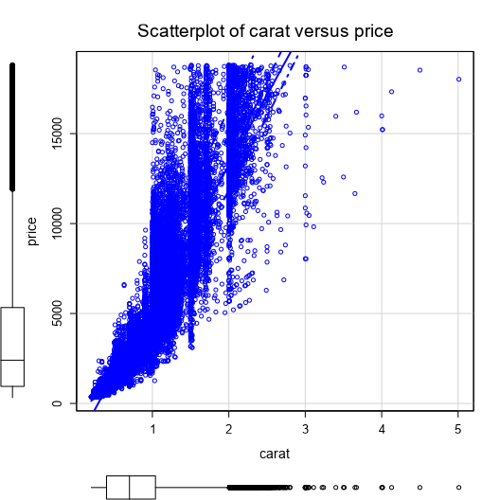

1. Plot 2 - Plot the data for the diamonds for which you are predicting prices with carat on the x-axis and predicted price on the y-axis.
   * **Note**: You can also plot both sets of data on the same chart in different colors.

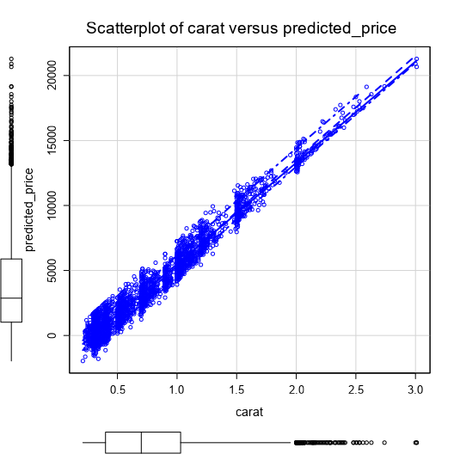

1. What strikes you about this comparison? After seeing this plot, do you feel confident in the model’s ability to predict prices?

The model can predict prices, but some are below 0, which is not possible.

Let us consider carat 1.0 then we can see a few predictions above and below the regression line. That is over and under estimation of price. But almost all points are very near to regression line.

Also we can see that as carat weight increases price increases. So I feel confident in model’s ability to predict prices.

# Step 3: Make a Recommendation

*Answer the following questions:*

1. What price do you recommend the jewelry company to bid? Please explain how you arrived at that number.

8213465.9320 unit[dollar] price is the recommended bid price for the jewelry.

All 3000 diamonds predicted prices are added and multiplied with 0.7 to arrive at the price.

