Market Analysis Report for National Clothing Chain

**Project Instructions**

In this project, we will use population statistics from the US Census Bureau to determine where the greatest income exists around the country and whether there is a correlation between sales and income. We don’t know the incomes of our customers, but we should be able to predict it by looking at their purchase history and locations and comparing that against the census data. Additionally, we want to analyze our inventory, specifically customer ratings and return rate and see if there’s a correlation between the two.

**Draw conclusions**

Draw conclusions from your analysis and use visuals to answer the following questions:

Analysis Questions:

1. What is the correlation (R2 value) between sales and income?

The R2 value between sales and income is 0.78

1. What is the correlation (R2 value) between customer ratings and product return rate?

The R2 value between customer ratings and product return rate is 0.50

1. What are the linear regression formulas to predict customer income from customer sales?

Customer income = (-722.1416 – customer sales) / -0.0107

1. Which customer do you predict has the highest income?

Jon Little has highest income of $ 556790.4987

1. Which product will be advertised the most?

Most advertised product is sweater.

**Present your analysis**

You’ll need to present your analysis as a 1-page written summary and visual report in Power BI. Use the following visuals to present your data:

* Income Distribution: Histogram

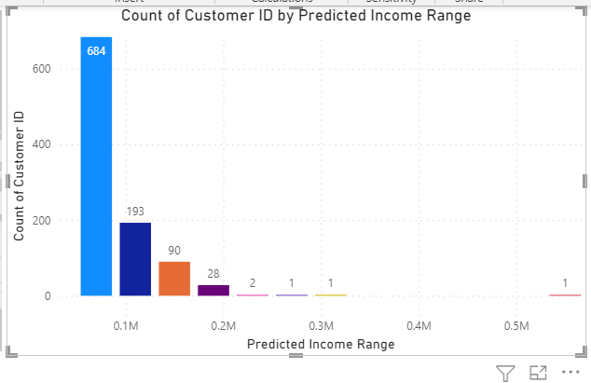

* Household Income by Location: Map

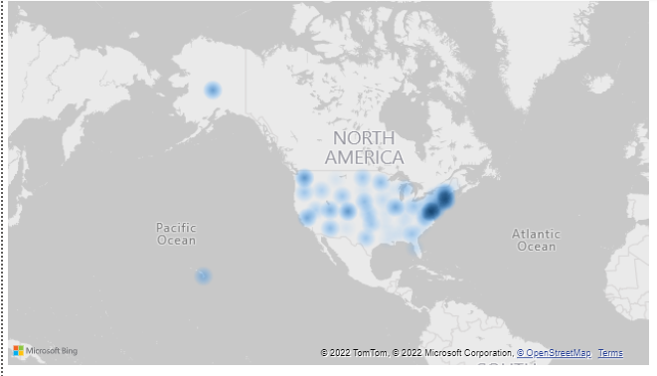

* Correlations: Scatter Plot with Trendline and Card with R^2 value

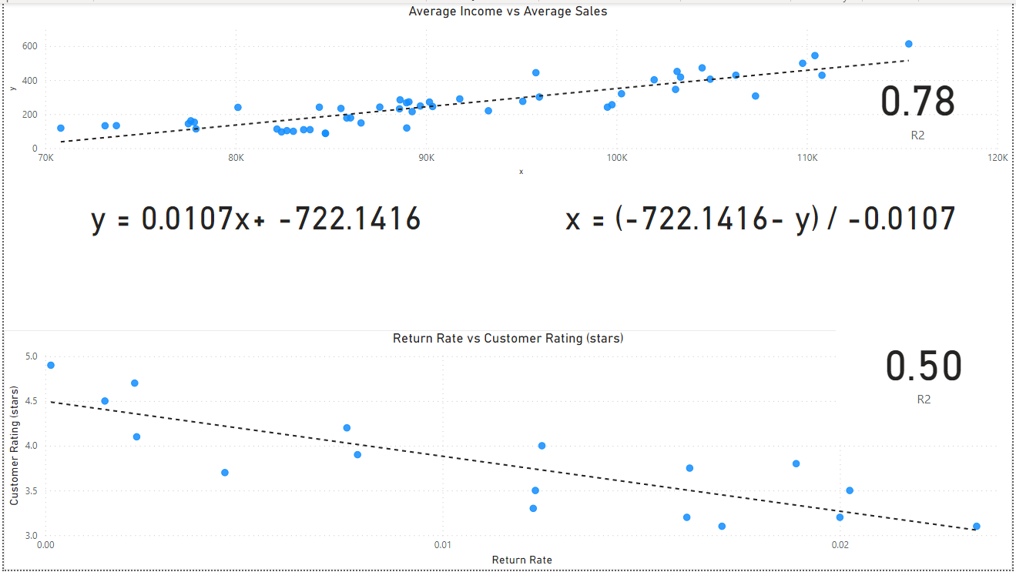

Use other visuals as-needed to further present the results of your analysis.

* Product Recommended: Donut chart and Waterfall chart to show the percentage of sales contributed.

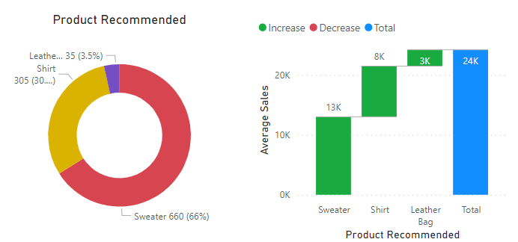

* Products stock distribution: Donut chart to show the stock distribution of various products.

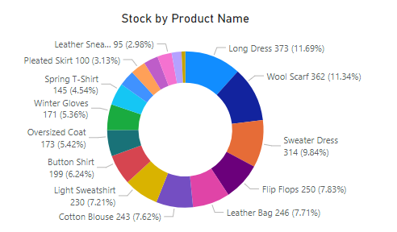

**Marketing Strategy**

Sweater products constitute majority sales, then comes shirt and leather bags. Leather bags are recommended for high income customers, while shirt and sweater products are recommended for medium and low-income customers.