Exchange ECP — 500 Unexpected Error
If you run into this error, here is how to find what is causing it — and a potential fix
Server: mail.anshuweb.online | June 14, 2026

Introduction
If you are seeing a "500 Unexpected Error" when trying to open the Exchange Admin Center (ECP). I ran into this exact problem and want to walk you through what was done— not just the fix, but more importantly, how we found the cause.
The most important thing to know upfront: a 500 error on ECP can be caused by many different things. The solution we found worked for our specific root cause, but your situation might be different. That is why this guide focuses on helping you diagnose the error first, so you can make an informed decision about what fix applies to you.
1 | The Problem  What we saw when ECP stopped working

We attempted to log in to the Exchange Admin Center and instead of the dashboard, the browser showed a blank 500 error page with no useful detail:
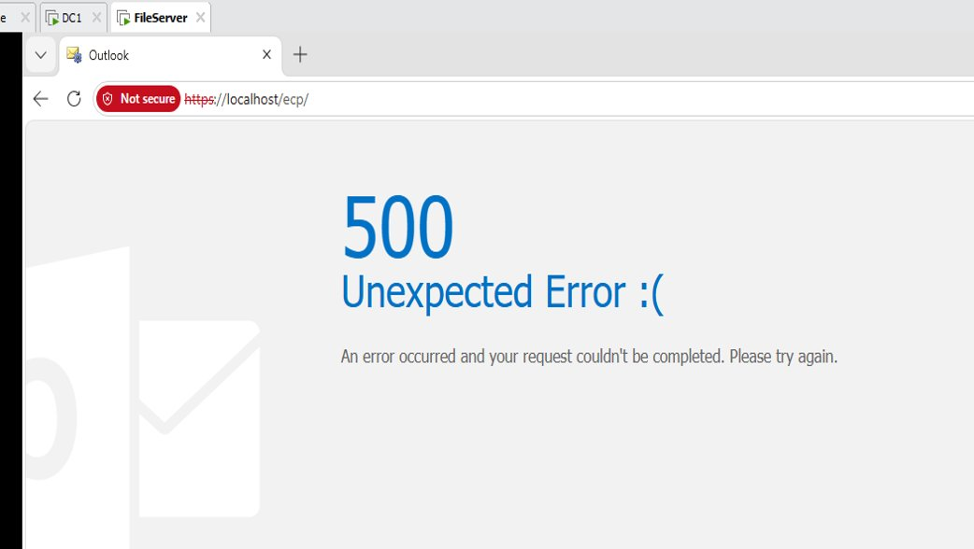
Figure 1 — 500 Unexpected Error on https://localhost/ecp/ . The browser gave no further information about what went wrong.
With nothing on the screen to go on, the immediate next step was to check the server logs.
2 | Step 1 — Check Event Viewer First  Always read the logs before touching anything

The first thing we did was open Event Viewer on the Exchange server. This should always be the very first move when ECP throws a 500 error — the Application log almost always contains the real exception that the browser is hiding.
💡 | Never run fix commands before checking Event Viewer. The log tells you exactly what Exchange is complaining about. Without it you are guessing — and the wrong fix wastes time and can make things worse.

How to find the error:
- Press Win + R, type eventvwr.msc and press Enter.
- Navigate to: Windows Logs → Application in the left panel.
- Click "Filter Current Log..." on the right and filter by Level: Error, Source: MSExchange Control Panel.
- Click the most recent error matching the time ECP failed.
- Open the Details tab to read the full exception and stack trace.
In this scenario, we cleared all the logs, applied a level-based filter, and then attempted to sign in to https://localhost/ecp to reproduce the issue again.This is what we found — multiple errors from MSExchange Control Panel (Event ID 4) clustered around the time ECP went down:
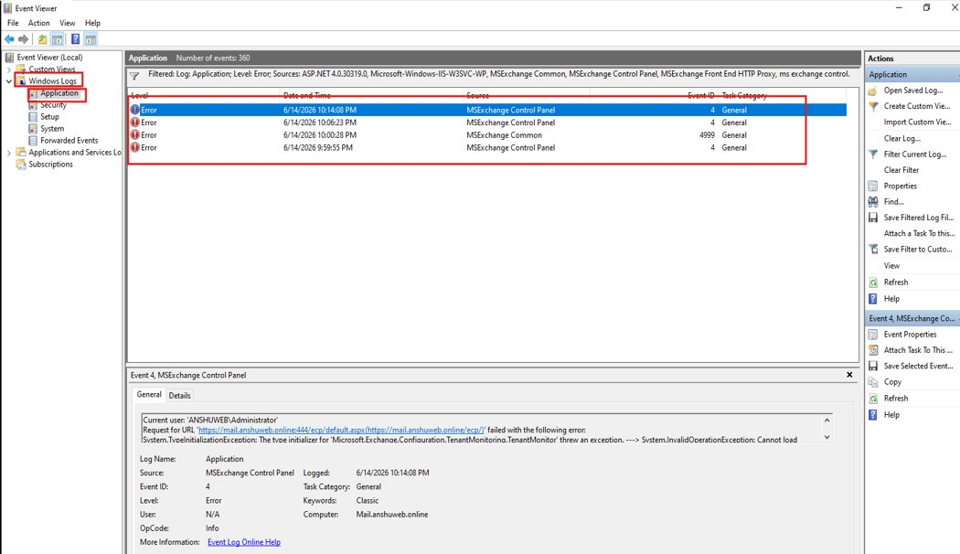
Figure 2 — Event Viewer Application log showing MSExchange Control Panel errors (Event ID 4) at 10:14 PM on 6/14/2026.
Clicking into the top error and switching to the Details tab revealed the full stack trace:
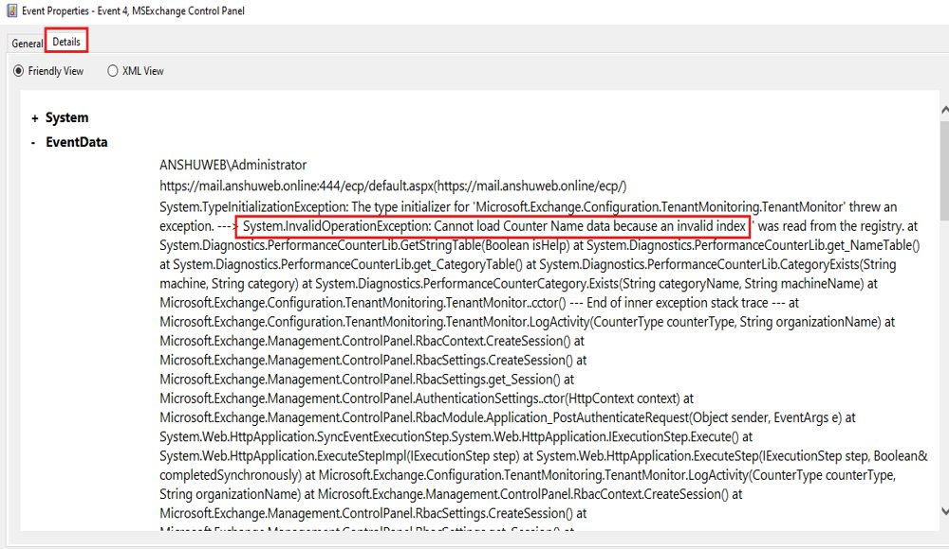
Figure 3 — Details tab showing the full exception. The key line is highlighted: System.InvalidOperationException — cannot load Performance Counter data from the registry.
The critical line was:
System.InvalidOperationException: Cannot load Counter Name data because an
invalid index was read from the registry.

System.TypeInitializationException: The type initializer for
'Microsoft.Exchange.Configuration.TenantMonitoring.TenantMonitor' threw an exception.

This pointed us directly to corrupted Windows Performance Counter registry entries as the root cause. Exchange's Tenant Monitor could not initialize because of this, crashing ECP before it could even load.
⚠️ | Your Event Viewer may show a completely different error — a certificate problem, missing DLL, database issue, or authentication failure. If so, the fix in this guide may not apply to you. Let your own Event Viewer findings guide which fix you use.

3 | Step 2 — PowerShell Diagnostic Commands  Ruling out other potential causes before fixing

Even with a lead from Event Viewer, we ran a series of PowerShell health check commands to rule out other common causes of ECP failures — such as stopped services, unmounted databases, or a crashed app pool. This is good practice because sometimes multiple things are wrong at once.

Check 1 — Is the Exchange Transport service running?
Get-Service MSExchangeTransport
This checks whether the Microsoft Exchange Transport service is running. If it is stopped, mail flow is broken which can sometimes surface as ECP errors. In our case it was running, so we also restarted it to rule out any transient issue:
Stop-Service MSExchangeTransport
Start-Service MSExchangeTransport

Check 2 — Are mailbox databases mounted?
Get-MailboxDatabase -Status | ft Name,Mounted
This confirms whether the mailbox database is mounted and accessible. A dismounted database can cause ECP to behave unexpectedly. Our database showed Mounted: True — so this was not the cause.

Check 3 — Overall Exchange service health
Test-ServiceHealth
This runs a health check across all Exchange server roles and lists which required services are running and which are not. In our case all required services were running (ServicesNotRunning returned empty), confirming the issue was not a stopped service.
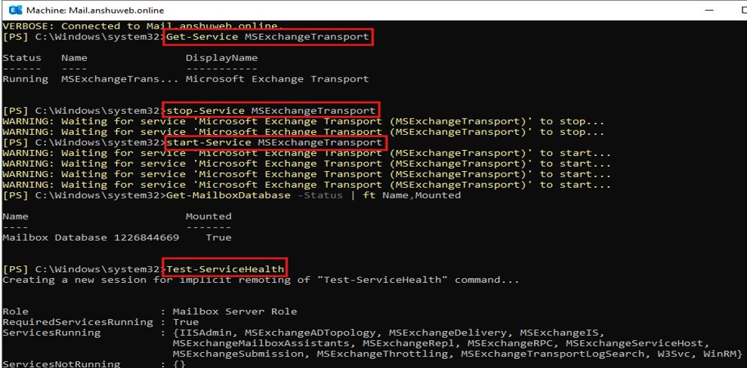
Figure 4 — PowerShell diagnostic results: Transport service running and restarted cleanly, Mailbox Database mounted (True), Test-ServiceHealth showing all required services running with ServicesNotRunning: {}

Check 4 — Is the ECP App Pool running in IIS?
Import-Module WebAdministration
Get-WebAppPoolState MSExchangeECPAppPool

This checks the state of the MSExchangeECPAppPool in IIS — the application pool that serves the ECP web application. It returned "Started", meaning the app pool itself was up. We restarted it anyway as a precaution:
Restart-WebAppPool MSExchangeECPAppPool

Check 5 — Verify ECP virtual directory URLs
Get-EcpVirtualDirectory | fl Identity,InternalUrl,ExternalUrl

This confirms that the ECP virtual directory is correctly configured with the right internal and external URLs. Our output showed the correct InternalUrl of https://mail.anshuweb.online/ecp and ExternalUrl was blank — both expected for our setup.
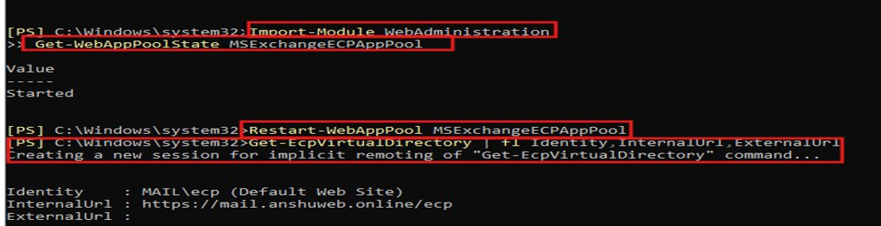
Figure 5 — App Pool state returned "Started". ECP virtual directory confirmed with correct InternalUrl. ExternalUrl blank as expected.
📋 | All five diagnostic checks came back healthy — services running, database mounted, app pool started, URLs correct. This confirmed the problem was not with any of these components and pointed us back to the Performance Counter root cause identified in Event Viewer.

4 | Step 3 — First Fix Attempt  Standard Exchange recovery commands — did not fully resolve the issue

With the root cause suspected but not yet fully confirmed, we first tried the standard Exchange recovery commands that are commonly used when ECP has issues. These are run from the Exchange Management Shell as Administrator:
cd "O:\Program Files\Microsoft Exchange Server\V15\Bin"
.\UpdateCas.ps1
.\UpdateConfigFiles.ps1
iisreset

What these do:
- UpdateCas.ps1 — Refreshes the Client Access Server configuration for OWA and ECP.
- UpdateConfigFiles.ps1 — Updates Exchange-related configuration files across the server.
- iisreset — Restarts IIS so Exchange picks up the refreshed configuration.

Figure 6 — Running UpdateCas.ps1 in Exchange Management Shell at 10:07 PM. Script found and updated OWA/ECP config on server

