Software Requirement Specifications
<College Teacher Roll Call & Management System>



Submitted by
<Ans bin Mushtaq (S23BINFT1M01047)>

Submitted to
<Dr Omer Riaz >

Department of Information Technology
Faculty of Computing
The Islamia University of Bahawalpur

Meeting Details
Sr No | Details | Date | Supervisor Signature
Summary
EduManage Pro is a web-based system designed to digitize and simplify college teacher management processes. It replaces manual record-keeping methods with a centralized platform for handling attendance, timetables, and staff data. The system enables teachers to mark attendance efficiently while allowing administrators to manage records and generate reports. It improves accuracy, reduces paperwork, and saves time through automation. With secure data storage and user-friendly design, the platform ensures reliable and easy access to information. Overall, EduManage Pro enhances productivity and streamlines academic administration in educational institutions.

Table of Contents
1. Introduction 4
1.1. Purpose 4
1.2. Scope 4
1.3. Product Perspective 4
1.4. User Characteristics 4
1.5. Similar apps and systems/Literature Review 4
1.6. Proposed Technologies 4
2. Requirements 5
2.1. Function Requirements 5
2.1.1. Sign Up 5
2.2. Non-Functional Requirements 5
3. Use Cases and Flow of Processes 6
3.1. Use Case 1 7
4. References 8

- Introduction
Edu Manage Pro is a web-based system designed to digitize and streamline administrative and academic record management for college teaching staff. The system replaces traditional paper-based methods with a centralized digital platform, improving efficiency, accuracy, and accessibility of teacher-related data such as attendance, schedules, and records.
1.1 Purpose
The purpose of this document is to provide a detailed description of the requirements for the EduManage Pro system. It outlines the system’s functionality, constraints, and features to guide developers, stakeholders, and evaluators in understanding the system design and implementation.
1.2 Scope
EduManage Pro is intended for colleges and educational institutions to manage teacher-related operations such as:
- Teacher registration and authentication
- Attendance and roll call management
- Subject and timetable assignment
- Record maintenance and reporting
The system will be accessible via web browsers and designed for both administrators and teaching staff.
1.3 Product Perspective
Edu Manage Pro is a standalone web application that integrates multiple administrative functions into one unified system. It replaces manual processes such as:
- Paper attendance registers
- Spreadsheet-based staff records
- Manual timetable handling
The system interacts with a centralized database to store and retrieve information securely.
1.4 User Characteristics
The system is designed for the following users:
- Administrator
  - Basic to intermediate computer skills
  - Responsible for managing teachers, schedules, and reports
- Teachers
  - Basic computer and internet knowledge
  - Use the system for attendance marking and viewing schedules
1.5 Similar Apps and Systems / Literature Review
Several systems exist that partially address academic management, such as:
- Learning Management Systems (LMS)
- Attendance Management Software
- ERP systems for educational institutions
However, many of these systems are either complex, expensive, or not specifically focused on teacher roll call and management. EduManage Pro aims to provide a simplified, cost-effective, and focused solution tailored for colleges.
1.6 Proposed Technologies
The system will be developed using modern web technologies:
- Frontend: HTML, CSS, JavaScript (React or Bootstrap)
- Backend: Node.js / PHP / Django (depending on implementation)
- Database: MySQL / MongoDB
- Version Control: Git
- Hosting: Cloud-based or local server
2. Requirements
2.1 Functional Requirements
The system must provide the following functionalities:
- User registration and login
- Role-based access control (Admin, Teacher)
- Teacher profile management
- Attendance marking system
- Timetable management
- Report generation
- Data storage and retrieval
2.1.1 Sign Up
The system shall allow new users to register by providing:
- Full name
- Email address
- Password
- Role (Teacher/Admin)
Validation Rules:
- Email must be unique
- Password must meet minimum security requirements
- All required fields must be filled
Post-condition:
- User account is created and stored in the database
2.2 Non-Functional Requirements
- Performance:
The system should respond to user actions within 2–3 seconds.
- Security:
  - User authentication and authorization must be implemented
  - Passwords must be encrypted
- Usability:
  - User-friendly interface
  - Easy navigation
- Reliability:
  - System should handle errors gracefully
  - Data should not be lost
- Scalability:
  - System should support increasing number of users
- Availability:
  - System should be accessible 24/7 (if hosted online)

- Use Cases and Flow of Processes
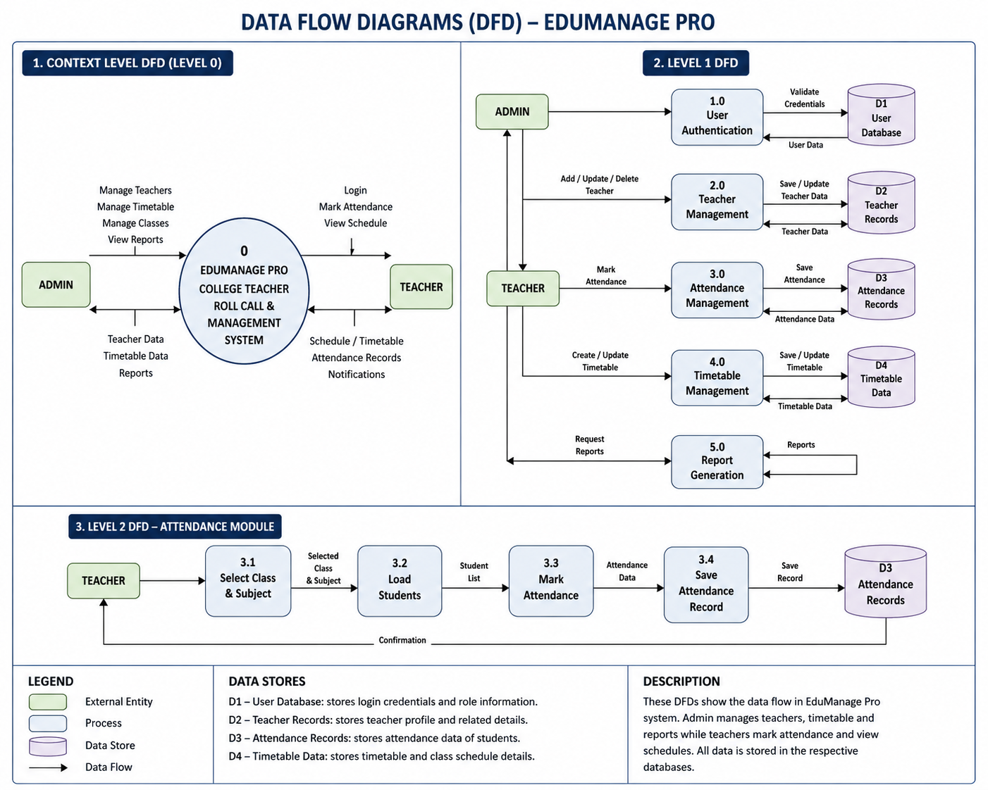
3.1 Use Case 1: Teacher Marks Attendance

Actors: Teacher
Preconditions:
- Teacher must be logged in
- Timetable must be assigned
Main Flow:
- Teacher logs into the system
- Navigates to attendance section
- Selects class and subject
- Marks student attendance
- Submits attendance
Postconditions:
- Attendance is stored in the database
- Records are available for reports
Alternative Flow:
- If internet fails → Data should be retried or saved temporarily
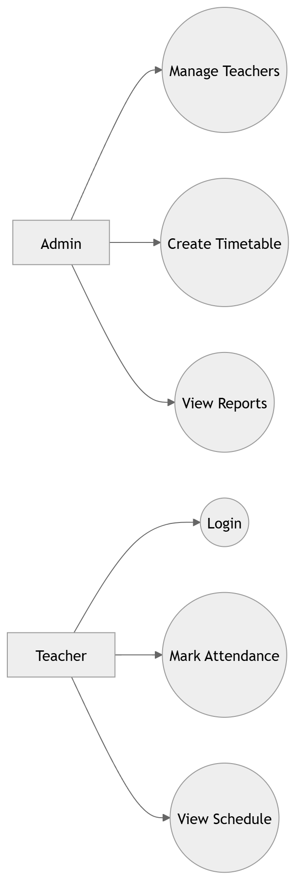

4. References
- IEEE SRS Documentation Standards
- Software Engineering Books and Academic Resources
- Online documentation for selected technologies (Node.js, MySQL, etc.)

