Contents

1 FAQ 2

1.1 Downtime 2

1.2 Publications in old regulation 2

# FAQ

## Downtime

Below are outlined the availability and down-times during the update

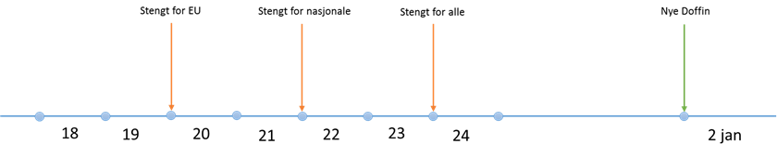

**19th December 24:00**

No more publication above EU-threshold

The stop applies to Doffin.no and all integrators

**21st December 24:00**

No more publications for national and volunteer notices

The stop applies to Doffin.no and all integrators

**23rd December 24:00**

All is closed

**The following are available until 23rd December**

* Fetch and Get statuses
* Approve translations for above EU threshold
* Send translations for above EU threshold
* Download published notices
* Search publication
* Register interest

## Publications in old regulation

Contracts with notices published under the old regime will after January 1st 2017 follow the new regulations for publishing notices regarding these contracts.

Notice for changes or additional information (F14) will be handled by use of new schemas

“Old notices” cannot be republished with a new version – new schemas has to be used if a new version of the contract award shall be published. I have not checked this, but most likely it will also be possible to use F20 even if the contract was made under the old regime.

There might be a few Contracting Authorities which has published a PIN in 2016 that would like to continue the process according to the old regime, but these will be handled one by one, since there are no good reasons for them to continue under the old regime.