Chapter 4 Results, Discussion, and Limitations
Bayesian and ML reconstruction of the long-term tillage dataset
Draft review note. Yellow highlighting identifies literature connections or substantive interpretation that should receive explicit author review.

3 Results and Discussion
Results are presented as evidence of ML calibration and predictor structure, annual and cumulative reconstruction, goodness of fit and temporal agreement, and cross-framework complementarity. Observed annual loads and runoff volumes are reported only when every expected physical event in a year-treatment group had the corresponding observation; incomplete annual subtotals are retained in the audit files but are not presented as observed annual values.

3.1 ML calibration, interval coverage, and predictor structure
Year-specific interval coverage varied across the record (Figure 1). Bayesian posterior-predictive concentration coverage ranged from 67.9% in 2025 to 95.2% in 2016, with weighted overall coverage of 80.5%. ML outer-LOYO concentration coverage ranged from 66.3% in 2025 to 97.2% in 2011, with weighted overall coverage of 80.8%. Neither framework had concentration observations available for annual coverage evaluation in 2018 or 2019.
Runoff-volume coverage separated the frameworks more clearly. Bayesian posterior-predictive volume coverage was 45.7% overall and ranged from 29.6% to 74.1% among evaluable years. ML outer-LOYO volume coverage was 87.6% overall, but fell to 11.1% in 2024. Coverage returned to 100.0% in the strongest year and was high in 2023 and 2025, so the 2024 failure was not explained by a simple late-record decline in data support. Instead, the 2024 result indicates a year-specific distribution shift or event and measurement conditions not represented adequately by the remaining years.
This temporal instability is consistent with long-term edge-of-field monitoring studies that treat missing observations, changing measurement methods, and measurement uncertainty as structural features of operational datasets rather than minor data-cleaning problems (Harmel et al., 2006, 2023; Daniels et al., 2018; Harmel, King, et al., 2018).
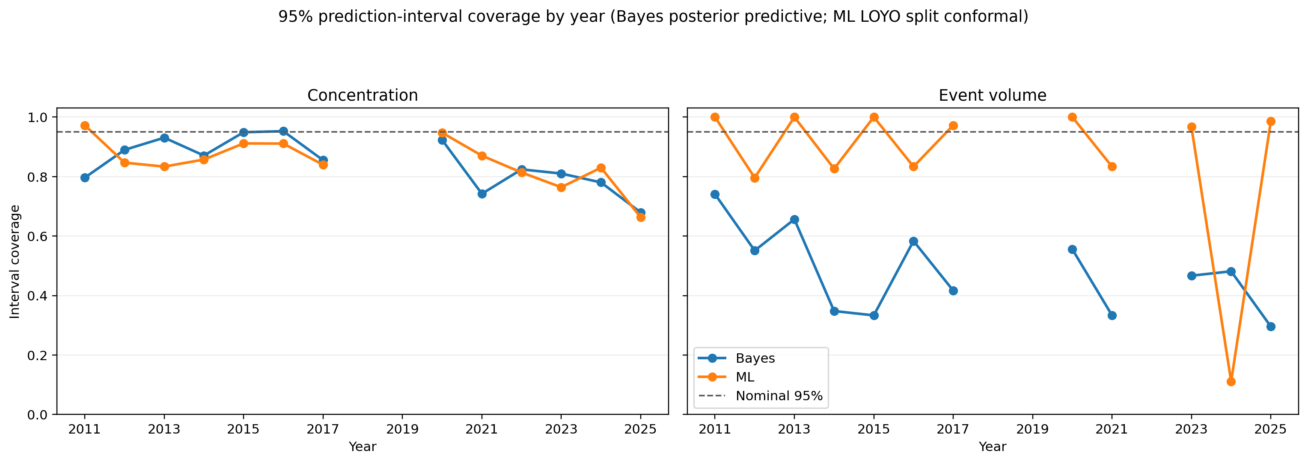
Figure 1. Year-specific concentration and runoff-volume interval coverage for Bayesian posterior-predictive intervals and ML outer leave-one-year-out (LOYO) prediction intervals. Years without observed targets have no coverage estimate.
Draft source: figures/comparison/v3p0_physical_event/postprocessing/loyo_interval_coverage_by_year.png
The concentration model was dominated by analyte identity, which accounted for a mean importance of 58.9, followed by inflow concentration at 11.6 (Figure 2). Laboratory reporting fields, including method detection and reporting limits, formed the next tier of predictors. Thus, the concentration model primarily learned differences among analytes and source-water chemistry, while also using information associated with laboratory methods. The presence of laboratory metadata among influential variables supports prediction within the historical record but also shows that part of the learned structure was specific to the measurement system.
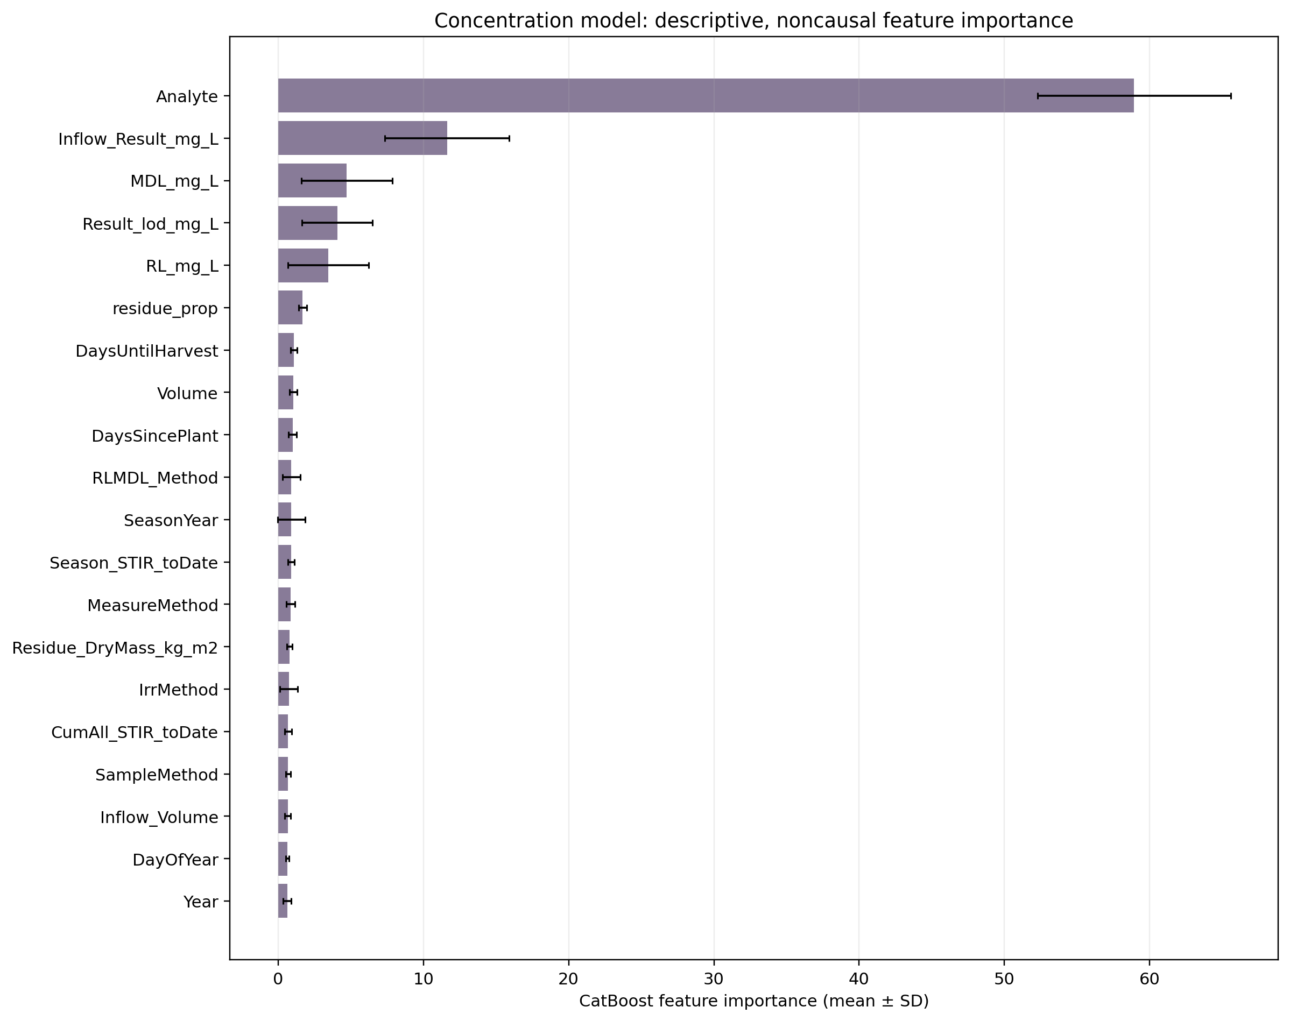
Figure 2. Descriptive CatBoost feature importance for concentration reconstruction. Bars show mean importance across fitted models and error bars show the corresponding standard deviation. Importance is descriptive and does not identify causal effects.
Draft source: figures/comparison/v3p0_physical_event/postprocessing/feature_importance_concentration.png
Runoff-volume importance was distributed across seasonal timing and measurement context (Figure 3). Days until harvest had the largest mean importance (18.5), followed by days since planting (10.5), measurement method (9.9), day of year (9.9), flume method (8.2), and inflow volume (6.7). This broader distribution is consistent with runoff volume being conditioned by within-season timing, water delivery, and the measurement configuration. Treatment variables were not dominant, so feature importance did not provide direct evidence that tillage caused the reconstructed volume differences.
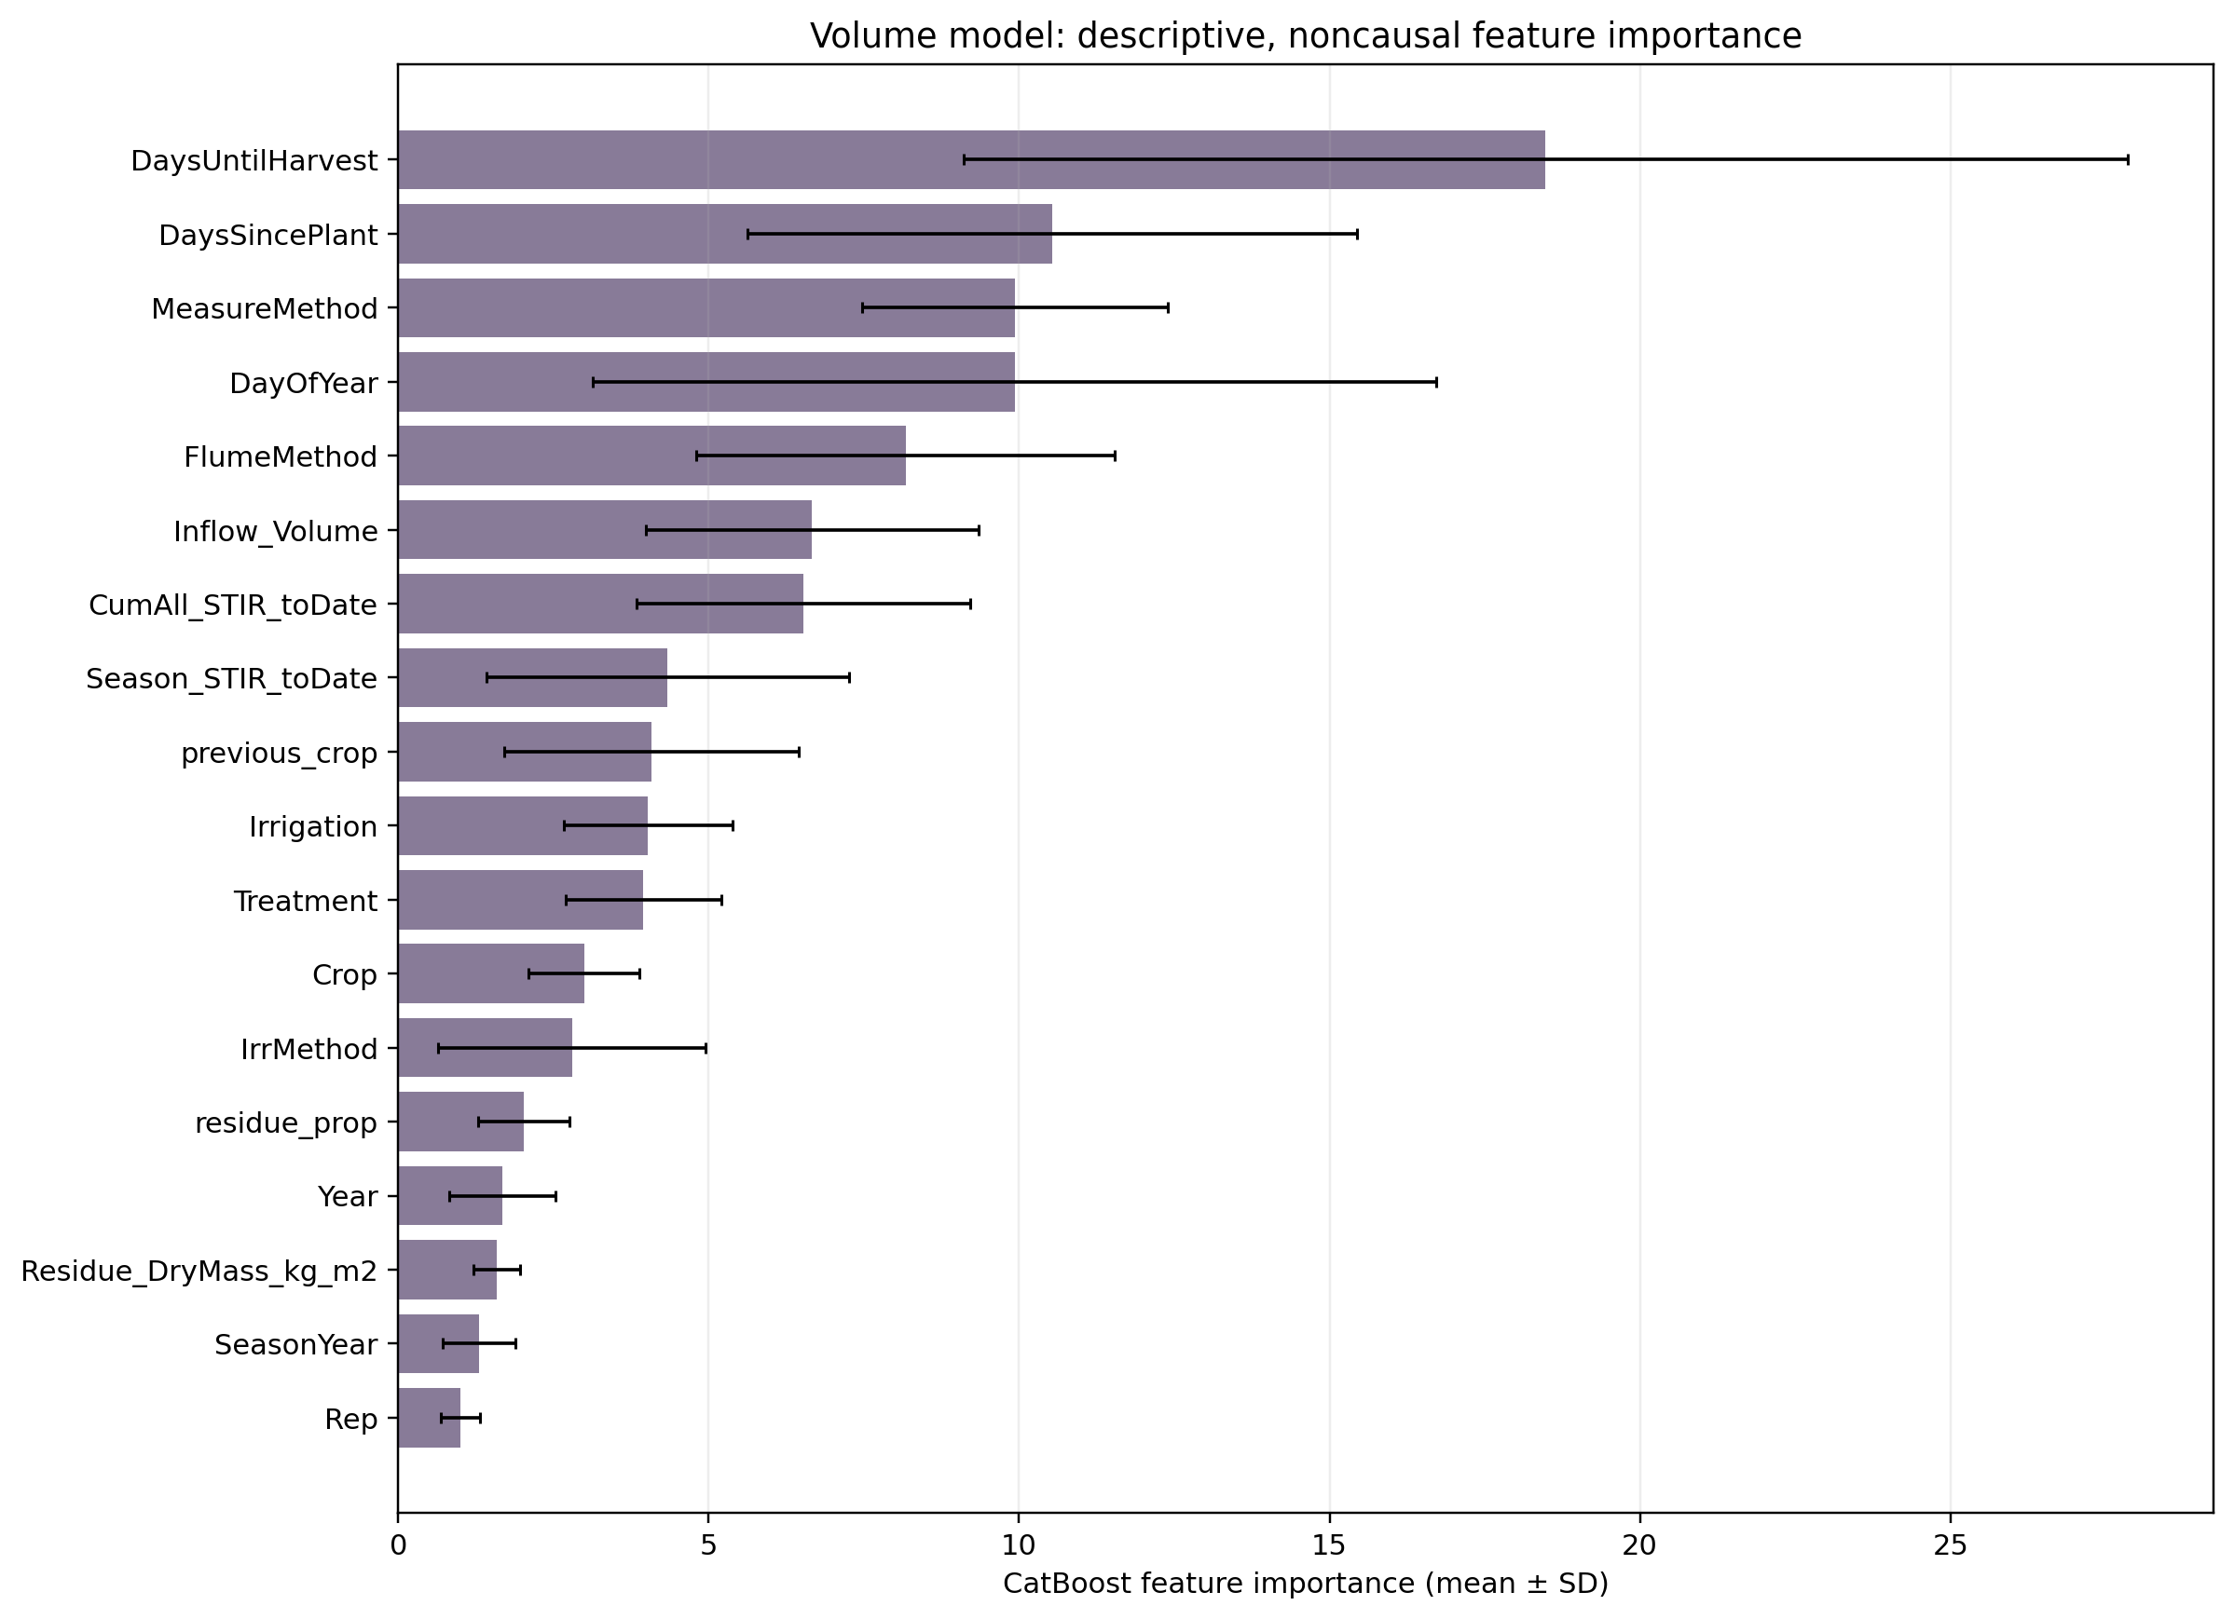
Figure 3. Descriptive CatBoost feature importance for runoff-volume reconstruction. Bars show mean importance across fitted models and error bars show the corresponding standard deviation.
Draft source: figures/comparison/v3p0_physical_event/postprocessing/feature_importance_volume.png

3.2 Annual and cumulative reconstruction
Only 19 of 135 possible annual load groups for TSS, TP, and TN had a complete observed event record. TSS and TP each had eight complete year-treatment groups, whereas TN had three, all in 2016. Complete annual runoff volume was available for 9 of 45 year-treatment groups. Reporting the remaining partial subtotals as annual observations would have implied that missing events produced zero load or volume. Their exclusion makes the information gap explicit and shows why model-based reconstruction was required for comparison across 2011-2025.

Bayesian annual runoff-volume estimates were generally larger and less variable from year to year than the ML point totals (Figure 4; Table 1). Across the nine complete annual volume groups, the ML point totals were descriptively closer to the observed totals than the Bayesian posterior means, but this comparison covers only 2015-2017 and is not an independent validation of the reconstructed record. The study-period sums of annual central estimates were 5,787, 5,432, and 5,430 kL for Bayesian CT, MT, and ST, compared with 3,819, 3,481, and 3,512 kL for ML. Differences in reconstructed volume therefore propagated directly into differences in constituent loads.
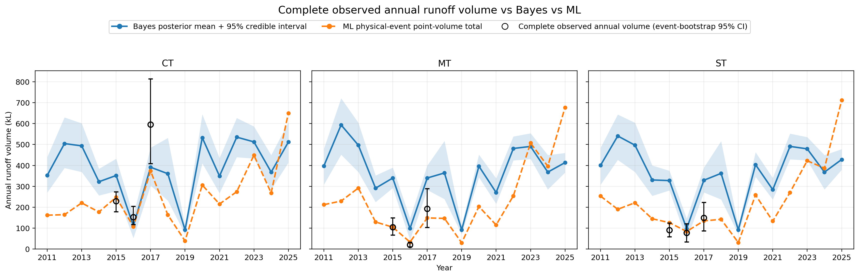
Figure 4. Annual runoff volume by treatment from the Bayesian and ML reconstructions. Observed annual markers are included only when every expected physical event had a runoff-volume observation. ML annual prediction intervals are omitted from the primary panel for readability.
Draft source: figures/comparison/v3p0_physical_event/annual_complete_observed/annual_runoff_volume_complete_observed_v3p0.png
Table 1. Annual runoff-volume reconstruction and complete observed totals (kL).
Year | CT  Observed | CT  Bayes | CT  ML | MT  Observed | MT  Bayes | MT  ML | ST  Observed | ST  Bayes | ST  ML
2011 | NA | 352.8 | 162.1 | NA | 397.6 | 212.3 | NA | 400.2 | 253.4
2012 | NA | 504.3 | 164.5 | NA | 593.4 | 229.6 | NA | 540.6 | 190.3
2013 | NA | 493.4 | 220.6 | NA | 496.6 | 291.9 | NA | 496.6 | 221.5
2014 | NA | 321.9 | 177.4 | NA | 291.1 | 129.7 | NA | 330.5 | 145.1
2015 | 229.2 | 351.7 | 247.6 | 105.3 | 339.8 | 104.8 | 90.4 | 327.4 | 126.5
2016 | 153.2 | 110.9 | 107.7 | 20.6 | 98.7 | 33.5 | 78.2 | 97.7 | 84.2
2017 | 595.1 | 391.2 | 373.2 | 192.4 | 339.8 | 149.0 | 149.2 | 329.1 | 134.8
2018 | NA | 360.4 | 163.7 | NA | 363.9 | 146.8 | NA | 362.1 | 142.3
2019 | NA | 91.9 | 39.1 | NA | 91.9 | 30.2 | NA | 91.9 | 31.4
2020 | NA | 532.5 | 306.1 | NA | 396.3 | 203.4 | NA | 403.5 | 258.5
2021 | NA | 348.9 | 215.4 | NA | 270.4 | 115.4 | NA | 283.9 | 133.7
2022 | NA | 535.1 | 274.2 | NA | 480.9 | 254.4 | NA | 490.8 | 270.5
2023 | NA | 512.4 | 448.8 | NA | 490.7 | 507.1 | NA | 479.1 | 422.4
2024 | NA | 367.8 | 268.5 | NA | 367.8 | 395.8 | NA | 367.8 | 386.4
2025 | NA | 511.9 | 649.8 | NA | 413.5 | 676.9 | NA | 428.2 | 711.2
Note. Bayes is the posterior mean; ML is the physical-event point total. NA indicates that at least one expected physical event lacked an observed runoff-volume value. Draft source: results/comparison/v3p0_physical_event/annual_runoff_volume_complete_observed_raw.csv

TSS produced the largest absolute loads and the strongest agreement in treatment direction (Figure 5; Table 2). The Bayesian reconstruction estimated a CT maximum of 1,136 kg in 2018, whereas the ML reconstruction estimated a CT maximum of 1,014 kg in 2017. The complete 2017 CT observation was 2,163 kg, showing that both annual central estimates underrepresented that observed peak. Despite differences in annual magnitude, both frameworks produced lower study-period TSS totals for MT and ST than for CT.
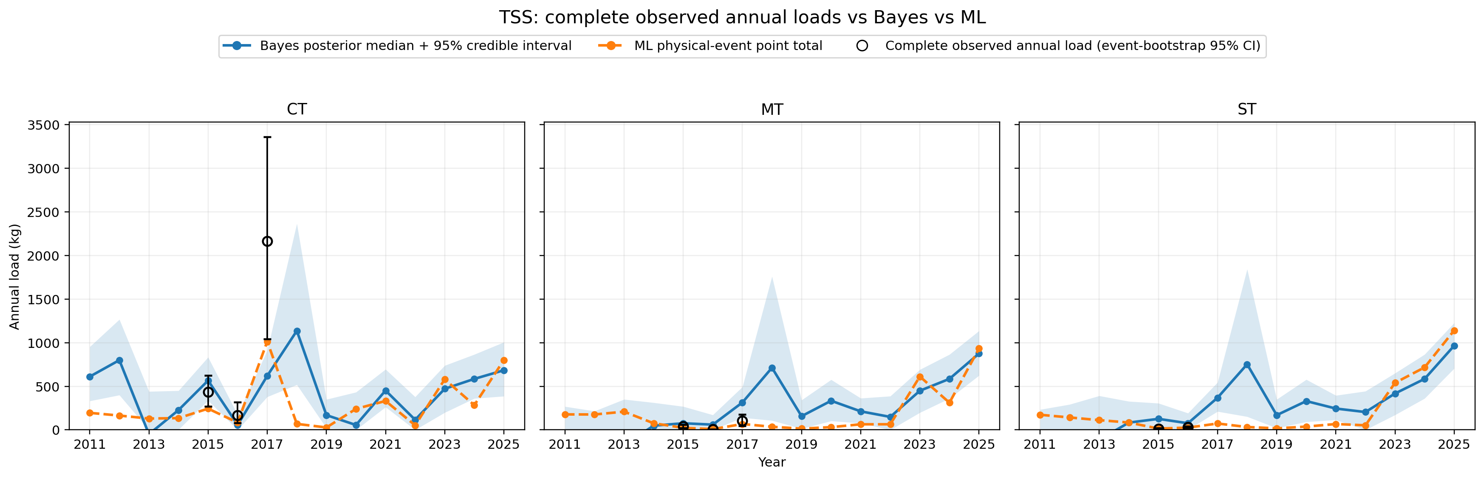
Figure 5. Annual TSS load by treatment from the Bayesian and ML reconstructions. Observed annual markers are included only when all expected physical-event TSS loads were observed.
Draft source: figures/comparison/v3p0_physical_event/annual_complete_observed/annual_load_tss_complete_observed_v3p0.png
Table 2. Annual TSS reconstruction and complete observed totals (kg).
Year | CT  Observed | CT  Bayes | CT  ML | MT  Observed | MT  Bayes | MT  ML | ST  Observed | ST  Bayes | ST  ML
2011 | NA | 611.1 | 195.0 | NA | -78.7 | 177.5 | NA | -125.6 | 173.1
2012 | NA | 799.7 | 164.1 | NA | -342.1 | 176.4 | NA | -225.8 | 142.2
2013 | NA | -49.9 | 129.7 | NA | -174.0 | 208.6 | NA | -114.0 | 111.5
2014 | NA | 227.1 | 134.9 | NA | 47.9 | 75.4 | NA | 83.2 | 84.0
2015 | 432.1 | 566.1 | 243.5 | 38.4 | 75.6 | 23.2 | 12.5 | 126.1 | 14.5
2016 | 165.9 | 57.0 | 83.5 | 5.0 | 59.8 | 8.5 | 29.1 | 75.8 | 25.7
2017 | 2162.9 | 619.6 | 1014.4 | 105.2 | 314.1 | 67.0 | NA | 368.7 | 72.7
2018 | NA | 1136.3 | 68.5 | NA | 712.7 | 35.5 | NA | 752.7 | 32.7
2019 | NA | 168.9 | 27.4 | NA | 156.8 | 14.1 | NA | 168.9 | 17.2
2020 | NA | 55.8 | 240.6 | NA | 333.8 | 31.2 | NA | 330.0 | 37.3
2021 | NA | 451.5 | 331.6 | NA | 212.3 | 63.7 | NA | 244.5 | 67.0
2022 | NA | 115.4 | 52.4 | NA | 148.6 | 64.1 | NA | 204.3 | 52.2
2023 | NA | 471.2 | 579.8 | NA | 448.8 | 611.9 | NA | 416.9 | 539.2
2024 | NA | 584.6 | 283.0 | NA | 585.0 | 311.4 | NA | 584.6 | 716.7
2025 | NA | 683.8 | 801.0 | NA | 875.4 | 933.9 | NA | 965.6 | 1141.0
Note. Bayes is the posterior median; ML is the physical-event point total. NA denotes an incomplete observed annual event record. Raw negative Bayesian annual medians are retained. Draft source: results/comparison/v3p0_physical_event/annual_load_complete_observed_raw.csv

TP showed the clearest disagreement in treatment interpretation (Figure 6; Table 3). Both frameworks identified 2025 as the largest reconstructed TP year in all three treatments. However, the Bayesian cumulative medians were 3.439, 2.279, and 2.092 kg for CT, MT, and ST, corresponding to 35.1% and 40.3% lower loads under MT and ST than CT. ML cumulative point totals were 3.053, 3.368, and 3.407 kg and therefore placed MT and ST 10.3% and 11.6% above CT. TP conclusions were consequently sensitive to model structure rather than being common to both reconstructions.
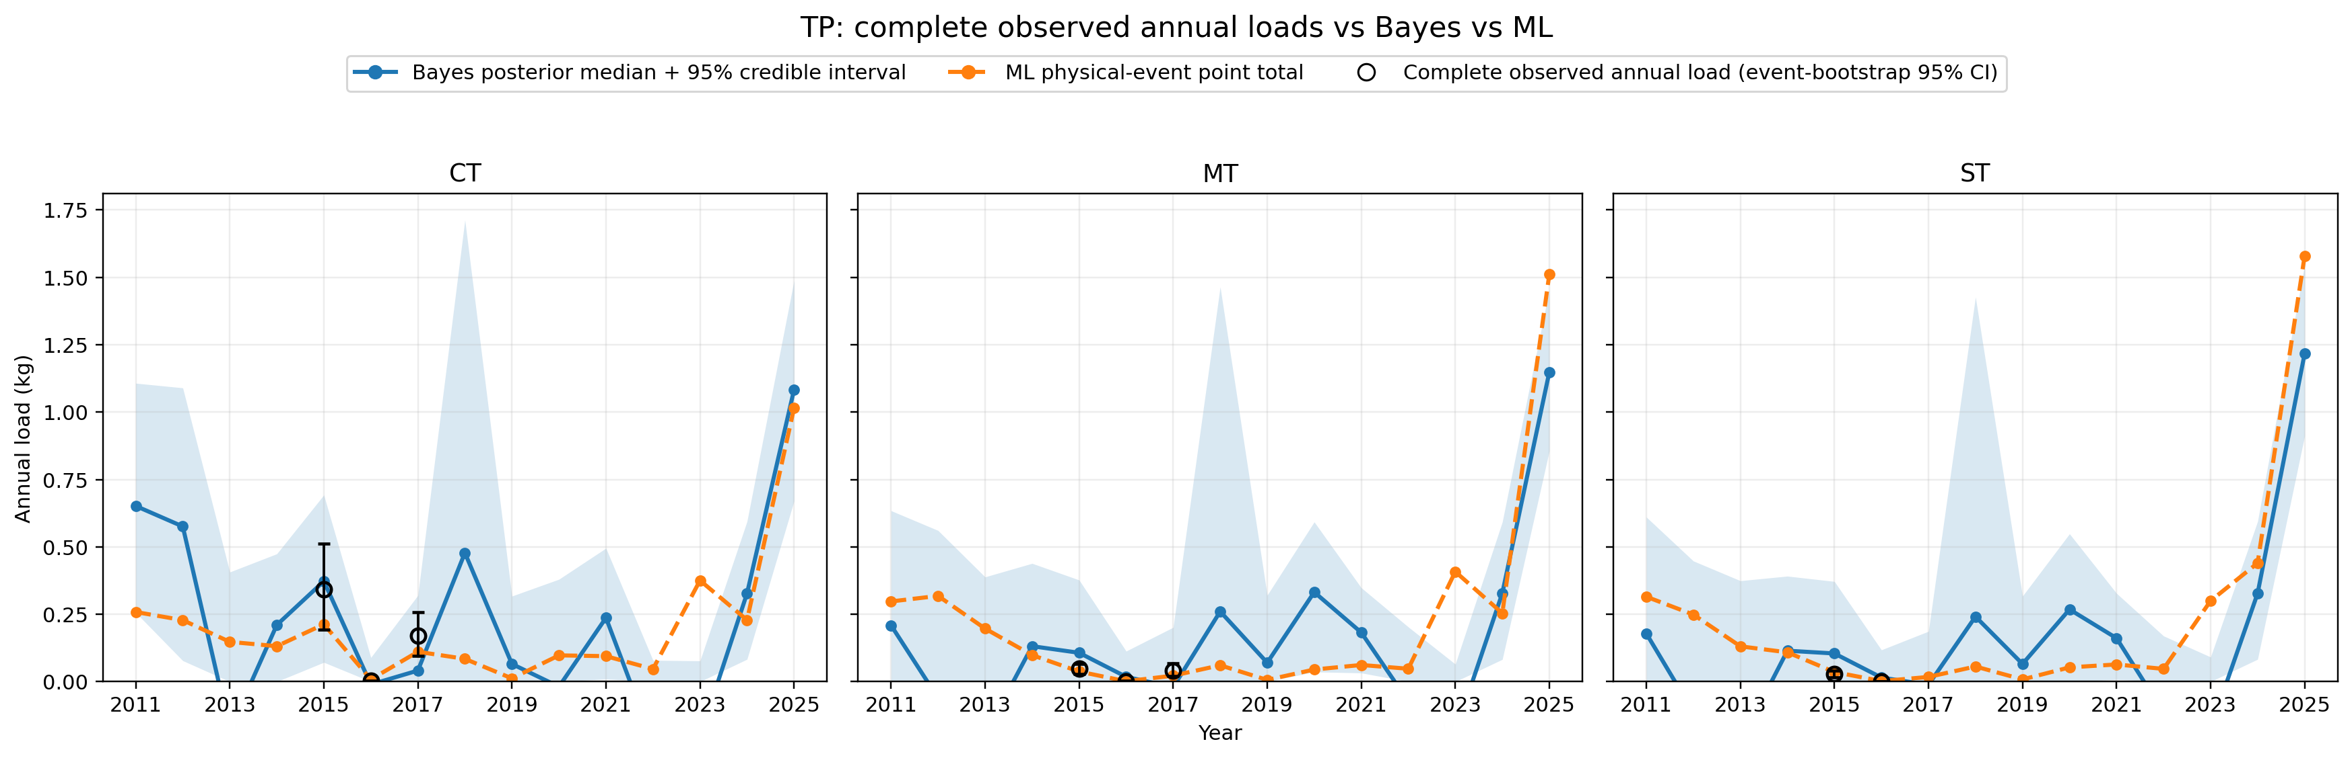
Figure 6. Annual TP load by treatment from the Bayesian and ML reconstructions. Observed annual markers are included only when all expected physical-event TP loads were observed.
Draft source: figures/comparison/v3p0_physical_event/annual_complete_observed/annual_load_tp_complete_observed_v3p0.png
Table 3. Annual TP reconstruction and complete observed totals (kg).
Year | CT  Observed | CT  Bayes | CT  ML | MT  Observed | MT  Bayes | MT  ML | ST  Observed | ST  Bayes | ST  ML
2011 | NA | 0.652 | 0.258 | NA | 0.209 | 0.298 | NA | 0.178 | 0.315
2012 | NA | 0.576 | 0.228 | NA | -0.061 | 0.318 | NA | -0.114 | 0.249
2013 | NA | -0.180 | 0.148 | NA | -0.196 | 0.197 | NA | -0.224 | 0.131
2014 | NA | 0.210 | 0.132 | NA | 0.132 | 0.098 | NA | 0.115 | 0.109
2015 | 0.342 | 0.373 | 0.213 | 0.049 | 0.107 | 0.037 | 0.028 | 0.105 | 0.036
2016 | 0.002 | -0.010 | 0.008 | 0.001 | 0.018 | 0.001 | 0.001 | 0.015 | 0.002
2017 | 0.172 | 0.041 | 0.111 | 0.042 | -0.021 | 0.022 | NA | -0.012 | 0.018
2018 | NA | 0.478 | 0.085 | NA | 0.260 | 0.061 | NA | 0.241 | 0.056
2019 | NA | 0.066 | 0.012 | NA | 0.070 | 0.006 | NA | 0.066 | 0.008
2020 | NA | -0.019 | 0.098 | NA | 0.332 | 0.045 | NA | 0.268 | 0.053
2021 | NA | 0.237 | 0.095 | NA | 0.182 | 0.062 | NA | 0.161 | 0.064
2022 | NA | -0.225 | 0.047 | NA | -0.074 | 0.048 | NA | -0.115 | 0.047
2023 | NA | -0.203 | 0.375 | NA | -0.187 | 0.408 | NA | -0.174 | 0.300
2024 | NA | 0.328 | 0.229 | NA | 0.328 | 0.254 | NA | 0.328 | 0.440
2025 | NA | 1.083 | 1.015 | NA | 1.149 | 1.512 | NA | 1.217 | 1.579
Note. Bayes is the posterior median; ML is the physical-event point total. NA denotes an incomplete observed annual event record. Raw negative Bayesian annual medians are retained. Draft source: results/comparison/v3p0_physical_event/annual_load_complete_observed_raw.csv

TN treatment direction was similar between frameworks, but reconstructed magnitude was not (Figure 7; Table 4). Bayesian cumulative medians were 32.463, 28.540, and 28.401 kg for CT, MT, and ST; ML point totals were 11.097, 7.850, and 7.965 kg. Thus, both methods placed MT and ST below CT, but Bayesian totals were approximately 2.9-3.6 times the ML totals. Agreement in treatment ordering therefore did not imply agreement in absolute load.
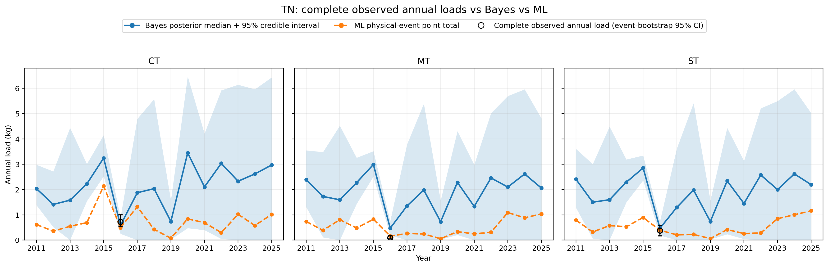
Figure 7. Annual TN load by treatment from the Bayesian and ML reconstructions. Observed annual markers are included only when all expected physical-event TN loads were observed.
Draft source: figures/comparison/v3p0_physical_event/annual_complete_observed/annual_load_tn_complete_observed_v3p0.png
Table 4. Annual TN reconstruction and complete observed totals (kg).
Year | CT  Observed | CT  Bayes | CT  ML | MT  Observed | MT  Bayes | MT  ML | ST  Observed | ST  Bayes | ST  ML
2011 | NA | 2.035 | 0.613 | NA | 2.386 | 0.736 | NA | 2.408 | 0.792
2012 | NA | 1.411 | 0.356 | NA | 1.726 | 0.387 | NA | 1.499 | 0.321
2013 | NA | 1.579 | 0.545 | NA | 1.593 | 0.808 | NA | 1.597 | 0.574
2014 | NA | 2.224 | 0.691 | NA | 2.271 | 0.479 | NA | 2.289 | 0.531
2015 | NA | 3.245 | 2.136 | NA | 2.990 | 0.824 | NA | 2.854 | 0.893
2016 | 0.722 | 0.581 | 0.488 | 0.099 | 0.471 | 0.159 | 0.376 | 0.468 | 0.391
2017 | NA | 1.873 | 1.323 | NA | 1.351 | 0.264 | NA | 1.292 | 0.209
2018 | NA | 2.034 | 0.424 | NA | 1.980 | 0.243 | NA | 1.977 | 0.224
2019 | NA | 0.736 | 0.078 | NA | 0.728 | 0.054 | NA | 0.736 | 0.061
2020 | NA | 3.449 | 0.840 | NA | 2.282 | 0.334 | NA | 2.341 | 0.417
2021 | NA | 2.104 | 0.689 | NA | 1.331 | 0.247 | NA | 1.449 | 0.259
2022 | NA | 3.033 | 0.298 | NA | 2.458 | 0.308 | NA | 2.573 | 0.284
2023 | NA | 2.328 | 1.020 | NA | 2.097 | 1.089 | NA | 1.997 | 0.847
2024 | NA | 2.617 | 0.577 | NA | 2.614 | 0.881 | NA | 2.618 | 1.002
2025 | NA | 2.970 | 1.018 | NA | 2.058 | 1.038 | NA | 2.192 | 1.160
Note. Bayes is the posterior median; ML is the physical-event point total. NA denotes an incomplete observed annual event record. Draft source: results/comparison/v3p0_physical_event/annual_load_complete_observed_raw.csv
Table 5. Study-period cumulative load central estimates and treatment differences relative to CT.
Analyte | Method | CT  (kg) | MT  (kg) | MT lower  than CT | ST  (kg) | ST lower  than CT
TSS | Bayes | 6521.1 | 3399.3 | 48.2% | 3862.0 | 40.9%
TSS | ML | 4349.4 | 2802.2 | 35.6% | 3227.0 | 25.8%
TP | Bayes | 3.439 | 2.279 | 35.1% | 2.092 | 40.3%
TP | ML | 3.053 | 3.368 | -10.3% | 3.407 | -11.6%
TN | Bayes | 32.463 | 28.540 | 12.3% | 28.401 | 12.3%
TN | ML | 11.097 | 7.850 | 29.3% | 7.965 | 28.2%
Note. Bayesian values are posterior medians from the model-only scenario. ML values are physical-event point totals from the full-record model-only scenario. Positive percentages indicate lower load than CT; negative percentages indicate higher load than CT. Draft source: results/comparison/v3p0_physical_event/cumulative_load_2011_2025_raw.csv
The shared TSS treatment direction, together with the smaller and less consistent TP and TN contrasts, follows the broader conservation-tillage literature in which sediment and particulate-associated nutrient responses are often more pronounced than dissolved constituent responses (Bjorneberg, Aase, et al., 2006; Kleinman et al., 2015; Prasad, Thomason, et al., 2023; Trimarco et al., 2025).

3.3 Goodness of fit, temporal agreement, and uncertainty
The three error summaries answered different questions and were not directly interchangeable (Figure 8). Bayesian posterior-predictive error measured fit within the single Bayesian model fitted to the complete record; no Bayesian LOYO analysis was conducted. ML full-record error described the fitted point predictions used for historical reconstruction. ML outer-LOYO error measured prediction in a year excluded from model fitting and was therefore the strictest test of temporal transfer.
Outer-LOYO NRMSE exceeded full-record ML NRMSE for every displayed target. For TSS, the Bayesian fit, ML reconstruction, and ML LOYO NRMSE values were 150.6%, 61.3%, and 118.4%, respectively. The corresponding values were 189.1%, 77.5%, and 140.1% for TP; 36.0%, 20.2%, and 60.1% for TN; and 65.2%, 44.9%, and 95.2% for runoff volume. Selenium produced the largest normalized error because its small mean observed concentration magnified the NRMSE denominator.
RMSE and NRMSE are useful diagnostics but do not provide a model-independent definition of adequacy. Their interpretation depends on response scale, measurement error, benchmark definition, and intended model use; normalized error can become unstable for low-mean or episodic constituents (Moriasi et al., 2007; Harmel and Smith, 2007; Guzman et al., 2015; Yen et al., 2014; Beven, 2006).
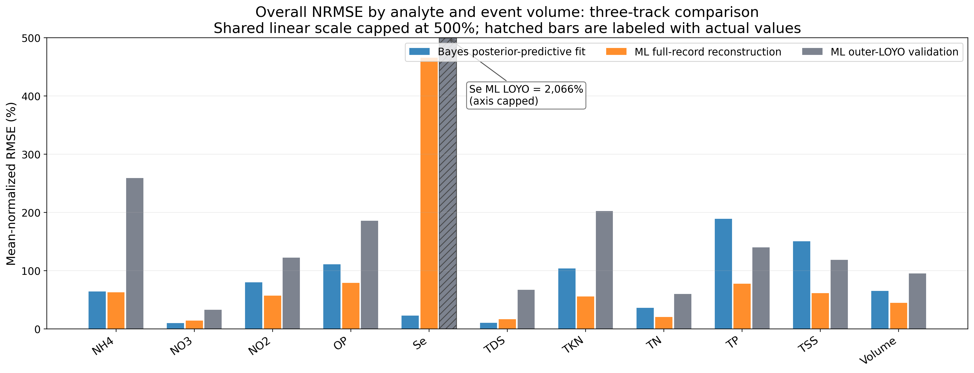
Figure 8. NRMSE for Bayesian posterior-predictive fit, ML full-record physical-event reconstruction, and ML outer-LOYO validation. Values are normalized by the mean observed target within each evaluation set. Selenium is shown with a capped display scale and an annotation for the full value.
Draft source: figures/comparison/v3p0_physical_event/gof_nrmse_bayes_ml_reconstruction_loyo_overall.png
Table 6. Spearman rank correlation between Bayesian and ML annual central estimates by treatment.
Analyte | CT rho | MT rho | ST rho
NH4 | 0.33 | 0.38 | 0.37
NO2 | 0.58* | 0.43 | 0.50
NO3 | 0.55* | 0.78* | 0.67*
OP | 0.22 | 0.25 | 0.27
Se | 0.26 | 0.55* | 0.60*
TDS | 0.39 | 0.72* | 0.68*
TKN | 0.48 | 0.52* | 0.49
TN | 0.51* | 0.62* | 0.64*
TP | 0.43 | 0.11 | 0.31
TSS | 0.37 | 0.15 | 0.18
Note. All correlations used 15 paired annual central estimates (2011-2025). * denotes an unadjusted p < 0.05. The tests are exploratory and were not adjusted for multiplicity. Correlation measures agreement in year ranking, not agreement in load magnitude. Draft source: results/comparison/v3p0_physical_event/temporal_spearman_raw.csv
Temporal rank agreement was strongest and most consistent for NO3, with rho values of 0.55, 0.78, and 0.67 for CT, MT, and ST (Table 6). TN also had positive correlations in all treatments (0.51-0.64), even though the reconstructed TN magnitudes differed sharply. In contrast, TP correlations ranged from 0.11 to 0.43 and TSS correlations from 0.15 to 0.37. These weak rank correlations indicate that agreement in cumulative TSS treatment direction arose despite different allocations of load among years.
ML annual prediction intervals were too wide to display with the annual point series without obscuring the treatment and year patterns. The median annual interval span was 27.3 times the TSS point total, 36.4 times the TP point total, and 27.8 times the TN point total. The wide bands resulted from propagating held-out residual uncertainty through event-level loads and annual sums; they are prediction intervals, not confidence intervals for a fitted mean. Event-level conformal coverage also does not guarantee nominal coverage for sums of correlated event loads. The complete interval products remain in the supplementary outputs even though the primary annual figures retain only ML point totals.

3.4 Agreement, disagreement, and complementarity
The two reconstructions agreed most clearly on the direction of the TSS treatment contrast and on the ordering of TN treatments. They disagreed on the size and timing of annual TSS loads, the absolute magnitude of TN, and the direction of the cumulative TP contrast. These differences were not random diagnostic noise: they identified conclusions that were dependent on model structure and therefore require more cautious interpretation.
The Bayesian model represented treatment, year, analyte, and process relationships through a joint probabilistic structure and propagated posterior uncertainty into annual and cumulative loads. The ML workflow flexibly learned nonlinear associations from the observed record and provided an explicit held-out-year assessment of temporal prediction. Agreement between these structurally different estimates increased confidence in a qualitative pattern, whereas disagreement located the parts of the reconstruction most sensitive to assumptions. The analyses were not combined by model averaging, and neither estimate was treated as an independent replicate of the observed system.
This complementary interpretation is consistent with recent water-quality modeling work that separates flexible predictive performance from process or causal structure rather than treating one as a substitute for the other (Badrudeen et al., 2026; Longchamps, Lanza, Wei, et al., 2025).
The ML reconstruction is consequently appropriate for interpolation within the historical study domain represented in model fitting, not for extrapolation to new management regimes or future years. A model would need to be recalibrated as new years, instruments, or management conditions are introduced, and its outer-LOYO performance would need to be reassessed. The Bayesian process structure provides a more defensible starting point for scenario analysis or forecasting, but forecasting was not validated in this study and should not be inferred from posterior fit alone.

4 Limitations

4.1 Incomplete observations and shared-data dependence
The most direct limitation was the scarcity of complete observed annual references. Only 19 of 135 TSS, TP, and TN year-analyte-treatment groups and 9 of 45 runoff-volume groups could be compared with a complete observed annual total. Those complete groups were concentrated in 2015-2017 and therefore did not independently test early or late portions of the reconstruction. Both models were also calibrated from the same monitoring record. Agreement between them reflects robustness to model structure within shared data; it does not constitute independent confirmation of the unobserved loads.

4.2 ML transfer and uncertainty
The ML analysis used one algorithm with prespecified tuning and did not compare alternative learners or conduct a separate hyperparameter search within every held-out year. Its feature importance values were descriptive, noncausal, and partly associated with laboratory and measurement methods that changed through time. The extreme width of the propagated annual intervals limited their usefulness for treatment-scale inference even when event-level coverage was acceptable. Point totals remain useful historical reconstructions, but they do not support forecasting beyond the observed covariate and management domain.

4.3 Bayesian validation and nonnegative support
The Bayesian fit was evaluated with posterior-predictive diagnostics but not with a held-out-year design comparable to ML outer-LOYO. Its lower-tail distributions also permitted physically impossible negative annual loads. Negative annual draws represented 8.6%-20.2% of TSS draws across treatments and 29.8%-34.5% of TP draws. The annual figures use a nonnegative display scale, but the raw summaries and manuscript tables retain the modeled values rather than silently replacing them.
Truncating annual Bayesian draws at zero reduced the median TSS treatment reduction from 48.2% to 38.4% for MT and from 40.9% to 33.1% for ST. For TP, the corresponding reductions changed from 35.1% to 27.2% and from 40.3% to 29.4%. The sensitivity of TSS and TP treatment contrasts to nonnegative support is a material limitation of the current Bayesian specification and should be resolved before these cumulative percentages are treated as final inferential estimates.

4.4 Metrics and generalizability
NRMSE was unstable for constituents with small observed means, and Spearman correlation captured annual rank agreement without measuring calibration or absolute agreement. Unadjusted correlation p-values were exploratory. Finally, the reconstructions describe one irrigated long-term tillage experiment with its specific soils, crop rotations, irrigation practices, instruments, and laboratory history. Transfer to other sites or management systems requires new calibration and validation rather than direct application of the reported annual loads.

