Q1



This is the output of the question 1 by using the function “combine_img”.

Q2

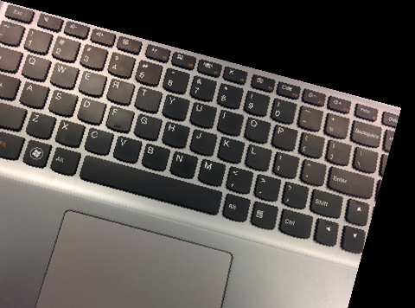

This is the output of the question 2 by using the function “rotate image”. The left-down corner has cut-off since it beyond the original border.  
the method is using the matrix [ [cos_theta, -sin_theta] [sin_theta, cos_theta] ] and multiple with [x,y]

Q3

original enlarge

It is difficult to shows the difference but from the code of using “resize_image” function. We calculate the x_scale = 1024/ (original pixel width) and y_scale = 1024/ (original pixel height). And then rescale the x , y by x/ x_scale and y/ y_scale. So that the 4 points are x1 = int(x/ x_scale), x2 = min(x1 + 1, width - 1), y1 = int(y_orig), y2 = min(y1 + 1, height - 1). And then calculate the x_dist = x_orig - x1 and y_dist = y_orig - y1. Finally, just use the formula of bilinear interpolation.

Q4



This is the result of the overlap.

Q5a



The above image is the flip image of lena



The above image is the watermarking of graveler on lena by using DCT with function ”embedding_watermark”



The above image is the graveler extract from last embedding image by using IDCT with function ”extract_watermark”