1. Use binary morphological operations to 1) fix the image shown below (“text-broken.tif”) and 2) find the boundaries of each character like….

1)



Steps:

1. Firstly, we read the image with only grayscale since we only want intensity channel.
2. We define the SE with 3X3 square with all ones.
3. To fix the broken image, we need to fill the surrounding by dilation method by package function.
4. To extract the boundary, we use the package method, “canny”.

2)



1. Please use linear stretching to enhance the contrast of the image “einstein-low-contrast.tif.”

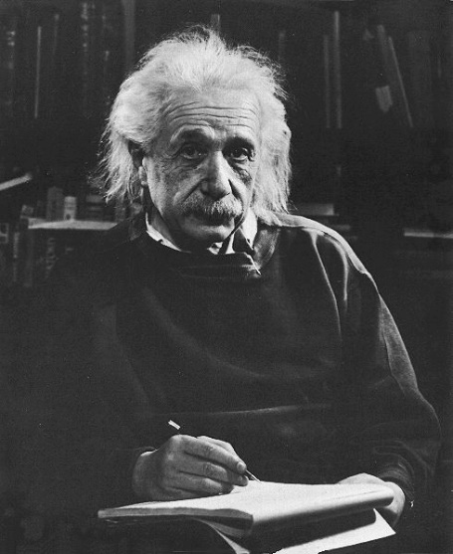

Steps:

1. Firstly, we read the image with only grayscale since we only want intensity channel.
2. We will use the formula in C7 slide page 8.
3. We define

M = max value (img.intensity)

m = min value (img.intensity)

1. a-c = 256, which is the possibly max and min intensity.
2. Result image is enhanced where the contrast of black and white is more obvious.
3. Please apply global HE to “einstein-low-contrast.tif” or “aerialview-washedout.tif.” You should implement it only using “for loop’ and +-*/.

Steps:

1. Firstly, we read the image with only grayscale since we only want intensity channel.
2. We will use the formula in C7 slide page 19.
3. We first define the histogram, which is the frequency with different level of intensity.
4. Calculate the cdf of the frequency.
5. Normalize the cdf by min and max method.
6. Refine the intensity to image.

Conclusion:  
the Einstein in this section is not perform as well as Q2, which is too light.

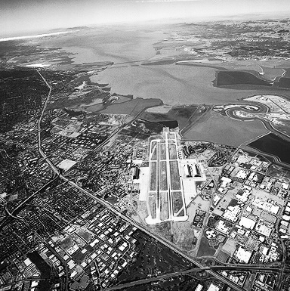

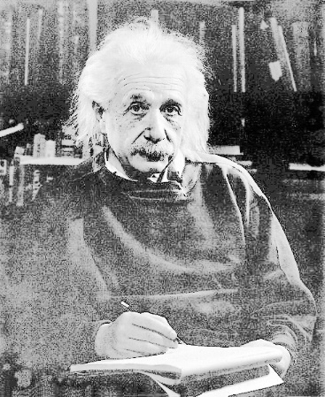

1. Please divide the histogram of “aerialview-washedout.tif” into two sub-histograms using the median μ of the image and apply HE to two sub-histograms separately (one ranging from 0~μ and the other from (μ+1)~255). You should implement it only using “for loop’ and +-*/.

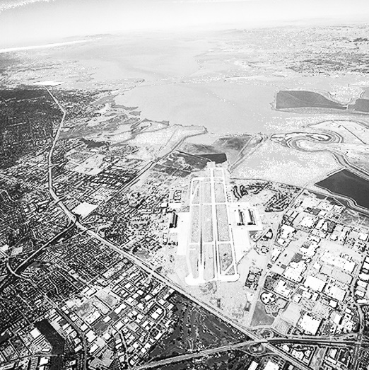

Steps:

1. Firstly, we read the image with only grayscale since we only want intensity channel.
2. We first define the histogram, which is the frequency with different level of intensity.
3. And we find the median of the intensity.
4. Then we divide the histogram to two part, from 0~μ and from (μ+1)~255 and do HE for 2 sections.

Conclusion, the result image in this section is worse than Q3 since it is too light.

1. Following Question 3, please implement the contrast enhancement method proposed in the paper “Two-dimensional histogram equalization and contrast enhancement (T. Celik 2012, as attached),” which was also taught in class as CVCE version 1. The window size could be set to 7x7.

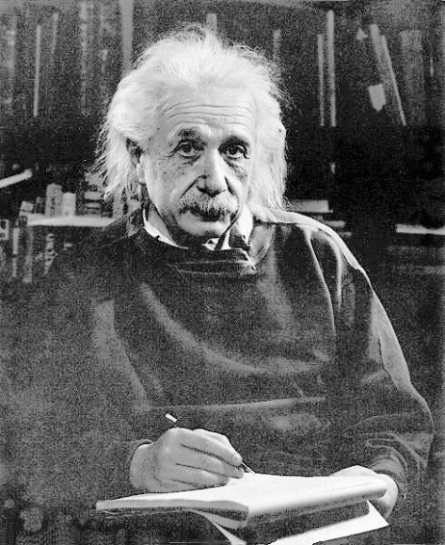

Steps:

1. Firstly, we read the image with only grayscale since we only want intensity channel.
2. We will use the formula in C7 slide page 28-31.
3. First, we need to construct the H_x(l,k). Noting that we have restriction of omega(p), by

if i >= half_size and i <= height - (half_size+1) and j >= half_size and j <= width - (half_size+1)

1. Next, we compute the cdf_p and cdf_u,

Conclusion, the result image in this section is the best among all the fixed image of “einstein-low-contrast.tif”.