已完成項目:

完成function: Data_Gen , choose_p (D) , kersey_GOAL

1: Data generator: binary, poisson, nonlinear, linear

多了num_cpi: 可調節式條Xc Xp Xi的數量 (1,2)

簡化 每一種Y對X的函式

2: 現在只用一個kersey_GOAL function 就可以跑所有類型的Y

**Treatment with measurement error ESSAY:**

taking a drug (X = 1) vs not taking it (X = 0)

incentivize the patients to take it or not (Z = 1 vs Z = 0)

a self-reported measurement of taking (M = 1) or not taking (M = 0)

the drug does not imply X = M

Data consists of records of ( Z ; M ; Y ), but the assumption X = M does not hold.

M = X + E(M)

Contribution is threefold:

• An estimator for the structural function f(x) without requiring latent variable (can’t observed RV) modeling. The resulting method can be applied without restrictive assumptions in the likelihood, such as the (requirement for Gaussian error terms); - error no need to normal

•A method to learn the conditional mean embedding [Muandet et al., 2017] of a latent variable distribution, which can be applied to many two-stage IV settings;

• we propose a way to exploit the connection between characteristic function methods and kernel methods, which may be applied to many settings outside of measurement error modelling (see Section 4.1).

**the structural function**

Assumption 1 Y = f(X) + e and E[e|Z] = 0

Assumption 2 p(xjz) is not constant in z



RKHS: HS is a Hilbert space with inner product

two important properties:

1. k(x; . ) belong to HS for all x belong to S,
2. the reproducing property: for all h belong to HS and x belong to S;



Similarly, for any conditional distribution p(xjz),

 is a conditional mean embedding (CME) of p(xjz)

The conditional mean embedding (CME) is estimated by the standard regression formula using the observed samples 

* 

The structural function f is estimated using a second stage sample: 

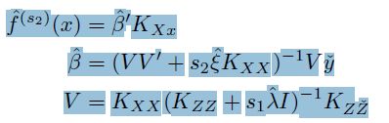V is from first stage

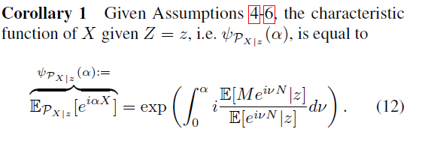

**Future work or thought:**

Use kersey GOAL to choose the variable and then apply “kernel-based nonparametric estimator

for the causal” to fix the A and estimate ATE