
The Hong Kong Polytechnic University Capstone Project COMP4913 Final report

Name: Liang Yulin
StudentID: 24028274d
Supervisor: Dr. Fan Wen qi
Title: NeoRAGRec——A Practical Knowledge-Graph Enhanced RAG-LLM Based Movie Recommendation System
Date: 10-4-2026

Abstract
In this paper we introduce NeoRAGRec — a hybrid movie recommendation system developed by utilizing a Retrieval-Augmented Generation (RAG) architecture. In this system, we combine a Neo4j knowledge graph, Approximate Nearest Neighbor (ANN) semantic retrieval, and local Large Language Models (LLMs) — like Ollama or Qwen — to provide interpretable and efficient recommendation services. We presented a Neo4j movie knowledge graph and a self-supervised graph embedding pipeline, used to learn semantic representations of movies from their 1-hop ego-subgraphs. Additionally, we developed a hybrid retrieval framework combining ANN and graph–based relational signals in the proposed models which we tested in offline experiments. The experimental results demonstrate that the implementation of GNN-based subgraph embedding techniques significantly improves both recommendation performance and maintains high recommendation coverage with respect to models that ignore embedding GNNs or only rely on content features and better than other comparable models. We also strengthened the features of this system with user interaction signals and an LLM-based explanation-generation module, and assessed it using ablation studies and comparative embedding analysis. This project thoroughly illustrates the practical integration and application of knowledge graph reasoning, self-supervised graph learning, hybrid retrieval, and evidence-based explanation generation algorithms in the movie recommendation systems field.

Table of Content
Abstract 1
Table of Content 2
1 Introduction 4
1.1 Background and Problem Statement 4
1.2 Objectives and Outcome 4
1.3 Software and Hardware Environment 5
2 Background Theory and Literature Review 8
2.1 Traditional Recommendation Methods 8
2.2 Knowledge-Graph-Based Recommendation Systems 8
2.3 Graph Neural Networks for Recommendation 9
2.4 Self-Supervised Learning on Graphs 9
2.5 Explainable Recommendation and Retrieval-Augmented Generation 10
2.6 Summary and Research Gap 11
3 Project Methodology 12
3.1 Requirement Analysis 15
3.2 Stage 1: Knowledge Graph Construction 16
3.3 Stage 2: Self-Supervised Graph Embedding Learning 18
3.4 Stage 2.5: User Interaction Behavior Collection and Integration 19
3.5 Stage 3: Hybrid Retrieval and Ranking 22
3.6. Stage 4: Explainable Recommendation via LLM 30
3.7. Stage 5: Evaluation and Optimization 34
4 Project Schedule 46
5 Conclusion and Future Work 48
6 References 50

Introduction

Background and Problem Statement
Traditional collaborative filtering (CF)—as a baseline algorithm—is hampered by the cold-start problem and lack of interpretability. Content-based methods and early RAG models can capture textual features and semantic similarity, but they cannot model multi-hop semantic relationships, such as those involving shared directors or actors in movie recommendations. Furthermore, methods relying solely on LLMs are prone to hallucinations and lack structured knowledge support. Recently, methods combining knowledge graphs (KGs) with large language models (LLMs) have shown promise in enhancing reasoning and interpretability. However, most models suffer from high computational overhead and lack deployability and integration with real-time user behavior. We propose an interpretable movie recommendation system—NeoRAGRec, to overcome the above-mentioned constraints. This system includes a Neo4j knowledge graph, self-supervised graph embedding learning, approximate nearest neighbor retrieval, and an explanation module based on Large Language Models (LLMs). Its capability to incorporate user interaction signals for a dynamic update of user representations allows the system to produce natural language explanations that are grounded in graph-based evidence, and provide recommendation services that are accurate, interpretable, and ready for practical deployment.

Objectives and Outcome
Construct and implement NeoRAGRec, an efficient and explainable movie recommendation model; integrating knowledge graph reasoning, user behavior, self-supervised graph embedding learning, and LLM-based natural language interpretation. Objectives are specific to:
- Build an Attention-based Self-supervised Graph Neural Network to learn semantic and structural embeddings of films from the Neo4j knowledge graph without labeled data.
- Create a hybrid retrieval and ranking scheme to integrate semantic similarity between approximate nearest neighbor (ANN) and strength of the graph relationship.
- Build a local Large Language Model (LLM) that achieves interpretability, where human-understandable justifications emerge for recommendations based on graph evidence.
- A system-level optimization of performance is conducted, focusing on retrieval efficiency and response latency in interactive environments for practical deployment.
- The proposed system is evaluated via offline recommendation experiments, and the quality-of-evidence-based explanations has been studied by case studies rather than user evaluations.Expected Outcomes
Upon completion, the project is expected to deliver:
- A functional prototype recommendation system (NeoRAGRec) integrating Neo4j, self-supervised Graph Transformer embedding, ANN retrieval, and a local explanation interface based on LLM.
- A set of trained movie embeddings that capture semantic and relational knowledge for future hybrid recommendation tasks.
- A comprehensive offline evaluation, conducted through ablation analysis and embedding comparisons, demonstrates the effectiveness of the proposed hybrid recommendation framework; furthermore, it includes a qualitative case study on evidence-based recommendation explanations.
- A validated framework combining knowledge graph reasoning with LLM interpretability, providing a practical reference for future research on explainable AI-based recommender systems.

Software and Hardware Environment
Software Environment
Category | Tool / Framework | Purpose
Programming Language | Python 3.10 | Core backend logic and model implementation
Deep Learning Framework | PyTorch 2.x | Training graph neural networks and embedding models
Graph Learning Library | PyTorch Geometric | Subgraph extraction and GNN-based embedding learning
Graph Database | Neo4j Desktop | Storage and querying of the movie knowledge graph
Similarity Search Engine | FAISS | Approximate nearest neighbor (ANN) retrieval
Backend Framework | FastAPI | RESTful API services and system integration
Local Database | SQLite | User interaction and behavior logging
Local LLM Runtime | Ollama | Generation of recommendation explanations
Frontend Framework | HTML, CSS, JavaScript, React | User interface for browsing, rating, and viewing recommendations
UI Styling Library | Bootstrap 5 | Responsive layout and interface styling
Hardware Environment
Component(Google colab) | Specification
CPU | Intel Core i5 (6 cores)
Memory | 16 GB RAM
Storage | - SSD

Cloud Training Environment
Cloud Training Environment | Cloud Training Environment
Platform: Google Colab | Platform: Google Colab
GPU: NVIDIA H100 | GPU: NVIDIA H100

Background Theory and Literature Review
Recommender systems are commonly researched to help users search for content in large-scale information domains. Traditional recommendation algorithms — collaborative filtering, content-based options, etc. — serve as the foundation for many industrial systems. But such methods suffer from some inherent downsides such as data sparsity, cold-start issues, and lack of interpretability, leading people to explore more expressive and structured models.

2.1 Traditional Recommendation Methods
CF (collaborative filtering) methods infer user preferences from past interactions between users and the items. On that front, CF-based algorithms are workable in high-density environments where interaction is prevalent, but they suffer from significant performance degradation due to lack of user feedback or insertion of new users and new items. The content-based recommendation methods alleviate sparsity partially by taking advantage of item attributes such as genres or textual descriptions, but they rely on shallow feature representations; they thus do not capture the complex semantic relationships among entities. Such limitations have also led to the inclusion of structured external knowledge to improve the accuracy and interpretability of the recommendations.

Knowledge-Graph-Based Recommendation Systems
Knowledge graphs (KGs) denote entities and their relationships in structured form, enabling rich semantic correlations such as movie–actor–director–genre associations to be modelled. Knowledge-enhanced recommender systems utilize these kinds of relationships to suggest more authoritative and explanatory recommendations. RippleNet, proposed by Wang et al. (2018), is one of the earliest works that propagates user preferences over a knowledge graph to capture higher-order interests. Zhang et al. (2017) provide a thorough survey of existing knowledge-enhanced recommender systems which include embedding methods, path-based methods and graph neural network-based methods. Their study demonstrates that KGs can resolve sparsity as well as provide interpretability, by directly supporting the recommendation with explicit, relational evidence. Nevertheless, several approaches built on KGs are based on supervised learning or manually established meta-paths, which hinder their scalability and adaptability during periods of changing environments.

Graph Neural Networks for Recommendation
Graph Neural Networks (GNNs) have become a popular paradigm to learn representations from graph-structured data. Graph Convolutional Network (GCN): Kipf and Welling (2017) introduced the Graph Convolutional Network (GCN) that combines the neighbors' information for learning node embeddings. Velicković et al. (2018) described the Graph Attention Network (GAT), including attentional features to dynamically weight neighbors and to improve the expressive capacity.
In recommender systems, GNNs have become widely used in modeling user–item interactions and knowledge graphs as a unified graph structure. Wu et al. (2020), offering a systematic survey of recommender systems based on GNNs has shown their capability to capture high-order connectivity patterns. He et al. (2020) introduces LightGCN, a simplified GCN architecture for recommendation tasks, making model complexity smaller. Yang et al. (2020) extended GNN-based recommendation, presenting the Contextualized Graph Attention Network (CGAT), which combines item knowledge graphs to capture both local and non-local contextual information. Despite them being powerful, much of the GNN-based recommender algorithms need large volumes of labeled interaction data or rigorous architectural tuning that can be difficult to implement in light-weight settings or small-scale environments.

Self-Supervised Learning on Graphs
Self-supervised learning (SSL) has recently been gaining attention as a way to learn robust representations in the absence of labeled data. For graph representation learning, SSL techniques usually use contrastive goals or predictive objectives to leverage structural and semantic features. Most importantly, Self-Supervised Graph Learning (SGL) is an important methodological base for the graph representation component of NeoRAGRec. Whereas strictly supervised graph approaches are based only on observed interaction data, SGL implements graph augmentation and contrastive learning, which permits auxiliary supervisory signals to be drawn from the graph structure itself. In particular, this approach creates multiple "graph views" by methods of node dropout, edge dropout, and random walks, and tries to maximize the consistency between the representations of the same node across these different views. This construction not only improves the stability of the representations but also helps to minimize the degree bias problem, and is particularly effective in limited and noisy interaction data situations (Wu et al., 2021).
You et al. (2020) introduced graph contrastive learning through data augmentation, showing how self-supervised objectives can considerably improve the quality of representation. Liu et al. (2023) offer a broad review of graph self-supervised learning techniques, including their performance in a number of downstream tasks. In the recommendation area, Wang et al. (2021) introduced the Knowledge Graph-based Intent Network (KGIN), which approximates fine-grained user intents using GNNs and knowledge graphs; and Liu et al. (2023) further showed that in sparse interaction situations, self-supervised objectives work well. Most recently, Pu et al. (2025) presented a graph neural network-based recommender, which integrates multi-scale attention and contrastive learning. Their work also offers empirical evidence as to how considering attention mechanisms at different structural scales together with contrastive learning can have a significant impact on recommendation performance. Although they emphasize algorithmic novelty and benchmarking, the results indicate the advantage of self-supervised graph representation learning.

Explainable Recommendation and Retrieval-Augmented Generation
Explainability has increased as an important problem for recommended systems. Zhang and Chen (2018) conduct an in-depth survey on explainable recommendation approaches that highlights transparency and trustworthiness. Knowledge graphs inherently endorse explainability, and make explicit the relational foundations of recommendations available for us. Retrieval-Augmented Generation (RAG) architectures, proposed by Lewis et al. (2020), improve language models through conditioning generation on retrieved external knowledge. Some recent research has generalized the concept of RAG for recommender systems, while Li et al. (2025) proposed G-Refer that leverages graph retrieval to provide explainable recommendations. Taken together, these works show that the anchoring of language model outputs to structured graph evidence does enhance factual consistency and interpretability. Nevertheless, existing methodology predominantly is concerned with conceptual models or large-scale models with little focus on system-level integrated capabilities and on real-time deployment. Of the recently proposed KG-RAG (Knowledge Graph-based Retrieval-Augmentation) methods, K-RagRec is an extremely similar reference system to NeoRAGRec at the system level. This approach introduces a knowledge graph retrieval-augmentation approach aimed directly at LLM-based recommendation systems. Their key ingredients can be broken down as follows: hop-field knowledge subgraph indexing, popularity-based selective retrieval, knowledge subgraph re-ranking, knowledge-augmented recommendation (Wang et al., 2025). Its main point is that structured subgraphs retrieved from a knowledge graph give more reliable and less noisy evidence (compared to unstructured text-based RAG) and better help to bolster the factual grounding and reliability of recommendation results. This stance correlates well with the explanation layer concept of NeoRAGRec—a level where the generation of recommendations is evidence-derived from graph structures rather than based mainly on the unconstrained free-form generation of the LLM. Unlike K-RagRec, the emphasis of the project is on implementing hybrid retrieval strategies, real-world implementation designs suitable for engineering deployment, and offline ranking evaluation.

Summary and Research Gap
In conclusion, prior studies have shown that the use of knowledge graphs, graph neural networks, self-supervised learning, and retrieval-augmented generation can significantly improve the accuracy and interpretability of recommender systems. However, the existing studies usually concentrate on isolated components or algorithmic innovation, so they do not consider practical deployment constraints like latency, system integration, and real-time user interaction. We aim to overcome this limitation with our proposal of NeoRAGRec: an end-to-end movie recommendation system in which knowledge graph reasoning, self-supervised graph embedding learning, hybrid retrieval, and LLM-based explainable recommendation can be fully integrated in a unified and deployable architecture. In focusing on practical usability and human-understandable explanations, the proposed study adds to current research and demonstrates how advanced recommendation techniques can be applied in real-world interactive scenarios.

Project Methodology
System Overview
- Stage 1: Knowledge Graph Construction
- Stage 2: Self-Supervised Graph Embedding Learning
- Stage 2.5: User Interaction Behavior Collection and Integration
- Stage 3: Hybrid Retrieval and Ranking
- Stage 4: Explainable Recommendation via LLM
- Stage 5: Evaluation and Optimization
Each phase adopts a modular design, allowing for incremental development and validation within the project deadline. The overall goal is to demonstrate that a small but well-integrated pipeline can provide explainable and efficient recommendations in real user interaction scenarios.

System Architecture Diagram
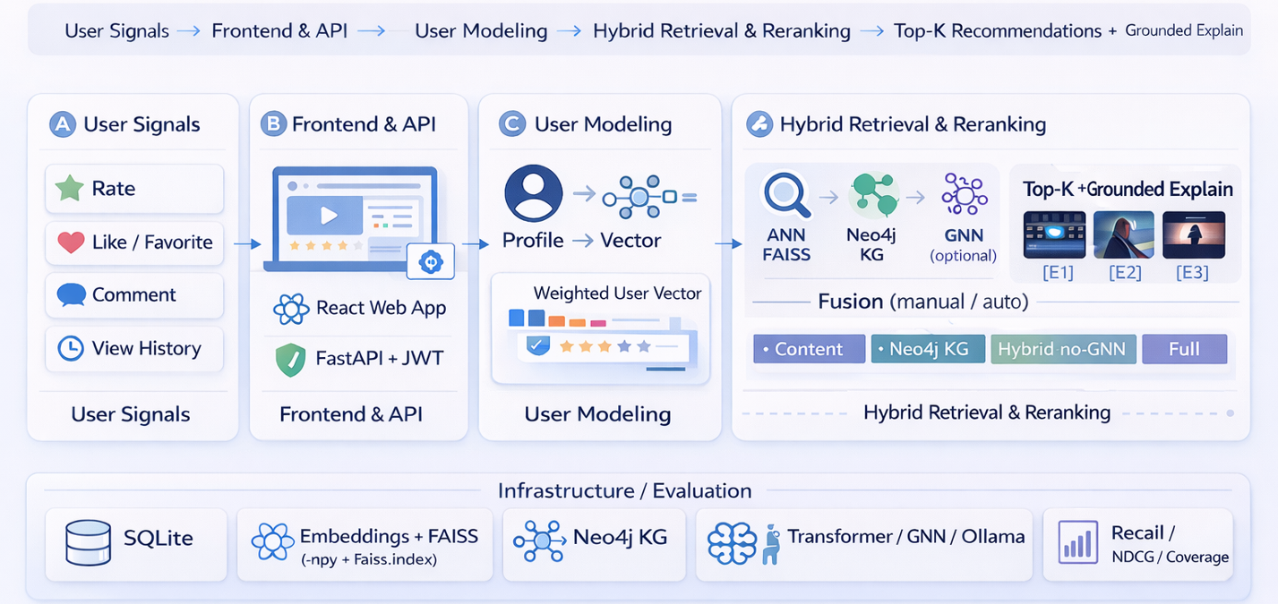
Figure 1

Data Flow Diagram
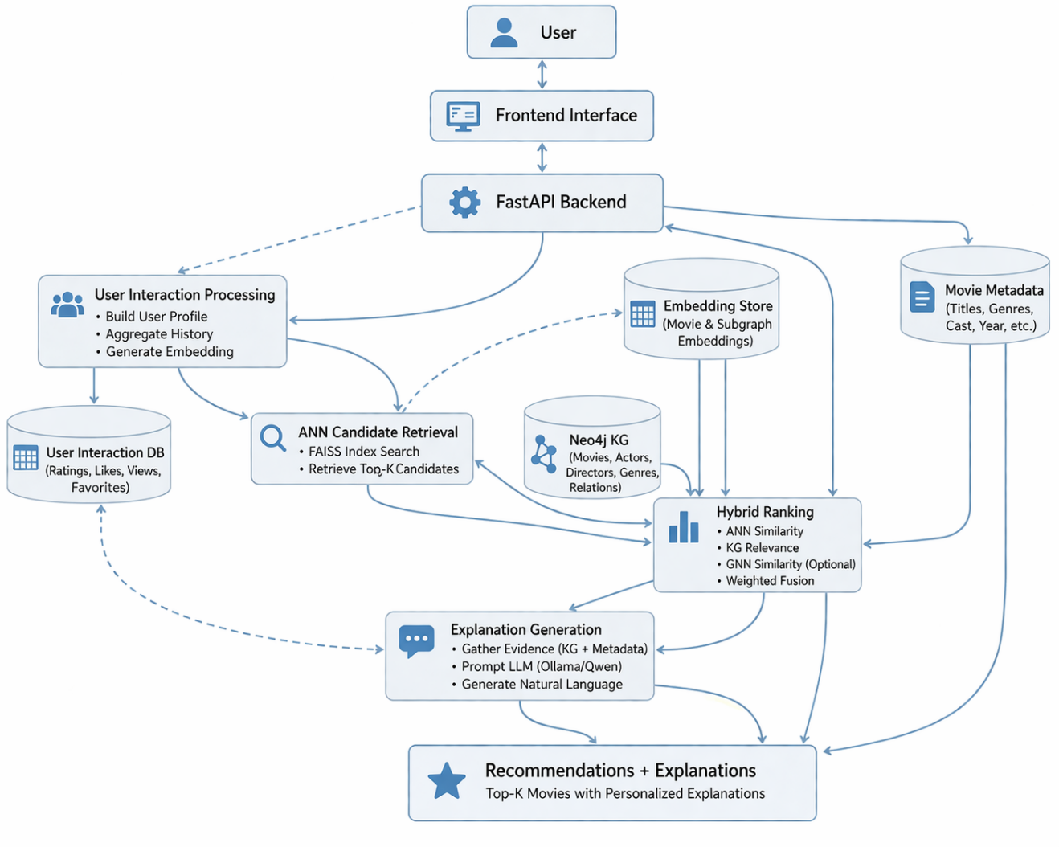
Figure 2

Requirement Analysis
Functional Requirements
- The system shall allow users to browse and search movies.
- The system shall record multi-type user interaction behaviors, including viewing history, ratings, likes, favorites, and comments.
- The system shall generate personalized movie recommendations based on user profiles and interaction history.
- The system shall utilize a knowledge graph to model multi-hop semantic relationships among movies and related entities.
- The system shall learn movie representations from graph-structured data using self-supervised Graph Neural Networks.
- The system shall retrieve candidate movies efficiently using approximate nearest neighbor (ANN) search.
- The system shall provide human-understandable explanations grounded in knowledge graph evidence.
- The system shall support logging explanation outputs and interaction traces for future evaluation.
- The system should support modular decision logic for selecting retrieval and explanation components.
Non-Functional Requirements
- The system shall support interactive recommendation with acceptable response latency.
- The system shall adopt a modular architecture to facilitate system maintenance and future extension.
- The system shall ensure stable operation under concurrent user requests.
- The system shall provide explanations that are concise, consistent, and easy to understand.
- The system shall be deployable on commodity hardware using local resources.
Data Requirements
- Movie metadata and relational information stored in a Neo4j knowledge graph.
- User interaction data stored in a local relational database.
- Learned movie embeddings stored as vector representations for ANN retrieval.
- Knowledge graph relations used as evidence for explanation generation.

Stage 1: Knowledge Graph Construction
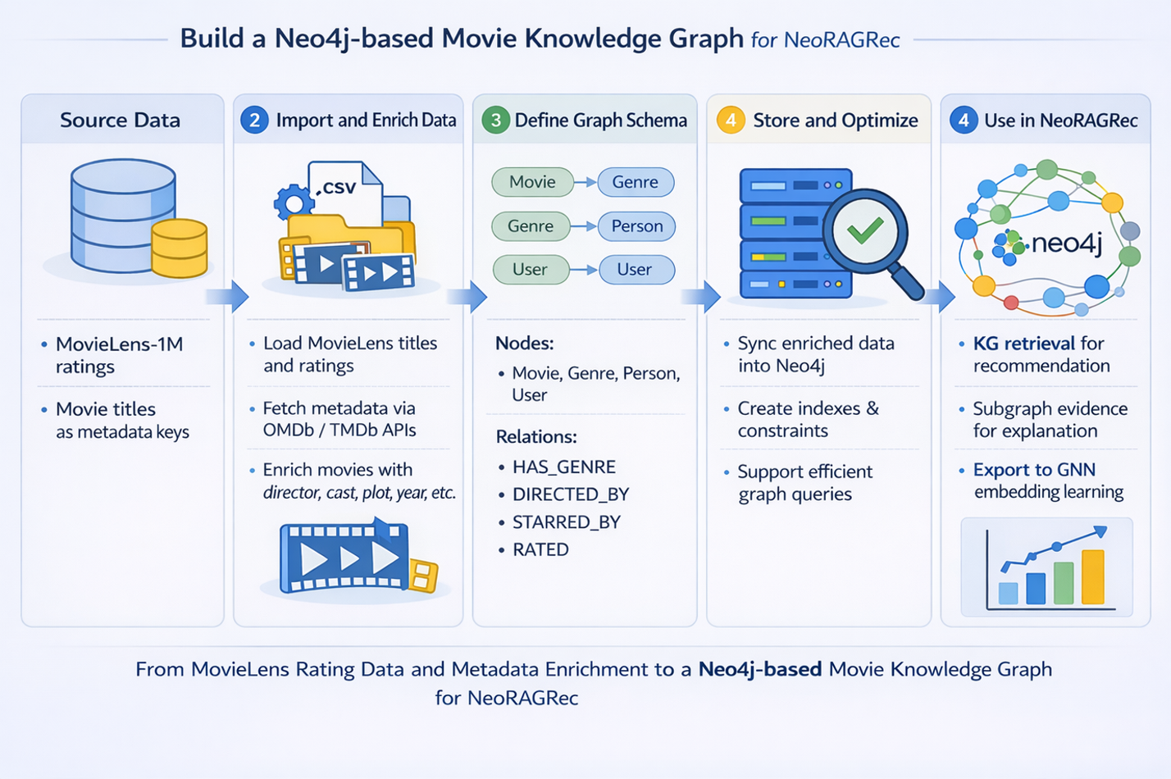
Figure 3
Objective:
Build a Neo4j-based movie knowledge graph connecting movies, directors, actors, genres, and users.
Approach:
- Import data from an existing open dataset (e.g., MovieLens 100K or IMDb subset).
- Define schema:
  - Nodes: Movie, Genre, Person (director/actor), User
  - Relations: HAS_GENRE, DIRECTED_BY, STARRED_BY, SIMILAR_TO, RATED, VIEWED, FAVORITED
- Create indexing and uniqueness constraints to ensure query efficiency.
- Verify data quality and visualize graph connectivity.
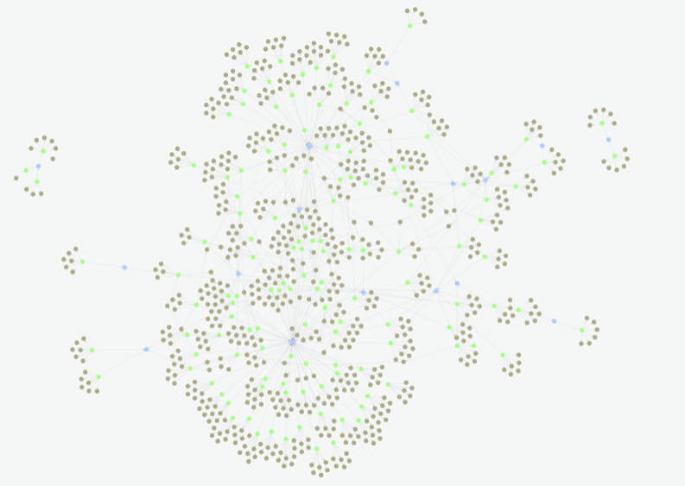 |  | 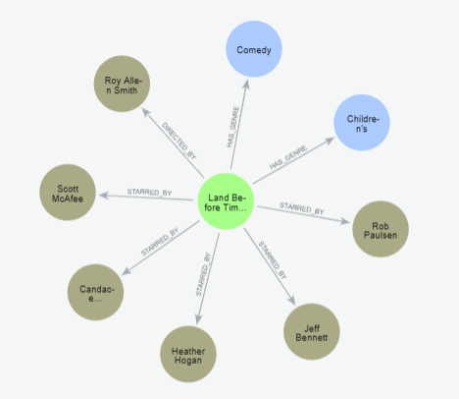
Figure 4 | Figure 5
Expected Output:
A function Neo4j database with 1,000–2,000 movies and multi-type relations, serving as the foundation for embedding learning.

Stage 2: Self-Supervised Graph Embedding Learning
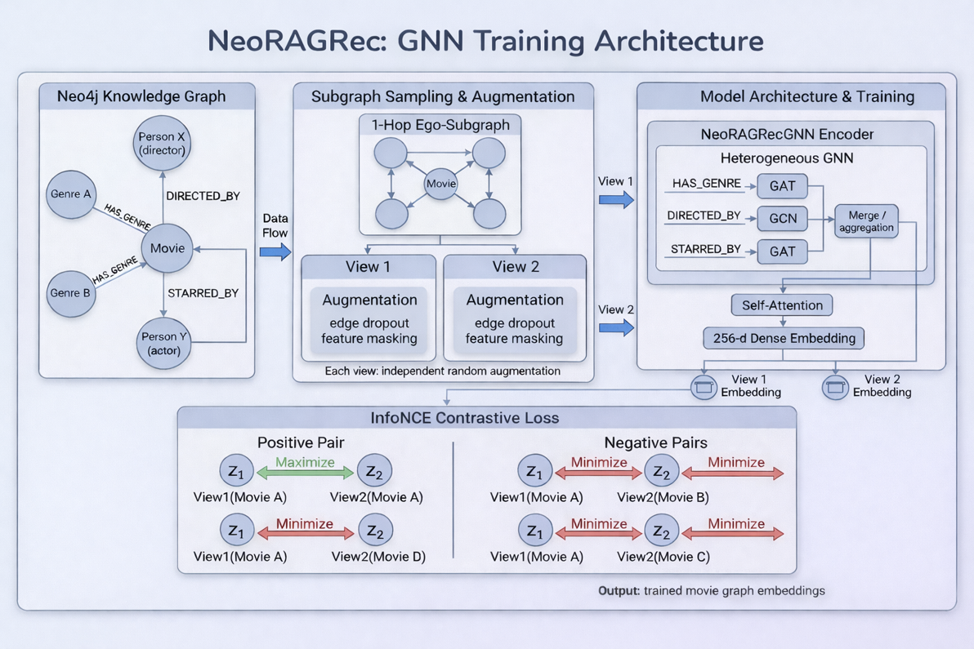
Figure 5
Objective:
Train an Enhanced Graph Transformer to generate meaningful subgraph embeddings for movies.
Approach:
- Extract 1-hop ego-subgraph around each movie using Neo4j queries.
- Convert subgraphs to HeteroData objects in PyTorch Geometric.
- Train a hybrid model combining:
  - GATConv (Graph Attention Network) — captures relational importance;
  - GCNConv — ensures global feature propagation;
  - Multi-Head Self-Attention — captures long-range semantic dependencies.
- Use a self-supervised contrastive loss (InfoNCE):
  - Positive pairs: augmented subgraphs of the same movie;
  - Negative pairs: subgraphs from different movies.
- Output 256-dimensional embeddings per movie for downstream retrieval.
Expected Output:
A trained embedding model and embedding dataset capturing semantic proximity and relational structure.

Stage 2.5: User Interaction Behavior Collection and Integration
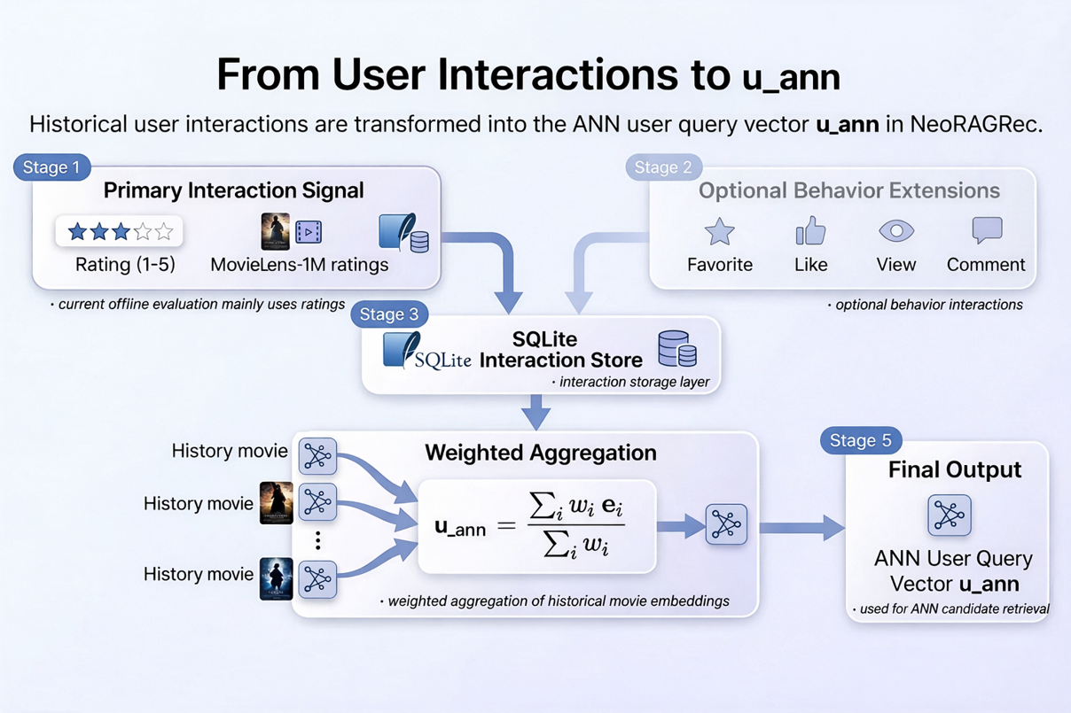
Figure 6
Objective:
To capture users evolving preferences from real-time interaction behaviors and construct an online-updated user representation for personalized recommendation. By modeling multiple types of user feedback, the system can dynamically adapt recommendation results as user interests change over time.
Approach:
User preference is modeled as a continuously updated user embedding, constructed from multi-type interaction signals. User behaviors, including ratings, likes, favorites, comments, and browsing history, are aggregated into a weighted interaction history. Each interaction contributes a weighted signal to the user profile, and the user embedding is recomputed by aggregating the embeddings of interacted movies.
Interaction Type | Representation in our system | How it is used
Rating (1–5) | Graded preference weight | Higher ratings contribute larger positive weights
Likes / Favorites | Strong positive implicit feedback | Reinforces items similar to liked/favorited content
Browsing History | Temporally decayed implicit feedback | Recent views have higher influence via exponential decay
Explicit Preference Form | Stored in user profile (optional) | Used for personalization/explanations; not required for
Weighted User Embedding Construction
Let$I$ be the set of interacted movies and$e_{i}$ be the embedding of movie $i$. We compute the user embedding by weighted averaging:
$$u=\frac{\sum_{i∈I}{w_{i}}⋅e_{i}}{\sum_{i∈I}{w_{i}}}$$where $w_{i}$reflects the importance of interaction. In particular, browsing interactions apply an exponential time-decay function:
$$w_{\text{view}}(Δt)=exp⁡(-Δt/τ)$$
with $Δt$ measured in days and $τ$ controlling the decay rate (larger $τ$ means slower decay).
Usage in Recommendation and Evaluation
During recommendation, the user embedding $u$is used as the query vector for FAISS-based approximate nearest neighbor retrieval, ensuring that recommendations adapt dynamically to new user behaviors. All interaction logs are persistently stored and can be used for offline evaluation (e.g., leave-one-out ranking metrics), as well as for future offline analysis of recommendation quality, diversity, and explanatory consistency.
Expected Output:
- A continuously updated user profile and embedding database.
- Real-time personalized recommendations responding to new user actions.
- Behavioral logs usable for later evaluation (e.g., Recall@K per user, diversity over time).

Stage 3: Hybrid Retrieval and Ranking
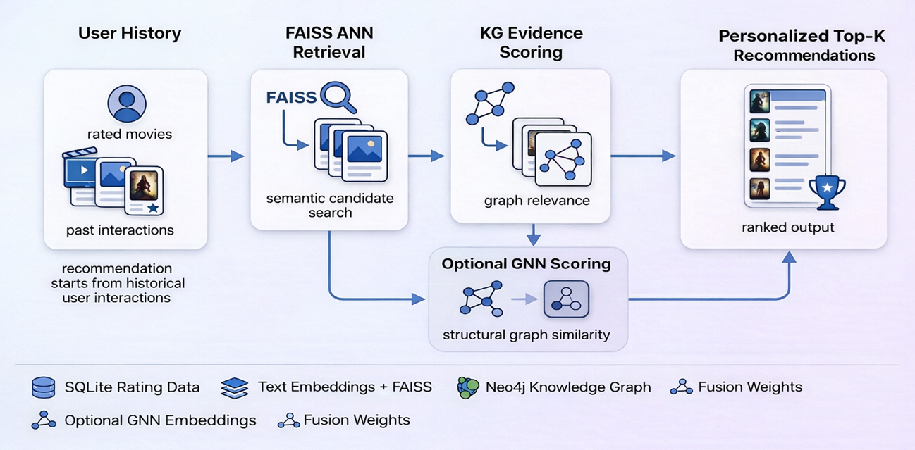
Figure 7
Objective:
The objective of this stage is to efficiently retrieve a compact set of high-quality candidate movies and rank them in a personalized and interpretable manner. Rather than relying on a single retrieval signal, NeoRAGRec integrates semantic similarity, relational evidence derived from knowledge graphs, and—optionally—similarity information based on graph structures. This hybrid design enhances the robustness of the recommendation system by allowing these diverse signals to complement one another across various user scenarios. For instance, semantic retrieval captures similarities at the thematic level, whereas relational information based on graph structures reveals features—such as shared actors, directors, or genres—that are often not fully captured by text embeddings alone.
Approach Overview
To address the aforementioned limitations, NeoRAGRec integrates three distinct ranking signals within a unified workflow: 1.ANN-based semantic retrieval 2.knowledge graph-based relational relevance 3.optional GNN-based structural similarity component. Within this framework, ANN retrieval serves as an efficient, coarse-grained retrieval stage; KG relevance preserves explicit structural evidence from the graph; and GNN similarity captures higher-order structural associations learned from the knowledge graph. By fusing these signals, the system achieves a balance among retrieval efficiency, recommendation accuracy, and interpretability. In the actual implementation, this design also supports multiple retrieval modes—including `popular`, `content_only`, `hybrid_no_gnn`, and `full`—which subsequently serve as the basis for ablation analysis.
Simply, The hybrid retrieval and ranking process consists of five main steps:
- User Representation Construction
- candidate retrieval using ANN,
- Optional GNN embedding for each movie
- multi-signal scoring
- weighted fusion for final ranking.
Motivation for Hybrid Retrieval
In real-world recommender systems, a single recommendation signal is often insufficient. While content retrieval based on Dense Embeddings can effectively identify semantically similar movies, it may overlook the higher-order relational information embedded within the Knowledge Graph. Conversely, similarity metrics based purely on graph structures may overemphasize explicit structural overlaps, thereby failing to capture more implicit semantic preferences. Furthermore, although the structural signals learned by Graph Neural Networks (GNNs) can encode useful neighborhood patterns, these signals are not always applicable to every item or every deployment scenario. Consequently, NeoRAGRec adopts a modular hybrid strategy: it treats Approximate Nearest Neighbor (ANN) similarity, Knowledge Graph (KG) relevance, and Graph Neural Network (GNN) similarity as mutually complementary components rather than mutually exclusive alternatives. This design also facilitates ablation experiments in a natural manner—simply by enabling or disabling different signals. In the actual implemented system, this corresponds to four operational modes: Popularity Mode (popular), Pure Content Mode (content_only), Hybrid (No GNN) Mode (hybrid_no_gnn), and Full Mode (full).
(1) User Representation Construction
The ranking process begins with constructing user representations based on historical interaction data. Rather than being confined to a single type of interaction, NeoRAGRec integrates various forms of user feedback—including browsing history, ratings, likes, favorites, and comments. Different user behaviors reflect varying degrees of preference intensity. Generally, explicit actions such as ratings and adding items to favorites are considered stronger signals than transient browsing behaviors; concurrently, through an exponential time-decay mechanism, recent browsing records are assigned a higher weight than older records. This design aligns with intuitive understanding: user preferences stem not only from diverse channels but also possess significant temporal sensitivity. The resulting user profile is represented as a weighted history derived from the movies with which the user has previously interacted, serving as the foundation for computing the user embedding vectors utilized in the retrieval phase.
A user embedding is constructed by mean-pooling the embeddings of previously interacted movies:
- $u_{ann}$: mean-pooled text/content embeddings, used for ANN-based vector retrieval
- $u_{gnn}$(optional): mean-pooled GNN-based graph embeddings, used to capture structural preferences when available
This design allows the system to represent users in both semantic space and graph-structural space.
(2) Candidate Retrieval via FAISS ANN
Once user representations have been constructed $u_{ann}$, the system employs FAISS-based "Approximate Nearest Neighbor" (ANN) search techniques to perform rapid candidate retrieval. All movie embedding vectors are pre-indexed, enabling the system to efficiently retrieve semantically similar movie entries based on a specific user's embedding vector (top-$K_{ann}$). This constitutes the "coarse retrieval" phase, designed to narrow down the search space from the entire movie library to a smaller pool of candidates, thereby laying the groundwork for the subsequent—and computationally more intensive—relationship scoring stage. During this process, movies with which the user has already interacted are excluded to prevent the system from repeatedly recommending items the user has already viewed. Furthermore, when necessary, the system activates a popularity-based "fallback mechanism" to ensure that a recommendation list can still be successfully generated, even in instances where personalized signals are weak or incomplete.
(3) Multi-Signal Scoring
For each candidate movie $m$, three complementary signals are computed and normalized
- ANN Similarity $s_{ann}(m)$
ANN scores are used to measure the semantic similarity between candidate movie embedding vectors and a user's content-based representation. This signal captures underlying content-level similarities and is particularly effective when a user exhibits stable thematic preferences—such as a preference for action thrillers, romance films, or science fiction. However, since the raw similarity values ​​derived from vector search may not be directly comparable with other signals, these values ​​must be normalized prior to fusion.
- Knowledge Graph Relevance $s_{kg}(m)$
The KG score serves to measure the degree of relational alignment between a candidate movie and a user's historical interests. Within the NeoRAGRec framework, this score is computed by comparing the set of graph neighbors associated with the candidate movie $N\left(m\right)$ against the union of neighbors extracted from the user's interaction history $N(H)$. These neighbors may encompass movie genres, directors, actors, and—optionally—similar items defined via the graph structure. The system employs lightweight overlap metrics, such as the Jaccard similarity coefficient, to quantify the shared relational evidence between these two sets. When integrated with a Neo4j database, this score can be further enriched by incorporating `SIMILAR_TO` relationships stored within the graph structure. This mechanism enables the system to retain traceable explanatory evidence—for instance: "This movie shares the same genre and actors as films you have previously rated highly," or "This movie is linked to films you have previously watched through graph-based similarity."
- Candidate neighbors: $N(m)$(genres, director, actors)
- User-history neighbors: $N(H)$(union of neighbors from history movies)
The core KG score is computed using Jaccard similarity:
$$s_{jac}(m)=\frac{∣N(m)∩N(H)∣}{∣N(m)∪N(H)∣}$$
When Neo4j is available, an additional SIMILAR_TO graph edge is incorporated:
$$s_{kg}(m)=(1-β)⋅s_{jac}(m)+β⋅s_{sim}(m)$$
where $β∈[0,1]$controls the contribution of graph-level similarity and allows traceable explanation paths.
If Neo4j is unavailable, a lightweight approximation based on SQL metadata overlap is used.
- GNN Structural Similarity $s_{gnn}(m)$(Optional)
This signal measures the dot-product similarity between the user’s graph embedding $u_{gnn}$and the candidate’s GNN embedding, capturing higher-order structural similarity in the knowledge graph.
When graph embeddings are available, the system computes a GNN-based similarity score. Unlike direct metadata overlap, this signal captures high-order structural information learned from the knowledge graph. Because the graph encoder is capable of aggregating local neighborhood and relational structures, two movies may yield similar graph embeddings even if they do not share identical metadata fields. Consequently, the GNN signal proves particularly effective at capturing latent structural connections that are difficult to express solely through explicit overlaps in genres or cast and crew. Within this system, this signal is an optional configuration, making it highly suitable for conducting ablation studies and embedding substitution experiments.
(4)Weighted Fusion for Final Ranking
A two-stage weighted fusion strategy is applied:
First, ANN and KG signals are combined:
$$base(m)=α⋅s_{ann}(m)+(1-α)⋅s_{kg}(m)$$
Then, the optional GNN signal is integrated:
$$FinalScore(m)=(1-w)⋅base(m)+w⋅s_{gnn}(m)$$
where:
- $α∈[0,1]$balances semantic similarity and KG relevance
- $w∈[0,1]$controls the influence of GNN-based structural similarity
Candidates are ranked by FinalScore, and the top-$K$ movies are returned.
Why Score Normalization Is Necessary
ANN similarity, KG relevance, and GNN similarity each originate from different spaces and have distinct numerical ranges, so they require normalization before fusion. ANN scores use cosine similarity or inner product searches, KG scores rely on overlap calculations, and GNN scores are based on learned dot-product similarities. Normalization prevents any single component from dominating due to scale differences. This process improves the robustness of fusion and enhances interpretability by making each component’s contribution directly comparable.

Weighted Fusion
After normalization, the system fuses signals in two stages. First, it combines semantic similarity and Knowledge Graph (KG) relevance to create a base score, balancing unstructured semantic retrieval with explicit relational evidence. Second, if graph embedding is enabled, Graph Neural Network (GNN) similarity is added as a structural component, producing the final ranking score. Explicit weights allow the model to be adjusted for different operational needs, such as emphasizing content similarity, relational interpretability, or graph structure generalizability. The fusion process supports both manual weight specification and an automatic mechanism with learned parameters. This approach maintains flexibility and practical utility, especially for small-scale deployments.

Hyperparameter Tuning
Fusion parameters for the weighted ranking function were chosen empirically through preliminary offline experiments. Specifically, $α$ controls the balance between ANN similarity and KG relevance; w sets the weight for GNN-based structural similarity; and β adjusts the contribution of graph-level similarity to the overall KG score. Instead of an exhaustive hyperparameter search, the project used a limited set of moderate parameter values and selected a stable configuration for final experiments.
Expected Output
This stage produces a hybrid recommendation module that returns:
- a ranked Top-$K$ recommendation list,
- decomposed scores $\left\{s_{ann} , s_{kg} , s_{gnn} , FinalScore\right\}$,
- traceable knowledge graph evidence (e.g., shared entities or SIMILAR_TO paths),
thereby enabling efficient online retrieval while supporting grounded and explainable recommendations.

  - Stage 4: Explainable Recommendation via LLM
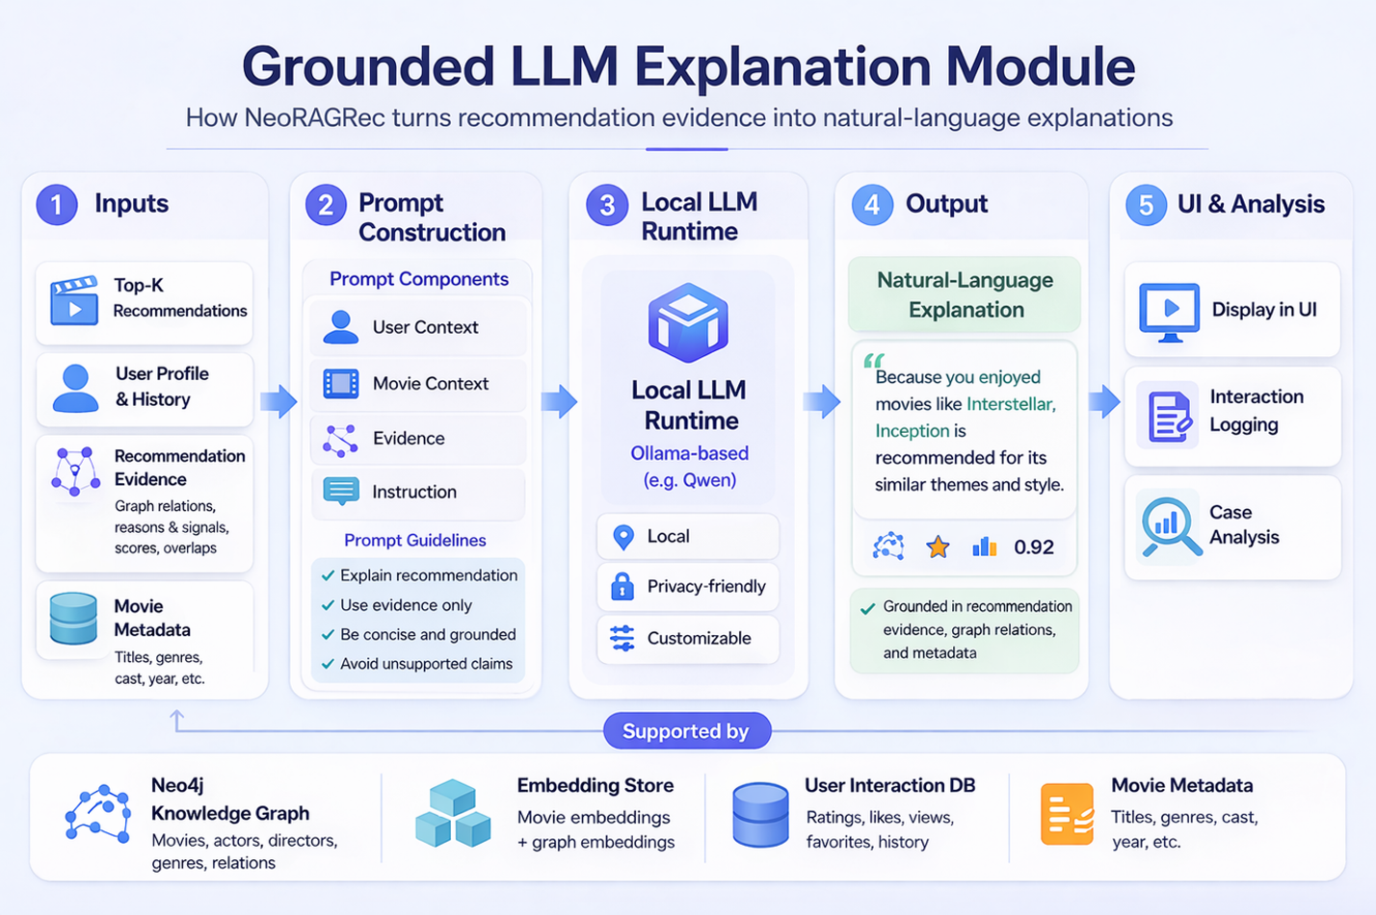
Figure 8
Objective:
The goal of this stage is to deliver short and understandable explanations for movies promoted by using natural-language outputs rooted in structured recommendation evidence. While NeoRAGRec’s hybrid retriever can successfully prioritise candidate items based on ANN similarity, Knowledge Graph (KG) relevance, and optional GNN-based structural signals, the resulting ranking scores are not inherently interpretable to end users. In order to tackle this problem, NeoRAGRec proposes an explanation module that takes recommendation data and converts it to an understandable justification. In particular, the system gathers evidence from the retrieval and ranking pipeline, like preference overlaps (e.g., shared genres, actors, directors), graph-derived signals (e.g., KG overlap or similarity references), and component scores (ANN/KG/GNN/final score). This evidence is then passed to a local LLM explanation component via constrained prompting. Thus explanations are grounded in recommender-produced facts rather than unconstrained generation, increasing transparency, and making sure facts are consistent.
Motivation
Without trustworthiness factors, even ranking accuracy alone is not enough in real recommender systems. Users may be reluctant to accept recommendations if they cannot ascertain why the items were recommended, even if they are actually relevant. This becomes very serious with hybrid recommenders, as final scores are derived from heterogeneous signals, not an intuitive rule. In NeoRAGRec, recommendation results depend on semantic similarity in embedding space, relational overlap in the KG, and structural signals from graph representation. These signals are opaque without an explanation layer. Thus, the explanation module is meant to connect internal ranking logic and user-facing outputs by translating underlying evidence into concise natural-language reasoning.
Explaining the Module's Inputs
The explanation module receives:
- Target movie context (metadata of the recommended item),
- User preference summary (historical preference cues), and
- Structured recommendation evidence from upstream retrieval/reranking.
Typical evidence includes:
- Overlap with user-preferred genres/directors/actors,
- KG-based similarity indicators (e.g., overlap/similarity references),
- Decomposed scores such as ANN, KG, GNN, and final fused score.
By preserving these inputs explicitly, the module remains tightly coupled with recommender logic and reduces reliance on unconstrained language generation.

Evidence Construction
Before prompting the LLM, NeoRAGRec organizes raw evidence into a compact evidence payload.
This step removes redundant items and retains high-relevance facts for the current recommendation. The motivation is practical: raw provenance is often noisy, while concise and structured evidence generally yields more reliable explanations from LLMs.
Let E={E1,…,En}E={E1​,…,En​} denote the evidence set, where each Ei​ is a short recommender-produced fact (e.g., shared entity, KG similarity cue, or component score). The LLM is prompted to generate explanations based on this evidence set.

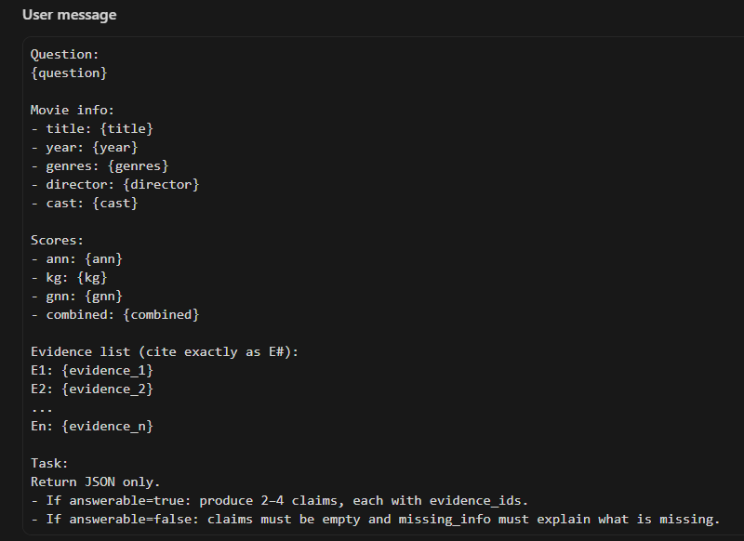 | 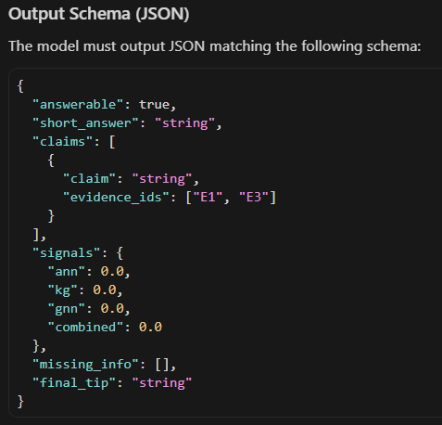
Figure 9 | Figure 10
Grounded Prompting strategy
A fundamental design principle is Grounded Prompting. The LLM is a natural language realization component, not an unqualified source of reasoning. Prompt instructions stress that explanations should be based on given evidence and scores only, and unsupported assertions have to be avoided. This grounded structure minimizes possible hallucination and enhances objective correspondence between the recommendation internals and the user-facing justification.

Prompting Approach (Implementation-Oriented)
NeoRAGRec adds recommendation evidence into a local LLM API (in this case Ollama/Qwen-like deployment), and sets structured constraints, which are as follows:
- use given evidence and scores,
- avoid creating user history or graph facts,
- prefer conservative responses to weak evidence.
In practice in engineering, some form of optional structured fields (e.g., evidence lists, references) can be added for downstream inspection in the field.

Robustness and Deployment Considerations
NeoRAGRec is intended for practical local/semi-local use; therefore, robustness must be explicitly considered. The generation of LLM explanations can be influenced by latency, temporary service unavailability, or insufficient evidence. Consequently, the explanation stage is combined with timeout handling and fallback behavior (for instance, simplified template-based explanation), ensuring recommendation service continuity even if generation quality is affected.

Expected Output
A FastAPI-integrated explanation generator that produces concise, evidence-grounded recommendation explanations with improved transparency and practical robustness.

Stage 5: Evaluation and Optimization
Objectives
The objective of this phase is to evaluate the effectiveness of NeoRAGRec within an offline recommendation setting and to analyze the contributions of its various system components to overall performance. Given that NeoRAGRec is designed as a practical hybrid recommendation system, this evaluation focuses on two complementary questions. First, the assessment examines whether the proposed hybrid design yields superior recommendation quality compared to simpler baseline models. Second, the evaluation investigates whether distinct embedding representations—derived from different graph structures—result in variations in recommendation performance when integrated into the same end-to-end retrieval pipeline. Consequently, this evaluation phase serves both as a validation of the system design and as an empirical analysis of the contributions made by its individual modules.
Experimental Setup
The final evaluation of NeoRAGRec was conducted under an offline recommendation setting, utilizing pre-partitioned interaction data. For each test user, the system leveraged their past interaction records to construct a user history and excluded items the user had previously viewed from the recommendation list. Subsequently, under a unified Top-K recommendation setting, the system retrieved and ranked candidate movies that the user had not yet seen. To ensure a fair comparison, all methods were evaluated using identical data splits, candidate filtering rules, and evaluation metric configurations. The final evaluation consisted of two complementary components:
  - Ablation experiments and benchmark comparisons examining various retrieval configurations
  - Embedding comparison experiments, wherein the entire NeoRAGRec pipeline remained fixed, with only the source of the Graph Embeddings being varied.
Evaluation Metrics
To assess ranking quality and recommendation diversity, this evaluation primarily reports three key metrics: Recall@K, NDCG@K, and Coverage. Recall@K measures whether relevant target items appear within the Top-K list of recommendations. NDCG@K further incorporates ranking position into the assessment; the higher an item ranks within the results, the more effective the recommendation is considered to be—signifying a greater likelihood of user preference. Coverage reflects the proportion of unique items recommended across all users, revealing whether the system tends to recommend only a small subset of highly popular movies or is capable of covering a broader scope of the item space. These metrics are particularly well-suited to the current system because NeoRAGRec aims not only to achieve precise recommendations but also to maintain a balance of reasonable recommendation diversity and practical utility.

- Ablation Methods
The first evaluation table is designed to facilitate an ablation study of the retrieval and ranking pipeline. Its objective is to examine the extent to which each major component contributes to the overall quality of the recommendations. The specific comparison methodology is as follows:
- Popularity-based Recommendation
This baseline recommends movies based solely on their global interaction frequency. While it often achieves high recall due to recommending a small set of highly popular items, it does not provide personalization.
- Content-based Recommendation (Content-only)
This method uses semantic similarity between user profiles and movie content embeddings. Approximate nearest neighbor (ANN) search is applied to retrieve candidate movies based on textual similarity alone, without using relational information.
- Hybrid Recommendation without GNN (Hybrid-no-GNN)
This baseline combines content similarity and knowledge graph (KG) signals, such as shared directors or genres, using a weighted fusion strategy. However, it does not incorporate GNN-based structural embeddings.
- Proposed Method: Hybrid Recommendation with GNN (Full Model)
The proposed approach extends the hybrid model by incorporating GNN-based subgraph embeddings learned from the movie knowledge graph. These embeddings capture higher-order relational and structural information and are integrated as an additional signal during ranking.

6 ablation Comparison
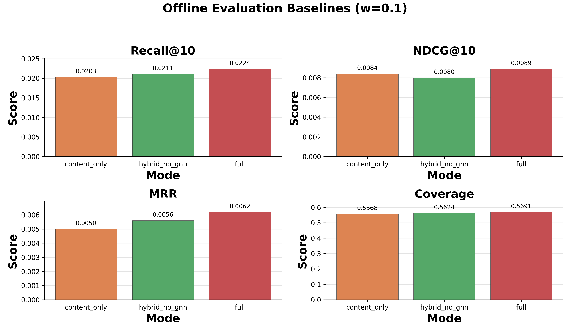
Figure 11
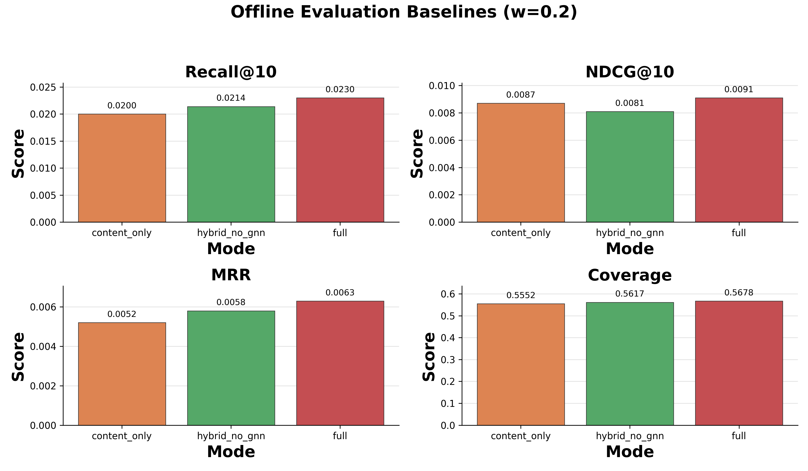
Figure 12
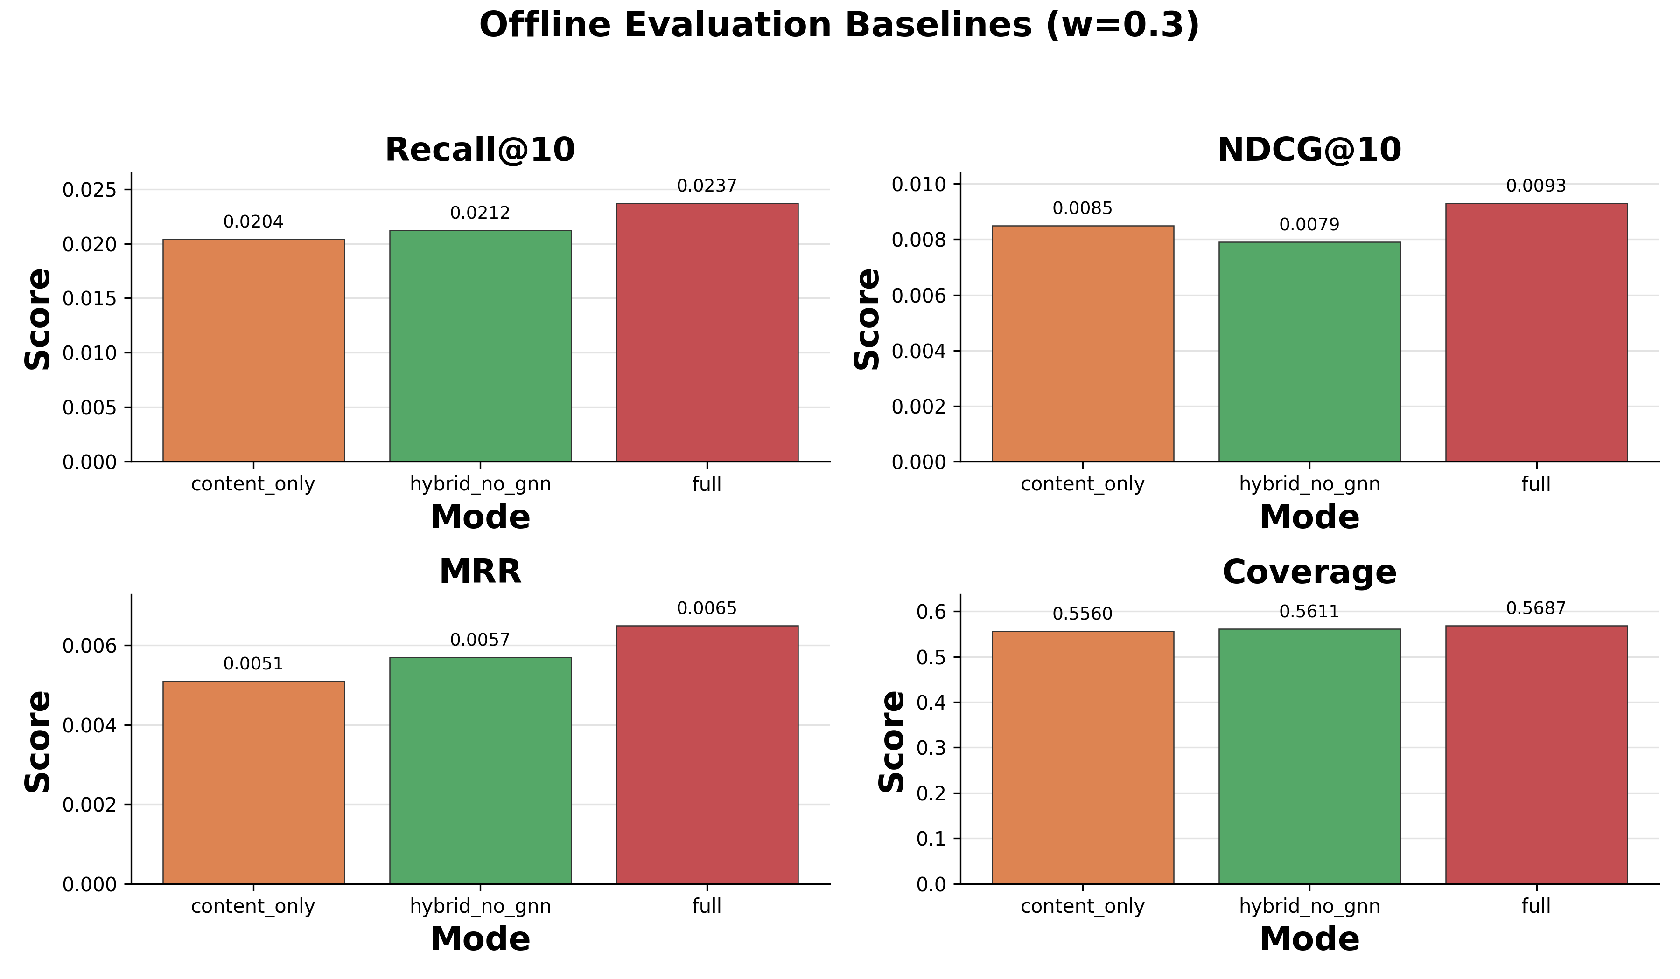
Figure 13
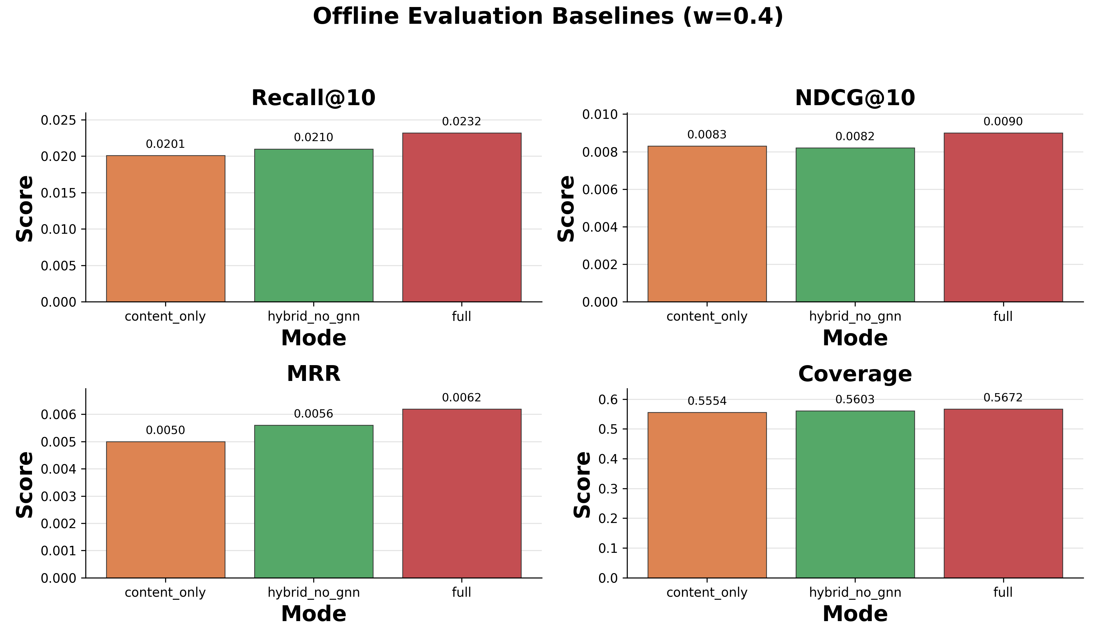
Figure 14
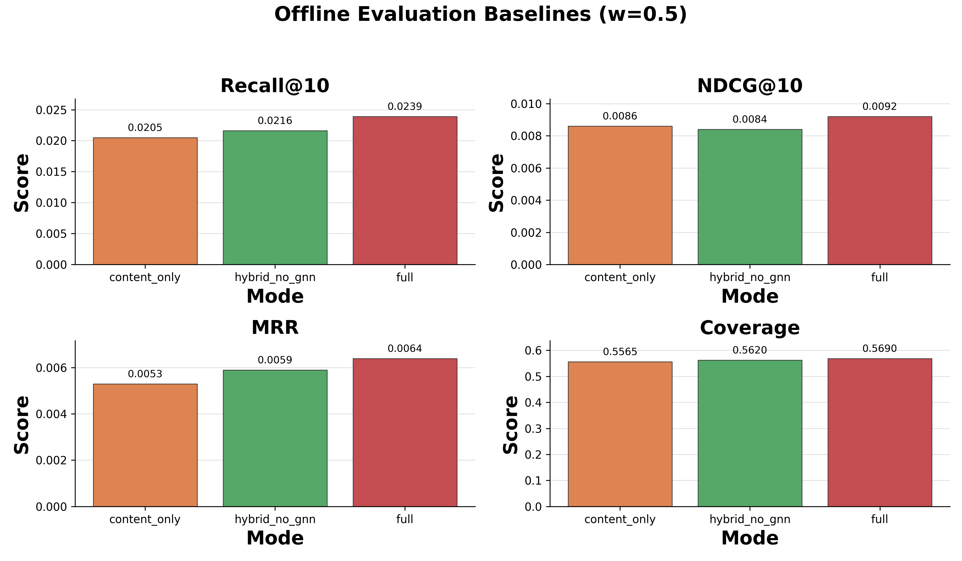
Figure 15
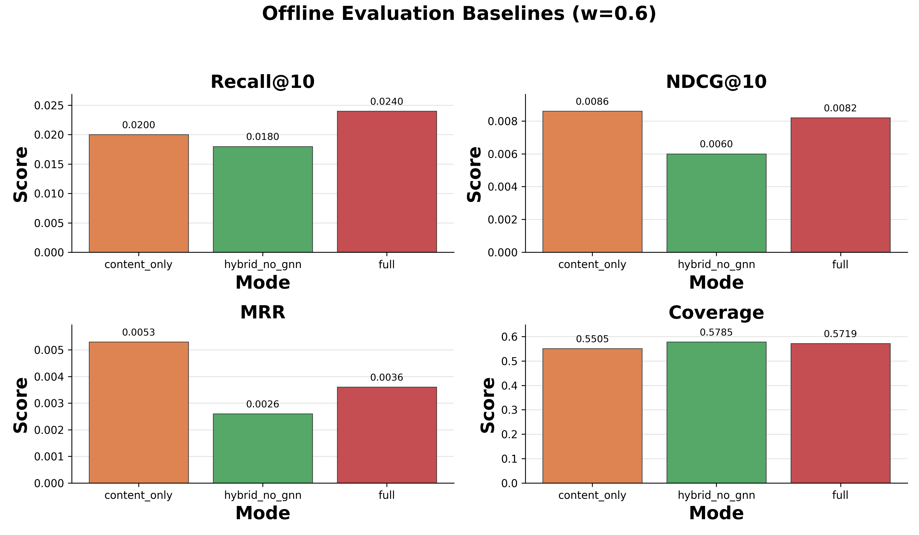
Figure 16
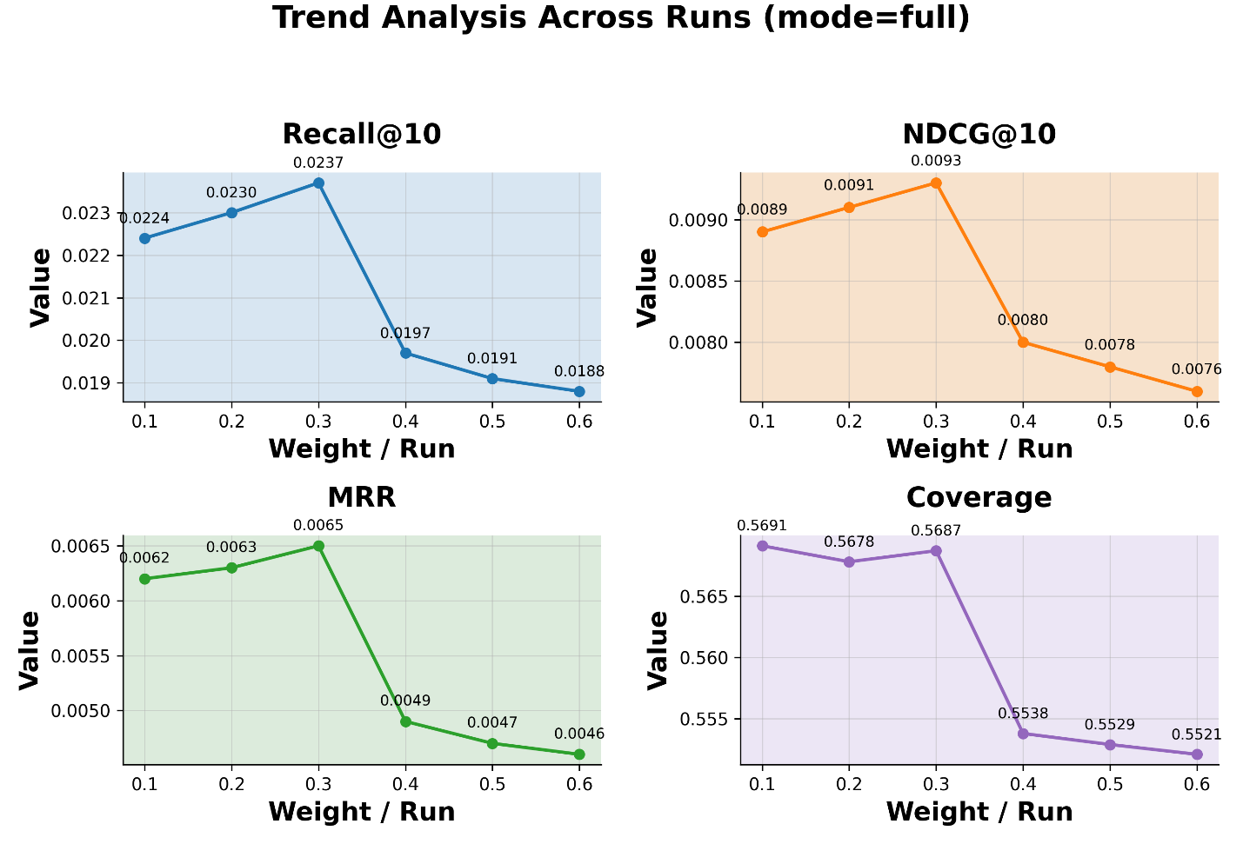
Figure 17
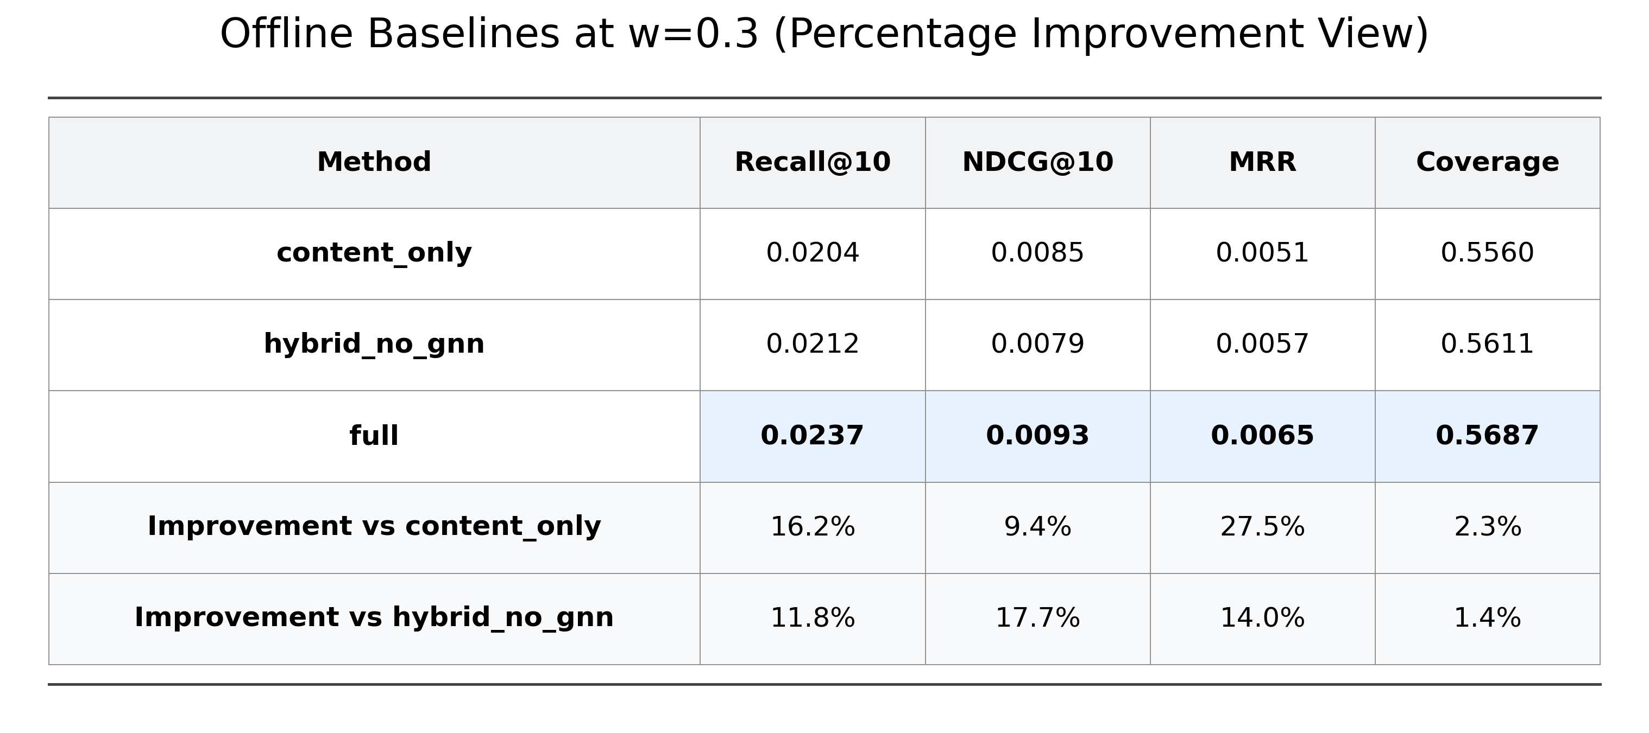
Figure 18
The influence of changing the fusion weight 𝑤 (controlling for the effect of GNN-based structural similarity on final ranking) can be shown by several diagrams. When w is close to 0, this means that the model relies largely on ANN similarity and knowledge-graph relevance, and that it does not take on a lot of structural information. As 𝑤 increases, Recall@10 and NDCG@10 improve, demonstrating that GNN-based structural similarity gives informative information in addition to semantic and relational information. That is, the highest performance is obtained when the GNN contribution is moderate, approximately 𝑤 ≈ 0.3, indicating that structural similarity is effective when it acts as a supplementary rather than dominating signal. When 𝑤 becomes too large, performance gradually declines, indicating that too much dependence on GNN-based similarity could reduce the effectiveness of ANN similarity and KG relevance. In general, these findings support the implementation of GNN-based structural representations in the hybrid recommendation framework.
2. Embedding Comparison Method
The second evaluation sheet is designed to examine the impact of employing different graph-based movie embeddings, assuming the remainder of the recommendation pipeline remains constant. In the current implementation, this comparison is achieved by executing the exact same complete recommendation model, with the sole modification being the alteration of the source of the graph embeddings utilized within the structural similarity component. The existing embedding replacement script supports the following three embedding variants:
- our_gnn: Graph embeddings generated by the current NeoRAGRec self-supervised GNN pipeline;
- kgin: Movie embeddings derived from a KGIN-based model;
- kgat: Movie embeddings derived from a KGAT-based model.

Comparison of Embeddings with KGIN and KGAT
In order to have a better evaluation of the representation layer, in this work we also compare the proposed NeoRAGRec graph embeddings with two representative “knowledge-aware recommendation” embedding algorithms, namely, KGIN and KGAT. KGIN is a knowledge graph-based recommendation model that mainly focuses on modeling the latent intentions in user interactions, where learned representations of items can reproduce fine-grained preference semantics supported by the graph structure. By contrast, KGAT relies on attention-based message passing over the knowledge graph so that the item embeddings retain information about neighborhood importance with a relational understanding. These two models are chosen because they are related to two important areas of research in knowledge-aware recommendation — “intent-aware graph recommendation” and “attention-based graph recommendation,” and in the comparison in this paper, they are not used to implement an entirely new NeoRAGRec system; instead, they act as external graph embedding baseline models — this allows the purpose of comparison to strictly be directed towards the quality of the movie representations within the graph structure itself. This design can be very good in practical terms because the effect of the graph representation quality is isolated from the rest of the recommendation system. So, the retrieval logic, the candidate generation process, the hybrid ranking framework remain the same thing, except the source of the structural embeddings has changed. As such, the comparative results directly respond to our query of how the self-supervised graph embeddings proposed in this paper stack up — relative to externally generated graph embeddings — against those based on an identical recommendation pipeline.
Implemented evaluation pipeline
In the introduced evaluation pipeline, comparative analysis is implemented via an embedded substitution design scheme. First, interaction data is extracted (as per the same training/evaluation splits used in the previous step) and graph triplets are exported from Neo4j and transformed to the respective datasets for the KGIN and KGAT models. In course of this extraction, the dataset defaults to contain only static relationships such as HAS_GENRE, DIRECTED_BY, and STARRED_BY; and the SIMILAR_TO relationship is excluded (unless specified in the user's instructions). This is to prevent "label leakage" which might occur if the similarity edges are added purely on the interaction data. When the external models have generated their own item embeddings, and the same encoding (processing) rules apply for all items in the embedding, standardization of the data format for the NeoRAGRec evaluation pipeline is in place. Specifically for the KGAT model, the exported embedding data are retrieved from the "item" part of the embedding matrix from the model checkpoint file, where these are saved – along with the movie ID mapping table – as a kgat_movie_embeddings.npy file. A comparable conversion is conducted for embedding data from the KGIN model, whereby embedding data from both source models can be uniformly loaded and processed within the same downstream evaluation pipeline.
3 embedding model comparison
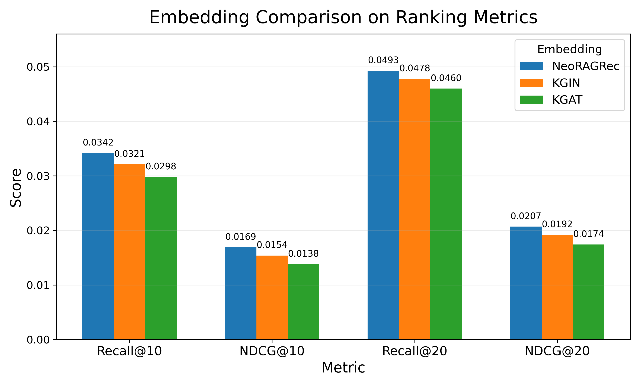
Figure 19
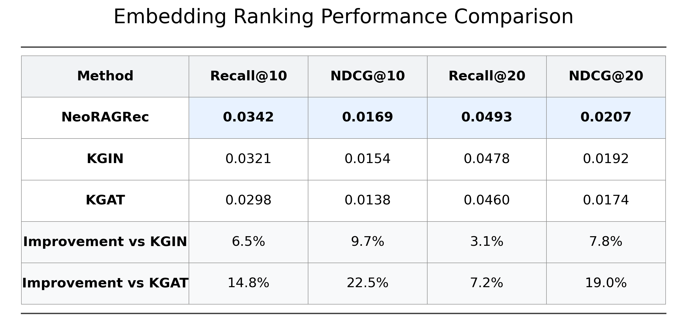
Figure 20
As seen in the embeddings of these comparisons, NeoRAGRec performs better on all ranking metrics and also produces the best coverage. This illustrates that in the same hybrid recommendation framework, the self-supervised graph embedding pipeline proposed in this paper outperforms the KGIN and KGAT embedding sources. For emphasis, if we look deeper the baseline popularity method that performs better than the others with Recall@10 score will be due to its tendency of repeatedly recommending a few popular items. This approach is effective on recall type metrics, but needs more personalization and diversity of content. NeoRAGRec strives to balance accuracy with coverage and therefore is more appropriate for real-world personalized recommendation scenarios.
The content-based approach greatly improves coverage, making the model able to recommend a broader range of movies based on semantic similarity. But it still shows a relatively low accuracy, indicating textual similarity in itself is not enough to find deeper user preferences. The hybrid model without GNN does not consistently outperform the content-only baseline, as the output of the hybrid model without GNN is poor. The outcome indicates that in the absence of proper expressive relational information, naïve fusion of knowledge graph signals may dilute strong content-based signals. However, the hybrid model with GNN embeddings provides stronger Recall@10 results than the non-GNN baselines and still gives a high coverage. Hence, it shows that GNN-based subgraph embeddings can capture higher-order relational information from the knowledge graph and can improve the performance of recommendation beyond simple hybrid fusion.
Overall, the results validate the effectiveness of incorporating GNN-based relational representations into a hybrid recommendation framework, even under a limited data setting and without extensive hyperparameter tuning. At the same time, incorporating a comparative analysis of embeddings serves to reveal whether the self-supervised graph embedding pipeline proposed in this paper possesses the competitive strength to rival external embedding methods such as KGIN and KGAT. Even if the performance gap proves negligible, such a comparison remains highly valuable; for while NeoRAGRec strives for ranking accuracy, it places equal emphasis on model integration, interpretability, and ease of practical deployment.
Limitations
The current study is limited by many factors. First, the scale of the current evaluation dataset is relatively small. While the use of self-supervised graph learning is able to address some aspects of sparsity in the data, the inclusion and validation of a larger dataset will facilitate evaluation of the proposed method’s generalization capabilities. Second, user embeddings are constructed in a manner that aggregates historical interaction behaviors rather than user representations learned from an end-to-end approach. As a result, the system is not capable of modeling more complex temporal dynamics or fine-grained evolution of user preferences. Thirdly, the quality of the generated explanations is still, partly, dependent on the reliability and completeness of the evidence collected. If evidence from the graph structure or metadata is sparse—even if the recommendation results themselves remain sound—the output from the explanation module may seem impoverished due to a lack of sufficient information.
Summary
This chapter presents an offline evaluation of NeoRAGRec and demonstrates that incorporating GNN-based knowledge graph embeddings leads to measurable improvements over content-only and non-GNN hybrid baselines. While popularity-based methods achieve high recall, they lack personalization and diversity. The proposed approach offers a balanced trade-off between accuracy and coverage, supporting its suitability for explainable and personalized recommendation.

Project Schedule
Week | Task | Description | Status
1–2 | Knowledge Graph Construction | Construct Neo4j schema; import MovieLens/IMDb data; define Movie–Actor–Director–Genre relations | Completed
3–4 | Subgraph Extraction & Data Preparation | Extract movie-centered subgraphs and convert them into PyTorch Geometric HeteroData format | Completed
5–6 | Self-Supervised GNN Training | Train GNN with GCN + GAT + self-supervised contrastive loss; generate movie embeddings | Completed
7 | ANN Index Construction | Build FAISS ANN index for movie embeddings; validate retrieval latency | Completed
8 | Hybrid Retrieval Module | Implement hybrid scoring (ANN + KG + optional GNN signals) | Completed
9 | Offline Evaluation | Conduct leave-one-out evaluation; compute Recall@10, NDCG@10, Coverage | Completed
10 | User Interaction Integration | Integrate ratings, likes, favorites, view history into user embedding construction | Completed
11 | LLM Explanation Module | Integrate local LLM (Ollama/Qwen); generate KG-grounded explanations | Completed
12 | System Optimization & Final Offline Evaluation | Perform parameter adjustment, latency optimization, and final offline evaluation, including ablation and embedding comparison | Completed
13 | Final Report & Demo | Final report writing; system demo preparation | Completed

Conclusion and Future Work
This article describes NeoRAGRec, which is a real-world movie recommendation system that integrates knowledge graph reasoning, self-supervised graph embedding learning with hybrid retrieval in combination with LLM-based explanation generation into a single, deployable framework. In this case the system works to respond to a few common limitations of conventional and content-only recommendation systems, which encompass weak interpretability, only limited capacity to model higher-order semantic relationships, and lack of structured evidence support. We implemented a Neo4j-based movie knowledge graph, on which movies, directors, actors, genres, and users can all use a model to determine the semantic relationships among movies, directors, actors, genres, and users. Derived from this graph, we created a self-supervised graph embedding pipeline capable of learning movie representations from 1-hop ego-subgraphs without any need for supervised annotations. These learned embeddings were then incorporated into a hybrid retrieval approach that incorporates approximate nearest-neighbor semantic retrieval, knowledge graph-based relational relevance, and—in one case—GNN-based structural similarity. Additionally, the data collected from user interaction signals including ratings, likes, favorites, comments, and browsing history was embedded into the recommendation pipeline to obtain dynamic and personalized user representations. In order to better understand the data and improve interpretation, we next developed a LLM-based explanation module that generates short, natural language explanations based on graph-based evidence and recommendation paths. Finally, the offline evaluation of this proposed hybrid framework shows that it provides better, balanced recommendation performance than simpler baseline models. With the introduction of GNN-based subgraph embeddings, the quality of the recommendation increased with reasonable item coverage, outperforming purely content-based and non-GNN hybrid configurations. Additionally, the performance of the self-supervised graph embedding pipeline based on the embedding from KGIN as well as KGAT for comparisons also proved its competitiveness as a structural representation aspect of the recommendation framework. So overall we find that knowledge graph reasoning, self-supervised graph learning, hybrid ranking, and evidence-based explanations can all be combined, and practically this combination is useful in movie recommendation scenes. These promising results notwithstanding, several limitations remain. The first is that it does not consider user satisfaction in the offline context, so it cannot reflect user satisfaction in the real-world interactive context where real-time user interaction is not possible. Second, the existing user representation is based on a weighted summation of past interactions instead of end-to-end learning-based user modeling, which restricts the model to model more dynamic temporal information and users preference changes. Third, the outputs of the produced explanations are ultimately contingent on the completeness and reliability of the retrieved evidence from the ground up as well as upon the generation of the generated explanations. With sparse graph-based or metadata evidence, the explanation side may get less informative outputs, even if the recommendation is still reasonable. This work could potentially be extended in multiple directions in future work. One such route could be to perform NeoRAGRec on larger and broader datasets to confirm the ability of NeoRAGRec’s generalization properties and robustness. Another path would be to include more robust recommendation baseline models and to perform a more systematic analysis of parameter sensitivity. In addition, possible improvements to this work upcoming, more fine-grained user modeling might be incorporated, benchmarking of the deployment latency, and stronger evidence-discovery criteria to develop explanations. These extensions in turn make NeoRAGRec even more practically applicable as an interpretable and knowledge-facilitated recommendation framework.

References
- He, X., Deng, K., Wang, X., Li, Y., Zhang, Y., & Wang, M. (2020). LightGCN: Simplifying and Powering Graph Convolution Network for Recommendation. ArXiv. https://arxiv.org/abs/2002.02126
- Kipf, T. N., & Welling, M. (2016). Semi-Supervised Classification with Graph Convolutional Networks. ArXiv. https://arxiv.org/abs/1609.02907
- Lewis, P., Perez, E., Piktus, A., Petroni, F., Karpukhin, V., Goyal, N., Küttler, H., Lewis, M., Yih, W., Rocktäschel, T., Riedel, S., & Kiela, D. (2020). Retrieval-Augmented Generation for Knowledge-Intensive NLP Tasks. ArXiv. https://arxiv.org/abs/2005.11401
- Pu, D., Zhang, Y., Qian, Z., Xie, G., & Pu, D. (2025). A graph neural network recommendation algorithm based on multi-scale attention and contrastive learning. Scientific Reports, 15(1), 32207. https://doi.org/10.1038/s41598-025-17925-y
- Veličković, P., Cucurull, G., Casanova, A., Romero, A., Liò, P., & Bengio, Y. (2017). Graph Attention Networks. ArXiv. https://arxiv.org/abs/1710.10903
- Wang, H., Zhang, F., Wang, J., Zhao, M., Li, W., Xie, X., & Guo, M. (2018). RippleNet: Propagating user preferences on the knowledge graph for recommender systems. In N. Paton, S. Candan, H. Wang, J. Allan, R. Agrawal, A. Labrinidis, A. Cuzzocrea, M. Zaki, D. Srivastava, A. Broder, & A. Schuster (Eds.), CIKM 2018 - Proceedings of the 27th ACM International Conference on Information and Knowledge Management (pp. 417-426). (International Conference on Information and Knowledge Management, Proceedings). Association for Computing Machinery. https://doi.org/10.1145/3269206.3271739
- Wang, X., Huang, T., Wang, D., Yuan, Y., Liu, Z., He, X., & Chua, T.-S. (2021). Learning Intents behind Interactions with Knowledge Graph for Recommendation. In The Web Conference 2021 - Proceedings of the World Wide Web Conference, WWW 2021 (pp. 878–887). (The Web Conference 2021 - Proceedings of the World Wide Web Conference, WWW 2021). Association for Computing Machinery (ACM). https://doi.org/10.1145/3442381.3450133
- Wang, S., Fan, W., Feng, Y., Lin, S., Ma, X., Wang, S., & Yin, D. (2025). Knowledge Graph Retrieval-Augmented Generation for LLM-based Recommendation. ArXiv. https://arxiv.org/abs/2501.02226
- Wu, S., Sun, F., Zhang, W., Xie, X., & Cui, B. (2020). Graph Neural Networks in Recommender Systems: A Survey. ArXiv. https://arxiv.org/abs/2011.02260
- Yang, S., Liu, Y., Xu, Y., Miao, C., Wu, M., & Zhang, J. (2020). Contextualized Graph Attention Network for Recommendation with Item Knowledge Graph. ArXiv. https://arxiv.org/abs/2004.11529
- Zhang, S., Yao, L., Sun, A., & Tay, Y. (2017). Deep Learning based Recommender System: A Survey and New Perspectives. ArXiv. https://doi.org/10.1145/3285029
- You, Y., Chen, T., Sui, Y., Chen, T., Wang, Z., & Shen, Y. (2020). Graph Contrastive Learning with Augmentations. ArXiv. https://arxiv.org/abs/2010.13902
- Liu, Y., Jin, M., Pan, S., Zhou, C., Zheng, Y., & Xia, F. (2023). Graph self-supervised learning: A survey. IEEE Transactions on Knowledge and Data Engineering, 35(6), 5879–5900. https://doi.org/10.1109/TKDE.2022.3172903
- Li, Y., Zhang, X., Luo, L., Chang, H., Ren, Y., King, I., & Li, J. (2025). G-Refer: Graph Retrieval-Augmented Large Language Model for Explainable Recommendation. ArXiv. https://arxiv.org/abs/2502.12586
- Zhang, Y., & Chen, X. (2018). Explainable Recommendation: A Survey and New Perspectives. ArXiv. https://doi.org/10.1561/1500000066
- Wu, J., Wang, X., Feng, F., He, X., Chen, L., Lian, J., & Xie, X. (2021). Self-supervised Graph Learning for Recommendation. SIGIR ’21.

