Section 1: Background

This document briefly describes the program “Safe” which is used to encrypt and store logins and notes into a computer.

In this program, we have already entered some logins and notes in advance. When you first start the program, you can enter the default password “masterpassword”. Then you can start to load the information.

The following are screenshots of the program:

Screenshot 1: First screen

Screenshot 2: Instructions menu

Screenshot 3: After entering the default password, and press load, we load the list.

Can try different group and notes.

Screenshots: You can press new to enter new entries, or delete or update existing entries:

After addition

After deletion

Screenshot: Example of stored encrypted file:

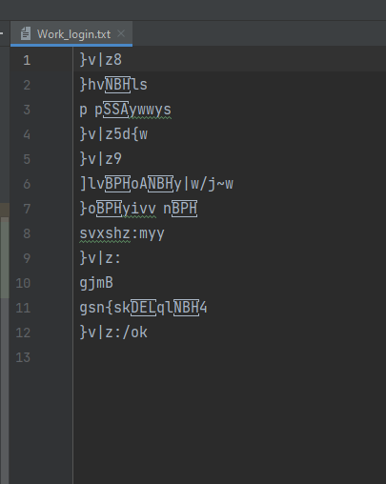

Section 2: Test outcomes:

All tests run successfully. See the following screenshots

Section 3: Instructions:

\*\*\* Important:  
\* This program helps the user to encrypt and store logins and notes securely in their computer.  
\* Make sure you are using the CORRECT master password before you save and load.  
\* The secure password is used to load and save encrypted files. Using the incorrect password, data will not be loaded correctly.  
\* Currently, the default password is "masterpassword". Once you load the list, you can enter a different master password and then save. This will update the password to encrypt the list.  
\* You need to remember which password you used when you save and load the list.  
\* Also, you can use different master passwords to protect different lists.  
\* Be careful when you modify and/or save the list, the master password must be correct. This program cannot verify the correctness of the password. The user must remember the master password.  
\*\*\*\*\*\*\*\*\*\*\*\*\*\*\*\*\*\*\*\*\*\*\*\*\*\*\*\*\*\*\*\*\*\*\*\*\*\*\*\*\*\*\*\*\*\*\*\*\*\*\*\*\*\*\*\*\*\*\*\*\*\*\*\*\*\*\*\*\*\*\*\*\*\*\*\*\*\*\*\*\*\*\*  
  
1) To save an (encrypted) list to a file  
 a) Choose the group name (e.g. home) and make sure the password is correct  
 b) Click the save button  
 c) The current list (login or notes) will save to a file  
2) To load the list from a file  
 a) Choose the group name and make sure the password is correct  
 b) Click the load button  
 c) The list (login or notes) will be loaded  
3) To add an item (login or note) to a list  
 a) Choose the group name  
 b) Enter the item information and press add button. The list will be automatically saved.  
4) To delete an item from a list  
 a) Select the item from the list.  
 b) Press delete and the item will be removed from the current list. The list will be automatically saved.  
5) Using Save button:  
 a) Normally, when you add, delete, or update, all changes will be saved automatically.  
 b) However, if you want to change the password used to encrypt the data, you can also change the password and then press save.  
  
6) Using the menu selection:  
 a) Choosing the menu item by itself will not load any data.  
 b) So remember to press load / save to load and save.