When Explanations Outlive Their Data: Faithfulness Decoupling in Graph-Attention MARL Fleet Dispatch under Telemetry Degradation
A Master's Dissertation
submitted in partial fulfilment of the requirements for the award of the degree of
Master of Science (MSc)
By
Hongwei Lin
P2982757
Supervisor: Farhan S. Ujager

School of Computing
De Montfort University, Dubai
August 2026

DECLARATION
I declare that this dissertation is my own original work carried out under the supervision of Farhan S. Ujager and that all sources and references have been acknowledged appropriately. This dissertation has not been submitted previously for academic credit at De Montfort University, Dubai, or any other institution.

Signature: ______________________________
Name: Hongwei Lin
Date: ______________________________

ACKNOWLEDGEMENT
I would like to express my sincere gratitude to my supervisor, Dr Farhan S. Ujager, for his valuable support, guidance, and encouragement throughout this research.
Student signature: ______________________________
Student name: Hongwei Lin

LIST OF FIGURES
Title | Page
Figure 3.1: Telemetry degradation data flow | 5
Figure 3.2: Decision-level explanation faithfulness occlusion protocol | 7
Figure 4.1: Model conditions and training process | 9
Figure 4.2: Observation graph for one dispatch decision | 10
Figure 4.3: Simplified graph-attention design | 10
Figure 5.1: Clean-telemetry faithfulness audit | 13
Figure 5.2: Capability spectrum under uniform and type-matched baselines | 14
Figure 5.3: Manipulation check for the nominal AoI ladder | 15
Figure 5.4: Stale-attention drift under telemetry degradation | 17
Figure 5.5: Coupled and decoupled explanation channels | 19

LIST OF TABLES
Title | Page
Table 4.1: Model conditions | 9
Table 4.2: Observation graph node types | 11
Table 5.1: Performance context | 12
Table 5.2: Construct-validity audit | 13
Table 5.3: Capability spectrum under both baselines | 14
Table 5.4: Manipulation check: realised AoI by nominal level | 15
Table 5.5: Degradation exposure and performance | 17
Table 5.6: Hypothesis outcomes | 18
Table 5.7: Mitigation results using the type-matched baseline | 19
Table 6.1: Limitations and impact | 22

LIST OF ABBREVIATIONS
Abbreviation | Full form
AoI | Age of Information
DEF | Decision-level Explanation Faithfulness
GAT | Graph Attention Network
GAE | Generalised Advantage Estimation
MAPPO | Multi-Agent Proximal Policy Optimisation
MARL | Multi-Agent Reinforcement Learning
MLP | Multilayer Perceptron
PPO | Proximal Policy Optimisation
RQ | Research Question
SUMO | Simulation of Urban MObility
WAMSN | Weighted Attention Mass on Stale Nodes

ABSTRACT
Graph-attention policies expose weights that are easy to display as explanations, but those explanations may remain plausible after the telemetry beneath them becomes stale. This dissertation studies that risk in multi-agent fleet dispatch. In a SUMO benchmark, tunnel entry triggers signal loss: vehicles continue to move, while the policy receives their last valid state and their Age of Information (AoI) increases. Decision-level explanation faithfulness (DEF) measures explanation quality, and weighted attention mass on stale nodes (WAMSN) measures attention to outdated vehicle information.
On clean telemetry, a standard random occlusion baseline gives margin-DEF of -0.541. This comparison is unfair because removing a passenger-request node also removes its dispatch action. Matching the random baseline to the same mixture of vehicle and request nodes changes the score to -0.009 [-0.016, -0.001]. Built-in attention is therefore approximately uninformative, not actively worse than random.
Under degradation, pooled WAMSN rises from 0 to 0.014. When a stale vehicle node is visible, it receives 13.4-14.8 % of vehicle-node attention. Pickups and aggregate faithfulness remain broadly flat, while decisions with more stale-node attention are less faithful within episodes (margin-DEF rho = -0.045; probability-DEF rho = -0.149). This is the observed faithfulness decoupling: explanation content shifts toward stale information without a warning from performance or aggregate faithfulness. Because the intended severity ladder did not produce distinct realised staleness levels, the evidence supports a clean-versus-degraded comparison rather than an AoI dose-response claim.
Degradation-aware training has no detectable effect. A separate explanation head improves clean margin-DEF by +0.023, but not detectably under degradation. The study shows how attention explanations can outlive their data and why the faithfulness test must itself be validated.
Keywords: explainable reinforcement learning, faithfulness evaluation, construct validity, graph attention, multi-agent reinforcement learning, fleet dispatch, Age of Information, SUMO

TABLE OF CONTENTS
Title | Page
Declaration | ii
Acknowledgement | iii
List of Figures | iv
List of Tables | v
List of Abbreviations | vi
Abstract | vii
Chapter 1: Introduction | 1
1.1 Background and Motivation | 1
1.2 Problem Statement | 1
1.3 Research Questions and Objectives | 1
1.4 Scope, Significance and Contributions | 1
Chapter 2: Literature Review | 3
2.1 Reinforcement Learning for Fleet Dispatch | 3
2.2 Attention as Explanation | 3
2.3 Perturbation-Based Faithfulness | 3
2.4 Age of Information | 4
2.5 Research Gap | 4
Chapter 3: Methodology | 5
3.1 Research Design | 5
3.2 SUMO Dispatch Environment | 5
3.3 Telemetry Degradation | 5
3.4 Training Protocol | 6
3.5 Explanation Metrics and Validity Audit | 6
3.6 Statistical Testing | 8
Chapter 4: Model Design and Implementation | 9
4.1 Model Conditions | 9
4.2 Graph-Attention Policy | 10
4.3 Gap-Model Alignment | 11
Chapter 5: Results and Discussion | 12
5.1 Performance Context | 12
5.2 Clean-Telemetry Faithfulness and Metric Validation | 12
5.3 Stale Telemetry and Explanation Content | 15
5.4 Mitigation Results | 18
5.5 Discussion | 19
Chapter 6: Conclusion | 21
6.1 Summary of Findings and Contributions | 21
6.2 Limitations | 21
Chapter 7: Future Work | 23
List of Publications | 24
References | 25
Appendices | 27

Chapter 1: Introduction

1.1 Background and Motivation
Fleet dispatch systems depend on timely vehicle locations, speeds and availability. In practice, those updates can be delayed by tunnels, signal loss and dense urban infrastructure. A dispatcher may continue to produce a decision from the last available state, but an explanation of that decision can then refer to information that is no longer current. Stable task performance alone does not show that the explanation remains trustworthy.
This dissertation studies that problem in a graph-attention multi-agent reinforcement learning (MARL) dispatcher. Fleet dispatch is relational: a taxi chooses among passenger requests while considering nearby vehicles and competing demand. Graph attention networks (Velickovic et al., 2018) provide a compact way to model those relationships and expose per-node attention weights. Because the weights are easy to visualise, they are tempting to present as explanations. Previous work has shown, however, that attention is not automatically faithful to a model's decision (Jain and Wallace, 2019; Wiegreffe and Pinter, 2019; Serrano and Smith, 2019; Liu et al., 2022).

1.2 Problem Statement
The central concern is faithfulness decoupling. In this study the term has a specific meaning: the content of the explanation shifts toward stale data, while task performance and aggregate faithfulness provide no corresponding warning. This is narrower than claiming that increasing AoI directly causes a monotonic loss of faithfulness. The experiments do not support that stronger dose-response claim.

1.3 Research Questions and Objectives
Three research questions organise the study:
1. RQ1: Is the GAT attention channel a faithful explanation of dispatch decisions under clean telemetry?
2. RQ2: How does stale telemetry affect explanation content and its relationship with task performance?
3. RQ3: Can degradation-aware training or a separate explanation head reduce the problem?

1.4 Scope, Significance and Contributions
Answering RQ1 requires validating the faithfulness test itself. Perturbation tests normally remove the inputs selected by an explanation and compare the effect with removing random inputs (DeYoung et al., 2020). In this dispatcher, however, a passenger-request node is also a dispatch action. Removing a nearby-taxi node only hides context; removing a request node also deletes an available action. A random baseline that removes more requests than the attention explanation therefore creates an unfair comparison. The study audits this effect and uses a type-matched baseline that removes the same mixture of vehicle and request nodes on both sides.
The experiment is conducted in SUMO (Lopez et al., 2018) on a tunnel-rich road network in Chongqing. Tunnel entry triggers simulated signal loss, but SUMO continues to move the vehicle using the true state. Only the observation supplied to the policy is degraded: its last valid position and speed are retained while Age of Information (AoI) (Kaul, Yates and Gruteser, 2012) grows. This separation keeps the physical traffic world intact and isolates the effect of stale information on the policy and its explanation.
The corrected clean-telemetry result is that built-in attention is approximately uninformative: type-matched margin-DEF is -0.009. Under degraded telemetry, attention moves onto stale vehicle nodes while pickups and aggregate faithfulness remain broadly flat. Decisions with more stale-node attention are also less faithful within episodes. Degradation-aware training does not change this result, and a decoupled explanation head provides only a small improvement on clean telemetry.
The intended {5, 15, 30, 60} s AoI ladder did not create distinct realised staleness levels because tunnel transit time dominated the lower settings and the observation encoded AoI with a 60 s cap. The degradation evidence is therefore reported as a clean-versus-degraded comparison. The learned policy also performs well below SUMO's greedy matcher, so the degradation findings are scoped to the experimental policy rather than a production-ready dispatcher.
The contributions are:
1. A controlled SUMO study showing that stale telemetry shifts graph attention toward stale vehicle nodes without a corresponding change in pickups or aggregate faithfulness.
2. Evidence that greater stale-node attention is associated with lower decision-level faithfulness within episodes.
3. A construct-validity audit showing why standard random occlusion is unfair when explanation units are also candidate actions, together with a type-matched correction.
4. An evaluation of training-side and explanation-side mitigations, neither of which restores meaningful faithfulness under degraded telemetry.
5. A reproducible experimental design that separates SUMO ground truth from the degraded observation and reports the failed severity manipulation explicitly.

Chapter 2: Literature Review

2.1 Reinforcement Learning for Fleet Dispatch
Reinforcement learning is widely used in ride-hailing and fleet management (Lin et al., 2018; Qin, Zhu and Ye, 2022). Multi-agent methods fit this problem because many vehicles act in the same city at the same time (Lowe et al., 2017; Rashid et al., 2020; Yu et al., 2022). This study uses MAPPO (Yu et al., 2022) with one shared policy for all taxis. It does not propose a new dispatch algorithm. The dispatcher provides a controlled setting in which each explanation can be tested. As Section 5.1 shows, it performs well below a greedy matcher.
Graph neural networks encode relationships between vehicles and requests (Scarselli et al., 2009). Graph attention adds a weight for each related entity (Velickovic et al., 2018) and has also been used in multi-agent critics (Iqbal and Sha, 2019). In this study, the important point is that these weights are visible and could be shown to an operator as an explanation.
Recent dispatch research shows how strongly the field is moving toward graph-based MARL at city scale. BMG-Q combines graph attention with bipartite vehicle-order matching (Hu, Feng and Li, 2025), CoopRide learns cooperation between city grids (Wang et al., 2025), and DualG-MARL jointly models vehicle-state and passenger-task graphs (Sha et al., 2026). These studies evaluate dispatch quality, scalability and coordination. The present work asks a complementary question: whether the attention exposed by such models can be trusted as an explanation when vehicle telemetry is stale. It is therefore positioned as an explanation-reliability study, not as a performance comparison with these larger dispatch systems.

2.2 Attention as Explanation
Whether attention explains a decision has been debated for several years. Jain and Wallace argued that attention can be weakly related to feature importance (Jain and Wallace, 2019); Wiegreffe and Pinter replied that this depends on what one asks of an explanation (Wiegreffe and Pinter, 2019); Serrano and Smith found attention only partially identifies the representations that matter (Serrano and Smith, 2019). Liu et al. formalised the pattern as a faithfulness violation test and found violations widespread across attention-based explainers (Liu et al., 2022). Jacovi and Goldberg's framing is adopted here: faithfulness is a property to be tested, not asserted, and it is distinct from plausibility (Jacovi and Goldberg, 2020). Attention is therefore treated throughout as a candidate explanation.
This debate has been conducted mostly on text classifiers. For graph models the analogous literature is a family of dedicated explainers — GNNExplainer (Ying et al., 2019), PGExplainer (Luo et al., 2020), and subsequent work surveyed by Yuan et al. (Yuan et al., 2023) — which exist partly because raw attention was found inadequate. Those methods are evaluated with the same perturbation logic audited here, and inherit the same vulnerability whenever the graph entities they rank are also action candidates. The audit is therefore not specific to attention as an explanation channel; it applies to the evaluation protocol.

2.3 Perturbation-Based Faithfulness
Comprehensiveness and sufficiency (DeYoung et al., 2020) are the standard perturbation tests: remove the explanation-selected inputs, or keep only those, and measure the change in model output. Because absolute effect sizes are not comparable across models, the result is normalised against the same operation on randomly selected inputs. Related concerns about perturbation-based attribution include sensitivity to the removal operator (Ribeiro, Singh and Guestrin, 2016) and instability under small input changes (Alvarez-Melis and Jaakkola, 2018); Lipton's broader critique of interpretability as an underspecified goal (Lipton, 2018) applies directly to the practice of reporting a single faithfulness scalar without validating the metric.
Less attention has been paid to what kinds of nodes the random control removes. Most earlier critiques compare masking with resampling or ask whether the perturbed input remains realistic. The problem here is different. Some graph nodes are also actions, while others only provide context. A random control can therefore change the action set more often than the explanation does. Existing explainable-RL surveys (Heuillet, Couthouis and Diaz-Rodriguez, 2021), causal approaches (Madumal et al., 2020), and local surrogate methods such as LIME (Ribeiro, Singh and Guestrin, 2016) do not directly address this case.

2.4 Age of Information
Age of Information measures how old a received state update is (Kaul, Yates and Gruteser, 2012). It is a natural description of stale telemetry and is used here in two ways: as the severity variable for simulated signal loss, and as the node-level freshness weight inside WAMSN. Section 5.3 reports a consequence of the second use that is easy to overlook — because AoI enters the observation normalised and clipped, the metric cannot distinguish degrees of staleness beyond the normalisation constant.

2.5 Research Gap
Recent graph-based MARL dispatch studies focus mainly on service quality, coordination and scale. Attention-faithfulness studies, in contrast, mostly use clean and static data. The literature does not show whether an attention explanation remains trustworthy when vehicle telemetry becomes stale while the physical system continues to operate. It also gives limited guidance for perturbation tests when an input node is simultaneously a candidate action. This dissertation addresses both gaps.

Chapter 3: Methodology

3.1 Research Design
The experiment has three moving parts: the simulator, the graph-attention policy, and the degradation layer.
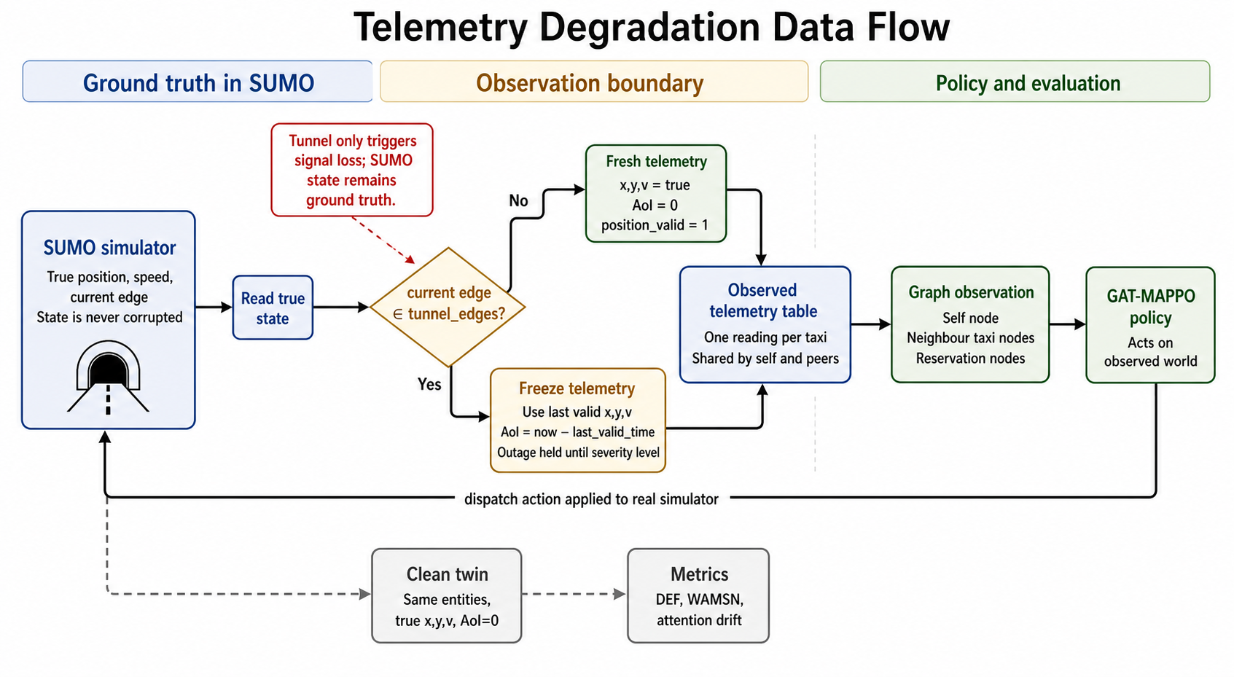
Figure 3.1: Telemetry degradation data flow. SUMO remains the ground-truth
world. Tunnel edges only trigger signal loss; the degradation itself is implemented when observations are built for the policy.
The study uses a controlled quantitative simulation. The independent condition is whether the policy observation contains clean or tunnel-triggered stale telemetry. The analysis measures dispatch pickups, decision-level explanation faithfulness and attention assigned to stale vehicle nodes. A construct-validity audit supports the primary research problem by checking that the faithfulness comparison is fair.

3.2 SUMO Dispatch Environment
The benchmark uses SUMO (Lopez et al., 2018) on a real OpenStreetMap extract of Central Park in Chongqing's Yubei district. The area contains real tunnel edges, which are used as physically grounded signal-loss zones. Each episode has 20 taxis, 50 ride requests, and 1,200 simulated seconds. Demand is generated from fixed seeds and split into train, validation, and held-out test variants.
Each idle taxi is an agent. At each decision step, the taxi can either do nothing or accept one of its five nearest pending reservations:
action 0 = no-op
actions 1-5 = accept one candidate reservation

3.3 Telemetry Degradation
Tunnel degradation is implemented as freeze semantics. If a taxi is on a tunnel edge, the degradation layer keeps returning its last valid position and speed. AoI grows as:
AoI = current time - last valid update time
The SUMO state is not changed. The taxi keeps moving in the simulator, and dispatch actions still apply to the real SUMO state. Only the policy's observation is stale.
The intended severity ladder is:
clean, 5 s, 15 s, 30 s, 60 s
Each degraded level holds the outage until the taxi's AoI reaches that level. Two facts about this design turn out to matter, and both are established empirically in Section 5.3 rather than assumed here. First, a taxi still inside a tunnel when its outage expires immediately re-triggers, so tunnel transit time places a floor under realised AoI that is independent of the nominal level. Second, AoI reaches the policy only through the normalised observation feature clip(AoI / AOI_MAX_S, 0, 1) with AOI_MAX_S = 60 s, and WAMSN reuses that same clipped quantity as its staleness weight. Staleness beyond 60 s is therefore not representable, either to the policy or to the metric. The manipulation check in Section 5.3 shows these two facts combine to flatten the ladder into a single degraded condition.

3.4 Training Protocol
All learned models use the same MAPPO training structure. Each epoch runs one complete SUMO episode, stores every acting taxi's observation, sampled action, log probability, value estimate, and team reward, then updates the shared policy with PPO.
The team reward is:
R = 10(pickups) + 0.5(successful dispatches) - 0.001(mean pending wait) | (3.1)
Generalised Advantage Estimation uses gamma = 0.99 and lambda = 0.95. PPO uses a clip ratio of 0.2, four PPO epochs, minibatches of 256, and entropy regularisation. The best checkpoint is selected by rolling mean training pickups, because the policies often suffer entropy collapse and the final epoch is not always the best one.

3.5 Explanation Metrics and Validity Audit
For a decision with selected action a*, DEF asks whether the top-k nodes chosen by the explanation actually matter to the decision.
One distinction is essential before the equations. Removing a nearby-taxi node hides contextual information, but the set of dispatch actions remains the same. Removing a passenger-request node also removes that request from the available actions. A fair random baseline must therefore remove the same mix of vehicle and request nodes as the explanation; matching only the number of removed nodes is not enough.
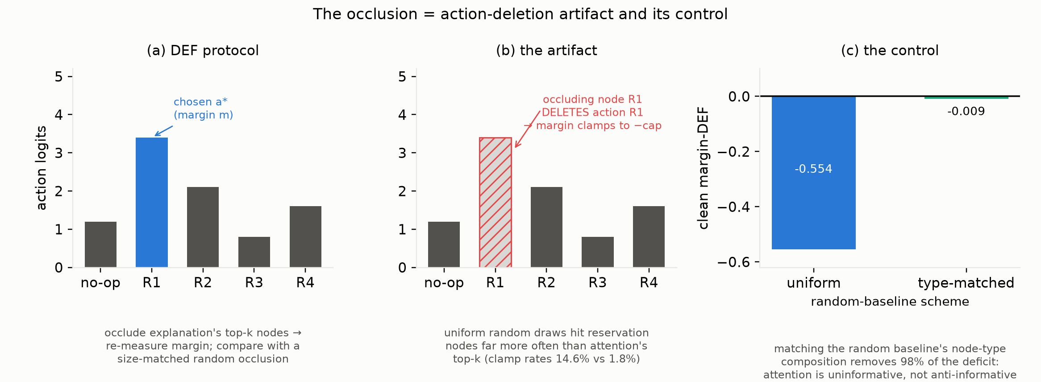
Figure 3.2: DEF occlusion protocol. The same decision is evaluated before and
after removing or keeping the explanation-selected nodes, then compared with a matched random baseline.
Comprehensiveness removes the explanation nodes:
Comp = f(a* | G) - f(a* | G - Rk) | (3.2)
Sufficiency keeps only the explanation nodes:
Suff = f(a* | G) - f(a* | Rk) | (3.3)
Both are compared with random subsets of the same size:
DEF = 1/2 [(Comp - Comprand) + (Suffrand - Suff)] | (3.4)
Two DEF variants are computed from the same counterfactual forwards. Probability-DEF uses f = pi(a*). Margin-DEF uses the logit gap between the chosen action and its closest competitor:
margin = logit(a*) - max a != a* logit(a) | (3.5)
Margin-DEF is the primary metric. The trained policies often assign a probability close to 1 to the chosen action, so probability-DEF changes very little after occlusion. Margin-DEF retains more signal. Probability-DEF is still reported when it gives a different result; Section 5.3 shows one such case. Margins are limited to +/-10 logits because removing the chosen action's node sends its logit to negative infinity. The clamp rate is reported because frequent clamping indicates that occlusion is deleting actions.
Random-baseline composition. Two sampling schemes are used for the control subsets. Uniform draws size-k subsets uniformly from all valid non-self nodes; this is the standard protocol and what the original analysis used. Type-matched draws subsets with the same taxi/reservation composition as the attention top-k set, so the control withholds the same mixture of evidence and actions that the explanation does. The comparison between the two is the audit.
WAMSN measures how much vehicle-node attention is placed on stale telemetry:
WAMSN = sum_i [alpha_i x clip(AoI_i / AoImax, 0, 1)] / sum_i alpha_i | (3.6)
Reservations carry no AoI, so WAMSN runs over the self and peer-taxi nodes only. The clip is the censoring discussed in Section 3.3: at AoI_max = 60 s every node past one minute of staleness receives weight exactly 1.0, so WAMSN is a stale-attention share rather than an AoI-weighted mean whenever outages are long.

3.6 Statistical Testing
The main sweep evaluates B2 over clean telemetry and four max-AoI levels, with eight environment seeds and three held-out test episodes per cell. One in eight decisions is scored for faithfulness, giving 17,764 scored decisions (17,444 with at least one valid reservation).
Decisions are clustered inside episodes, which share demand, geography and policy state, so no test treats decisions as independent:
• H1 and H3: episode-block permutation trend tests, where level labels are permuted between whole episodes and never within them.
• H2: paired sign-flip test over severity cells.
• H4: Spearman association computed inside each episode and aggregated across episodes, with a sign test on the episode-level coefficients. Ties are corrected by average ranks; this is not cosmetic, since WAMSN is exactly zero for roughly 90 % of decisions and uncorrected ranks reverse the sign of the coefficient.
• Confidence intervals: cluster bootstrap resampling episodes, 10,000 draws.
• Holm correction across the H1-H4 family.
Permutation tests use 10,000 draws, so the smallest attainable p-value is 1/10,001. Results at that floor are reported as p <= 1e-4 rather than as p < 0.001, which would misstate the available resolution.
Two sweeps are referenced and are kept distinct throughout. B2_aoi_ladder is the source of the preregistered H1-H4 statistics. B2_aoi_ladder_v2 is the re-run with clamp, exposure and AoI instrumentation added, and is the source of every diagnostic quantity. Where both are available the numbers agree to within 0.01 margin-DEF.

Chapter 4: Model Design and Implementation

4.1 Model Conditions
The main model is B2, a GAT-MAPPO dispatcher. The other conditions are not extra models for their own sake. Each one answers a specific control question: what happens without learning, without graph attention, without AoI features, or with degradation-aware training?
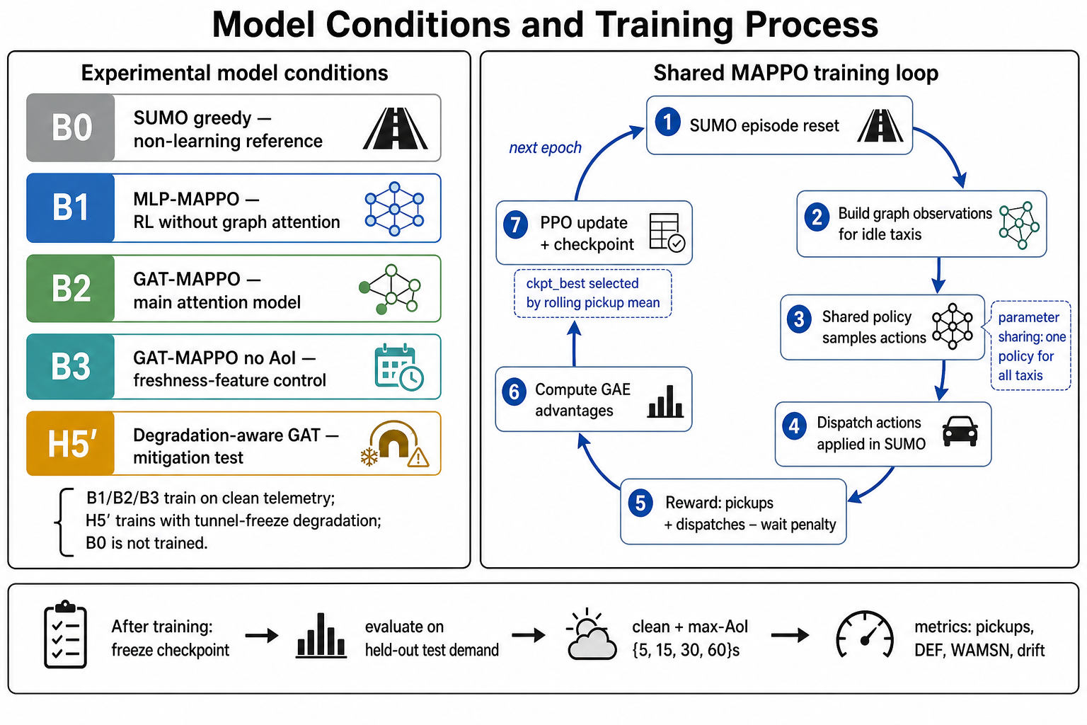
Figure 4.1: Model conditions and training process. B2 is the main audited
attention model. B0, B1, B3, and H5' are included to separate task performance, graph attention, AoI input, and degradation-aware training.
Table 4.1: Model Conditions
Condition | Trained? | Training telemetry | Purpose
B0 SUMO greedy | No | Not trained | Non-learning dispatch reference
B1 MLP-MAPPO | Yes | Clean | RL baseline without graph attention
B2 GAT-MAPPO | Yes | Clean | Main attention model under audit
B3 GAT-MAPPO without AoI | Yes | Clean | Control for explicit freshness input
H5' degradation-aware GAT | Yes | Tunnel-freeze degradation | Test whether degraded training helps

B1, B2, and B3 are trained on clean telemetry. H5' is trained with tunnel-triggered freeze degradation. After training, checkpoints are frozen and evaluated on held-out test demand under clean telemetry and the AoI severity ladder.

4.2 Graph-Attention Policy
For each acting taxi, the environment builds one self-centred graph. The graph contains the taxi itself, up to five nearby taxis, and up to five candidate reservations. One graph therefore corresponds to one taxi decision.
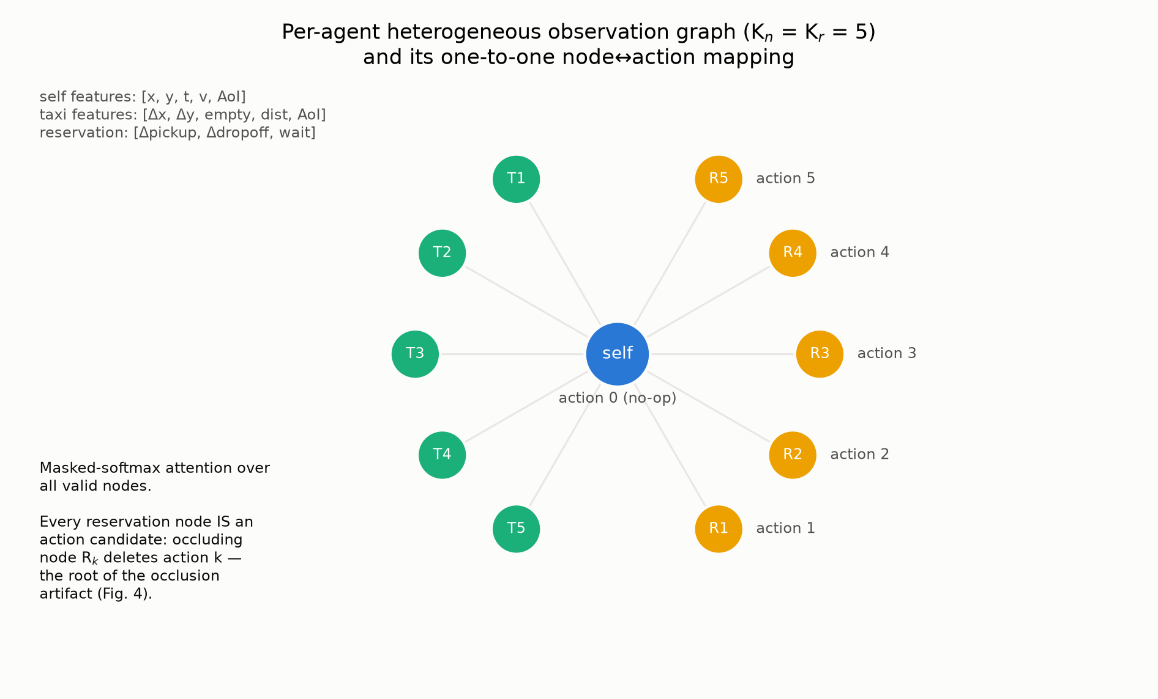
Figure 4.2: Observation graph for one dispatch decision. The policy sees the
acting taxi, nearby taxi context, and candidate reservations in a single small graph.
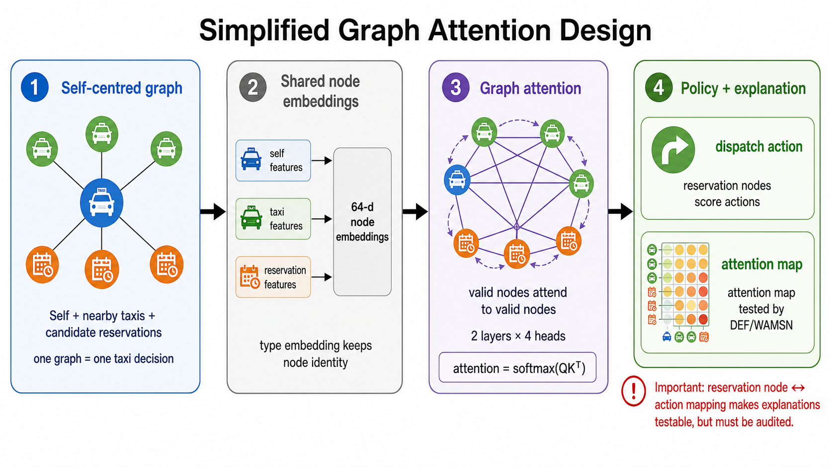
Figure 4.3: Simplified graph-attention design. The policy first embeds the
self, taxi, and reservation nodes into a shared space. Valid nodes then attend to each other. The final embeddings produce dispatch actions, while the attention map is kept for faithfulness testing.
The node types are:
Table 4.2: Observation Graph
Node type | Main features | Role
Self taxi | position, time, velocity, AoI | The acting vehicle
Peer taxi | relative position, availability, distance, AoI | Local fleet context
Reservation | pickup/drop-off vectors, waiting time | Candidate action

The graph is fully connected over valid nodes. This is manageable because the graph has at most 11 nodes. Padding masks remove missing neighbours or reservations from attention and from the action logits.
The GAT uses two layers and four attention heads. The actor reads the final self embedding to score the no-op action, and the final reservation embeddings to score reservation actions. The attention tensor is returned by the forward pass and used as the coupled explanation channel.
This design is compact and easy to audit, and it instantiates the structural property this dissertation is about:
reservation node <-> reservation action
Each reservation node is an action. Occluding it therefore removes a candidate from the action set rather than withholding evidence about it. Peer taxi nodes carry no action, so occluding one is evidence removal in the intended sense. A single occlusion protocol thus performs two categorically different operations depending on which node type it happens to hit, and the proportion of each type in a subset determines what is being measured. This is the mechanism audited in Section 5.2.

4.3 Gap-Model Alignment
The graph policy represents the dispatch decision as relations between one acting taxi, nearby taxis and passenger requests. This makes node-level attention visible for audit. The observation-layer freeze then changes information freshness without changing SUMO's physical state. Together, these design choices allow the experiment to test the identified gap directly: whether an explanation can continue to look usable after the data supporting it has become stale.

Chapter 5: Results and Discussion

5.1 Performance Context
The learned dispatchers are weak compared with SUMO's greedy matcher. The greedy baseline completes about 32 pickups per episode; the learned policies complete 6-8, with B2 at 6.7 +/- 1.9. The training runs suffer entropy collapse, and two of three H5' seeds reach their best rolling performance at epochs 17-22.
This is stated first because it bounds every claim that follows. Nothing here is evidence for a deployable dispatcher. It matters less for the methodological result than it might appear, however, and Section 5.2 establishes why: the metric pathology is demonstrated across seven checkpoints spanning 1.0 to 11.8 pickups per episode, including an untrained one, so it is not a property of weak policies.
Table 5.1: Performance Context
Policy | Role | Pickups per episode
SUMO greedy | Non-learning reference | ~32
B2 GAT-MAPPO | Main audited policy | 6.7 +/- 1.9
Learned-policy range | B1/B2/B3/H5' | 6-8
Capability spectrum (Table 5.3) | Seven audited checkpoints | 1.0-11.8

5.2 Clean-Telemetry Faithfulness and Metric Validation

Why Uniform Occlusion Is Unfair
With the standard uniform random baseline, B2's clean margin-DEF is -0.541 [-0.556, -0.527]. Taken alone, this suggests that attention is much worse than random node selection.
The clamp rate shows why this reading is wrong. It measures how often occlusion deletes the chosen action and forces the decision margin to its limit. Random sets clamp in 14.8 % of decisions, compared with 2.2 % for attention top-k sets. The random control removes request actions much more often than the attention explanation. The two sides are therefore not comparable.
Matching the random set to the same mix of taxi and request nodes removes almost all of the effect. Across 1,199 paired decisions, margin-DEF changes from -0.554 to -0.009 [-0.016, -0.001]. The unfair baseline accounts for 98.3 % of the original deficit.
Two independent controls agree with the corrected value:
• Clamp-free subset. When neither side deletes the chosen action, margin-DEF is +0.000 [-0.003, +0.003] (n = 90). This subset is small and contains easier decisions, so it supports but does not replace the type-matched result.
• Chosen-action exclusion variant. Protecting the chosen request node on both sides changes an apparent +0.586 to -0.024 [-0.025, -0.023]. This test applies to only 136 of 17,444 decisions, so it is supporting evidence.
The corrected conclusion is simple: attention is approximately uninformative. It performs close to a random explanation that selects the same kinds of nodes. The original score mainly measured the link between request nodes and dispatch actions.
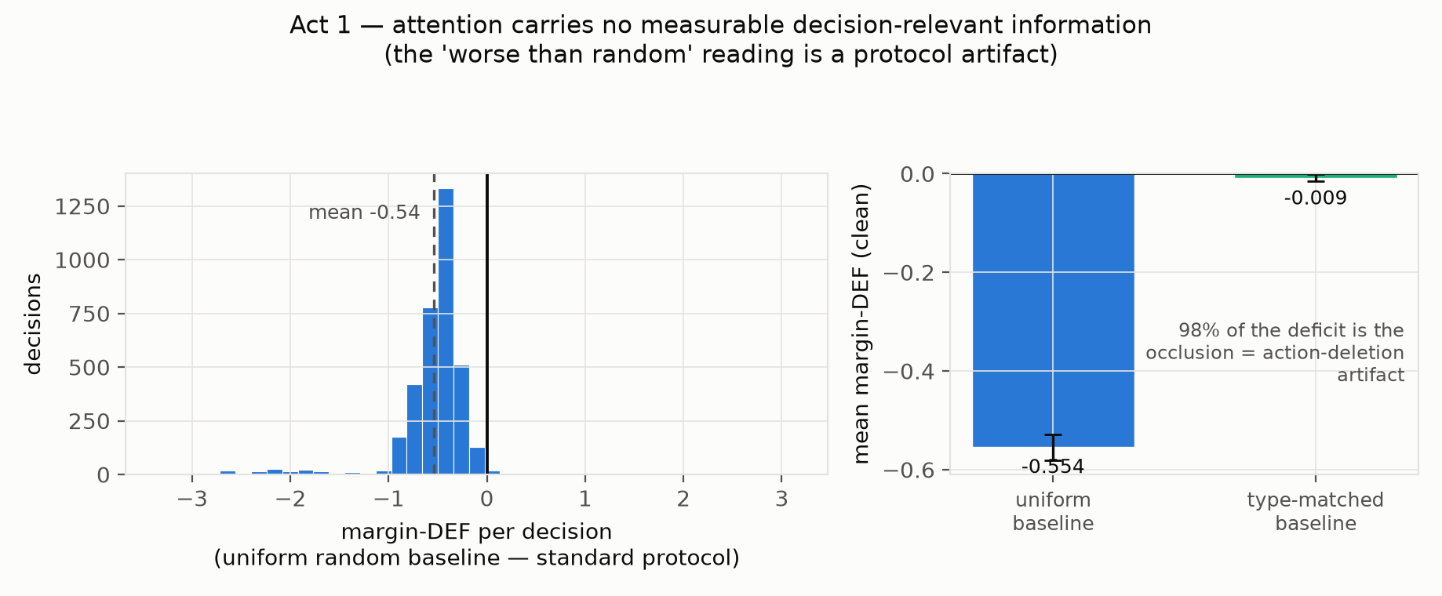
Figure 5.1: Clean-data faithfulness audit. The apparent worse-than-random
result collapses to near zero when the random baseline is matched to the node types selected by attention.
Table 5.2: Construct-Validity Audit
Quantity | Value | n | Interpretation
Uniform clean margin-DEF | -0.541 [-0.556, -0.527] | 3,565 | Apparent worse-than-random result
Paired uniform baseline | -0.554 [-0.581, -0.529] | 1,199 | Same decisions, before correction
Type-matched baseline | -0.009 [-0.016, -0.001] | 1,199 | Corrected: uninformative, not adversarial
Artifact share | 98.3 % | — | Fraction of the deficit that is protocol
Clamp-free subset | +0.000 [-0.003, +0.003] | 90 | Independent control, no modelling assumption
Chosen-action exclusion variant | -0.024 [-0.025, -0.023] | 136 | Apparent +0.586 on the same decisions
Clamp rate, random baseline | 14.8 % (16.4 % per level) | 17,444 | Random occlusion deletes actions often
Clamp rate, attention top-k | 2.2 % (4.0 % per level) | 17,444 | Attention rarely selects the chosen action's node

Stability Across Policy Capability
Seven checkpoints were tested to check whether the result depends on one weak policy. They cover 1.0 to 11.8 pickups per episode, two architectures, and three H5' training seeds.
Table 5.3: Capability Spectrum Under Both Baselines (clean test demand)
Checkpoint | Epoch | Pickups | Entropy | n | Uniform margin-DEF | Type-matched margin-DEF
B2 untrained | 0 | 1.00 | 1.560 | 56 | -1.352 | +0.158 [-0.120, +0.509]
B2 mid-training | 50 | 6.25 | 0.040 | 678 | -0.468 | +0.001 [-0.007, +0.013]
B2 best | 91 | 7.50 | 0.062 | 641 | -0.549 | -0.003 [-0.013, +0.012]
B3 best (no AoI input) | 25 | 9.25 | 0.087 | 537 | +1.687 | -0.005 [-0.005, -0.004]
H5' seed 42 best | 17 | 7.25 | 0.061 | 578 | -0.802 | +0.015 [+0.013, +0.016]
H5' seed 43 best | 91 | 3.00 | 0.035 | 654 | -0.488 | -0.007 [-0.009, -0.006]
H5' seed 44 best | 22 | 11.75 | 0.103 | 552 | +1.775 | +0.007 [+0.006, +0.007]

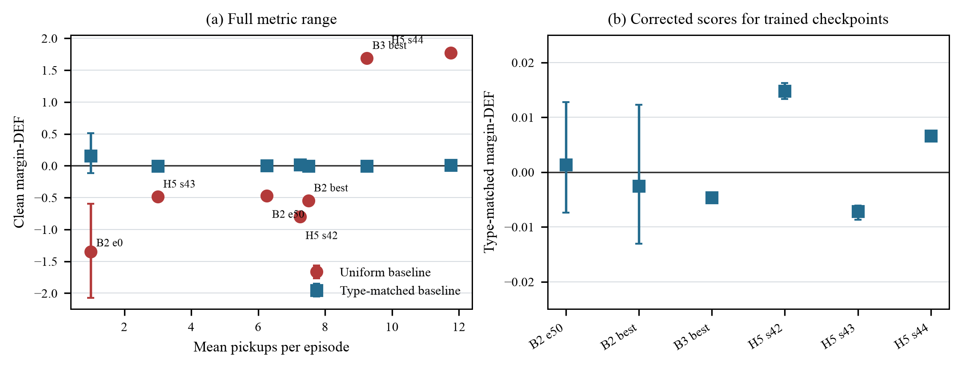
Figure 5.2: Capability spectrum under both occlusion baselines. The uniform
score changes from strongly negative to strongly positive as checkpoint performance changes. After node types are matched, every trained checkpoint stays close to zero.
Under the uniform baseline the score ranges from -1.352 to +1.775 — from "far worse than random" to "far better than random". Under the type-matched baseline the six trained checkpoints span -0.007 to +0.015, all within 0.015 of zero despite a fourfold spread in task performance. The untrained checkpoint reads +0.158, but on only 56 scored decisions with a confidence interval spanning zero, so it is uninformative rather than anomalous.
The uniform baseline gives opposite conclusions for channels that all score near zero after correction. B3 and H5' seed 44 even appear strongly positive under the uniform protocol and also have the highest pickup counts. This could lead a reader to conclude that better dispatchers have more faithful attention. The type-matched result shows that this conclusion is false.
This capability check strengthens the correction used to answer RQ1. It shows that the artifact is not limited to one weak checkpoint, architecture or training seed. It also shows why the uniform score cannot be repaired by a different threshold or sign convention: it gives sharply different verdicts for channels that all sit near zero under the fair comparison.

5.3 Stale Telemetry and Explanation Content
Before reporting the degradation hypotheses, the manipulation must be checked, because the check changes what can be concluded.
The severity ladder did not vary realised staleness. AoI reaches both the policy and WAMSN only through clip(AoI / 60 s, 0, 1), so staleness past 60 s is not representable. Independently, a taxi still inside a tunnel when its outage expires re-triggers immediately, so transit time places a floor under realised AoI. The two effects combine:
Table 5.4: Manipulation Check: Realised AoI by Nominal Level
Nominal level | Realised p50 | Realised p90 | At censoring cap | n exposed
5 s | 60.0 s | 60.0 s | 78.3 % | 345
15 s | 60.0 s | 60.0 s | 84.9 % | 416
30 s | 60.0 s | 60.0 s | 81.1 % | 349
60 s | 60.0 s | 60.0 s | 79.4 % | 388

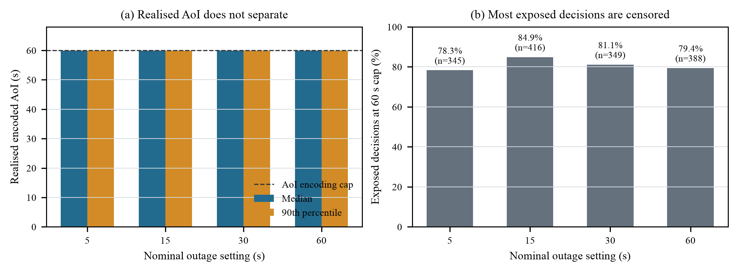
Figure 5.3: Manipulation check for the nominal AoI ladder. The median and
90th percentile remain at the 60 s encoding cap for every degraded setting. Most exposed decisions are censored, so the four settings cannot be read as a dose-response experiment.
Median and 90th percentile are identical at every level, and 81 % of exposed decisions sit at the cap. The {5, 15, 30, 60} s ladder collapses to a single degraded condition.
Consequence for H1. The preregistered hypothesis — that faithfulness declines as severity rises — is untestable on this data, not unsupported. The trend test returns rho = -0.001 (p = 0.87), but a null result against an unmanipulated factor is uninformative: there was no severity gradient for the metric to respond to. The earlier reading, that flat DEF reflected a floor effect from the near-zero clean baseline, is superseded; near zero is the fair random level, not a floor, and margin-DEF had ample room to move downward. What the data supports is the binary clean-versus-degraded contrast, which is well powered.
H3, restated. WAMSN rises from exactly 0 on clean telemetry to 0.014 pooled the moment staleness exists. On the preregistered sweep the episode-block trend is rho = +0.092, p <= 1e-4, cluster CI [+0.052, +0.128] (instrumented sweep: +0.081, p <= 1e-4). Within the degraded conditions, however, there is no trend at all: rho = +0.002, p = 0.88, n = 14,154. The entire association is the clean-versus-degraded step. The supported claim is therefore WAMSN rises when staleness appears and is flat thereafter — consistent with Table 5.4, and narrower than "severity increases WAMSN".
Exposure. The pooled WAMSN is small because most decisions never see a stale node, and two distinct exposure rates were previously conflated:
Quantity | Value | Meaning
Acting-agent degradation rate | ~2 % | the deciding taxi's own telemetry is stale
Stale-node visibility | 9.8-11.7 % per level | the decision's graph contains a stale vehicle node
Stale node in attention top-3, given exposure | 7.7-9.3 % | a stale node reached the displayed explanation
WAMSN given exposure | 13.4-14.8 % | share of vehicle-node attention on stale telemetry

Conditional on exposure is the informative framing: when a stale vehicle node is visible at all, it takes roughly one seventh of the attention the policy distributes over vehicles.
H4 is supported, and is metric-dependent. Within episodes, decisions with more stale-node attention are less faithful. On the primary metric, margin-DEF, mean within-episode rho = -0.045, negative in 64.6 % of the 96 usable episodes (B2_aoi_ladder: -0.043, 74.0 %). On probability-DEF the same estimator gives rho = -0.149, negative in 92.7 % of episodes (B2_aoi_ladder: -0.140, 88.5 %). Both replicate across sweeps, and the preregistered one-sided sign-flip test reaches its resolution floor (p <= 1e-4) for both; an exact two-sided sign test on the episode-level coefficients gives p = 0.006 for margin-DEF and p < 1e-5 for probability-DEF.
The direction is robust, but the effect is roughly three times larger on the secondary metric. The margin-DEF value is quoted as primary for consistency with Section 3.5. The divergence is itself interpretable: probability-DEF responds mainly to decisions where occlusion collapses a saturated softmax, which is exactly where stale peer nodes are most likely to be attended, so it registers a stronger association than the margin does.
H2 is the weakest result. Faithfulness-degradation rates exceeded performance-degradation rates across 32 cells: Holm-adjusted p = 0.039 on probability-DEF (raw p = 0.0195; raw p = 0.028 on margin-DEF). Given that the severity factor was not manipulated, this rate framing should be read as a clean-versus-degraded difference and not as a dose-response. H3 and H4 carry the degradation argument.
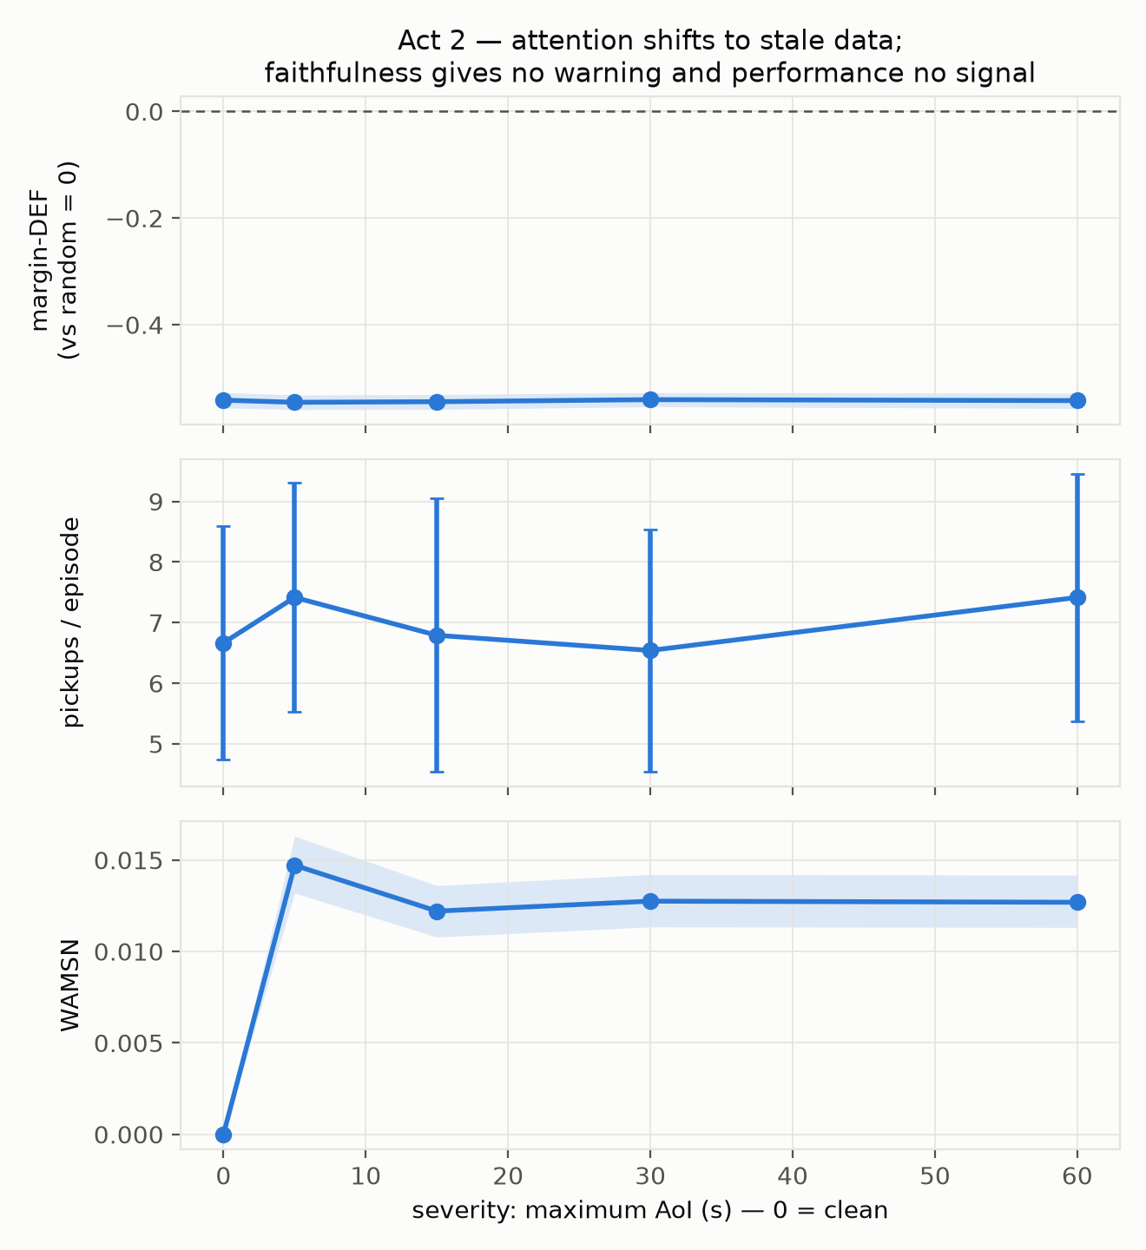
Figure 5.4: Silent stale-attention drift. Margin-DEF and pickups stay flat
across the nominal severity ladder, while WAMSN rises the moment staleness is introduced. Per Table 5.4 the ladder is a single degraded condition, so the flat profiles should be read as clean versus degraded rather than as a dose-response.
Pickups and WAMSN are cell means over eight seeds from B2_aoi_ladder; stale-node visibility and conditional WAMSN come from the instrumented B2_aoi_ladder_v2. The conditions are labelled nominal because Table 5.4 shows that the four degraded settings did not produce distinct realised AoI levels. Artifact-prone uniform DEF values are omitted from this main table.
Table 5.5: Degradation Exposure and Performance
Nominal condition | Pickups | WAMSN | Stale-node visibility | WAMSN given exposure
Clean | 6.67 | 0.000 | 0.0 % | —
5 s | 7.42 | 0.015 | 9.8 % | 0.139
15 s | 6.79 | 0.012 | 11.7 % | 0.148
30 s | 6.54 | 0.013 | 10.0 % | 0.140
60 s | 7.42 | 0.013 | 10.8 % | 0.134

Table 5.6: Hypothesis Outcomes
Hypothesis | Result | Reading
H1: severity lowers DEF | Untestable | Severity not manipulated (Table 5.4); rho = -0.001, p = 0.87 against an unmanipulated factor
H2: faithfulness drops faster than performance | Supported cautiously | Holm p = 0.039 (prob-DEF); clean-vs-degraded, not dose-response
H3: staleness raises WAMSN | Supported, restated | Step at onset (rho = +0.092, p <= 1e-4); no trend within degraded levels (rho = +0.002, p = 0.88)
H4: WAMSN relates negatively to DEF | Supported | margin-DEF rho = -0.045 (64.6 % of episodes); prob-DEF rho = -0.149 (92.7 %)
H5: degradation-aware training helps | No effect | H5' ~ B2 ~ 0 under the fair baseline, three seeds

5.4 Mitigation Results
Two mitigations were tested: training with degraded telemetry and using a separate explanation head.
Degradation-aware training (H5'). B2's exact configuration retrained with tunnel-freeze degradation active reaches 7.80 +/- 1.33 pickups on clean test demand, so degraded training costs nothing in performance. Under the uniform baseline it appeared worse than B2 at every level (-0.77 versus -0.54), which was originally reported as evidence that degraded training harms interpretability. Under the type-matched baseline that finding disappears: H5' sits at approximately zero across three training seeds (+0.02, -0.01, +0.01 in Table 5.3), which is similar to B2. The earlier negative result came from the unfair baseline. The supported conclusion is that degradation-aware training has no detectable effect on explanation faithfulness.
Decoupled explanation head. An occlusion-distilled explainer trained directly to predict occlusion effects (validation Spearman +0.60) was compared against coupled attention, paired per decision. Under the uniform baseline it appeared to gain +0.107 on clean telemetry and +0.113 under tunnel degradation. Under the type-matched baseline, roughly 80 % of that advantage disappears. The remaining clean-data gain is small: the decoupled head scores +0.010 against coupled attention's -0.013, a paired gain of +0.023 (n = 983, p <= 1e-4), and it is the only channel tested that scores above the fair random baseline. Under tunnel degradation at max-AoI 60 s the gain falls to +0.005 and is not detectable (n = 878, p = 0.21).
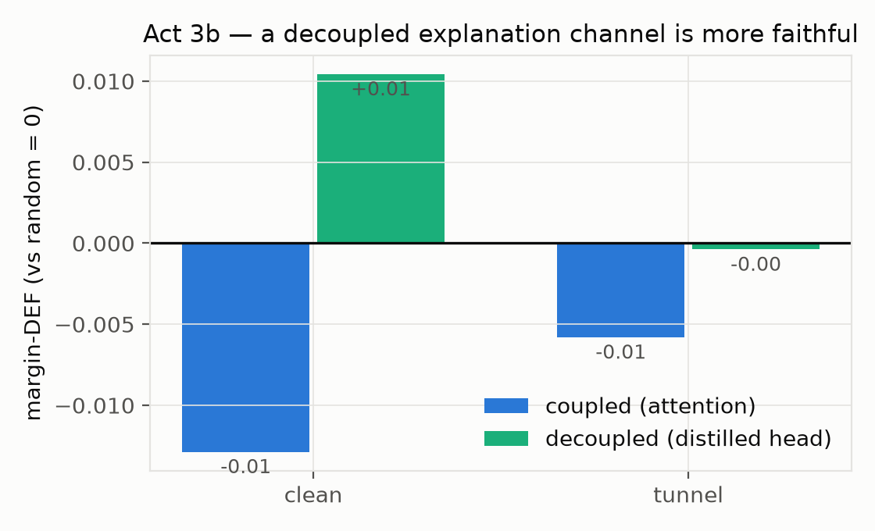
Figure 5.5: Coupled vs decoupled explanation. Training an explanation head
directly helps on clean telemetry, but the improvement is small and does not survive degradation.
Table 5.7: Mitigation Results (type-matched baseline)
Condition | Coupled attention | Mitigated channel | Delta | n | p
H5' degradation-aware training, clean | ~0 | ~0 | ~0 | 3 seeds | no effect
Decoupled head, clean | -0.013 | +0.010 | +0.023 | 983 | <= 1e-4
Decoupled head, tunnel 60 s | -0.006 | -0.000 | +0.005 | 878 | 0.21

The uniform baseline gave gains of +0.107 on clean data and +0.113 in the tunnel condition. These values are about five times larger than the corrected effect and should not be used to judge the mitigation.

5.5 Discussion
The three research questions lead to one coherent interpretation. Built-in attention is not a faithful clean-data explanation, stale telemetry changes the content of that explanation without changing the aggregate warning signals, and neither tested mitigation restores meaningful faithfulness under degradation. The measurement audit is important because it establishes which parts of that interpretation survive a fair comparison.

5.5.1 Metric Validation
A perturbation test is valid only when both sides change evidence in the same way. If removing a node also removes an action, the policy is solving a different decision problem. Explanation-selected and random nodes can then be compared only when they remove the same kinds of entities.
Three practical consequences follow.
First, the random baseline must match the relevant structure. Here, it must match node type. Matching only the number of removed nodes is not enough.
Second, the evaluation should report how often occlusion makes a score undefined. The 14.8 % versus 2.2 % clamp rates revealed the problem. A single average faithfulness score did not.
Third, the metric should be checked across several policies. Across seven checkpoints, the uniform score ranged from -1.35 to +1.78 even though the corrected scores were near zero. Testing only one checkpoint would have hidden this instability.
The problem can affect any model that chooses among entities in its input. Examples include pointer networks, retrieval rankers, and matching or scheduling policies. Graph explainers (Ying et al., 2019; Luo et al., 2020; Yuan et al., 2023) face the same risk when they are evaluated by removing nodes that also define available actions.

5.5.2 Interpreting Faithfulness Decoupling
The degradation result is specific. Aggregate faithfulness does not clearly fall. Instead, the explanation shifts toward stale data while pickups and aggregate margin-DEF remain broadly flat. When a stale vehicle node is visible, it receives about one seventh of vehicle-node attention. Decisions with a larger stale-attention share are also less faithful.
This matters because an operator watching task performance or aggregate faithfulness would see no warning. WAMSN detects the change because it measures what the explanation uses, not only how well the explanation scores. A practical monitoring system should therefore report both explanation quality and explanation content.
In this dissertation, "faithfulness decoupling" means that explanation content moves toward stale data while performance and aggregate faithfulness remain stable. It does not mean that higher AoI was shown to cause a steady fall in faithfulness.

5.5.3 Learning from Negative Results
Two post-hoc checks found limits in the original experiment design.
First, the severity ladder did not create different realised AoI levels. The 60 s input cap also became the measurement cap, while tunnel travel time dominated the lower settings. Future work should check realised severity before running the full sweep.
Second, H4 is about three times larger with probability-DEF than with the primary margin-DEF metric. Both are now reported and clearly labelled. Their difference shows that policy saturation affects the measured effect size.

Chapter 6: Conclusion

6.1 Summary of Findings and Contributions
This study asked whether graph-attention explanations remain trustworthy when fleet telemetry becomes stale. The main finding is that degradation changes what the explanation attends to without producing a clear warning elsewhere. Attention shifts onto stale vehicle nodes, receiving about one seventh of vehicle-node attention when such a node is visible, while pickups and aggregate faithfulness remain broadly flat. Within episodes, decisions with more stale-node attention are less faithful. This is the form of faithfulness decoupling supported by the experiment: explanation content moves toward outdated information even though the usual summary signals appear stable.
Interpreting that result required an audit of the faithfulness measurement. The standard random occlusion baseline often removed passenger requests and therefore removed available actions, whereas the attention explanation more often selected vehicle context. That unfair comparison produced a clean margin-DEF score of -0.541. Matching the random baseline to the same mixture of vehicle and request nodes changed the score to -0.009, showing that built-in attention is approximately uninformative rather than actively worse than random. The correction remains stable across the tested capability range and prevents the measurement artifact from being mistaken for a telemetry effect.
Neither tested mitigation solves the problem. Degradation-aware training has no detectable effect on explanation faithfulness. The decoupled explanation head improves clean-telemetry margin-DEF by +0.023, but the improvement is not detectable under degradation. These findings are limited to a low-performing policy in one simulated district. They also establish only a clean-versus-degraded contrast because the nominal AoI ladder did not produce distinct realised severity levels.
The practical implication is straightforward. Attention weights should not be presented as trustworthy explanations merely because the architecture exposes them. In fleet systems where telemetry can become stale, explanation quality and explanation content should be monitored separately, and the evaluation protocol itself should be checked before its score is treated as evidence.

6.2 Limitations
Severity was not manipulated as intended. Table 5.4 shows no separation in realised AoI between the four nominal degraded levels. H1 is therefore untestable, and H2 can only be read as a clean-versus-degraded contrast. A genuine dose-response study would need a higher AoI encoding cap and a new sweep based on realised rather than nominal severity.
Corrected DEF is unavailable for the intermediate degraded conditions. The type-matched control has been run on clean and tunnel-60 s conditions, but not on the intermediate cells. It requires new counterfactual forward passes and cannot be reconstructed from the saved uniform-DEF scalars. For this reason, Table 5.5 omits DEF and the degradation argument rests primarily on WAMSN, exposure, and the within-episode H4 association. H2 should be treated as secondary evidence.
The learned policy is far below the greedy baseline. Claims are scoped to the learned-policy regime achieved. The capability spectrum in Section 5.2 mitigates this specifically for the metric result, which holds across 1.0 to 11.8 pickups and an untrained checkpoint, but not for the degradation result, which rests on B2.
Training instability. Entropy collapses from 1.56 to 0.03, and best checkpoints land at epochs 17-22 for two of three H5' seeds. Checkpoint selection by rolling mean pickups is a workaround, not a fix; the reward scale (10 x pickups against 0.001 x mean wait) leaves the waiting-time term numerically inert between sparse pickup events, which is the likely cause.
One training seed for the main policy. The severity sweeps use eight environment seeds and H5' uses three training seeds, but B2 itself is one run.
Sparse and geographically constrained exposure. Stale-node visibility is 9.8-11.7 % of decisions, and in-tunnel transits dominate. Pooled WAMSN values are correspondingly small, so conditional-on-exposure figures are the informative ones.
One district, one occlusion operator. The benchmark is 20 taxis, 50 requests and 1,200 s episodes in one district of one city. Faithfulness is measured through masking-based occlusion only; gradient and surrogate attributions may show different failure modes, though any method evaluated by perturbation inherits the audit's concern.
Table 6.1: Limitations and Impact
Limitation | Impact
Severity not manipulated (AoI censoring + geography) | H1 untestable; degradation claims are binary clean-vs-degraded
Intermediate type-matched DEF unavailable | Main table omits DEF; a corrected full sweep remains future work
Learned policy below greedy baseline | Degradation claims scoped to low-capability dispatch; metric claims are capability-invariant
Entropy collapse in training | Best-checkpoint selection is a workaround; reward scaling likely at fault
One main B2 training seed | Stronger training replication is future work
Sparse tunnel exposure | Conditional WAMSN is the informative statistic, not pooled
One city district | Multi-city generality remains open
Masking-based occlusion only | Other attribution operators should be tested

Chapter 7: Future Work
Future work should first repeat the degradation experiment with a higher AoI encoding cap and conditions defined by realised, rather than nominal, staleness. This would make a genuine dose-response test possible.
The main policy should then be retrained with improved reward scaling and several independent training seeds. A stronger dispatch policy would show whether faithfulness decoupling persists at capability levels closer to the greedy reference.
The evaluation should also cover additional districts, traffic patterns and explanation methods. Gradient, surrogate and graph-specific explainers may fail differently from attention, but each method still needs a fair perturbation baseline when input entities define available actions.
Finally, an operational study could test a monitoring interface that reports both explanation quality and the share of explanation weight assigned to stale data. This would move the work from diagnosis toward a practical trustworthiness control.

List of Publications
No publication is claimed in this dissertation draft.

References
Alvarez-Melis, D. and Jaakkola, T.S. (2018) ‘On the robustness of interpretability methods’, arXiv:1806.08049.
DeYoung, J. et al. (2020) ‘ERASER: A benchmark to evaluate rationalized NLP models’, in Proceedings of the ACL, pp. 4443-4458.
Heuillet, A., Couthouis, F. and Diaz-Rodriguez, N. (2021) ‘Explainability in deep reinforcement learning’, Knowledge-Based Systems, vol. 214.
Hu, Y., Feng, S. and Li, S. (2025) ‘BMG-Q: Localized bipartite match graph attention Q-learning for ride-pooling order dispatch’, arXiv:2501.13448.
Iqbal, S. and Sha, F. (2019) ‘Actor-Attention-Critic for Multi-Agent Reinforcement Learning’, in Proceedings of the International Conference on Machine Learning.
Jacovi, A. and Goldberg, Y. (2020) ‘Towards faithfully interpretable NLP systems: How should we define and evaluate faithfulness?’, in Proceedings of the ACL, pp. 4198-4205.
Jain, S. and Wallace, B.C. (2019) ‘Attention is not Explanation’, in Proceedings of the NAACL-HLT, pp. 3543-3556.
Kaul, S., Yates, R. and Gruteser, M. (2012) ‘Real-time status: How often should one update?’, in Proceedings of the IEEE INFOCOM, pp. 2731-2735.
Lin, K., Zhao, R., Xu, Z. and Zhou, J. (2018) ‘Efficient large-scale fleet management via multi-agent deep reinforcement learning’, in Proceedings of the ACM SIGKDD Int. Conf. Knowledge Discovery and Data Mining, pp. 1774-1783.
Lipton, Z.C. (2018) ‘The mythos of model interpretability’, Queue, vol. 16, no. 3, pp. 31-57.
Liu, Y. et al. (2022) ‘Rethinking attention-model explainability through faithfulness violation test’, in Proceedings of the ICML.
Lopez, P.A. et al. (2018) ‘Microscopic traffic simulation using SUMO’, in Proceedings of the IEEE International Conference on Intelligent Transportation Systems, pp. 2575-2582.
Lowe, R. et al. (2017) ‘Multi-Agent Actor-Critic for Mixed Cooperative-Competitive Environments’, in Advances in Neural Information Processing Systems.
Luo, D. et al. (2020) ‘Parameterized explainer for graph neural network’, in Advances in Neural Information Processing Systems, pp. 19620-19631.
Madumal, P., Miller, T., Sonenberg, L. and Vetere, F. (2020) ‘Explainable reinforcement learning through a causal lens’, in Proceedings of the AAAI Conference on Artificial Intelligence.
Qin, Z., Zhu, H. and Ye, J. (2022) ‘Reinforcement learning for ridesharing: An extended survey’, Transportation Research Part C: Emerging Technologies, vol. 144.
Rashid, T. et al. (2020) ‘Monotonic value function factorisation for deep multi-agent reinforcement learning’, Journal of Machine Learning Research, vol. 21, no. 178, pp. 1-51.
Ribeiro, M.T., Singh, S. and Guestrin, C. (2016) ‘'Why should I trust you?': Explaining the predictions of any classifier’, in Proceedings of the ACM SIGKDD, pp. 1135-1144.
Scarselli, F., Gori, M., Tsoi, A.C., Hagenbuchner, M. and Monfardini, G. (2009) ‘The graph neural network model’, IEEE Transactions on Neural Networks, vol. 20, no. 1, pp. 61-80.
Serrano, S. and Smith, N.A. (2019) ‘Is attention interpretable?’, in Proceedings of the ACL, pp. 2931-2951.
Sha, J. et al. (2026) ‘A multi-agent reinforcement learning scheduling algorithm integrating state graph and task graph structural modeling for ride-sharing dispatching’, Scientific Reports, vol. 16, art. no. 5461.
Vaswani, A. et al. (2017) ‘Attention is all you need’, in Advances in Neural Information Processing Systems.
Velickovic, P. et al. (2018) ‘Graph Attention Networks’, in Proceedings of the International Conference on Learning Representations.
Wang, J. et al. (2025) ‘CoopRide: Cooperate all grids in city-scale ride-hailing dispatching with multi-agent reinforcement learning’, in Proceedings of the 31st ACM SIGKDD Conference on Knowledge Discovery and Data Mining, pp. 1457-1468.
Wiegreffe, S. and Pinter, Y. (2019) ‘Attention is not not Explanation’, in Proceedings of the EMNLP-IJCNLP, pp. 11-20.
Ying, R., Bourgeois, D., You, J., Zitnik, M. and Leskovec, J. (2019) ‘GNNExplainer: Generating explanations for graph neural networks’, in Advances in Neural Information Processing Systems, pp. 9240-9251.
Yu, C. et al. (2022) ‘The surprising effectiveness of PPO in cooperative multi-agent games’, in Advances in Neural Information Processing Systems.
Yuan, H., Yu, H., Gui, S. and Ji, S. (2023) ‘Explainability in graph neural networks: A taxonomic survey’, IEEE Transactions on Pattern Analysis and Machine Intelligence, vol. 45, no. 5, pp. 5782-5799.

Appendices

Appendix A: Experiment Reproduction
The complete reproduction procedure is provided in REPRODUCE_EXPERIMENTS.md in the project repository. It records environment setup, model checkpoints, experiment commands and expected outputs.

Appendix B: Supporting Artefacts
The project repository contains the experiment scripts, trained checkpoints, result tables and figure sources used in this dissertation. Large raw outputs and code listings are kept outside the dissertation so that the main document remains readable.

