When Explanations Outlive Their Data: Faithfulness Decoupling in Graph-Attention MARL Fleet Dispatch under Telemetry Degradation
A Master's Dissertation
submitted in partial fulfillment of the requirements for the award of the degree of
MSc in Artificial Intelligence
By
Hongwei Lin
P2982757
Supervisor: Dr Farhan S. Ujager

School of Computing
De Montfort University, Dubai
September 2026

DECLARATION
I declare that this dissertation is my own original work carried out under the supervision of Dr Farhan S. Ujager and that all sources and references have been acknowledged appropriately. This dissertation has not been submitted previously for academic credit at De Montfort University, Dubai, or any other institution.

Signature: ______________________________
Name: Hongwei Lin
Date: ______________________________

ACKNOWLEDGMENT
I would like to express my sincere gratitude to my supervisor, Dr Farhan S. Ujager, for his valuable support and guidance throughout this research. His advice, encouragement and careful feedback helped me refine the experiment, interpret the findings responsibly and complete this dissertation.
Student signature: ______________________________
Student name: Hongwei Lin

LIST OF FIGURES
Figure 1.1 Stale data and the explanation-release decision 3
Figure 3.1 Local observation graph and request-to-action mapping 11
Figure 3.2 Graph-attention policy and audit channel 13
Figure 3.3 Training, selection and held-out evaluation 15
Figure 3.4 Tunnel-triggered observation-layer telemetry degradation 16
Figure 3.5 Construct-validity controls for action-linked request nodes 19
Figure 4.1 GAT and GAT-Outage training and checkpoint-selection diagnostics 25
Figure 4.2 Clean-telemetry completed journeys by training seed 26
Figure 4.3 Faithfulness perturbation controls by checkpoint 28
Figure 4.4 Attention aggregation sensitivity 29
Figure 4.5 Attention query-row sensitivity 30
Figure 4.6 Top-k overlap and DEF resolution 31
Figure 4.7 Outage-duration sweep by policy and training seed 32
Figure 4.8 Paired attention and faithfulness shift by training seed 33
Figure 4.9 Faithfulness analysis by action type 34
Figure 4.10 Tunnel-triggered and random telemetry-loss sensitivity 35
Figure 4.11 WAMSN-DEF relationship and H4 result 35
Figure 5.1 Evidence interpretation summary 39
Figure 5.2 Freshness-aware explanation audit workflow 41

LIST OF TABLES
Table 2.1 Recent graph-based dispatch literature compared with this study 9
Table 3.1 Observation graph node types and roles 11
Table 3.2 Policy conditions used in the experiment 13
Table 3.3 Validation-selected checkpoint indices (zero-based) 14
Table 3.4 Training and optimization settings 14
Table 3.5 Checkpoint-acceptance criteria 14
Table 3.6 Explanation measures and roles 18
Table 3.7 Held-out evaluation structure and episode counts 20
Table 3.8 Telemetry conditions used in held-out evaluation 20
Table 3.9 Hypothesis map and analysis roles 21
Table 4.1 Policy capability on held-out demand 26
Table 4.2 Protocol correction and numeric-precision audit 27
Table 4.3 Decision-relevance controls under clean and degraded telemetry 27
Table 4.4 Valid node-count distribution in scored graphs 30
Table 4.5 Exposure-conditioned paired attention and DEF shifts 33
Table 4.6 Action composition and paired DEF by action type 34
Table 4.7 Tunnel and random-trigger sensitivity summary 35
Table 4.8 Hypothesis outcomes across training seeds 36
Table 4.9 Freshness-aware explanation audit decisions 37
Table 5.1 Freshness-aware explanation audit framework 41
Table 5.2 Audit framework inputs and outputs 42
LIST OF ABBREVIATIONS
Abbreviation | Full form
AoI | Age of Information
BMG-Q | Localized Bipartite Match Graph Attention Q-learning
CI | Confidence Interval
CTDE | Centralized Training with Decentralized Execution
DEF | Decision-level Explanation Faithfulness
GAT | Graph Attention Network
GNN | Graph Neural Network
GxI | Gradient x Input
LOO | Leave-One-Out
MADDPG | Multi-Agent Deep Deterministic Policy Gradient
MAPPO | Multi-Agent Proximal Policy Optimization
MARL | Multi-Agent Reinforcement Learning
MLP | Multilayer Perceptron
PPO | Proximal Policy Optimization
RL | Reinforcement Learning
SUMO | Simulation of Urban Mobility
WAMSN | Weighted Attention Mass on Stale Nodes
XRL | Explainable Reinforcement Learning
ABSTRACT
Graph-attention multi-agent reinforcement learning (MARL) can expose attention weights as explanations of fleet-dispatch decisions. However, an attention map may remain visible after its supporting vehicle telemetry becomes stale. This dissertation asks whether raw graph-attention weights can be trusted as explanations under clean and degraded telemetry.
The experiment simulates 20 taxis in Simulation of Urban Mobility (SUMO). Tunnel entry triggers an observation-layer outage that freezes an affected taxi's last valid position and speed for 10, 20, 30, or 60 seconds while SUMO retains the current traffic state. This produces paired clean and degraded observations for the same decision. Graph-attention network (GAT) policies trained on clean data or with 30-second outages are evaluated across three independent training seeds. Decision-level explanation faithfulness (DEF) compares attention-ranked nodes with type-matched, action-protected random controls. Weighted attention mass on stale nodes (WAMSN) separately measures attention assigned to stale vehicle information. Further checks cover leave-one-out rankings, attention extraction, action type, and random telemetry-loss triggers.
The results do not validate raw attention as a reliable explanation. Under clean telemetry, action-aware margin-DEF is below its matched-random control, while a leave-one-out positive control is above zero. Longer outages consistently increase stale-data exposure, but they do not produce the proposed decline in faithfulness. Attention shows a clear shift toward stale nodes in three checkpoints, a clear shift away in two, and no clear shift in one, while paired probability DEF increases slightly in all six. No-op and dispatch decisions move in opposite DEF directions, and alternative attention heads or layers can reverse the stale-attention result. Therefore, the tested weights do not provide stable evidence of decision relevance.
The dissertation develops and applies a freshness-aware explanation audit framework that reports freshness and action composition separately, applies action-aware faithfulness tests, checks the attention extraction rule, and requires consistent evidence across checkpoints. Attention remains an internal diagnostic when these checks fail. The framework governs explanation release; it does not repair the model. Its demonstrative application returns WITHHOLD for both model families and all six checkpoints.
Keywords: explainable reinforcement learning; graph attention; multi-agent reinforcement learning; fleet dispatch; telemetry degradation; faithfulness.

TABLE OF CONTENTS
Chapter 1: Introduction 1
1.1 Context 1
1.2 Problem statement 1
1.3 Research questions 1
1.4 Objectives 2
1.5 Main findings 2
1.6 Contributions 3
1.7 Dissertation structure 4
Chapter 2: Literature Review 5
2.1 Reinforcement learning for fleet dispatch 5
2.2 Explainability in reinforcement learning 5
2.3 Is attention an explanation? 6
2.4 Explaining graph neural networks 7
2.5 Evaluating faithfulness: methods and pitfalls 7
2.6 Age of Information and telemetry degradation 8
2.7 From explanation evaluation to explanation assurance 8
2.8 Research gap and positioning 9
Chapter 3: Methodology 10
3.1 Study design 10
3.2 SUMO environment and data 10
3.3 Observation graph and action space 10
3.4 Policy models and training 11
3.5 Telemetry degradation 15
3.6 Explanation measures 16
3.6.1 Decision-level explanation faithfulness 16
3.6.2 Stale-node attention 18
3.7 Construct-validity audit 18
3.8 Evaluation design 19
3.8.1 Primary evaluation 19
3.8.2 Supporting analyses 21
3.9 Hypotheses and statistical analysis 21
3.9.1 Statistical procedure 22
3.9.2 Interpretation limits 22
3.10 Audit decision implementation 22
3.11 Reproducibility 23
3.12 Ethics and data governance 24
Chapter 4: Results 25
4.1 Policy capability and training stability 25
4.2 Protocol correction and precision audit 26
4.3 Decision-relevance controls 27
4.4 Small-graph resolution 30
4.5 Telemetry manipulation and stale exposure 31
4.6 Paired clean and degraded observations 32
4.7 Analysis by action type 33
4.8 Random-trigger sensitivity analysis 34
4.9 Hypothesis results 35
4.10 Answers to the research questions 36
4.11 Explanation-release audit 37
Chapter 5: Discussion 38
5.1 Answer to the central problem 38
5.2 How to read the evidence 38
5.3 Why the result is not consistent 39
5.4 Why the construct-validity controls matter 40
5.5 Why outage training did not solve the problem 40
5.6 Proposed audit framework 40
5.6.1 Purpose and scope 40
5.6.2 Inputs, outputs and use 42
5.6.3 Application to this study 42
5.7 Limitations 43
5.8 Future work 43
Chapter 6: Conclusion 45

Chapter 1: Introduction

1.1 Context
Fleet dispatch is relational. A taxi's useful action depends on nearby vehicles, open passenger requests, road conditions, and competition for the same demand. Graph neural networks (GNNs) represent these relationships directly, and graph attention networks (GATs) add learned weights over neighboring nodes (Scarselli et al., 2009; Velickovic et al., 2018). Because the weights are easy to display, they are often read as an explanation of which vehicles or requests influenced a decision.
That reading is convenient, but it is not automatically valid. Prior work has shown that an attention weight can be weakly related to the evidence that actually changes a model's output (Jain and Wallace, 2019; Serrano and Smith, 2019; Wiegreffe and Pinter, 2019; Liu et al., 2022). The issue becomes more serious in an operational system because the input itself may no longer describe the current world.

1.2 Problem statement
Vehicle telemetry can be interrupted by tunnels and other signal-loss areas. During an interruption, a dispatch platform may keep the last received position and speed. The reading remains available, but its Age of Information (AoI) grows (Kaul, Yates and Gruteser, 2012). An attention map can therefore look complete even though some nodes represent old information. The interface reveals where the model placed attention, but it does not reveal whether that information is fresh or whether removing it would change the decision.
This creates an assurance problem. An operator may read a complete attention map as a trustworthy reason even when its evidence is stale, and stable dispatch performance cannot show whether the explanation is valid. This dissertation focuses on explanation reliability rather than increasing the number of pickups. It tests whether raw graph-attention weights provide reliable evidence about a decision under clean and degraded telemetry.
This dissertation uses faithfulness decoupling to describe a situation in which an explanation still appears credible after its supporting data have become stale, even though the displayed attention weights may not reliably identify the evidence that influenced the decision. One possible pattern is declining faithfulness while dispatch performance remains stable. The core question is whether attention provides reliable evidence under the tested conditions.

1.3 Research questions
The central research question is:
Can raw graph-attention weights be trusted as explanations of fleet-dispatch decisions when vehicle telemetry becomes stale?
Four operational questions provide the evidence needed to answer it:
- RQ1: Under clean telemetry, do raw graph-attention weights identify decision-relevant nodes more reliably than type-matched random controls?
- RQ2: Does tunnel-triggered telemetry degradation change the attention assigned to stale vehicle nodes relative to the paired clean observation?
- RQ3: As outage duration increases, are changes in stale-node attention and decision-level faithfulness consistent across independently trained checkpoints?
- RQ4: In the tested configurations, does degradation-aware training produce more consistent attention and faithfulness responses under telemetry degradation than clean training?
The construct-validity audit supports the interpretation of all four research questions. It is not a separate primary problem. Its purpose is to check that the faithfulness evaluator measures the effect of removing information rather than the accidental removal of an available action.

1.4 Objectives
The measurable objectives are to:
- develop a reproducible Simulation of Urban Mobility (SUMO) fleet-dispatch benchmark that creates paired clean and degraded observations from the same simulated state and uses held-out test demand;
- evaluate whether raw graph-attention weights identify decision-relevant nodes under clean telemetry using action-protected, type-matched controls and a leave-one-out (LOO) positive control;
- quantify the paired change in attention assigned to stale vehicle nodes under tunnel-triggered outages and test its sensitivity to randomly triggered telemetry loss;
- assess whether stale-node attention and decision-level faithfulness responses are consistent across outage durations, independently trained checkpoints, action groups, and attention-extraction choices;
- compare the matched clean-trained and degradation-aware configurations to assess whether the tested degradation-aware configuration gives more consistent attention and faithfulness responses;
- implement and apply a freshness-aware explanation audit framework that converts the collected evidence into an ELIGIBLE, WITHHOLD, or INCOMPLETE explanation-release decision.

1.5 Main findings
Overall, this study does not validate raw graph-attention weights as reliable explanations of fleet-dispatch decisions. Figure 1.1 summarizes the central finding: an attention explanation can remain available after the policy begins receiving stale vehicle information, but its availability does not show that it reliably identifies the evidence behind the decision.
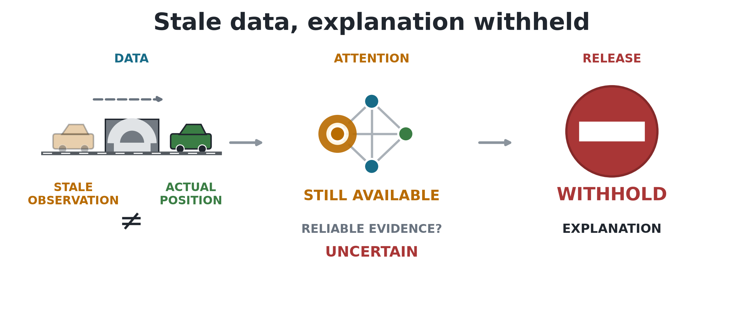
Figure 1.1. Main finding. A tunnel-triggered outage leaves the policy with a stale observation. Attention remains available, but the audit withholds it because freshness and faithfulness are not both established.
Under clean telemetry, raw-attention margin-DEF falls below its type-matched random control for both model families. A leave-one-out control produces a positive response, showing that the evaluator can detect a more decision-relevant ranking even though raw attention does not provide one.
Longer outages consistently increase the measured exposure to stale vehicle information. However, the paired attention response differs across trained policies: three checkpoints show a clear increase in attention to stale nodes, two show a clear decrease, and one is inconclusive. Probability DEF shows a small increase, rather than the expected decline, for all six checkpoints. The study therefore does not find the proposed degradation-related loss of faithfulness, or one consistent attention response.
The interpretation also depends on how attention is extracted and on whether the selected action is dispatch or no-op. Dispatch accounts for most scorable decisions in the corrected experiment, but the two action groups have opposite paired DEF directions. Degradation-aware training does not remove the checkpoint variation.
The practical conclusion is that data freshness and explanation faithfulness must be checked separately for each trained policy. In the present experiment, the policy may still produce an action, but its raw attention weights should be withheld as an explanation.

1.6 Contributions
The dissertation makes four main contributions:
- a reproducible paired clean/degraded benchmark that creates two observations from the same SUMO state, separates physical ground truth from policy input, and distinguishes the tunnel trigger from the observation-layer outage;
- an action-aware, type-matched evaluation protocol that reduces the deletion bias caused by request nodes representing both information and available actions, checked through LOO, overlap, and action-type diagnostics;
- evidence across independently trained checkpoints showing that stale-data exposure increases consistently with outage duration, while direct paired attention and DEF shifts vary across checkpoints and attention-extraction choices, with the pattern also tested under random telemetry loss;
- an implemented freshness-aware explanation audit framework that combines freshness, faithfulness, action composition, extraction sensitivity, and checkpoint-consistency evidence to return an ELIGIBLE, WITHHOLD, or INCOMPLETE explanation-release decision.

1.7 Dissertation structure
Chapter 1: Introduction. Defines the research problem, research questions, objectives, main findings, and contributions.
Chapter 2: Literature Review. Reviews MARL fleet dispatch, graph attention, explanation faithfulness, graph explainability, and telemetry freshness.
Chapter 3: Methodology. Describes the SUMO environment, policy models, observation-layer degradation, faithfulness measures, evaluation design, and audit rules.
Chapter 4: Results. Reports policy capability, construct-validity checks, faithfulness results, stale-data exposure, sensitivity analyses, and audit decisions.
Chapter 5: Discussion. Interprets the findings, explains their limitations, and presents the freshness-aware explanation audit framework.
Chapter 6: Conclusion. Answers the research questions and summarizes the practical implications for trustworthy fleet-dispatch explanations.

Chapter 2: Literature Review
This chapter reviews the literature needed to define the research gap. It first considers reinforcement learning for relational fleet dispatch, then examines explanations for sequential and graph-based decisions. It also reviews the debate over attention and the limits of faithfulness tests. The final sections connect these topics to stale telemetry and position the experiment.

2.1 Reinforcement learning for fleet dispatch
Fleet dispatch links vehicles, passenger requests, and a road network over time. A decision for one taxi changes the demand available to others, so a collection of independent single-agent policies can create competition or duplicated assignments. Lin et al. (2018) model city-scale fleet management as a cooperative multi-agent reinforcement-learning (MARL) problem. Qin, Zhu and Ye (2022) show that reinforcement learning (RL) is used for matching, repositioning, pricing, and route decisions, often under changing supply and demand.
MARL offers several ways to represent coordination. Multi-Agent Deep Deterministic Policy Gradient (MADDPG) learns decentralized actors with centralized critics (Lowe et al., 2017). QMIX factorizes a team value into agent values while preserving a monotonic relation to the joint action (Rashid et al., 2020). Multi-Agent Proximal Policy Optimization (MAPPO) uses the more familiar Proximal Policy Optimization (PPO) objective with centralized training and decentralized execution; its empirical stability makes it a practical baseline for cooperative tasks (Yu et al., 2022). This dissertation adopts MAPPO because the research focus is the explanation attached to each taxi's local decision, not a new MARL algorithm.
Graphs provide a natural representation of the local dispatch problem. Nodes can represent the acting taxi, nearby taxis, and open requests; edges permit their information to be combined (Scarselli et al., 2009). A graph attention network (GAT) assigns learned weights while aggregating neighboring nodes (Velickovic et al., 2018). Actor-Attention-Critic uses attention in its centralized critic to select information from other agents (Iqbal and Sha, 2019). This makes GAT-MARL a suitable test case, not because it is assumed to be the best dispatch model, but because it matches the relational, multi-agent structure of fleet dispatch while exposing an attention channel that can be audited. These weights are easy to visualize, which makes them tempting to present as reasons for an action. Ease of display, however, is not evidence that the weights identify the information that caused the decision.
Recent dispatch methods continue to use relational structure. Hu, Feng and Li (2025) propose Localized Bipartite Match Graph Attention Q-learning (BMG-Q), which uses a local bipartite graph for ride-pooling dispatch. CoopRide studies cooperation across city grids (Wang et al., 2025), while DualG-MARL combines vehicle-state and task graphs (Sha et al., 2026). These studies evaluate dispatch or scheduling quality rather than whether their learned graph or attention weights can be presented as faithful explanations when vehicle telemetry becomes stale. They provide useful task benchmarks, but not direct faithfulness benchmarks.

2.2 Explainability in reinforcement learning
Explainable reinforcement learning (XRL) covers more than a visual saliency map. An explanation may describe which state features mattered, summarize a policy, contrast the selected action with an alternative, or show the sequence of events that led to an outcome. Reviews by Heuillet, Couthouis and Diaz-Rodriguez (2021) and Milani et al. (2024) stress that the method must match the user's question. A model developer debugging a policy and an operator checking one live action do not need the same output. The systematic taxonomy by Bekkemoen (2024) reaches the same conclusion across a larger body of recent XRL studies.
This dissertation concerns a local, post-decision operator question: which visible vehicles or requests supported the selected action, whether dispatch or no-op? Earlier XRL work offers several ways to answer this question. Greydanus et al. (2018) perturb image regions to visualize what changes an Atari policy. Madumal et al. (2020) use a causal model to generate contrastive explanations. Mott et al. (2019) introduce an attention bottleneck intended to expose what an RL agent uses. These approaches differ in mechanism, but they share an important lesson: a useful picture and a faithful account of model dependence are separate properties.
For an operational dashboard, readability and faithfulness must be considered separately. An explanation may be easy to read but weakly connected to the policy computation. A faithful explanation should change when information that matters to the action is removed or retained. This experiment tests that link through a controlled decision-level faithfulness test; it does not measure user preference for the attention map.

2.3 Is attention an explanation?
A widely cited challenge to attention-based explanations was presented by Jain and Wallace (2019). They found that attention weights could be weakly correlated with other importance measures and that very different attention distributions could produce similar predictions. Wiegreffe and Pinter (2019) argued that this does not justify rejecting all attention explanations and proposed more careful tests. Serrano and Smith (2019) likewise showed that removing high-attention items can affect outputs, but that the relationship varies by model and task. The literature therefore supports neither a universal acceptance nor a universal rejection of attention. Each explanation claim needs an explicit definition and an appropriate test.
Attention became widely visible through Transformer models (Vaswani et al., 2017), but visibility also encouraged a broader interpretability claim than the mechanism alone can support. Lipton (2018) warns that the word interpretability often combines several different goals that should be evaluated separately.
Jacovi and Goldberg (2020) separate plausibility, which concerns whether an explanation looks reasonable to a person, from faithfulness, which concerns whether it reflects the model behavior that produced the output. This dissertation follows that distinction. It treats the attention weights as a candidate explanation and measures their decision relevance rather than accepting them simply because they are part of the actor.
Layer and head aggregation add another difficulty. A two-layer, multi-head network does not produce one unique attention map. Averaging heads, selecting a layer, taking a maximum, or composing attention across layers can produce different rankings. Abnar and Zuidema (2020) propose attention rollout and flow to account for information mixing across layers, and report stronger correlations with ablation and gradient importance than raw attention in Transformers. Although their model is not a GAT-MARL dispatcher, the methodological point transfers: an attention result is incomplete unless the aggregation rule is defined and its sensitivity is checked. Shin et al. (2025) similarly show that raw self-attention coefficients can give weak graph attributions when message-passing paths are ignored.

2.4 Explaining graph neural networks
GNN explanations may identify important features, nodes, edges, or subgraphs. GNNExplainer learns a compact subgraph and feature mask that preserves a prediction (Ying et al., 2019). PGExplainer parameterizes explanation generation so that it can be shared across examples (Luo et al., 2020). SubgraphX searches for important subgraphs using Shapley-value approximations (Yuan et al., 2021). These methods show that graph explanation is a distinct problem: removing one node can alter both its own features and the messages available to other nodes.
The survey by Yuan et al. (2023) organizes GNN explainers by target, mechanism, and scope. GraphFramEx goes further by comparing explanation methods under different user needs and combining necessity and sufficiency views (Amara et al., 2022). Its results show that no single method dominates every evaluation dimension. This supports the use of several checks in the present study: DEF tests counterfactual relevance, taxi-only rank correlation compares attention with leave-one-out effects, and stale-attention measures describe freshness exposure. Azzolin et al. (2025) further show that GNN faithfulness metrics are not interchangeable, reinforcing the need to define what each measure tests.
Most GNN explainability benchmarks study node or graph classification. Fleet dispatch differs because some graph nodes also define actions. A passenger request is both information and a selectable action, while a nearby taxi is context only. Deleting them creates different interventions. This action-linked graph structure motivates the construct-validity audit in Section 3.7.

2.5 Evaluating faithfulness: methods and pitfalls
Comprehensiveness and sufficiency are common perturbation measures. In the ERASER benchmark, comprehensiveness asks how much a prediction weakens when the explanation is removed, while sufficiency asks how well the selected evidence alone preserves it (DeYoung et al., 2020). Liu et al. (2022) similarly test attention by measuring faithfulness violations. These measures are useful because they connect an explanation to model behavior instead of visual appeal.
Model-agnostic methods such as LIME also use local perturbations to estimate which inputs support a prediction (Ribeiro, Singh and Guestrin, 2016). Their usefulness depends on whether the perturbed samples remain meaningful for the model and task.
Perturbation is not automatically valid. Removing input features may create samples unlike the data seen during training. The Remove and Retrain (ROAR) benchmark shows why deletion can confound attribution quality with distribution shift (Hooker et al., 2019). Zheng et al. (2024) identify this problem in GNN fidelity measures and propose more robust alternatives. Adebayo et al. (2018) argue that explanations should respond when model parameters or labels are randomized. Li et al. (2024) show that small graph changes can preserve a prediction while substantially changing its explanation. Together, these studies show that the evaluator itself must be audited.
The present action-deletion problem is related but more specific. If a selected request node is masked, its action logit becomes unavailable. A large margin change can then occur even if the request features carried no useful evidence. A random baseline that removes more request nodes than the attention top-k is not a fair comparison. Type matching, selected-action protection, and clamp logging are introduced to control this mechanism. A leave-one-out perturbation ranking acts as a positive control for comprehensiveness, while Gradient x Input (Ancona et al., 2018) provides a comparator that does not use attention coefficients.
The small graph creates a second limit. When k = 3 and only a few valid nodes exist, a random size-three set must overlap substantially with the explanation set. This compresses the possible difference between them. Reporting the exact expected overlap and a taxi-only rank correlation makes that limitation visible instead of treating every near-zero DEF as decisive evidence.

2.6 Age of Information and telemetry degradation
Age of Information (AoI) measures the time since the newest received update was generated (Kaul, Yates and Gruteser, 2012). It is widely used to study communication freshness, including the relationship between update age, estimation, and control (Yates et al., 2021). The explanation question is different. A dispatch action and its attention map may remain available even when a vehicle reading has stopped updating. The operator can see a strong weight without knowing that its source is old.
Delayed-observation reinforcement learning studies how an agent can continue to act when observations or actions arrive late. Bouteiller et al. (2021) model random action and observation delays and propose a delay-correcting actor-critic method. Liotet et al. (2022) learn a delayed policy from demonstrations produced without delay. Both studies focus on maintaining decision performance under delay. They do not test whether an explanation remains faithful when the policy receives stale telemetry.
This dissertation uses AoI only as a node-level freshness descriptor and as the weight inside weighted attention mass on stale nodes (WAMSN). The experiment manipulates the duration of an observation-layer outage triggered by tunnel entry, not AoI itself. It therefore makes no causal claim that a larger AoI value lowers faithfulness. The analysis instead asks whether stale exposure and attention-based explanation behavior provide consistent evidence under controlled outages.

2.7 From explanation evaluation to explanation assurance
An explanation test becomes an assurance process when its result is used to decide whether an explanation should be shown to a user. The NIST AI Risk Management Framework treats testing, validation, documentation, and monitoring as parts of managing the risks of AI systems (Tabassi, 2023). It provides general risk management guidance rather than a test for attention explanations.
This dissertation applies that general assurance principle to a narrower question: whether an attention map has enough supporting evidence to be presented for a fleet-dispatch decision. The resulting framework checks the data status, the validity of the faithfulness test, and consistency across independently trained policies. It then returns one of three decisions: ELIGIBLE, WITHHOLD, or INCOMPLETE. These labels and their decision rules are proposed in this dissertation; they are not prescribed by the NIST framework. Recent work also shows why such caution is needed: Azzolin et al. (2026) show that a self-explaining GNN can produce an explanation unrelated to its prediction process and that some metrics may miss this failure. Although their setting is graph classification, the result supports auditing an explanation before presenting it as evidence.

2.8 Research gap and positioning
The literature supports four points: relational RL is appropriate for fleet dispatch; attention is easy to expose but disputed as an explanation; GNN faithfulness requires graph-aware perturbations; and stale state matters to operational control. Recent work examines GNN explanation fidelity, instability, and auditing (Zheng et al., 2024; Li et al., 2024; Azzolin et al., 2025; Shin et al., 2025; Azzolin et al., 2026), but does not combine MARL fleet dispatch, paired clean and stale observations, and action-linked request nodes. This narrower gap is addressed here through a focused narrative review rather than a systematic one.
Recent graph-based dispatch studies provide the closest task comparison, but they answer a different question from this dissertation. Hu, Feng and Li (2025) evaluate BMG-Q, Wang et al. (2025) evaluate CoopRide, and Sha et al. (2026) evaluate DualG-MARL. Table 2.1 summarizes how their aims differ from the present study.
Table 2.1: Recent graph-based dispatch literature compared with this study
Study | Data and graph design | Main purpose | Unaddressed assurance question
BMG-Q (2025) | ride-pooling with a local bipartite matching graph | dispatch quality and scalability | Are graph weights faithful under stale telemetry?
CoopRide (2025) | cooperative MARL across city grids and real order data | city-scale dispatch quality | Are node-level explanations faithful?
DualG-MARL (2026) | vehicle-state and task graphs with real order data | ride-sharing scheduling quality | Do explanations remain supported under paired telemetry degradation?
This dissertation | local GAT-MAPPO taxi/request graphs in controlled SUMO runs | explanation assurance | Tests paired degradation, action-aware faithfulness, and release conditions.
These methods are not treated as performance baselines because their tasks, action spaces, and data-generation procedures differ. They are benchmark literature for positioning the contribution: recent work improves relational dispatch, whereas this dissertation tests whether an exposed attention channel has enough evidence to be presented as an explanation.
Across the graph- and RL-explainability and delayed-observation studies reviewed in Sections 2.2-2.7, no evaluation protocol was identified that combines all of the following:
- a graph-attention MARL action explained at decision level;
- paired clean and stale versions of the same operational observation;
- explicit measurement of attention placed on stale telemetry;
- a control for graph nodes that also remove available actions;
- replication across independently trained checkpoints.
This thesis contributes an audit protocol rather than a new dispatch algorithm. SUMO supplies a controlled state (Lopez et al., 2018), and GAT-MAPPO supplies an auditable attention channel. The contribution is a reproducible test of whether that channel supports a freshness-aware, decision-relevant explanation and a rule for withholding it when the evidence is insufficient.

Chapter 3: Methodology

3.1 Study design
The study uses a controlled simulation because the research question requires the same decision to be observed in two ways: once with current telemetry and once with degraded telemetry. A conventional observational fleet log would not normally provide this exact clean twin. SUMO provides the simulated physical state, while a separate observation layer controls what the policy receives.
The protocol is defined in version-controlled configuration files. It contains three stages: training, validation-based checkpoint selection, and held-out evaluation. Faithfulness sweeps are run only after the selected checkpoints are frozen.
The six objectives are implemented through the paired observation benchmark, clean faithfulness controls, telemetry-degradation sweep, cross-checkpoint consistency analyses, matched training comparison, and final explanation-release audit.

3.2 SUMO environment and data
The road network is an OpenStreetMap extract of the Central Park area in Yubei, Chongqing. Roads marked as tunnels supply physically meaningful signal-loss triggers. SUMO simulates 20 taxis and 50 passenger requests during each 1,200-second episode. Taxi dispatch is controlled through TraCI, while SUMO continues to update the true position and speed of every vehicle.
Twenty generated demand variants use one fixed taxi seed (42) and passenger request seeds 1000-1019. Variants 0-13 form the training split, variants 14-16 form the validation split, and variants 17-19 form the held-out test split. The policy is fitted on the 14 training variants. Candidate checkpoints are compared on the three validation variants. The final reported runs use only the three test variants. This separation prevents test results from influencing model selection. During evaluation, consecutive episodes cycle through the three test variants, and actions are sampled from the policy's probability distribution. Evaluation seeds control this action sampling; they do not create additional independent demand datasets.
SUMO is a microscopic traffic simulator (Lopez et al., 2018), not a source of directly observed traffic data. Its outputs depend on the chosen road network, generated demand, routes, vehicle behavior parameters, tunnel locations, and random seeds. The experiment is therefore not described as free from bias. Instead, it uses these assumptions consistently in a paired design. At each sampled decision, the clean and degraded observations share the same underlying SUMO state and trained-policy checkpoint; only the observation-layer telemetry differs. This controls the comparison well enough to isolate the effect of the implemented degradation within this scenario, but it does not make the simulated fleet representative of every real city.

3.3 Observation graph and action space
Each idle taxi receives a self-centered graph. Table 3.1 summarizes its node types, features, and roles.
Table 3.1: Observation graph node types and roles
Node type | Main features | Role
Self taxi | position, normalized time, speed and AoI; separate position-valid indicator | acting vehicle
Peer taxi | relative position, availability, distance, AoI | nearby fleet context
Passenger request | pickup/drop-off vectors, waiting time | candidate request and action
The graph contains up to five nearby taxis and five nearby requests. Features are normalized, and request and taxi masks prevent padded nodes from receiving attention. The discrete action space contains no-op plus one action for each visible passenger request. Figure 3.1 shows the maximum graph size and the request-to-action mapping. This mapping is important for the faithfulness evaluation: masking a passenger request node also removes its associated action, whereas masking a peer-taxi node removes only information about that taxi. Section 3.7 explains how the evaluation accounts for the different effects of masking request and peer-taxi nodes.
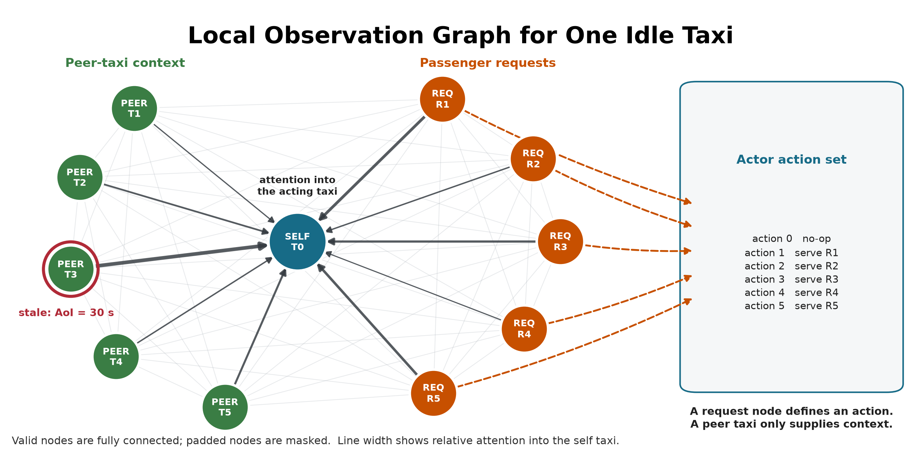
Figure 3.1. Maximum configured graph: one self taxi, five peer taxis, and five requests. Valid nodes are fully connected, and unused slots are masked. The red ring marks stale telemetry; dark edges show illustrative attention into the self taxi. Each request maps to one dispatch action.

3.4 Policy models and training
The main policy uses per-node-type feature projections followed by two graph attention layers with four heads. The actor scores no-op and the visible requests. The critic estimates value for MAPPO training (Yu et al., 2022) with centralized training and decentralized execution (CTDE). The GAT implementation returns its attention tensors directly so they can be audited without changing the trained network.
During training, the centralized critic pools the valid node embeddings from all agents in the same transition and returns one shared team-value estimate. The actor does not receive this pooled representation: each taxi selects its action from its own local graph. At execution and during the explanation audit, the actor therefore remains decentralized.
The implementation uses scaled dot-product graph attention on the fully connected set of valid local nodes. This differs from the additive attention score in the original GAT paper, so "GAT" in the experiment labels denotes the graph-attention policy family, not an exact reproduction of that layer. For node i, node j, layer l, and head h:
 | $\begin{aligned}q_{i}=W_{Q,h}\text{LayerNorm}(h_{i}^{l}) \\ k_{j}=W_{K,h}\text{LayerNorm}(h_{j}^{l}) \\ v_{j}=W_{V,h}\text{LayerNorm}(h_{j}^{l}) \\ s_{ij}^{l,h}=\frac{q_{i}k_{j}}{\sqrt{d_{\text{head}}}} \\ α_{ij}^{l,h}={\text{softmax}}_{j}(s_{ij}^{l,h}) \\ z_{i}={\text{concat}}_{h}(Σ_{j}(α_{ij}^{l,h}×v_{j})) \\ u_{i}=h_{i}^{l}+W_{O}z_{i} \\ h_{i}^{l+1}=u_{i}+\text{FFN}(\text{LayerNorm}(u_{i}))\end{aligned}$ | (3.1)
Here, FFN denotes the feed-forward network within each attention layer. The mask removes padded nodes before the softmax. A residual connection keeps the previous node embedding. The actor reads the updated self embedding for no-op and each updated request embedding for its matching dispatch action. The default explanation is the self row (i = 0) averaged over both layers and all four heads, then renormalized:
 | $α_{j}=\text{normalize}(\frac{Σ_{l,h}(α_{0j}^{l,h})}{LH})$ | (3.2)
This aggregation is declared before evaluation. A sensitivity analysis also reports each layer, head-wise values, head maximums, and attention rollout; it does not select an aggregation after seeing which result is favorable. The explanation average is an analysis choice: inside the policy, head outputs are concatenated and projected rather than averaged.
The fixed self row represents the acting taxi's dashboard view and is the explanation channel originally declared for audit. It directly contributes to the no-op embedding. A request-action logit, however, is read from that request's updated embedding, so its corresponding request row is more directly aligned with the selected logit. A sensitivity analysis therefore reports a separate request-action sensitivity comparison between the fixed self row and the selected request row. This comparison is not used to redefine the primary metric after seeing the result.
Figure 3.2 summarizes the policy path and the read-only audit channel.
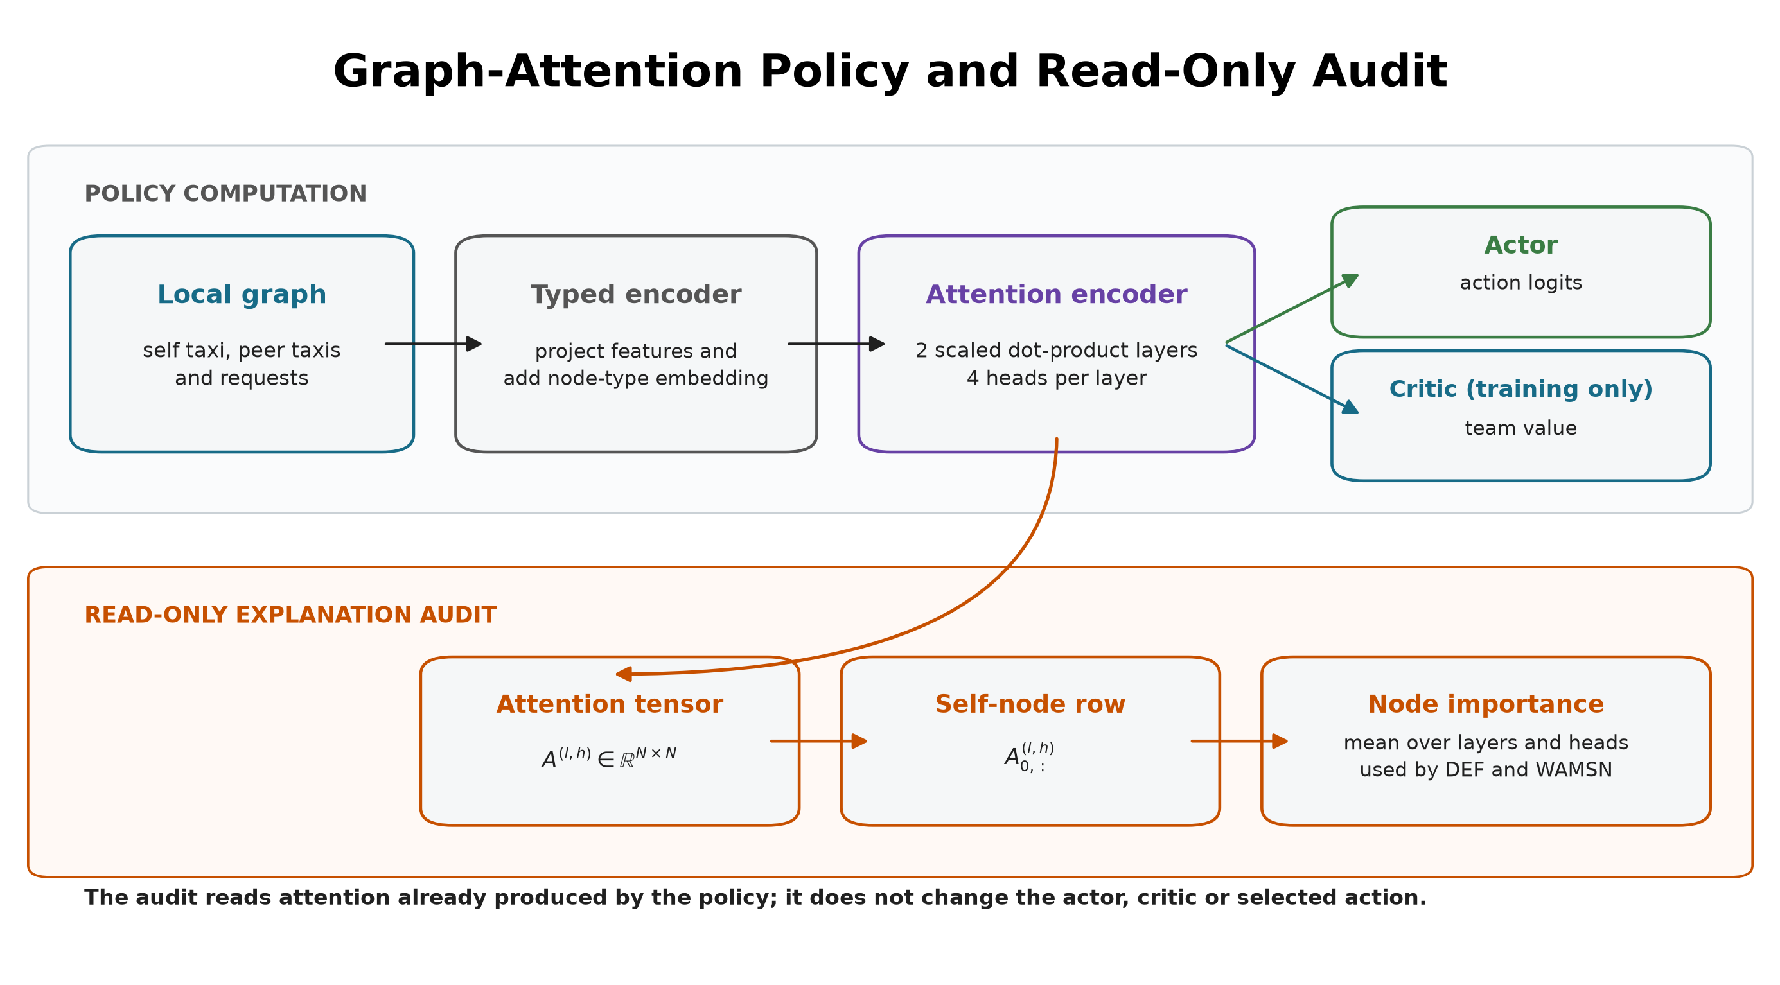
Figure 3.2. The policy and audit share the same two-layer attention encoder. The default audit reduces the self-node attention row to node importance without modifying the actor, critic, or selected action; the selected-request row is evaluated separately as a sensitivity check.
Table 3.2 lists the three policy conditions included in the experiment. The non-graph baseline uses a multilayer perceptron (MLP).
Table 3.2: Policy conditions used in the experiment
Model | Policy | Training observations | Purpose
MLP | MLP-MAPPO | clean | performance context without graph attention
GAT | GAT-MAPPO | clean | primary attention model under audit
GAT-Outage | GAT-MAPPO | tunnel-triggered 30-second outages | tested degradation-aware training configuration
Each model is trained in three independently initialized runs using seeds 42, 43, and 44. Corresponding GAT and GAT-Outage seeds are paired in the H5 comparison.
The maximum training budgets were fixed from validation-only stability diagnostics before the held-out evaluation. Clean GAT uses 40 epochs to limit late policy drift. MLP and GAT-Outage use 50 epochs because their earlier development runs needed the longer budget to meet the stability checks. The same fixed budgets are used for all three seeds within each model condition.
These choices improve stability but mean that GAT and GAT-Outage do not have identical optimization horizons: their learning rates decay over 40 and 50 epochs, respectively. H5 therefore compares the two fitted training configurations descriptively. It does not isolate the effect of degraded training observations from the difference in training budget.
Candidate checkpoints include periodic trained snapshots, the final snapshot, and a rolling-best snapshot that may come from any trained epoch. The epoch-0 snapshot is evaluated only as an initialization diagnostic and cannot be selected as the final model. Because the implementation records zero-based indices, index 39 denotes the checkpoint saved after 40 training epochs. Selection uses eight sampled-action validation episodes with seed 2026 and the mean number of completed passenger journeys as the primary criterion; mean reward and the earlier checkpoint index break ties. MLP and GAT are selected under clean validation observations. GAT-Outage is selected under its 30-second tunnel-triggered training condition. The test split is not read during selection. Table 3.3 reports the selected checkpoint index for each training run.
Table 3.3: Validation-selected checkpoint indices (zero-based)
Model | seed 42 | seed 43 | seed 44
MLP | 45 | 30 | 38
GAT | 30 | 20 | 39
GAT-Outage | 10 | 40 | 9
Table 3.4 reports the training and optimization settings.
Table 3.4: Training and optimization settings
Setting | Value
Training epochs | 40 (GAT), 50 (MLP and GAT-Outage)
Learning rate | 0.0001 (GAT variants), 0.0003 (MLP)
Learning-rate schedule | linear decay over each run (GAT variants); constant (MLP)
Discount factor (gamma) | 0.99
Generalized advantage estimation factor (lambda) | 0.95
PPO clip ratio | 0.20
PPO passes per update | 4
Minibatch size | 256
Value-loss coefficient | 0.25
Value clip ratio | 0.20
Entropy coefficient | 0.05, adaptive to a 0.20 entropy floor
Maximum adaptive entropy coefficient | 0.20
Target Kullback-Leibler divergence | 0.015
Gradient-norm limit | 0.50
Dispatch credit reward | 1.00
Critic encoder gradient scale | 0.10
GAT hidden width / layers / heads | 64 / 2 / 4
GAT attention dropout | 0
MLP hidden width / layers | 176 / 3
Table 3.5 separates checkpoint acceptance from the optimizer settings. Final validation retention is the final checkpoint's mean validation completed journeys divided by the selected checkpoint's mean validation completed journeys. The stability window defines where the training measures are calculated; the remaining four gates must pass before a training run is accepted for evaluation.
Table 3.5: Checkpoint-acceptance criteria
Checkpoint-acceptance setting | Required value
Stability window | Final 10 training epochs
Minimum final-window mean completed journeys | 5.0
Maximum consecutive zero-completion epochs | 4
Minimum selected validation completed journeys | 5.0
Minimum final validation retention | 0.80
At simulation step t, the reported shared team reward is:
 | $r_{t}=10N_{\text{pickup},t}+0.5N_{\text{dispatch},t}-0.001{\text{mean_wait}}_{t}$ | (3.3)
For PPO training, taxi i receives an additional difference credit only when its dispatch is accepted:
 | $r_{i,t}^{\text{train}}=r_{t}+1.0I_{\text{successful dispatch by i at t}}$ | (3.4)
Here, N_complete,t counts target passengers who reach their destinations; it is not a boarding count. I(.) is one when the condition is true and zero otherwise. A taxi can be absent from the action set while it serves a request. The implementation therefore keeps its last decision open and accumulates the shared reward from every intervening simulation step. For a gap of Delta steps, the interval return discounts those rewards by gamma^j, bootstraps with gamma^Delta, and applies the GAE trace factor (gamma lambda)^Delta. Terminal intervals do not bootstrap into the next episode. This semi-Markov treatment prevents rewards earned while a taxi is busy from disappearing. Neither reward contains a term for a faithful, stable, or human-readable attention map.
Figure 3.3 shows how training, validation selection, and held-out evaluation remain separated.
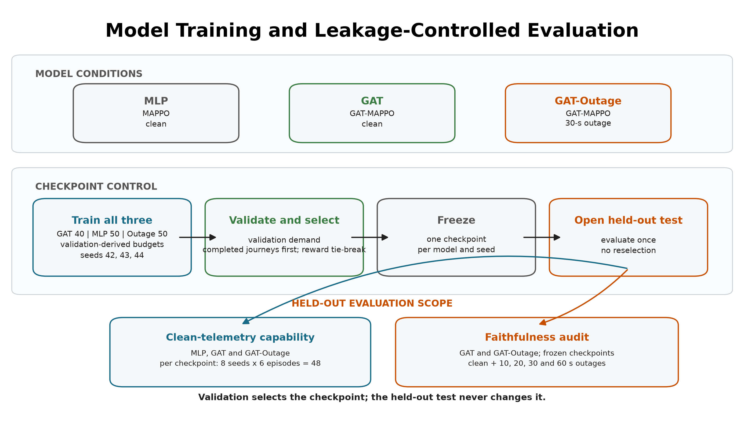
Figure 3.3. Shared training and validation-based selection pipeline with the model-specific budgets described above. Each frozen checkpoint receives 48 clean held-out episodes. The faithfulness audit then compares the frozen GAT and GAT-Outage checkpoints across clean and four outage conditions without reselection. This produces 720 faithfulness-sweep episodes per GAT model and 1,440 in total.

3.5 Telemetry degradation
The trigger and the degradation location are separate parts of the design.
Step 1 - Trigger: when a taxi enters a tunnel edge, the event starts one outage.
Step 2 - Observation-layer outage: for the declared duration, the policy sees the taxi's last valid position and speed. SUMO continues to simulate the true state.
Step 3 - Recovery: after the fixed window expires, a current reading is accepted. A taxi must leave and enter a tunnel again before another tunnel-entry event can trigger.
The fixed outage durations are 10, 20, 30, and 60 seconds. They are easy to monitor and compare, and they create increasing empirical degradation rates. They are not treated as direct causal doses of explanation faithfulness.
AoI is calculated as the current simulation time minus the time of the last valid update and is included in each GAT observation. WAMSN uses normalized AoI as a staleness weight. For this reason, an increase in WAMSN with outage duration partly verifies that the manipulation created longer stale exposure; it is not by itself proof that AoI changed DEF. Figure 3.4 illustrates this separation between physical state and policy observation.
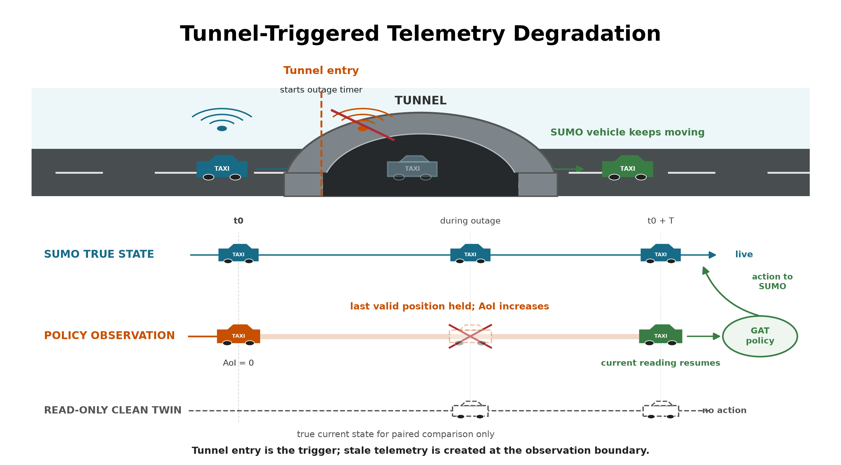
Figure 3.4. Tunnel entry triggers an observation-layer outage. SUMO keeps moving the vehicle while the policy sees its last valid position; the clean twin reads current state but never acts. The paired observations keep the same node identities, node order, masks, and selected action.

3.6 Explanation measures

3.6.1 Decision-level explanation faithfulness
DEF asks whether the nodes ranked highly by an explanation affect the chosen action more than a size- and type-matched random set. Two score functions are recorded from the same counterfactual forward passes. Probability DEF uses the selected action probability, p(G,a), and is bounded by the probability scale. Logit-margin DEF uses the selected action logit minus the strongest available alternative, m(G,a). The margin can retain resolution when the softmax probability is saturated, but its value depends on a checkpoint's logit scale.
For top-k nodes R_k, comprehensiveness measures the output change when those nodes are removed; sufficiency measures the output retained when only those nodes remain. The self node is always retained and is not a deletion candidate. The candidate set contains only valid peer-taxi and request nodes. The two gains are compared with five matched random subsets for each k in {1,2,3} and then averaged.
Let s(G,a) denote either p(G,a) or m(G,a). The action a is sampled from the policy observation being audited. For a degraded/clean pair, the action sampled on the degraded side is held fixed when both observations and every counterfactual subset are scored. For explanation subset R_k and each matched random subset indexed by b:
 | $\begin{aligned}\text{Comp}(R_{k},a)=\text{s}(G,a)-\text{s}(G∖R_{k},a) \\ \text{Suff}(R_{k},a)=\text{s}(G,a)-\text{s}(G[R_{k}],a) \\ g_{\text{comp}}(k;a)=\text{Comp}(R_{k},a)-{\text{mean}}_{b}\text{Comp}(B_{k}^{b},a) \\ g_{\text{suff}}(k;a)={\text{mean}}_{b}\text{Suff}(B_{k}^{b},a)-\text{Suff}(R_{k},a) \\ \text{DEF}(a)={\text{mean}}_{k}\frac{1}{2}[g_{\text{comp}}(k;a)+g_{\text{suff}}(k;a)]\end{aligned}$ | (3.5)
Comprehensiveness is better when removing the explanation weakens the action more than removing random nodes. Sufficiency is better when keeping the explanation loses less evidence than keeping random nodes. The logit margin is clipped to [-10, 10] only when an action becomes unavailable or unopposed; every clamp is logged.
Type-matched random subsets are the control baseline; they are not themselves a faithfulness score. Corrected DEF is the measured difference between the attention-ranked subset and this matched random control. Its sign is interpreted as follows:
- Positive DEF: the attention-ranked nodes affect the selected action more than comparable random nodes. This supports decision-level faithfulness.
- DEF near zero: the attention ranking has no measured advantage over the matched random control.
- Negative DEF: the attention-ranked nodes affect the selected action less than the matched random nodes. This does not support the attention ranking as a faithful explanation.
These interpretations apply to both score functions. For no-op decisions, the primary metric uses standard type-matched DEF because no request action is selected. For dispatch decisions, it uses the chosen-action-protected variant so that the selected request cannot be removed. This hybrid action rule applies to both probability DEF and logit-margin DEF.
The predeclared H1-H4 analysis family and the paired clean-twin comparison use hybrid action-protected probability DEF, following the declared analysis plan. Logit-margin DEF is used for the construct-validity and ranking-control diagnostics because it can show output movement that a saturated probability hides. The two score functions have different units and cannot be converted into one another. Both use the type-matched baseline described in Section 3.7. DEF provides comparative perturbation evidence; even a positive value does not prove that attention is a complete causal explanation.
The study uses related measures for different questions. They should not be read as interchangeable estimates. Table 3.6 states the role of each measure.
Table 3.6: Explanation measures and roles
Measure | Decisions and score | Role in the study
Probability DEF (hybrid action rule) | standard type-matched score for no-op; selected request protected for dispatch | primary H1-H4 and paired clean/degraded analysis
Logit-margin DEF (hybrid action rule) | standard type-matched score for no-op; selected request protected for dispatch | construct-validity and ranking diagnostics when probability is saturated
Dispatch self-row margin-DEF | sampled dispatch actions only; declared self-row explanation | release check for decision relevance under clean and 60-second outage conditions
WAMSN | stale-exposed decisions; AoI-weighted attention | freshness-exposure indicator and H3 manipulation check
Paired attention and DEF shifts | degraded observation minus its clean twin | direct within-decision response to the observation-layer intervention

3.6.2 Stale-node attention
WAMSN measures attention attached to stale vehicle information:
 | $\text{WAMSN}=\frac{Σ_{i}({\text{attention}}_{i}×{\text{normalized_AoI}}_{i})}{Σ_{i}({\text{attention}}_{i})}$ | (3.6)
Only self and peer-taxi nodes contribute because request nodes do not carry vehicle telemetry. The analysis reports WAMSN when at least one stale vehicle node is visible, together with stale-node attention share, stale-node mass, and whether a stale node enters the top three.
The paired stale-attention shift compares the degraded observation with its exact clean twin at the same simulation step. Positive values mean the degraded observation assigns more attention mass to nodes marked stale; negative values mean it assigns less.

3.7 Construct-validity audit
The audit supports the primary research problem by checking whether DEF is a valid comparison in this action-candidate graph.
A uniform random occlusion can select passenger requests more often than the attention top-k. Removing such a request changes both the observation and the available action set. A nearby-taxi occlusion changes only information. The result can therefore reflect different node-type composition rather than explanation quality.
The corrected protocol uses three controls:
- type matching: random subsets contain the same mixture of taxi and request nodes as the explanation subset;
- chosen-action protection: the request associated with the selected action is not deleted in the action-protected variant;
- clamp logging: counterfactual action-margin clamps are counted so that action deletion can be detected.
Figure 3.5 illustrates why these controls are required.
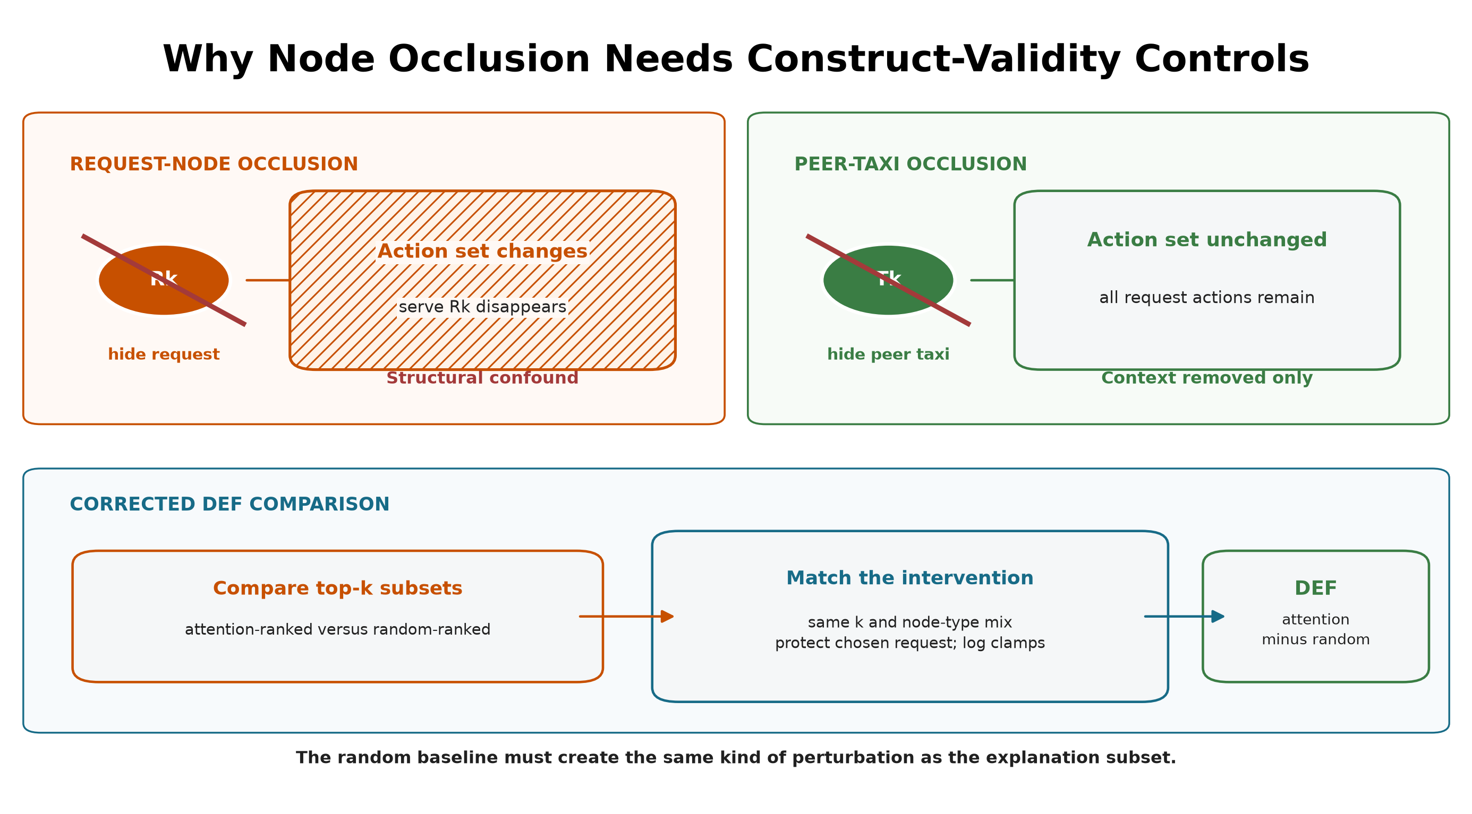
Figure 3.5. Request-node occlusion can remove its action, while peer-taxi occlusion removes context only. Corrected DEF matches subset size and node types, protects the chosen request, and logs margin clamps.
Uniform-baseline results are retained only as an audit trail. They are not used for the final hypothesis verdicts.
Three additional diagnostics test whether a near-zero DEF can be interpreted. First, a leave-one-out (LOO) control masks each valid node separately and ranks nodes by the resulting selected-action margin loss. The selected request is protected. This control is expected to strengthen comprehensiveness because it is built from the same single-node perturbation, but it is not an independent proof that the combined DEF is optimal. Second, Gradient x Input (GxI) ranks each node by the L2 norm of the selected-action logit gradient multiplied by its raw features. It is a post-hoc comparator that does not use attention weights. Third, the audit reports valid taxi/request counts and the exact expected top-k overlap with a type-matched random subset. Taxi-only Spearman correlation between attention and LOO effects supplies a ranking measure that does not delete request actions and does not depend on random subset overlap.

3.8 Evaluation design

3.8.1 Primary evaluation
MLP, GAT, and GAT-Outage are evaluated under clean telemetry with eight evaluation seeds (42-49) and six episodes per seed. One checkpoint is frozen for each model and training seed, giving 48 held-out episodes per checkpoint. The clean capability evaluation contains 432 episode evaluations:
 | $\text{3 × 3 × 8 × 6}=432$ | (3.7)
Table 3.7 summarizes the complete evaluation structure. An episode evaluation is one complete rollout of one frozen checkpoint under one telemetry condition.
Table 3.7: Held-out evaluation structure and episode counts
Evaluation | Model families | Total frozen checkpoints | Telemetry cases | Episodes/cell | Total
Clean capability context | 3 | 9 | 1 | 48 | 432
Exposure-conditioned faithfulness sweep | 2 | 6 | 5 | 48 | 1,440
Full ranking controls | 2 | 6 | 2 | 9 | 108
Request-row sensitivity | 2 | 6 | 2 | 9 | 108
Random-trigger sensitivity analysis | 2 | 6 | 3 | 24 | 432
GAT and GAT-Outage receive the full faithfulness sweep:
 | $\text{2 × 3 × 5 × 8 × 6}=1,440$ | (3.8)
This gives 720 episode evaluations per GAT model and 1,440 across both models.
Table 3.8 lists the five telemetry conditions and their roles.
Table 3.8: Telemetry conditions used in held-out evaluation
Telemetry condition | Observation-layer treatment | GAT-Outage relation | Evaluation purpose
Clean | Current vehicle readings | No imposed outage | Capability context and faithfulness baseline
10 s | Freeze last valid reading for 10 seconds | Unseen shorter duration | Mild-degradation transfer test
20 s | Freeze last valid reading for 20 seconds | Unseen shorter duration | Intermediate transfer test
30 s | Freeze last valid reading for 30 seconds | Training-matched duration | In-condition degradation test
60 s | Freeze last valid reading for 60 seconds | Unseen longer duration | Severe stress and transfer test
The legal-random capability baseline samples uniformly from no-op and the currently valid request actions. The greedy baseline is deliberately naive: each idle taxi chooses its nearest visible request independently. If several taxis choose the same request, the environment accepts the first action in the step and rejects the later conflicts; there is no fleet-wide assignment or conflict optimization. The policy is deterministic for a fixed demand variant, so its uncertainty is based on three independent demand variants rather than the repeated evaluation-seed records. It is therefore interpreted only as a lower bound, not as a competitive dispatch algorithm.
The relation column refers only to GAT-Outage; the clean-trained GAT has not seen any imposed outage duration during training. The evaluation changes the observation-layer condition but never retrains or reselects a checkpoint. Outside stale exposure, faithfulness is sampled every 16 decisions. Every decision that contains at least one stale vehicle node is scored. Each such observation is also compared with its exact clean twin at the same simulation step. The pair keeps the same trained checkpoint, agent, graph-node identities, node order, validity masks, and sampled action. Only telemetry-dependent feature values and freshness indicators differ. The degraded and clean evaluations also reuse the same matched-random subsets, so the paired difference does not contain avoidable baseline-sampling noise.
Each degraded condition must contain at least 20 stale-exposed records from at least three episodes. Preflight also checks expected cells, clean source provenance, type-matched controls, chosen-action exclusion, complete event capture, and separation in empirical AoI between conditions. A checkpoint sweep is included in the analysis only if it passes these gates.

3.8.2 Supporting analyses
Actions in the primary learned-policy evaluation are sampled from the policy distribution, matching training and preserving both no-op and dispatch decisions for audit. A separate descriptive diagnostic applies deterministic argmax to each of the six GAT checkpoints over three held-out episodes. It does not affect checkpoint selection or the primary capability comparison.
The action-type diagnostic separates scorable decisions into no-op and dispatch; cases with no available request are excluded because no-op is then forced. Records are averaged by episode within each action group. This shows whether combined results apply to both action types or mainly reflect the more common action.
The random-trigger sensitivity analysis evaluates the six frozen checkpoints under clean telemetry, a 30-second tunnel-triggered freeze, and a 30-second randomly triggered freeze. The per-taxi, per-step trigger probability is fixed at 0.0023 for every checkpoint. This value was chosen before the revised-model test, but the corrected policies follow different trajectories and produce less random-trigger exposure than tunnel-trigger exposure. The two conditions are therefore not treated as exposure matched. The analysis reports realized exposure and uses the random condition only to check whether the direction of the paired response depends entirely on the tunnel trigger. It is a post-study sensitivity analysis, not a confirmatory test.
The ranking controls use the same held-out demand and action-sampling protocol. They evaluate GAT and GAT-Outage under clean telemetry and a 60-second outage:
 | $\text{2 × 3 × 2 × 3 × 3}=108$ | (3.9)
The control evaluation uses seeds 42, 43, and 44 and covers all three held-out demand files in each run. LOO, Gradient x Input, overlap, and aggregation diagnostics are sampled every eight decisions. Query-row sensitivity uses the same cadence and retains only sampled selected-request actions. Records are averaged within episodes before bootstrap intervals are calculated. Attention-aggregation sensitivity is reported by training seed for decisions with at least one visible stale vehicle node. These controls support interpretation of the main 48-episode-per-checkpoint sweep; they do not replace it.

3.9 Hypotheses and statistical analysis
Table 3.9 provides one map of the five hypotheses, their analyses, and their roles. H1, H3, and H4 were predeclared as primary tests. H2 is a supporting exploratory diagnostic rather than a test of the main research claim, and H5 is a matched-seed descriptive comparison.
Table 3.9: Hypothesis map and analysis roles
Hypothesis | Question | Analysis | Role
H1 | DEF across outage durations | episode-block probability-DEF trend | primary
H2 | Faithfulness versus capability decline | paired clean-relative change | supporting exploratory diagnostic
H3 | WAMSN across outage durations | episode-block WAMSN trend | primary check
H4 | Within-episode WAMSN-DEF link | Spearman correlation and sign-flip test | primary
H5 | Weaker relationships for GAT-Outage | matched-seed correlation comparison | descriptive
RQ1 uses clean DEF, type-matched random controls, LOO, and ranking controls. RQ2 uses the paired clean/degraded stale-attention comparison. RQ3 uses H1, H3, and H4 together with the paired and action-type diagnostics. RQ4 uses H5.

3.9.1 Statistical procedure
H1 and H3 use episode-block permutation trend tests and cluster bootstrap confidence intervals. H2 uses paired cell-level sign flips relative to each evaluation seed's clean condition. H4 first calculates a Spearman correlation within each episode and then applies a sign-flip test. Holm adjustment is applied to H1-H4 within each trained policy; H2 remains exploratory.
All tests use 10,000 permutation draws, 2,000 bootstrap draws, statistical seed 0, and 95% percentile bootstrap intervals. Episodes, rather than individual decisions, are the resampling blocks. Each training seed represents one trained policy. Three seeds can show variation but cannot support a population-level claim, so cross-seed results are reported as ranges and counts of supporting seeds without a population p-value.
H5 is supported for a matched seed only when both the outage-duration/DEF and WAMSN/DEF correlations are closer to zero for GAT-Outage than for GAT. The result is the number of supporting pairs out of three; no cross-seed significance test is used.

3.9.2 Interpretation limits
H2's original rate divides by clean DEF. Because clean DEF is close to zero, that ratio can exaggerate a small absolute change. The analysis therefore uses the support verdict and absolute trajectories as its main evidence.
H3 is a manipulation check, not evidence that AoI causes DEF to change. WAMSN contains normalized AoI by definition, so H3 only confirms that longer outages create more AoI-weighted stale exposure.
H5 compares two fitted configurations with different maximum training budgets and learning-rate decay horizons. It does not isolate the effect of degraded training observations. The exposure-conditioned paired follow-up is also kept separate from H1-H5: it subtracts clean-twin DEF from degraded DEF for the same decision and reports episode-block intervals, effect size, direction across trained policies, and uncertainty.

3.10 Audit decision implementation
The experiment pipeline produces measurements; a separate release-audit stage turns those measurements into a decision about whether attention may be shown as an explanation. The stage reads saved evidence and leaves the policy, selected action, SUMO state, and observations unchanged.
Its inputs are the frozen-checkpoint preflight reports, condition summaries, action-type results, training-seed synthesis, deterministic diagnostics, faithfulness controls, and tunnel-versus-random trigger comparison. These artifacts jointly cover telemetry freshness, decision relevance, action composition, attention extraction, checkpoint replication, and the action rule intended for deployment.
The implementation applies nine checks:
- evidence integrity;
- separate freshness reporting;
- type-matched and action-protected controls;
- dispatch-action decision relevance;
- no-op and dispatch composition;
- attention-extraction stability;
- consistency across independently trained checkpoints;
- capability of the action rule intended for deployment;
- robustness to tunnel and random loss triggers.
Decision relevance passes only when the 95% confidence-interval lower bound of self-row dispatch margin-DEF is greater than zero under both clean and 60-second outage evaluation. A positive value means that the attention ranking is more informative than its type-matched random control. Extraction stability fails if an audited layer, head, maximum, or rollout rule reverses the direction produced by the declared self-row mean. Trigger robustness uses confidence intervals: a direction is supported only when its 95% interval excludes zero, and supported tunnel and random-trigger directions must agree. An interval that crosses zero is INDETERMINATE, not evidence of a reversal. The remaining rules test evidence availability, action coverage, checkpoint agreement, and the action rule declared for deployment.
The present audit concerns actions sampled from the policy distribution. The argmax evaluation is therefore retained as a descriptive limitation rather than a mandatory release gate. If an argmax policy were intended for deployment, its held-out capability check would become mandatory. The current action-composition gate requires both action groups and at least 20 dispatch decisions at the model and individual-checkpoint levels, matching the minimum stale-exposure record floor used by the evaluation preflight. It confirms that dispatch evidence is present but does not by itself establish that a sparse dispatch group is representative.
The output has three states. ELIGIBLE means that every required check passed within the stated scope. WITHHOLD means that at least one check failed and attention must remain an internal diagnostic. INCOMPLETE means that required evidence is missing, so no release decision can be made. Eligibility is not proof of a complete causal explanation; it only permits presentation with an explicit freshness indicator and audit scope as an audited candidate explanation.
The release rules are a post-study synthesis of the risks identified by the experiment. Their application to the present results is therefore demonstrative and is not an additional confirmatory test of H1-H5. For future candidate models, the rules and thresholds must be fixed before held-out evaluation.

3.11 Reproducibility
The experiment runner records the configuration, commands, seeds, checkpoint hashes, source revision, and preflight reports in versioned run directories. Compact outputs include the summary, performance context, deterministic diagnostic, action-type audit, and training-seed synthesis tables. The training-seed synthesis makes consistency across trained policies explicit. Reproduction commands, file locations, and expected outputs are documented in docs/REPRODUCE_EXPERIMENTS.md. The complete frozen-checkpoint workflow is available as a single framework stage. It produces a machine-readable JSON decision, a CSV check table, and a reader-facing Markdown report. The detailed input and output contract is documented in docs/FRESHNESS_AWARE_EXPLANATION_AUDIT.md.

3.12 Ethics and data governance
The experiment uses a simulated taxi fleet, generated demand, and an OpenStreetMap-derived road network. It contains no human participants, personal records, live vehicle identifiers, or commercial dispatch data. Its main ethical risk is miscommunication: presenting attention as a trustworthy reason could give an operator false confidence. The reporting therefore keeps freshness, task behavior, and faithfulness separate and avoids unsupported causal claims.

Chapter 4: Results
All nine clean capability evaluations and all six faithfulness sweeps passed their preflight checks. Results are reported by training seed because one checkpoint, rather than each decision, is the independent trained-policy replicate. Unless stated otherwise, intervals are 95% confidence intervals (CIs) formed from episode blocks.

4.1 Policy capability and training stability
Validation selected different epochs for different training seeds, as shown in Table 3.3. Epoch 0 was retained only as an initialization diagnostic and could not be selected. Every training run passed the declared stability gates.
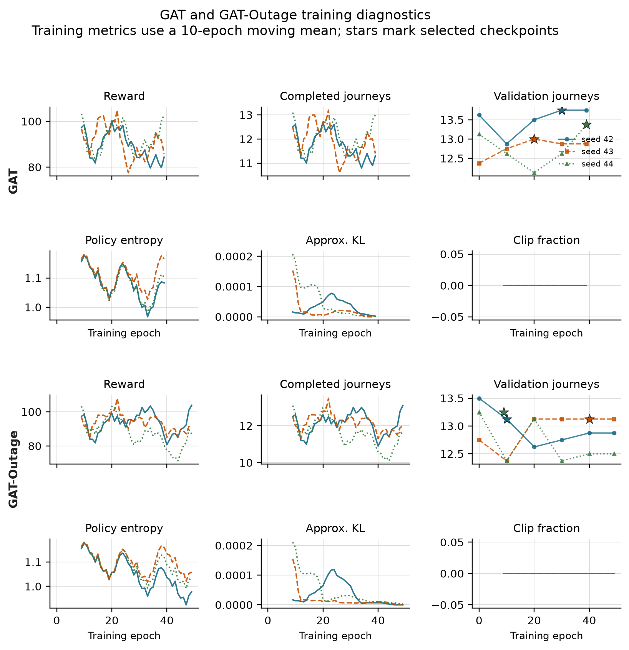
Figure 4.1. Training diagnostics for GAT (upper panels) and GAT-Outage (lower panels). Curves use a ten-epoch moving mean; stars mark the checkpoints selected on validation data. All six runs passed the stability gates, although the curves still show variation between epochs.
Table 4.1 reports clean held-out capability. The learned policies complete about 12.5 to 13.0 passenger journeys per episode. Their results overlap the legal-random CI and the range of the simple greedy policy. Therefore, the comparison establishes that the audited policies can dispatch and complete journeys; it does not show that GAT is better than the baselines or MLP.
Table 4.1: Policy capability on held-out demand
Policy | Mean completed journeys per episode | Uncertainty or training-seed range
Legal random | 12.708 | 95% episode CI [11.875, 13.542]
Greedy nearest request | 12.000 | 95% demand-variant CI [10.000, 15.000]
MLP | 12.472 | training-seed range 12.458-12.500
GAT | 12.674 | training-seed range 12.563-12.833
GAT-Outage | 12.799 | training-seed range 12.667-13.000
The legal-random estimate uses 48 episode records. The greedy policy is deterministic for a fixed demand file, so its effective replication unit is the three held-out demand variants. Each learned-policy point uses 48 held-out episodes: eight action-sampling seeds and six episodes per seed.
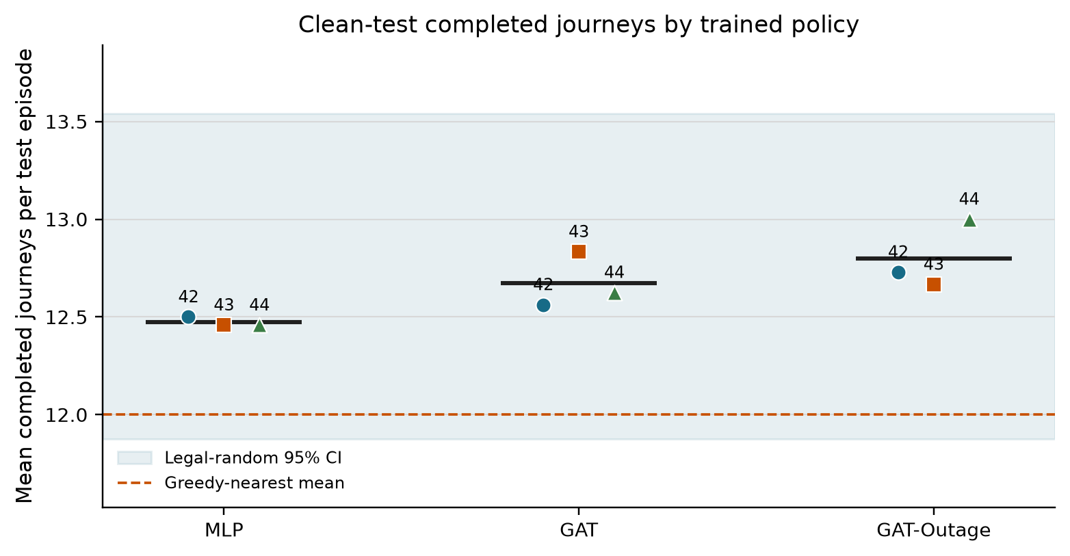
Figure 4.2. Clean-test completed journeys for each selected policy. The shaded band is the legal-random 95% CI and the dashed line is the greedy mean. Performance is capability context, not the main explanation outcome.
The separate argmax diagnostic also completes journeys. Across three held-out episodes, GAT checkpoint means are 8.0, 7.3, and 9.7; GAT-Outage means are 7.0, 7.7, and 10.0. None of the 18 checkpoint-episodes has zero completed journeys.

4.2 Protocol correction and precision audit
The corrected experiment addresses four implementation risks found during the code review: rewards earned while a taxi was busy are now accumulated over the whole decision interval; completed passenger journeys are counted globally; request-linked actions are protected in dispatch DEF; and unrounded numeric values are stored for analysis. Checkpoint selection was then repeated using validation data, followed by a new held-out evaluation. No corrected result is combined with an earlier run.
Table 4.2 reports the numeric-precision check. Repeating the hypothesis analysis after rounding stored values to four decimals changed some estimates slightly but changed no direction or verdict. Full precision remains the official analysis.
Table 4.2: Protocol correction and numeric-precision audit
Precision check | Checkpoints tested | Direction changes | Verdict changes | Use in thesis
Full precision versus four-decimal sensitivity | 6 | 0 | 0 | full precision
This check is important because DEF values are small. It shows that the reported signs and hypothesis decisions are not artifacts of early rounding.

4.3 Decision-relevance controls
The supporting control experiment evaluates raw attention, Gradient x Input (GxI), and leave-one-out (LOO) rankings under clean and 60-second outages. Each model-condition estimate combines 27 episode blocks: three training seeds, three evaluation seeds, and three episodes.
Table 4.3: Decision-relevance controls under clean and degraded telemetry
Model | Condition | Raw-attention margin-DEF [95% CI] | GxI margin-DEF [95% CI] | LOO margin-DEF [95% CI]
GAT | clean | -0.001355 [-0.002316, -0.000589] | -0.000388 [-0.001083, 0.000303] | +0.005595 [0.004053, 0.007436]
GAT | 60 s | -0.001027 [-0.001867, -0.000401] | +0.000002 [-0.000647, 0.000672] | +0.005735 [0.004151, 0.007636]
GAT-Outage | clean | -0.000596 [-0.000812, -0.000404] | -0.000584 [-0.001059, -0.000131] | +0.004001 [0.003037, 0.005108]
GAT-Outage | 60 s | -0.000454 [-0.000656, -0.000274] | -0.000553 [-0.001001, -0.000117] | +0.003949 [0.002968, 0.005064]
Raw attention does not beat its type-matched random control: all four CIs are below zero. LOO is positive in every case. This shows that the evaluator can reward a perturbation-based ranking, but LOO is a positive control rather than a ground-truth explanation. GxI gives mixed or negative results.
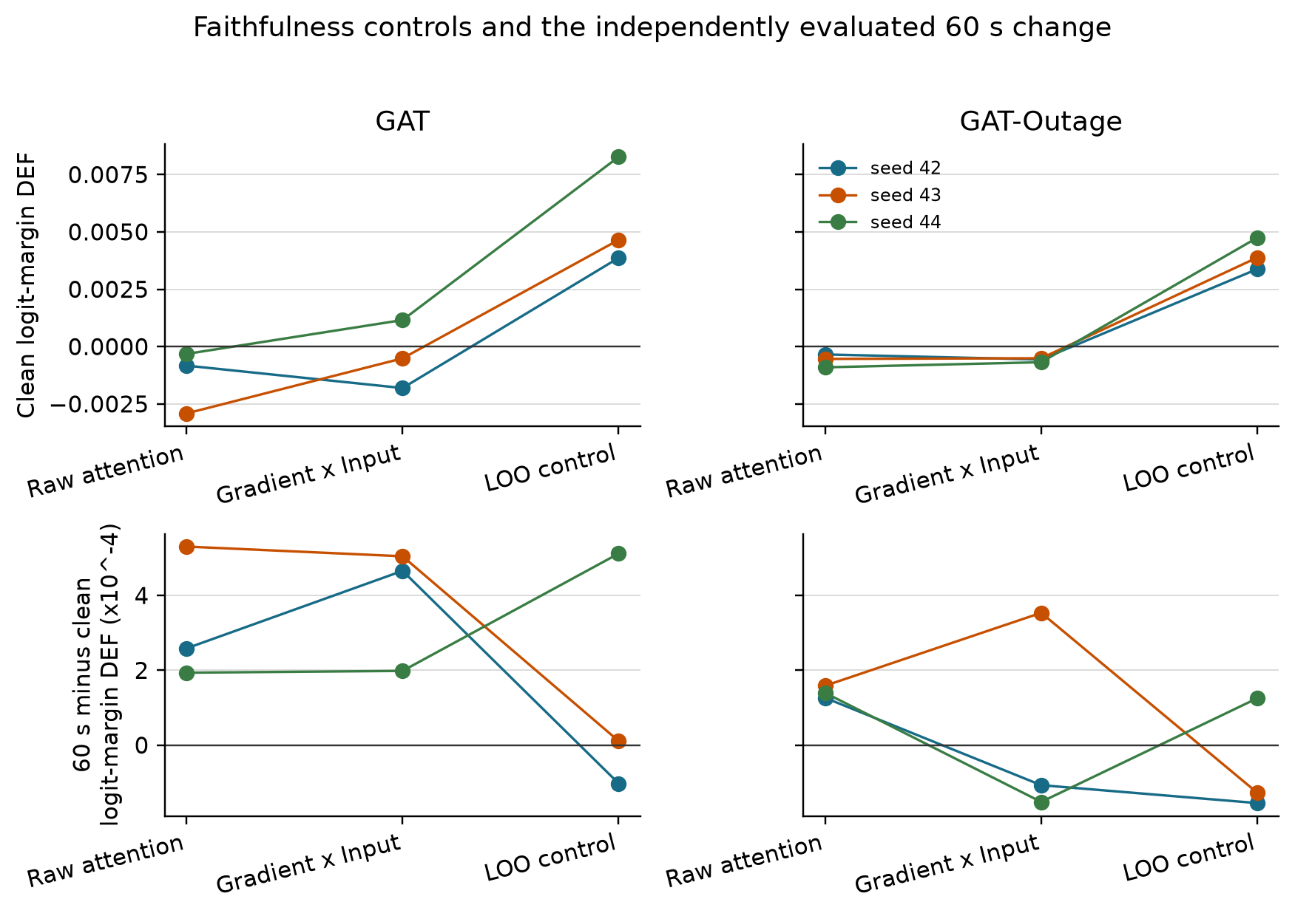
Figure 4.3. Top: clean logit-margin DEF. Bottom: independently evaluated 60-second result minus clean. LOO gives the clearest positive response; raw attention does not show a matched-random advantage.
The attention result also depends on how weights are extracted. Every checkpoint has at least one audited layer, head, maximum, or rollout choice that reverses the direction of its default stale-attention shift.
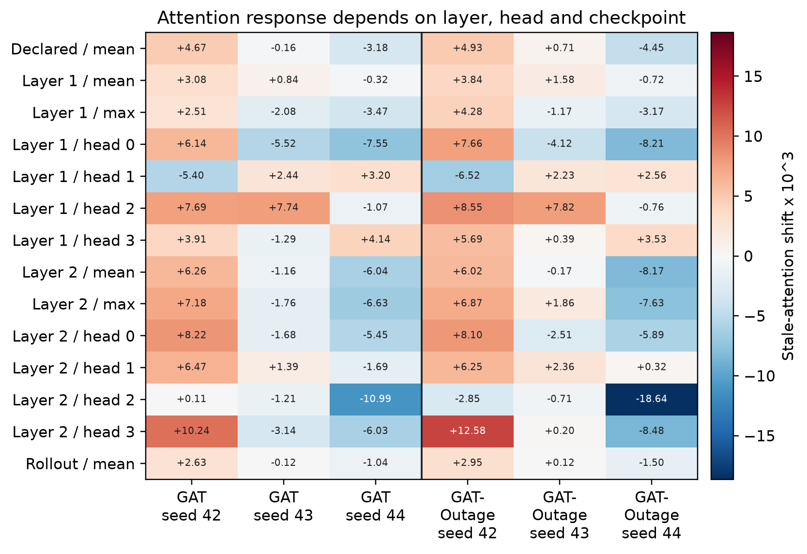
Figure 4.4. Stale-attention shift under alternative extraction rules, multiplied by 1,000. Positive and negative values within the same checkpoint show that the conclusion can depend on the chosen layer or head.
For dispatch decisions, the declared self-row margin-DEF is negative for both models under clean and 60-second conditions. Using the selected request row moves the estimate closer to zero, but its CIs include zero and it does not provide consistent positive evidence.
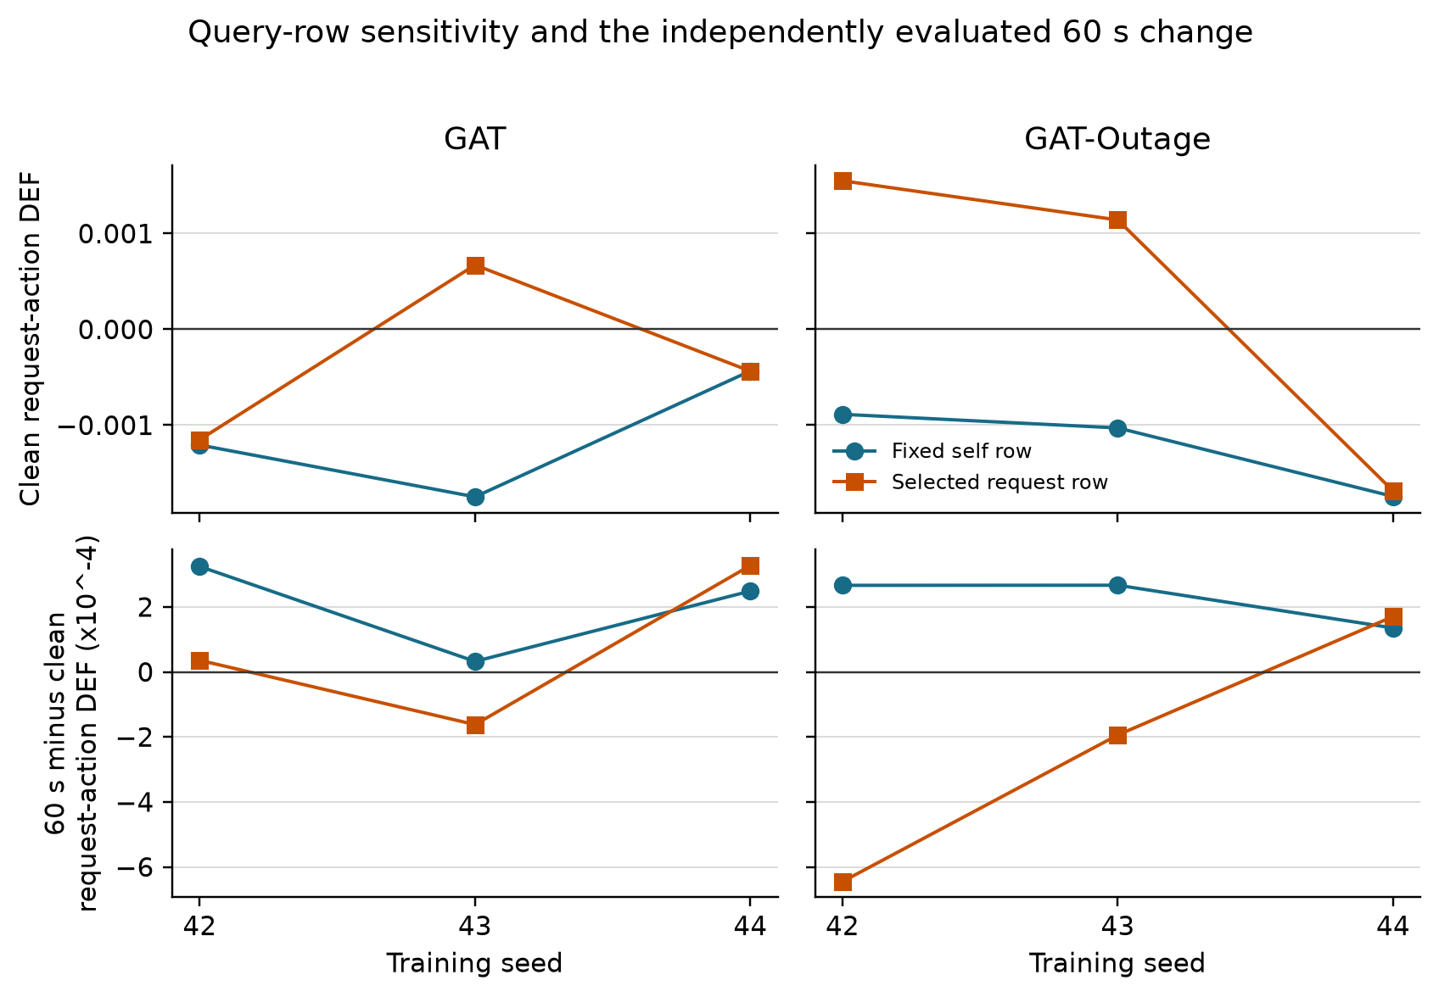
Figure 4.5. Dispatch-action margin-DEF from the fixed self row and selected request row. The lower panels show the independently evaluated 60-second minus clean change. Changing the query row does not make decision relevance reliable.

4.4 Small-graph resolution
The scored graph contains five visible peer taxis in nearly every record and a smaller, variable number of request nodes. Table 4.4 describes the eligible non-self nodes.
Table 4.4: Valid node-count distribution in scored graphs
Model | Node type | Mean | Median | 5th percentile | 95th percentile
GAT | peer taxis | 5.00 | 5 | 5 | 5
GAT | requests | 2.53 | 2 | 1 | 5
GAT | all non-self nodes | 7.53 | 7 | 6 | 10
GAT-Outage | peer taxis | 5.00 | 5 | 5 | 5
GAT-Outage | requests | 2.55 | 2 | 1 | 5
GAT-Outage | all non-self nodes | 7.55 | 7 | 6 | 10
In a small candidate set, a top-k explanation and a matched random set can overlap by chance. For GAT, attention-LOO agreement is below the expected random overlap at k=1, 2, and 3. For GAT-Outage, it is slightly above random at k=1 but below random at k=2 and 3. The overlap reduces DEF's ability to separate rankings, especially as k increases.
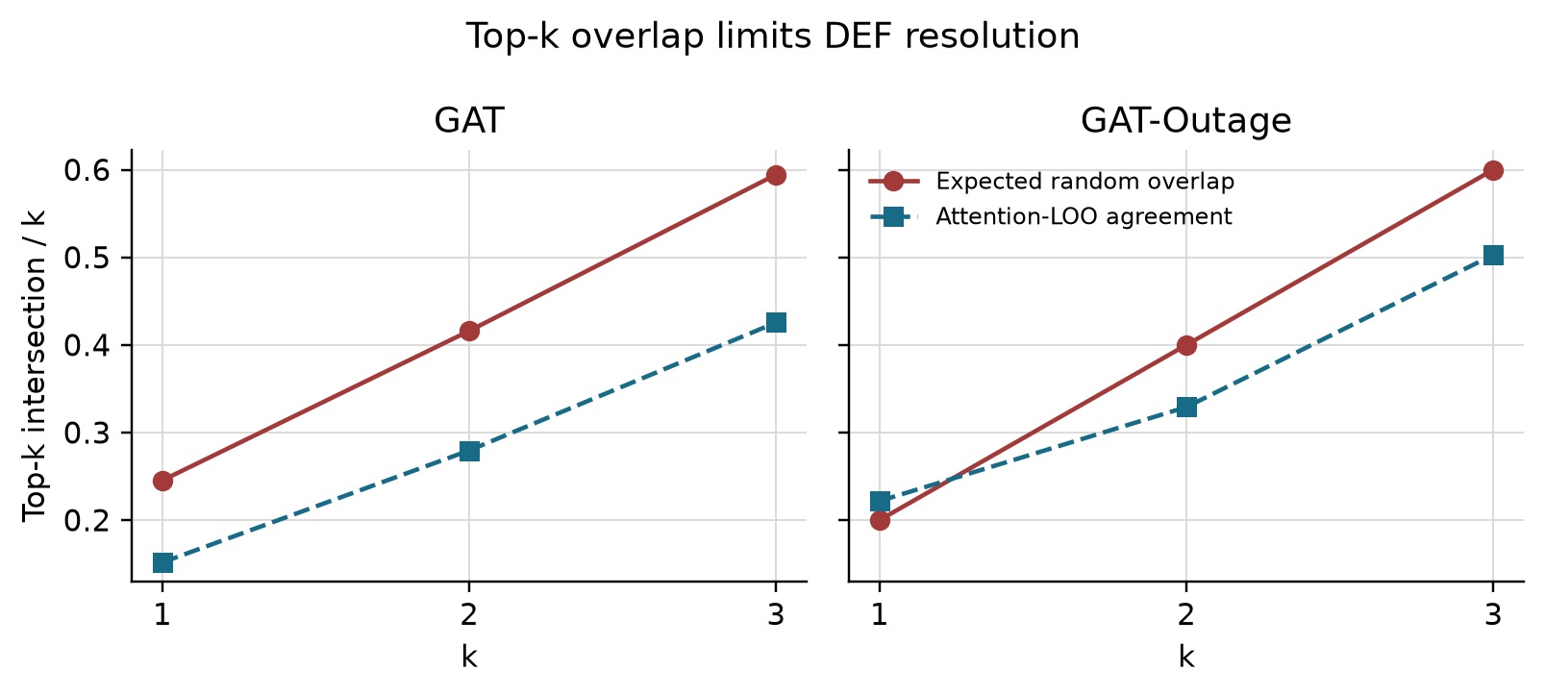
Figure 4.6. Observed attention-LOO agreement compared with expected random overlap. Large expected overlap limits the resolution of a top-k comparison; it does not by itself prove or disprove faithfulness.

4.5 Telemetry manipulation and stale exposure
The outage manipulation worked as intended. Conditional WAMSN rises from about 0.027-0.029 at 10 seconds to about 0.071-0.076 at 60 seconds. Across the six checkpoints, H3 correlations between duration and WAMSN are 0.458-0.477 and remain significant after Holm correction. H3 is therefore supported for all six checkpoints.
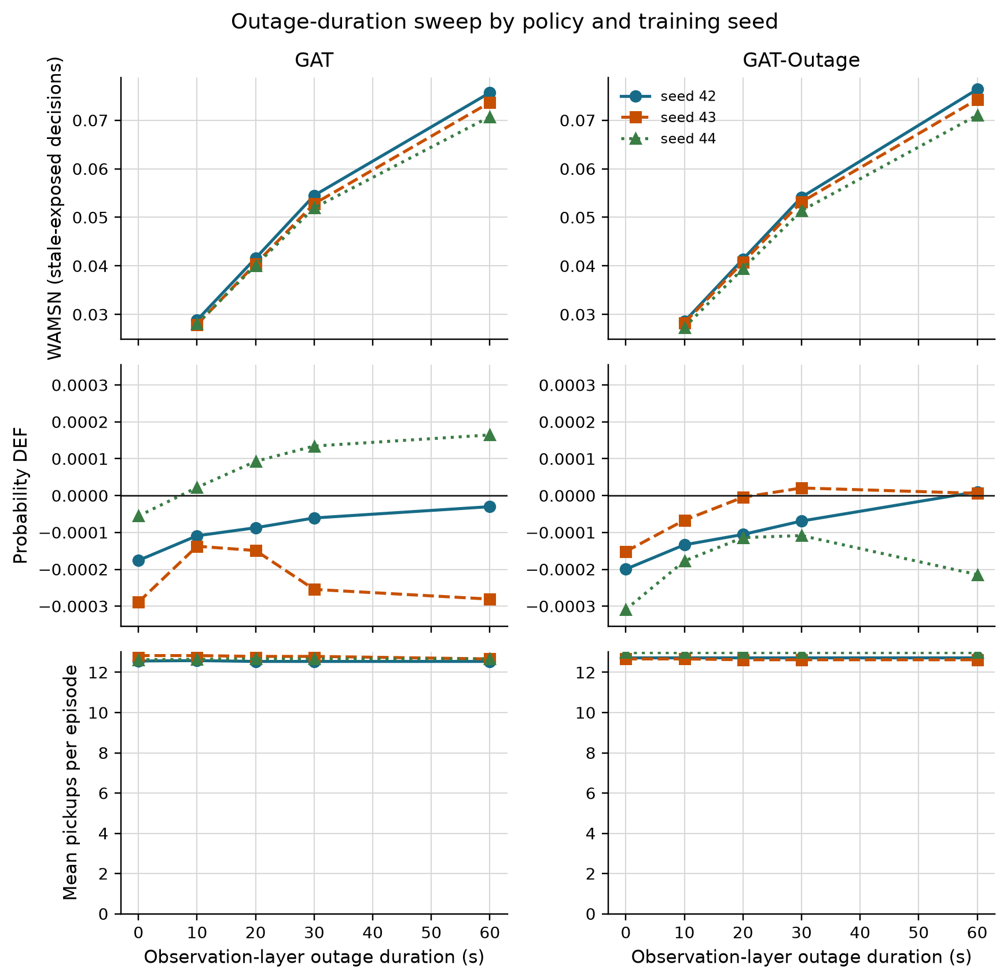
Figure 4.7. Longer observation outages increase WAMSN for every checkpoint. Completed journeys remain broadly stable. Probability DEF does not show the proposed decline. WAMSN verifies stale exposure; it does not show that AoI causes a change in faithfulness.

4.6 Paired clean and degraded observations
The paired audit compares each degraded observation with its exact clean twin at the same SUMO step. Positive attention shift means that the degraded observation assigns more attention to nodes marked stale. Positive DEF shift means that measured DEF is higher, not lower, under degradation.
Table 4.5: Exposure-conditioned paired attention and DEF shifts
Model | Seed | Stale-attention shift x 1,000 | Probability-DEF shift x 10,000
GAT | 42 | +3.834 | +0.852
GAT | 43 | +0.015 | +1.222
GAT | 44 | -2.639 | +1.889
GAT-Outage | 42 | +3.347 | +0.855
GAT-Outage | 43 | +0.928 | +1.596
GAT-Outage | 44 | -3.578 | +0.514
Three checkpoints show a clear increase in attention to stale nodes, two show a clear decrease, and GAT seed 43 is inconclusive because its 95% CI crosses zero. The direction follows the training seed more closely than the training condition: both seed-44 checkpoints are negative. All six paired DEF changes are small and positive, which is opposite to the proposed degradation-related decline.
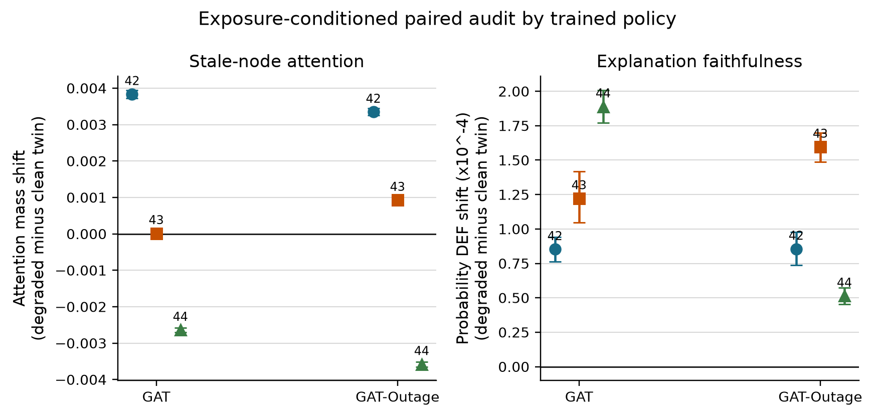
Figure 4.8. Exposure-conditioned degraded-minus-clean shifts by frozen checkpoint. Error bars are episode-block bootstrap CIs. Attention direction varies across checkpoints, while probability DEF increases slightly in all six.

4.7 Analysis by action type
The corrected reward handling changes the action composition compared with the earlier experiment. Dispatch now accounts for 9,649 of 12,028 scorable decisions (80.2%); no-op accounts for 2,379 (19.8%). Table 4.6 shows that this balance still differs by checkpoint.
Table 4.6: Action composition and paired DEF by action type
Checkpoint | No-op (%) | Dispatch (%) | All-action DEF shift x 10,000 | No-op DEF shift x 10,000 | Dispatch DEF shift x 10,000
GAT, seed 42 | 16.3 | 83.7 | +0.852 | -0.228 | +1.095
GAT, seed 43 | 25.8 | 74.2 | +1.222 | -0.420 | +2.146
GAT, seed 44 | 17.3 | 82.7 | +1.889 | -1.093 | +2.660
GAT-Outage, seed 42 | 33.8 | 66.2 | +0.855 | -0.450 | +1.584
GAT-Outage, seed 43 | 26.0 | 74.0 | +1.596 | -1.024 | +2.760
GAT-Outage, seed 44 | 30.8 | 69.2 | +0.514 | -0.456 | +0.999
The two action groups move in opposite directions in every checkpoint: no-op DEF decreases, while dispatch DEF increases. The positive all-action estimate is therefore driven by the larger dispatch group. A combined result should not be presented as if it describes both kinds of decision.
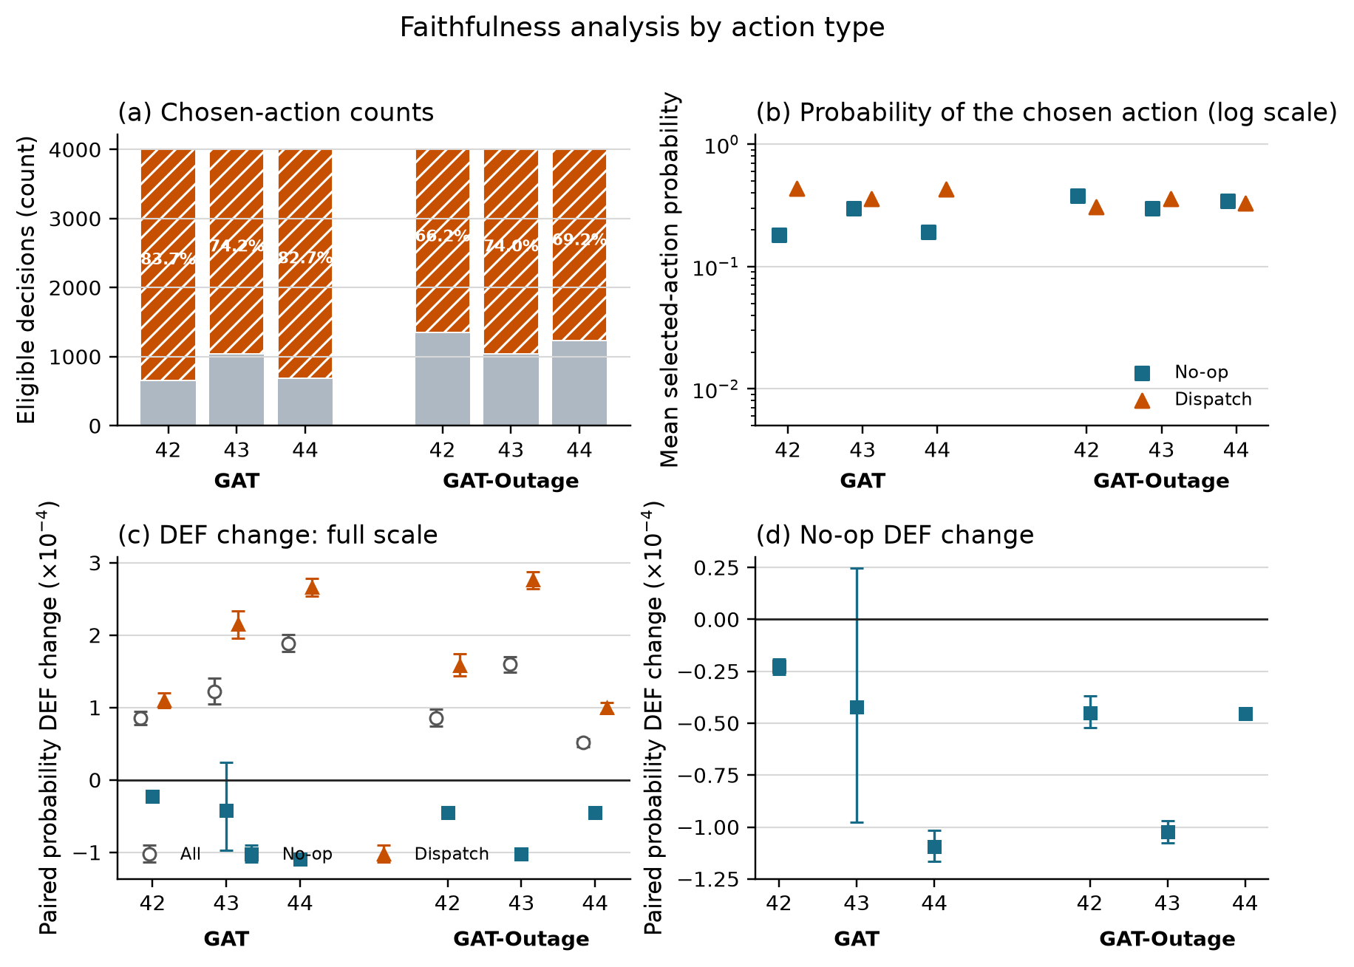
Figure 4.9. (a) Scorable action counts and dispatch share; (b) selected action probability; (c) all, no-op, and dispatch paired DEF changes; and (d) an enlarged view of the no-op changes. Error bars are episode-block bootstrap CIs.

4.8 Random-trigger sensitivity analysis
The random-loss control replaces tunnel entry with an independent per-taxi, per-step trigger while retaining a 30-second observation-layer freeze. The configured trigger rate is fixed, but realized random exposure is only about 18% of tunnel exposure. This is a trigger-location sensitivity check, not an exposure-matched causal comparison.
Table 4.7: Tunnel and random-trigger sensitivity summary
Result compared between tunnel and random triggers | Checkpoints agreeing in direction | Interpretation
Stale-attention shift | 5/6 | broad seed pattern remains, with one near-zero mismatch
Probability-DEF shift | 6/6 | both triggers give a small positive shift
Exposure rate | 0/6 matched | random condition has much lower realized exposure
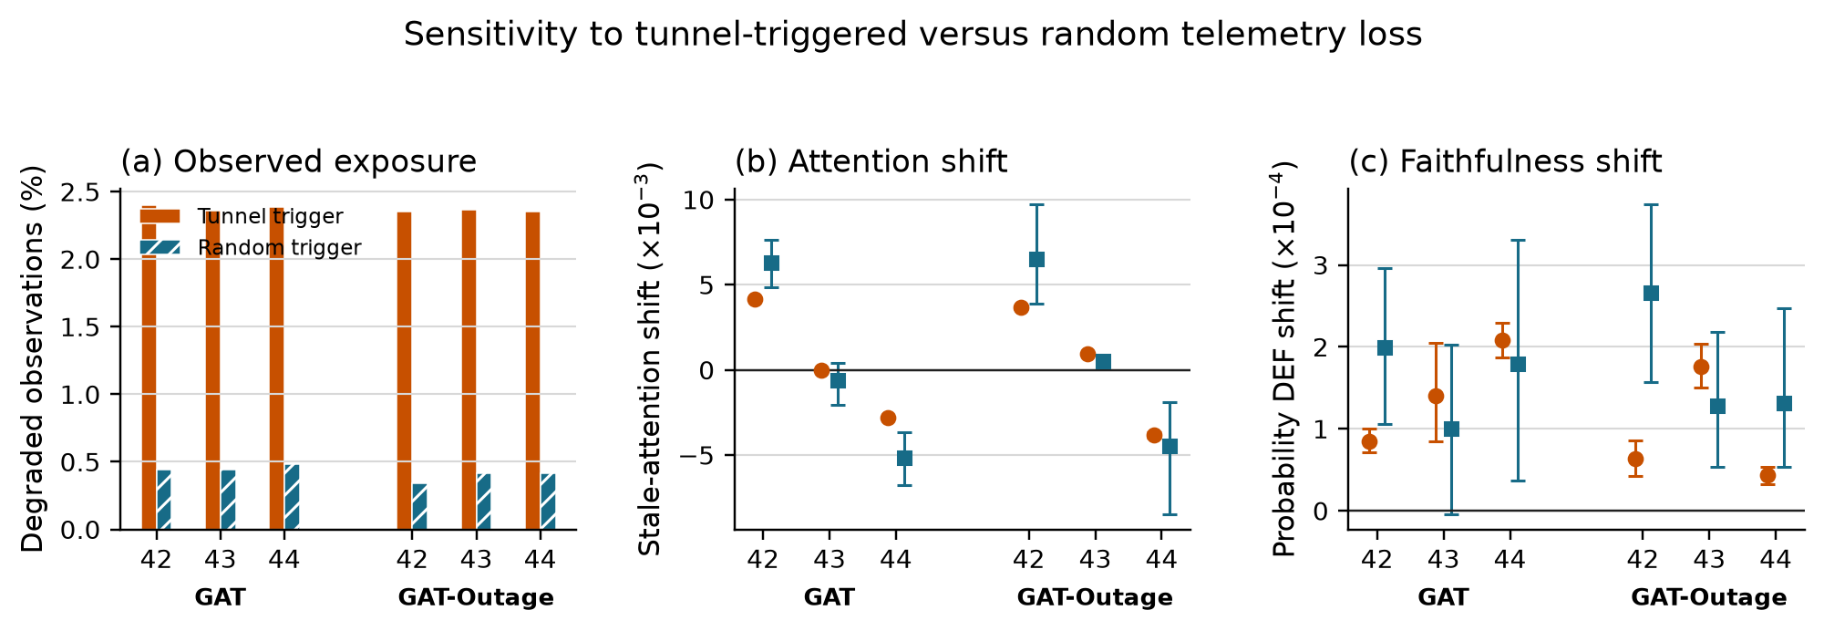
Figure 4.10. Tunnel and random triggers under a 30-second freeze. The random condition creates less exposure. Attention direction agrees for five checkpoints and DEF direction for all six, but several random-condition CIs are wide because few stale-exposed decisions occur.

4.9 Hypothesis results
Figure 4.11 makes the corrected H4 result visible. DEF rank rises rather than falls across within-episode WAMSN groups, and all six checkpoint correlations are positive. The one-sided test for a negative association therefore supports zero checkpoints.
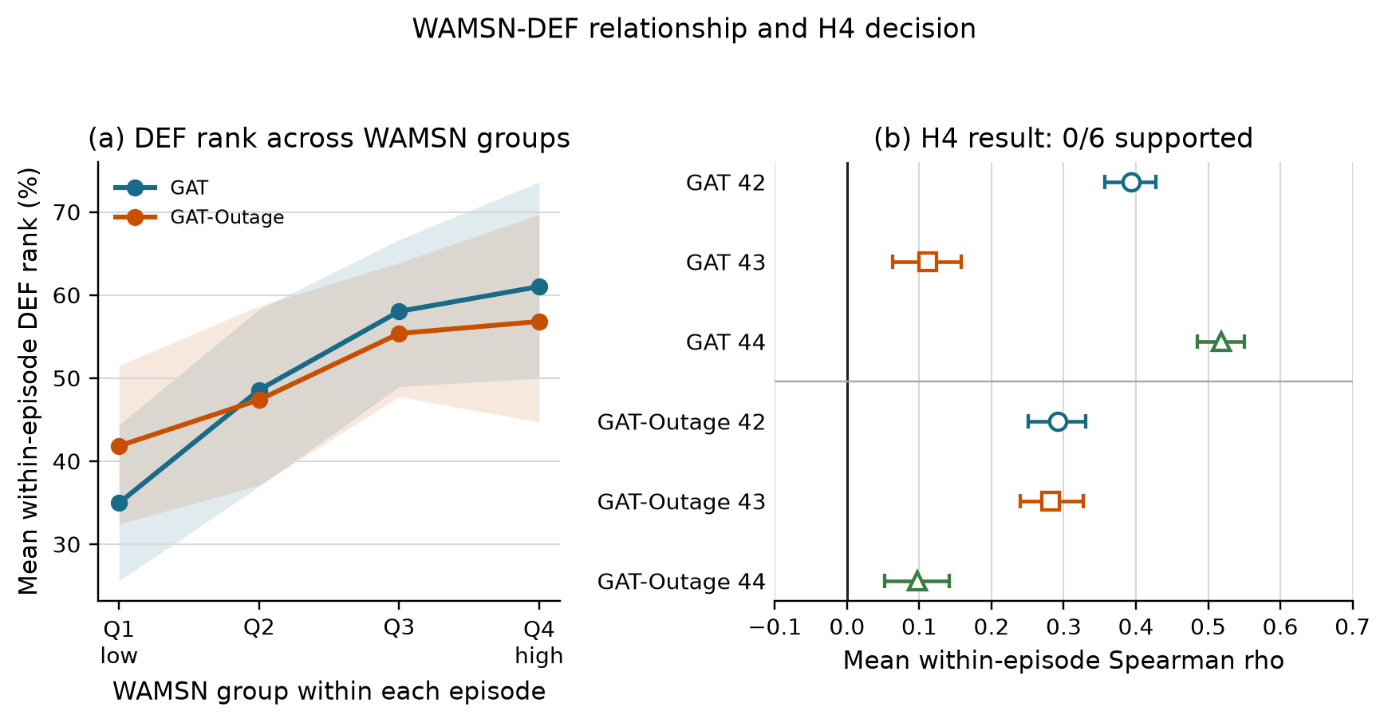
Figure 4.11. Panel (a) groups WAMSN within each episode and shows mean DEF rank. Panel (b) reports the per-checkpoint mean Spearman correlation and CI. H4 predicted a negative relationship; all six estimates are positive, so H4 is not supported.
Table 4.8: Hypothesis outcomes across training seeds
Hypothesis | GAT seeds supporting | GAT-Outage seeds supporting | Verdict
H1: DEF decreases as outage duration increases | 0/3 | 0/3 | not supported
H2: faithfulness declines faster than performance | 0/3 | 0/3 | not supported
H3: WAMSN increases as outage duration increases | 3/3 | 3/3 | supported manipulation check
H4: higher WAMSN is associated with lower DEF | 0/3 | 0/3 | not supported
H5: GAT-Outage gives weaker H1 and H4 relationships | n/a | 2/3 matched comparisons | not consistent across seeds
H1 correlations are non-negative (0.015-0.226), and H4 mean within-episode correlations are also non-negative (0.097-0.518). H2 cannot be supported when the expected faithfulness decline is absent. GAT-Outage has weaker absolute H1 and H4 relationships than its matched GAT checkpoint for seeds 42 and 44, but not seed 43; H5 is therefore not consistent.

4.10 Answers to the research questions
RQ1: Raw attention does not reliably identify decision-relevant nodes under clean telemetry. Its matched-random margin-DEF is negative, while LOO gives a positive control response.
RQ2: Degradation changes stale-node attention, but not in one consistent direction. Three checkpoints show a clear shift toward stale nodes, two show a clear shift away, and one is inconclusive.
RQ3: Longer outages consistently increase stale exposure, but the proposed decline in DEF is not observed. The result also differs by action type and by attention-extraction choice.
RQ4: The tested outage-trained configuration does not remove checkpoint variation or make raw attention pass the decision-relevance check.

4.11 Explanation-release audit
The final framework decision is WITHHOLD for GAT, GAT-Outage, and all six checkpoints. This means that the evidence is complete enough to audit, but raw attention should not be presented as the reason for a dispatch or no-op decision.
Table 4.9: Freshness-aware explanation audit decisions
Audit check | GAT | GAT-Outage | Main reason
Evidence integrity | PASS | PASS | all sweep preflights passed
Freshness visibility | PASS | PASS | AoI-derived exposure is reported separately
Action-aware controls | PASS | PASS | type matching, action protection, and LOO are present
Decision relevance | FAIL | FAIL | dispatch self-row margin-DEF CIs are below zero
Action composition | PASS | PASS | no-op and dispatch are reported separately
Extraction stability | FAIL | FAIL | alternative heads or layers reverse direction
Checkpoint consistency | FAIL | FAIL | stale-attention direction differs across seeds
Deployment-action capability | NOT APPLICABLE | NOT APPLICABLE | audit scope uses sampled actions
Trigger robustness | INDETERMINATE | PASS | GAT seed 43 random-trigger interval crosses zero
Model decision | WITHHOLD | WITHHOLD | required release checks do not pass
WITHHOLD is the intended output when an explanation lacks reliable support; it is not a failed execution. Attention may still be used as an internal model diagnostic, with freshness shown separately, but not as an audited explanation of the selected action.

Chapter 5: Discussion

5.1 Answer to the central problem
The central problem is whether a graph-attention map can still be trusted when some of its vehicle data are stale. The answer is clear: the map remains available, but its displayed weights do not provide consistent evidence that the highlighted information is current or that it influenced the selected action. The explanation can therefore outlive the data that support it.
This finding is about explanation reliability, not dispatch performance. A policy can still select an action while the evidence shown as its explanation is stale or weakly related to that action. Stable task output therefore cannot be used to validate the attention map.
The practical result is a release decision. Raw attention should remain an internal diagnostic unless separate tests establish both freshness and decision relevance. In this study, those tests do not provide sufficiently consistent evidence, so every tested checkpoint receives WITHHOLD.

5.2 How to read the evidence
The experiment provides four related but different forms of evidence.
Clean baseline. Under clean telemetry, raw-attention margin-DEF is below its type-matched random control for both models, while the LOO positive control is clearly above zero. The evaluator can therefore reward a ranking built from output changes, but raw attention does not provide the required evidence of decision relevance.
Stale-data exposure. WAMSN rises as the outage becomes longer. This shows that more displayed attention is attached to old vehicle information. It does not show that data age causes faithfulness to decline because AoI is part of the WAMSN definition.
Duration and within-policy association. The proposed negative relationships are not supported. DEF does not decline as outage duration or WAMSN increases. These null and opposite-direction results must be reported rather than turned into a claim that data age improves faithfulness.
Direct paired change. The clean/degraded pairs compare the same decision before and after the observation-layer change. Three checkpoints show a clear shift toward stale nodes, two show a clear shift away, and one is inconclusive. DEF increases slightly in all six, which is opposite to the expected decline. This does not validate attention: the clean decision-relevance control has already failed.
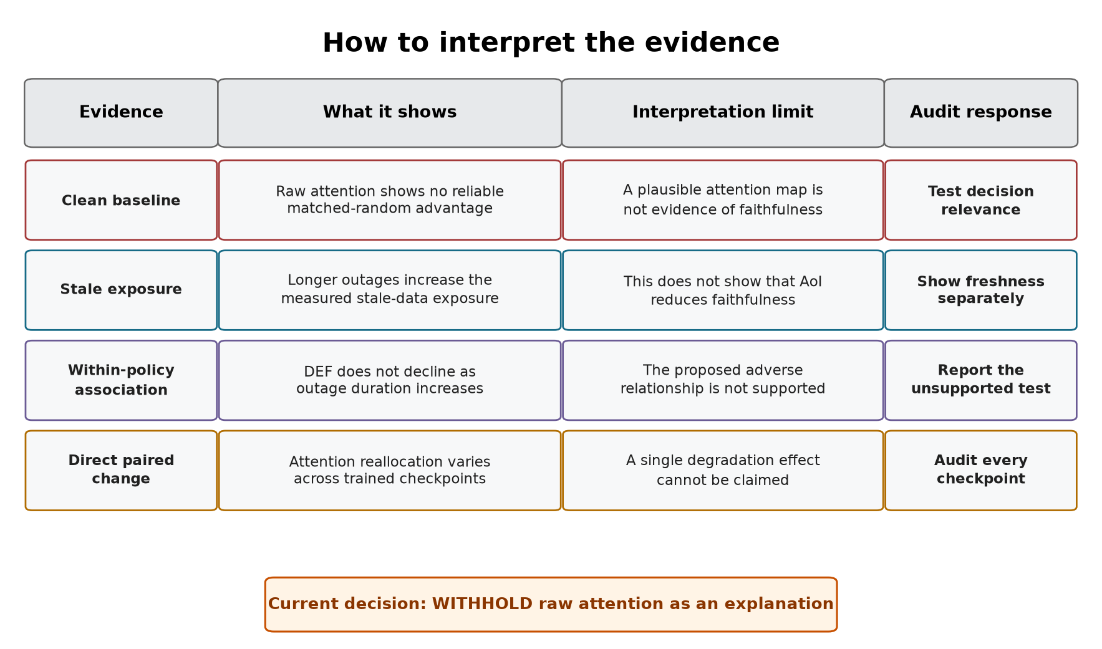
Figure 5.1. How the four forms of evidence should be interpreted. Each form answers a different question and leads to a separate audit requirement.
These measures answer different questions. WAMSN checks whether stale evidence is present, the duration tests describe an ordered condition, and paired shifts measure the direct response of the same decision to a changed observation. Keeping them separate prevents a freshness measure from being presented as a faithfulness effect.

5.3 Why the result is not consistent
Checkpoint dependence. Independently trained checkpoints do not respond in the same direction. The pattern appears under both tunnel and random triggers, which reduces concern that it is produced only by the chosen tunnel. However, the random trigger does not create identical stale-node populations and cannot rule out scenario effects. The result therefore supports checkpoint dependence, not a general effect of telemetry loss.
Action composition. Dispatch accounts for 80.2% of scorable decisions in the corrected experiment. Dispatch DEF increases slightly under degradation, whereas no-op DEF decreases in every checkpoint. The combined positive shift is therefore driven by the larger dispatch group and does not describe both action types.
Attention extraction. Different heads, layers, aggregations, or query rows can change the direction or strength of the result. The network does not supply one self-evident attention map. Any map shown to an operator therefore needs a predeclared extraction rule that has been tested for stability.
Action rule. The main audit samples actions from the learned policy, matching the declared scope. The smaller deterministic diagnostic also completes journeys, but it is not part of the confirmatory audit. A deployment audit must use the same action rule that the deployed system will use.

5.4 Why the construct-validity controls matter
A passenger-request node represents both information and an available action. Removing it can therefore remove the action being explained. A peer-taxi node is different: removing it hides vehicle information but leaves the action space unchanged. A uniform random baseline would mix these two effects and could make an explanation appear stronger simply because an action disappeared.
The type-matched, action-protected baseline makes the comparison fairer. It compares request nodes with request nodes and taxi nodes with taxi nodes, while protecting the selected request action. A positive DEF can then be interpreted as an advantage over comparable random information rather than an advantage created by deleting the chosen action.
LOO serves as a positive control. It ranks each node by the output change caused by removing that node, and it produces a clearer DEF response than raw attention for every checkpoint. This shows that the evaluator can respond to a more informative perturbation ranking. LOO is not a ground-truth explanation, and it does not prove that the evaluator captures every form of decision relevance.
The overlap check adds one final limit. In a small graph, explanation and random top-k sets increasingly share the same nodes as k grows. This reduces the resolution of DEF. The controls therefore support a careful conclusion: raw attention lacks reproducible evidence of faithfulness within the resolution of the present evaluator. They do not show that every attention map is wrong.

5.5 Why outage training did not solve the problem
The tested configuration trained with 30-second outages does not solve the explanation problem. GAT-Outage does not make the direct clean/degraded response more consistent across independently trained policies. Training with stale observations may improve robustness for other purposes, but the present results do not show that it makes raw attention a more reliable explanation.
This is not a general rejection of degradation-aware training. The two tested configurations have different optimization horizons, so the comparison does not isolate the effect of degraded training observations. More importantly, the reward contains no term for explanation stability or faithfulness. A future test of model improvement would require a common training budget, independent training runs, and an explicit explanation objective.

5.6 Proposed audit framework

5.6.1 Purpose and scope
To address this risk, the thesis develops and applies a freshness-aware explanation audit framework. The framework leaves the trained policy unchanged and does not claim to make attention faithful. Instead, it sets rules for deciding when an attention map has enough evidence to be shown as an audited candidate explanation within a stated scope. Table 5.1 links each observed risk to the required evidence and decision rule.
Table 5.1: Freshness-aware explanation audit framework
Observed risk | Required check | Evidence | Decision rule
Attention may be attached to stale data | Report freshness separately | AoI and WAMSN | Never infer freshness from attention strength
Attention may not identify decision-relevant nodes | Use action-aware, type-matched tests | DEF, margin-DEF, and LOO | Do not claim a reason without evidence of decision relevance
Combined results may be dominated by no-op | Report no-op and dispatch groups | Action counts and action-specific DEF | Do not generalize a combined result across action types
The result may depend on attention extraction | Test the query row, layer, head, and aggregation | Sensitivity audits | Predeclare the extraction rule and report material sensitivity
One checkpoint may not represent another | Audit each checkpoint before release | Per-checkpoint results | Repeat after retraining or replacement
A pattern may not reproduce | Compare independent training runs | Results across seeds | Require a consistent conclusion across runs
The audited action may differ from deployment | Test the intended deployment action rule | Sampled-policy or argmax capability evidence | Require argmax capability only when deployment uses argmax
A tunnel-specific pattern may not transfer | Compare tunnel and random triggers | Paired shifts and 95% confidence intervals | Withhold when supported directions conflict or remain indeterminate
The framework is intended for offline release review before an attention map is shown to a dispatcher or other operator. It should be repeated after retraining, checkpoint replacement, changes to the telemetry or graph pipeline, transfer to a new operating scenario, and during periodic model review. It is not a live freshness monitor. A deployed system must still display freshness separately and suppress or warn about explanations based on stale inputs. Figure 5.2 shows the corresponding offline audit workflow.
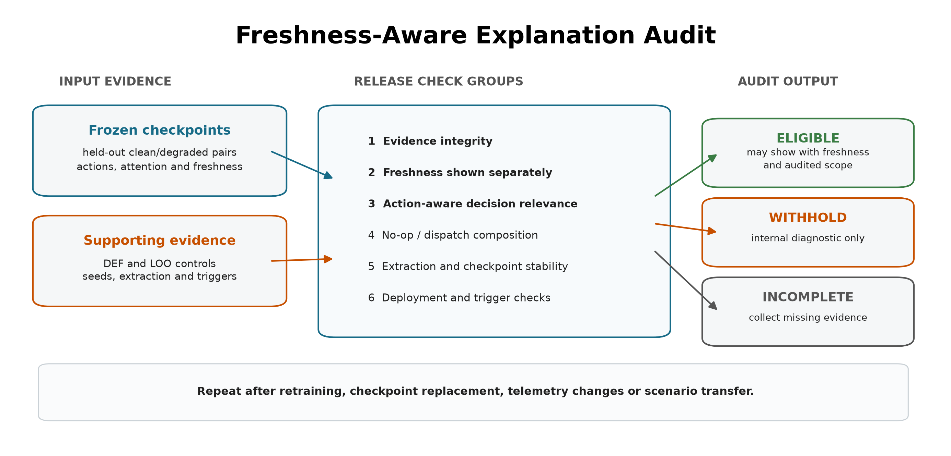
Figure 5.2. Saved evidence from frozen checkpoints passes through nine release checks, grouped here into six categories. The output controls whether attention may be presented as an explanation; it does not alter the model or selected action.

5.6.2 Inputs, outputs and use
The framework accepts evidence rather than raw attention alone. Table 5.2 summarizes its inputs and outputs.
Table 5.2: Audit framework inputs and outputs
Component | Contents | Role in the audit
Candidate scope | frozen checkpoints, model names, training seeds, and held-out conditions | defines exactly what the decision covers
Freshness evidence | paired clean/degraded records, AoI, stale-node masks, WAMSN, and stale-attention shift | separates data age from attention strength
Faithfulness evidence | type-matched and action-protected DEF, LOO, and dispatch-action results | tests whether highlighted nodes matter to the action
Stability evidence | action groups, extraction alternatives, checkpoint synthesis, deployment-action diagnostic, and trigger comparison | tests whether the conclusion survives relevant choices
Audit output | per-check status, per-checkpoint decision, model decision, failed reasons, and permitted use | supports a traceable explanation-release decision
The operating procedure is:
- freeze the candidate checkpoint and evaluation protocol;
- generate paired freshness, action-aware faithfulness, action-composition, and sensitivity evidence on held-out demand;
- run preflight to establish that the evidence is complete and valid to analyze;
- apply every release check to each checkpoint and then compare independent training runs;
- present attention externally only if the result is ELIGIBLE, together with its freshness indicator and audited scope.
A preflight PASS is not an explanation-release pass. It only confirms that the evidence can be analyzed. The release output is ELIGIBLE, WITHHOLD, or INCOMPLETE. Individual checks may also be INDETERMINATE when the evidence is complete but does not support a direction. A failed or indeterminate required check produces WITHHOLD; missing evidence produces INCOMPLETE. In both cases, attention must not be presented as the reason for the action.

5.6.3 Application to this study
Applying the framework to the completed evidence gives WITHHOLD for GAT and GAT-Outage and for all six individual checkpoints. This is not a failed experiment. The audit has completed and has found that the evidence is insufficient for explanation release. In particular, the dispatch-action decision-relevance intervals do not exceed the matched-random boundary, attention extraction can reverse the stale-attention direction, and the stale-attention response changes direction across training seeds. The random trigger check passes for GAT-Outage but is indeterminate for GAT because one checkpoint interval crosses zero. The argmax diagnostic completes journeys, but it remains descriptive because the audit scope uses sampled actions.
Sampled dispatch performance provides evidence of task capability, but it cannot show that the displayed reason is current or decision-relevant.
The framework checks whether an explanation has enough evidence to be shown; it does not make the model itself more faithful. Improving the model would require an explicit explanation objective and independent evaluation, as discussed in Section 5.8.
The current study demonstrates the framework's rejection path but does not show that a real trained model can reach ELIGIBLE. The LOO positive control shows that the evaluator can reward a more informative ranking, while software tests confirm that complete passing evidence produces an ELIGIBLE decision. A future faithfulness-aware model is still needed to validate the eligibility path empirically. The current thresholds must not be weakened after seeing these results simply to obtain a passing model.

5.7 Limitations
The study uses one simulated district, 20 taxis, and 50 requests. Tunnel exposure remains scenario-dependent, although the event-aware audit scores every observed stale-exposed decision. It evaluates three independent training seeds per model. Three seeds reveal variation but cannot estimate the wider distribution of training outcomes. The selected policies pass the training stability gates, but their held-out completed-journey results overlap the legal-random CI and the simple greedy range. These baselines are capability context, not evidence of a task-performance advantage. The experiment also does not isolate the contribution of graph edges to policy capability.
Clean GAT and GAT-Outage also use different maximum training budgets and learning-rate decay horizons, selected from validation-only stability diagnostics. Their matched-seed comparison describes the two fitted configurations but cannot isolate the effect of degraded training observations.
The local graph is small. Type matching makes random top-k sets overlap heavily with the explanation, which compresses DEF. LOO is based on the same single-node perturbation as comprehensiveness and is not an independent ground truth explanation. Other perturbation choices or post-hoc explainers may give different results.
The degradation layer freezes position and speed for fixed windows. Real telemetry may include delayed packets, partial failures, map-matching errors, and asynchronous recovery. The study audits attention as an explanation; it does not claim that attention is useless inside the policy computation.
The paired clean/degraded comparison supports internal validity for the tested observation-layer change because both observations come from the same simulated traffic state. Simulation and scenario-design bias remain. Road-network choice, generated demand, vehicle behavior, and tunnel placement may affect which taxis become stale and how those taxis are positioned in the local graph. In particular, a fixed tunnel can create an exposure-selection effect if its traffic conditions differ from the rest of the network. The conclusions are therefore limited to the tested SUMO setting and should not be read as population estimates for real fleets or cities.

5.8 Future work
Future experiments should add training seeds and use multiple road networks, demand levels, tunnel placements, and public mobility traces. The present random-trigger control should be extended to several calibrated exposure rates and persistent loss processes so that trigger location, exposure frequency, and outage duration can be separated. Experiments should also include disconnected-edge and message-passing ablations to establish how much the policy uses its graph channel. Delayed, intermittent, and biased telemetry should be compared with fixed freezes.
The explanation audit should also compare LOO with graph-specific post-hoc methods and evaluate objectives that directly reward explanation consistency. Any proposed improvement should be tested on held-out checkpoints, not only on more episodes from one trained model. A human-factors study could then test whether explicit freshness warnings lead operators to interpret the map more appropriately.

Chapter 6: Conclusion
This dissertation asked whether raw graph-attention weights can be trusted as explanations of fleet-dispatch decisions when vehicle telemetry becomes stale. The tested weights should not be released as explanations. They remain available under clean and degraded observations, but they do not pass the required checks for decision relevance, extraction stability, and consistency across independently trained checkpoints.
The corrected experiment does not show that telemetry degradation reduces DEF. Longer outages consistently increase stale-data exposure, confirming that the manipulation worked, but H1, H2, and H4 are not supported. Paired DEF increases slightly for all six checkpoints. This opposite-direction result must not be interpreted as improved explanation quality because raw attention already performs below its type-matched random control under clean telemetry. Telemetry freshness and explanation faithfulness are separate assurance questions.
The research questions are answered as follows.
- RQ1: Raw attention does not reliably identify decision-relevant nodes under clean telemetry. Its action-aware margin-DEF is negative for both models, while LOO gives a positive control response.
- RQ2: Degradation changes the attention assigned to stale nodes, but the direction is not consistent. Three checkpoints show a clear shift toward stale nodes, two show a clear shift away, and one is inconclusive.
- RQ3: Outage duration consistently increases WAMSN, but it does not produce the proposed decline in DEF. The measured response also differs between no-op and dispatch actions and can reverse under alternative attention-extraction choices.
- RQ4: The tested GAT-Outage configuration does not make raw attention reliably decision-relevant or remove checkpoint variation. Because GAT and GAT-Outage use different maximum training budgets, this comparison does not isolate outage training as the cause.
The construct-validity audit is essential to these answers. A passenger-request node represents both information and an available action, whereas a peer-taxi node represents information only. Type matching and chosen-action protection prevent request deletion from creating an artificial faithfulness result. The positive LOO response shows that the evaluator can reward a ranking based on output sensitivity. The top-k overlap analysis also shows that the small graph limits measurement resolution.
The main practical contribution is the freshness-aware explanation audit framework. It accepts frozen checkpoints and held-out evidence, checks freshness, decision relevance, action composition, extraction stability, checkpoint consistency, action-rule capability, and trigger sensitivity, and returns ELIGIBLE, WITHHOLD, or INCOMPLETE. In this study, both model families and all six checkpoints receive WITHHOLD. The evidence is complete, but it does not justify presenting attention as the reason for a dispatch or no-op decision.
This outcome completes the audit rather than failing it. A trustworthy explanation system must be able to reject a visually credible explanation when its evidence is weak or unstable. Future work should evaluate more training seeds and road networks, calibrate random loss to match tunnel exposure, and train a model with an explicit explanation objective. Any future ELIGIBLE result should remain limited to its tested scope and should display telemetry freshness separately.
In summary, attention can outlive the data on which it was calculated, but the continued presence of an attention map is not proof that it explains the decision. The proposed framework turns that distinction into a reproducible release decision.

List of Publications
No publication is claimed in this dissertation.

References
Abnar, S. and Zuidema, W. (2020) 'Quantifying attention flow in transformers', in Proceedings of the 58th Annual Meeting of the Association for Computational Linguistics, pp. 4190-4197. Available at: https://doi.org/10.18653/v1/2020.acl-main.385.
Adebayo, J. et al. (2018) 'Sanity checks for saliency maps', Advances in Neural Information Processing Systems, vol. 31. Available at: https://proceedings.neurips.cc/paper/2018/hash/294a8ed24b1ad22ec2e7efea049b8737-Abstract.html.
Amara, K. et al. (2022) 'GraphFramEx: Towards systematic evaluation of explainability methods for graph neural networks', in Proceedings of the First Learning on Graphs Conference, Proceedings of Machine Learning Research, vol. 198, pp. 44:1-44:23. Available at: https://proceedings.mlr.press/v198/amara22a.html.
Ancona, M., Ceolini, E., Oztireli, C. and Gross, M. (2018) 'Towards better understanding of gradient-based attribution methods for deep neural networks', in Proceedings of the International Conference on Learning Representations. Available at: https://openreview.net/forum?id=Sy21R9JAW.
Azzolin, S., Longa, A., Teso, S. and Passerini, A. (2025) 'Reconsidering faithfulness in regular, self-explainable and domain invariant GNNs', in Proceedings of the 13th International Conference on Learning Representations. Available at: https://openreview.net/forum?id=kiOxNsrpQy.
Azzolin, S., Teso, S., Lepri, B., Passerini, A. and Malhotra, S. (2026) 'GNN explanations that do not explain and how to find them', in Proceedings of the 14th International Conference on Learning Representations. Available at: https://proceedings.iclr.cc/paper_files/paper/2026/hash/75a58cfb4d0de35db7663714e0f52dfa-Abstract-Conference.html.
Bekkemoen, Y. (2024) 'Explainable reinforcement learning (XRL): A systematic literature review and taxonomy', Machine Learning, vol. 113, no. 1, pp. 355-441. Available at: https://doi.org/10.1007/s10994-023-06479-7.
Bouteiller, Y., Ramstedt, S., Beltrame, G., Pal, C.J. and Binas, J. (2021) 'Reinforcement learning with random delays', in Proceedings of the 9th International Conference on Learning Representations. Available at: https://openreview.net/forum?id=QFYnKlBJYR.
DeYoung, J. et al. (2020) 'ERASER: A benchmark to evaluate rationalized NLP models', in Proceedings of the 58th Annual Meeting of the Association for Computational Linguistics, pp. 4443-4458. Available at: https://doi.org/10.18653/v1/2020.acl-main.408.
Greydanus, S. et al. (2018) 'Visualizing and understanding Atari agents', in Proceedings of the 35th International Conference on Machine Learning, Proceedings of Machine Learning Research, vol. 80, pp. 1792-1801. Available at: https://proceedings.mlr.press/v80/greydanus18a.html.
Heuillet, A., Couthouis, F. and Diaz-Rodriguez, N. (2021) 'Explainability in deep reinforcement learning', Knowledge-Based Systems, vol. 214, article 106685. Available at: https://doi.org/10.1016/j.knosys.2020.106685.
Hooker, S. et al. (2019) 'A benchmark for interpretability methods in deep neural networks', Advances in Neural Information Processing Systems, vol. 32. Available at: https://proceedings.neurips.cc/paper/2019/hash/fe4b8556000d0f0cae99daa5c5c5a410-Abstract.html.
Hu, Y., Feng, S. and Li, S. (2025) 'BMG-Q: Localized bipartite match graph attention Q-learning for ride-pooling order dispatch', IEEE Transactions on Intelligent Transportation Systems, vol. 26, no. 10, pp. 15407-15421. Available at: https://doi.org/10.1109/TITS.2025.3595653.
Iqbal, S. and Sha, F. (2019) 'Actor-attention-critic for multi-agent reinforcement learning', in Proceedings of the 36th International Conference on Machine Learning, Proceedings of Machine Learning Research, vol. 97, pp. 2961-2970. Available at: https://proceedings.mlr.press/v97/iqbal19a.html.
Jacovi, A. and Goldberg, Y. (2020) 'Towards faithfully interpretable NLP systems: How should we define and evaluate faithfulness?', in Proceedings of the 58th Annual Meeting of the Association for Computational Linguistics, pp. 4198-4205. Available at: https://doi.org/10.18653/v1/2020.acl-main.386.
Jain, S. and Wallace, B.C. (2019) 'Attention is not explanation', in Proceedings of the 2019 Conference of the North American Chapter of the Association for Computational Linguistics: Human Language Technologies, vol. 1, pp. 3543-3556. Available at: https://aclanthology.org/N19-1357/.
Kaul, S., Yates, R. and Gruteser, M. (2012) 'Real-time status: How often should one update?', in Proceedings of IEEE INFOCOM, pp. 2731-2735. Available at: https://doi.org/10.1109/INFCOM.2012.6195689.
Li, J., Pang, M., Dong, Y., Jia, J. and Wang, B. (2024) 'Graph neural network explanations are fragile', in Proceedings of the 41st International Conference on Machine Learning, Proceedings of Machine Learning Research, vol. 235, pp. 28551-28567. Available at: https://proceedings.mlr.press/v235/li24bd.html.
Lin, K. et al. (2018) 'Efficient large-scale fleet management via multi-agent deep reinforcement learning', in Proceedings of the 24th ACM SIGKDD International Conference on Knowledge Discovery and Data Mining, pp. 1774-1783. Available at: https://doi.org/10.1145/3219819.3219993.
Liotet, P., Maran, D., Bisi, L. and Restelli, M. (2022) 'Delayed reinforcement learning by imitation', in Proceedings of the 39th International Conference on Machine Learning, Proceedings of Machine Learning Research, vol. 162, pp. 13528-13556. Available at: https://proceedings.mlr.press/v162/liotet22a.html.
Lipton, Z.C. (2018) 'The mythos of model interpretability', Queue, vol. 16, no. 3, pp. 31-57. Available at: https://doi.org/10.1145/3236386.3241340.
Liu, Y. et al. (2022) 'Rethinking attention-model explainability through faithfulness violation test', in Proceedings of the 39th International Conference on Machine Learning, Proceedings of Machine Learning Research, vol. 162, pp. 13807-13824. Available at: https://proceedings.mlr.press/v162/liu22i.html.
Lopez, P.A. et al. (2018) 'Microscopic traffic simulation using SUMO', in Proceedings of the 21st IEEE International Conference on Intelligent Transportation Systems, pp. 2575-2582. Available at: https://doi.org/10.1109/ITSC.2018.8569938.
Lowe, R. et al. (2017) 'Multi-agent actor-critic for mixed cooperative-competitive environments', Advances in Neural Information Processing Systems, vol. 30. Available at: https://proceedings.neurips.cc/paper/2017/hash/68a9750337a418a86fe06c1991a1d64c-Abstract.html.
Luo, D. et al. (2020) 'Parameterized explainer for graph neural network', Advances in Neural Information Processing Systems, vol. 33, pp. 19620-19631. Available at: https://proceedings.neurips.cc/paper/2020/hash/e37b08dd3015330dcbb5d6663667b8b8-Abstract.html.
Madumal, P. et al. (2020) 'Explainable reinforcement learning through a causal lens', Proceedings of the AAAI Conference on Artificial Intelligence, vol. 34, no. 3, pp. 2493-2500. Available at: https://doi.org/10.1609/aaai.v34i03.5631.
Milani, S. et al. (2024) 'Explainable reinforcement learning: A survey and comparative review', ACM Computing Surveys, vol. 56, no. 7, pp. 1-36. Available at: https://doi.org/10.1145/3616864.
Mott, A. et al. (2019) 'Towards interpretable reinforcement learning using attention augmented agents', Advances in Neural Information Processing Systems, vol. 32. Available at: https://proceedings.neurips.cc/paper/2019/hash/e9510081ac30ffa83f10b68cde1cac07-Abstract.html.
Qin, Z., Zhu, H. and Ye, J. (2022) 'Reinforcement learning for ridesharing: An extended survey', Transportation Research Part C: Emerging Technologies, vol. 144, article 103852. Available at: https://doi.org/10.1016/j.trc.2022.103852.
Rashid, T. et al. (2020) 'Monotonic value function factorisation for deep multi-agent reinforcement learning', Journal of Machine Learning Research, vol. 21, no. 178, pp. 1-51. Available at: https://jmlr.org/papers/v21/20-081.html.
Ribeiro, M.T., Singh, S. and Guestrin, C. (2016) 'Why should I trust you? Explaining the predictions of any classifier', in Proceedings of the 22nd ACM SIGKDD International Conference on Knowledge Discovery and Data Mining, pp. 1135-1144. Available at: https://doi.org/10.1145/2939672.2939778.
Scarselli, F. et al. (2009) 'The graph neural network model', IEEE Transactions on Neural Networks, vol. 20, no. 1, pp. 61-80. Available at: https://doi.org/10.1109/TNN.2008.2005605.
Serrano, S. and Smith, N.A. (2019) 'Is attention interpretable?', in Proceedings of the 57th Annual Meeting of the Association for Computational Linguistics, pp. 2931-2951. Available at: https://doi.org/10.18653/v1/P19-1282.
Sha, J. et al. (2026) 'A multi-agent reinforcement learning scheduling algorithm integrating state graph and task graph structural modeling for ride-sharing dispatching', Scientific Reports, vol. 16, article 5461. Available at: https://doi.org/10.1038/s41598-026-35004-8.
Shin, Y.-M., Li, S., Cao, X. and Shin, W.-Y. (2025) 'Faithful and accurate self-attention attribution for message passing neural networks via the computation tree viewpoint', Proceedings of the AAAI Conference on Artificial Intelligence, vol. 39, no. 19, pp. 20461-20469. Available at: https://doi.org/10.1609/aaai.v39i19.34254.
Tabassi, E. (2023) Artificial Intelligence Risk Management Framework (AI RMF 1.0). NIST AI 100-1. Gaithersburg, MD: National Institute of Standards and Technology. Available at: https://doi.org/10.6028/NIST.AI.100-1.
Vaswani, A. et al. (2017) 'Attention is all you need', Advances in Neural Information Processing Systems, vol. 30, pp. 5998-6008. Available at: https://proceedings.neurips.cc/paper/2017/hash/3f5ee243547dee91fbd053c1c4a845aa-Abstract.html.
Velickovic, P. et al. (2018) 'Graph attention networks', in Proceedings of the International Conference on Learning Representations. Available at: https://openreview.net/forum?id=rJXMpikCZ.
Wang, J. et al. (2025) 'CoopRide: Cooperate all grids in city-scale ride-hailing dispatching with multi-agent reinforcement learning', in Proceedings of the 31st ACM SIGKDD Conference on Knowledge Discovery and Data Mining, vol. 1, pp. 1457-1468. Available at: https://doi.org/10.1145/3690624.3709205.
Wiegreffe, S. and Pinter, Y. (2019) 'Attention is not not explanation', in Proceedings of the 2019 Conference on Empirical Methods in Natural Language Processing and the 9th International Joint Conference on Natural Language Processing, pp. 11-20. Available at: https://doi.org/10.18653/v1/D19-1002.
Yates, R.D. et al. (2021) 'Age of information: An introduction and survey', IEEE Journal on Selected Areas in Communications, vol. 39, no. 5, pp. 1183-1210. Available at: https://doi.org/10.1109/JSAC.2021.3065072.
Ying, R. et al. (2019) 'GNNExplainer: Generating explanations for graph neural networks', Advances in Neural Information Processing Systems, vol. 32, pp. 9240-9251. Available at: https://proceedings.neurips.cc/paper/2019/hash/d80b7040b773199015de6d3b4293c8ff-Abstract.html.
Yu, C. et al. (2022) 'The surprising effectiveness of PPO in cooperative multi-agent games', Advances in Neural Information Processing Systems, vol. 35, pp. 24611-24624. Available at: https://doi.org/10.52202/068431-1787.
Yuan, H. et al. (2021) 'On explainability of graph neural networks via subgraph explorations', in Proceedings of the 38th International Conference on Machine Learning, Proceedings of Machine Learning Research, vol. 139, pp. 12241-12252. Available at: https://proceedings.mlr.press/v139/yuan21c.html.
Yuan, H. et al. (2023) 'Explainability in graph neural networks: A taxonomic survey', IEEE Transactions on Pattern Analysis and Machine Intelligence, vol. 45, no. 5, pp. 5782-5799. Available at: https://doi.org/10.1109/TPAMI.2022.3204236.
Zheng, X., Shirani, F., Wang, T., Cheng, W., Chen, Z., Chen, H., Wei, H. and Luo, D. (2024) 'Towards robust fidelity for evaluating explainability of graph neural networks', in Proceedings of the 12th International Conference on Learning Representations. Available at: https://proceedings.iclr.cc/paper_files/paper/2024/hash/34293d684b1012ed45c3274b4a7edc00-Abstract-Conference.html.

Appendices

Appendix A: Experiment Reproduction
The complete procedure is provided in docs/REPRODUCE_EXPERIMENTS.md. The guide identifies the required environment, fixed configurations, commands, validation checks, and expected outputs. The final audit uses configs/experiments/dissertation_v10_corrected.toml, and its version-controlled results are stored under results/dissertation_v10_corrected/.

Appendix B: Supporting Artifacts
The repository contains the experiment configuration, source code, validation selections, preflight reports, per-seed analyses, summary tables, figure sources, selected checkpoints, and archived raw cells used in this dissertation. The release package includes a SHA-256 manifest for verification.

