When Explanations Outlive Their Data: Faithfulness Decoupling in Graph-Attention MARL Fleet Dispatch under Telemetry Degradation
A Master's Dissertation
submitted in partial fulfilment of the requirements for the award of the degree of
Master of Science (MSc)
By
Hongwei Lin
P2982757
Supervisor: Farhan S. Ujager

School of Computing
De Montfort University, Dubai
August 2026

DECLARATION
I declare that this dissertation is my own original work carried out under the supervision of Farhan S. Ujager and that all sources and references have been acknowledged appropriately. This dissertation has not been submitted previously for academic credit at De Montfort University, Dubai, or any other institution.

Signature: ______________________________
Name: Hongwei Lin
Date: ______________________________

ACKNOWLEDGEMENT
I would like to express my sincere gratitude to my supervisor, Dr Farhan S. Ujager, for his valuable support and guidance throughout this research. His advice, encouragement and careful feedback helped me refine the experiment, interpret the findings responsibly and complete this dissertation.
Student signature: ______________________________
Student name: Hongwei Lin

LIST OF FIGURES
Figure 3.1 Local observation graph and request-to-action mapping 9
Figure 3.2 Graph-attention policy and audit channel 10
Figure 3.3 Training, selection and held-out evaluation 11
Figure 3.4 Tunnel-triggered observation-layer telemetry degradation 12
Figure 3.5 Construct-validity controls for action-linked request nodes 14
Figure 4.1 GAT training and checkpoint-selection diagnostics 17
Figure 4.2 Clean-test pickups by training seed 18
Figure 4.3 Faithfulness perturbation controls by checkpoint 19
Figure 4.4 Attention aggregation sensitivity 20
Figure 4.5 Attention query-row sensitivity 21
Figure 4.6 Top-k overlap and DEF resolution 22
Figure 4.7 Outage-duration sweep by policy and training seed 23
Figure 4.8 Paired attention and faithfulness shift by training seed 24
Figure 4.9 WAMSN-DEF correlation by training seed 25
Figure 5.1 Cross-seed evidence matrix 26

LIST OF TABLES
Table 3.1 Observation graph node types and roles 8
Table 3.2 Policy conditions used in the experiment 10
Table 3.3 Validation-selected checkpoint epochs 10
Table 3.4 Shared training and optimisation settings 11
Table 3.5 Held-out evaluation structure and episode counts 15
Table 3.6 Telemetry conditions used in held-out evaluation 15
Table 4.1 Policy capability on held-out demand 18
Table 4.2 Construct-validity audit of random controls 18
Table 4.3 Clean-telemetry faithfulness controls by training seed 19
Table 4.4 Valid node-count distribution in scored graphs 21
Table 4.5 Exposure-conditioned paired attention and DEF shifts 23
Table 4.6 Hypothesis outcomes across training seeds 25
LIST OF ABBREVIATIONS
Abbreviation | Full form
AoI | Age of Information
CTDE | Centralised Training with Decentralised Execution
DEF | Decision-level Explanation Faithfulness
GAT | Graph Attention Network
MAPPO | Multi-Agent Proximal Policy Optimisation
MARL | Multi-Agent Reinforcement Learning
SUMO | Simulation of Urban MObility
WAMSN | Weighted Attention Mass on Stale Nodes
XAI | Explainable Artificial Intelligence
ABSTRACT
Graph-attention multi-agent reinforcement learning (GAT-MARL) can expose attention weights as explanations of fleet-dispatch decisions. The map remains available when vehicle telemetry becomes stale, but does not show whether its evidence is current or decision-relevant. This dissertation asks: can raw graph-attention weights be trusted as explanations when fleet telemetry is degraded?
The experiment simulates 20 taxis in SUMO. Tunnel entry triggers signal loss, and the observation layer freezes the affected vehicle's last-known position and speed for 10, 20, 30, or 60 seconds. SUMO retains the true state, allowing paired clean and degraded observations. Clean-trained and degradation-trained GAT policies use three independent training seeds. Decision-level explanation faithfulness (DEF) compares attended nodes with type-matched random nodes, while WAMSN measures stale-data exposure. A construct-validity audit controls for request nodes that also represent actions.
The results do not validate raw attention as a dependable explanation. Under clean telemetry, DEF varies in sign across checkpoints and is lower than a leave-one-out perturbation control in all six policies. Longer outages increase stale-data exposure, but the paired change in attention toward stale nodes is positive for two training seeds and negative for one under both training regimes. Within-policy tests associate greater exposure with lower DEF, but the direct paired DEF change is negative for four policies and positive for two. The result also depends on the trained checkpoint and how attention is reduced to one explanation.
The conclusion is not that stale telemetry always reduces faithfulness. It is that raw attention provides no stable guarantee of either data freshness or decision relevance across independently trained policies. An attention map can therefore outlive the data supporting it while still appearing complete. Attention weights should be treated as model internals unless each released checkpoint passes separate freshness and faithfulness checks.
Keywords: explainable reinforcement learning; graph attention; multi-agent reinforcement learning; fleet dispatch; telemetry degradation; Age of Information; faithfulness.

TABLE OF CONTENTS
Chapter 1: Introduction 1
1.1 Context 1
1.2 Problem statement 1
1.3 Research questions 1
1.4 Objectives 2
1.5 Main findings 2
1.6 Contributions 3
1.7 Dissertation structure 3
Chapter 2: Literature Review 4
2.1 Reinforcement learning for fleet dispatch 4
2.2 Explainability in reinforcement learning 4
2.3 Is attention an explanation? 5
2.4 Explaining graph neural networks 6
2.5 Faithfulness evaluation and its pitfalls 6
2.6 Age of Information and telemetry degradation 7
2.7 Research gap and positioning 7
Chapter 3: Methodology 8
3.1 Study design 8
3.2 SUMO environment and data 8
3.3 Observation graph and action space 8
3.4 Policy models and training 9
3.5 Telemetry degradation 11
3.6 Explanation measures 12
3.6.1 Decision-level explanation faithfulness 12
3.6.2 Stale-node attention 13
3.7 Construct-validity audit 13
3.8 Evaluation matrix 14
3.9 Hypotheses and statistics 15
3.10 Reproducibility 16
3.11 Ethics and data governance 16
Chapter 4: Results 17
4.1 Policy capability and training stability 17
4.2 Construct-validity audit 18
4.3 Evaluator sensitivity and ranking controls 19
4.4 Small-graph resolution 21
4.5 Telemetry manipulation and stale exposure 22
4.6 Exposure-conditioned paired audit 23
4.7 Faithfulness hypotheses 24
4.8 Result summary 25
Chapter 5: Discussion 26
5.1 Answer to the central problem 26
5.2 What the stale-exposure result means 26
5.3 Dependence on checkpoint and analysis choice 27
5.4 Role of the construct-validity audit 27
5.5 Degradation-aware training 27
5.6 Practical implications 28
5.7 Limitations 28
5.8 Future work 28
Chapter 6: Conclusion 30

Chapter 1: Introduction

1.1 Context
Fleet dispatch is relational. A taxi's useful action depends on nearby vehicles, open passenger requests, road conditions, and competition for the same demand. Graph neural networks represent these relationships directly, and graph attention networks (GATs) add learned weights over neighbouring nodes (Scarselli et al., 2009), (Velickovic et al., 2018). Because the weights are easy to display, they are often read as an explanation of which vehicles or requests influenced a decision.
That reading is convenient, but it is not automatically valid. Prior work has shown that an attention weight can be weakly related to the evidence that actually changes a model's output (Jain and Wallace, 2019; Wiegreffe and Pinter, 2019; Serrano and Smith, 2019; Liu et al., 2022). The issue becomes more serious in an operational system because the input itself may no longer describe the current world.

1.2 Problem statement
Vehicle telemetry can be interrupted by tunnels and other signal-loss areas. During an interruption, a dispatch platform may keep the last received position and speed. The reading remains available, but its Age of Information (AoI) grows (Kaul, Yates and Gruteser, 2012). An attention map can therefore continue to look complete even though some of the nodes represent old information. The interface reveals where the model placed attention, but it does not reveal whether that information is fresh or whether removing it would change the decision.
This creates an assurance problem. An operator may read a complete attention map as a trustworthy reason even when its evidence is stale, and stable dispatch performance cannot show whether the explanation is valid. The dissertation is therefore not trying to improve the number of pickups. It is trying to determine whether raw graph-attention weights provide dependable evidence about a decision under clean and degraded telemetry.
The study uses faithfulness decoupling for the risk that an explanation remains available and visually plausible after the freshness of its supporting data has expired, without a dependable link between the displayed weights and the evidence that changes the decision. The original hypothesis expected faithfulness to decline while performance remained stable. The final experiment tests this possible pattern, but the broader problem is whether attention offers a reliable assurance at all.

1.3 Research questions
The central research question is:
Can raw graph-attention weights be trusted as explanations of fleet-dispatch decisions when vehicle telemetry becomes stale?
Four operational questions provide the evidence needed to answer it:
- RQ1: Is graph attention a faithful explanation under clean telemetry?
- RQ2: When tunnel-triggered outages occur, does attention move toward stale vehicle nodes?
- RQ3: As outage duration increases, does the relationship between attention, stale-data exposure, and decision relevance remain dependable?
- RQ4: Does training the policy under telemetry degradation make the explanation response more reliable?
The construct-validity audit supports RQ1-RQ3. It is not a separate primary problem. Its purpose is to check that the faithfulness metric measures hidden information rather than the accidental deletion of an available action.

1.4 Objectives
The measurable objectives are to:
- build a reproducible SUMO fleet-dispatch benchmark with train, validation, and held-out test demand;
- train clean and degradation-aware policies across three independent seeds;
- trigger signal loss from tunnel entry while applying the resulting freeze at the observation boundary;
- compare clean telemetry with fixed observation-layer outages of 10, 20, 30, and 60 seconds;
- measure explanation faithfulness with action-aware, type-matched counterfactual controls;
- check whether the faithfulness evaluator responds to an LOO perturbation ranking and quantify the resolution lost through top-k overlap;
- measure how much attention is assigned to stale vehicle information;
- test whether conclusions change across attention layers, heads, rollout, and the query row used as the explanation;
- treat the trained policy, rather than each individual decision, as the unit for judging whether a finding is consistent.

1.5 Main findings
The completed experiment gives one consistent overall answer: raw attention weights are not validated as dependable explanations by this study. This is a negative assurance result, supported by three connected findings.
First, clean type-matched DEF varies from -0.0009 to +0.0031 across the audited checkpoints. An LOO perturbation control is larger and positive in every checkpoint. Taxi-only rank agreement with LOO is positive but ranges from 0.088 to 0.699. Attention therefore contains some decision-relevant ordering, but not one reproducible strength of evidence. The supporting audit also shows why a uniform random baseline is misleading when request nodes are actions.
Second, longer outages consistently increase WAMSN. This result appears in all three GAT policies and all three GAT-Outage policies. It shows that more of the displayed attention is attached to stale information when stale exposure lasts longer. It does not show that AoI causes lower faithfulness.
Third, the paired change in stale-node attention is not consistent across training seeds. It is positive for seeds 42 and 43 but negative for seed 44 in both GAT and GAT-Outage. H1 is supported in five of six policies and the within-episode WAMSN-DEF association is supported in all six. However, the direct clean-twin DEF shift is negative for four policies and positive for two. This distinction matters: a within-policy association can be reproducible without giving every trained policy the same response to degradation.
The result is also sensitive to how attention is turned into one explanation. Individual heads can reverse the stale-attention direction within a checkpoint, and changing from the self row to the selected request row mainly improves the seed-43 policies. These checks make the lack of a default explanation guarantee more precise.
Finally, degradation-aware training does not remove training-seed variation. All selected policies pass the declared capability and stability gates, so the mixed explanation response cannot be dismissed as a failed training run. Taken together, the results do not prove that attention is always unfaithful. They show that attention cannot be trusted by default; freshness and faithfulness must be checked separately for every released policy.

1.6 Contributions
The dissertation contributes:
- a paired clean/degraded benchmark in which SUMO ground truth is separated from the observation received by the policy;
- an explicit distinction between a tunnel trigger and an observation-layer outage;
- an action-aware faithfulness protocol for graphs where request nodes also define available actions, supported by LOO and overlap diagnostics;
- a sensitivity audit showing how layer, head, rollout, and query-row choices affect the reported attention explanation;
- evidence across independently trained policies that stale-data exposure is consistent, while attention reallocation and faithfulness effects are not;
- a reproducible experiment runner, validation-selected checkpoints, preflight checks, machine-readable results, and training-seed synthesis.

1.7 Dissertation structure
Chapter 2 reviews MARL dispatch, graph attention, explanation faithfulness, and AoI. Chapter 3 describes the simulator, models, degradation layer, metrics, and statistical design. Chapter 4 reports the results. Chapter 5 discusses what can and cannot be concluded. Chapter 6 closes with the practical implications for trustworthy fleet-dispatch explanations.

Chapter 2: Literature Review
This chapter develops the research gap in five steps. It first explains why fleet dispatch is a relational reinforcement-learning problem. It then asks what an explanation should provide in sequential decision making, why raw attention is disputed as an explanation, how graph predictions are commonly explained, and why faithfulness tests can themselves be misleading. The final sections connect these issues to stale telemetry and position the experiment.

2.1 Reinforcement learning for fleet dispatch
Fleet dispatch links vehicles, passenger requests, and a road network over time. A decision for one taxi changes the demand available to others, so a collection of independent single-agent policies can create competition or duplicated assignments. Lin et al. (2018) model city-scale fleet management as a cooperative multi-agent reinforcement-learning (MARL) problem. Qin, Zhu and Ye (2022) show that reinforcement learning is used for matching, repositioning, pricing, and route decisions, often under changing supply and demand (Qin, Zhu and Ye, 2022).
MARL offers several ways to represent coordination. MADDPG learns decentralised actors with centralised critics (Lowe et al., 2017). QMIX factorises a team value into agent values while preserving a monotonic relation to the joint action (Rashid et al., 2020). MAPPO uses the more familiar PPO objective with centralised training and decentralised execution; its empirical stability makes it a practical baseline for cooperative tasks (Yu et al., 2022). This dissertation adopts MAPPO because the research focus is the explanation attached to each taxi's local decision, not a new MARL algorithm.
Graphs provide a natural representation of the local dispatch problem. Nodes can represent the acting taxi, nearby taxis, and open requests; edges permit their information to be combined (Scarselli et al., 2009). A graph attention network (GAT) assigns learned weights while aggregating neighbouring nodes (Velickovic et al., 2018). Actor-Attention-Critic similarly uses attention for communication in MARL (Iqbal and Sha, 2019). These weights are easy to visualise, which makes them tempting to present as reasons for an action. Ease of display, however, is not evidence that the weights identify the information that caused the decision.
Recent dispatch methods continue to use relational structure. BMG-Q represents ride-pooling dispatch through a local bipartite matching graph (Hu, Feng and Li, 2025); CoopRide studies cooperation across city grids (Wang et al., 2025); and DualG-MARL combines vehicle-state and task graphs (Sha et al., 2026). Their primary outcomes are dispatch or scheduling quality. They do not test whether graph weights remain valid explanations when vehicle telemetry becomes stale. These studies are therefore useful task benchmarks, but not direct faithfulness benchmarks.

2.2 Explainability in reinforcement learning
Explainable reinforcement learning (XRL) covers more than a visual saliency map. An explanation may describe which state features mattered, summarise a policy, contrast the selected action with an alternative, or show the sequence of events that led to an outcome. Reviews by Heuillet, Couthouis and Diaz-Rodriguez (2021), Puiutta and Veith (2020), and Milani et al. (2024) all stress that the method must match the user's question. A model developer debugging a policy and an operator checking one live action do not need the same output. The systematic taxonomy by Bekkemoen (2024) reaches the same conclusion across a larger body of recent XRL studies.
This dissertation concerns a local, post-decision operator question: which visible vehicles or requests supported this dispatch action? Earlier XRL work demonstrates several possible answers. Greydanus et al. (2018) perturb image regions to visualise what changes an Atari policy. Madumal et al. (2020) use a causal model to generate contrastive explanations. Mott et al. (2019) introduce an attention bottleneck intended to expose what an RL agent uses. These approaches differ in mechanism, but they share an important lesson: a useful picture and a faithful account of model dependence are separate properties.
That distinction is especially important in an operational dashboard. A plausible explanation may be easy for a person to read but weakly connected to the policy computation. A faithful explanation should change when information that matters to the action is removed or retained. The experiment therefore does not ask whether users like the attention map. It asks whether its ranking passes a controlled decision-level faithfulness test.

2.3 Is attention an explanation?
The modern debate began with Jain and Wallace (2019), who found that attention weights could be weakly correlated with other importance measures and that very different attention distributions could produce similar predictions. Wiegreffe and Pinter (2019) argued that this does not justify rejecting all attention explanations and proposed more careful tests. Serrano and Smith (2019) likewise showed that removing high-attention items can affect outputs, but that the relationship varies by model and task. The useful conclusion is not a universal yes or no. It is that attention needs an explicit claim and an appropriate test.
Attention became widely visible through Transformer models (Vaswani et al., 2017), but visibility also encouraged a broader interpretability claim than the mechanism alone can support. Lipton (2018) warns that the word interpretability often combines several different goals that should be evaluated separately.
Jacovi and Goldberg (2020) separate plausibility, which concerns whether an explanation looks reasonable to a person, from faithfulness, which concerns whether it reflects the model's actual reasoning process. This dissertation follows that distinction. The attention weights are not rejected because they are internal values, and they are not accepted because they are coupled to the actor. They are treated as a candidate explanation whose decision relevance must be measured.
Layer and head aggregation add another difficulty. A two-layer, multi-head network does not produce one unique attention map. Averaging heads, selecting a layer, taking a maximum, or composing attention across layers can produce different rankings. Abnar and Zuidema (2020) propose attention rollout and flow to account for information mixing across layers, and report stronger correlations with ablation and gradient importance than raw attention in Transformers. Although their model is not a GAT-MARL dispatcher, the methodological point transfers: an attention result is incomplete unless the aggregation rule is defined and its sensitivity is checked.

2.4 Explaining graph neural networks
GNN explanations may identify important features, nodes, edges, or subgraphs. GNNExplainer learns a compact subgraph and feature mask that preserves a prediction (Ying et al., 2019). PGExplainer parameterises explanation generation so that it can be shared across examples (Luo et al., 2020). SubgraphX searches for important subgraphs using Shapley-value approximations (Yuan et al., 2021). These methods show that graph explanation is a distinct problem: removing one node can alter both its own features and the messages available to other nodes.
The survey by Yuan et al. (2023) organises GNN explainers by target, mechanism, and scope. GraphFramEx goes further by comparing explanation methods under different user needs and combining necessity and sufficiency views (Amara et al., 2022). Its results show that no single method dominates every evaluation dimension. This supports the use of more than one diagnostic in the present study: DEF tests counterfactual relevance, taxi-only rank correlation compares attention with leave-one-out effects, and stale-attention measures describe freshness exposure.
Most GNN explainability benchmarks study node or graph classification. Fleet dispatch differs because some graph nodes also define actions. A passenger request is both information and a selectable action, while a nearby taxi is context only. Deleting these node types is therefore not the same intervention. This action-linked graph structure motivates the construct- validity audit in Section 3.7.

2.5 Faithfulness evaluation and its pitfalls
Comprehensiveness and sufficiency are common perturbation measures. In the ERASER benchmark, comprehensiveness asks how much a prediction weakens when the explanation is removed, while sufficiency asks how well the selected evidence alone preserves it (DeYoung et al., 2020). Liu et al. (2022) similarly test attention by measuring faithfulness violations. These measures are useful because they connect an explanation to model behaviour instead of visual appeal.
Model-agnostic methods such as LIME also use local perturbations to estimate which inputs support a prediction (Ribeiro, Singh and Guestrin, 2016). Their usefulness depends on whether the perturbed samples remain meaningful for the model and task.
Perturbation is not automatically valid. Removing input features may create samples unlike the data seen during training. ROAR addresses this issue by removing features and retraining the model, showing why a simple deletion test can confound attribution quality with distribution shift (Hooker et al., 2019). Adebayo et al. (2018) provide a different sanity check: an explanation should respond when model parameters or training labels are randomised. Alvarez-Melis and Jaakkola (2018) show that explanation methods can also be locally unstable. Together, these studies make the evaluator part of the object being audited.
The present action-deletion problem is related but more specific. If a selected request node is masked, its action logit becomes unavailable. A large margin change can then occur even if the request features carried no useful evidence. A random baseline that removes more request nodes than the attention top-k is not a fair comparison. Type matching, selected-action protection, and clamp logging are introduced to control this mechanism. A leave-one-out perturbation ranking acts as a positive control for comprehensiveness, while Gradient x Input provides a comparator that does not use attention coefficients.
The small graph creates a second limit. When k = 3 and only a few valid nodes exist, a random size-three set must overlap substantially with the explanation set. This compresses the possible difference between them. Reporting the exact expected overlap and a taxi-only rank correlation makes that limitation visible instead of treating every near-zero DEF as decisive evidence.

2.6 Age of Information and telemetry degradation
Age of Information (AoI) measures the time since the newest received update was generated (Kaul, Yates and Gruteser, 2012). It is widely used to study communication freshness and the effect of delayed state on estimation or control. The explanation question is different. A dispatch action and its attention map may remain available even when a vehicle reading has stopped updating. The operator can see a strong weight without knowing that its source is old.
This dissertation uses AoI only as a node-level freshness descriptor and as the weight inside WAMSN. The manipulated condition is the declared duration of an observation-layer outage triggered by tunnel entry. The design does not manipulate AoI independently, so it does not claim that a larger AoI value causes lower faithfulness. Instead, it asks whether stale exposure and attention behaviour remain separately trustworthy under controlled outages.

2.7 Research gap and positioning
The reviewed work establishes four points: relational RL is appropriate for fleet dispatch; attention is easy to expose but disputed as an explanation; GNN faithfulness requires graph-aware perturbations; and stale state matters to operational control. What is not joined is the assurance question at their intersection.
Within the graph- and RL-explainability studies reviewed in Sections 2.2-2.5, no evaluation protocol was identified that combines all of the following:
- a graph-attention MARL action explained at decision level;
- paired clean and stale versions of the same operational observation;
- explicit measurement of attention placed on stale telemetry;
- a control for graph nodes that also remove available actions; and
- replication across independently trained checkpoints.
The contribution is therefore an audit protocol and an empirical test, not a new dispatch algorithm. SUMO supplies a controlled simulated state (Lopez et al., 2018). The GAT- MAPPO policy supplies a realistic attention channel. The research contribution is to test whether that channel gives a reproducible freshness-aware and decision-relevant explanation, and to state clearly when the evidence cannot support that claim.

Chapter 3: Methodology

3.1 Study design
The study uses a controlled simulation because the research question requires the same decision to be observed in two ways: once with current telemetry and once with degraded telemetry. A real operational log cannot provide this exact clean twin. SUMO provides the simulated physical state, while a separate observation layer controls what the policy receives.
The final training protocol and exposure-conditioned audit are defined in configs/experiments/dissertation_v8.toml and configs/experiments/dissertation_v9_exposure_audit.toml. The full run contains three stages: training, validation-based checkpoint selection, and held-out evaluation. Faithfulness sweeps are run only after the selected checkpoints are frozen.

3.2 SUMO environment and data
The road network is an OpenStreetMap extract of the Central Park area in Yubei, Chongqing. Roads marked as tunnels supply physically meaningful signal-loss triggers. SUMO simulates 20 taxis and 50 passenger requests during each 1,200-second episode. Taxi dispatch is controlled through TraCI, while SUMO continues to update the true position and speed of every vehicle.
Demand variants are separated into training, validation, and test splits. The policy is fitted on training demand. Candidate checkpoints are compared on validation demand. The final reported runs use held-out test demand. This separation prevents test results from influencing model selection.
SUMO is a simulator rather than a neutral source of observed data (Lopez et al., 2018). Its outputs depend on the chosen road network, generated demand, routes, vehicle behaviour parameters, tunnel locations, and random seeds. The experiment is therefore not described as free from bias. Instead, it uses these assumptions consistently in a paired design. At each sampled decision, the clean and degraded observations share the same underlying SUMO state and trained-policy checkpoint; only the observation-layer telemetry differs. This controls the comparison well enough to isolate the effect of the implemented degradation within this scenario, but it does not make the simulated fleet representative of every real city.

3.3 Observation graph and action space
Each idle taxi receives a self-centred graph containing:
Table 3.1: Observation graph node types and roles
Node type | Main features | Role
Self taxi | position, time, speed, AoI, position-valid flag | acting vehicle
Peer taxi | relative position, availability, distance, AoI | nearby fleet context
Passenger request | pickup/drop-off vectors, waiting time | candidate request and action
The graph contains up to five nearby taxis and five nearby requests. Features are normalised and request/taxi masks prevent padded nodes from receiving attention.
The discrete action space contains no-op plus one action for each visible passenger request. This one-to-one relationship is important: deleting a passenger-request node also removes the associated action, whereas deleting a peer-taxi node only hides information about that taxi. Section 3.7 explains how the faithfulness audit controls this asymmetry.
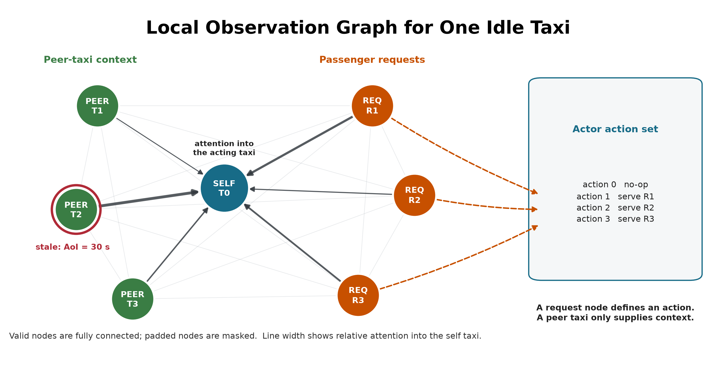
Figure 3.1. Valid self, peer-taxi and request nodes form a fully connected local graph. The red ring marks a stale peer observation, and the illustrative edge widths show attention into the acting taxi. Only request nodes map directly to dispatch actions, which motivates the construct-validity controls.

3.4 Policy models and training
The main policy uses per-node-type feature projections followed by two graph attention layers with four heads. The actor scores no-op and the visible requests. The critic estimates value for MAPPO training with centralised training and decentralised execution. The GAT implementation returns its attention tensors directly so they can be audited without changing the trained network.
The implementation uses scaled dot-product graph attention on the fully connected set of valid local nodes. For node i, node j, layer l, and head h: This differs from the additive attention score in the original GAT paper, so "GAT" in the experiment labels denotes the graph-attention policy family, not an exact reproduction of that layer.
q_i = W_Q,h LayerNorm(h_i^l), k_j = W_K,h LayerNorm(h_j^l)
v_j = W_V,h LayerNorm(h_j^l)
s_ij^(l,h) = (q_i dot k_j) / sqrt(d_head)
alpha_ij^(l,h) = softmax_j(s_ij^(l,h))
z_i = concat_h sum_j alpha_ij^(l,h) v_j
u_i = h_i^l + W_O z_i
h_i^(l+1) = u_i + FFN(LayerNorm(u_i))
The mask removes padded nodes before the softmax. A residual connection keeps the previous node embedding. The actor reads the updated self embedding for no-op and each updated request embedding for its matching dispatch action. The default explanation is the self row (i = 0) averaged over both layers and all four heads, then renormalised:
alpha_j = normalise((1 / (L H)) sum_l sum_h alpha_0j^(l,h))
This aggregation is declared before evaluation. A sensitivity analysis also reports each layer, head-wise values, head maximums, and attention rollout; it does not select an aggregation after seeing which result is favourable. The explanation average is an analysis choice: inside the policy, head outputs are concatenated and projected rather than averaged.
The fixed self row represents the acting taxi's dashboard view and is the explanation channel originally declared for audit. It directly contributes to the no-op embedding. A request-action logit, however, is read from that request's updated embedding, so its corresponding request row is more directly aligned with the selected logit. The revision audit therefore reports a separate request-action sensitivity comparison between the fixed self row and the selected request row. This comparison is not used to redefine the primary metric after seeing the result.
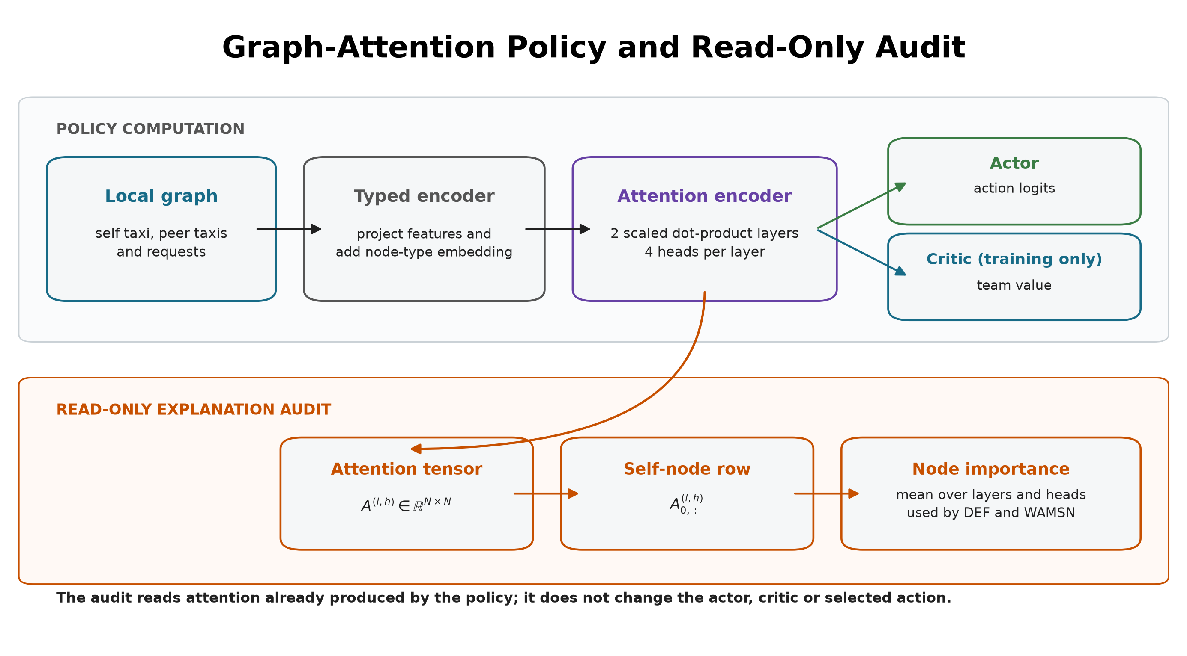
Figure 3.2. The policy and audit share the same two-layer attention encoder. The audit reduces the self-node attention row to node importance without modifying the actor, critic or selected action.
Three policy conditions are included:
Table 3.2: Policy conditions used in the experiment
Model | Policy | Training observations | Purpose
MLP | MLP-MAPPO | clean | performance context without graph attention
GAT | GAT-MAPPO | clean | primary attention model under audit
GAT-Outage | GAT-MAPPO | tunnel-triggered 30-second outages | degradation-aware training condition
MLP is trained for 50 epochs, GAT for 40 epochs, and GAT-Outage for 50 epochs. Each condition uses independent training seeds 42, 43, and 44.
Candidate checkpoints are saved every ten epochs. Selection uses eight stochastic validation episodes with seed 2026 and mean pickups as the primary criterion; mean reward and earlier epoch break ties. The test split is not read during selection. The selected epochs are:
Table 3.3: Validation-selected checkpoint epochs
Model | seed 42 | seed 43 | seed 44
MLP | 20 | 40 | 34
GAT | 39 | 39 | 30
GAT-Outage | 49 | 40 | 40
The shared optimisation settings are shown below.
Table 3.4: Shared training and optimisation settings
Setting | Value
Training epochs | 40 (GAT), 50 (MLP and GAT-Outage)
Learning rate | 0.0001 (GAT variants), 0.0003 (MLP)
Discount factor (gamma) | 0.99
GAE factor (lambda) | 0.95
PPO clip ratio | 0.20
PPO passes per update | 4
Minibatch size | 256
Value-loss coefficient | 0.25
Entropy coefficient | 0.05, adaptive to a 0.20 entropy floor
Target KL divergence | 0.015
Gradient-norm limit | 0.50
GAT hidden width / layers / heads | 64 / 2 / 4
At simulation step t, the shared team reward is:
r_t = 10 N_pickup,t + 0.5 N_dispatch,t - 0.001 mean_wait_t
The reward trains dispatch behaviour. It contains no term that rewards a faithful, stable, or human-readable attention map.
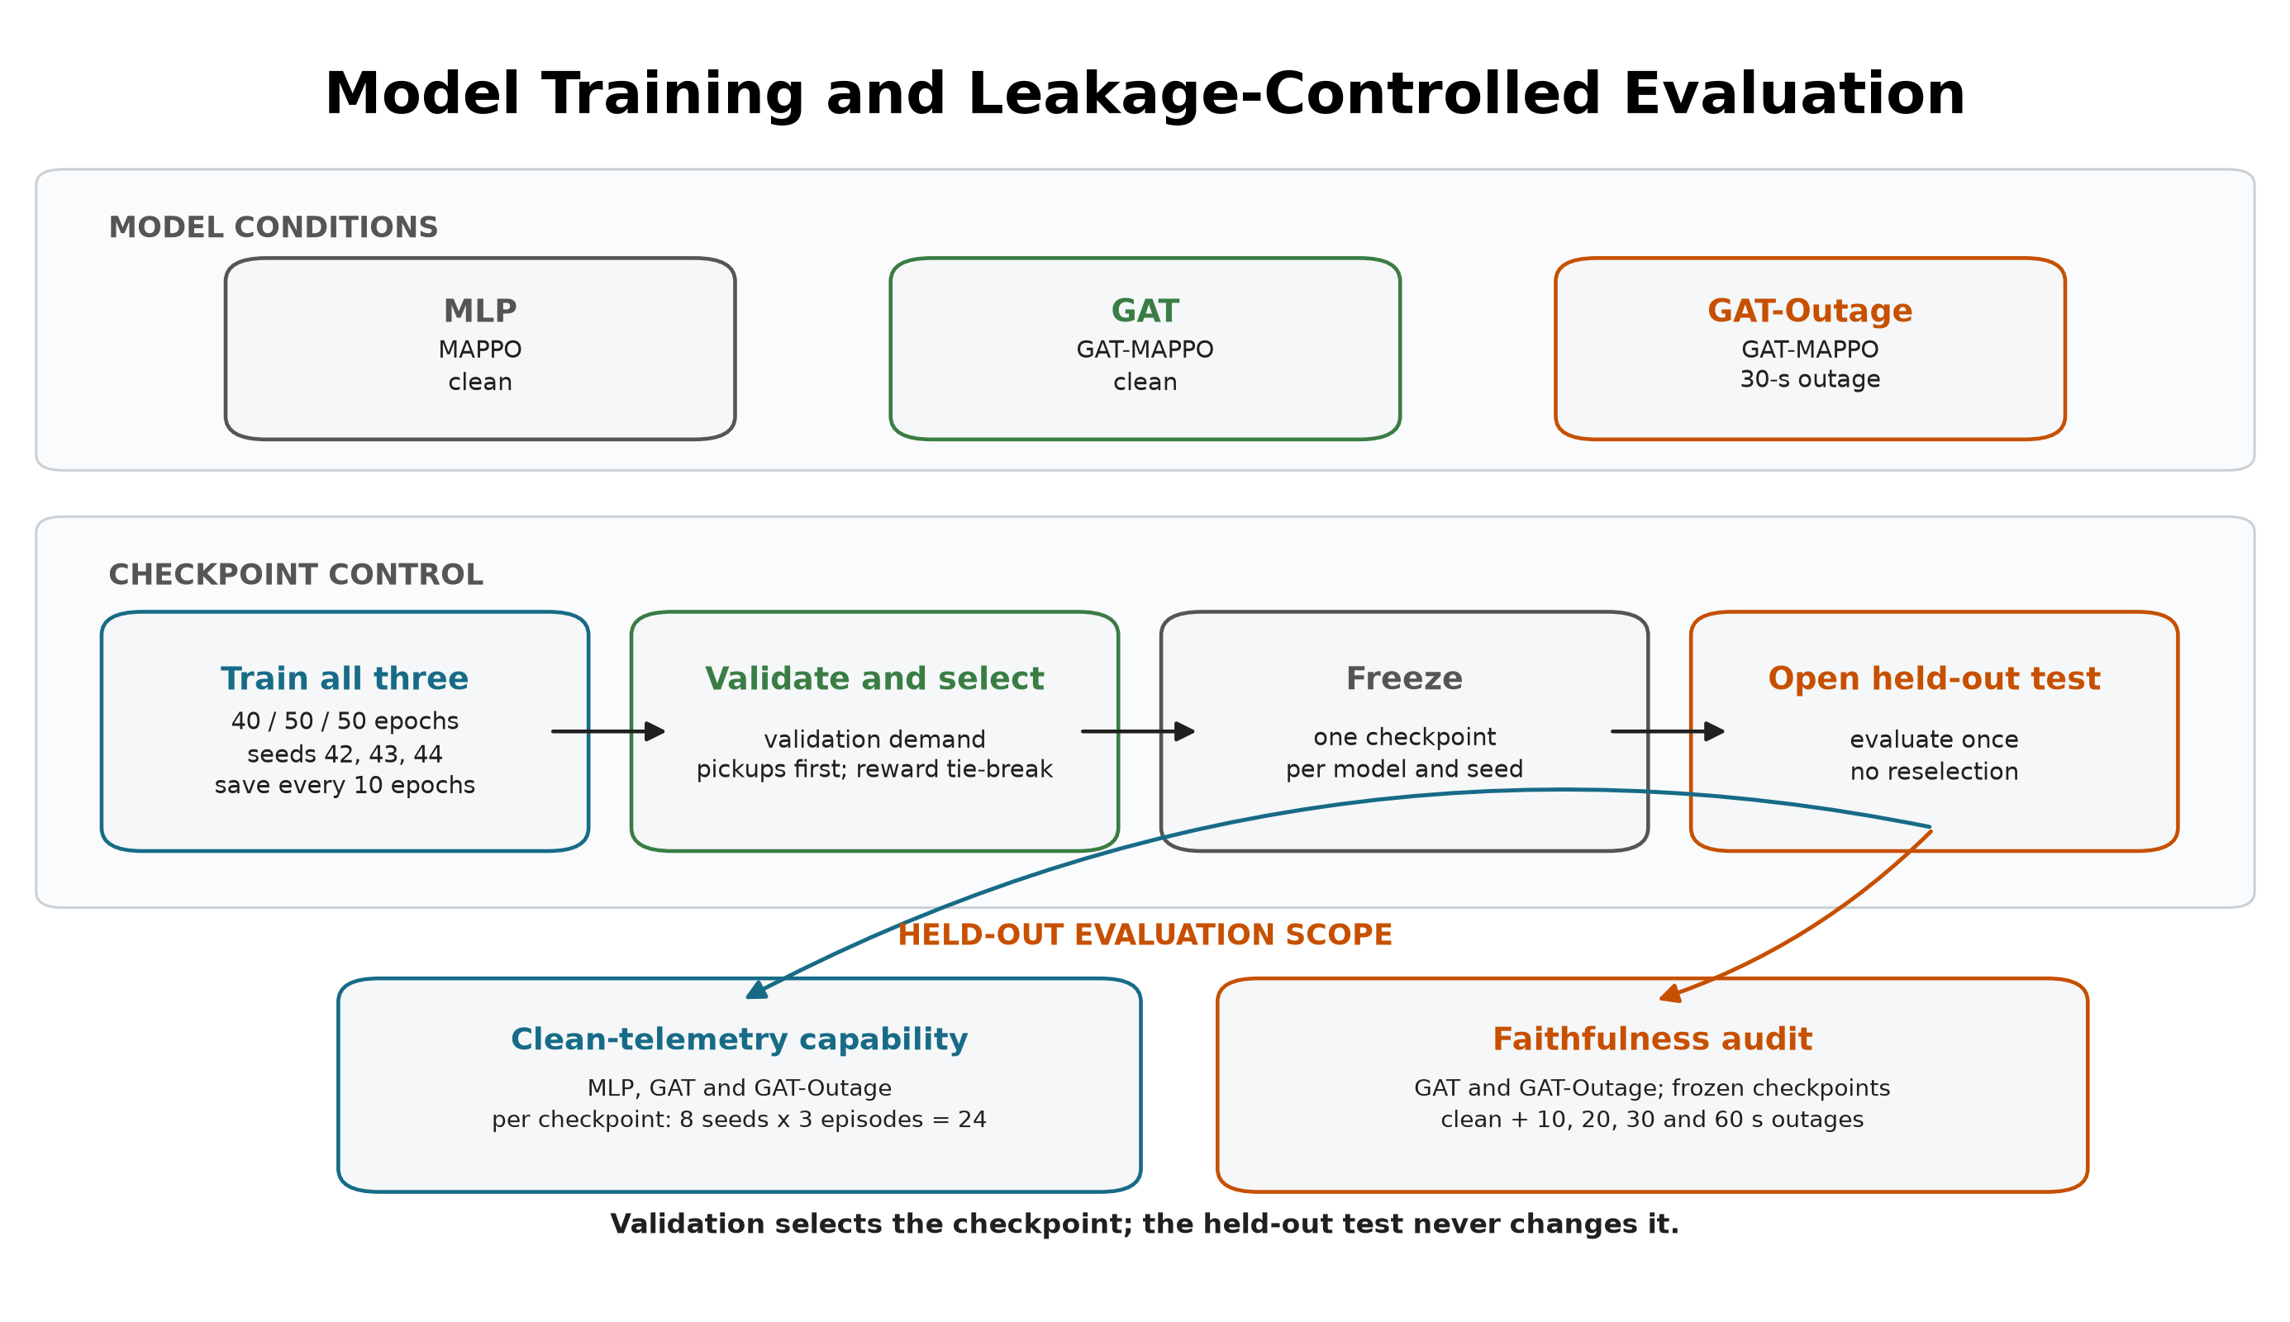
Figure 3.3. Common training and validation-based checkpoint selection for all three model conditions. Each frozen checkpoint receives 24 clean held-out episodes. The faithfulness audit then compares the frozen GAT and GAT-Outage checkpoints across clean and four outage conditions without reselection.

3.5 Telemetry degradation
The trigger and the degradation location are separate parts of the design.
Step 1 - Trigger: when a taxi enters a tunnel edge, the event starts one outage.
Step 2 - Observation-layer outage: for the declared duration, the policy sees the taxi's last valid position and speed. SUMO continues to simulate the true state.
Step 3 - Recovery: after the fixed window expires, a current reading is accepted. A taxi must leave and enter a tunnel again before another tunnel-entry event can trigger.
The fixed outage durations are 10, 20, 30, and 60 seconds. They are easy to monitor and compare, and they create increasing empirical degradation rates. They are not treated as direct causal doses of explanation faithfulness.
AoI is calculated as the current simulation time minus the time of the last valid update and is included in each GAT observation. WAMSN uses normalised AoI as a staleness weight. For this reason, an increase in WAMSN with outage duration partly verifies that the manipulation created longer stale exposure; it is not by itself proof that AoI changed DEF.
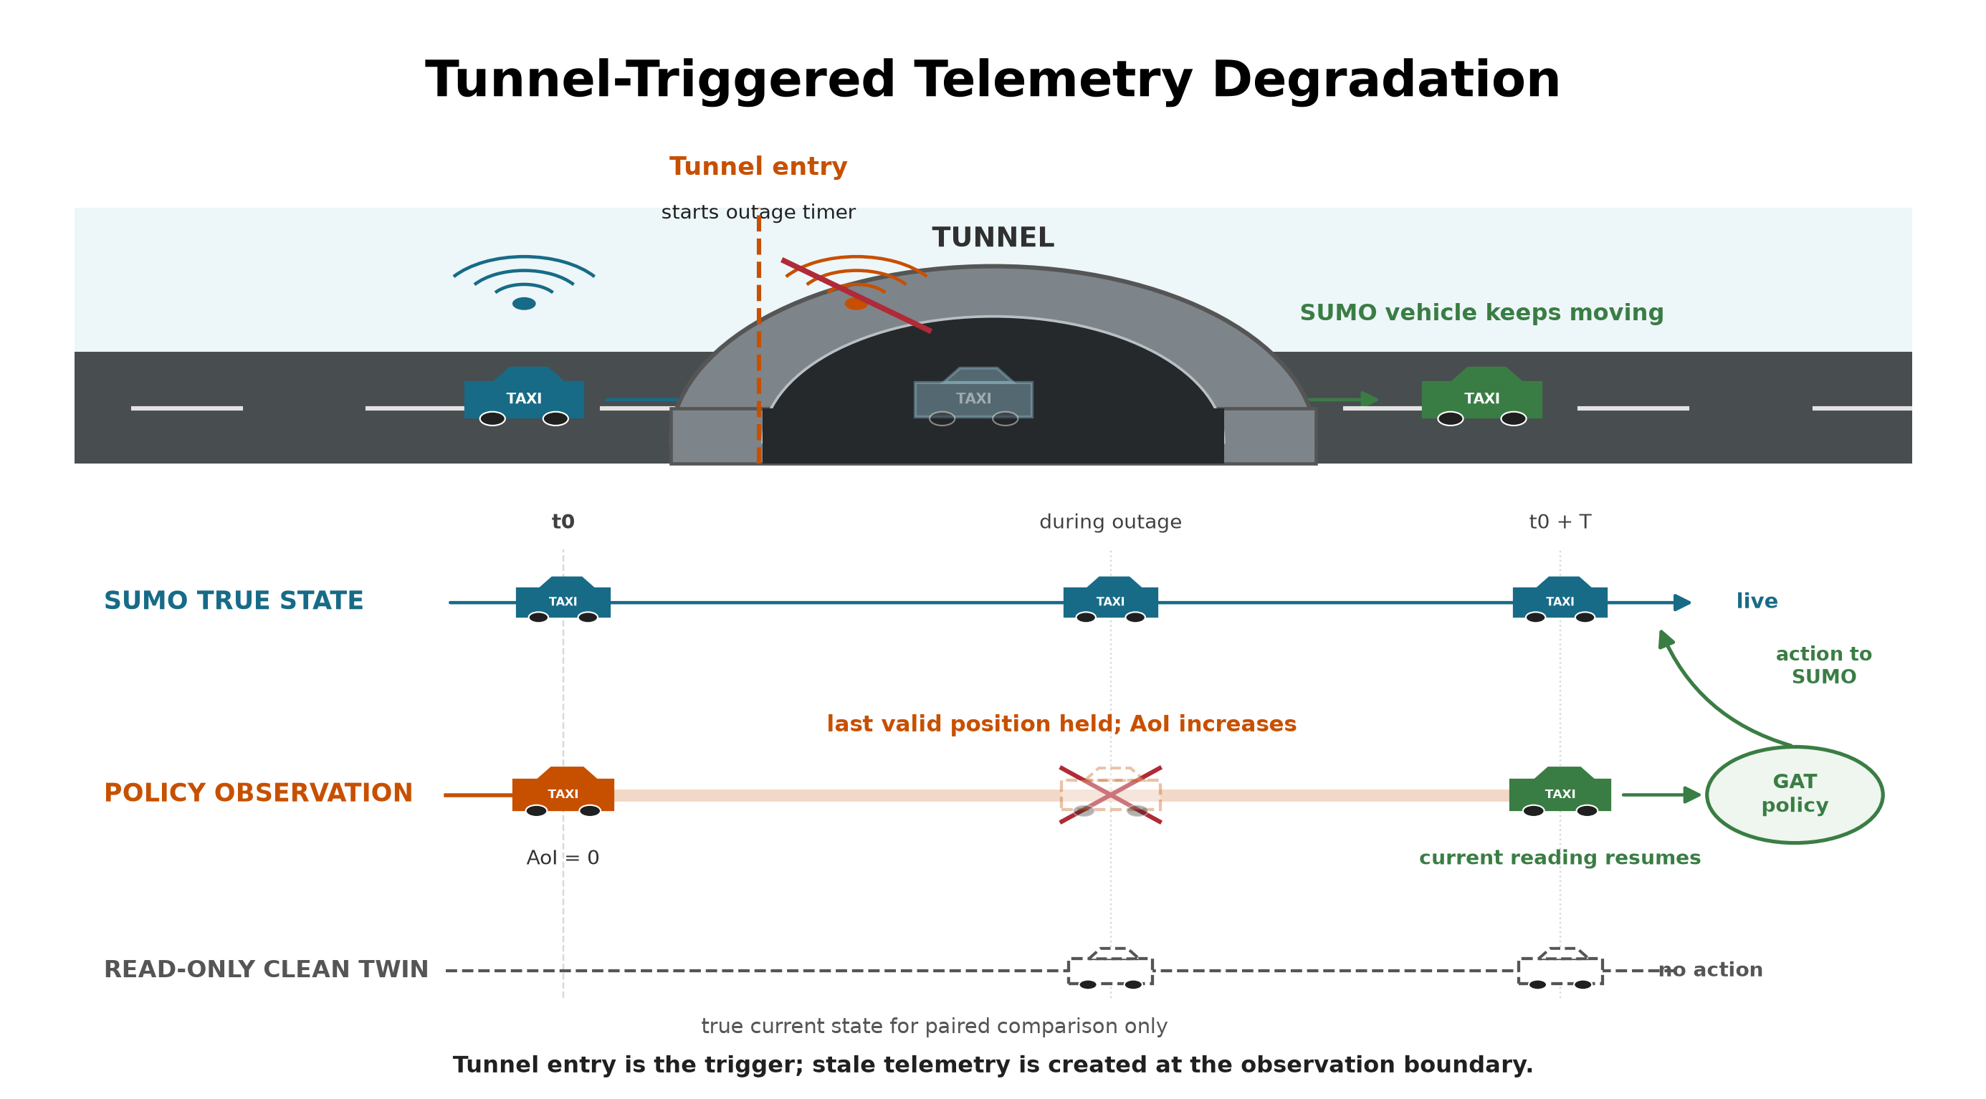
Figure 3.4. Tunnel entry triggers an observation-layer outage. SUMO keeps moving the vehicle while the policy sees its last valid position; the clean twin reads current state but never acts.

3.6 Explanation measures

3.6.1 Decision-level explanation faithfulness
DEF asks whether the nodes ranked highly by an explanation affect the chosen action more than a size- and type-matched random set. For top-k nodes R_k, comprehensiveness measures the output change when those nodes are removed; sufficiency measures the output retained when only those nodes remain. The two gains are compared with five matched random subsets for each k in {1,2,3} and then averaged.
Let m(G,a) be the selected action's logit minus its strongest available alternative. For explanation subset R_k and a matched random subset B_k:
Comp(R_k) = m(G,a) - m(G without R_k,a)
Suff(R_k) = m(G,a) - m(G keeping only R_k,a)
g_comp(k) = Comp(R_k) - mean_b Comp(B_k,b)
g_suff(k) = mean_b Suff(B_k,b) - Suff(R_k)
DEF = mean_k 0.5 [g_comp(k) + g_suff(k)]
Comprehensiveness is better when removing the explanation weakens the action more than removing random nodes. Sufficiency is better when keeping the explanation loses less evidence than keeping random nodes. The logit margin is clipped to [-10, 10] only when an action becomes unavailable or unopposed; every clamp is logged.
Type-matched random subsets are the control baseline; they are not themselves a faithfulness score. Corrected DEF is the measured difference between the attention-ranked subset and this matched random control. Its sign is interpreted as follows:
- Positive DEF: the attention-ranked nodes affect the selected action more than comparable random nodes. This supports decision-level faithfulness.
- DEF near zero: the attention ranking has no measured advantage over the matched random control.
- Negative DEF: the attention-ranked nodes affect the selected action less than the matched random nodes. This does not support the attention ranking as a faithful explanation.
These interpretations apply to both probability DEF and the action-protected logit-margin DEF. The final hypothesis tests use the type-matched baseline described in Section 3.7. DEF provides comparative perturbation evidence; even a positive value does not prove that attention is a complete causal explanation.

3.6.2 Stale-node attention
WAMSN measures attention attached to stale vehicle information:
WAMSN = sum(attention_i * normalised_AoI_i) / sum(attention_i)
Only self and peer-taxi nodes contribute because request nodes do not carry vehicle telemetry. The analysis reports WAMSN when at least one stale vehicle node is visible, together with stale-node attention share, stale-node mass, and whether a stale node enters the top three.
The paired stale-attention shift compares the degraded observation with its exact clean twin at the same simulation step. Positive values mean the degraded observation assigns more attention mass to nodes marked stale; negative values mean it assigns less.

3.7 Construct-validity audit
The audit supports the primary research problem by checking whether DEF is a valid comparison in this action-candidate graph.
A uniform random occlusion can select passenger requests more often than the attention top-k. Removing such a request changes both the observation and the available action set. A nearby-taxi occlusion changes only information. The result can therefore reflect different node-type composition rather than explanation quality.
The corrected protocol uses three controls:
- type matching: random subsets contain the same mixture of taxi and request nodes as the explanation subset;
- chosen-action protection: the request associated with the selected action is not deleted in the action-protected variant;
- clamp logging: counterfactual action-margin clamps are counted so that action deletion can be detected.
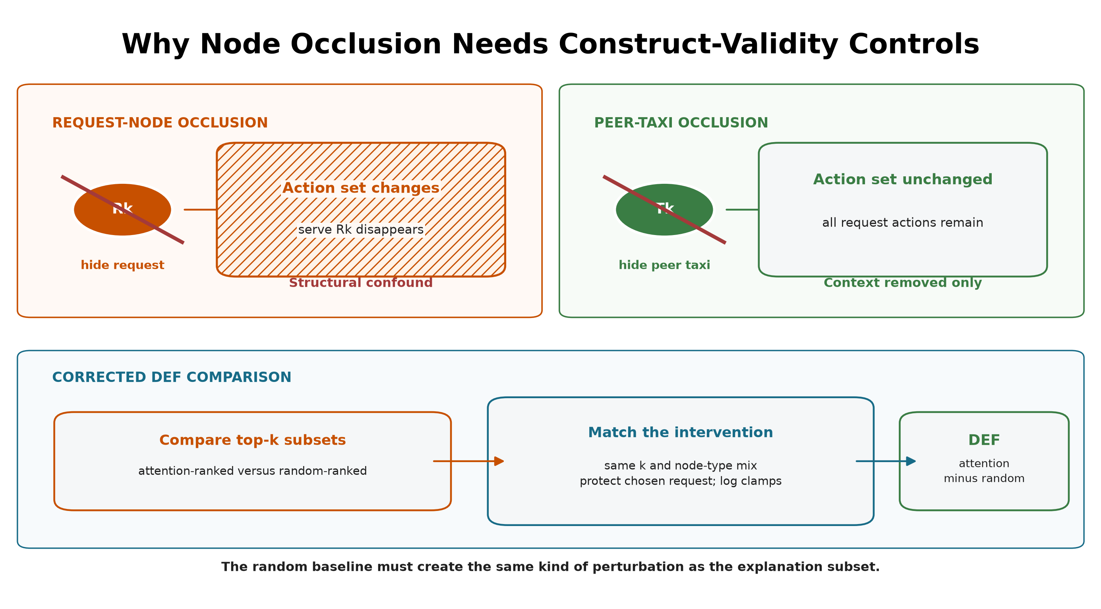
Figure 3.5. Request-node occlusion can remove its action, while peer-taxi occlusion removes context only. Corrected DEF matches subset size and node types, protects the chosen request, and logs margin clamps.
The earlier uniform-baseline results are retained only as an audit trail. They are not used for the final hypothesis verdicts.
Three additional diagnostics test whether a near-zero DEF can be interpreted. First, a leave-one-out (LOO) control masks each valid node separately and ranks nodes by the resulting selected-action margin loss. The selected request is protected. This control is expected to strengthen comprehensiveness because it is built from the same single-node perturbation, but it is not an independent proof that the combined DEF is optimal. Second, Gradient x Input ranks each node by the L2 norm of the selected-action logit gradient multiplied by its raw features. It is a post-hoc comparator that does not use attention weights. Third, the audit reports valid taxi/request counts and the exact expected top-k overlap with a type-matched random subset. Taxi-only Spearman correlation between attention and LOO effects supplies a ranking measure that does not delete request actions and does not depend on random subset overlap.

3.8 Evaluation matrix
MLP, GAT, and GAT-Outage are evaluated under clean telemetry with eight evaluation seeds (42-49) and three episodes per seed. One checkpoint is frozen for each model and training seed, so this gives 24 held-out episodes per checkpoint. The clean capability evaluation therefore contains 216 episode evaluations:
3 models x 3 frozen checkpoints per model x 8 evaluation seeds x 3 episodes
The complete evaluation structure is summarised below. An episode evaluation is one complete rollout of one frozen checkpoint under one telemetry condition.
Table 3.5: Held-out evaluation structure and episode counts
Evaluation | Models | Checkpoints | Conditions | Episodes per cell | Total episodes
Clean capability context | 3 | 9 | 1 | 24 | 216
Exposure-conditioned faithfulness sweep | 2 | 6 | 5 | 48 | 1,440
Added ranking controls | 2 | 6 | 2 | 24 | 288
GAT and GAT-Outage receive the full faithfulness sweep:
3 training seeds x 5 conditions x 8 evaluation seeds x 6 episodes
The five conditions and their roles are:
Table 3.6: Telemetry conditions used in held-out evaluation
Condition | Observation-layer treatment | GAT-Outage relation | Evaluation purpose
Clean | Current vehicle readings | No imposed outage | Capability context and faithfulness baseline
10 s | Freeze last valid reading for 10 seconds | Unseen shorter duration | Mild-degradation transfer test
20 s | Freeze last valid reading for 20 seconds | Unseen shorter duration | Intermediate transfer test
30 s | Freeze last valid reading for 30 seconds | Training-matched duration | In-condition degradation test
60 s | Freeze last valid reading for 60 seconds | Unseen longer duration | Severe stress and transfer test
The relation column refers only to GAT-Outage; the clean-trained GAT has not seen any imposed outage duration during training. The evaluation changes the observation-layer condition but never retrains or reselects a checkpoint. Outside stale exposure, faithfulness is sampled every 16 decisions. Every decision that contains at least one stale vehicle node is scored. Each such observation is also compared with its exact clean twin at the same simulation step. The degraded and clean evaluations reuse the same matched-random draw, so the paired difference does not contain avoidable baseline-sampling noise.
Each degraded condition must contain at least 20 stale-exposed records from at least three episodes. Preflight also checks expected cells, clean source provenance, type-matched controls, chosen-action exclusion, complete event capture, and empirical AoI differentiation. All six sweeps pass these gates.

3.9 Hypotheses and statistics
The confirmatory hypotheses are:
- H1: DEF decreases as outage duration increases.
- H2: faithfulness declines faster than dispatch performance.
- H3: WAMSN increases as outage duration increases.
- H4: decisions with greater WAMSN have lower DEF within an episode.
- H5: degradation-aware training changes or mitigates these relationships.
H1 and H3 use episode-block permutation trend tests and cluster bootstrap confidence intervals. H2 uses paired cell-level sign flips relative to each evaluation seed's clean condition. H4 calculates Spearman correlation within each episode before a sign-flip test. Holm correction is applied to H1-H4 within each trained policy.
The exposure-conditioned paired follow-up directly subtracts clean-twin DEF from degraded DEF for the same decision. Negative values mean lower measured faithfulness under the degraded observation. This paired estimate is reported with an episode-block confidence interval and is interpreted by effect size, direction across trained policies, and uncertainty rather than by a decision- level p-value alone.
H2 is retained as a pre-declared but exploratory comparison. Its original rate divides by clean DEF, which is close to zero and can make a small absolute change look arbitrarily large. The analysis therefore reports the support verdict and absolute trajectories, but does not use the ratio as the main evidence for faithfulness decoupling.
Thousands of decisions improve measurement precision but do not replace independent model replication. The final synthesis therefore treats each training seed as one trained-policy replicate. With only three seeds per model, the dissertation reports the range and number of supporting seeds and does not claim a cross-seed population p-value.
The added ranking controls use the same held-out demand and stochastic action protocol. They evaluate GAT and GAT-Outage under clean telemetry and a 60-second outage:
2 models x 3 training seeds x 2 conditions x 8 evaluation seeds x 3 episodes
LOO, Gradient x Input, overlap, and aggregation diagnostics are sampled every eight decisions. Query-row sensitivity is evaluated at every selected-request action because it asks whether the explanation row matches the node that produces that action logit. Decision records are averaged within episodes before bootstrap confidence intervals are calculated. Attention-aggregation sensitivity is reported per training seed and only for decisions where at least one stale vehicle node is visible.

3.10 Reproducibility
The experiment runner records the configuration, commands, seeds, checkpoint hashes, source revision, and preflight reports under the local runs/dissertation_v9_exposure_audit/ directory. Compact thesis-ready outputs are committed under results/dissertation_v9_exposure_audit/: summary.csv, performance_context.csv, and training_seed_synthesis.csv. The last file makes training-seed consistency explicit. Reproduction commands and expected outputs are documented in docs/REPRODUCE_EXPERIMENTS.md.

3.11 Ethics and data governance
The experiment uses a simulated taxi fleet, generated demand, and an OpenStreetMap-derived road network. It contains no human participants, personal records, live vehicle identifiers, or commercial dispatch data. Its main ethical risk is miscommunication: presenting attention as a trustworthy reason could give an operator false confidence. The reporting therefore keeps freshness, task behaviour, and faithfulness separate and avoids unsupported causal claims.

Chapter 4: Results
The primary experiment outputs are stored in results/dissertation_v9_exposure_audit/. The additional baseline and faithfulness-control outputs are stored in results/dissertation_revision_v1/. The source audit passed all 100 provenance and protocol checks. Results are reported by training seed because decisions and episodes from one checkpoint do not replace independent model replication.

4.1 Policy capability and training stability
Validation selected GAT epochs 39, 39, and 30 and GAT-Outage epochs 49, 40, and 40 for seeds 42, 43, and 44. The selected epoch is reported for each policy rather than hidden behind one common label.
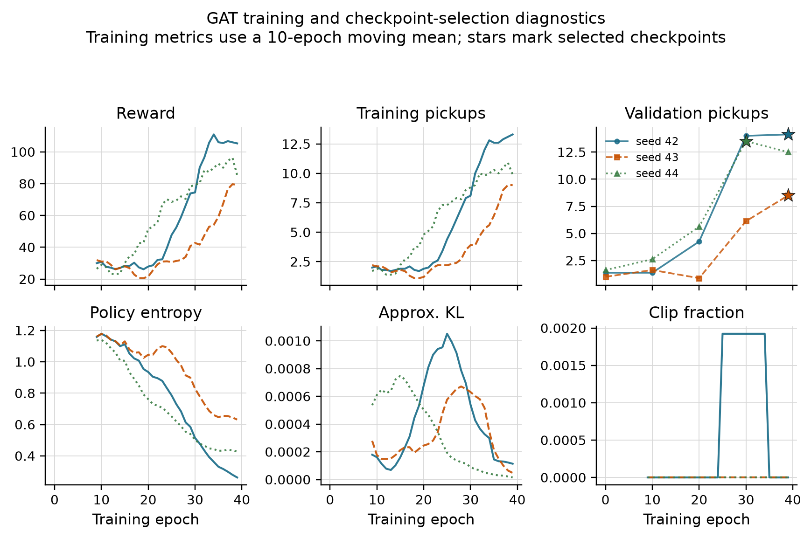
Figure 4.1. GAT training metrics use a ten-epoch moving mean. Stars mark validation-selected checkpoints. Reward and pickups still vary between epochs, but entropy remains above the collapse threshold and PPO clipping is limited.
All nine training runs pass the declared stability gates. For GAT, the final ten-epoch mean pickups are 13.3, 9.0, and 9.9, and final validation retains 100%, 100%, and 92.6% of the selected validation score. The corresponding GAT-Outage values are 12.4, 14.1, and 13.8 pickups, with validation retention of 100%, 93.9%, and 96.5%. This does not make every epoch smooth, but it removes the earlier zero-pickup collapse as an explanation for the audit result.
Table 4.1 places the selected policies above two lower bounds evaluated on the same held-out demand. Performance is reported only to establish that the audit does not concern a random-level policy.
Table 4.1: Policy capability on held-out demand
Policy | Mean pickups | Uncertainty or replicate range
Legal random | 1.50 | 95% episode-cluster CI [1.08, 1.96]
Greedy nearest request | 2.00 | 95% demand-variant CI [1.00, 3.00]
MLP | 13.63 | training-seed range 12.83-14.17
GAT | 11.64 | training-seed range 9.42-13.71
GAT-Outage | 12.97 | training-seed range 11.79-14.58
The legal-random baseline has 24 independent episode clusters. Greedy nearest is deterministic, so its effective sample is the three demand variants rather than 24 repeated seed-episode records. GAT's seed means are 13.71, 9.42, and 11.79. Every selected policy exceeds both lower bounds. This establishes task capability for the policies under audit; it does not show that graph attention caused that capability.
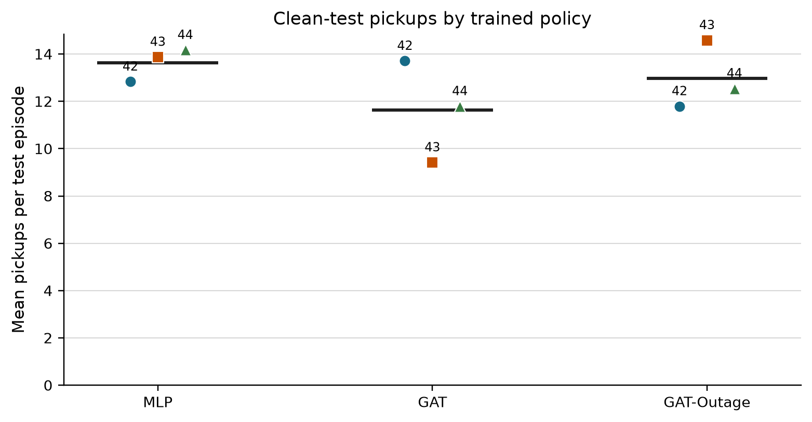
Figure 4.2. Each point is one selected policy evaluated over 24 held-out episodes. Horizontal lines show the cross-seed mean.

4.2 Construct-validity audit
Removing a request node can remove an available action, while removing a peer taxi only hides information. A uniform random occlusion therefore compares unlike interventions.
Table 4.2: Construct-validity audit of random controls
Control baseline used to calculate DEF | Mean margin-DEF | 95% CI | Interpretation
Uniform random | -0.5540 | [-0.5808, -0.5288] | dominated by node-type and action-deletion imbalance
Type-matched random | -0.0093 | [-0.0159, -0.0013] | small negative result after matching node types
The type-matched interval excludes zero, but its magnitude is about two orders smaller than the uniform-control artefact. This earlier 1,199-decision audit supports the measurement design; it is not a separate answer to the primary research question. The final protocol uses type matching, protects the chosen request in the margin variant, and logs action-margin clamps.

4.3 Evaluator sensitivity and ranking controls
Raw attention, Gradient x Input, and an LOO perturbation ranking are evaluated under clean and 60-second conditions. Each model, training seed, and condition contains eight evaluation seeds and three episodes. Table 4.3 shows clean results. The 60-second aggregate means remain close to clean.
Table 4.3: Clean-telemetry faithfulness controls by training seed
Model | Seed | Raw DEF | GxI DEF | LOO DEF | Taxi-only rho
GAT | 42 | +0.0003 | -0.0055 | +0.0008 | +0.088
GAT | 43 | -0.0009 | -0.0033 | +0.0099 | +0.404
GAT | 44 | +0.0015 | +0.0012 | +0.0030 | +0.426
GAT-Outage | 42 | +0.0011 | -0.0019 | +0.0020 | +0.472
GAT-Outage | 43 | +0.0006 | -0.0010 | +0.0089 | +0.602
GAT-Outage | 44 | +0.0031 | +0.0052 | +0.0044 | +0.699
LOO is positive and larger than raw attention for all six checkpoints. This shows that DEF responds to a ranking built from single-node margin loss. LOO is still a perturbation control, not a ground-truth explanation. Gradient x Input changes sign across checkpoints and provides no uniform improvement.
Raw-attention DEF ranges from -0.0009 to +0.0031. Taxi-only rank correlation with LOO is positive in all six checkpoints, but ranges from 0.088 to 0.699. Attention therefore contains some decision-relevant ordering, while the size of that agreement remains policy-dependent.
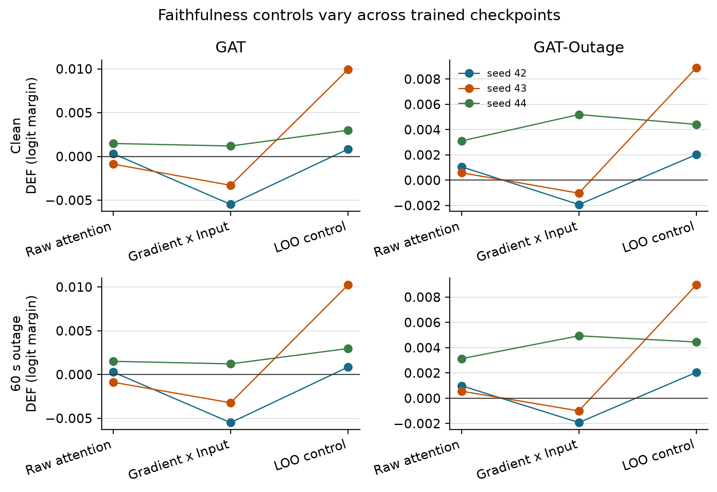
Figure 4.3. Episode means are first calculated within each checkpoint. Lines identify training seeds; they are not population trends. LOO exceeds raw attention for every checkpoint under clean and 60-second conditions.
The attention reduction rule remains important. Across the declared mean, individual heads, layer maxima, and rollout, every checkpoint contains both a positive and a negative stale-attention shift. The widest ranges are -0.0109 to +0.0063 for GAT seed 44 and -0.0097 to +0.0064 for GAT-Outage seed 44.
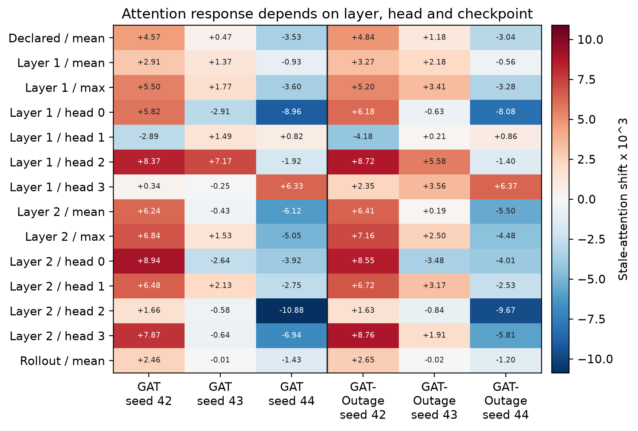
Figure 4.4. Stale-attention shift multiplied by 1,000. Selecting a layer, head, or rollout rule after seeing the result could reverse the conclusion.
Changing from the declared self row to the selected request row has little effect for seeds 42 and 44, but increases request-action DEF by about 0.0064 for GAT seed 43 and 0.0073 for GAT-Outage seed 43. The aggregate gap is +0.0022 for GAT and +0.0025 for GAT-Outage because it averages these different policy responses.
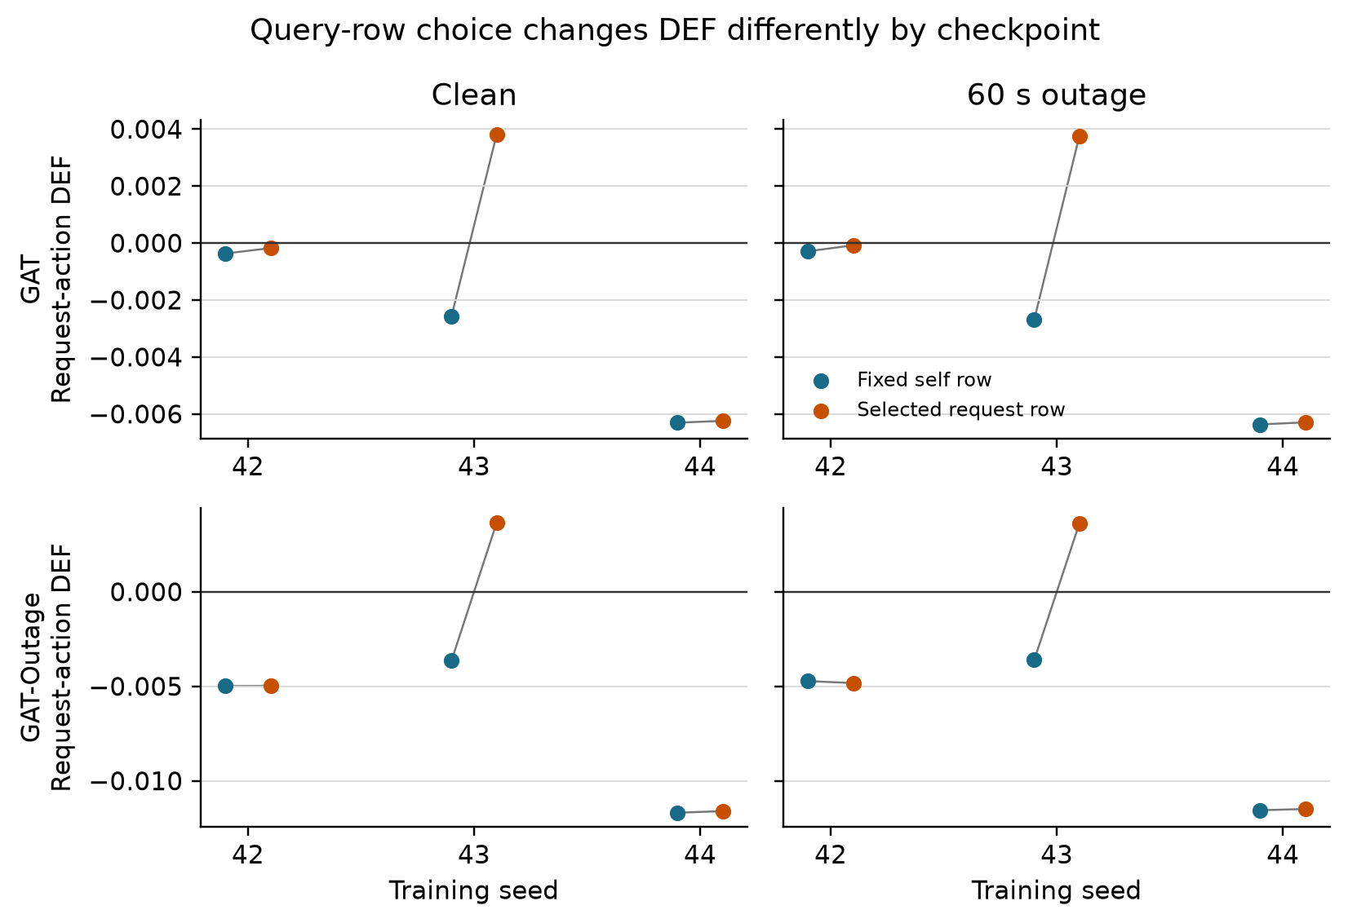
Figure 4.5. Each grey line joins the two query-row results for one checkpoint. The selected request row helps seed 43 but is not a general fix.

4.4 Small-graph resolution
The scored graphs usually contain the maximum number of visible nodes.
Table 4.4: Valid node-count distribution in scored graphs
Model | Node count | Mean | Median | 5th percentile | 95th percentile
GAT | peer taxis | 5.00 | 5 | 5 | 5
GAT | requests | 4.51 | 5 | 1 | 5
GAT | non-self total | 9.51 | 10 | 6 | 10
GAT-Outage | peer taxis | 5.00 | 5 | 5 | 5
GAT-Outage | requests | 4.52 | 5 | 1 | 5
GAT-Outage | non-self total | 9.52 | 10 | 6 | 10
Even so, type matching creates substantial top-k overlap. The expected random intersection is about 0.22 for k=1, 0.41 for k=2, and 0.60 for k=3. Attention-LOO agreement at k=1 exceeds random overlap for both models. At k=3, it is 0.60 for GAT and 0.49 for GAT-Outage, compared with expected overlap of about 0.60. Restricting analysis to at least six non-self nodes does not change the sample because every scored decision already meets that threshold.
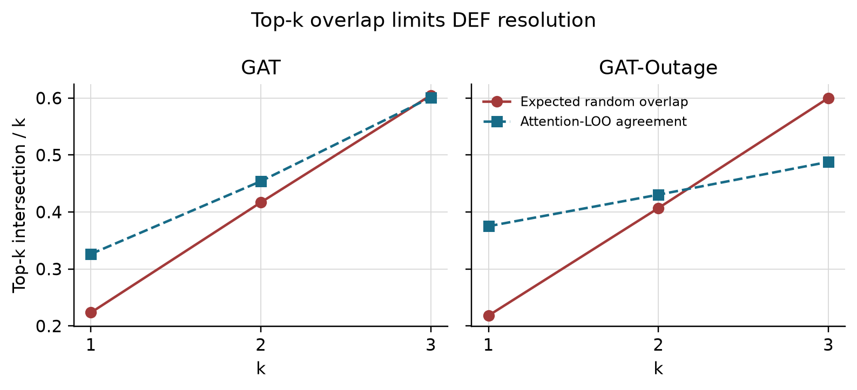
Figure 4.6. Large expected overlap between the explanation and its matched random set compresses DEF, especially at k=3.

4.5 Telemetry manipulation and stale exposure
Tunnel-triggered observation outages create increasing stale exposure. The event-aware audit scores every decision that contains at least one stale taxi, instead of relying on periodic sampling. Across GAT checkpoints, the number of stale-exposed records ranges from 347-382 at 10 seconds and 1,476-1,806 at 60 seconds. The GAT-Outage ranges are 353-372 and 1,566-1,697. Every degraded cell exceeds the pre-declared coverage gates.
Conditional WAMSN rises from 0.0275-0.0289 at 10 seconds to 0.0804-0.0900 at 60 seconds. H3 is supported for all six policies. Because WAMSN contains normalised AoI, this verifies increasing stale exposure; it does not show that AoI causes lower faithfulness.
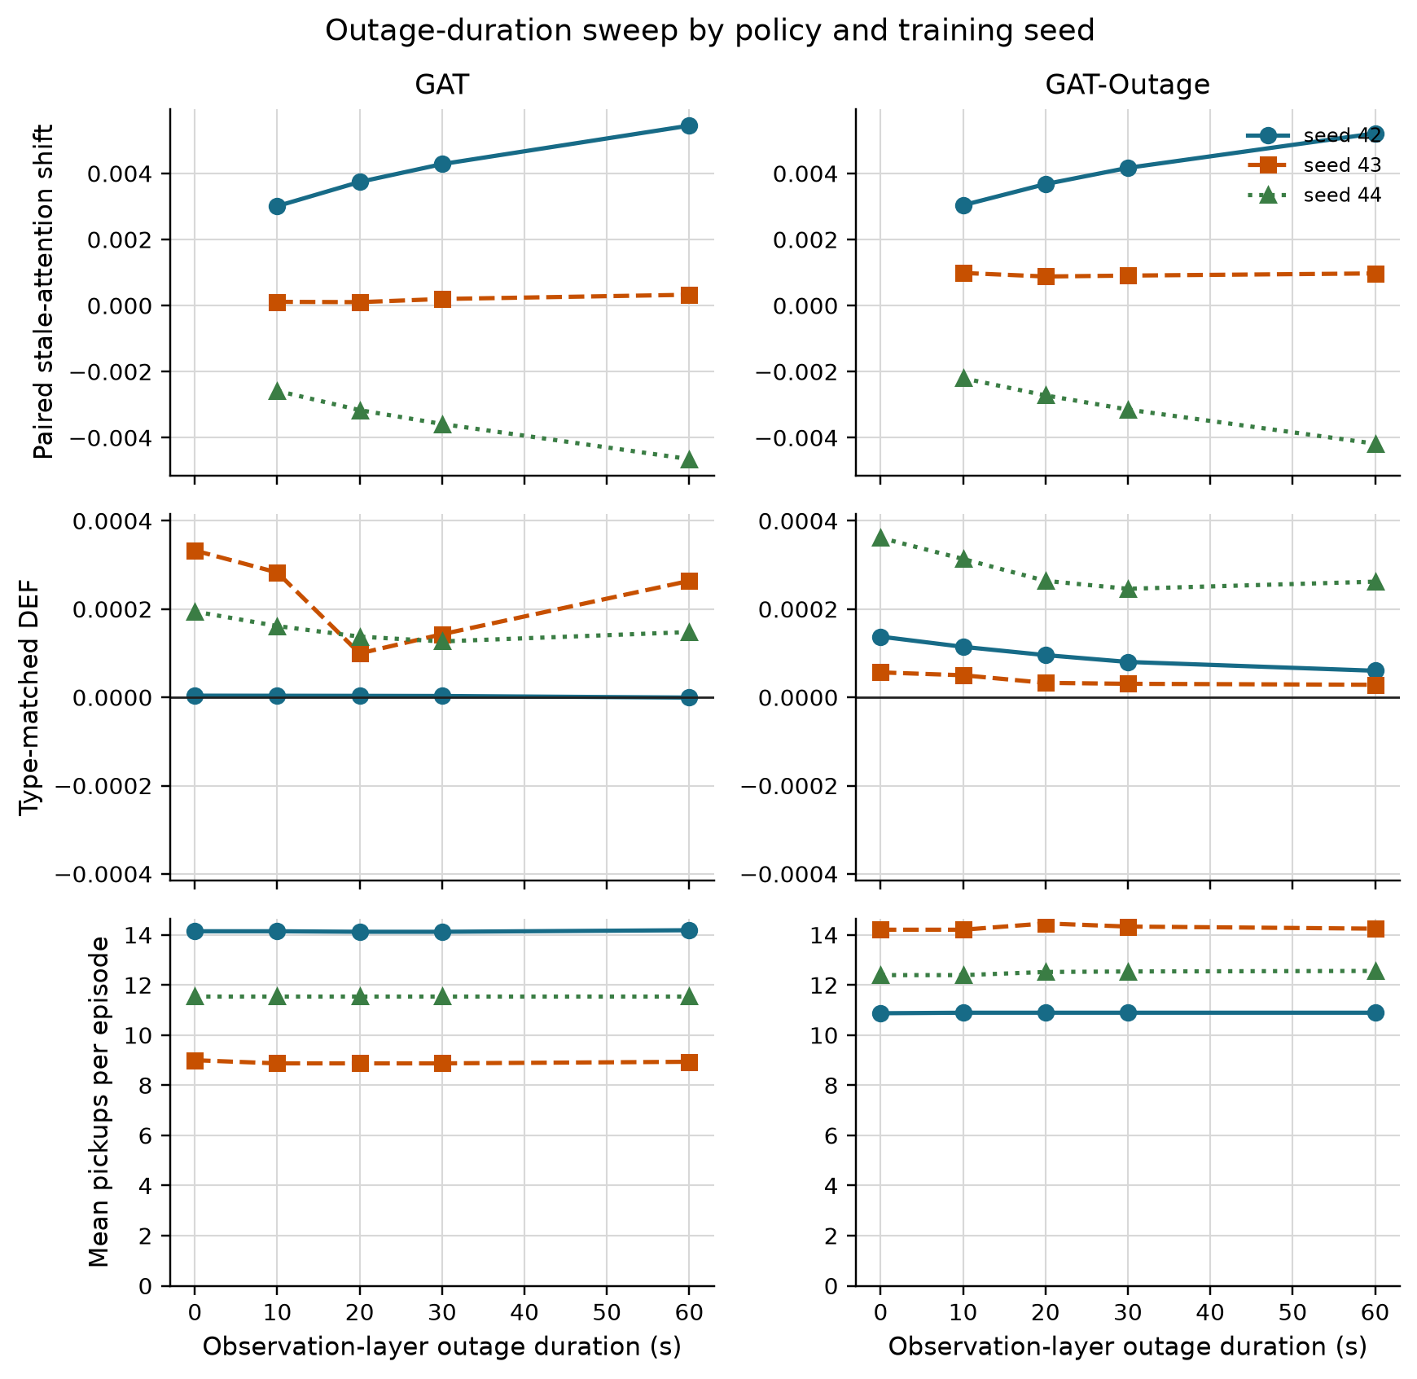
Figure 4.7. Longer observation outages increase WAMSN for every policy. DEF changes are much smaller, while pickups remain supporting context rather than the research outcome.

4.6 Exposure-conditioned paired audit
The paired audit compares each degraded observation with its exact clean twin at the same simulation step. Positive attention shift means more attention is assigned to nodes marked stale. Negative DEF shift means lower measured faithfulness under degradation.
Table 4.5: Exposure-conditioned paired attention and DEF shifts
Model | Seed | Attention shift [95% CI] | Paired probability-DEF shift [95% CI]
GAT | 42 | +0.004074 [+0.0039, +0.0042] | -0.0000041 [-0.0000060, -0.0000022]
GAT | 43 | +0.000208 [+0.0002, +0.0003] | -0.0000839 [-0.0001892, +0.0000143]
GAT | 44 | -0.003483 [-0.0036, -0.0034] | +0.0000092 [+0.0000068, +0.0000116]
GAT-Outage | 42 | +0.003975 [+0.0038, +0.0041] | -0.0000253 [-0.0000323, -0.0000193]
GAT-Outage | 43 | +0.000959 [+0.0009, +0.0010] | -0.0000114 [-0.0000343, +0.0000061]
GAT-Outage | 44 | -0.003038 [-0.0031, -0.0029] | +0.0000172 [+0.0000135, +0.0000212]
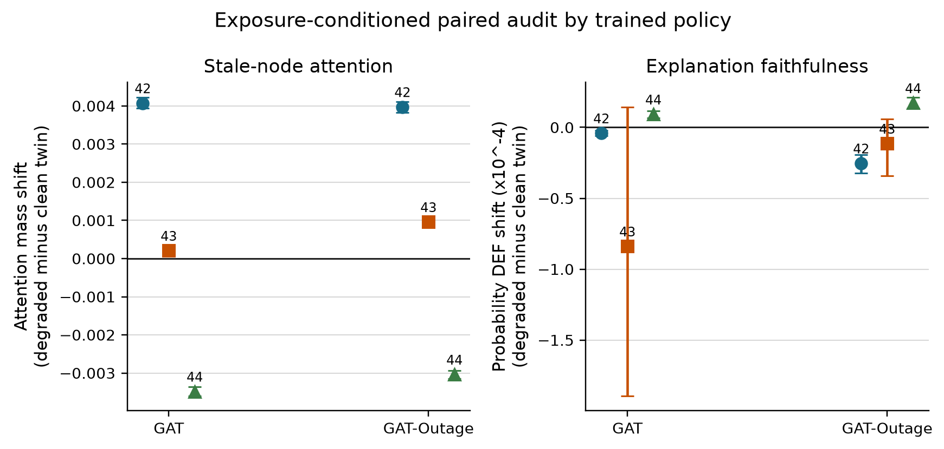
Figure 4.8. Seeds 42 and 43 move attention toward stale nodes and have a negative mean DEF shift. Seed 44 reverses both directions. Error bars are 95% episode-block bootstrap intervals.
The same seed pattern appears in both training regimes: four of six policies have a positive attention shift and four have a negative mean DEF shift. Only the seed-42 DEF decrease is separated from zero in both models; both seed-43 intervals include zero, while both seed-44 policies show a small increase. The effects are numerically small and directionally heterogeneous. This is not evidence for a universal claim that telemetry degradation moves attention toward stale nodes or always lowers faithfulness.

4.7 Faithfulness hypotheses
The denser audit changes the decision-level trend tests because stale exposure is no longer represented by a small periodic sample. H1 is supported for two of three GAT policies and all three GAT-Outage policies. H4 is supported for all six: within-episode WAMSN-DEF correlations range from -0.199 to -0.084 for GAT and from -0.423 to -0.212 for GAT-Outage. H3 remains consistently supported.
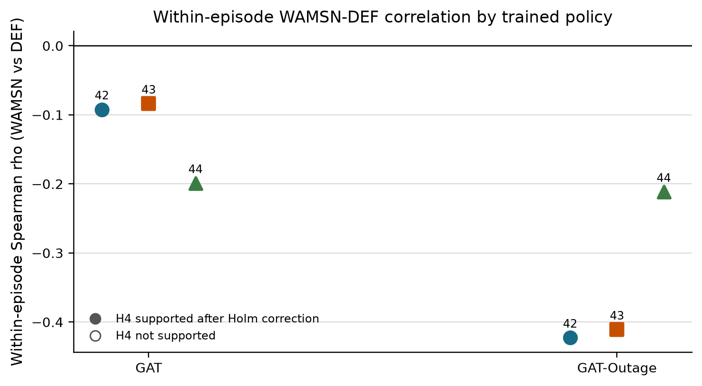
Figure 4.9. Every checkpoint has a negative within-episode WAMSN-DEF association after Holm correction. This association does not remove the mixed direction of the direct degraded-minus-clean paired effect.
Table 4.6: Hypothesis outcomes across training seeds
Hypothesis | GAT seeds supporting | GAT-Outage seeds supporting | Verdict
H1: outage duration increases, DEF decreases | 2/3 | 3/3 | strong but not universal
H2: faithfulness declines faster than performance | 1/3 | 3/3 | model-dependent; exploratory
H3: outage duration increases, WAMSN increases | 3/3 | 3/3 | consistently supported
H4: higher WAMSN is associated with lower DEF | 3/3 | 3/3 | consistently supported within episodes
H5: degradation-aware training mitigates the effect | n/a | 0/3 | not supported
H1 and H4 are association tests within one trained policy. They do not by themselves establish that AoI causes lower faithfulness. The paired clean-twin audit supplies the more direct intervention contrast, and its sign still changes with training seed. H2 is retained as exploratory because clean DEF is close to zero and the relative-rate formulation is unstable.

4.8 Result summary
The experiment establishes three points. First, longer outages reliably increase stale-data exposure. Second, higher exposure is associated with lower DEF within episodes, but the direct paired change in attention and DEF reverses for seed 44. Third, 30-second outage training does not remove this seed dependence. The trustworthy conclusion is therefore not that degradation has one fixed effect. It is that raw attention does not provide a reproducible freshness or faithfulness guarantee across independently trained policies.

Chapter 5: Discussion

5.1 Answer to the central problem
The central problem is whether a complete graph-attention map can be trusted when some of its vehicle data are stale. The answer from this experiment is: not without separate validation. Raw attention is not shown to provide a stable assurance of freshness or decision relevance.
This answer does not depend on one p-value. Longer outages increase stale-data exposure, and within-policy tests usually associate that exposure with lower DEF. The direct clean-twin comparison is less uniform: attention reallocation and paired DEF shift have the expected directions for seeds 42 and 43, but both directions reverse for seed 44 under both training regimes. The measured effects are also small.
The added controls make the interpretation stronger and narrower. LOO produces a positive DEF for every checkpoint, so the evaluator has some sensitivity to a perturbation-based ranking. However, expected top-k overlap reaches about 60% at k=3, which limits resolution. Taxi-only attention-LOO correlation is positive but varies substantially in strength. The result is not “the evaluator is perfect and attention fails.” It is “within a measured but limited audit, attention gives no reproducible explanation guarantee.”
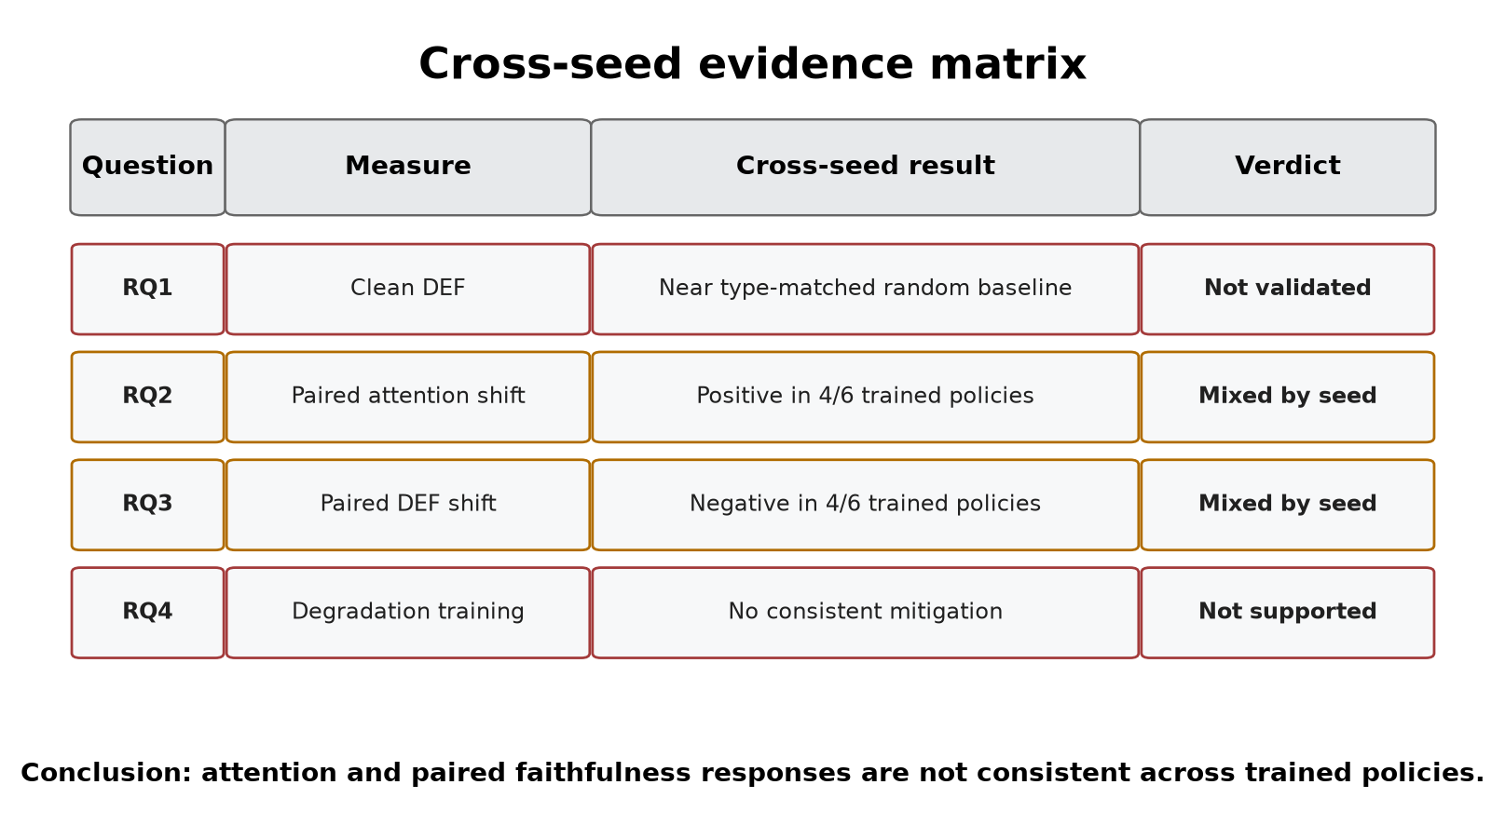
Figure 5.1. The evidence separates capability, evaluator validity, stale exposure, attention response, and decision relevance. These are not treated as one causal chain.

5.2 What the stale-exposure result means
WAMSN rises with outage duration for every GAT and GAT-Outage checkpoint. It is useful as an operational exposure indicator: it shows when an attention map contains more weight attached to old vehicle readings.
WAMSN is not evidence that AoI causes lower faithfulness. The metric itself weights attention by normalised AoI, so part of the increase follows directly from the manipulation. H1 and H4 show that DEF tends to be lower at greater exposure within most frozen policies. The paired audit asks a stricter question: does replacing the current observation with its degraded twin change attention and DEF at the same decision? That result changes sign across seeds. Exposure, within-policy association, and paired intervention therefore answer different questions and should remain separate.

5.3 Dependence on checkpoint and analysis choice
The primary aggregation gives positive stale-attention shifts for seeds 42 and 43 and negative shifts for seed 44. The values are small: approximately -0.0035 to +0.0041 of total attention mass. Paired probability-DEF shifts are also small and reproduce the seed direction in both training regimes. This cross-model seed pattern suggests sensitivity to the learned policy instance, not a stable response created by outage-aware training.
The aggregation audit reveals a second problem. Individual heads can reverse the sign within the same checkpoint. The six checkpoint ranges extend from -0.0109 to +0.0089 across the tested reductions. An analyst could therefore obtain a different verbal conclusion by selecting another head or layer after seeing the data. The declared mean remains the primary result, but the sensitivity analysis shows that it is not a unique explanation produced by the network.
Query-row choice is similarly checkpoint-dependent. The selected request row improves request-action DEF by about 0.0064 for GAT seed 43 and 0.0073 for GAT-Outage seed 43, but changes little for the other four checkpoints. This rules out a simple explanation that one query-row change generally corrects near-zero or negative DEF. An operator-facing attention map needs a declared and tested rule for choosing its query, layer, and heads.

5.4 Role of the construct-validity audit
The construct-validity audit supports the primary experiment. Request nodes are both information and actions; peer taxis are context only. Uniform random deletion therefore creates a large action-removal artefact. Type matching and chosen-request protection make the comparison fairer.
The LOO control checks a different question: can DEF respond when nodes are ranked by their own single-node margin loss? Its consistently positive result shows limited sensitivity, mainly for comprehensiveness. It is not an oracle for the combined comprehensiveness-sufficiency score. Gradient x Input changes sign across checkpoints and is not automatically a stronger explanation in this task.
Together, these checks change the conclusion from a simple “attention is near random” statement to a more defensible one. Raw attention remains below the LOO control in all six checkpoints and has positive taxi-only agreement with LOO, but both DEF and rank agreement vary by trained policy. The aggregation and query-row audits add further sensitivity. This is partial evidence of decision relevance, not a stable default assurance.

5.5 Degradation-aware training
Training with 30-second outages does not solve the explanation problem. GAT-Outage retains the same seed-dependent attention and paired DEF directions as GAT. It strengthens the H1 and H4 associations, but does not make the direct degraded-minus-clean response consistent across independently trained policies.
This does not show that all robustness training is ineffective. The reward contains no term for explanation stability or faithfulness, so there is no reason to expect task-reward optimisation alone to align attention with a human explanation. A future intervention would need an explicit explanation objective and evaluation on independently trained models.

5.6 Practical implications
An operator interface should not label raw graph-attention weights as reasons without additional evidence. A deployment should:
- display telemetry freshness separately from attention strength;
- monitor stale-node exposure without treating it as a faithfulness score;
- declare the query row and layer/head aggregation used in the interface;
- run action-aware faithfulness tests for every released checkpoint;
- repeat the audit after retraining, because the qualitative result can change;
- avoid using stable dispatch output as evidence that explanations remain trustworthy.

5.7 Limitations
The study uses one simulated district, 20 taxis, and 50 requests. Tunnel exposure remains scenario-dependent, although the event-aware audit now scores every observed stale-exposed decision. It evaluates three independent training seeds per model. Three seeds are sufficient to expose heterogeneity, but not to estimate a population distribution of training outcomes. The selected policies pass the training stability gates and outperform random and greedy lower bounds, but the study does not isolate the contribution of graph edges to that capability.
The local graph is small. Type matching makes random top-k sets overlap heavily with the explanation, which compresses DEF. LOO is based on the same single-node perturbation as comprehensiveness and is not an independent ground truth explanation. Other perturbation choices or post-hoc explainers may give different results.
The degradation layer freezes position and speed for fixed windows. Real telemetry may include delayed packets, partial failures, map-matching errors, and asynchronous recovery. The study audits attention as an explanation; it does not claim that attention is useless inside the policy computation.
The paired clean/degraded comparison gives the study internal validity for its implemented observation-layer intervention: both observations are derived from the same simulated traffic state. It does not remove simulation or scenario- design bias. Road-network choice, generated demand, vehicle behaviour, and tunnel placement may affect which taxis become stale and how those taxis are positioned in the local graph. In particular, a fixed tunnel can create an exposure-selection effect if its traffic conditions differ from the rest of the network. The conclusions are therefore limited to the tested SUMO setting and should not be read as population estimates for real fleets or cities.

5.8 Future work
Future experiments should add training seeds and use multiple road networks, demand levels, tunnel placements, and public mobility traces. A randomised telemetry-loss control would help distinguish a general stale-node effect from one produced by tunnel location. Experiments should also include disconnected- edge and message-passing ablations to establish how much the policy uses its graph channel. Delayed, intermittent, and biased telemetry should be compared with fixed freezes.
The explanation audit should also compare LOO with graph-specific post-hoc methods and evaluate objectives that directly reward explanation consistency. Any proposed improvement should be tested on held-out checkpoints, not only on more episodes from one trained model. A human-factors study could then test whether explicit freshness warnings lead operators to interpret the map more appropriately.

Chapter 6: Conclusion
This dissertation examined a practical assurance problem: a graph-attention map can remain visible and appear complete after some vehicle telemetry has become stale. Attention strength alone does not tell an operator whether its source is current or whether the highlighted node affected the action.
The central answer is clear: this experiment does not validate raw graph-attention weights as dependable explanations under clean or degraded telemetry. This is not a claim that every attention map is wrong. It means that attention cannot be trusted by default.
The research questions lead to that answer:
- RQ1: Is attention faithful under clean telemetry? No stable result is found. Raw-attention DEF ranges from -0.0009 to +0.0031 across checkpoints. LOO gives a larger positive result for all six checkpoints, while taxi-only attention-LOO rank correlation ranges from +0.088 to +0.699.
- RQ2: Does attention move toward stale vehicle nodes? Not consistently. The declared aggregation moves toward stale nodes for seeds 42 and 43 and away from them for seed 44 under both training regimes. Individual heads can reverse the direction within one checkpoint.
- RQ3: Does the explanation remain dependable as outage duration increases? No cross-policy guarantee is found. H1 is supported in five of six policies and H4 in all six, but the direct paired DEF shift is negative for four policies and positive for two. The effect is small and reverses for seed 44.
- RQ4: Does degradation-aware training improve explanation reliability? No consistent mitigation is observed. GAT-Outage retains the same seed-dependent paired direction as GAT.
The construct-validity audit is essential to this interpretation. Deleting a request can also delete an action, while deleting a peer taxi only hides context. Type-matched and action-protected controls remove much of this artefact. The positive LOO result shows that DEF has some perturbation sensitivity, but the high expected top-k overlap limits its resolution. The conclusion is therefore based on several checks rather than one near-zero number.
In this thesis, faithfulness decoupling is the assurance gap between a visible explanation and valid supporting evidence. An attention map can outlive the freshness of its inputs without giving a stable indication of decision relevance. The gap does not require DEF to decline monotonically with outage duration.
The practical resolution is to separate freshness from explanation. Stable dispatch output is not evidence that an explanation remains trustworthy. Attention weights should be treated as model internals until each released checkpoint passes freshness-aware, action-aware, and aggregation-sensitive faithfulness tests, and the result reproduces across independent training runs.

List of Publications
No publication is claimed in this dissertation draft.

References
Abnar, S. and Zuidema, W. (2020) 'Quantifying attention flow in transformers', in Proceedings of the 58th Annual Meeting of the Association for Computational Linguistics, pp. 4190-4197. Available at: https://doi.org/10.18653/v1/2020.acl-main.385.
Adebayo, J. et al. (2018) 'Sanity checks for saliency maps', Advances in Neural Information Processing Systems, vol. 31. Available at: https://proceedings.neurips.cc/paper/2018/hash/294a8ed24b1ad22ec2e7efea049b8737-Abstract.html.
Alvarez-Melis, D. and Jaakkola, T.S. (2018) 'On the robustness of interpretability methods', arXiv preprint arXiv:1806.08049. Available at: https://doi.org/10.48550/arXiv.1806.08049.
Amara, K. et al. (2022) 'GraphFramEx: Towards systematic evaluation of explainability methods for graph neural networks', in Proceedings of the First Learning on Graphs Conference, Proceedings of Machine Learning Research, vol. 198, pp. 44:1-44:23. Available at: https://proceedings.mlr.press/v198/amara22a.html.
Bekkemoen, Y. (2024) 'Explainable reinforcement learning (XRL): A systematic literature review and taxonomy', Machine Learning, vol. 113, no. 1, pp. 355-441. Available at: https://doi.org/10.1007/s10994-023-06479-7.
DeYoung, J. et al. (2020) 'ERASER: A benchmark to evaluate rationalized NLP models', in Proceedings of the 58th Annual Meeting of the Association for Computational Linguistics, pp. 4443-4458. Available at: https://doi.org/10.18653/v1/2020.acl-main.408.
Greydanus, S. et al. (2018) 'Visualizing and understanding Atari agents', in Proceedings of the 35th International Conference on Machine Learning, Proceedings of Machine Learning Research, vol. 80, pp. 1792-1801. Available at: https://proceedings.mlr.press/v80/greydanus18a.html.
Heuillet, A., Couthouis, F. and Diaz-Rodriguez, N. (2021) 'Explainability in deep reinforcement learning', Knowledge-Based Systems, vol. 214, article 106685. Available at: https://doi.org/10.1016/j.knosys.2020.106685.
Hooker, S. et al. (2019) 'A benchmark for interpretability methods in deep neural networks', Advances in Neural Information Processing Systems, vol. 32. Available at: https://proceedings.neurips.cc/paper/2019/hash/fe4b8556000d0f0cae99daa5c5c5a410-Abstract.html.
Hu, Y., Feng, S. and Li, S. (2025) 'BMG-Q: Localized bipartite match graph attention Q-learning for ride-pooling order dispatch', IEEE Transactions on Intelligent Transportation Systems, vol. 26, no. 10, pp. 15407-15421. Available at: https://doi.org/10.1109/TITS.2025.3595653.
Iqbal, S. and Sha, F. (2019) 'Actor-attention-critic for multi-agent reinforcement learning', in Proceedings of the 36th International Conference on Machine Learning, Proceedings of Machine Learning Research, vol. 97, pp. 2961-2970. Available at: https://proceedings.mlr.press/v97/iqbal19a.html.
Jacovi, A. and Goldberg, Y. (2020) 'Towards faithfully interpretable NLP systems: How should we define and evaluate faithfulness?', in Proceedings of the 58th Annual Meeting of the Association for Computational Linguistics, pp. 4198-4205. Available at: https://doi.org/10.18653/v1/2020.acl-main.386.
Jain, S. and Wallace, B.C. (2019) 'Attention is not explanation', in Proceedings of the 2019 Conference of the North American Chapter of the Association for Computational Linguistics: Human Language Technologies, vol. 1, pp. 3543-3556. Available at: https://aclanthology.org/N19-1357/.
Kaul, S., Yates, R. and Gruteser, M. (2012) 'Real-time status: How often should one update?', in Proceedings of IEEE INFOCOM, pp. 2731-2735. Available at: https://doi.org/10.1109/INFCOM.2012.6195689.
Lin, K. et al. (2018) 'Efficient large-scale fleet management via multi-agent deep reinforcement learning', in Proceedings of the 24th ACM SIGKDD International Conference on Knowledge Discovery and Data Mining, pp. 1774-1783. Available at: https://doi.org/10.1145/3219819.3219993.
Lipton, Z.C. (2018) 'The mythos of model interpretability', Queue, vol. 16, no. 3, pp. 31-57. Available at: https://doi.org/10.1145/3236386.3241340.
Liu, Y. et al. (2022) 'Rethinking attention-model explainability through faithfulness violation test', in Proceedings of the 39th International Conference on Machine Learning, Proceedings of Machine Learning Research, vol. 162, pp. 13807-13824. Available at: https://proceedings.mlr.press/v162/liu22i.html.
Lopez, P.A. et al. (2018) 'Microscopic traffic simulation using SUMO', in Proceedings of the 21st IEEE International Conference on Intelligent Transportation Systems, pp. 2575-2582. Available at: https://doi.org/10.1109/ITSC.2018.8569938.
Lowe, R. et al. (2017) 'Multi-agent actor-critic for mixed cooperative-competitive environments', Advances in Neural Information Processing Systems, vol. 30. Available at: https://proceedings.neurips.cc/paper/2017/hash/68a9750337a418a86fe06c1991a1d64c-Abstract.html.
Luo, D. et al. (2020) 'Parameterized explainer for graph neural network', Advances in Neural Information Processing Systems, vol. 33, pp. 19620-19631. Available at: https://proceedings.neurips.cc/paper/2020/hash/e37b08dd3015330dcbb5d6663667b8b8-Abstract.html.
Madumal, P. et al. (2020) 'Explainable reinforcement learning through a causal lens', Proceedings of the AAAI Conference on Artificial Intelligence, vol. 34, no. 3, pp. 2493-2500. Available at: https://doi.org/10.1609/aaai.v34i03.5631.
Milani, S. et al. (2024) 'Explainable reinforcement learning: A survey and comparative review', ACM Computing Surveys, vol. 56, no. 7, pp. 1-36. Available at: https://doi.org/10.1145/3616864.
Mott, A. et al. (2019) 'Towards interpretable reinforcement learning using attention augmented agents', Advances in Neural Information Processing Systems, vol. 32. Available at: https://proceedings.neurips.cc/paper/2019/hash/e9510081ac30ffa83f10b68cde1cac07-Abstract.html.
Puiutta, E. and Veith, E.M.S.P. (2020) 'Explainable reinforcement learning: A survey', in Holzinger, A. et al. (eds.) Machine Learning and Knowledge Extraction. Lecture Notes in Computer Science, vol. 12279. Cham: Springer, pp. 77-95. Available at: https://doi.org/10.1007/978-3-030-57321-8_5.
Qin, Z., Zhu, H. and Ye, J. (2022) 'Reinforcement learning for ridesharing: An extended survey', Transportation Research Part C: Emerging Technologies, vol. 144, article 103852. Available at: https://doi.org/10.1016/j.trc.2022.103852.
Rashid, T. et al. (2020) 'Monotonic value function factorisation for deep multi-agent reinforcement learning', Journal of Machine Learning Research, vol. 21, no. 178, pp. 1-51. Available at: https://jmlr.org/papers/v21/20-081.html.
Ribeiro, M.T., Singh, S. and Guestrin, C. (2016) 'Why should I trust you? Explaining the predictions of any classifier', in Proceedings of the 22nd ACM SIGKDD International Conference on Knowledge Discovery and Data Mining, pp. 1135-1144. Available at: https://doi.org/10.1145/2939672.2939778.
Scarselli, F. et al. (2009) 'The graph neural network model', IEEE Transactions on Neural Networks, vol. 20, no. 1, pp. 61-80. Available at: https://doi.org/10.1109/TNN.2008.2005605.
Serrano, S. and Smith, N.A. (2019) 'Is attention interpretable?', in Proceedings of the 57th Annual Meeting of the Association for Computational Linguistics, pp. 2931-2951. Available at: https://doi.org/10.18653/v1/P19-1282.
Sha, J. et al. (2026) 'A multi-agent reinforcement learning scheduling algorithm integrating state graph and task graph structural modeling for ride-sharing dispatching', Scientific Reports, vol. 16, article 5461. Available at: https://doi.org/10.1038/s41598-026-35004-8.
Vaswani, A. et al. (2017) 'Attention is all you need', Advances in Neural Information Processing Systems, vol. 30, pp. 5998-6008. Available at: https://proceedings.neurips.cc/paper/2017/hash/3f5ee243547dee91fbd053c1c4a845aa-Abstract.html.
Velickovic, P. et al. (2018) 'Graph attention networks', in Proceedings of the International Conference on Learning Representations. Available at: https://openreview.net/forum?id=rJXMpikCZ.
Wang, J. et al. (2025) 'CoopRide: Cooperate all grids in city-scale ride-hailing dispatching with multi-agent reinforcement learning', in Proceedings of the 31st ACM SIGKDD Conference on Knowledge Discovery and Data Mining, vol. 1, pp. 1457-1468. Available at: https://doi.org/10.1145/3690624.3709205.
Wiegreffe, S. and Pinter, Y. (2019) 'Attention is not not explanation', in Proceedings of the 2019 Conference on Empirical Methods in Natural Language Processing and the 9th International Joint Conference on Natural Language Processing, pp. 11-20. Available at: https://doi.org/10.18653/v1/D19-1002.
Ying, R. et al. (2019) 'GNNExplainer: Generating explanations for graph neural networks', Advances in Neural Information Processing Systems, vol. 32, pp. 9240-9251. Available at: https://proceedings.neurips.cc/paper/2019/hash/d80b7040b773199015de6d3b4293c8ff-Abstract.html.
Yu, C. et al. (2022) 'The surprising effectiveness of PPO in cooperative multi-agent games', Advances in Neural Information Processing Systems, vol. 35, pp. 24611-24624. Available at: https://doi.org/10.52202/068431-1787.
Yuan, H. et al. (2023) 'Explainability in graph neural networks: A taxonomic survey', IEEE Transactions on Pattern Analysis and Machine Intelligence, vol. 45, no. 5, pp. 5782-5799. Available at: https://doi.org/10.1109/TPAMI.2022.3204236.
Yuan, H. et al. (2021) 'On explainability of graph neural networks via subgraph explorations', in Proceedings of the 38th International Conference on Machine Learning, Proceedings of Machine Learning Research, vol. 139, pp. 12241-12252. Available at: https://proceedings.mlr.press/v139/yuan21c.html.

Appendices

Appendix A: Experiment Reproduction
The complete reproduction procedure is provided in docs/REPRODUCE_EXPERIMENTS.md. Compact citable outputs are stored under results/dissertation_v9_exposure_audit/.

Appendix B: Supporting Artefacts
The repository contains the experiment configuration, source code, validation selections, preflight reports, per-seed analyses, summary tables and figure sources used in this dissertation. Raw cells and checkpoints remain outside the document because of their size.

