**Course: CIS 3090 Instructor: Hatim Mouissa**

**Project #3 MaxCar Dealership**

**Student Name:** ___Anson Vuong_________________________

**Course Section:** ____CIS3090. ____ _____

**Extra Credit:** ( X ) No I didn’t use validator for validation  
( ) Yes I used the validator for validation

**Student attestation:**

I _________Anson Vuong_______________________, attest that this project is my own work.

Table of Contents

**Input and Output Screen Shots *(See test data in handout)*** 3

1. Display MENU 3

2. ADD 3

3. ADD 3

4. ADD 3

5. ADD 3

6. ADD 4

7. List Cars 4

8. UPDATE 4

9. UPDATE 4

10. List Cars 4

11. FIND 4

12. DELETE 5

13. FIND 5

14. ADD 5

15. ADD 5

16. List cars 5

# **Input and Output Screen Shots *(See test data in handout)***

## Display MENU

## ADD

## ADD

## ADD

## ADD

## ADD

## List Cars

## UPDATE

## UPDATE

## List Cars

## FIND

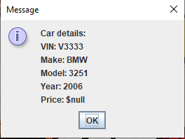

## DELETE

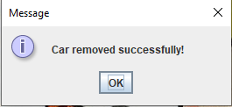

## FIND

## ADD

## ADD

## List cars

