End to end reproducible manuscript example

Silas Tittes and Kelly K

2018

Reproducibility matters. Let's learn how to do it together!

## Introduction

Something totally mind-blowing

## Methods

The mean flight distance is .

Python thinks it is important to report, .

## Results

Equations are good too (Fisher, 1919).

$$\sum_{e}^{2}{∣}\frac{θ}{λ}$$

The figure can be referenced in-text (1).

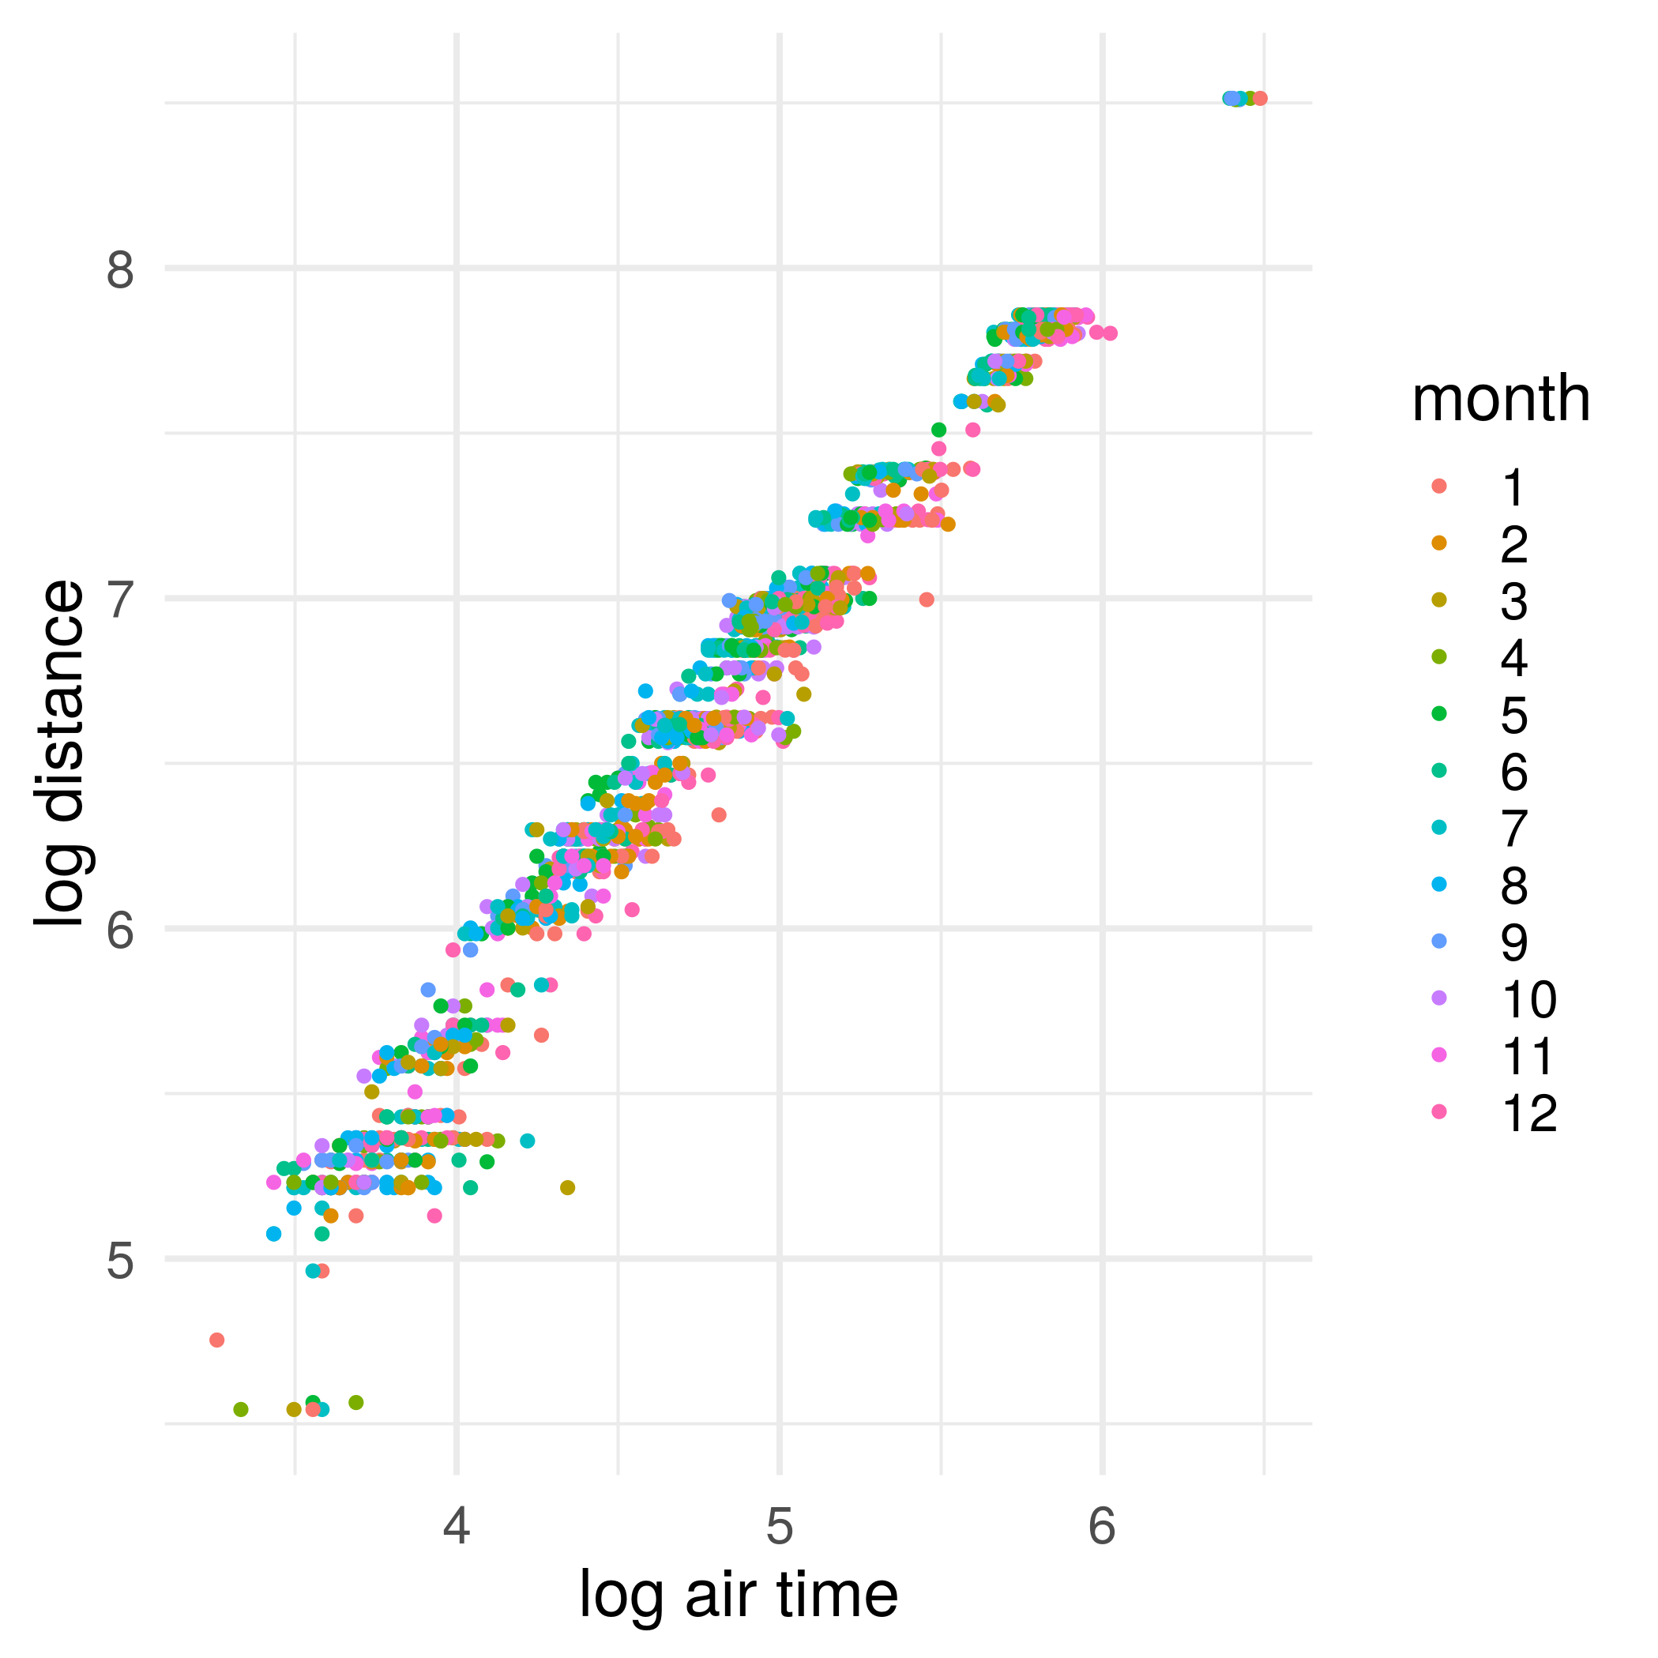

Figure 1: Something about flights

## Conclusion

Everything I know I learned from reading Fisher (1919).

## References

Fisher, R.A. (1919). XV.—The correlation between relatives on the supposition of mendelian inheritance. Earth and Environmental Science Transactions of the Royal Society of Edinburgh *52*, 399–433.