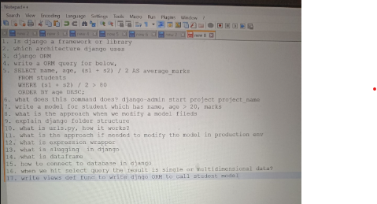

Explain in details of Authentication and authorisation in django? And how does it works with some examples?
Use of django project file?
When to Use WSGI or ASGI?
Session in django?
Models in django?
Custom model methods for additional functionalities.
Model inheritance to extend models.
Signals to execute actions on model changes.
Custom Model Methods – More advanced use cases like computed fields, instance methods, and class methods.
Model Inheritance – More real-world examples, use cases, and best practices.
Signals – More advanced use cases, such as logging changes, auditing models, or modifying related models dynamically.
Authentication – Custom authentication backends, token-based authentication (JWT, DRF auth).

API Development – Building REST APIs with Django REST Framework (DRF), serializers, views, and authentication.
Caching – Using Django caching for performance optimization.
Crud operation in django?
Cascade operation in Django?
How to find 2nd highest salary in SQL?
How to find 3rd highest salary in SQL?
Asgi and wsgi in django?
Middleware in django?
Admin.py files in django?
Django ORM?
Join in django?
How to handle left joins in django?
What is jinja template in django?
Token used in Django?

How to find 2nd highest salary in SQL?
How to find 3rd highest salary in SQL?
Abstraction in python?
Encapsulation in python?
Polymorphism in python?
Inheritance in python?
Which is faster list or Set in python?
What is hash table?
What is multithreading and Thread in Python?
What is static method in python? And its benefits or uses in the class?
How to handle errors without using try except in python?
Difference between dump and dumps method in python?
How to add element in tuple in python?
Overloading in python?
What is the meaning of use case from above sentence?
Explain Time complexity and space complexity in Python?
Pickling in python.
How to manage to push their code in git while many people working?
How to manage conflicts in git?
How to handle large datasets in python?
What is loc and iloc in pandas?
How to use joins in pandas?
What is df.concat()?
How to remove duplicate data in pandas?
how to find, count, and optionally visualize duplicates in a DataFrame before deleting them.
Count Duplicates in the Whole DataFrame?
Count Duplicates by Column?
View Duplicates?
Reverse list in many ways in python?
Copy method in python?
Sorting in python?
Method in string in python?
List of modules in python?
Pep in python?
Init method in python?
Doc string in python?
How to call SQL through API?
How to load large datasets like 10 GB CSV files in MYSQL database if memory is not sufficient?
Python Script: Chunked CSV to MySQL?
How to connect database in python?
How to select data from database and export to csv file in python?
What is multithreading in python?
Multithreading example with real time project in python?
Linked list in python?
Different types of sorting techniques in python?
SQL query to get list of employees whose projects started on same day?
SQL Query to get the list of departments and count of employees for the same?
SQL query to find 2nd highest salary from employee table belongs to particular department?
How to create a table from another table?
What is View in SQL?
Indexes?
How to delete duplicate data in sql?

Python programming:
arr1 = [0,1,0,0,0,1,1,1]
Find a subarray of maximum length which has equal number of 0 and 1?

Find all occurrences of the word "ERROR" in the logs and display the filenames and line numbers where they occur?
Count the number of times the word "404" appears in the access logs?
Extract and display all lines that contain IP addresses from the access logs?
Find and display all lines that contain the word "timeout" but exclude lines that contain the word "debug"?
Search for lines that contain the word "user" at the beginning of the line in the error logs?
How do you find all files within /var/log/webserver/ that have permissions 777 and change them to 755?
How can you add execute permissions to all log files for the owner without changing other existing permissions?

