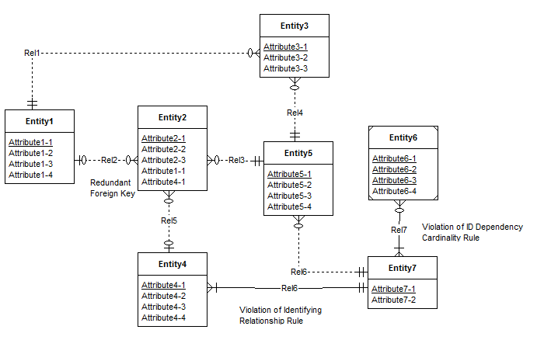

**Fig1: ERD showing the Rule violations**

Redundant Foreign Key : Attribute4-1 and Attribute1-1 in Entity2 is redundant with Rel5 and Rel2 respectively.

Violation of Identifying Relationship Rule: Rel6 is Identifying but but neither Entity4 nor Entity7 is a weak entity.

Violation of Identification Dependency cardinality Rule: The cardinality of Rel7 from Entity6 to Entity7 should be (1,1).

**Possible Resolutions:**

Redundant Foreign Key: Attribute4-1 and Attribute1-1 in Entity2 should be removed.

Identifying Relationship Rule: By adding a weak entity type or making the relationship non-identifying. Here the problem is resolved by making Rel6 relationship non-identifying.

Identification Dependency cardinality Rule: By changing the weak entity type’s cardinality to (1,1).

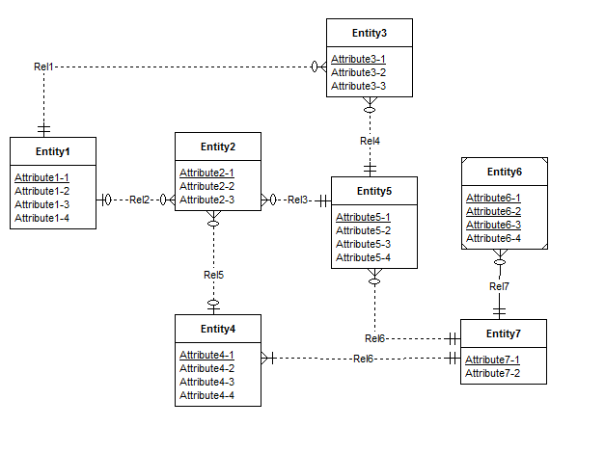

**Fig2: Rule violations of Fig1 corrected in this ERD**