Screenshots are positioned with the workflow steps they illustrate.
Structured guide based on the supplied specification, database design, workflow rules, and application screenshots.
Implementation, Configuration & Approval Workflow Guide

Performance Management Module

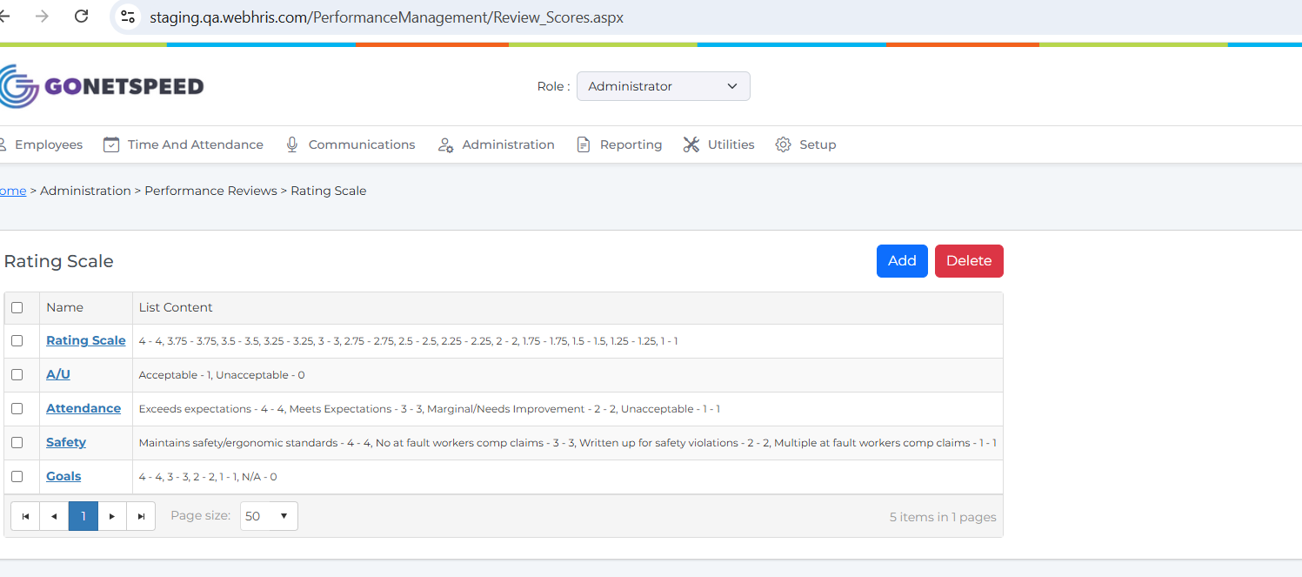
Screenshot – Performance Management Module

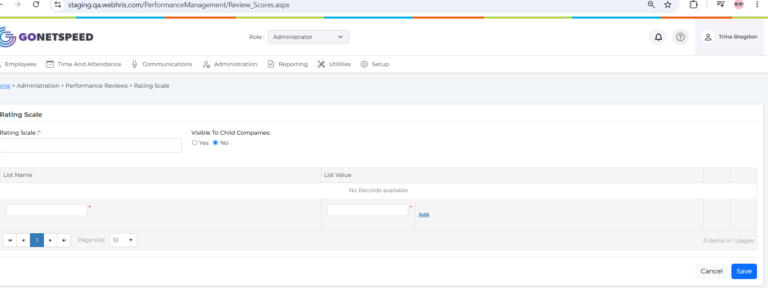
Screenshot – Performance Management Module

CREATE TABLE [dbo].[Review_Score_Content](
[ID] [int] IDENTITY(1,1) NOT NULL,
[Item_Name] [varchar](50) NULL,
[Item_Value] [float] NULL,
[Review_Score_ID] [int] NULL,
[Company] [int] NULL,
CONSTRAINT [PK_Review_Score_Content] PRIMARY KEY CLUSTERED
(
[ID] ASC
)WITH (PAD_INDEX = OFF, STATISTICS_NORECOMPUTE = OFF, IGNORE_DUP_KEY = OFF, ALLOW_ROW_LOCKS = ON, ALLOW_PAGE_LOCKS = ON, OPTIMIZE_FOR_SEQUENTIAL_KEY = OFF) ON [PRIMARY]
) ON [PRIMARY]

1. Rating Scale Setup

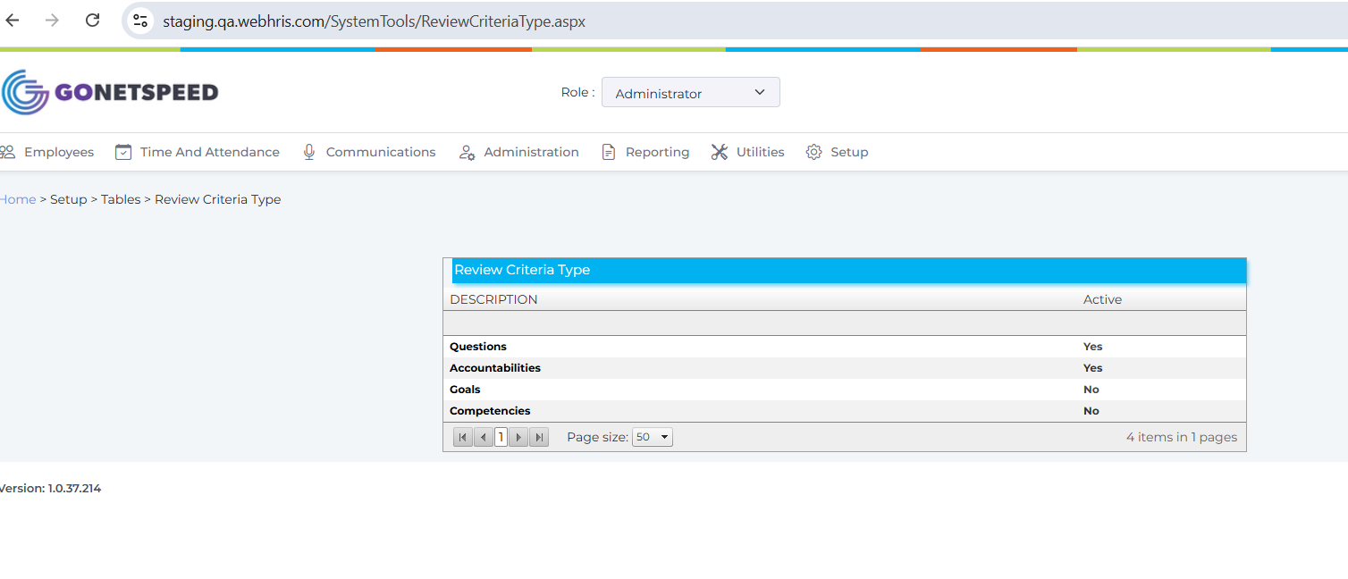
Screenshot – 1. Rating Scale Setup
CREATE TABLE [dbo].[PR_ReviewCriteriaType](
[ReviewCriteriaTypeID] [int] IDENTITY(1,1) NOT NULL,
[Description] [varchar](max) NULL,
[IsActive] [bit] NULL,
[CompanyID] [int] NULL,
CONSTRAINT [PK__PR_Revie__D0CA538D34BA25F0] PRIMARY KEY CLUSTERED
(
[ReviewCriteriaTypeID] ASC
)WITH (PAD_INDEX = OFF, STATISTICS_NORECOMPUTE = OFF, IGNORE_DUP_KEY = OFF, ALLOW_ROW_LOCKS = ON, ALLOW_PAGE_LOCKS = ON, OPTIMIZE_FOR_SEQUENTIAL_KEY = OFF) ON [PRIMARY],
CONSTRAINT [UQ__PR_Revie__D0CA538C28544F0B] UNIQUE NONCLUSTERED
(
[ReviewCriteriaTypeID] ASC
)WITH (PAD_INDEX = OFF, STATISTICS_NORECOMPUTE = OFF, IGNORE_DUP_KEY = OFF, ALLOW_ROW_LOCKS = ON, ALLOW_PAGE_LOCKS = ON, OPTIMIZE_FOR_SEQUENTIAL_KEY = OFF) ON [PRIMARY]
) ON [PRIMARY] TEXTIMAGE_ON [PRIMARY]

2. Review Criteria Type Setup

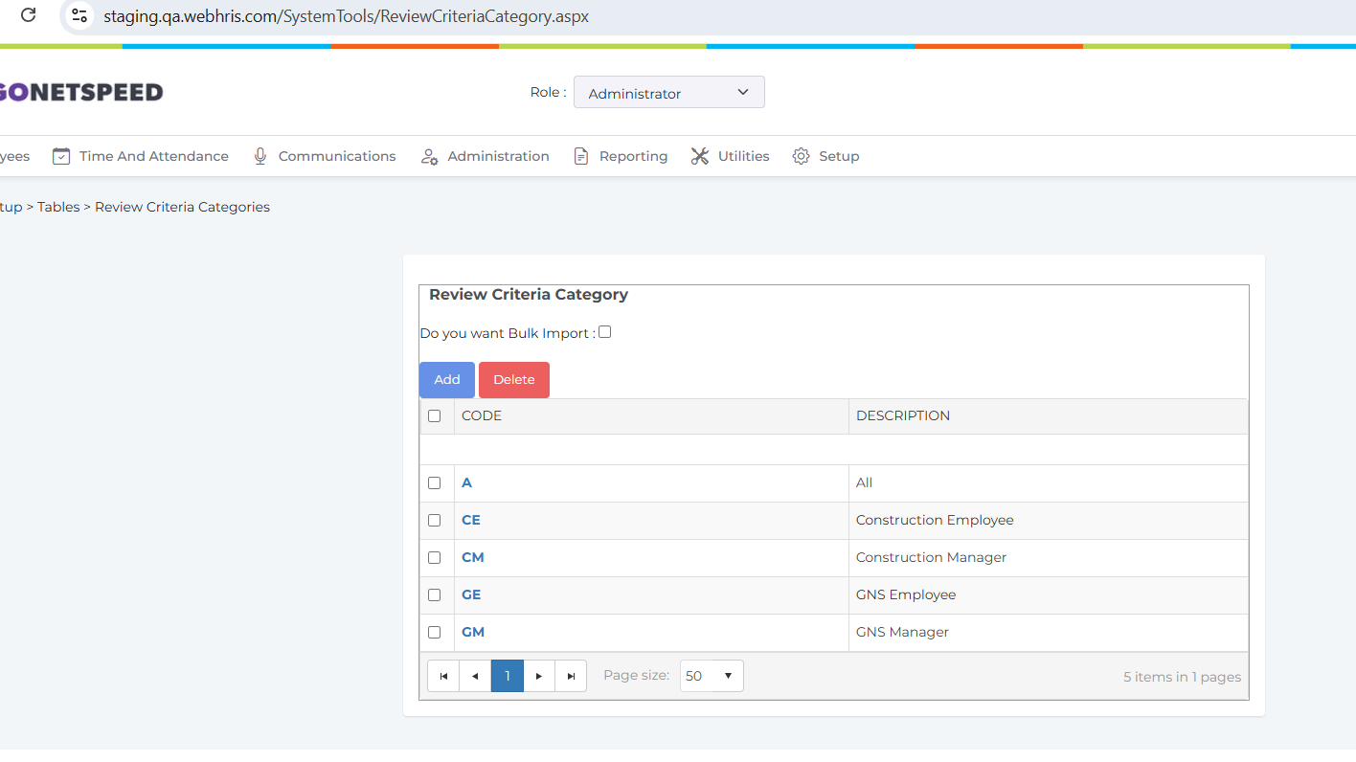
Screenshot – 2. Review Criteria Type Setup

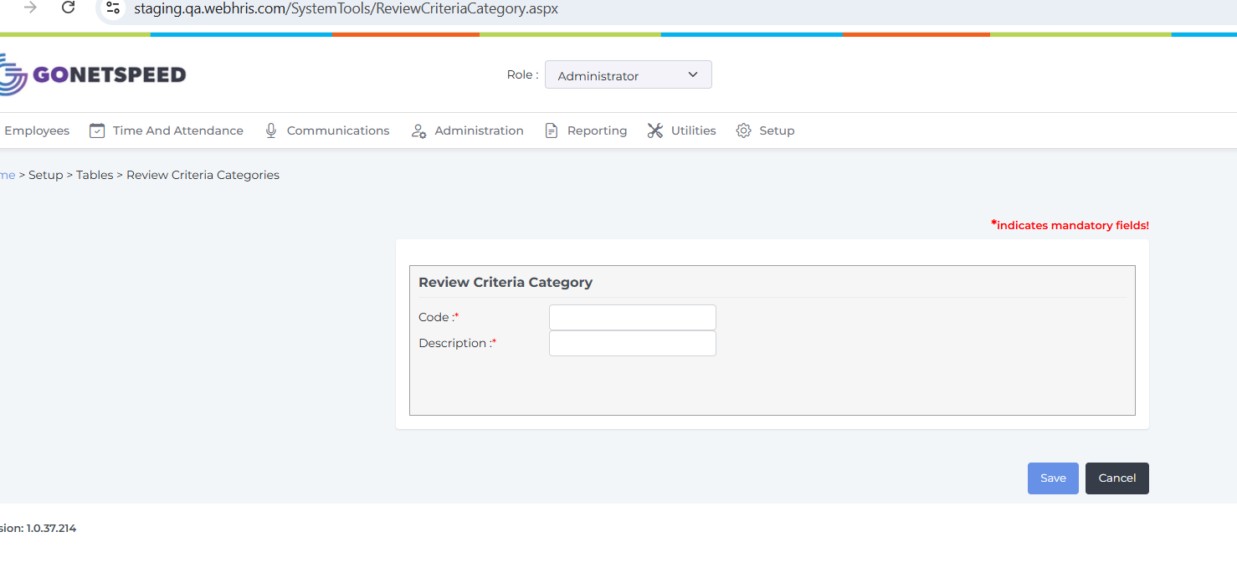
Screenshot – 2. Review Criteria Type Setup

CREATE TABLE [dbo].[PR_ReviewCriteriaType](
[ReviewCriteriaTypeID] [int] IDENTITY(1,1) NOT NULL,
[Description] [varchar](max) NULL,
[IsActive] [bit] NULL,
[CompanyID] [int] NULL,
CONSTRAINT [PK__PR_Revie__D0CA538D34BA25F0] PRIMARY KEY CLUSTERED
(
[ReviewCriteriaTypeID] ASC
)WITH (PAD_INDEX = OFF, STATISTICS_NORECOMPUTE = OFF, IGNORE_DUP_KEY = OFF, ALLOW_ROW_LOCKS = ON, ALLOW_PAGE_LOCKS = ON, OPTIMIZE_FOR_SEQUENTIAL_KEY = OFF) ON [PRIMARY],
CONSTRAINT [UQ__PR_Revie__D0CA538C28544F0B] UNIQUE NONCLUSTERED
(
[ReviewCriteriaTypeID] ASC
)WITH (PAD_INDEX = OFF, STATISTICS_NORECOMPUTE = OFF, IGNORE_DUP_KEY = OFF, ALLOW_ROW_LOCKS = ON, ALLOW_PAGE_LOCKS = ON, OPTIMIZE_FOR_SEQUENTIAL_KEY = OFF) ON [PRIMARY]
) ON [PRIMARY] TEXTIMAGE_ON [PRIMARY]

3. Review Criteria Setup

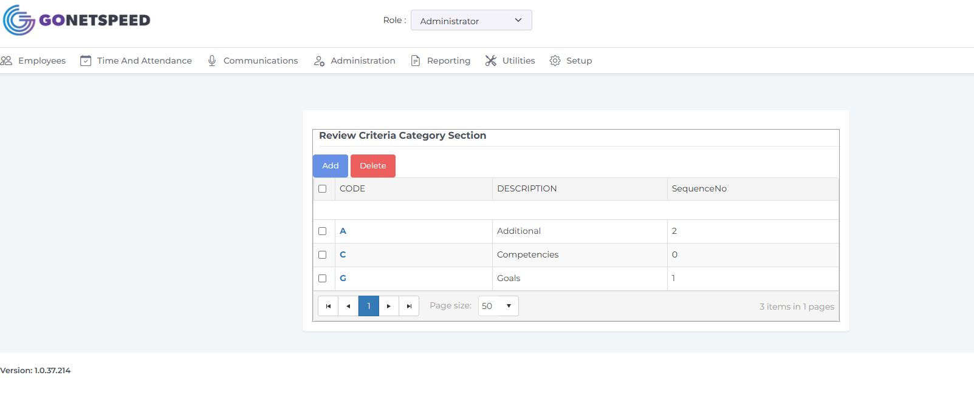
Screenshot – 3. Review Criteria Setup

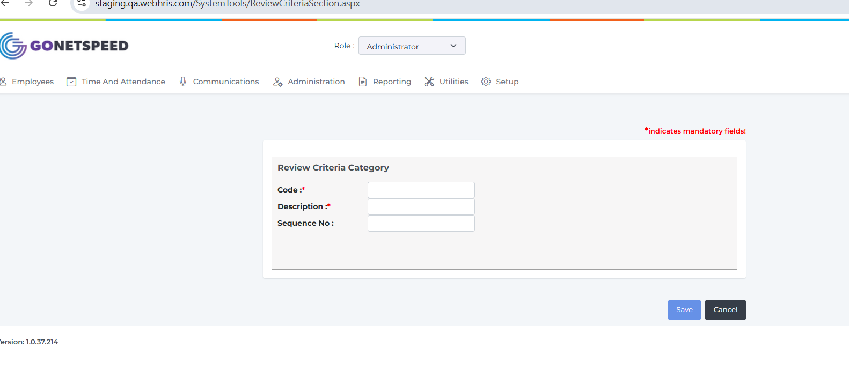
Screenshot – 3. Review Criteria Setup

CREATE TABLE [dbo].[HTABLES](
[ID] [int] IDENTITY(1,1) NOT NULL,
[HTABLES_TABLE] [varchar](20) NULL,
[CODE] [varchar](100) NULL,
[HTABLES_DESC] [nvarchar](1000) NULL,
[CompanyID] [int] NULL,
[IsActive] [bit] NULL,
CONSTRAINT [PK_HTABLES_1] PRIMARY KEY CLUSTERED
(
[ID] ASC
)WITH (PAD_INDEX = OFF, STATISTICS_NORECOMPUTE = OFF, IGNORE_DUP_KEY = OFF, ALLOW_ROW_LOCKS = ON, ALLOW_PAGE_LOCKS = ON, FILLFACTOR = 90, OPTIMIZE_FOR_SEQUENTIAL_KEY = OFF) ON [PRIMARY]
) ON [PRIMARY]

4. Review Criteria Section Setup
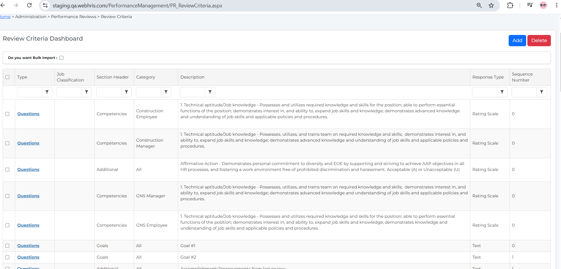
Screenshot – 4. Review Criteria Section Setup

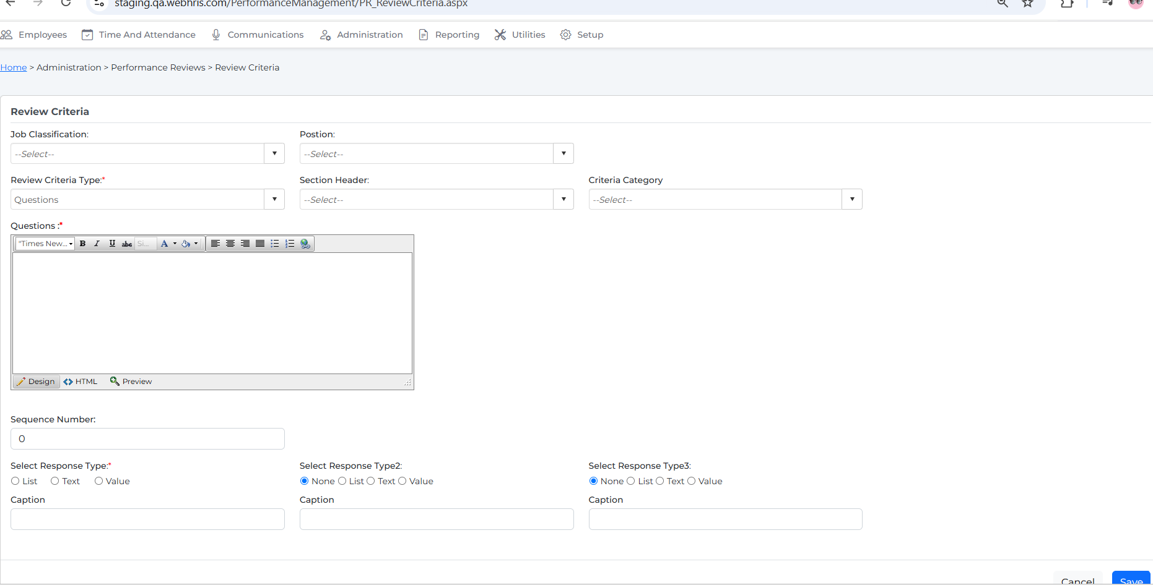
Screenshot – 4. Review Criteria Section Setup

Rule :
1. Job Classification is dropdown binding from Job Classification,
2.Postion is dropdown binding from position
3. Review Criteria Type is dropdown and binding above Review Criteria Type
4. Review Criteria sections is dropdown list binding from drop above screen
5. Criteria Category is dropdown binding from Criteria Category setup screen

CREATE TABLE [dbo].[PR_ReviewCriteria](
[ReviewCriteriaID] [int] IDENTITY(1,1) NOT NULL,
[CompanyID] [int] NULL,
[CriteriaTypeID] [int] NULL,
[JobTitleID] [int] NULL,
[PositionID] [int] NULL,
[CategoryID] [int] NULL,
[Description] [varchar](max) NULL,
[ResponseTypeID] [int] NULL,
[IsActive] [bit] NULL,
[ScoreID] [int] NULL,
[Comments] [varchar](max) NULL,
[ResponseTypeId2] [int] NULL,
[ScoreId2] [int] NULL,
[Caption1] [varchar](200) NULL,
[Caption2] [varchar](200) NULL,
[SectionHeaderId] [int] NULL,
[SequenceNumber] [int] NOT NULL,
[ResponseTypeId3] [int] NULL,
[ScoreId3] [int] NULL,
[Caption3] [varchar](200) NUL
)

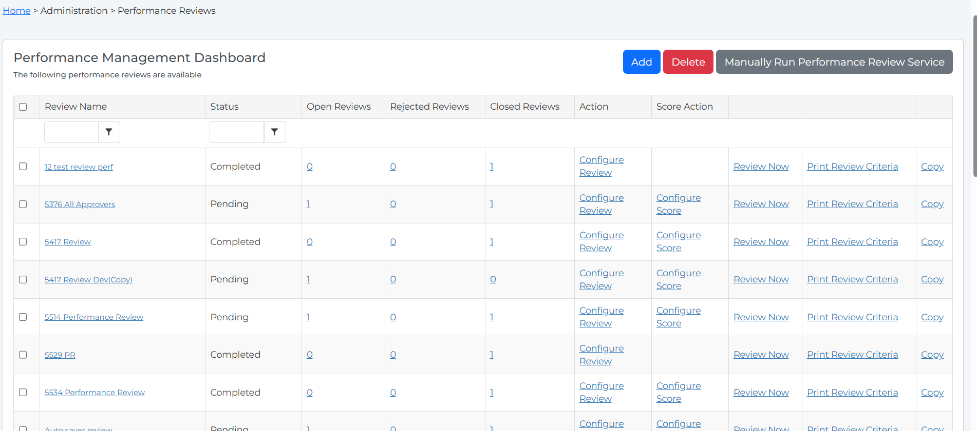
Screenshot – )

Rule :
1. when will click Add button below screen need to show
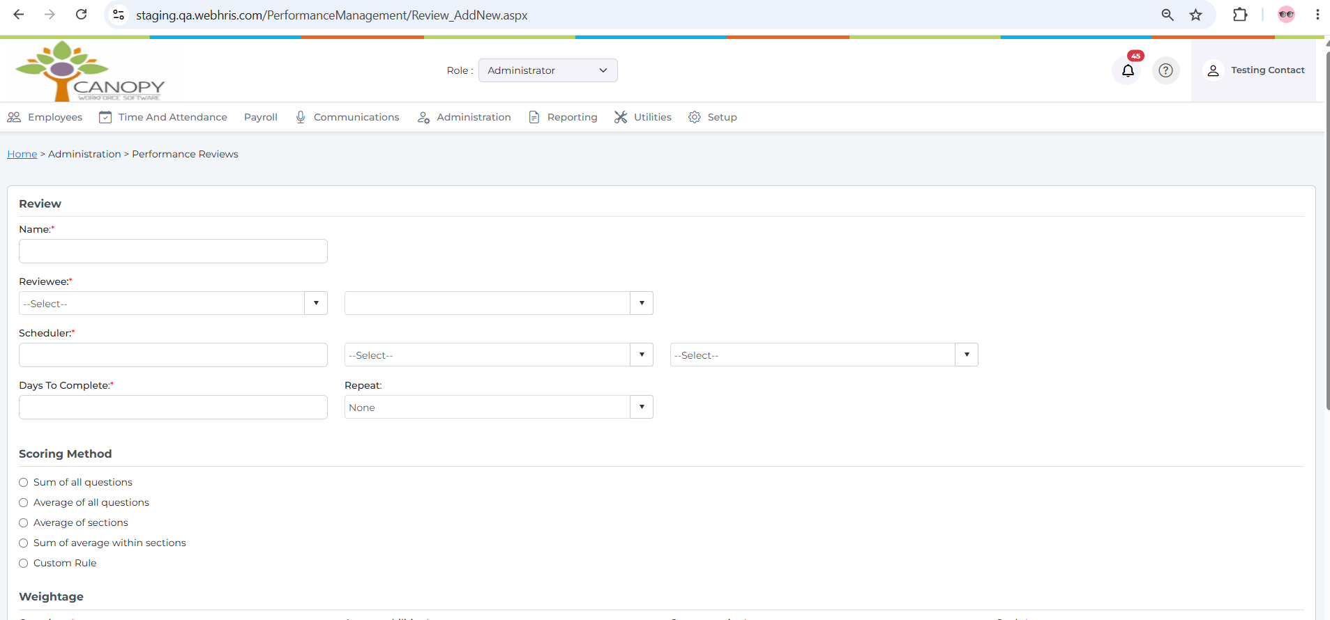
Screenshot – 1. when will click Add button below screen need to show
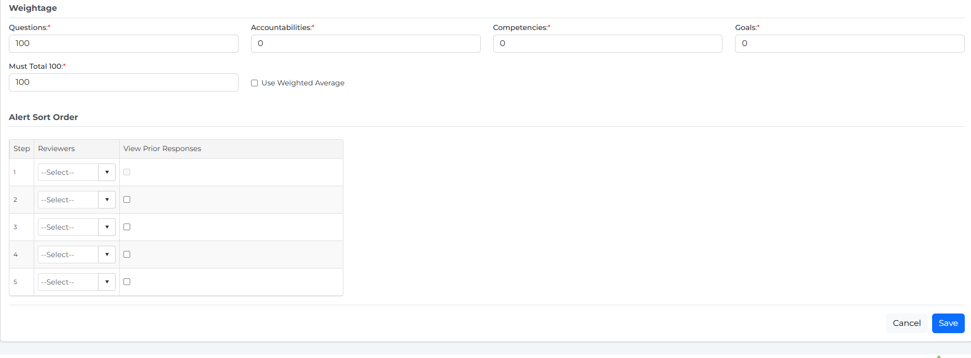
Screenshot – 1. when will click Add button below screen need to show

Rule :
- 5.1 Review Master Configuration
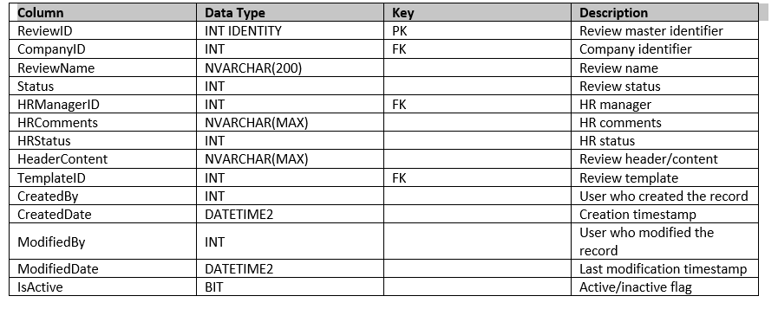
Screenshot – 5.1 Review Master Configuration
1.Reviewee: this fields a dropdown values (Employee, Position, Department, Review By supervisor)
2. Once select Employee next drop down binding the all employees in company with multiple selections.
3.After Scheduler dropdown binding the (Day,Week,Month)
4.Next dropdown binding the (Hire Date, Custom Date)
5. Once custom date select need to show calendar control select date
6.Drop down Repeat binding values (30 days, 90 days,180 days, Annually)
7. Admin can select drop down Approver1, Approver2,Other employee, Employee)
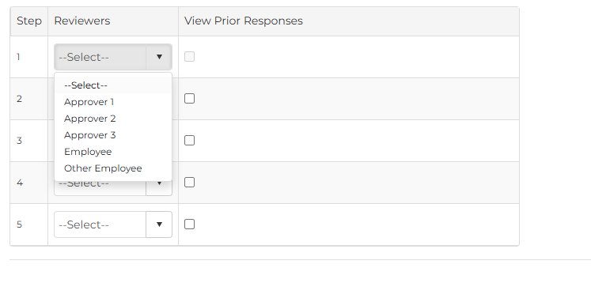
Screenshot – 7. Admin can select drop down Approver1, Approver2,Other employee, Employee)
8 Saved the Reviewreviewer – table (example ReviewerMasterID is approveer1, approver 2 ids etc ..
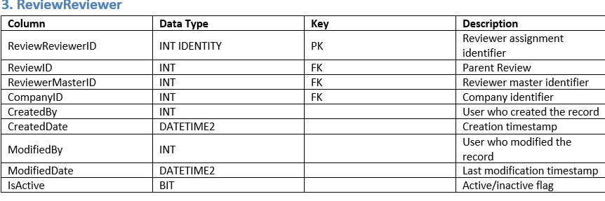
Screenshot – 8 Saved the Reviewreviewer – table (example ReviewerMasterID is approveer1, approver 2 ids etc
Rule :
1. steps 7 insert into ReviewNotificationStep table

Column | Data Type | Null | Key | Purpose
Id | INT IDENTITY(1,1) | No | PK | Unique notification-step ID
CompanyId | INT | Yes | FK* | Company associated with the review
ReviewId | INT | Yes | FK* | Review associated with the notification
StepId | INT | Yes | FK* | Review workflow/notification step
ReviewerId | INT | Yes | FK* | Reviewer associated with the step
IsViewPriorResponses | BIT | Yes |  | Determines whether the reviewer can view prior responses
CreatedBy | UNIQUEIDENTIFIER | No |  | User who created the record
CreatedOn | DATETIME | No |  | Record creation date/time
ModifiedBy | UNIQUEIDENTIFIER | Yes |  | User who last modified the record
ModifiedOn | DATETIME | Yes |  | Last modification date/time
2. Steps 3-4 can save this table and screen
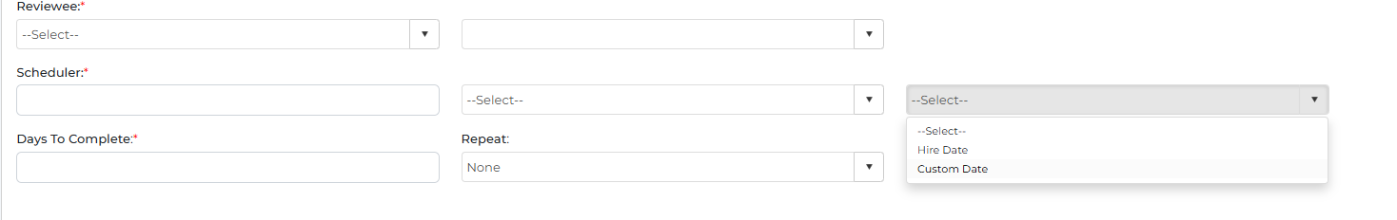
Screenshot – 2. Steps 3-4 can save this table and screen

5.3 Review Schedule
Column | Data Type | Nullable | Key | Description
ID | INT | No | PK* | Unique schedule record ID
ScheduleValue | INT | Yes |  | Numeric schedule value
Company | INT | Yes | FK* | Company associated with the schedule
IntervalType | CHAR(10) | Yes |  | Schedule interval type
FromSchedule | VARCHAR(MAX) | Yes |  | Schedule starting/reference value
FromDate | DATETIME | no |  | Schedule start date
Days_To_Complete | INT | no |  | Number of days allowed to complete the review
ReviewID | INT | Yes | FK* | Review associated with this schedule
Repeat | INT | No |  | Repeat interval/count

5.4 Scoring Rule Configuration

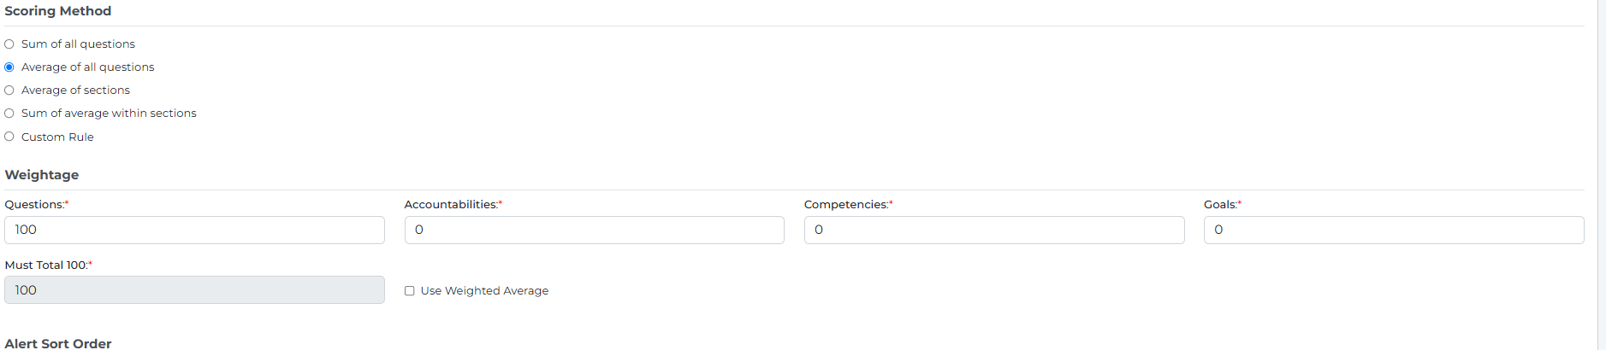
Screenshot – 5.4 Scoring Rule Configuration

CREATE TABLE [dbo].[ReviewScoringRule]
(
[ID] INT IDENTITY(1,1) NOT NULL,
[Question] FLOAT NULL,
[Accountability] FLOAT NULL,
[Competency] FLOAT NULL,
[Goal] FLOAT NULL,
[Review_ID] INT NULL,
[Company] INT NULL,
[WeightedAverage] BIT NULL,
[IsSumofallquestions] BIT NOT NULL,
[IsAverageofallquestions] BIT NOT NULL,
[IsAverageofsections] BIT NOT NULL,
[IsSumofaveragewithinsections] BIT NOT NULL,
[IsCustomRule] BIT NOT NULL,

CONSTRAINT [PK_ReviewScoringRule]
PRIMARY KEY CLUSTERED ([ID] ASC)
);
3. Steps 1-2 can save this table and screen ,

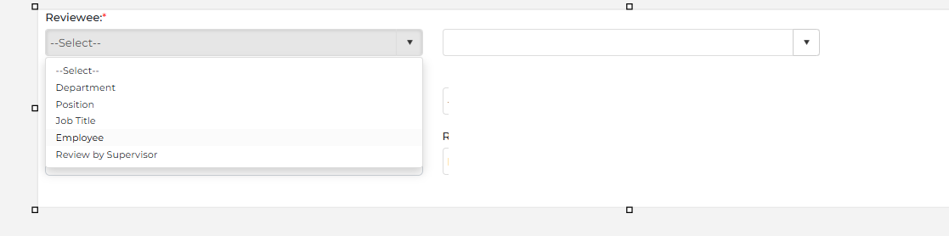
Screenshot – 3. Steps 1-2 can save this table and screen ,

5.5 Review Employee Details
Column | Data Type | Nullable | Key | Description
Id | INT | No | PK* | Unique record ID
CompanyId | INT | No | FK* | Company associated with the review
ReviewId | INT | No | FK* | Review associated with the employee
PositionId | INT | Yes | FK* | Employee's position
EmployeeId | UNIQUEIDENTIFIER | Yes | FK* | Employee/user identifier
DepartmentId | INT | Yes | FK* | Employee's department
JobTitleId | INT | Yes | FK* | Employee's job title
Createdby , createdon
Modifyedon , modifiedby

3. based on selection of Reviewee next dropdown binding (example if select employee then binding employee next dropdown with multiple selection employee.

6. Configure Review and Assign Criteria
2. Steps 7 select values binding dynamic this approver1, approver2, apprver3, other employee, employee.
3.When will click bule Add criteria button then open this Review Criteria page list , admin can select the review critriya for the approver 1 , approver 2 whichever the select on steps 7.
4. admin can select the appropriate questions from this screen and save .
5. select HR dropdown for particular performance

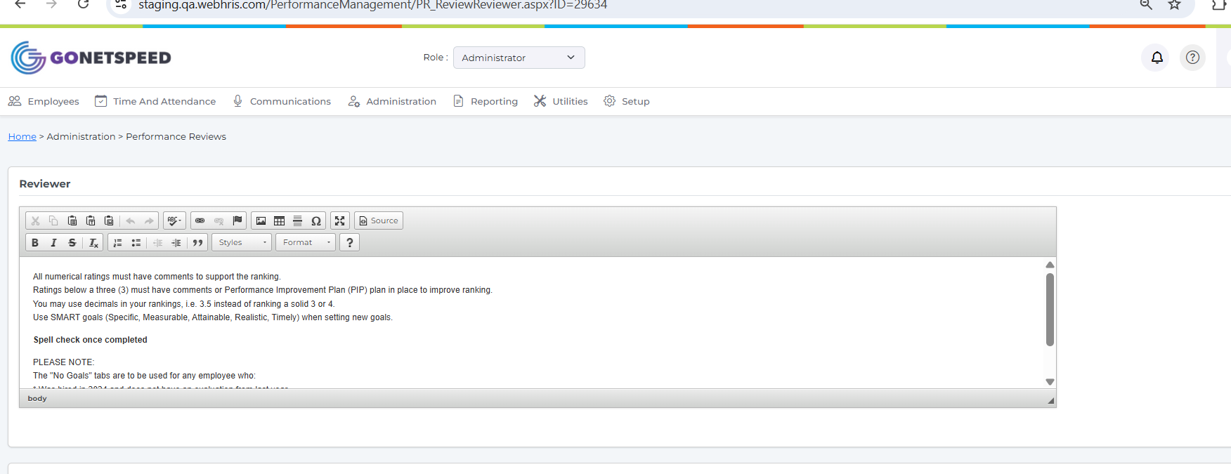
Screenshot – 5. select HR dropdown for particular performance
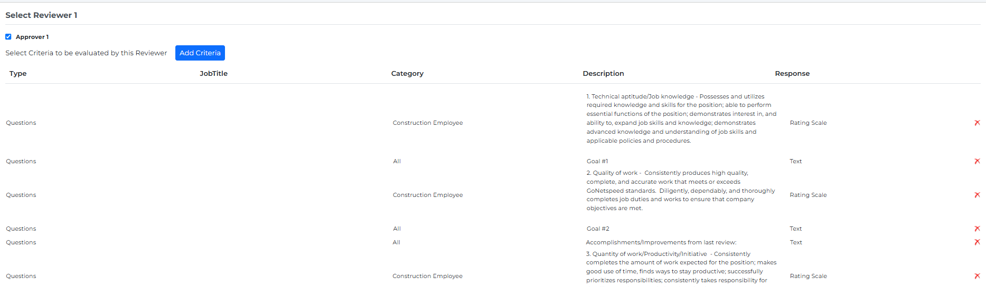
Screenshot – 5. select HR dropdown for particular performance

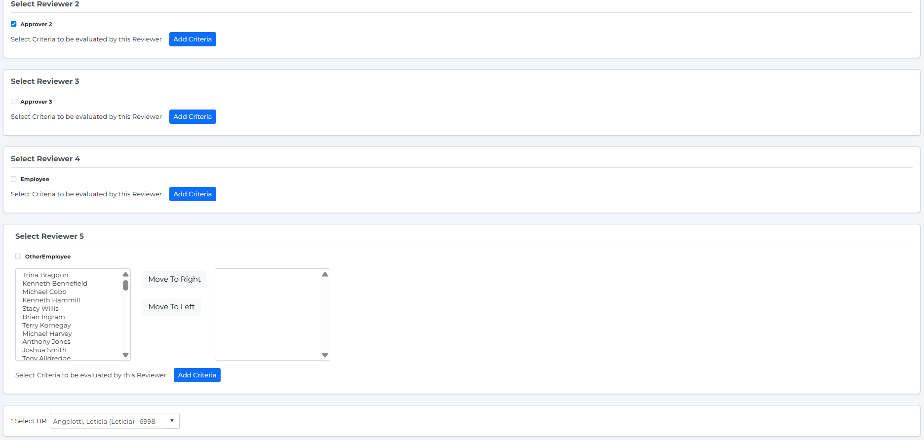
Screenshot – 5. select HR dropdown for particular performance

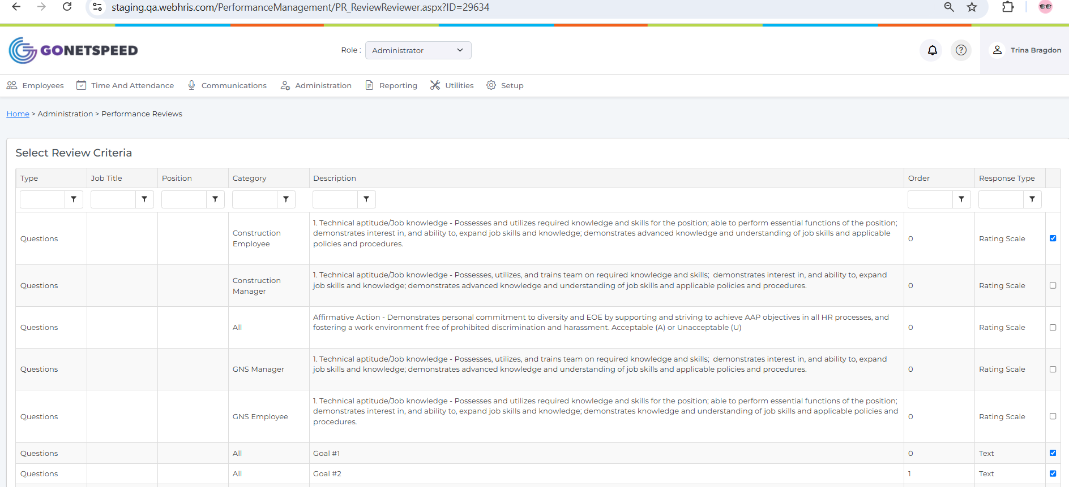
Screenshot – 5. select HR dropdown for particular performance

6.1 Save Reviewer Criteria
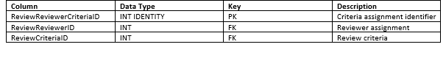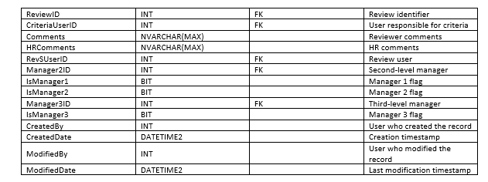
Screenshot – 6.1 Save Reviewer Criteria

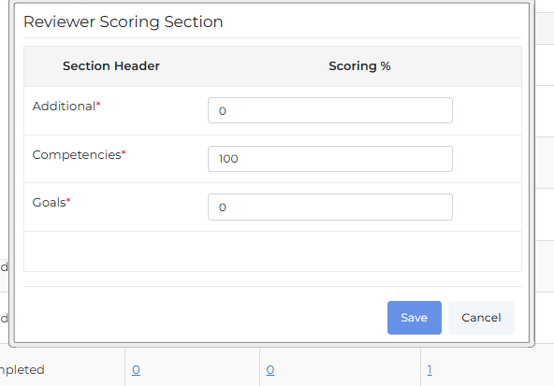
Screenshot – 6.1 Save Reviewer Criteria

6.2 Scoring Section Setup
Column | Data Type | Nullable | Key | Description
Id | INT IDENTITY(1,1) | No | PK | Unique scoring section ID
ReviewId | INT | Yes | FK* | Review associated with the scoring section
SectionHeaderId | INT | Yes | FK* | Section header associated with the score
Scorepercentage | DECIMAL(18,2) | Yes |  | Percentage/weight assigned to the section
CompanyId | INT | Yes | FK* | Company associated with the review
CreatedBy | UNIQUEIDENTIFIER | Yes |  | User who created the record
CreatedOn | DATETIME | Yes |  | Creation date/time
ModifiedBy | UNIQUEIDENTIFIER | Yes |  | User who last modified the record
ModifiedOn | DATETIME | Yes |  | Last modification date/time

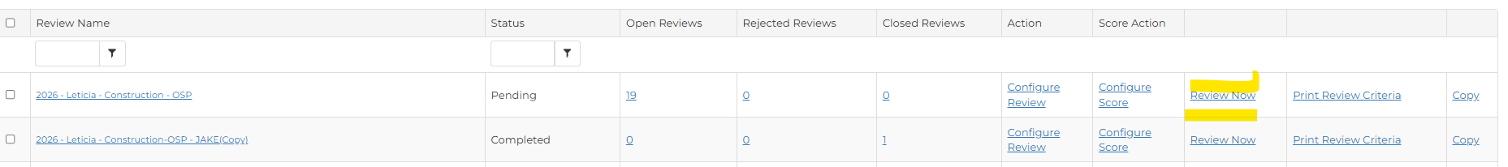
Screenshot – 6.2 Scoring Section Setup

7. Start Review / Send to First Approver
Below screen and checked. rule is custom date matched with system current date and scheduler is 0.
Screenshot – Below screen and checked. rule is custom date matched with system current date and scheduler is

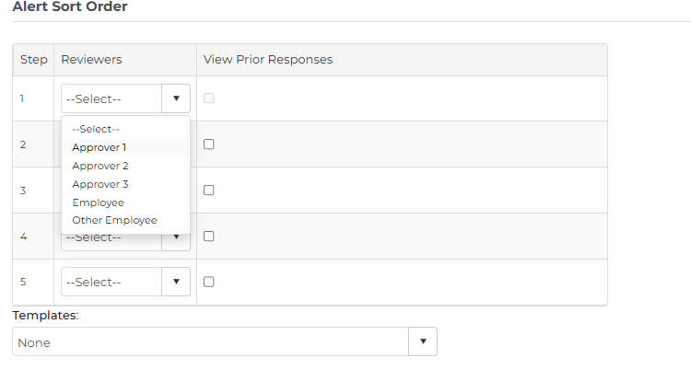
Screenshot – Below screen and checked. rule is custom date matched with system current date and scheduler is

Saved the default Records into this ReviewReviewerEmployee table .
And notification table insert. And approver 1 = Equal to Report to Positon from employee positon screen and same Approver 2 = Manager 2 and Approver 3 = Manager3 getting from employee position screen .

7.1 Notification Record and Email

CREATE TABLE [dbo].[notificatoninfo] ( [ID] INT NOT NULL, [UserID] UNIQUEIDENTIFIER NOT NULL, [CompanyId] INT NULL, [Event] VARCHAR(50) NOT NULL, [EventID] VARCHAR(100) NULL, [ReceivedOn] DATETIME NULL, [Contents] NVARCHAR(MAX) NULL, [BinaryData] IMAGE NULL, [ConfirmationNo] VARCHAR(8) NULL, [ConfirmedOn] DATETIME NULL, [HTable] VARCHAR(25) NULL );

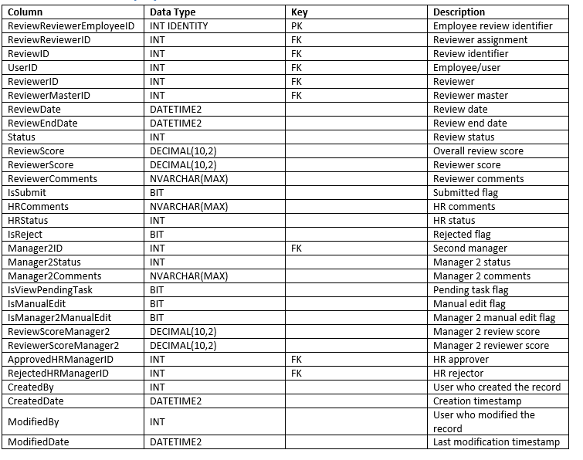
Screenshot – CREATE TABLE [dbo].[notificatoninfo] ( [ID] INT NOT NULL, [UserID] UNIQUEIDENTIFIER NOT NULL, [

Send notification email to approver
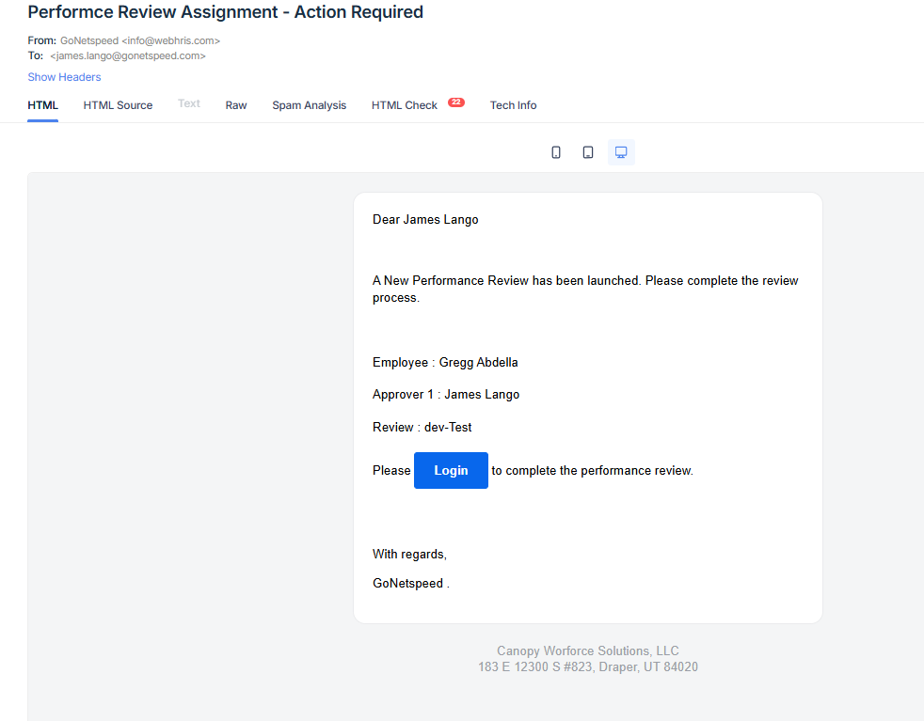
Screenshot – Send notification email to approver
For future scalability, approval-level information should preferably be moved into a separate ReviewApproval table rather than adding Manager4, Manager5, and additional manager-specific columns.

8. Approval Workflow

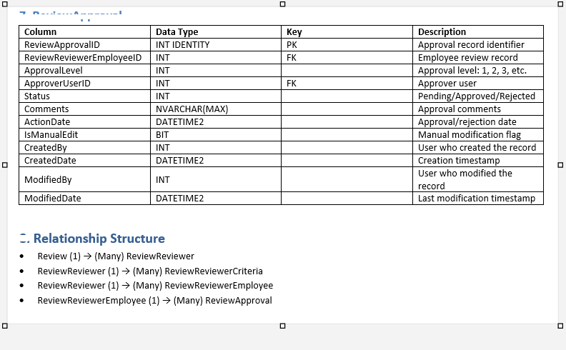
Screenshot – 8. Approval Workflow

- 8.1 Approver Notification and Task List
- Notification getting from notificatoninfo table.

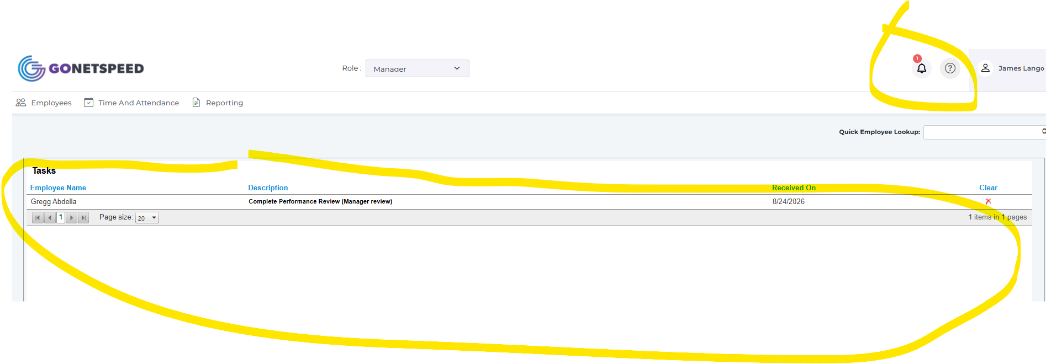
Screenshot – Notification getting from notificatoninfo table.

- 8.2 Performance Approval Screen

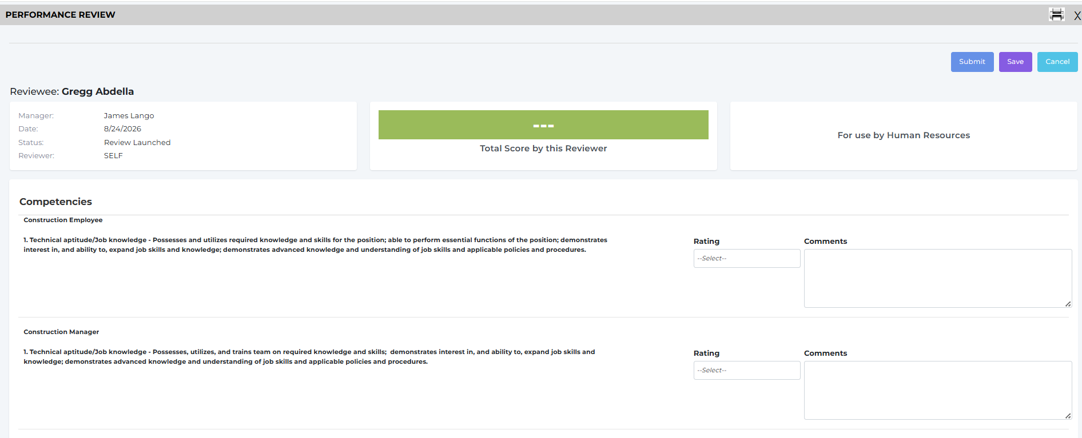
Screenshot – 8.2 Performance Approval Screen
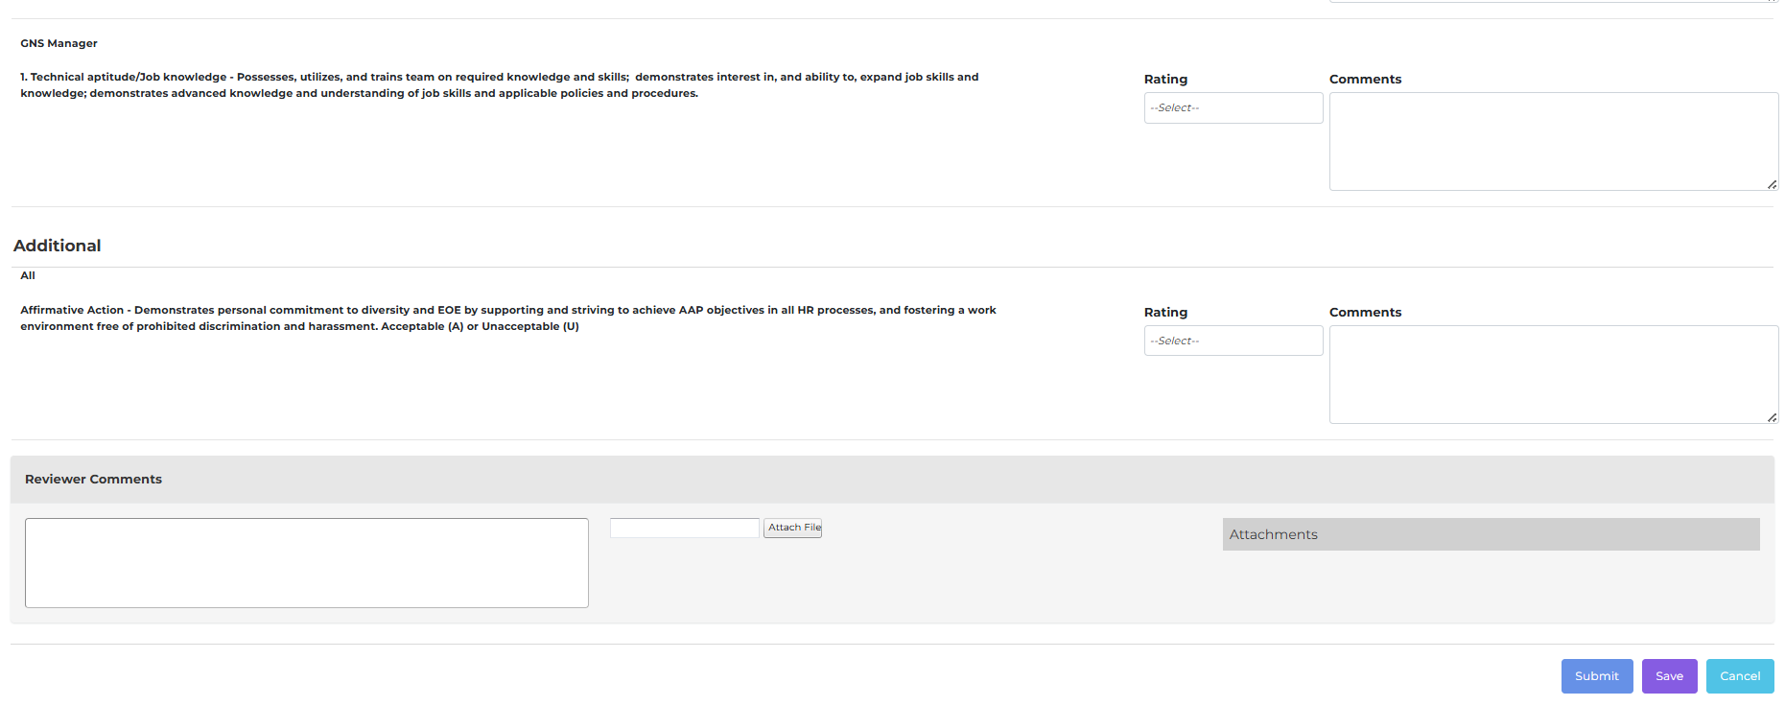
Screenshot – 8.2 Performance Approval Screen
- This screen binding from base on approver 1 setup Review Criteria setup done setup screen
- Admin can select review and add comments and each question and add reviewer comments if any attachment then and submit.
- Once submit then send to next approver to email and insert into notification tables
- Once save then just save the information admin can again back and submit as per his convince.
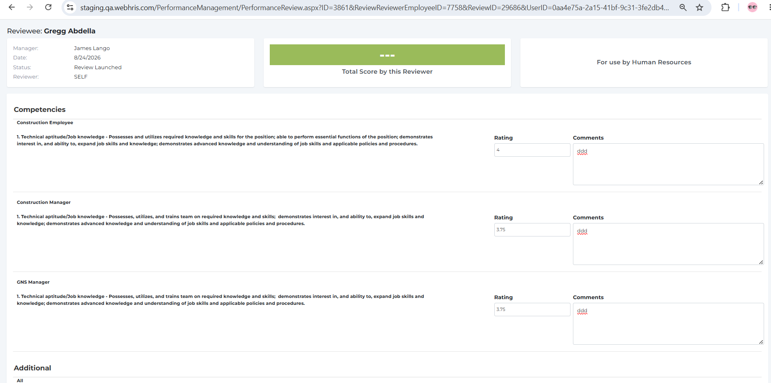
Screenshot – Once save then just save the information admin can again back and submit as per his convince.

8.3 Save Ratings and Reviewer Comments

CREATE TABLE [dbo].[PRReviewReviewerScoreDetails] ( [ID] INT IDENTITY(1,1) NOT NULL, [CompanyID] INT NULL, [ReviewReviewerEmployeeID] INT NULL, [ReviewCriteriaID] INT NULL, [Answers] VARCHAR(MAX) NULL, [ReviewReviewerID] INT NULL, [Answer2] VARCHAR(MAX) NULL, [Answer3] VARCHAR(MAX) NULL, [Manager2Answer1] VARCHAR(MAX) NULL, [Manager2Answer2] VARCHAR(MAX) NULL, [Manager2Answer3] VARCHAR(MAX) NULL, CONSTRAINT [PK_ReviewReviewerAnswers] PRIMARY KEY CLUSTERED ([ID] ASC) );

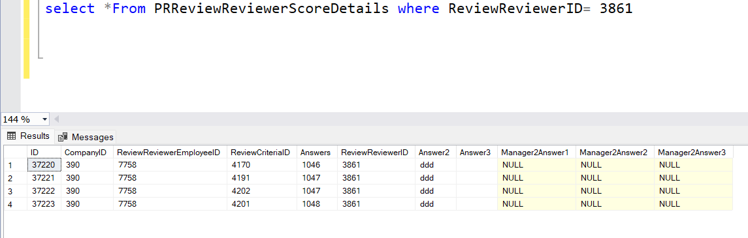
Screenshot – CREATE TABLE [dbo].[PRReviewReviewerScoreDetails] ( [ID] INT IDENTITY(1,1) NOT NULL, [CompanyID

- base on rating selection sun/avg based selection on setup screen calculate the total score by this Reviewer and once approved then hide the notification table to approver.

8.5 Reviewer Score Calculation Procedure

ALTER PROC [dbo].[PRCalculateReviewerScore] @CompanyID INT
,@ReviewReviewerID INT
,@ReviewReviewerEmployeeID INT
,@EmployeeId VARCHAR(50)
AS
BEGIN
--Declare @CompanyID INT=375,
-- @ReviewReviewerID INT=2469,
-- @ReviewReviewerEmployeeID INT =2735
DECLARE @ResponseTypeID INT
,@ResponseTypeId2 INT
,@ResponseTypeId3 INT
,@ReviewCriteriaID INT
,@ReviewId INT
,@IsWeightedAvg BIT = 0
DECLARE @TblResponseTypeID TABLE (
id INT IDENTITY(1, 1)
,responsetypeid INT
,responsetypeid2 INT
,responseTypeId3 INT
,reviewcriteriaid DECIMAL(8, 2)
)
DECLARE @TblReviewerScore TABLE (
id INT IDENTITY(1, 1)
,reviewerscore DECIMAL(8, 2)
)

SELECT @IsWeightedAvg = weightedaverage
,@ReviewId = a.id
FROM review a
INNER JOIN reviewreviewer b ON b.reviewid = a.id
INNER JOIN review_type_score c ON c.review_id = a.id
WHERE b.id = @ReviewReviewerID

--select @IsWeightedAvg
IF @IsWeightedAvg = 1
BEGIN
INSERT INTO @TblReviewerScore (reviewerscore)
EXEC [Prcalculatereviewscorebyweightedavg] @ReviewId
,@CompanyID
,@ReviewReviewerEmployeeID
END
ELSE
BEGIN
INSERT INTO @TblResponseTypeID (
reviewcriteriaid
,responsetypeid
,responsetypeid2
,responseTypeId3
)
SELECT DISTINCT C.reviewcriteriaid
,C.responsetypeid
,C.responsetypeid2
,C.ResponseTypeId3
FROM reviewreviewer A
INNER JOIN reviewreviewercriteria B ON A.id = B.reviewreviewerid AND B.RevSUserID = @EmployeeId
INNER JOIN pr_reviewcriteria C ON C.reviewcriteriaid = B.reviewcriteriaid
LEFT OUTER JOIN jduties D ON C.description = CONVERT(VARCHAR(200), D.id)
WHERE A.id = @ReviewReviewerID and A.ReviewID = @ReviewId

DECLARE @RowCount INT
DECLARE @I INT

SET @RowCount = (
SELECT Count(*)
FROM @TblResponseTypeID
)
SET @I = 1

WHILE (@I <= @RowCount)
BEGIN
(
SELECT @ResponseTypeID = responsetypeid
,@ReviewCriteriaID = reviewcriteriaid
,@ResponseTypeId2 = responsetypeid2
,@ResponseTypeId3 = responsetypeid3
FROM @TblResponseTypeID
WHERE id = @I
)

IF (
@ResponseTypeID = 1
OR @ResponseTypeId2 = 1
OR @ResponseTypeId3 = 1
)
BEGIN
INSERT INTO @TblReviewerScore (reviewerscore)
SELECT Isnull(Avg(I.item_value), 0) + Isnull(Avg(K.item_value), 0) + Isnull(Avg(L.item_value), 0) AS ReviewerScore
FROM prreviewreviewerscoredetails A
LEFT OUTER JOIN review_score_content I ON CONVERT(VARCHAR(100), I.id) = CONVERT(VARCHAR(100), A.answers)
LEFT OUTER JOIN review_score_content K ON CONVERT(VARCHAR(100), K.id) = CONVERT(VARCHAR(100), A.answer2)
LEFT OUTER JOIN review_score_content L ON CONVERT(VARCHAR(100), L.id) = CONVERT(VARCHAR(100), A.answer3)
WHERE A.reviewreviewerid = @ReviewReviewerID
AND A.companyid = @CompanyID
AND A.reviewrevieweremployeeid = @ReviewReviewerEmployeeID
AND A.reviewcriteriaid = @ReviewCriteriaID
END

IF (
@ResponseTypeID = 3
OR @ResponseTypeID2 = 3
OR @ResponseTypeID3 = 3
)
BEGIN
INSERT INTO @TblReviewerScore (reviewerscore)
SELECT CASE
WHEN B.responsetypeid = 3
THEN CONVERT(DECIMAL(8, 2), A.answers)
ELSE 0.0
END + CASE
WHEN B.responsetypeid2 = 3
THEN CONVERT(DECIMAL(8, 2), A.Answer2)
ELSE 0
END + CASE
WHEN B.responsetypeid3 = 3
THEN CONVERT(DECIMAL(8, 2), A.Answer3)
ELSE 0
END AS REVIEWSCORE
FROM prreviewreviewerscoredetails A
INNER JOIN pr_reviewcriteria B ON A.reviewcriteriaid = B.reviewcriteriaid
WHERE A.reviewreviewerid = @ReviewReviewerID
AND A.companyid = @CompanyID
AND A.reviewrevieweremployeeid = @ReviewReviewerEmployeeID
--AND B.responsetypeid = 3
AND B.reviewcriteriaid = @ReviewCriteriaID
END

SET @I = @I + 1
END
END

SELECT Sum(reviewerscore) AS ReviewerScore
FROM @TblReviewerScore
END
ALTER PROC [dbo].[PRCalculateReviewScoreByWeightedAvg] @ReviewId INT
,@CompanyID INT
,@ReviewReviewerEmployeeID INT
AS
BEGIN
--DECLARE @ReviewId int = 2571,
-- @CompanyID int = 375,
-- @ReviewReviewerEmployeeID int = 2735
DECLARE @ResponseTypeID INT
DECLARE @ReviewCriteriaID INT
DECLARE @ResponseTypeID2 INT
DECLARE @ResponseTypeID3 INT
DECLARE @TblResponseTypeID TABLE (
ID INT IDENTITY(1, 1)
,ReviewCriteriaID INT
,ResponseTypeID INT
,responsetypeid2 INT
,responseTypeId3 INT
)
DECLARE @TblReviewScore TABLE (
ID INT IDENTITY(1, 1)
,ReviewScore DECIMAL(18, 2)
)

INSERT INTO @TblResponseTypeID (
ReviewCriteriaID
,ResponseTypeID
,responsetypeid2
,responseTypeId3
)
SELECT C.ReviewCriteriaID
,C.ResponseTypeID
,C.ResponseTypeId2
,C.ResponseTypeId3
FROM ReviewReviewerEmployee RRE
INNER JOIN ReviewReviewer A ON RRE.ReviewReviewerID = A.ID
INNER JOIN ReviewReviewerCriteria B ON A.ID = B.ReviewReviewerID AND B.RevSUserID = RRE.UserID
INNER JOIN PR_ReviewCriteria C ON C.ReviewCriteriaID = B.ReviewCriteriaID
LEFT OUTER JOIN JDuties D ON C.Description = CONVERT(VARCHAR(200), D.ID)
WHERE A.ReviewID = @ReviewId
AND RRE.ID = @ReviewReviewerEmployeeID
GROUP BY C.ReviewCriteriaID
,C.ResponseTypeID
,C.ResponseTypeId2
,C.ResponseTypeId3

DECLARE @RowCount INT
DECLARE @I INT

SET @RowCount = (
SELECT COUNT(*)
FROM @TblResponseTypeID
)
SET @I = 1

WHILE (@I <= @RowCount)
BEGIN
(
SELECT @ResponseTypeID = ResponseTypeID
,@ReviewCriteriaID = ReviewCriteriaID
,@ResponseTypeID2 = responsetypeid2
,@ResponseTypeID3 = responseTypeId3
FROM @TblResponseTypeID
WHERE ID = @I
)

IF (@ResponseTypeID = 1
OR @ResponseTypeID2 = 1
OR @ResponseTypeID3 = 1)
BEGIN
INSERT INTO @TblReviewScore (ReviewScore)
SELECT ReviewScore = (
CASE
WHEN G.Description = 'Accountabilities'
THEN SUM(H.Item_Value + CONVERT(DECIMAL(10, 4), ISNULL(NULLIF(J.Item_Value, ''), '0')) + CONVERT(DECIMAL(10, 4), ISNULL(NULLIF(K.Item_Value, ''), '0'))) * AVG(I.Accountability)
ELSE SUM(H.ITEM_VALUE + CONVERT(DECIMAL(10, 4), ISNULL(NULLIF(J.Item_Value, ''), '0')) + CONVERT(DECIMAL(10, 4), ISNULL(NULLIF(K.Item_Value, ''), '0'))) * AVG(I.Question)
END
) / 100
FROM ReviewReviewerEmployee A
INNER JOIN ReviewReviewerEmployee D ON D.UserID = A.UserID
AND A.ID = D.ID
INNER JOIN ReviewReviewer B ON D.ReviewReviewerID = B.ID
INNER JOIN Review C ON B.ReviewID = C.ID
INNER JOIN PRReviewReviewerScoreDetails E ON E.ReviewReviewerEmployeeID = D.ID
INNER JOIN PR_ReviewCriteria F ON F.ReviewCriteriaID = E.ReviewCriteriaID
INNER JOIN PR_ReviewCriteriaType G ON F.CriteriaTypeID = G.ReviewCriteriaTypeID
INNER JOIN Review_Score_Content H ON CONVERT(VARCHAR(max), H.ID) = E.Answers
LEFT OUTER JOIN Review_Score_Content J ON CONVERT(VARCHAR(max), J.ID) = E.Answer2
LEFT OUTER JOIN Review_Score_Content K ON CONVERT(VARCHAR(max), K.ID) = E.Answer3
INNER JOIN Review_Type_Score I ON I.Review_ID = C.ID
WHERE C.ID = @ReviewId
AND C.Company = @CompanyID
AND A.ID = @ReviewReviewerEmployeeID
AND F.ReviewCriteriaID = @ReviewCriteriaID
GROUP BY G.Description
END

IF (
@ResponseTypeID = 3
OR @ResponseTypeID2 = 3
OR @ResponseTypeID3 = 3
)
BEGIN
INSERT INTO @TblReviewScore (ReviewScore)
SELECT ReviewScore = (
CASE
WHEN G.Description = 'Accountabilities'
THEN (
CASE
WHEN B.responsetypeid = 3
THEN CONVERT(DECIMAL(8, 2), A.answers)
ELSE 0.0
END + CASE
WHEN B.responsetypeid2 = 3
THEN CONVERT(DECIMAL(8, 2), A.Answer2)
ELSE 0
END + CASE
WHEN B.responsetypeid3 = 3
THEN CONVERT(DECIMAL(8, 2), A.Answer3)
ELSE 0
END
) * AVG(I.Accountability)
ELSE (
CASE
WHEN B.responsetypeid = 3
THEN CONVERT(DECIMAL(8, 2), A.answers)
ELSE 0.0
END + CASE
WHEN B.responsetypeid2 = 3
THEN CONVERT(DECIMAL(8, 2), A.Answer2)
ELSE 0
END + CASE
WHEN B.responsetypeid3 = 3
THEN CONVERT(DECIMAL(8, 2), A.Answer3)
ELSE 0
END
) * AVG(I.Question)
END
) / 100
FROM PRReviewReviewerScoreDetails A
INNER JOIN PR_ReviewCriteria B ON A.ReviewCriteriaID = B.ReviewCriteriaID
INNER JOIN PR_ReviewCriteriaType G ON B.CriteriaTypeID = G.ReviewCriteriaTypeID
INNER JOIN Review_Type_Score I ON I.Review_ID = @ReviewId
WHERE A.CompanyID = @CompanyID
AND A.ReviewReviewerEmployeeID = @ReviewReviewerEmployeeID
--AND B.ResponseTypeID = 3
AND B.ReviewCriteriaID = @ReviewCriteriaID
GROUP BY G.Description
,A.Answers
,A.Answer2
,A.Answer3
,B.responsetypeid
,B.responsetypeid2
,B.responsetypeid3
END

SET @I = @I + 1
END

SELECT Sum(ReviewScore) AS ReviewScore
FROM @TblReviewScore
END

9. Second Approver Workflow

Getting the second approver 2 and login and see the task and approved again.
Note: this example approver 1 and approver2 .

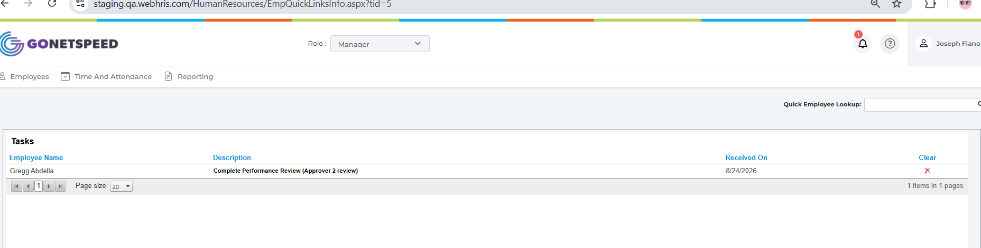
Screenshot – Note: this example approver 1 and approver2 .

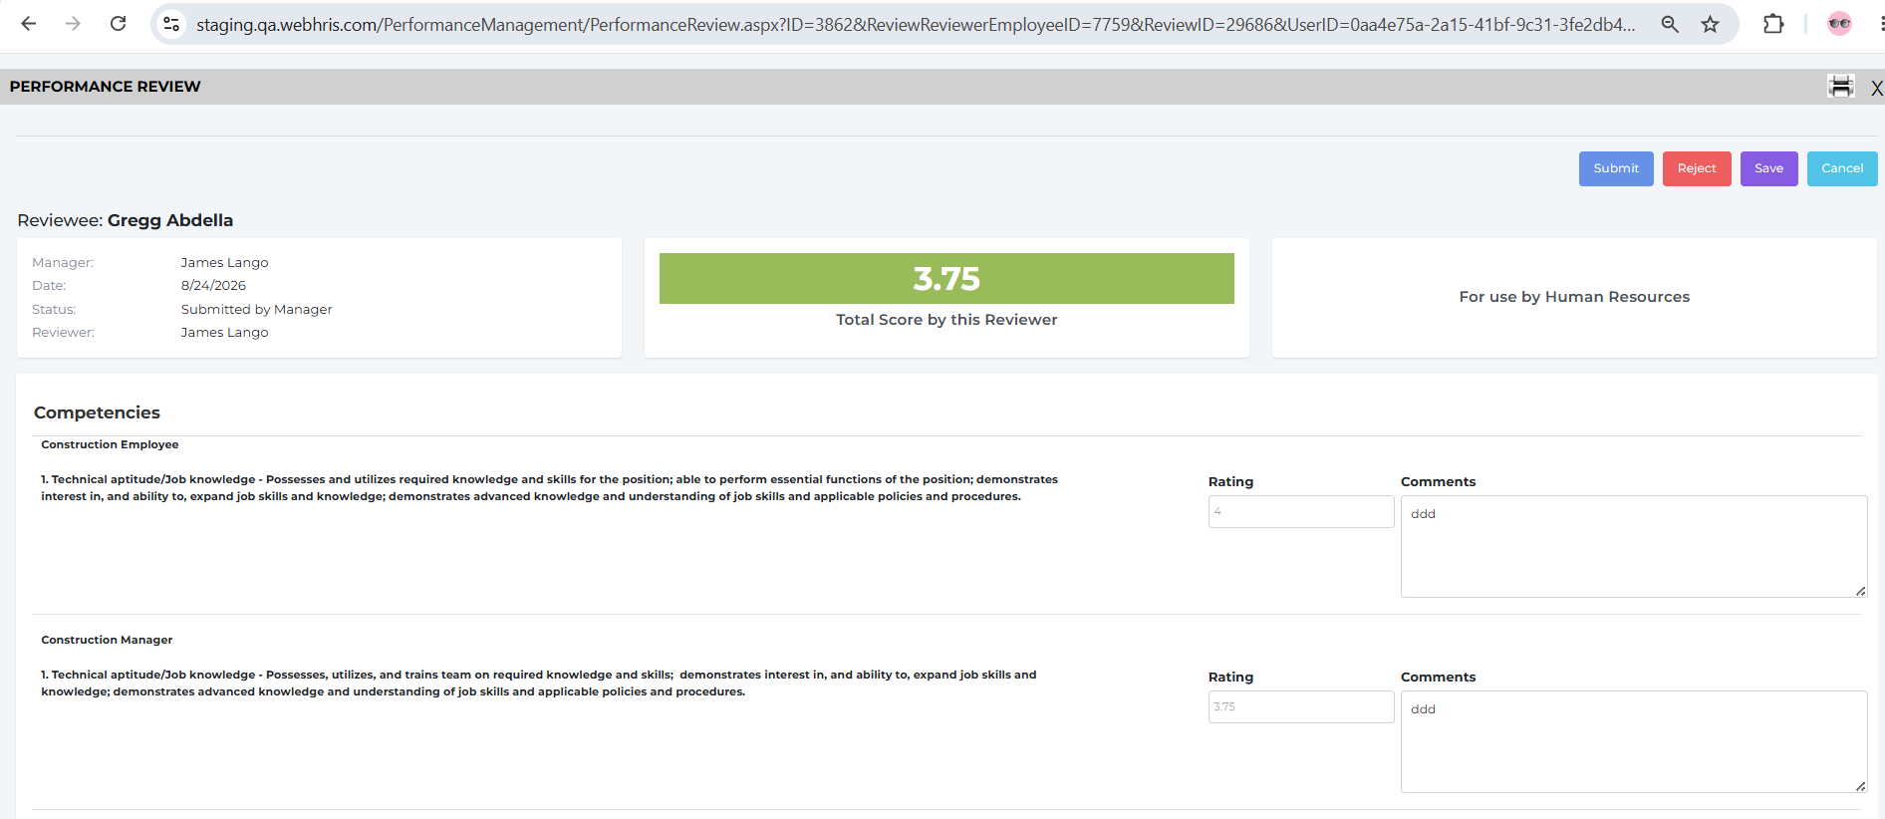
Screenshot – Note: this example approver 1 and approver2 .
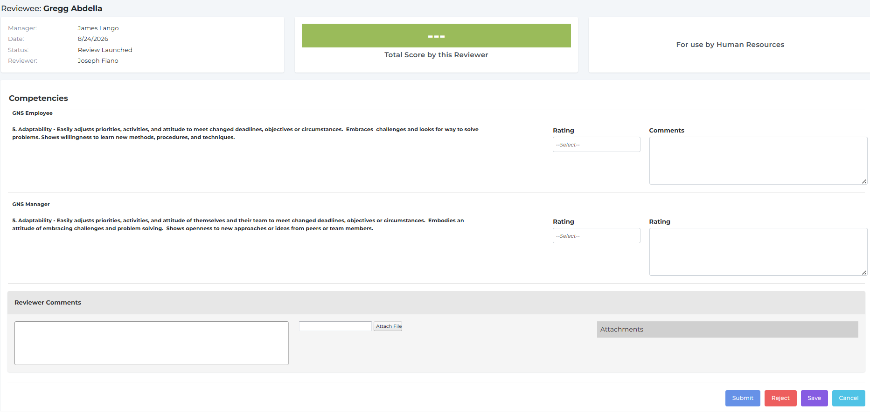
Screenshot – Note: this example approver 1 and approver2 .

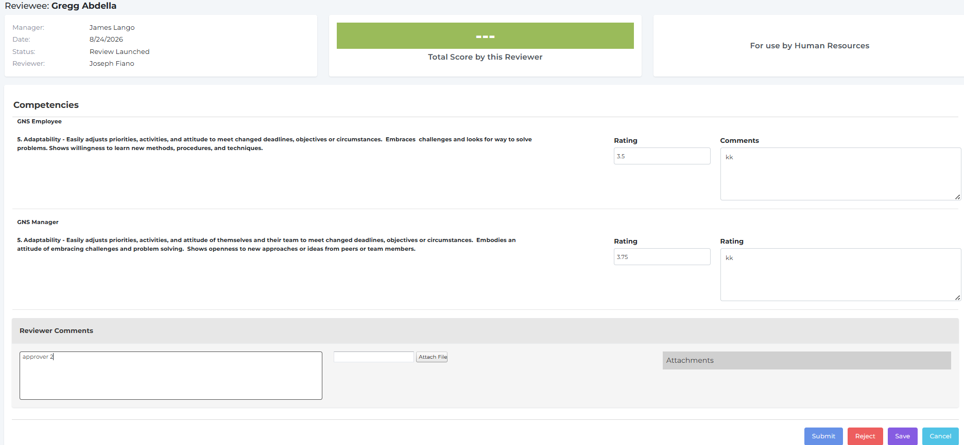
Screenshot – Note: this example approver 1 and approver2 .

10. HR Final Review

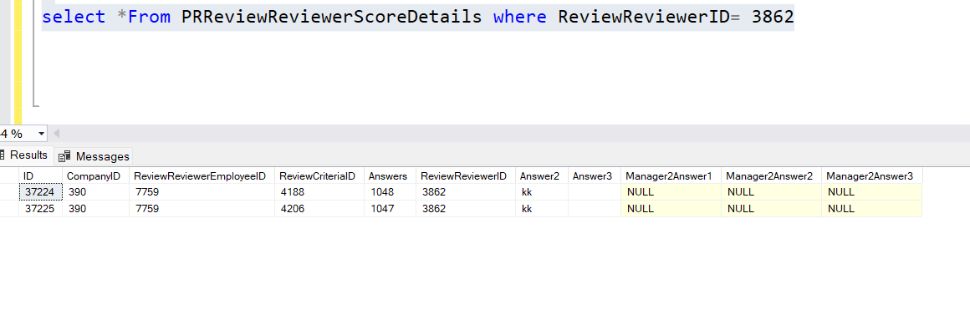
Screenshot – 10. HR Final Review

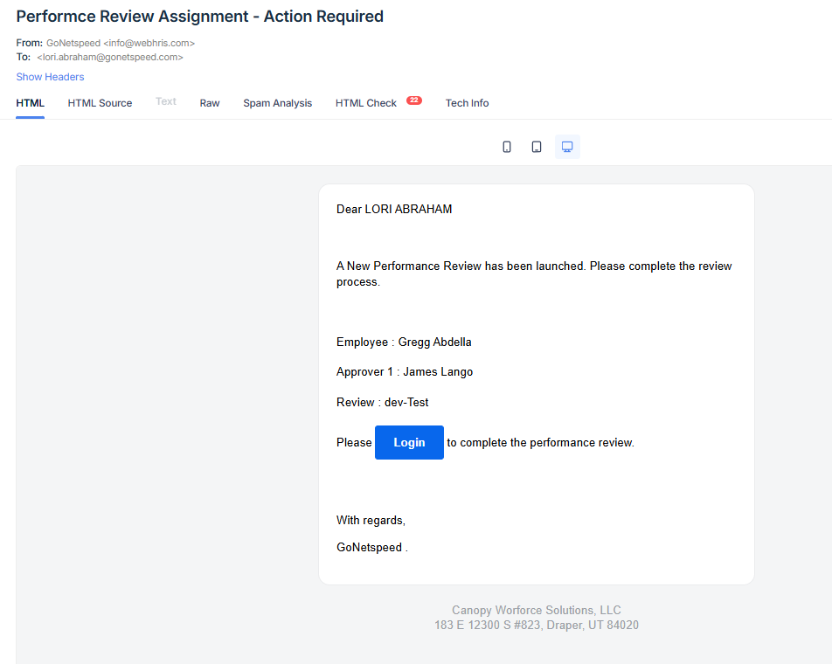
Screenshot – 10. HR Final Review

10.1 HR Final Approval
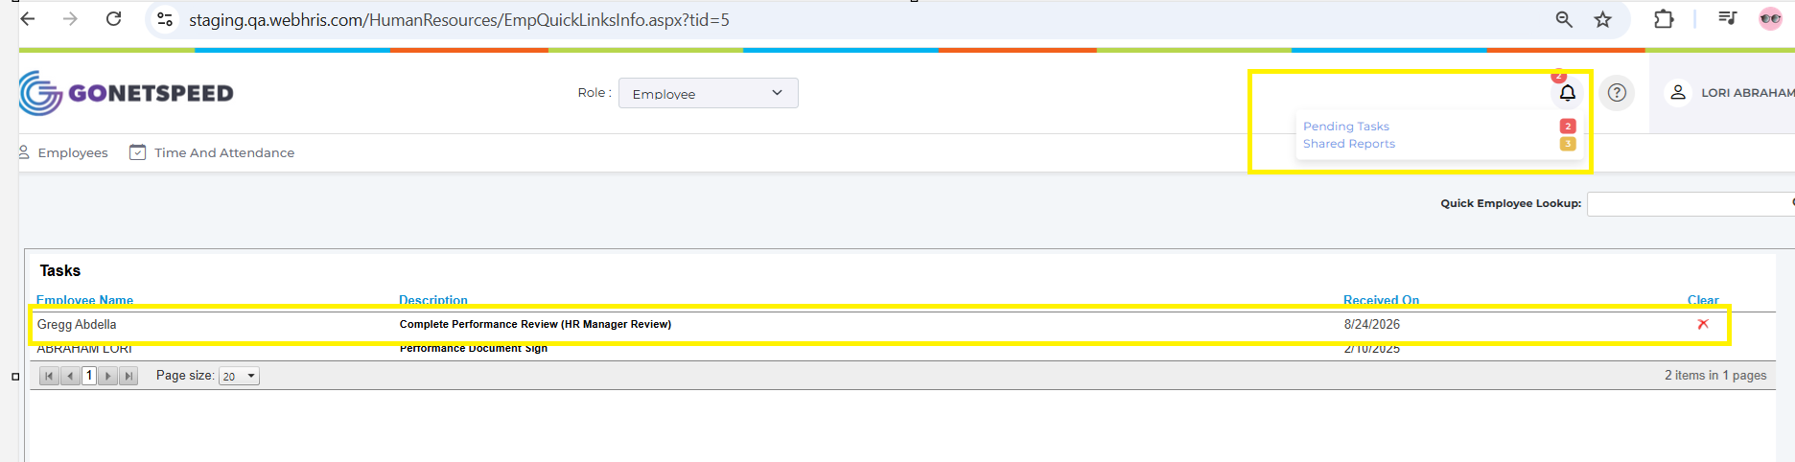
Screenshot – 10.1 HR Final Approval

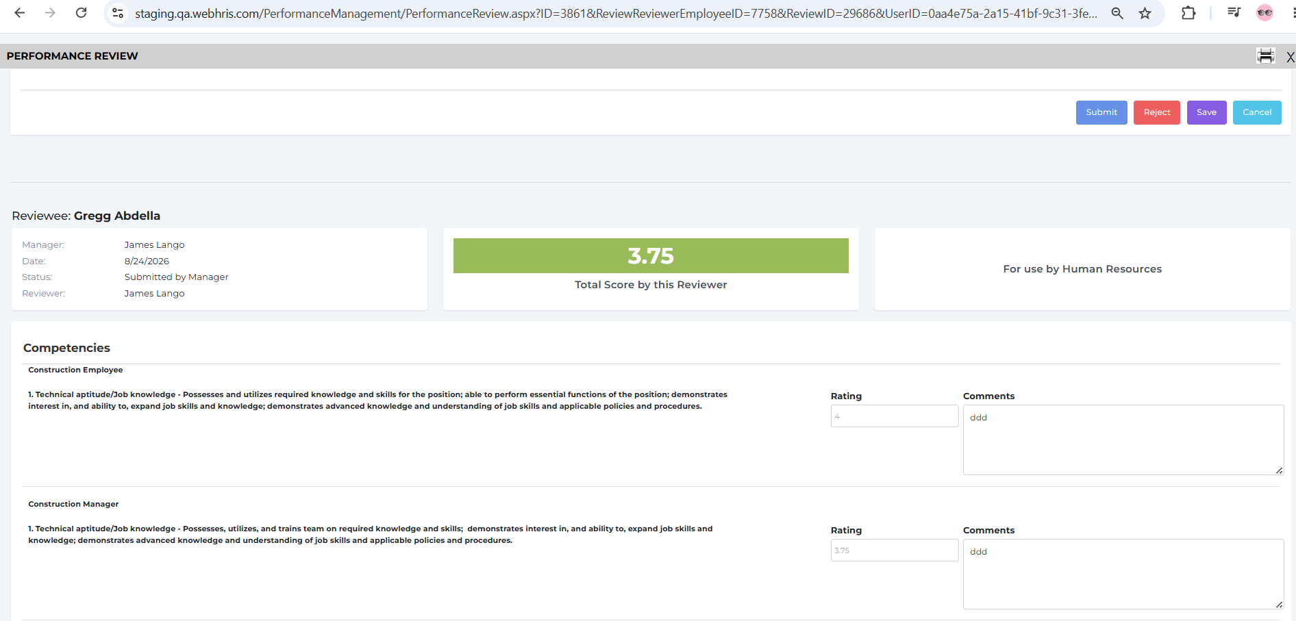
Screenshot – 10.1 HR Final Approval
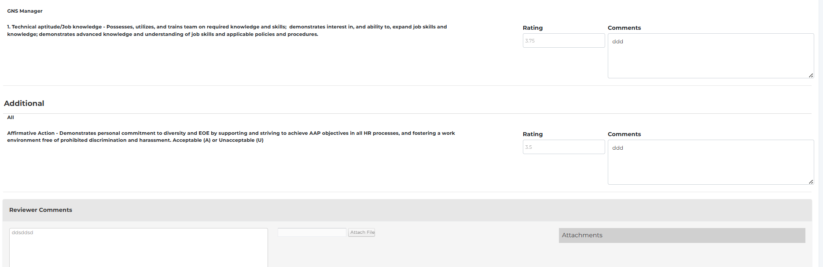
Screenshot – 10.1 HR Final Approval

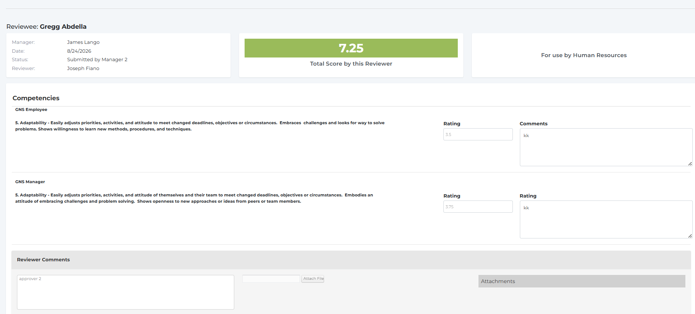
Screenshot – 10.1 HR Final Approval
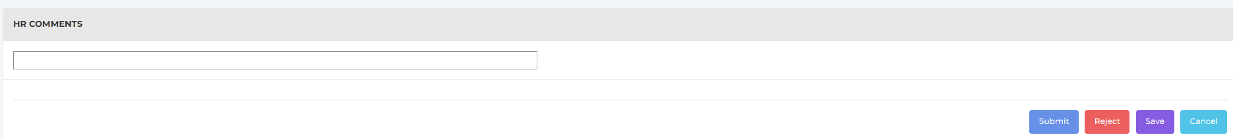
Screenshot – 10.1 HR Final Approval

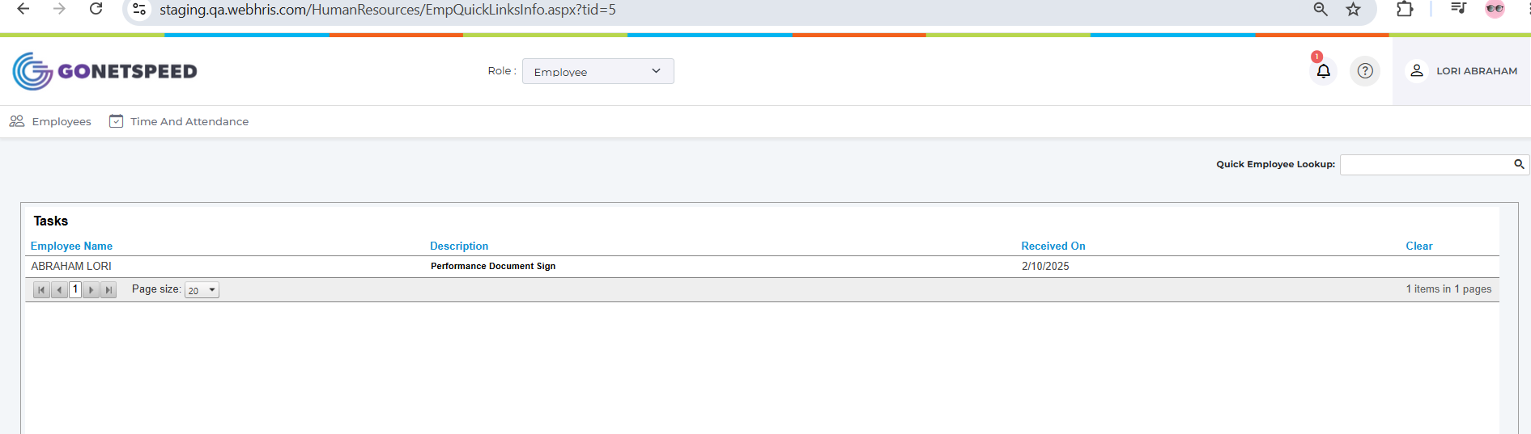
Screenshot – 10.1 HR Final Approval

11. Employee Performance Report and E-Sign
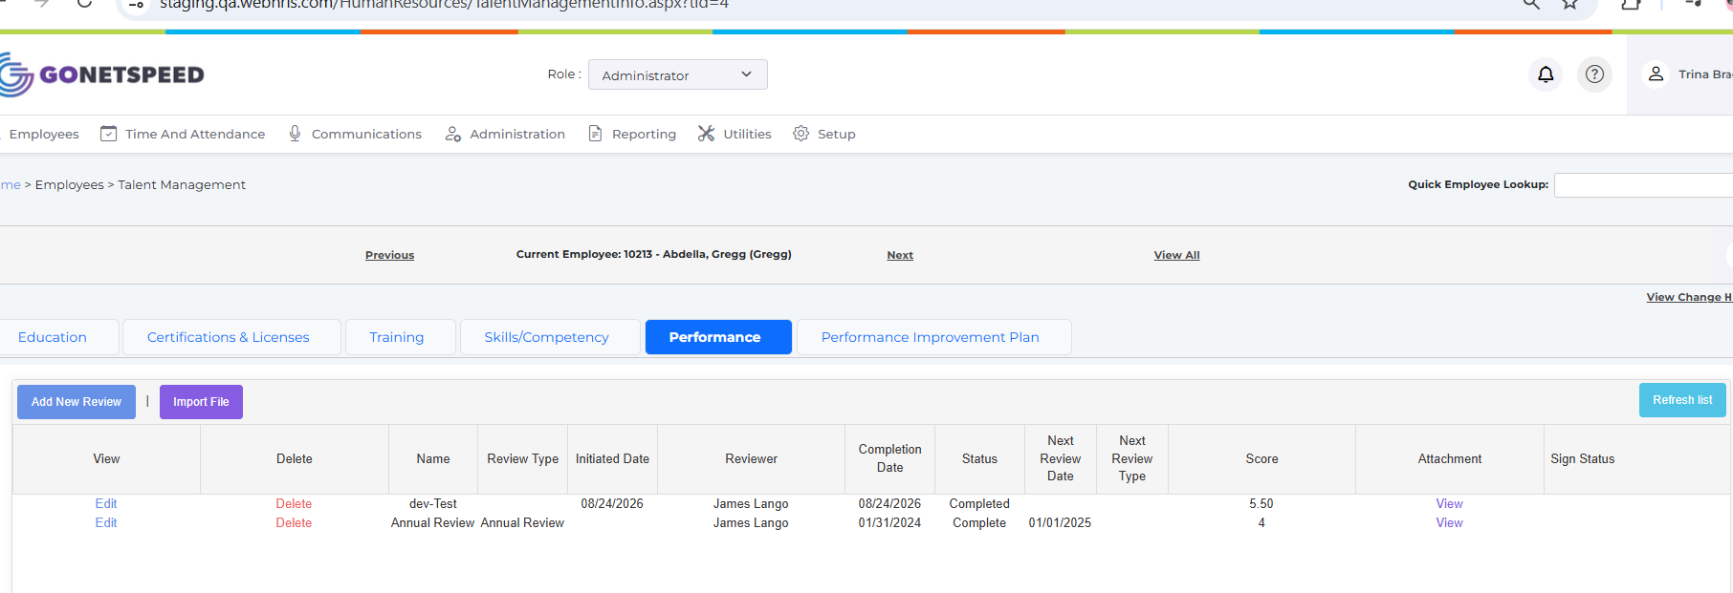
Screenshot – 11. Employee Performance Report and E-Sign
Attached all view form can you download by employee and admin.
In grid on open Sign , Manager login can sent employee to final sign the documents
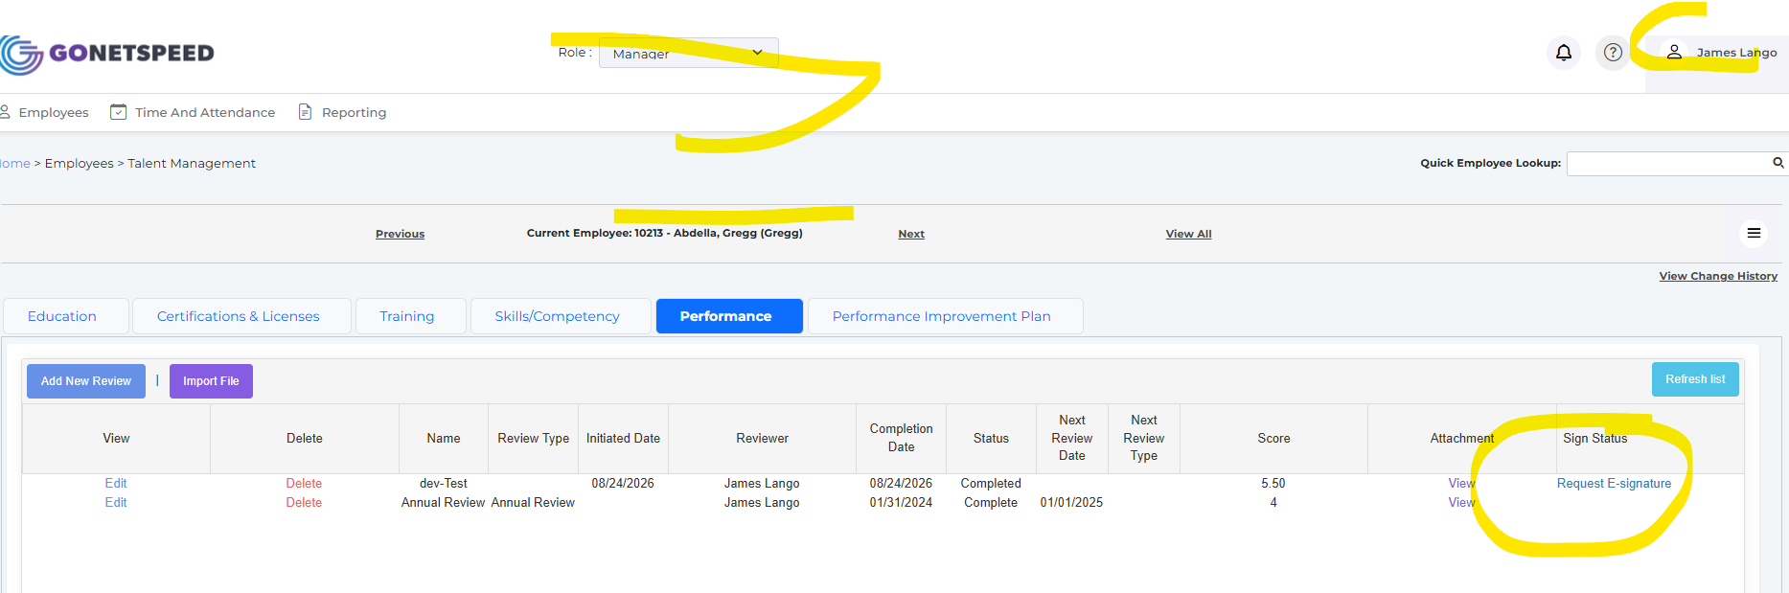
Screenshot – In grid on open Sign , Manager login can sent employee to final sign the documents

12. Final Approval Notification

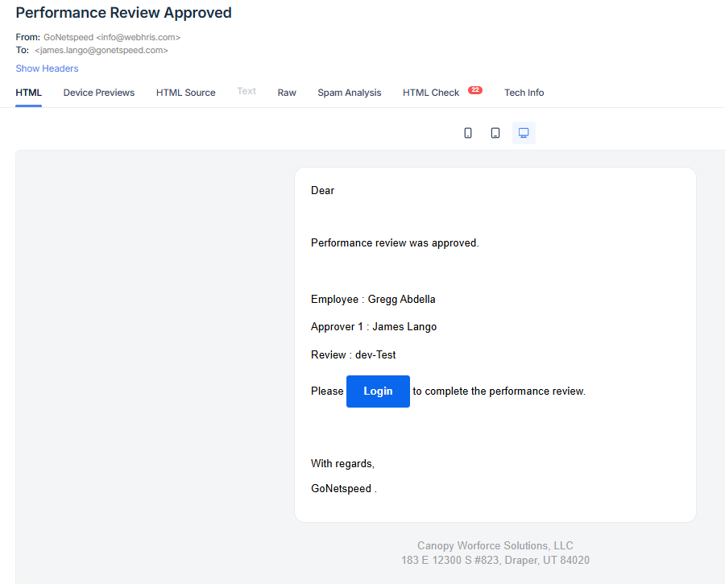
Screenshot – 12. Final Approval Notification

