BI-DIRECTIONAL PERSON COUNTER

**AIM OF THE EXPERIMENT: -**

To make a people counter using laser light and Light Dependant Resistor. This proposed project is to count the number of people in room by adding from 0 onwards and subtract when someone leaves the room.

**OBJECTIVE: -**

The sole objective of our project is to make a people counter in low budget. A Bi-Directional person counter is a device which can be used to monitor the number of objects entering / exiting through it. It has a wide range of applications including automatic parking slots monitoring, number of people entering / exiting a mall, number of students in a class, etc.

**COMPONENTS REQUIRED: -**

1.2 x Laser-Diodes

2. 2 x Small LDRs

3. 2 x 10k ohm resistors

4. Arduino (any microcontroller would serve the purpose)

5. Bread boards, Jumpers

6.Voltage converter (that should give 5V output)

**DESCRIPTION: -**

A bi-directional people counter is a simple person counter that counts the number of person in the room. As two LDR and two laser diodes are used so it keeps the accuracy in counting, unlike in pervious one-directional person counter where one laser is used to count people as follows.

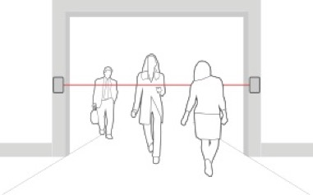

The above is **highly inefficient method** of counting people. That’s why we propose the bi-directional people counter.

The bi-directional person counter not only add value when person enter but also subtract the from the existing value when a person leaves.

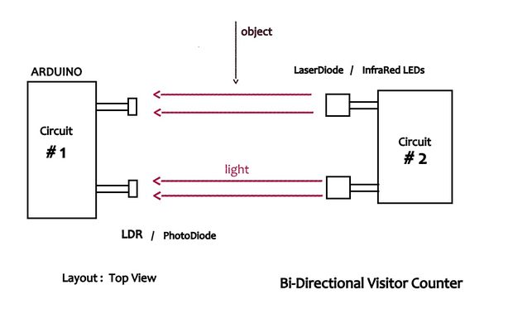

There are two parts of the counter:

1.Laser Source

2.Sensor plate

In the above picture as we can see the proposed schematic of bi-directional person counter. When a person enters (as shown object entering) the 1st LDR is being disturbed or shows change in reading, so when the value 1st LDR changes afterwards value of 2nd LDR changes, then the counter increases itself by adding one hence number of people in displayed increases.

When someone leaves the room the 2nd LDR will be first disturbed afterwards the value of 2nd LDR changes, then the counter decreases itself by subtracting one hence number of people displayed decreases.

**CONNECTIONS: -**

**Circuit # 1:**

Two LDRs are connected to the A0 and A1 analog pins of Arduino. One leg of the LDR is grounded and the other end is connected to +5v through a 10k ohm pull-up resistor. The Junction of the LDR's leg and the resistor is connected to the analog pin.

When the resistance of the LDR goes below 10k ohm, the analog pin reads 0 v and if it goes above 10k ohm , the analog values will be displayed accordingly.

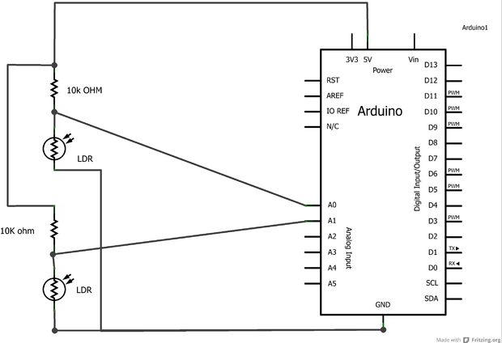

**CIRCUIT #1**

**Circuit # 2:**

This circuit just converts 9v to 5v using 7805 voltage regulator to drive the Laser Diodes. A 10k ohm pot is added to protect the Laser Diodes. Two laser diodes are connected in parallel to the power source. Instead one can use the **ASM 1117** Module that gives 5v output form 12v/9v without using potentiometer.

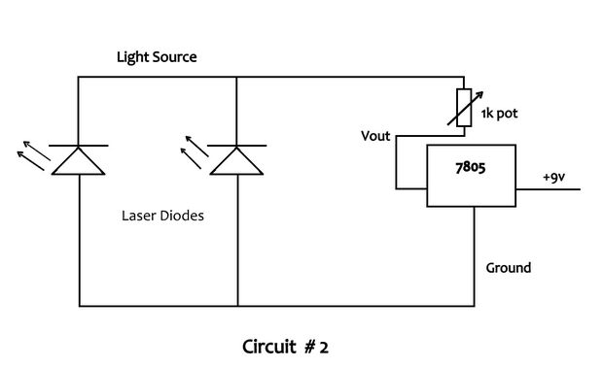

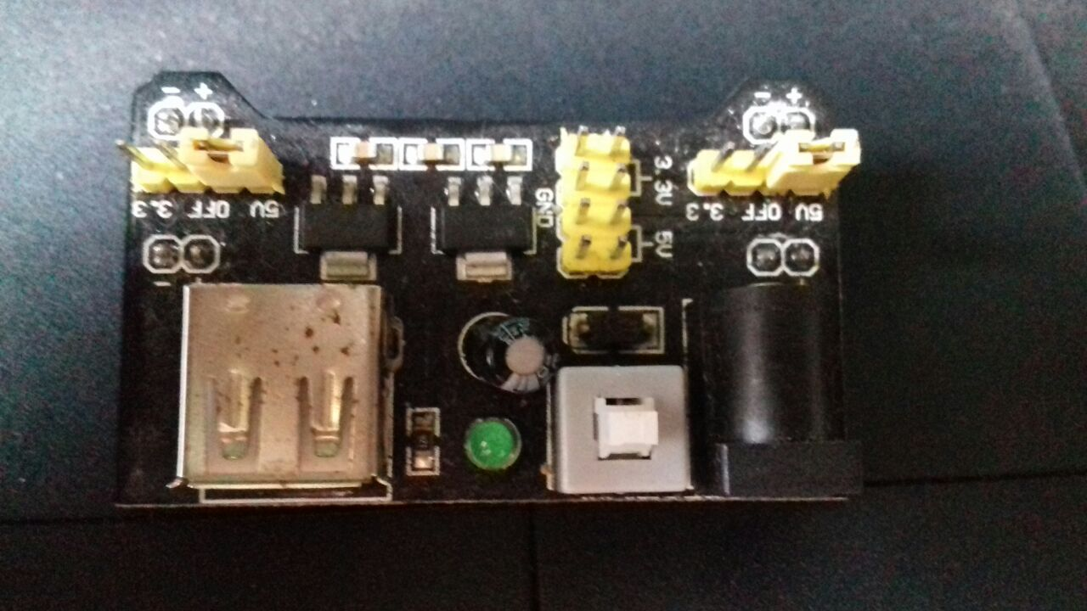

**(ASM 1117-Voltage Regulator Module)**

**Circuit #3:**

Here we are using seven segment multiplex display array to show the number of people. The pins of the seven segment are connected to the digital pins of the Arduino as shown below.

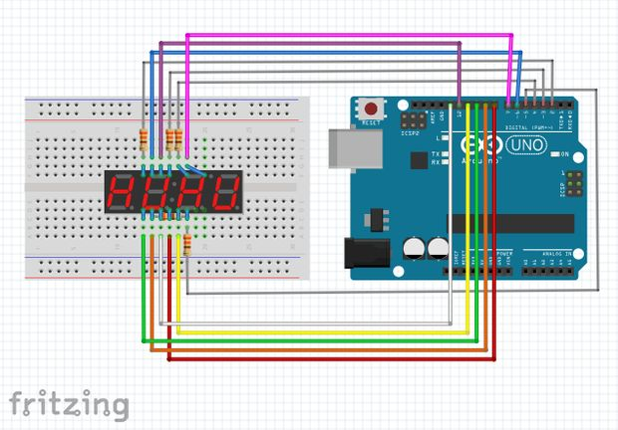

(Multiplex Seven Segment Connection with Arduino)

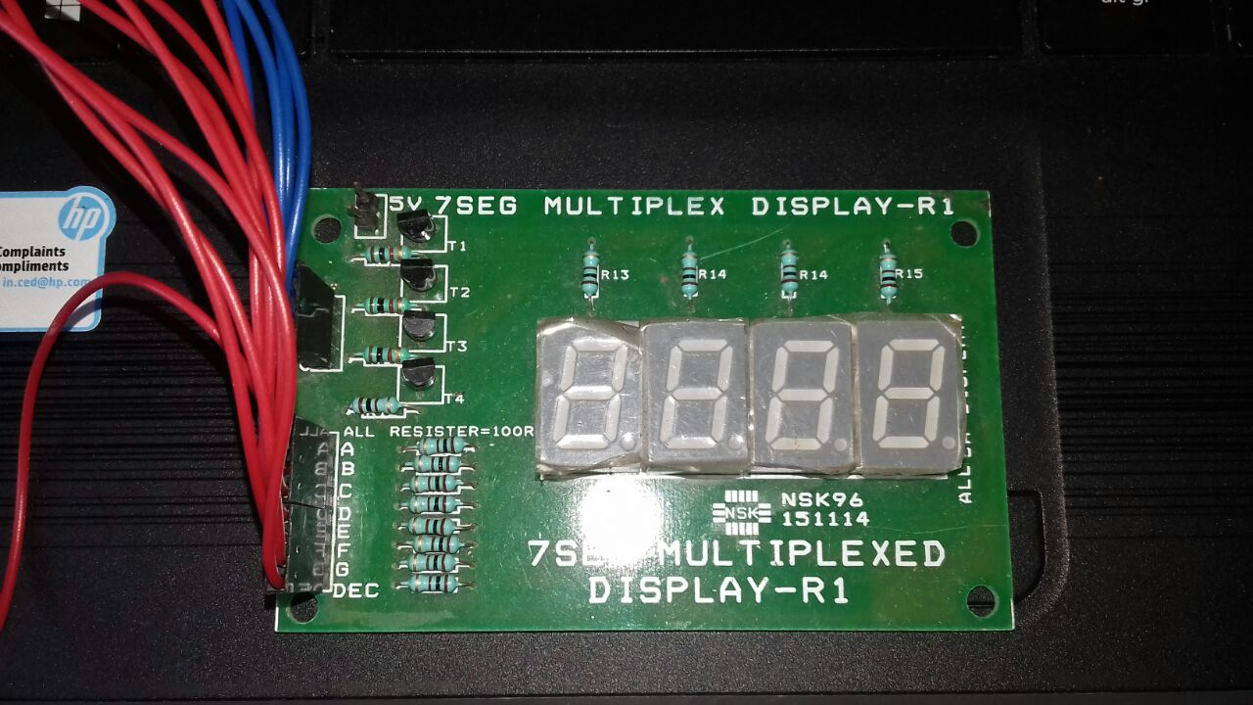

(A single Seven Segment display array)

**Images of the components Used: -**

1. Arduino Uno:

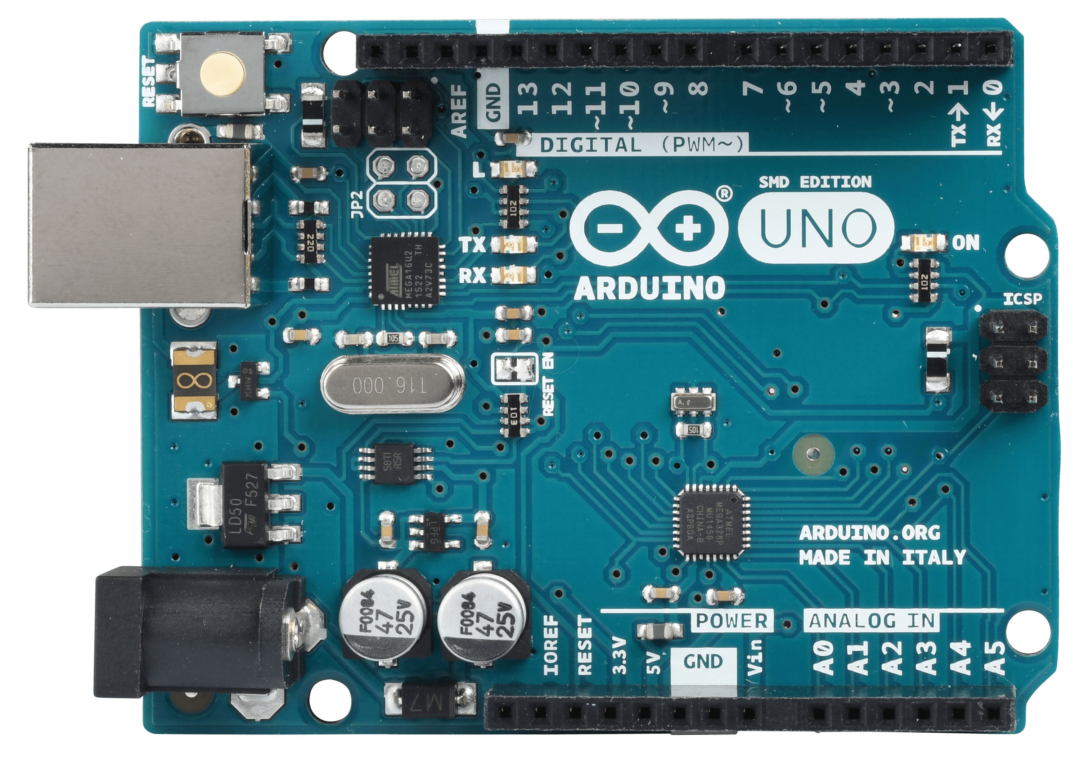

1. Light Dependant Resistor

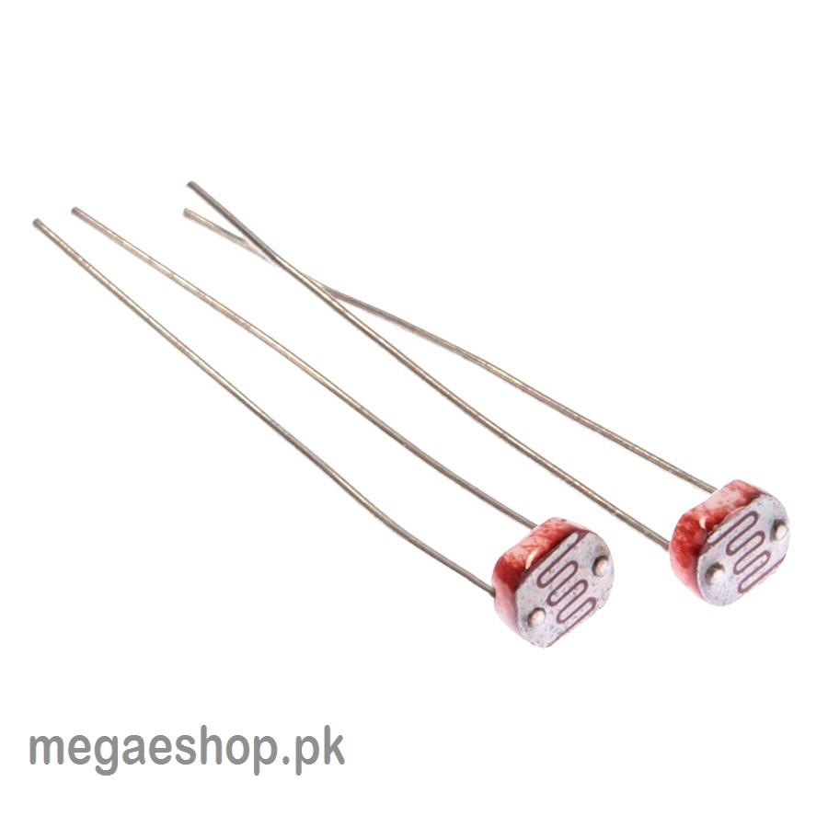

1. Laser Diodes:

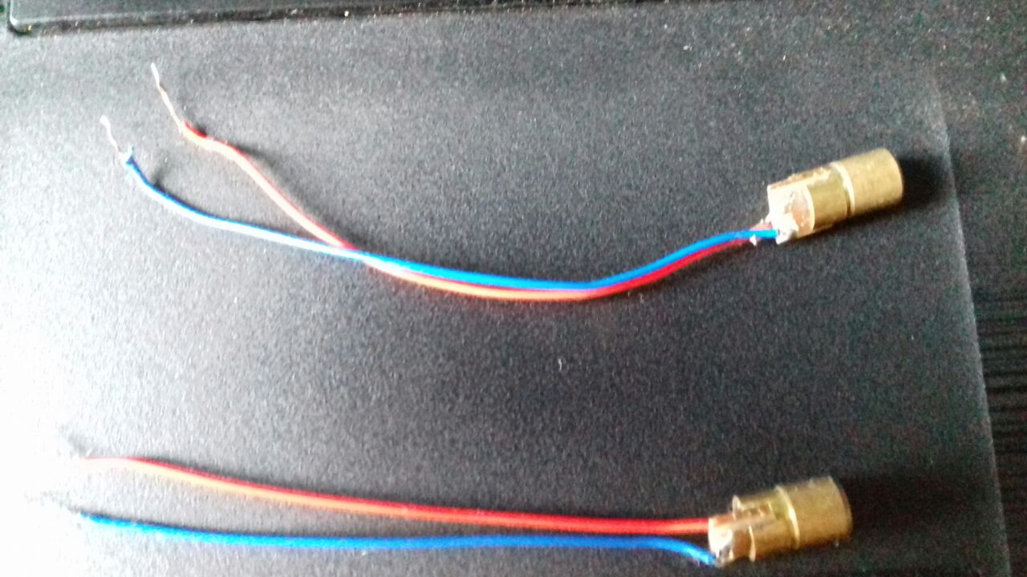

1. Voltage regulator:



1. Resistor, Breadboard

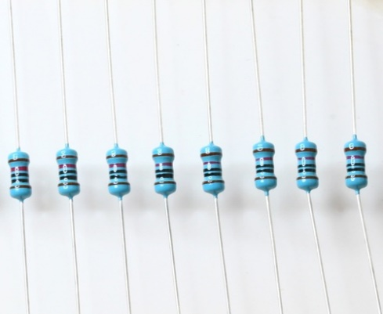

(10k resistors)

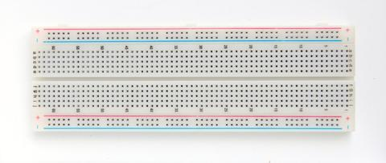

(Breadboard)

**Application of Bi-directional People counter: -**

**Retail stores**

**Conversion rate:** People counting systems in the retail environment are used to calculate the conversion rate, which is the percentage of total visitors versus the number that make purchases.

**Marketing effectiveness:** Shopping mall marketing professionals rely on visitor statistics to measure the effectiveness of the current marketing campaign. Often, shopping mall owners measure marketing effectiveness with the same conversion rate as retail stores.

**Staff planning:** Retailers can use the different business metrics in order to determine their staffing allocation. Accurate visitor counting is also useful for optimizing staff shifts. Staff requirements are often directly related to the density of visitor traffic, and services such as cleaning and maintenance are typically undertaken when traffic is at its lowest.

**Shopping malls**

**Monitoring of high-traffic areas:** Shopping centre use people counters to measure the number of visitors in a given area. People counters also assist in measuring the areas where people tend to congregate. The areas where people tend to gather are often charged higher rent.

**Determining popularity of particular brands:** Shopping malls are prevalent in terms of leasing their units and store lot to only the most popular brand. This is due to the predominant stream of revenue a brand will be able to generate if there is enough demand for it. People counters help shopping malls determine footfall pattern and traffic. With people counters, shopping mall owners are able to determine the flow of traffic per each customer, and which areas and entrances are widely used throughout the whole mall.