LANDGUARD AI
Predictive Land Acquisition Delay Intelligence System
SMART INDIA HACKATHON 2026
Problem Statement ID: SIH26017
Predictive Analytics System for Early Detection of Land Acquisition Delays
Theme: Smart Automation | Category: Software
Team: Null Pointers
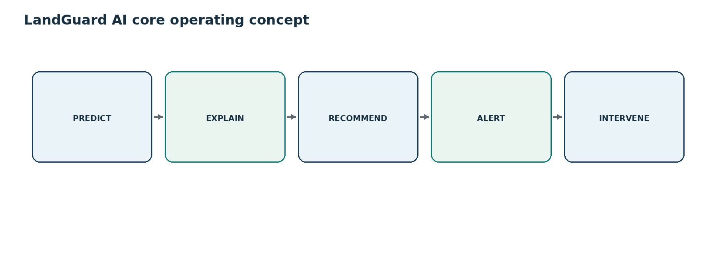
Cover visual: LandGuard AI operating concept
DOCUMENT STATUS: Technical blueprint and team handbook based on the SIH idea submission. Unimplemented components are explicitly marked as proposed or illustrative.

Contents
01. Executive Summary
02. Problem Statement
03. Proposed Solution
04. Complete System Workflow
05. System Architecture
06. Technology Stack
07. Dataset and Data Design
08. Data Preprocessing
09. Feature Engineering
10. Machine Learning Pipeline
11. Model Evaluation
12. Delay Probability
13. Risk Scoring
14. Explainable AI
15. Recommendation Engine
16. GIS Module
17. Administrator Dashboard
18. Role-Based Access Control
19. Alert System
20. Database Design
21. API Design
22. End-to-End Example
23. User Journey
24. Feasibility
25. Security and Privacy
26. Model Governance
27. Implementation Roadmap
28. Team Responsibilities
29. Testing Strategy
30. Limitations
31. Future Scope
32. Impact and Benefits
33. How to Explain to a Judge
34. Expected Judge Questions
35. Demo Script
36. Technical Glossary
37. Final One-Page System Summary
38. Source and Reference Section

1. Executive Summary
LandGuard AI is a proposed AI-powered predictive decision-support platform for early detection of land-acquisition delay risk. Instead of waiting for a project delay to become visible through manual reporting, the system is designed to analyze project, acquisition, approval, compensation, legal, rehabilitation, possession, stakeholder and historical information to identify projects that may be moving toward delay.
For each project, the proposed system produces a delay probability, risk score, risk category, predicted delay indicator, key contributing factors and recommended corrective actions. Its goal is not to replace administrators, but to help them prioritize attention earlier and understand why a project is being flagged.
The expected users include Land Requiring Bodies, Land Acquiring Authorities, district administration, state governments, central ministries, project implementing agencies and policy makers. The system is intended to support project-level drill-down as well as district-wise and state-wise monitoring.
Figure 1: PREDICT → EXPLAIN → RECOMMEND → ALERT → INTERVENE
CORE PRINCIPLE: Prediction becomes useful only when it is understandable and connected to a practical administrative response.

2. Problem Statement
Land acquisition is a multi-stage administrative process. Delay can emerge from several interacting factors, including pending approvals, legal disputes, delayed compensation, incomplete documentation, ownership conflicts, rehabilitation issues and inter-departmental bottlenecks. These factors may not appear as one dramatic failure; they often accumulate until a project is already delayed.

Potential delay factors from the SIH idea
- Pending approvals
- Legal disputes
- Delayed compensation
- Incomplete documentation
- Ownership conflicts
- Rehabilitation issues
- Inter-departmental bottlenecks
A purely reactive system becomes useful only after the project impact is already visible. LandGuard AI shifts the monitoring objective toward early warning: use available project information to identify emerging risk, explain the main drivers and allow administrators to act before delays become critical.
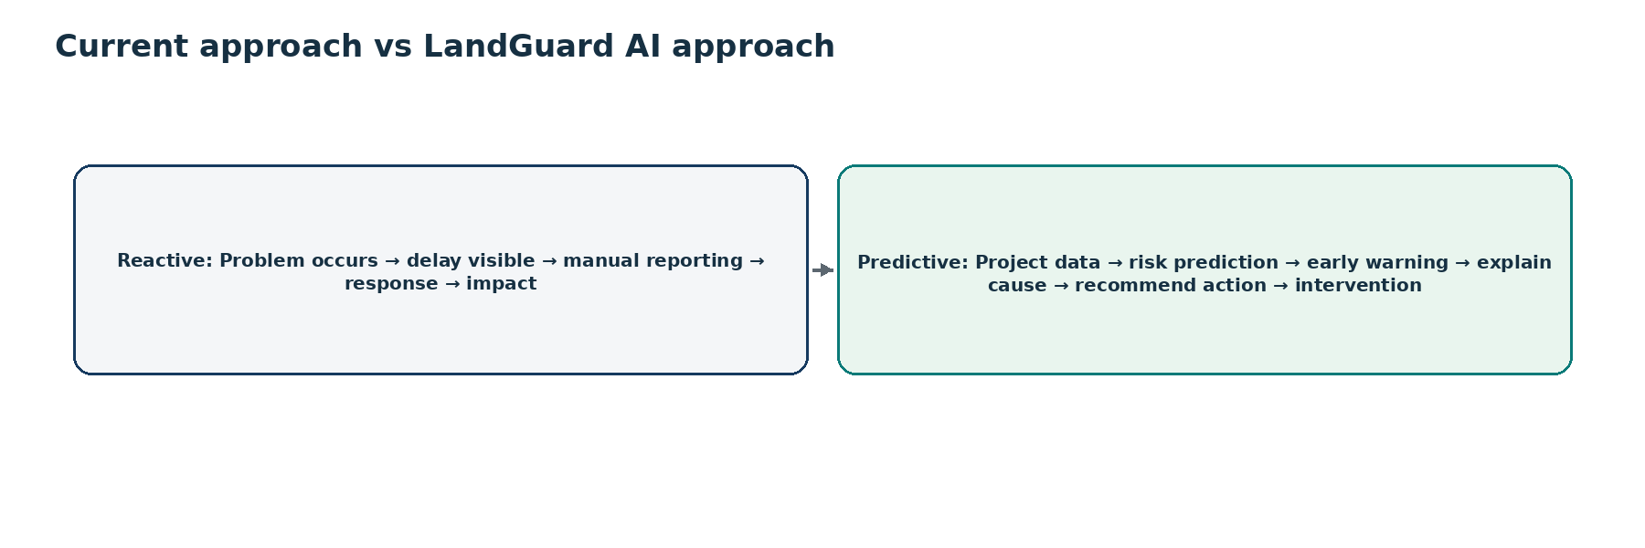
Figure 2: Reactive monitoring versus the proposed predictive approach

3. Proposed Solution
LandGuard AI is designed as an AI-powered predictive decision-support platform. It combines structured project data, machine-learning models, explainability, GIS visualization, recommendation logic and alerts in one administrative workflow.

Information analyzed
- Project type
- Land area
- Affected families
- Compensation status
- Approval timelines
- Legal disputes
- Possession status
- Rehabilitation progress
- Stakeholder responsiveness
- Notifications
- Historical performance

Proposed project-level outputs
- Delay probability
- Risk score
- Risk category
- Predicted delay indicator
- Key contributing factors
- Recommended corrective actions
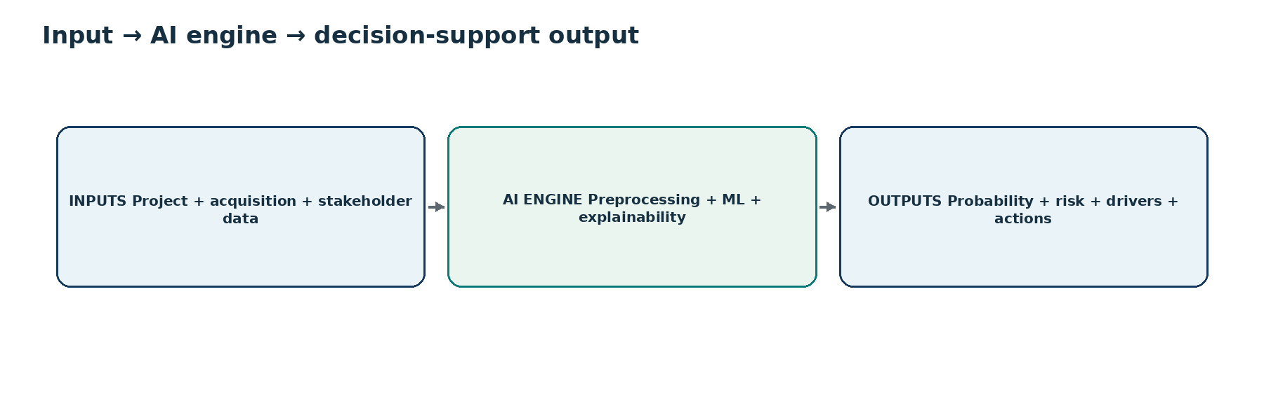
Figure 3: Input → AI engine → output
IMPORTANT: The platform provides decision support. It does not make automatic legal or administrative decisions.

4. Complete System Workflow
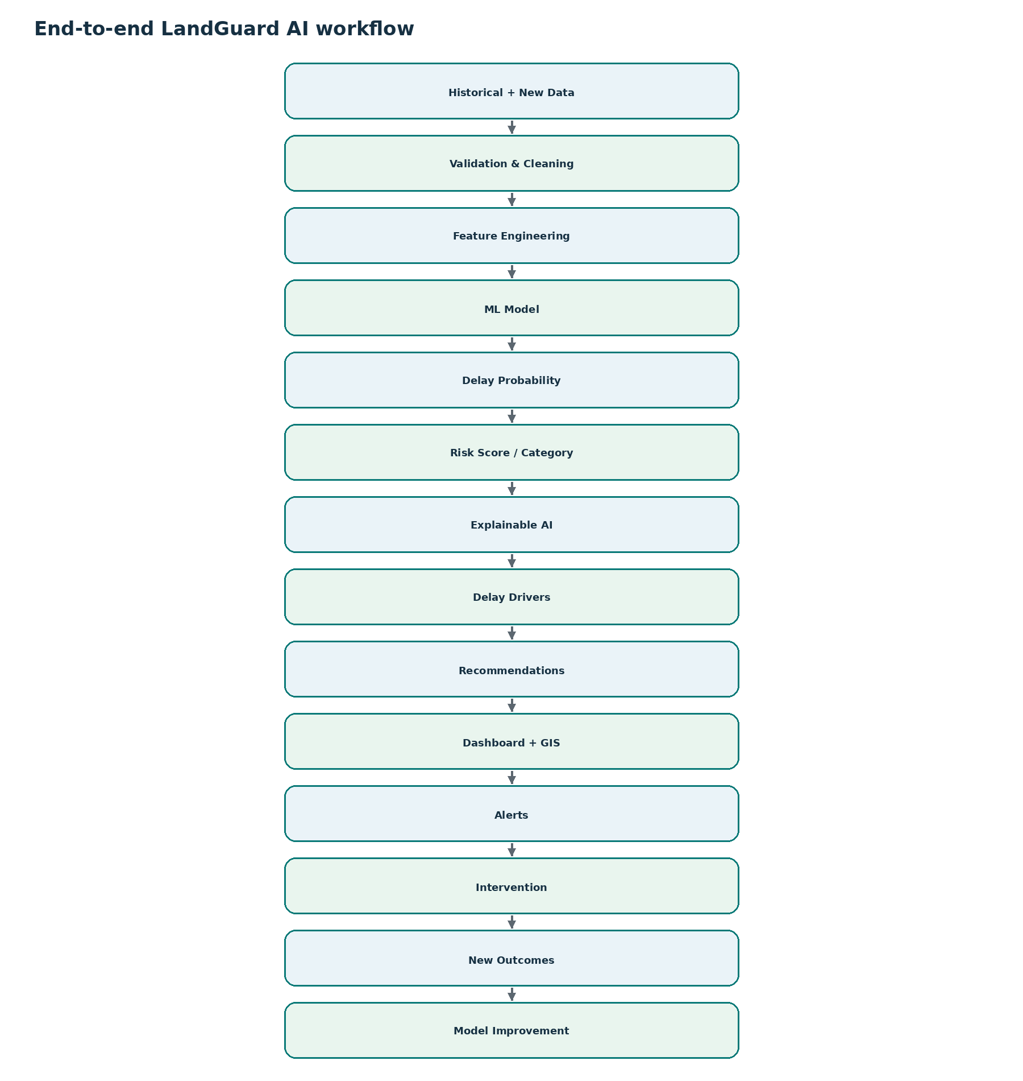
Figure 4: End-to-end LandGuard AI prediction workflow
Stage | Purpose | Input | Processing | Output | Why it matters
Historical + new project data | Collect structured project and acquisition information. | Project records and new updates. | Ingest standardized records. | Validated input candidate. | Provides evidence for prediction.
Data validation & cleaning | Improve reliability before modeling. | Raw or integrated records. | Check missing, duplicates, types and ranges. | Cleaned data. | Bad inputs can create misleading risk.
Feature engineering | Convert raw fields into predictive signals. | Clean project data. | Create derived measures such as approval delay or completion percentages. | Model-ready features. | Models learn from numeric/categorical patterns.
ML model | Estimate likelihood of delay. | Model-ready features. | Run trained classification and, if developed, regression models. | Probability / delay indicator. | Creates early-warning signal.
Risk score & category | Translate model output into operational priority. | Predicted probability. | Apply validated scoring and threshold logic. | Low/Medium/High risk. | Makes model output easy to triage.
Explainable AI | Show why a project was flagged. | Prediction + feature values. | Generate feature importance / SHAP explanation. | Top risk drivers. | Supports trust and human review.
Recommendation engine | Map important drivers to possible interventions. | Risk drivers + project context. | Apply proposed decision-support rules. | Suggested actions. | Connects analysis to next steps.
Dashboard + GIS | Present results visually. | Predictions, project metadata, spatial data. | Aggregate, filter and map. | Project and geographic views. | Supports monitoring at multiple levels.
Risk-based alerts | Bring urgent cases to attention. | Risk category / trigger. | Generate dashboard or permitted channel alert. | Notification. | Reduces dependence on manual discovery.
Administrative intervention | Authorized officials review and act. | Prediction, explanation, recommendation. | Human judgement and existing procedures. | Administrative action. | Keeps accountability with officials.
New project outcomes | Capture what actually happened. | Observed outcomes. | Store completion/delay result and context. | New labelled records. | Enables evaluation.
Model improvement | Update and govern the model. | New outcomes + performance monitoring. | Re-evaluate, retrain and version when justified. | Improved validated model. | Addresses drift and changing patterns.

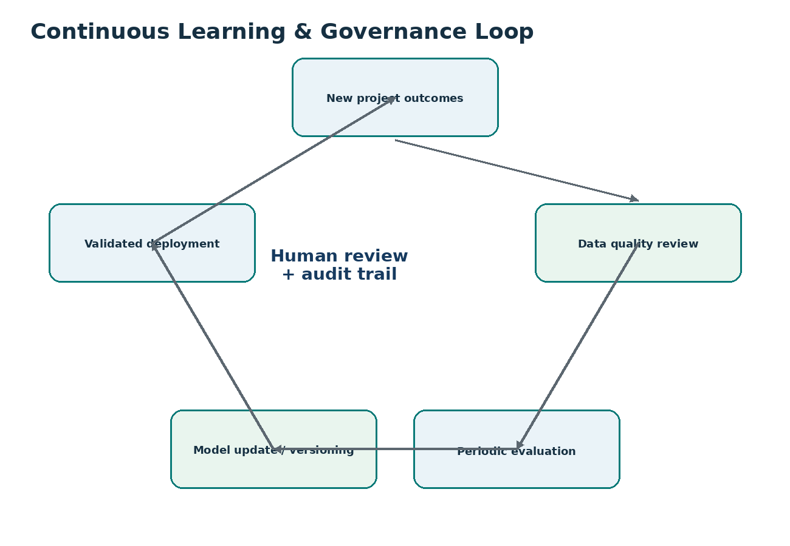
Figure 5: Continuous learning and governance loop

5. System Architecture
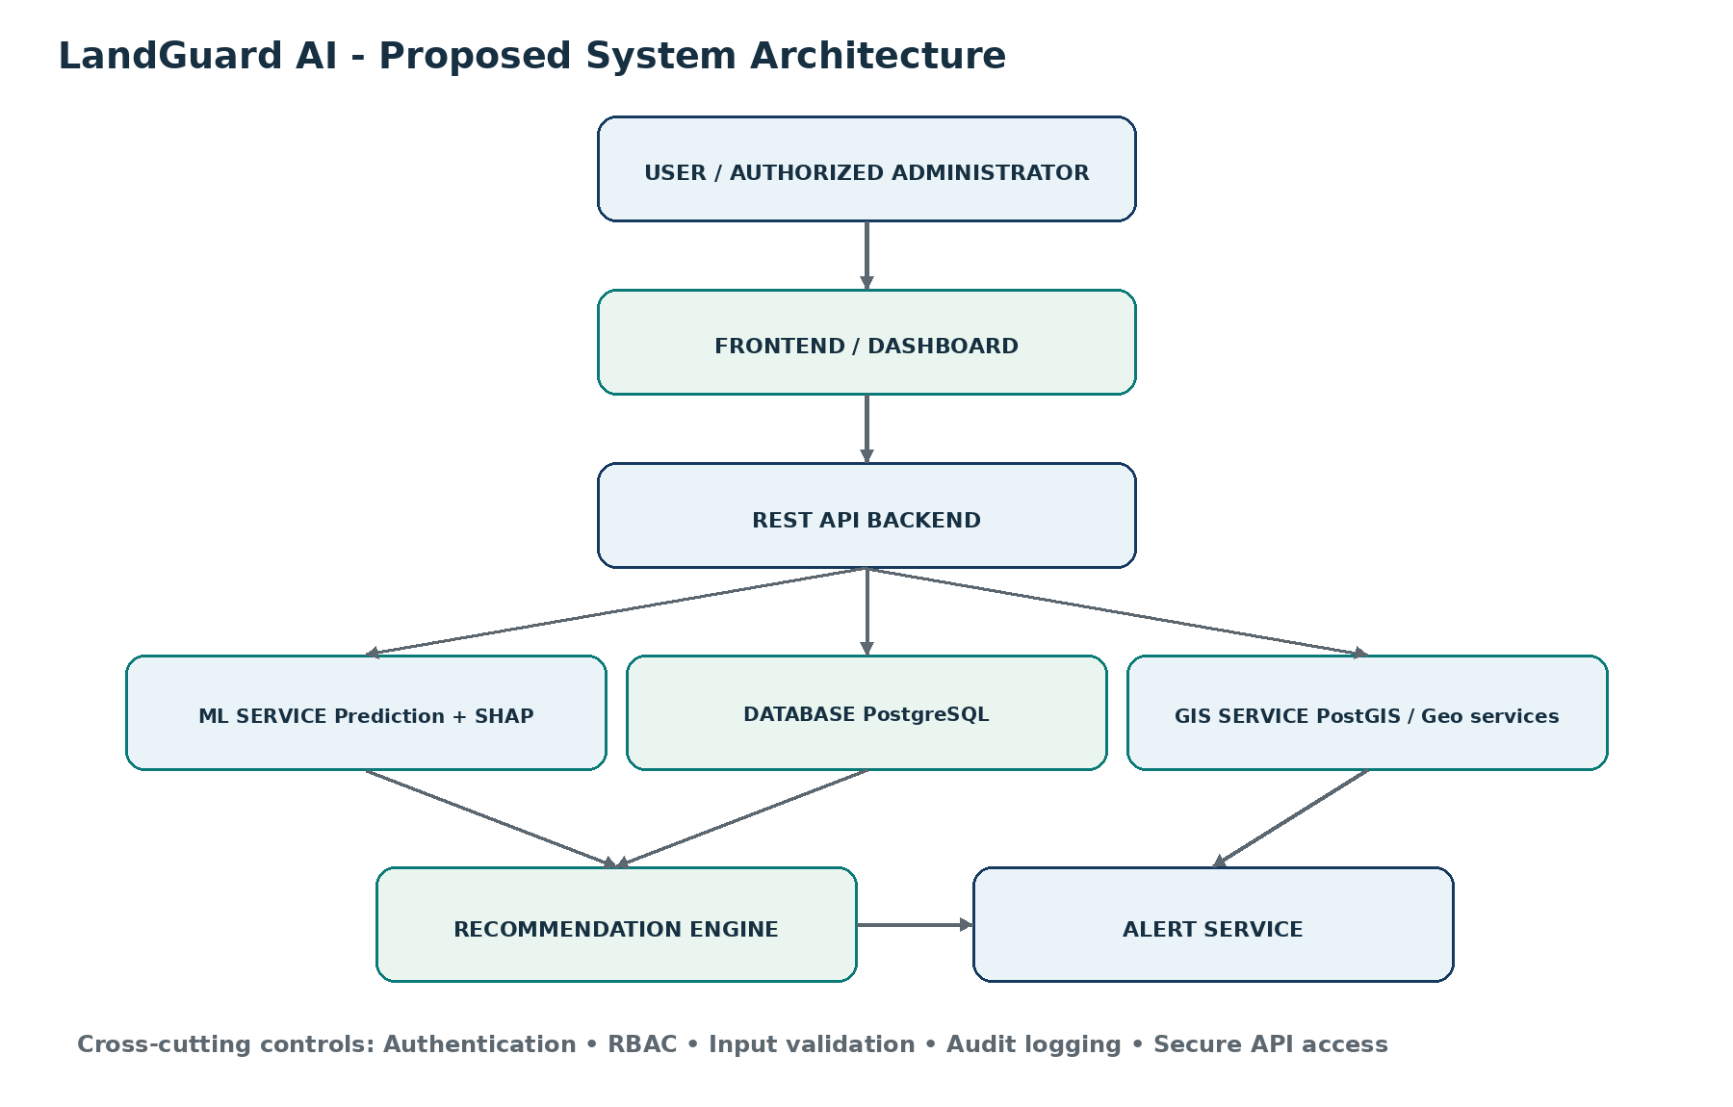
Figure 6: Proposed technical architecture
Component | Role in LandGuard AI
Frontend / dashboard | React or HTML/CSS/JavaScript interface for administrators, filters, project drill-down, charts, GIS and alerts.
REST API backend | Python service layer using FastAPI or Flask. It receives requests, validates data, coordinates prediction, database and GIS functions, and returns structured responses.
Database | PostgreSQL stores structured records; PostGIS adds spatial types and geospatial querying.
ML service | Loads the trained model, transforms request features consistently and returns prediction outputs.
Explainable AI | SHAP / feature importance converts model behavior into human-readable drivers.
Recommendation engine | Proposed mapping from identified risk factors to suggested administrative actions.
GIS service | Supports project locations, district/state filtering, risk markers and spatial drill-down.
Alert service | Generates dashboard, email, push or SMS notifications where permitted.
Authentication / RBAC | Restricts access according to authorized role and least-privilege design.

6. Technology Stack
Layer | Proposed technology | Why it is used
Frontend | React / HTML / CSS / JavaScript | Builds responsive dashboards and interactive project views.
Backend | Python - FastAPI or Flask | Python aligns with the ML ecosystem; FastAPI/Flask provide straightforward REST service development.
Database | PostgreSQL + PostGIS | Combines transactional data with spatial project information and GIS queries.
Machine Learning | Scikit-learn; XGBoost or equivalent | Supports baseline and ensemble models for tabular predictive analytics.
Explainable AI | SHAP; feature importance | Makes model outputs interpretable to administrators and reviewers.
GIS | Leaflet / OpenLayers / GeoServer | Enables map rendering, geospatial layers and spatial services.
Visualization | Plotly / Grafana / Apache Superset | Supports analytical charts and monitoring views depending on implementation choice.
APIs | REST APIs | Decouples frontend, ML, GIS and future government integrations.
Notifications | Email / Push / SMS where permitted | Delivers risk-based alerts through approved channels.
Authentication | Role-Based Access Control | Restricts functionality and information by authorized role.

7. Dataset and Data Design

What
One record represents one project observation or project-state snapshot used for training or inference. The exact granularity must be finalized according to data availability.

How
The proposed training dataset requires project attributes, acquisition progress indicators, bottleneck indicators and an outcome label. For classification, a possible target is Delayed = 1 and Not Delayed = 0. A separate regression target may estimate delay duration in days.

Why it matters for LandGuard AI
The target definition determines what the model actually learns; ambiguous labels would produce ambiguous predictions.
DATA STATUS: Dataset size, real field availability and final target definition: To be determined during implementation.

Project ID | Project Type | Land Area | Affected Families | Compensation Status | Legal Dispute | Approval Delay | Possession Status | Rehab Progress | Stakeholder Resp. | Historical Perf. | Delayed
P1042 | Road | Illustrative | Illustrative | Pending | Yes | Illustrative | Partial | Illustrative | Illustrative | Illustrative | 1
P10XX | Rail | Illustrative | Illustrative | Completed | No | Illustrative | Illustrative | Illustrative | Illustrative | Illustrative | 0

Table note: Illustrative example - not actual project data.

8. Data Preprocessing
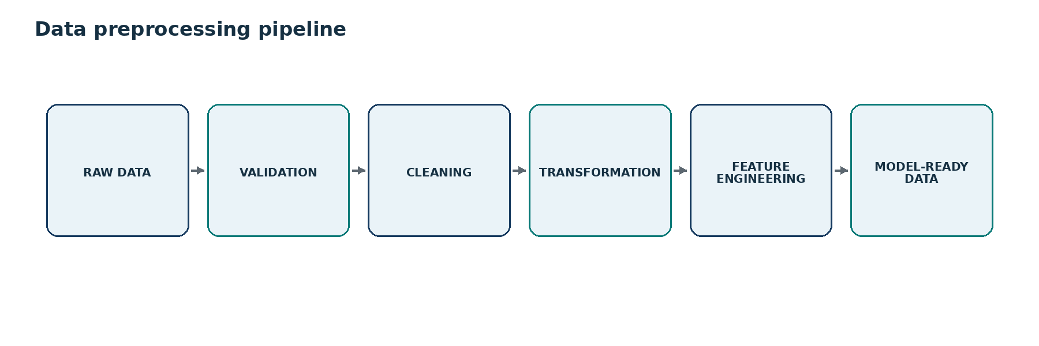
Figure 7: Proposed data preprocessing pipeline
- Data collection from confirmed sources
- Schema and type validation
- Missing-value handling based on field meaning
- Duplicate detection and removal
- Invalid-value and range checks
- Date normalization
- Categorical encoding
- Numerical scaling where required by the selected model
- Outlier review and handling
- Feature selection
- Cross-field data consistency checks
WHY DATA QUALITY MATTERS: Government decision-support systems can amplify data errors into misleading priorities. Validation, traceability and human review are therefore part of the model pipeline, not optional cleanup.

9. Feature Engineering
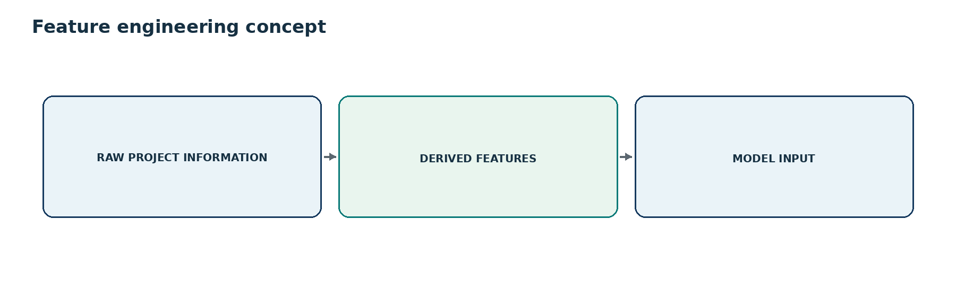
Figure 8: Raw information → derived features → model input
Proposed derived feature | Meaning
Approval delay | Elapsed time beyond an expected or recorded approval milestone. Exact formula: proposed / to be finalized.
Compensation completion percentage | Share of required compensation cases completed, if source data supports it.
Possession percentage | Share of required land for which possession is recorded.
Rehabilitation completion percentage | Progress of rehabilitation and resettlement activities.
Number of legal disputes | Count or indicator derived from available legal-dispute records.
Number of pending approvals | Count of approval steps not yet completed.
Stakeholder response time | Elapsed time between a request/notification and response where timestamps exist.
Elapsed acquisition duration | Time since acquisition process began or relevant milestone.

IMPLEMENTATION TIP: Keep every derived feature reproducible from stored source fields and document its formula, unit, missing-data rule and version.

10. Machine Learning Pipeline
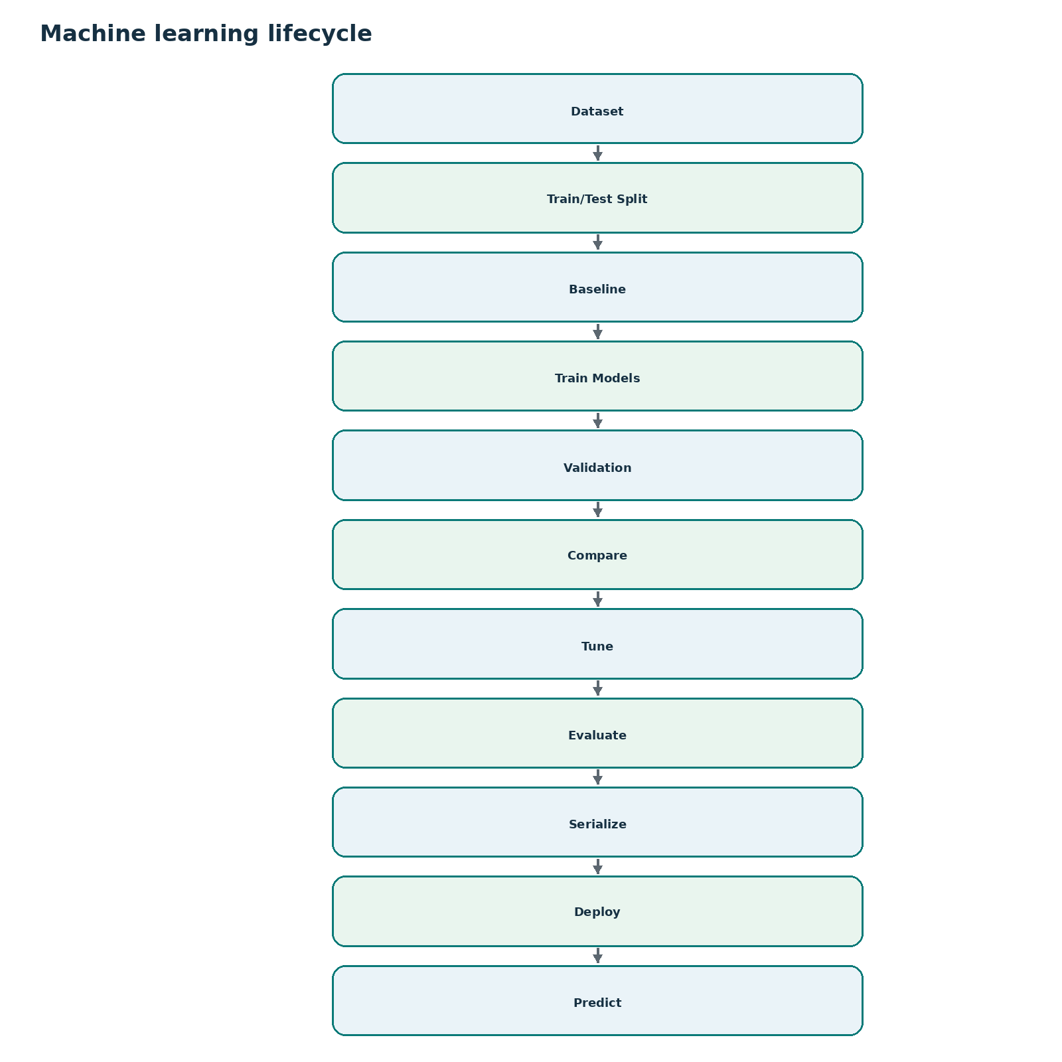
Figure 9: Proposed machine-learning lifecycle
The model-development process should begin with a simple baseline and then compare stronger models. Logistic Regression provides a useful interpretable baseline. Random Forest and Gradient Boosting / XGBoost can capture non-linear relationships and feature interactions in tabular data. A regression model may be evaluated separately if the team predicts delay duration in days.
Candidate model | Possible use | Why compare it
Logistic Regression | Classification baseline | Simple, interpretable and useful for checking whether more complex models add value.
Random Forest | Classification / possible regression | Robust ensemble of decision trees; can model non-linear interactions.
Gradient Boosting | Classification / regression | Sequentially builds trees to correct errors and often performs well on structured data.
XGBoost or equivalent | Classification / regression | Optimized gradient boosting candidate; should be selected only if validation supports it.

IMPORTANT: Do not claim XGBoost is the best model. Final model selection must follow validation performance, interpretability, stability and operational requirements.

11. Model Evaluation
Metric | Interpretation
Accuracy | Overall share of correct classifications. Useful, but can be misleading with class imbalance.
Precision | Of projects flagged delayed/high-risk, how many are truly delayed. Important for controlling false alarms.
Recall | Of actually delayed projects, how many were detected. Important when missing a risky project is costly.
F1-score | Harmonic balance of precision and recall; useful when both false alarms and misses matter.
ROC-AUC | Ranking quality across decision thresholds.
Confusion Matrix | Counts true/false positives and true/false negatives to make error types visible.

Recall and F1-score can be especially important when the system is used to surface high-risk delayed projects, because a high accuracy score alone may hide missed delayed cases.
 | Predicted Delayed | Predicted Not Delayed
Actual Delayed | TP | FN
Actual Not Delayed | FP | TN

Illustrative example only - replace with actual model results.
Model | Accuracy | Precision | Recall | F1 | ROC-AUC
Logistic Regression | TBD | TBD | TBD | TBD | TBD
Random Forest | TBD | TBD | TBD | TBD | TBD
Gradient Boosting / XGBoost | TBD | TBD | TBD | TBD | TBD

12. Delay Probability
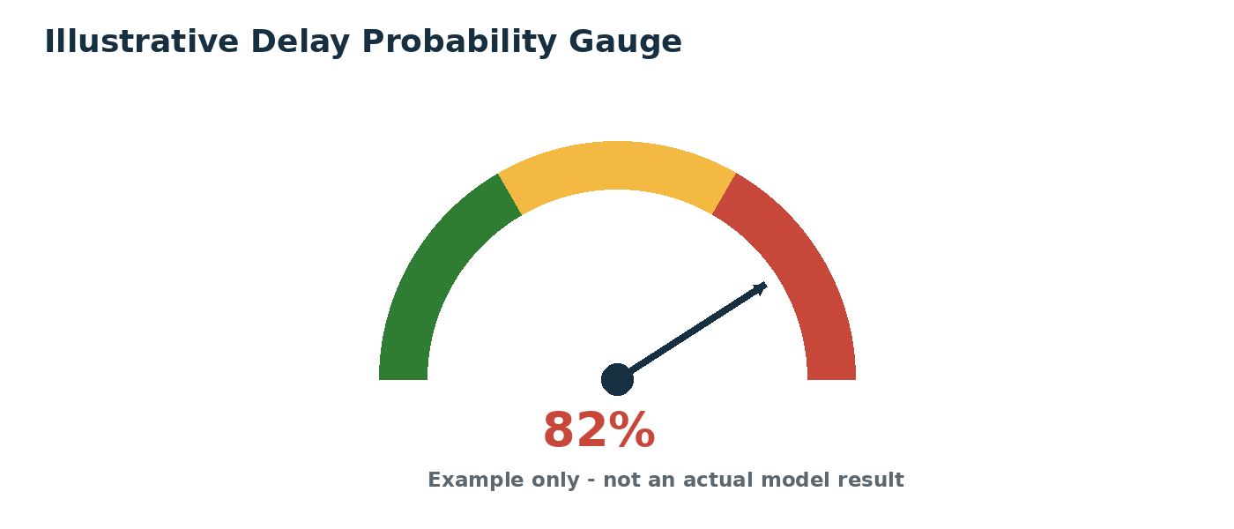
Figure 10: Illustrative probability gauge
Delay probability is the model-estimated probability that a project belongs to the delayed-risk class, subject to model calibration and validation. For example, an illustrative 82% prediction means the model estimates an 82% probability for the delayed-risk class; it does not mean delay is certain.

13. Risk Scoring
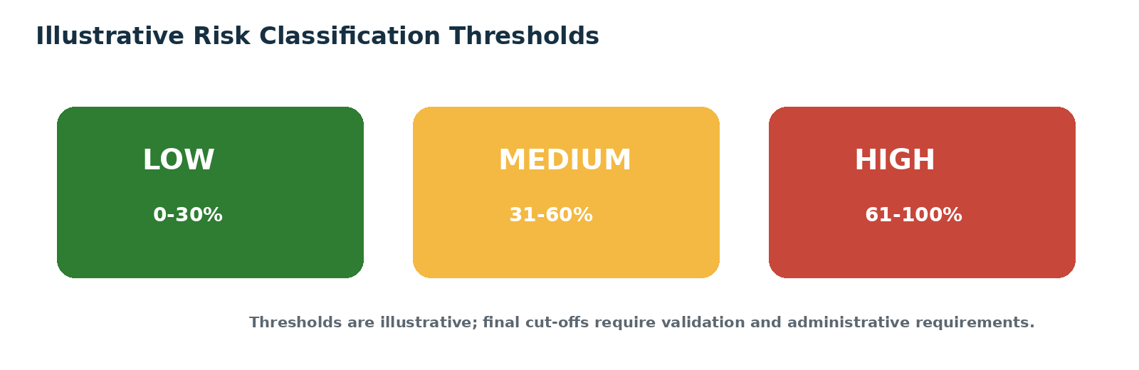
Figure 11: Illustrative Low / Medium / High risk classification
A risk score translates model output into an operational priority. Example thresholds such as 0-30% Low, 31-60% Medium and 61-100% High can be used for interface design, but final thresholds should be set using validation results, false-alarm tolerance and administrative requirements.

14. Explainable AI

What
Explainable AI answers the question: “Why is this project considered high risk?”

How
Feature importance can provide global understanding of which variables matter across many projects. SHAP can provide both global and local explanations by showing how individual feature values push a prediction toward higher or lower risk.

Why it matters for LandGuard AI
Administrators need a reasoned basis for review. Explanation improves transparency, trust, auditability and the ability to challenge an incorrect or data-driven flag.
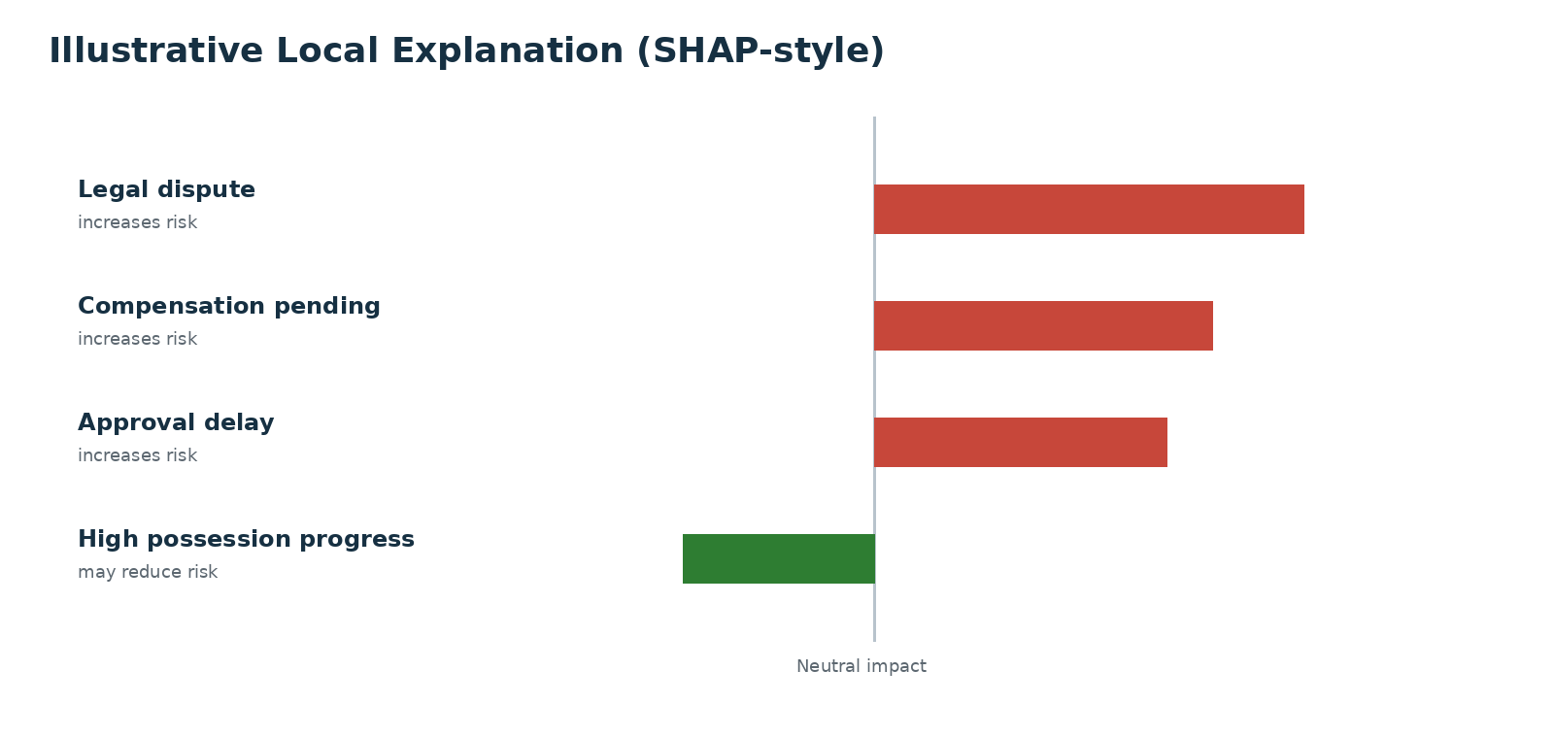
Figure 12: Illustrative SHAP-style local explanation
NOTE: The displayed factors are illustrative. Actual explanations depend on the final trained model and project data.

15. Recommendation Engine
The recommendation engine converts a detected risk factor into a proposed administrative next step. It should begin as transparent decision-support logic rather than an opaque autonomous system.
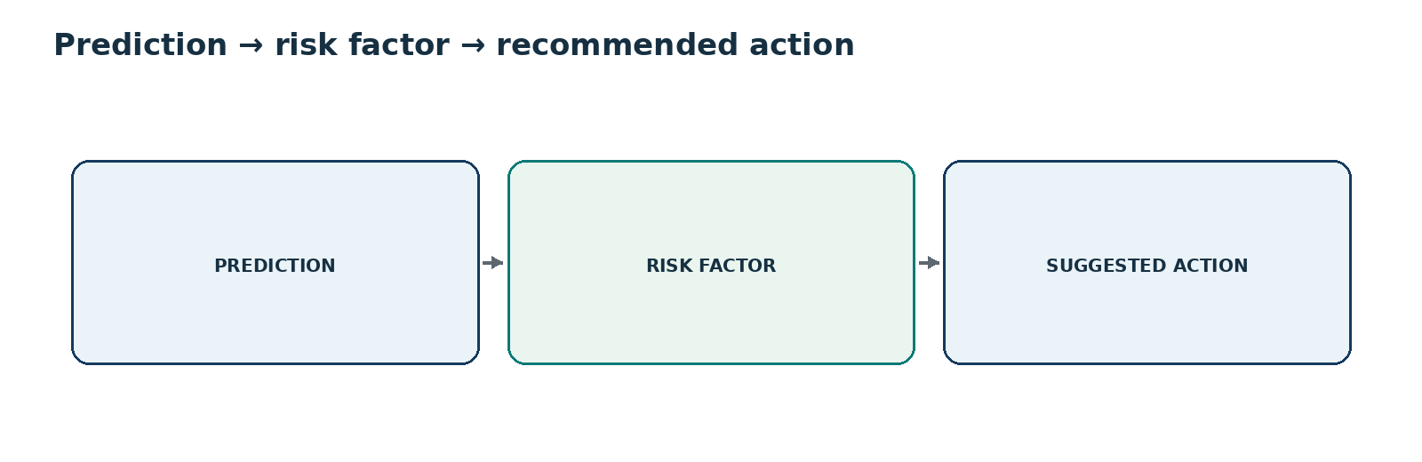
Figure 13: Recommendation logic
Risk factor | Suggested administrative action
Legal dispute | Legal review / escalation
Compensation pending | Prioritize compensation processing
Ownership conflict | Verification / resolution process
Approval bottleneck | Escalate pending approval
Rehabilitation delay | Prioritize R&R actions
Low stakeholder responsiveness | Follow-up / escalation

GOVERNANCE: These are proposed decision-support recommendations, not automatic legal or administrative decisions.

16. GIS Module
The GIS module adds location context to the risk model. Each geocoded project can be shown as a marker or layer with risk-based styling. Users may filter by district or state, inspect geographic patterns and open a project-level drill-down.
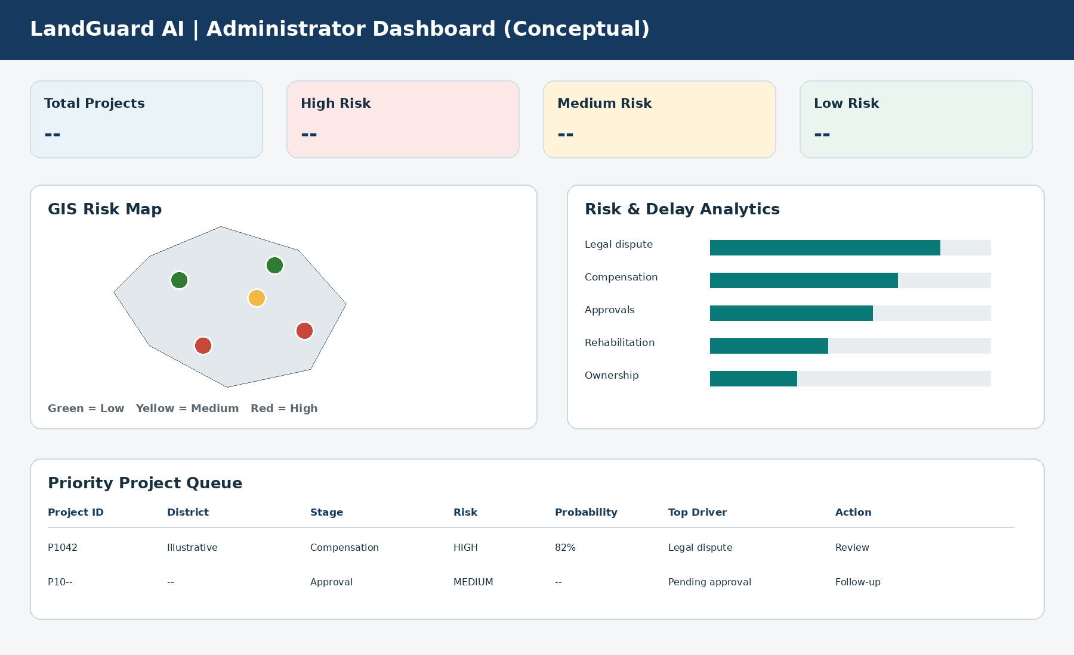
Figure 14: Conceptual dashboard with GIS risk map

Project marker drill-down
- Project ID
- Location
- Risk score
- Delay probability
- Risk category
- Top risk factors
- Recommended actions

17. Administrator Dashboard
The administrator dashboard is the primary monitoring interface. It should summarize portfolio-level status while allowing rapid movement from aggregate indicators to a single project.
- Summary cards: Total Projects, High Risk, Medium Risk, Low Risk
- Risk distribution
- District-wise risk
- Acquisition stage distribution
- Delay-factor distribution
- Project timeline
- Priority project table with Project ID, District, Stage, Risk, Probability, Top Driver and Action
Figure 15: Conceptual administrator dashboard

18. Role-Based Access Control
Role-Based Access Control (RBAC) restricts views and actions according to authorized responsibilities. Exact permissions should be finalized with the implementing authority.
Role | Proposed access scope
Administrator | Proposed: manage system-level configuration, users/roles, full monitoring access subject to policy.
District Officer | Proposed: view and act on authorized district projects.
State Officer | Proposed: state-level monitoring and comparison across districts.
Implementing Agency | Proposed: access assigned projects, updates and relevant recommendations.
Other authorized stakeholder | Proposed: limited role-specific view or reporting access.

19. Alert System
Risk-based alerts surface important project changes without requiring an official to continuously inspect every project. Alerts should be generated using validated thresholds and routed only through permitted channels.
Alert field | Example
Project | P1042 (fictional)
Risk | HIGH
Delay Probability | 82% (illustrative)
Top factors | Legal dispute; compensation pending; approval bottleneck
Recommended | Immediate administrative review (illustrative)

- Dashboard alerts
- Email
- Push notifications
- SMS where permitted

20. Database Design
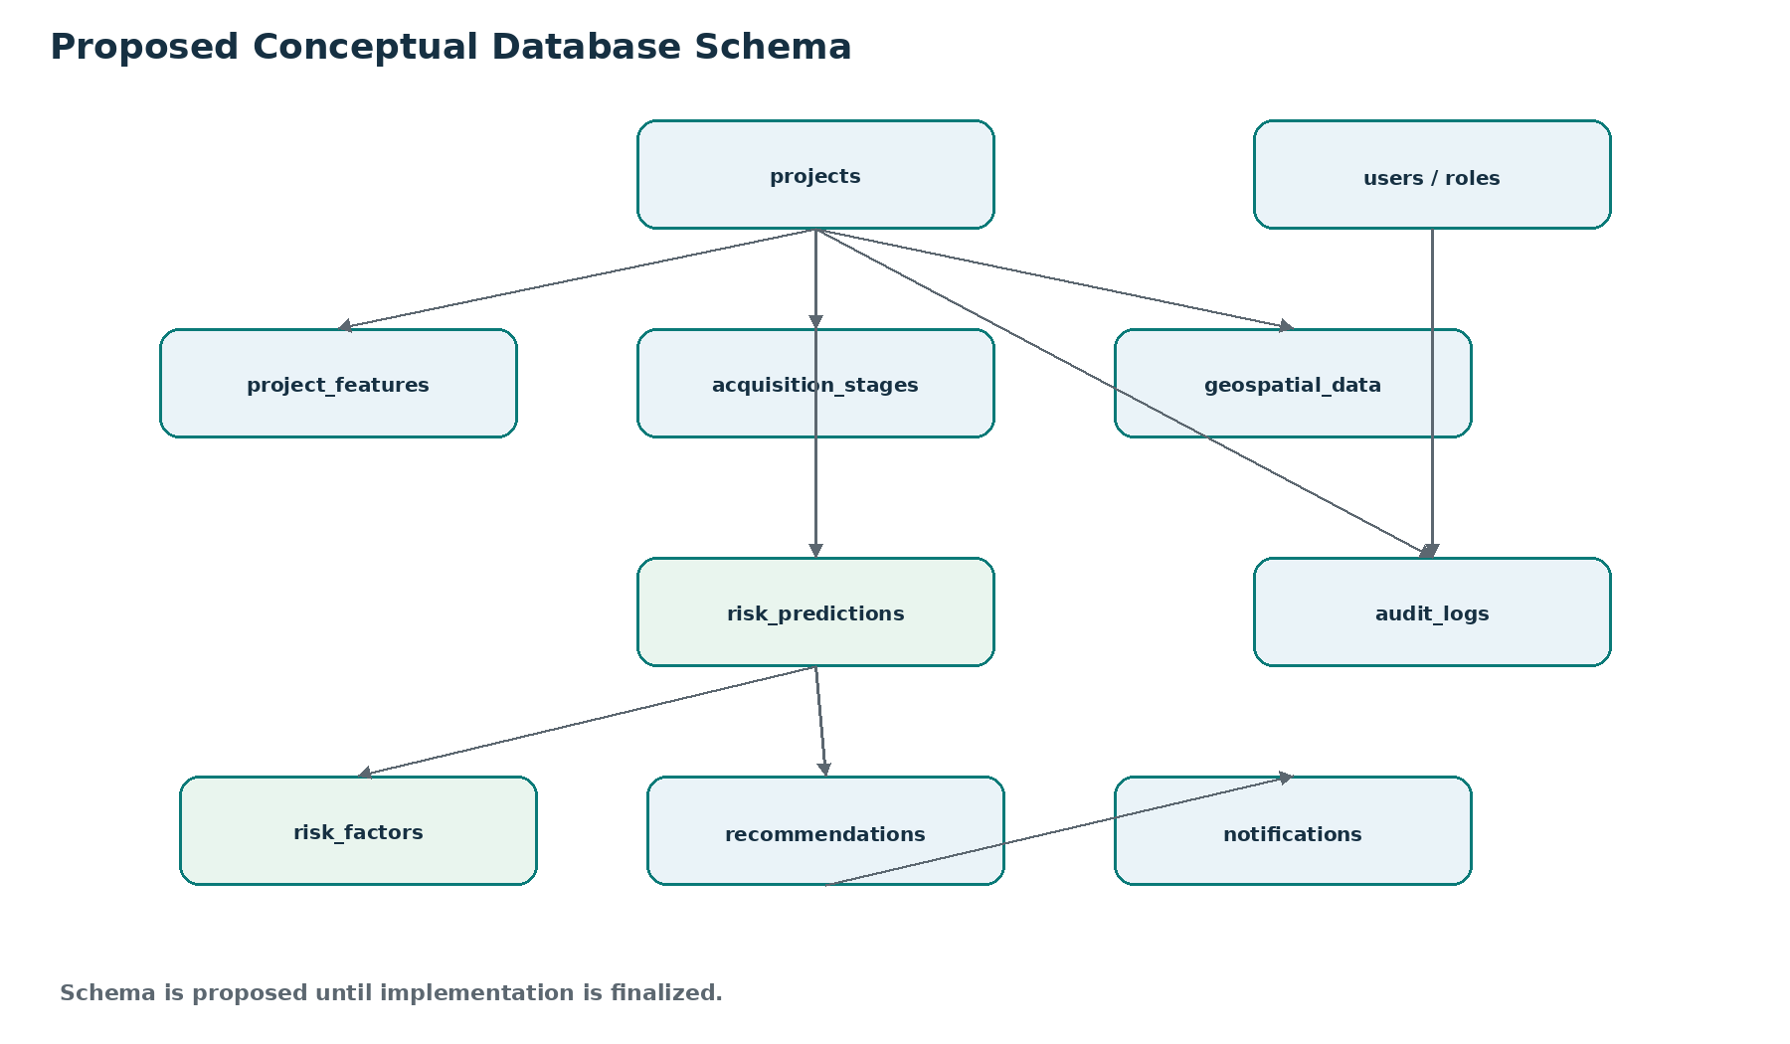
Figure 16: Proposed ER-style database schema
A proposed normalized design separates project identity, features, stages, predictions, explanations, recommendations, notifications, users/roles, audit logs and geospatial information. Relationships should preserve prediction history rather than overwriting older results, enabling auditability and model governance.

21. API Design
The REST API layer decouples the frontend from data, ML and GIS services. The following endpoints are proposed unless already implemented during development.
Endpoint | Purpose | Input | Output | Illustrative response
POST /predict | Submit project features for prediction | Validated project feature payload | Probability, risk category, drivers, recommendation references | {"project_id":"P1042","delay_probability":0.82,"risk":"HIGH"}
GET /projects | List/filter authorized projects | Query filters | Project summary list | {"items":[...]}
GET /projects/{id} | Get project detail | Project ID | Project, stage, prediction and metadata | {"project_id":"P1042",...}
GET /risk-summary | Dashboard aggregate | Authorized scope / filters | Counts and distributions | {"high": "TBD", "medium": "TBD", "low": "TBD"}
GET /high-risk-projects | Priority queue | Scope / filter | High-risk project summaries | {"items":[...]}
GET /map-data | GIS layer data | Bounding/filter parameters | Locations + risk fields | {"features":[...]}
GET /recommendations/{id} | Get project recommendations | Project ID | Suggested actions and drivers | {"recommendations":[...]}

22. End-to-End Example
ILLUSTRATIVE EXAMPLE: Project P1042 and every numerical value in this section are fictional. They demonstrate system behavior only.

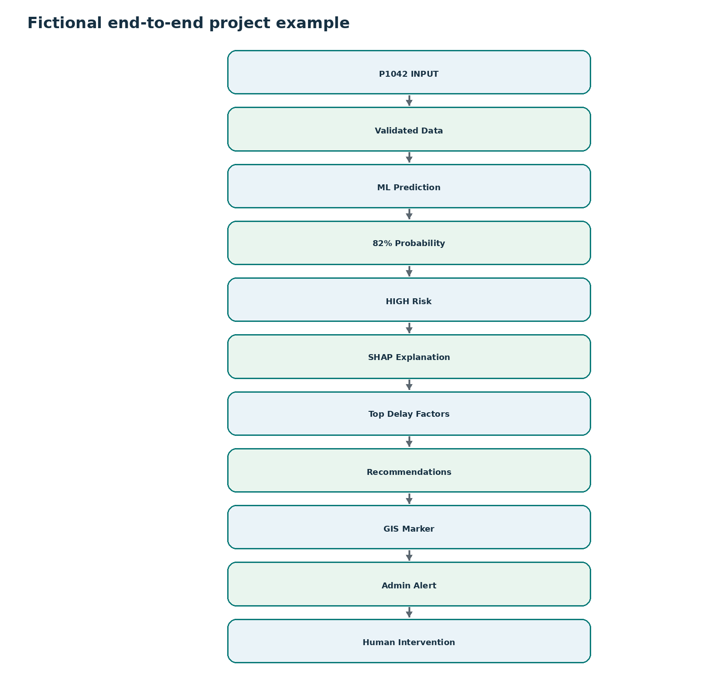
Figure 17: Fictional P1042 journey through LandGuard AI
Suppose P1042 contains indicators for a legal dispute, pending compensation and an approval bottleneck. After validation and feature transformation, the classification model produces an illustrative 82% probability for the delayed-risk class. The illustrative threshold maps this to HIGH risk. SHAP-style explanation highlights the strongest contributing factors. The recommendation engine proposes review/escalation actions; the project appears as a high-risk GIS marker and an alert is shown to an authorized administrator. The official reviews evidence and decides what action, if any, is appropriate.

23. User Journey
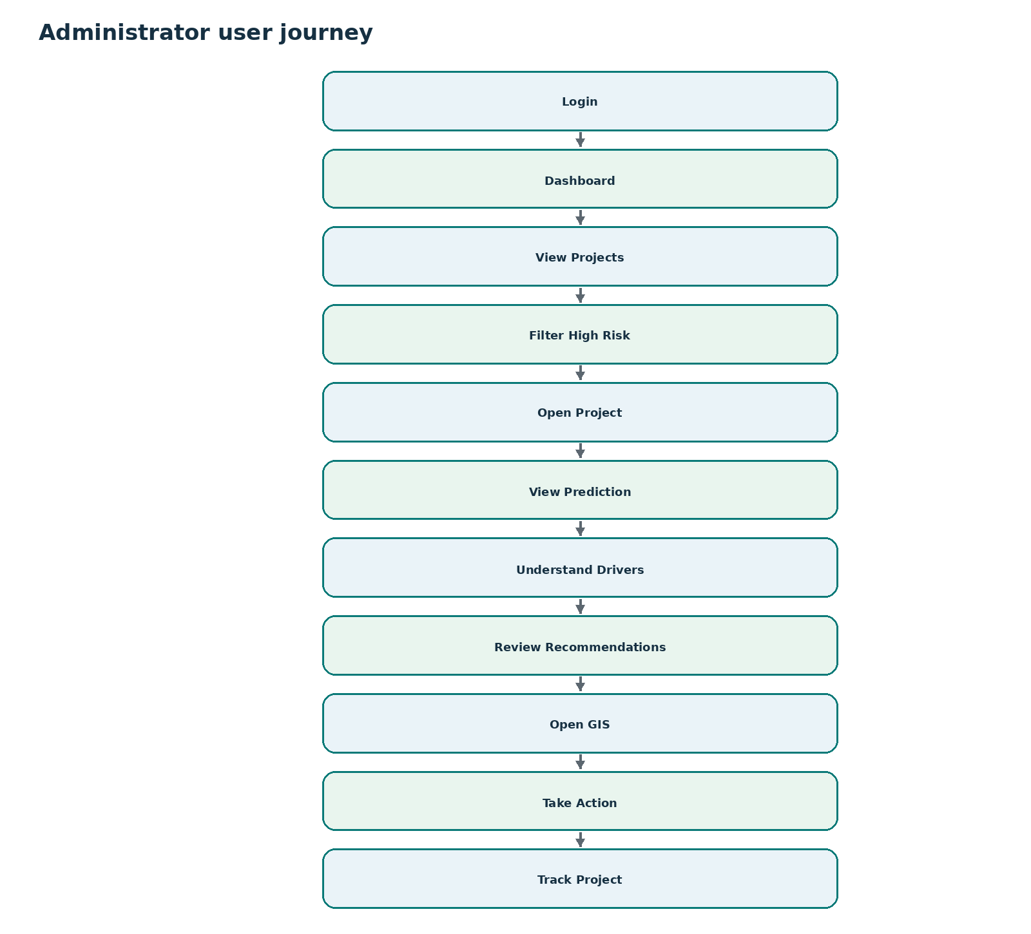
Figure 18: Administrator user journey

24. Feasibility

Technical feasibility
The proposed system uses established web, database, GIS and machine-learning technologies. Tabular project data is suitable for supervised ML when reliable labels are available, while APIs allow ML, dashboard and GIS components to remain modular.

Operational feasibility
The workflow aligns with monitoring activities: officials review project status, prioritize high-risk cases, inspect risk drivers and track interventions. Explainability and human review reduce the risk of treating model output as an unquestionable decision.

Scalability
PostgreSQL/PostGIS can support structured and spatial information, prediction services can be separated from the dashboard/database layers, and new historical outcomes can be added for periodic model evaluation and retraining.
Challenge | Mitigation
Inconsistent historical records | Data validation; quality checks; clear provenance.
Different department formats | Standardized schema and ingestion mappings.
Limited labelled outcomes | Careful target definition; start with available labels; document uncertainty.
Missing data | Field-specific missing-value handling and completeness indicators.
Government-system integration | Modular REST APIs and staged integration.
Model drift | Periodic evaluation, retraining and model versioning.

25. Security and Privacy
Sensitive government and project information must be handled according to applicable government policies, access rules and security requirements. The prototype should demonstrate secure design without claiming certifications that have not been obtained.
- Authentication
- Role-based access control
- Authorization checks on every protected API
- Secure API transport and secrets handling
- Encryption where required
- Audit logs
- Input validation
- Database security and backups
- Least-privilege access
IMPORTANT: No compliance certification or production-security claim should be made until formally verified.

26. Model Governance
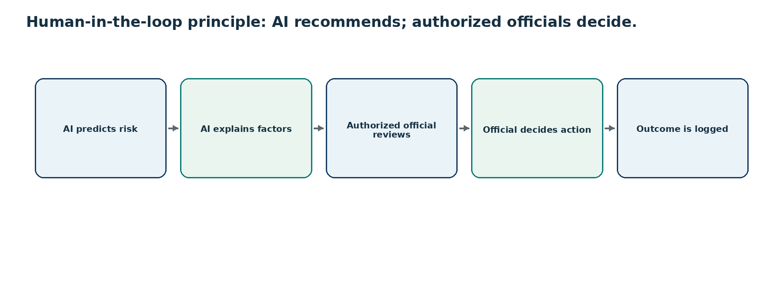
Figure 19: Human-in-the-loop governance
- Model validation before use
- Performance monitoring over time
- Model drift detection
- Retraining only when justified by data and evaluation
- Model and feature versioning
- Prediction logging
- Auditability of data, model version, explanation and user action
PRINCIPLE: AI recommends; authorized officials decide.

27. Implementation Roadmap
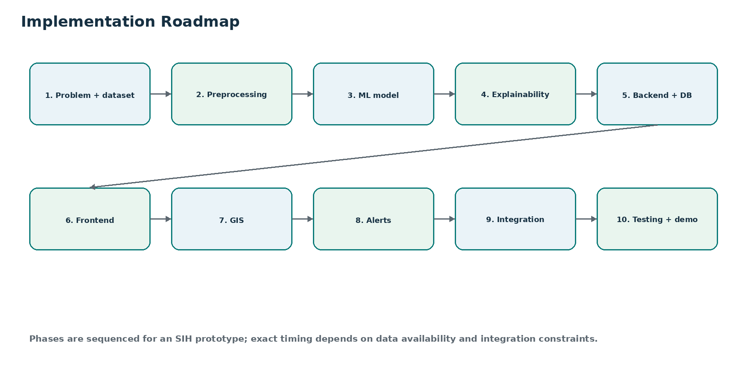
Figure 20: Proposed phased development roadmap

28. Team Responsibilities
Role | Responsibilities | Deliverables | Dependencies
ML / Data Engineer | Dataset schema, preprocessing, feature engineering, model training/evaluation, explainability | Versioned pipeline, trained candidate models, evaluation report, SHAP integration | Needs validated data schema and backend contract
Backend Developer | REST APIs, authentication hooks, ML service integration, database access, alerts | Backend service, API docs, integration endpoints | Depends on DB schema and model input/output contract
Frontend Developer | Dashboard, project drill-down, charts, alert UI, role-aware views | Responsive interface and demo flow | Depends on APIs and design schema
GIS / Integration Developer | PostGIS, map layers, location filters, integration adapters | GIS services and map module | Depends on location data and backend interfaces
Project Lead / Documentation / Testing | Scope control, documentation, demo narrative, integration testing, issue tracking | Handbook, demo script, test evidence, final presentation | Coordinates every workstream

29. Testing Strategy
Test type | Focus
Unit testing | Functions, validators, feature transformations and recommendation rules.
Integration testing | Frontend-backend-ML-database-GIS interactions.
API testing | Request validation, authorization, error handling and response contracts.
ML validation | Hold-out evaluation, class imbalance checks, calibration where needed, error analysis.
UI testing | Filters, forms, accessibility, responsive layouts and failure states.
GIS testing | Marker correctness, filtering, map performance and missing-coordinate handling.
Security testing | Authentication, authorization, input validation, secrets and logging behavior.
Performance testing | API latency, batch queries, dashboard load and map layer responsiveness.
End-to-end testing | Complete fictional project flow from input through intervention logging.

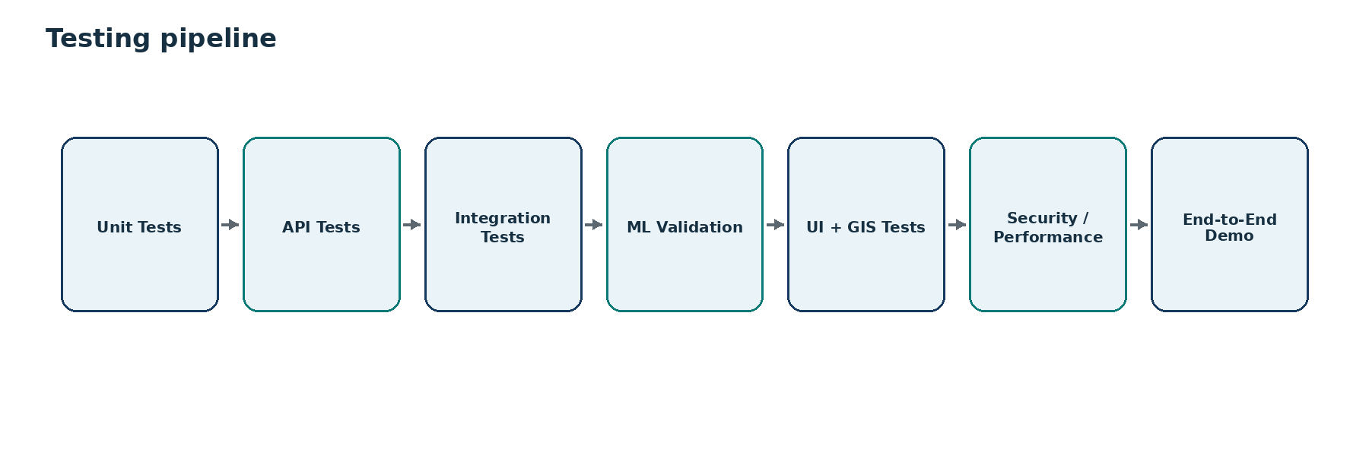
Figure 21: Proposed testing pipeline

30. Limitations
Limitation | Management approach
Data quality | Incomplete or inconsistent data can reduce prediction reliability. Manage through validation, provenance and completeness indicators.
Limited labelled outcomes | A predictive model requires defensible labels. Start only with available evidence and avoid overstating performance.
Changing acquisition patterns | Patterns may shift with policy, process or project mix. Monitor performance over time.
Model drift | Use periodic evaluation and versioned retraining.
Incomplete records | Use explicit missing-value handling and avoid treating unknown as negative.
Integration challenges | Adopt modular APIs and phased integration.
Prediction uncertainty | Present probability and explanations; retain human review and do not present predictions as certainty.

31. Future Scope
- More government data integration
- Improved and automated model retraining governance
- Advanced geospatial analytics
- Temporal prediction
- More sophisticated delay-duration forecasting
- Additional notification channels
- Mobile interface
- Advanced administrative analytics
STATUS: These are future extensions, not currently implemented capabilities.

32. Impact and Benefits
Impact area | Expected benefit
Administrative Impact | Earlier identification of likely delays; better prioritization of interventions; faster bottleneck identification.
Economic Impact | Better resource allocation and reduced risk of prolonged delay; any savings must be measured rather than assumed.
Infrastructure Impact | Improved visibility of acquisition progress and coordination across stakeholders.
Governance Impact | Shift toward predictive monitoring, transparent risk assessment and district/state comparative views.

Figure 22: Impact logic - from prediction to intervention

33. How to Explain to a Judge
Version | What to say | What to show | Key point
30 seconds | “LandGuard AI predicts which land-acquisition projects are at risk of delay before the delay becomes critical. It combines project data with machine learning, explains the reasons using SHAP, suggests corrective actions, shows risk geographically through GIS, and alerts administrators. The final decision always remains with authorized officials.” | Show the core five-stage cycle. | Prediction is actionable because it is explainable.
1 minute | Add the problem factors, project-level outputs and GIS/alert workflow. Explain that the model is validated on historical outcomes and new outcomes support periodic improvement. | Show problem-vs-proposed visual, then dashboard. | Shift from reactive monitoring to proactive intervention.
3 minutes | Walk through input data, preprocessing, candidate models, probability → risk category, SHAP, recommendation engine, GIS and alerts. Mention data-quality challenges and human review. | Show end-to-end workflow and architecture. | This is a complete decision-support system, not just a classifier.
5 minute technical | Explain target definition, feature engineering, baseline/model comparison, evaluation metrics, calibration/thresholds, SHAP, API separation, PostGIS, RBAC, audit logging and model governance. Use P1042 as a fictional demo. | Show ML pipeline, architecture, SHAP visual, ER/API and fictional example. | Technical credibility comes from validation, explainability and governance, not from claiming unverified accuracy.

34. Expected Judge Questions
Judge question | Technically accurate answer
What exactly are you predicting? | Primary proposed task: probability that a project belongs to a delayed-risk class. A separate regression task may estimate delay duration if reliable labels exist.
What is your target variable? | Proposed classification target: Delayed = 1, Not Delayed = 0. Final definition must be confirmed against available government records and timing rules.
Where does the training data come from? | The source proposal references official government land-acquisition and infrastructure project records, including DoLR/LACRRIS and MoSPI/PAIMANA where applicable. Actual access and usable fields must be confirmed.
How do you handle missing data? | Validate completeness, apply field-specific imputation only when defensible, preserve missingness indicators where useful, and reject records that are insufficient for safe inference.
Why XGBoost? | It is a candidate because boosted trees often perform well on structured/tabular data. We will not assume it is best; we compare it with a baseline and alternatives using validation.
Why not only use historical rules? | Rules are transparent but may miss complex combinations of factors. ML can learn interactions; the recommendation layer can still remain transparent and rules-based.
How do you explain predictions? | Feature importance for global understanding and SHAP/local explanations for project-specific drivers.
What is SHAP? | A model-explanation method that estimates how each feature contributes toward raising or lowering an individual prediction relative to a baseline.
How is the risk score calculated? | The initial concept derives risk from model probability and validated thresholds. Exact scoring logic is to be finalized and must be versioned.
How do you avoid false alarms? | Tune thresholds using precision/recall trade-offs, review calibration, analyze false positives, and keep human review before administrative action.
What happens if the prediction is wrong? | The official can reject or override the recommendation, the decision is logged, and observed outcomes support evaluation and future model improvement.
Is the system replacing government officials? | No. It is a decision-support system. AI recommends; authorized officials decide.
How does GIS help? | It adds geographic context, district/state filtering, risk markers and visual patterns that are difficult to see in a table alone.
How does the recommendation engine work? | Initially, transparent mappings from risk drivers to proposed administrative responses. It should remain reviewable and policy-aligned.
How will the model improve over time? | Store new outcomes, periodically evaluate performance, retrain when justified, validate the new version, and keep version history.
How will you handle model drift? | Monitor performance and feature distributions, compare against prior periods and trigger review/retraining when evidence shows degradation.
How is sensitive data protected? | Authentication, RBAC, authorization, secure APIs, encryption where required, audit logs, input validation and least-privilege access.
How does the system scale? | Separate frontend, API, database, GIS and ML services; use PostgreSQL/PostGIS; scale prediction services independently when required.
What happens when new project data arrives? | Validate and transform it with the same feature pipeline, run inference, store the prediction/explanation, refresh views and trigger alerts if conditions are met.
How can this integrate with existing government systems? | Through modular REST APIs and data adapters, subject to the actual interfaces, permissions and security requirements of those systems.

35. Demo Script
Step | What to click | What to show | What to say | Why it matters
1. Login | Open login screen | Authenticated role | “Only authorized users access project-risk information.” | Introduces RBAC.
2. Dashboard | Enter dashboard | Summary cards, charts, GIS | “This is the portfolio view; we can immediately see priority risk.” | Shows triage.
3. Select high-risk project | Click P1042 | Project drill-down | “P1042 is fictional and used only to demonstrate workflow.” | Avoids implying real data.
4. Show project information | Open details | Input fields / acquisition progress | “These features describe project and acquisition status.” | Connects data to model.
5. Run prediction | Click Predict / refresh | Inference result | “The model processes validated features using the deployed version.” | Shows ML in action.
6. Show probability | Open prediction card | 82% illustrative | “This is a probability, not certainty.” | Demonstrates calibrated language.
7. Show risk score | View risk badge | HIGH illustrative | “Validated thresholds translate probability into operational priority.” | Makes output actionable.
8. Show SHAP explanation | Open Why? panel | Top contributing factors | “We can see which factors pushed the prediction up or down.” | Builds trust.
9. Show recommendations | Open actions panel | Suggested actions | “These are reviewable decision-support recommendations.” | No autonomous decision claim.
10. Open GIS location | Click map | Risk marker and nearby context | “GIS supports district/state spatial monitoring.” | Shows geographic visibility.
11. Show alert | Open alert center | Risk alert | “High-priority projects can trigger approved notification channels.” | Shows proactive monitoring.
12. Explain intervention | Open action log | Official action / note | “Authorized officials decide and record the response.” | Human in loop.
13. Show continuous improvement | Open model info visual | Outcome → evaluation loop | “New outcomes allow future evaluation and retraining.” | Closes the learning loop.

36. Technical Glossary
Term | Simple explanation
Machine Learning | Algorithms learn patterns from historical examples to make predictions on new data.
Classification | Predicting a category, such as delayed vs not delayed.
Regression | Predicting a numeric value, such as estimated delay days.
Feature | An input variable used by a model.
Target Variable | The outcome the model is trained to predict.
XGBoost | A gradient-boosted tree algorithm and candidate model for structured data.
Random Forest | An ensemble of many decision trees.
Logistic Regression | A statistical classification model and useful baseline.
SHAP | A method for explaining how features contribute to a prediction.
Explainable AI | Methods that make model behavior understandable to people.
Risk Score | Operational representation of predicted project risk.
Probability | Model-estimated likelihood; not certainty.
PostgreSQL | Relational database system.
PostGIS | Spatial extension for PostgreSQL.
GIS | Geographic Information System for location-based data and analysis.
REST API | HTTP-based interface between system components.
RBAC | Role-Based Access Control: permissions determined by authorized role.
Model Drift | Decline/change in model behavior as real-world patterns change.
Feature Engineering | Turning raw data into useful model inputs.
Data Validation | Checking data type, range, completeness and consistency.
Prediction | Output generated by a trained model for a new record.
Inference | The act of applying the trained model to new input data.

37. Final One-Page System Summary
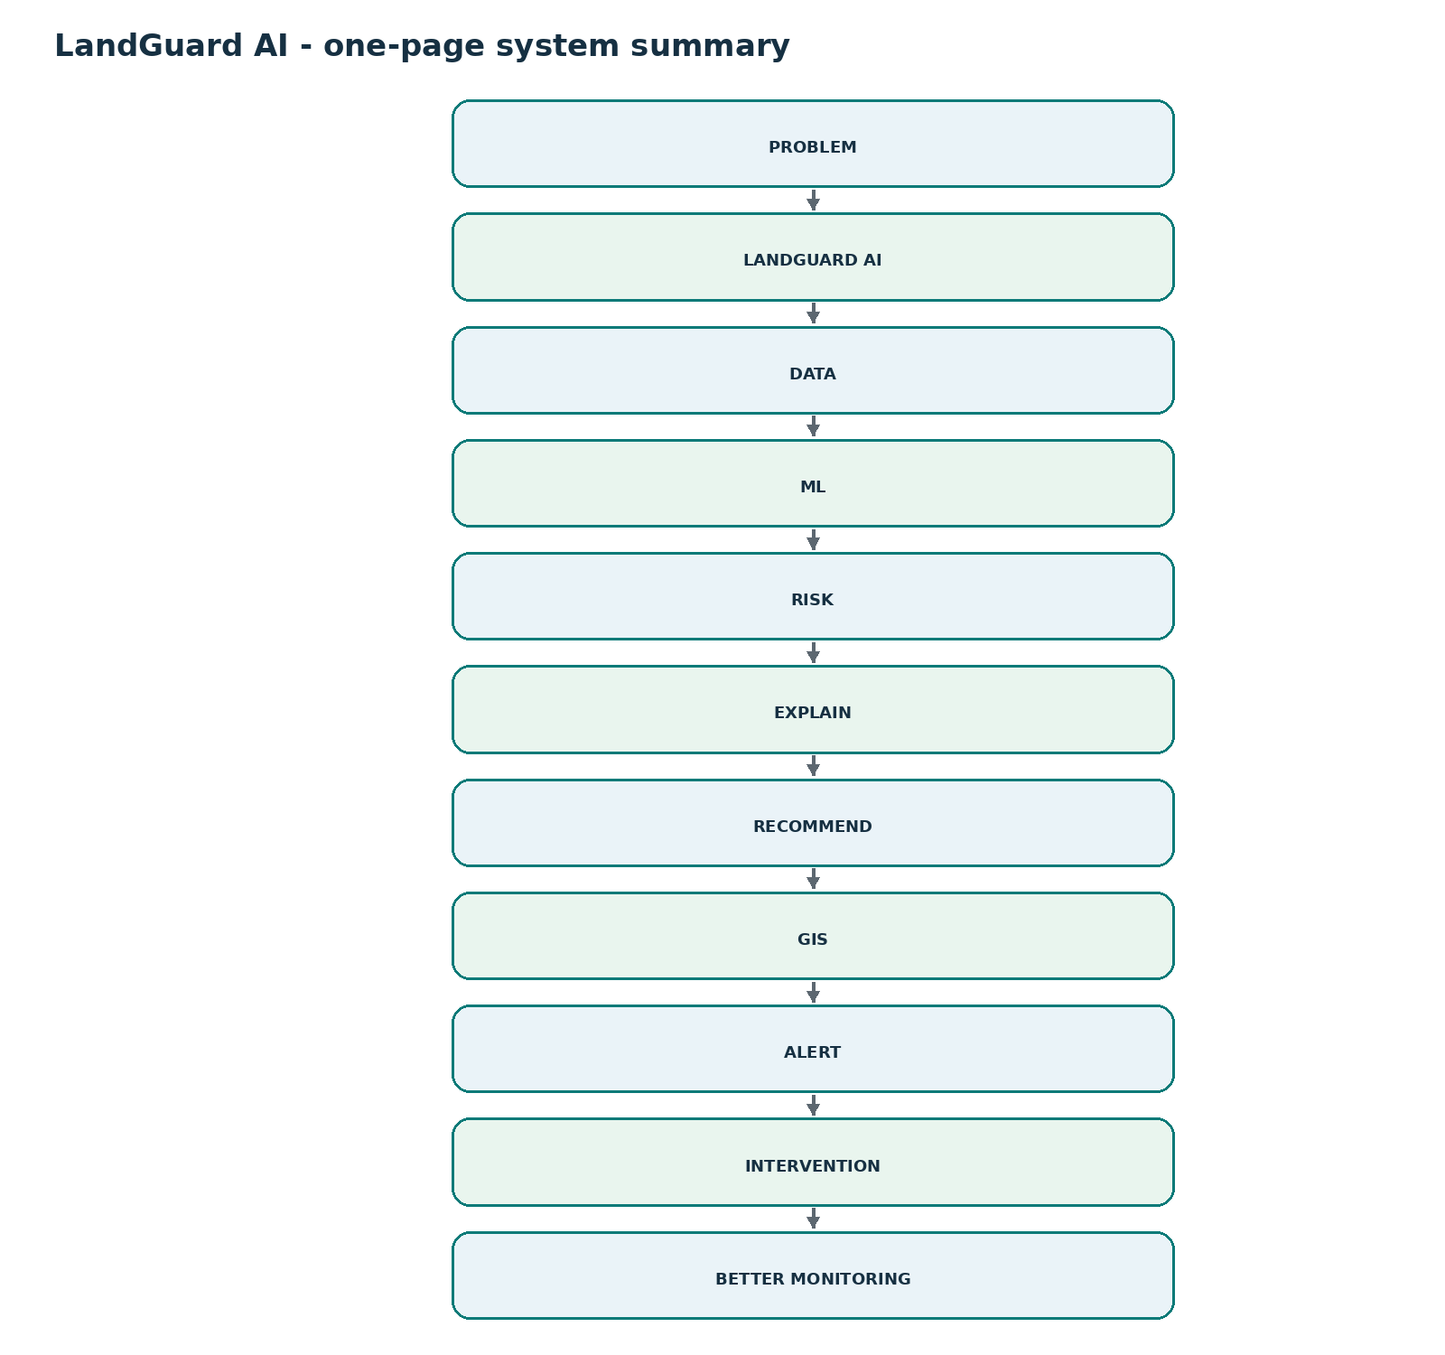
Figure 23: LandGuard AI one-page system summary
PREDICT → EXPLAIN → RECOMMEND → ALERT → INTERVENE

38. Source and Reference Section
Primary source for this handbook: the LandGuard AI SIH 2026 Idea Submission deck for Problem Statement SIH26017. The source proposal identifies the following reference directions; URLs are intentionally not fabricated here:
- SIH 2026 - Problem Statement SIH26017: “Predictive Analytics System for Early Detection of Land Acquisition Delays.”
- DoLR, Ministry of Rural Development: Land Acquisition Compensation, Rehabilitation and Resettlement Information System (LACRRIS).
- Ministry of Statistics & Programme Implementation: project monitoring / infrastructure project information through PAIMANA where applicable.
- Official government land-acquisition and infrastructure project records: project timelines, acquisition stages, compensation status, approval information, possession status, rehabilitation information and geographic information.
- Research areas: predictive analytics for project delay, explainable machine learning, risk scoring, GIS-based infrastructure monitoring and decision-support systems.
ACCURACY RULE: Do not fabricate dataset size, project counts, model metrics, government statistics, deployment status, production integrations or actual prediction results. Use “To be determined during implementation”, “Illustrative example”, or “Proposed architecture” as appropriate.

LANDGUARD AI
Predict early. Explain clearly. Recommend transparently. Alert responsibly. Intervene with human authority.

