Contents
1. Event Driven Architecture Patterns 1
1.1. Publish-Subscribe 2
1.2. Event-Driven Routing (Content based routing). 4
1.3. Event-By-Reference (Event Notification). 6

Event Driven Architecture Patterns
Event-driven patterns are architectural styles used in software design where the flow of the program is determined by events—such as user actions, sensor outputs, or messages from other programs or threads. These patterns are especially useful in systems that require high scalability, responsiveness, and decoupling between components.
Apache Kafka supports several event-driven architectural patterns that help build scalable, decoupled, and resilient systems. Here are the most common Kafka patterns used in real-world applications.

Publish-Subscribe
Publish-subscribe interactions are driven by events – a publisher makes information available for general distribution. A subscriber is triggered to receive the information upon the arrival of data. Communication flows in one direction.
Example applications include Star Ratings data feed handlers publish the latest Star Ratings to tens of consumers simultaneously.
Use Cases
- Event-Driven Architectures: Trigger downstream processes based on events (e.g., user actions, IoT data).
- Data Pipelines: Stream data between systems, such as databases, analytics platforms, or machine learning models.
- Microservices Communication: Enable loosely coupled communication between microservices.
Solution
Publish-subscribe applications are event-driven, as opposed to client-driven or demand-driven.
In publish-subscribe interactions, data producers are decoupled from data consumers – they do not coordinate data transmission with each other, except by using the same address (Topic) names.
- Producers (Publishers):
  - Producers send messages to topics in Kafka. A topic is a logical channel where messages are stored temporarily.
  - Each message is appended to the topic in the order it is received.
- Topics:
  - Topics act as the central hub for communication. They are partitioned for scalability, allowing multiple producers and consumers to work concurrently.
  - Messages in topics are retained for a configurable period, enabling asynchronous processing.

- Consumers (Subscribers):
  - Consumers subscribe to one or more topics to receive messages.
  - Kafka supports consumer groups, where each consumer in a group processes a subset of the topic's partitions, ensuring load balancing.
- Decoupling:
  - Producers and consumers are independent of each other. Producers don’t need to know who the consumers are, and consumers can process messages at their own pace.

Event-Driven Routing (Content based routing).
Messages originating from a single source are processed by multiple applications based on attributes such as state name, provider name, or client number.
For instance, B2G sends provider information to GPMS, which then needs to re-route these messages to different backend systems according to the provider category, since each category requires distinct processing logic.
Use Cases
Event-Driven Architectures: The messages generated by the source system must be sent to different destinations based on the content (field values) in the message. However, the source system is not capable of communicating directly with multiple destination interfaces or simply do not care or is not aware of the multiple destinations the messages must reach.

Solution
Event driven routing /Content-based router is used as the filter to re-route source messages to their appropriate destinations.
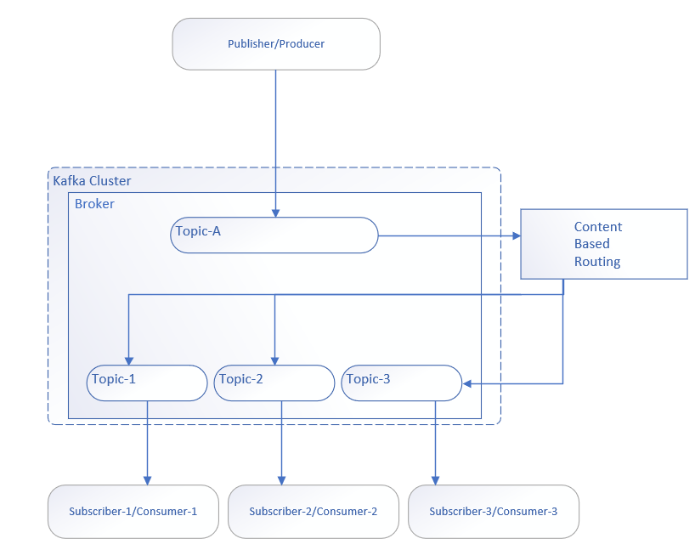

- Producers (Publishers):
  - Producers send messages to topics in Kafka. A topic is a logical channel where messages are stored temporarily.
  - Each message is appended to the topic in the order it is received.

- Topics:
  - Topics act as the central hub for communication. They are partitioned for scalability, allowing multiple producers and consumers to work concurrently.
  - Messages in topics are retained for a configurable period, enabling asynchronous processing.

- Kafka Streams Application : Reads messages, inspects content (e.g., JSON field type), and applies routing logic.
- Runs on Amazon EC2 or EKS.
- Implements routing logic using Kafka Streams API.
- Connects securely to MSK using TLS and IAM (if enabled).

- Consumers (Subscribers):
  - Consumers subscribe to the topic to receive already filtered messages based on matching content condition.
  - Kafka supports consumer groups, where each consumer in a group processes a subset of the topic's partitions, ensuring load balancing.
- Decoupling:
  - Producers and consumers are independent of each other. Producers don’t need to know who the consumers are, and consumers can process messages at their own pace.

Event-By-Reference (Event Notification).

Event Notification is an event-driven pattern where a producer publishes an event to indicate that an action has occurred. These events usually contain minimal details, such as an identifier or reference, rather than the complete state. Consumers then receive the event and retrieve any additional information from the producer or another service as needed.
Use Cases
Integration with backend Systems: When full state transfer is not feasible due to size or complexity (Ex:- Salesforce sending platform event with reference details when there is change in business object).
Solution
Event by reference/ Event Notification is used by event source/producer to emits an event to notify the changes in source system by providing minimal information (e.g., Object reference) rather than the full data object.
    - Producer:
- Publishes minimal event (e.g., {"EventUuid": "4953bffa-7025-438e-a37f-534fbd121e37","replayId": 8447323,"EventApiName": "Notification__e" }) sent to topics in Kafka.
- Each message is appended to the topic in the order it is received.
    - Topics:
    - Topics act as the central hub for communication. They are partitioned for scalability, allowing multiple producers and consumers to work concurrently.
    - Messages in topics are retained for a configurable period, enabling asynchronous processing.
    - Consumers (Subscribers):
    - Consumers subscribe to topic to receive messages.
    - On receiving event, consumer Invoke an Producer’s API based on event details to get complete payload from source system to consume.
    - Kafka supports consumer groups, where each consumer in a group processes a subset of the topic's partitions, ensuring load balancing.

