**GRADING SUBMITTED MEDIA ASSIGNMENTS ON CANVAS (INSTRUCTORS)**

1. Go to Gradebook and locate the student (in this case, “Test Student”).

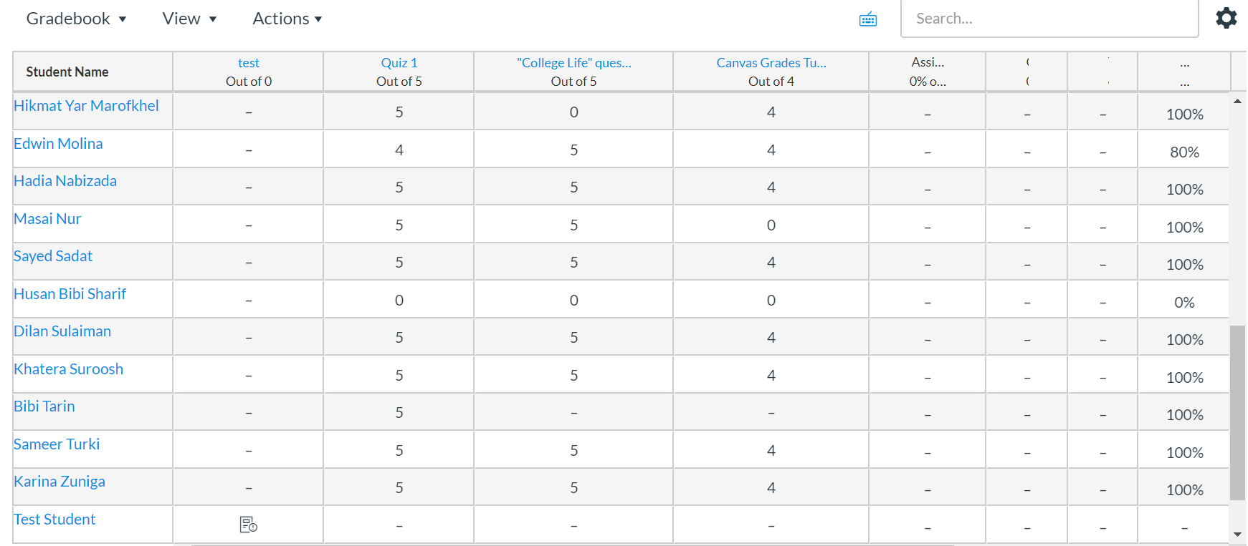

1. Click on the icon here, pictured to the right of the student’s name (“Test Student”).



1. This is what you will see after clicking the icon. Click on the right arrow (on right of screenshot).

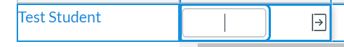

1. A side tab will pop in from the right side. Click on **SpeedGrader.**

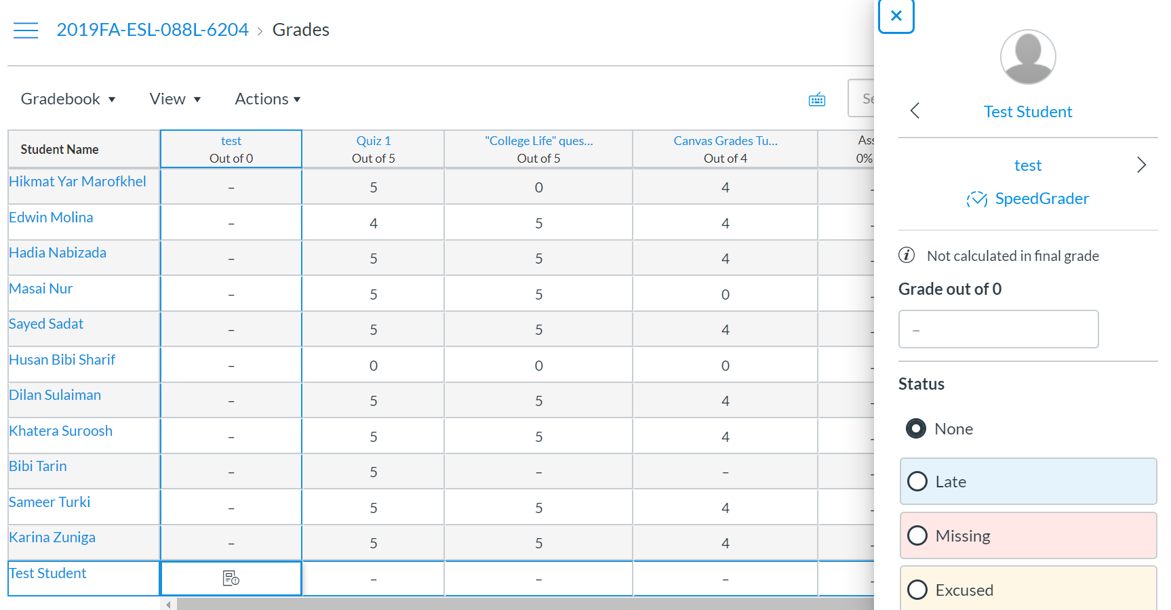

1. You will be taken to this page. Click on the “click here to view” link at the top left to view the submitted recording.

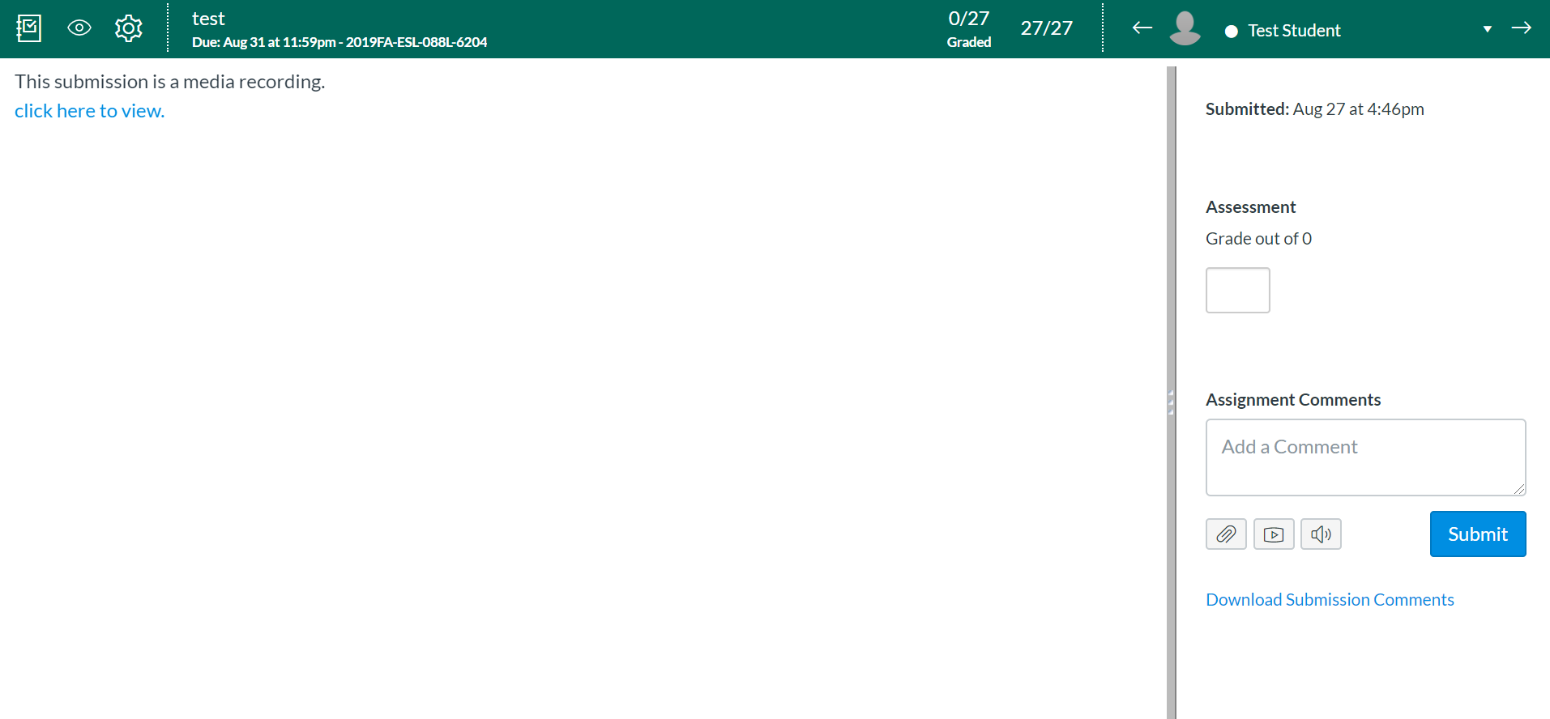

1. You can now view the recording.

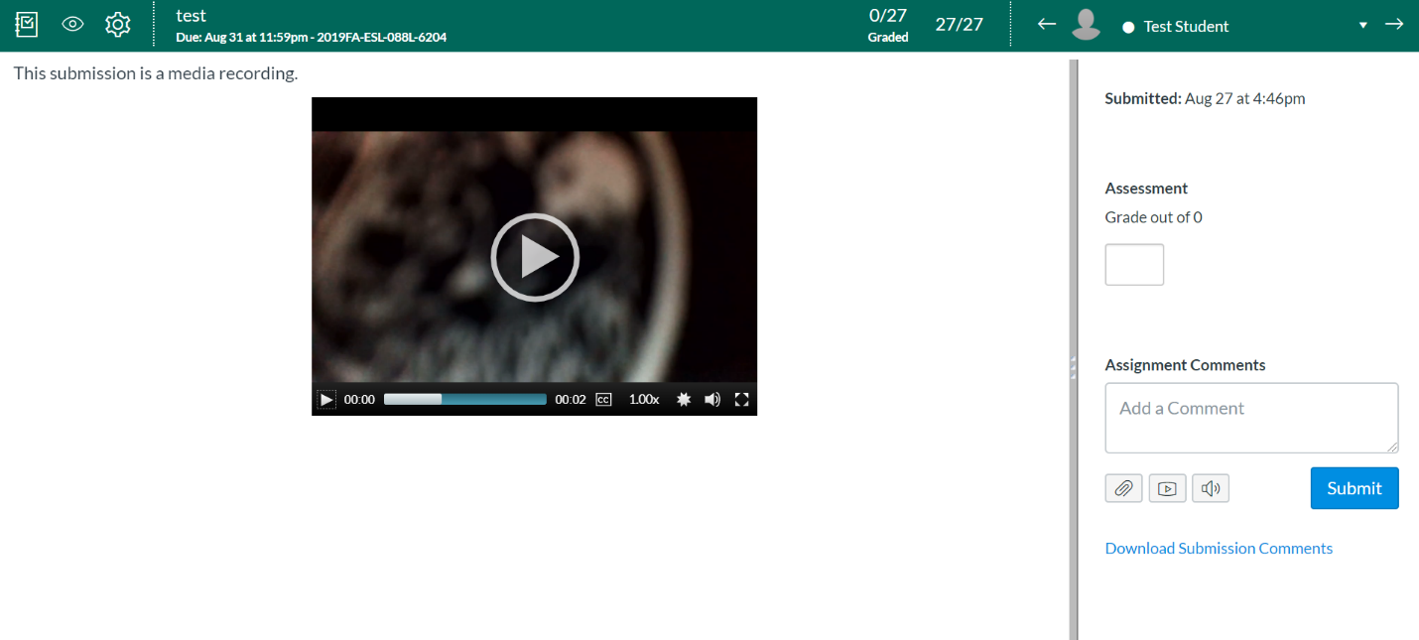

1. Enter the grade for the assignment and comments. Click Submit.

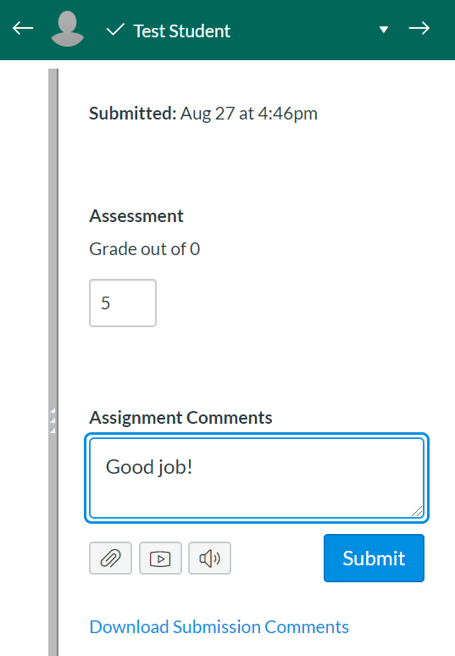

1. You will see a message saying that “Your comment has been submitted.” Click on the far-left icon (the one with the check mark) on the navbar to go back to the Gradebook.

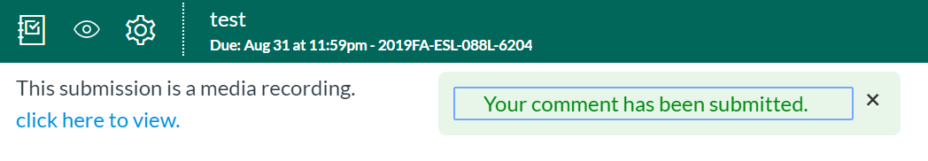

1. The student’s score now appears in the assignment column.



1. Students can go to Grades to view their grade (screenshot is taken from Student View). They can click on the icon on the far right to view their comments.

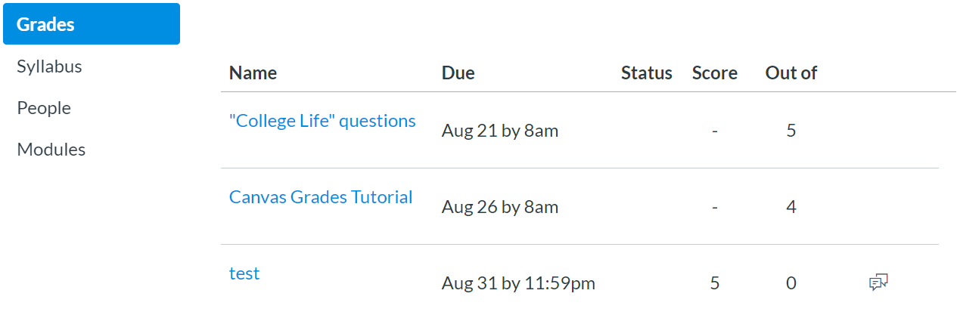

1. The comments are now visible.

