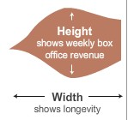

**Height**

Shows event heat

**Width**

Shows longevity

The **area** of the shape (and its **color**) corresponds to the event’s heat

0

20

40

60

80

100